LEARNING IN THE DIGITAL ERA

STUDENT NAME: Mariana –Valentina Marcu STUDENT ID NUMBER: 2211972

TASK 1. PREPARING FOR HIGHER EDUCATION

As a student, you are required to have certain abilities to study efficiently, such as self-management, academics, interpersonal relationships, and task completion.
Study skills are important since they allow you to study more efficiently, know what you're doing, plan your studies, write better essays, and save time. S. COTRELL (2019).

The student is the primary protagonist of the European Higher Education Area (EHEA) learning process. Teachers must be aware of the cognitive-motivational factors influencing their students' learning. The academic goals, learning strategies, and levels of academic engagement demonstrated by university students in their first year of adaptation to the European Higher Education Area and the interaction between these variables are examined in this study. According to the findings, most students are averagely oriented towards learning goals and highly trained towards accomplishment goals, use numerous learning strategies regularly, and have average levels of academic engagement.

Some of these variables have positive and significant associations. More research is needed to understand the role of various variables in the construction of quality autonomous learning processes, not just about students, as in this study, but also about teachers, tasks, contexts, and academic institutions, as well as the various interactions between them keywords: academic goals; learning strategies; academic engagement; European Higher Education Area; autonomous learning.

Many students who begin university are unprepared for this type of education. Although they may begin with the necessary knowledge, they lack the necessary learning tools and exhibit deficiencies in self-regulation, inadequate time management, and even their involvement, effort, and motivation, all of which hinder autonomous learning, which is such an important component of the EHEA (Nelson, Quinn, Marlington, & Clarke, 2012).

However, in addition to introducing students to a new academic context, beginning university involves a personal and social transition that can result in a mismatch between the person and the context, which explains why the first year has the highest percentage of dropouts (Cabrera, Tomás, Varez, & González, 2006). This reflects a personal, family, and social issue. Given this, the EHEA strives to address the personal factors offered by students, emphasising the responsibility of teachers in guiding and supporting them, as well as assisting in the prevention of potential difficulties, particularly with new students. Thus, our worries arise in this setting, as does our desire to learn more about the personal characteristics of new students that determine whether they continue their studies and adopt quality independent learning practices.

studies which are characterised by vigour, dedication, and absorption (Schaufeli, Salanova, González-Romá, & Bakker, 2002). Vigour refers to levels of high effort, energy, and persistence while one is studying. Dedication implies involvement, enthusiasm, inspiration, pride, and belief in what one is doing. Absorption involves being concentrated and happy while studying, having the impression that time flies while doing it, and not wanting to stop. As a result of their interest in acquiring new skills and improving their knowledge, as well as their belief that they can achieve this through effort, students who have learning goals seek out different ways of learning, dedicating more time, persistence, and commitment to the tasks set (Pintrich, 2000; Valle et al., 2009). This is because they perceive tasks as an opportunity to acquire more competencies and feel control (Valle et al., 2009). By Cognitive-motivational variables of students / Variables cognitive-motivational del alumnado 419 contrast, students with achievement goals, who consider skills to be a stable feature separaisfrom the effort invested, believe that the greater effort made, the lesser the skills. As a result of this, they put in the minimum effort and dedication (Elliot, McGregor, & Gable, 1999). These results show that academic goals are related to the use of learning strategies and academic engagement, a variable, considered essential in focusing efforts to prevent academic failure and improve(Nelson et al., 2012). Given this, we aim to inquire into the Givenoals, learning strategies and levels of academic engagement shown by university students in their first year of adaptation to the European Higher Education Area. We also aim to show if any relationships exist between these variables. We thus aim to obtain information on the cognitive-motivational characteristics of our students, which will be highly relevant in terms of the learning processes that we drive forward and support as teachers Davies, C 20 21)
As a student, the expectations are: to be independent, in other words,s to” stand on your own feet”, to be independent, to be self-motivated, to be part of a team, to be open to working with others, to be able to work with the rs, to be able to work things out for your elf, to be able to set up goals to improve your work, to be organised, to be able to set up a time when and how you learn best ( Cotrell, S,p 13 )
We concentrate on academic goals, learning strategies, and academic engagement since the literature currently available indicates that these factors are of interest. Academic objectives are the things that students want to accomplish by studying and are the academic motivations behind their actions. According to the goal orientation approach (Hayamizu & Weiner, 1991), there are three distinct types of goals: one is focused on learning, and the other two are productivity-related: "social reinforcement goals" and "achievement goals." (1) Students who are drawn to the task and who view learning as a goal, engaging in this learning to gain knowledge and enhance their competencies, are identified as having "learning goals." (2) Students who have "social reinforcement goals" are those who wish to be highly regarded by others. The causes have nothing to do with education or academic success. Nevertheless, they are significant because they are connected to the emotional experience brought on by the reactions of others to their successes or failures. (3) "Achievement goals" are a reflection of students' propensity to learn how to get good grades, move ahead in their studies, and prepare themselves for the future. In conclusion, students study in order to: (1) learn; (2) feel good about themselves; and (3) pass. These objectives have typically been mutually exclusive. The several studies 418 E. Escolano-Pérez conducted, however, did not find any association between them (Corral de Zurita & Leite, 2002; Hayamizu & Weiner, 1991), demonstrating their independence and the potential for one, none of them, or multiple of them to be adopted. Other studies (Church, Elliot, & Gable, 2001; Grant & Dweck, 2003; Skaalvik, 1997; Valle, González Cabanach, Cuevas, & Nez, 1996) have discovered relationships between some. Different academic goals may coexist depending on various personal variables (academic self-perception, self-efficacy, causal attributions, learning styles, and strategies, etc.) and contextual variables (task to be completed, evaluation system, classroom climate, teaching style, and other aspects related to the teacher), according to the "theory of multiple goals" (Pintrich, 2000). As a result, although motivation is the outcome of an internal and personal process, context plays a role as well. Academic goals have an impact on academic performance as well as the quantity and quality of learning activities students engage in as well as their emotional, cognitive, and behavioural reactions to the outcomes (Taye & Monette, 2010). In this regard, some research examines the connection between students' academic objectives and their chosen learning techniques. According to Beltrán (2003), learning strategies are the cognitive, affective, and motor-skill processes that encourage students to actively pursue particular learning objectives in particular circumstances. The application of developed learning strategies, such as organisation-related cognitive strategies and self-regulation-related metacognitive strategies, is favourably and significantly related to learning goals and promotes meaningful learning (Valle, González, Nez, Rodriguez, & Pieiro, 2001). In contrast, achievement goals are linked to tactics that promote a shallow understanding of the material, leading to learning that is of lower quality but does not necessarily result in lower grades. Students that are focused on social reinforcement goals employ learning techniques that are not especially successful and involve inefficient information processing (González & Tourón, 1992). There have also been differences in other personal characteristics, such as effort, persistence, involvement, and concentration on studies, depending on the predominant goals among students. These characteristics are crucial components of the academic engagement construct, which is a persistent and favourable affective-cognitive state associated with one's studies and is characterised by vigour, dedication, and absorption (Schaufeli, Salanova, González-Romá, & Bakker, 2002). Vigour is the term used to describe degrees of intense effort, vigour, and perseverance during learning. Dedication indicates participation, zeal, inspiration, pride, and confidence in one's work. Studying while feeling pleased and focused, as well as having the sense that time is flying by, is referred to as being absorbed. Students who have learning goals look for alternative methods of learning, investing more time, persistence, and commitment to the tasks given (Pintrich, 2000; Valle et al., 2009), because they are motivated to learn new skills and advance their knowledge and because they believe they can do so through effort. This is because they view tasks as chances to improve their competence and feel in control (Valle et al., 2009). Students with success goals who view skills as a stable feature separate from the effort put forward think that the more work put out, the lower the skills will be.
This is in contrast to students with achievement goals, who believe that skills are a stable feature apart from the effort put forth. Because of this, they make the least amount of effort and commitment possible (Elliot, McGregor, & Gable, 1999). These findings demonstrate the connection between academic goals, the employment of learning techniques, and academic engagement, a variable that is thought to be crucial in concentrating efforts to avoid academic failure and advance (Nelson et al., 2012). In light of this, our goal is to learn more about the academic engagement levels, learning styles, and behaviours that university students exhibit throughout the first year of adjusting to the European Higher Education Area. We also want to demonstrate any connections between these variables. Thus, our goal is to gather data on the cognitive-motivational traits of our pupils, which will be very important for the learning processes that we promote and encourage as teachers. C. Davies (20, 21)

As a student, you are expected to: be independent, or "stand on your own two feet," to be self-motivated, to be a part of a team, to be open to working with others, to be able to work with the teachers, to be able to figure things out on your own, to be organised, and to determine the best time and environment for learning. Cotrell, S., p.
Task 2 A mind map

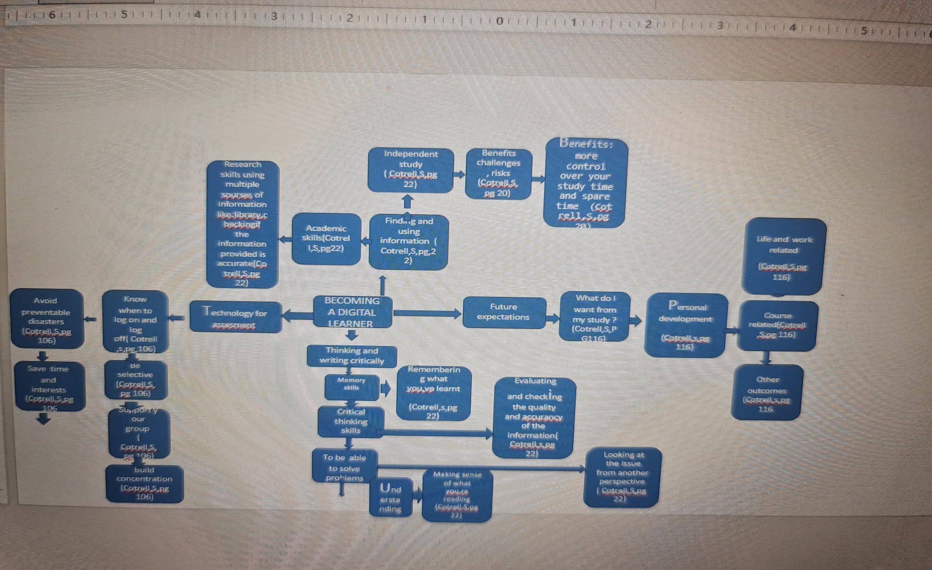

TASK 3 A two–minute video presentation

https://youtu.be/c8w64LDkzJw

TASK 4
Starting university
If you were lucky enough to attend university, you probably recall those joyful days. But transitioning from a family home to a life of independence and from a tightly controlled school to free options about when and how much to study is extremely difficult and appears to be even more so for today's students.
In a survey conducted by the University Partnerships Programme, 87% of students reported difficulty managing the social, academic, and/or financial aspects of university life. The pressure is heightened for people who have pre-existing mental health issues as well as those who become aware of strains and sudden changes at home.
What can parents do to make this vital transition as smooth and joyful as possible? Prepare wisely. Create a budget with your undergraduate once they've determined where they'll be living. Ask how they'll keep track of spending; it's far too easy to overspend if they don't, and this will serve as a starting point for discussion when they return home. If they know you'll assist them if they can demonstrate deficiencies with actual figures, they'll be more likely to behave responsibly and feel more in charge of this intimidating area of university life.

Keep in touch on a regular basis, but only on their terms. Before you leave them out on the first day of school, ask where and how you may reach them next. Decide on an approach that allows you to hear what they're saying and, perhaps, see them. In this manner, you're going to be in an ideal position to identify problems.

Let them have control throughout discussions. Never be hesitant to ask about concerns. Allow for breaks. Enjoy their best moments and, when they're low, try to confirm their feelings rather than express criticism. If you think they're having trouble, ask about how you could support them in finding the right assistance. Avoid talking about your own issues. Request that they select someone so that you can contact them again at the conclusion of every conversation.

Preserve consistency in the household. Families might think it is best to put off significant adjustments, such as separation or relocation, until the kids depart home. However, it may be somewhat bothersome because new students usually seek comfort in a comfortable home setting when they're feeling anxious. If parents postpone significant modifications—at least throughout a term and ideally for all of the first year—this can help a new student stay on track. Taking time to reflect under the new circumstances may help parents make more informed choices.

Lastly, make sure that your child understands that there's always an inviting atmosphere back home if they're in need of a break Blair, L. (2019) ‘Facing the challenges of starting university; The Surgery; MIND HEALING’, Daily telegraph (London, England : 1969), p. 20–.

REFERENCES

TASK 1. Cottrell, S 2019, The Study Skills Handbook, Bloomsbury Publishing Plc, London. Available from: ProQuest eBook Central. [8 November 2022]
Task 2. Cottrell, S 2019, pg. 20, pg22, pg. 116T, pg. 116, The Study Skills Handbook, Bloomsbury Publishing Plc, London. Available from: ProQuest eBook Central. [8 November 2022]
Task 3
- https://doi.org/10.1080/11356405.2014.965446

BLAIR, L., 2019, Sep 23. Facing the challenges of starting university: The Surgery MIND HEALING. The Daily Telegraph, 20. ISSN 03071235.

Blair, L. (2019) ‘Facing the challenges of starting university; The Surgery; MIND HEALING’, Daily telegraph (London, England : 1969), p. 20–.

