User Experience Design
Ux Design analysis
Rebecca Jones (2305750)
2026
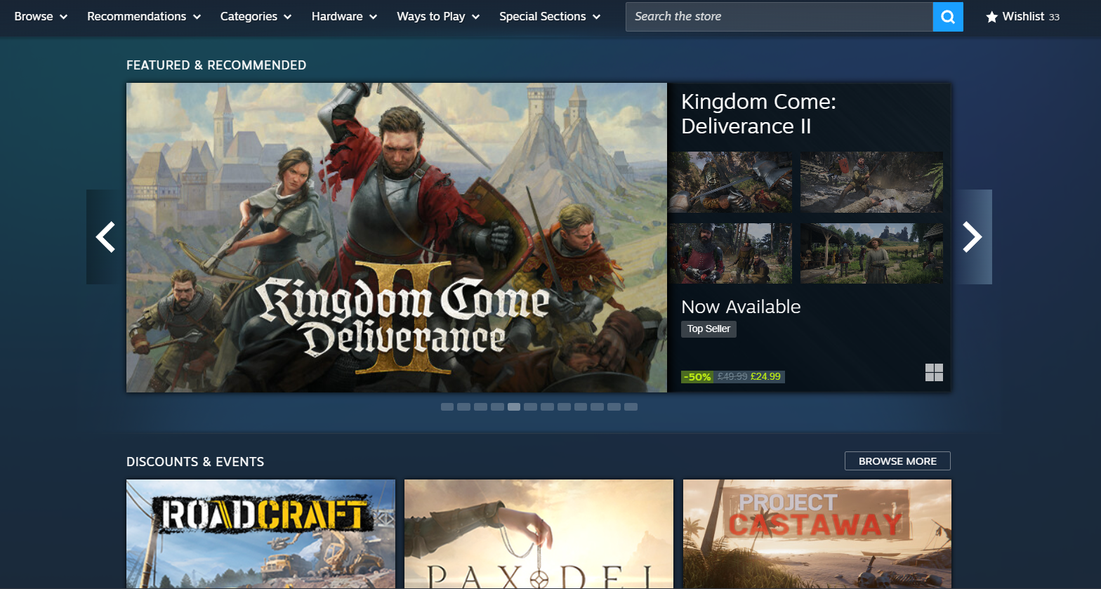
Steam is an online video game store front where users can purchase and download digital games. It was launched in 2003 and contains multiple features aside from the store. Steam can also be used a social network, giving users with accounts the ability to message and friend each other, create posts, review games, see friend activity and discuss games as well as many other features [1].
Screenshot of the steam home page [1].
When first opening the steam web application, it will usually take you to the front page of the store. This shows that Steam is trying to push users to spend money on products they do not yet own. In this example, the store has a “Featured & Recommended” banner, showing games personalised to the user’s tastes or what games are currently popular. Steam is telling the user that the displayed game is a “Top seller”, featured games can also have tags based on software the user has previously or recently played.


Screenshot of a game being recommended due to previously experienced titles.
Friends of users are also able to recommend games they like, which can also appear on the home page.



Screenshots showing the categories menu of Steam.
As well as recommending you products based on your history, the steam store also contains an easy to find “Categories” menu. Users can view their top categories and tags based on play history, as these are the most likely for a user to be looking for. The number of categories could be overwhelming to someone who does not know what they are looking for, so by making the most likely options larger, it separates it into neater areas which can be more easily read by users.
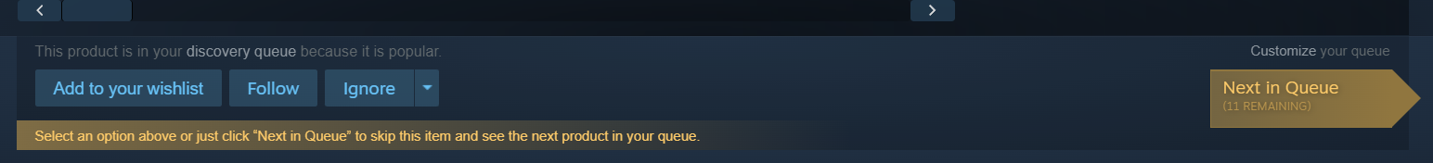
Steam’s store front homepage is focused around bringing what the user could want to the foreground to make it easier for them to make a purchase, this is observed in the “Recommended” menu, the “Your top categories section” and the front-page featured banner. As well as making any discounts or sales obvious, as some users may only purchase certain games if they are on sale.


Screenshot showing elements of Steam’s “discovery queue” feature.
For those who do not know what they want, Steam has a “Discovery queue” feature found in the recommendations menu. This is really helpful to both users and developers so games can reach more people. While usually based on recommendations, reasons for a game being recommended while reviewing were “because this game is popular” or “because this game is a top seller” rather than user preference.
Steam features are mostly locked unless you create or own a steam account. Testing the website without an account was only really good for general game browsing, looking at reviews and price checking games.
While the web and desktop versions are similar, the mobile app version feels significantly more clunky to use. Pages and the different icons on them feel like they take longer to load and due to the nature of it being a mobile app, the layout has changed from the PC versions and mean that a new unfamiliar layout had to be created. The mobile app contains mostly the same features as the web and desktop editions, however, has its own “Steam Shield” feature where users can log into the app and then use it to log on to other devices by scanning a QR code that appears. This feature can also be used to verify a log in attempt, rather than be emailed a verification code. This is a very convenient feature which is what makes the mobile app worth having and enhances the ease of use in the other versions.
A feature that the steam app could be useful for would be chatting with friends; however, this is a separate app that users would have to download and log in to separately despite having access to some social features like the friends list on the main app.

Navigation of Steam’s storefront home is made easier with how it presents choices to the user. Rather than showing the user every category in the same size as a list, the most likely options to be picked are made larger while the remaining categories are available below in a smaller size. This follows Career Foundry’s principle of choices and also the principle of disclosure [2]. A selection of choices is made more obvious to the user, keeping the list to a minimum (the principle of choices) while the larger list underneath shows that more information is available should they wish to access it (the principle of disclosure) [2]. Features like this are especially useful for navigating and making the information architecture of a product more satisfying to use and increases user satisfaction.
The design of the website stays very consistent, letting users know that each element of Steam is part of the same brand and decreases the chances of causing confusion or frustration to the user. The layout between the web and desktop versions are consistent with each other, while the mobile version needs to change to a more vertical layout due to its platform which means that users of the PC version will need more time to figure it out.
As Steam is a primarily PC application, the mobile version suffers from the lack of focus in its design, and less screen space means that more features have to be included in a smaller area. This is seen in the previously mentioned categories page. The desktop version goes from categories to whatever chosen section the user is looking for. While the mobile version goes from menu, to categories, and if the section the user is looking for is not in the four suggested categories they will need to go through and load another page, which takes longer on mobile. Examples like this are found throughout when comparing the two, mobile features are often hidden behind multiple menus.
Mobile pages will often take a few seconds to load, show a blank screen and only then starts to load icons. While the desktop version may take a few seconds to load, the page appears all at once. Its for reasons like this that the mobile version feels slower and more clunky than its other counterparts which can affect user experience and may run the risk of users quitting the app or giving up, especially considering the app’s increased number of menus required to access different sections.

In order to improve the user experience, enhancements could be very impactful to the mobile experience’s clunky design. Firstly, in fixing the issue of the loading times, users will be more likely to use the mobile app and will have a more positive time using it. Even if this was the only change, it would make the app’s menu navigation less frustrating to users. Mentioning menus, the layout of the menus could also be improved to a more concise design.
To accomplish this, rather than trying to cramp all of the desktops versions features into a smaller space, a ‘light’ version of the app could be created where less features would be available but would make for a better browsing experience. This could take the form of the app only having Steam’s store features, which is the main draw for the software, rather than trying to half incorporate their social features (referring to a separate mobile app being required for Steams chatting functions).

In conclusion, Steam’s overall UX design is of excellent quality and is relatively easy to navigate its information architecture to find what the user requires. This was found by interacting with this product as a user and trying to browse through to various products and categories. While Steam’s PC editions are easier to use, the mobile version suffers from trying to include all of the original’s features within a smaller area which can be changed by trimming down some of these features to only the most important or most frequently accessed by users. Creating a better mobile experience would only help users in being able to access the products being offered and create a user-friendly experience, free from frustration.

Bibliography:

[1] Steam. (2003). Valve. Accessed: Jan. 21, 2026. [Online]. Available: https://store.steampowered.com
[2] P. Klancar, “An Excellent Beginner’s Guide to Information Architecture,” Careerfoundry.com, 2019. https://careerfoundry.com/en/blog/ux-design/a-beginners-guide-to-information-architecture/

