"It's Okay to Ask": A Community-Led Mental Health Campaign Promoting Early Help-Seeking for Young Adults in the UK
BSc (Hons) Health and Social Care
Changemakers: Creativity and Value Creation
BMHP5014
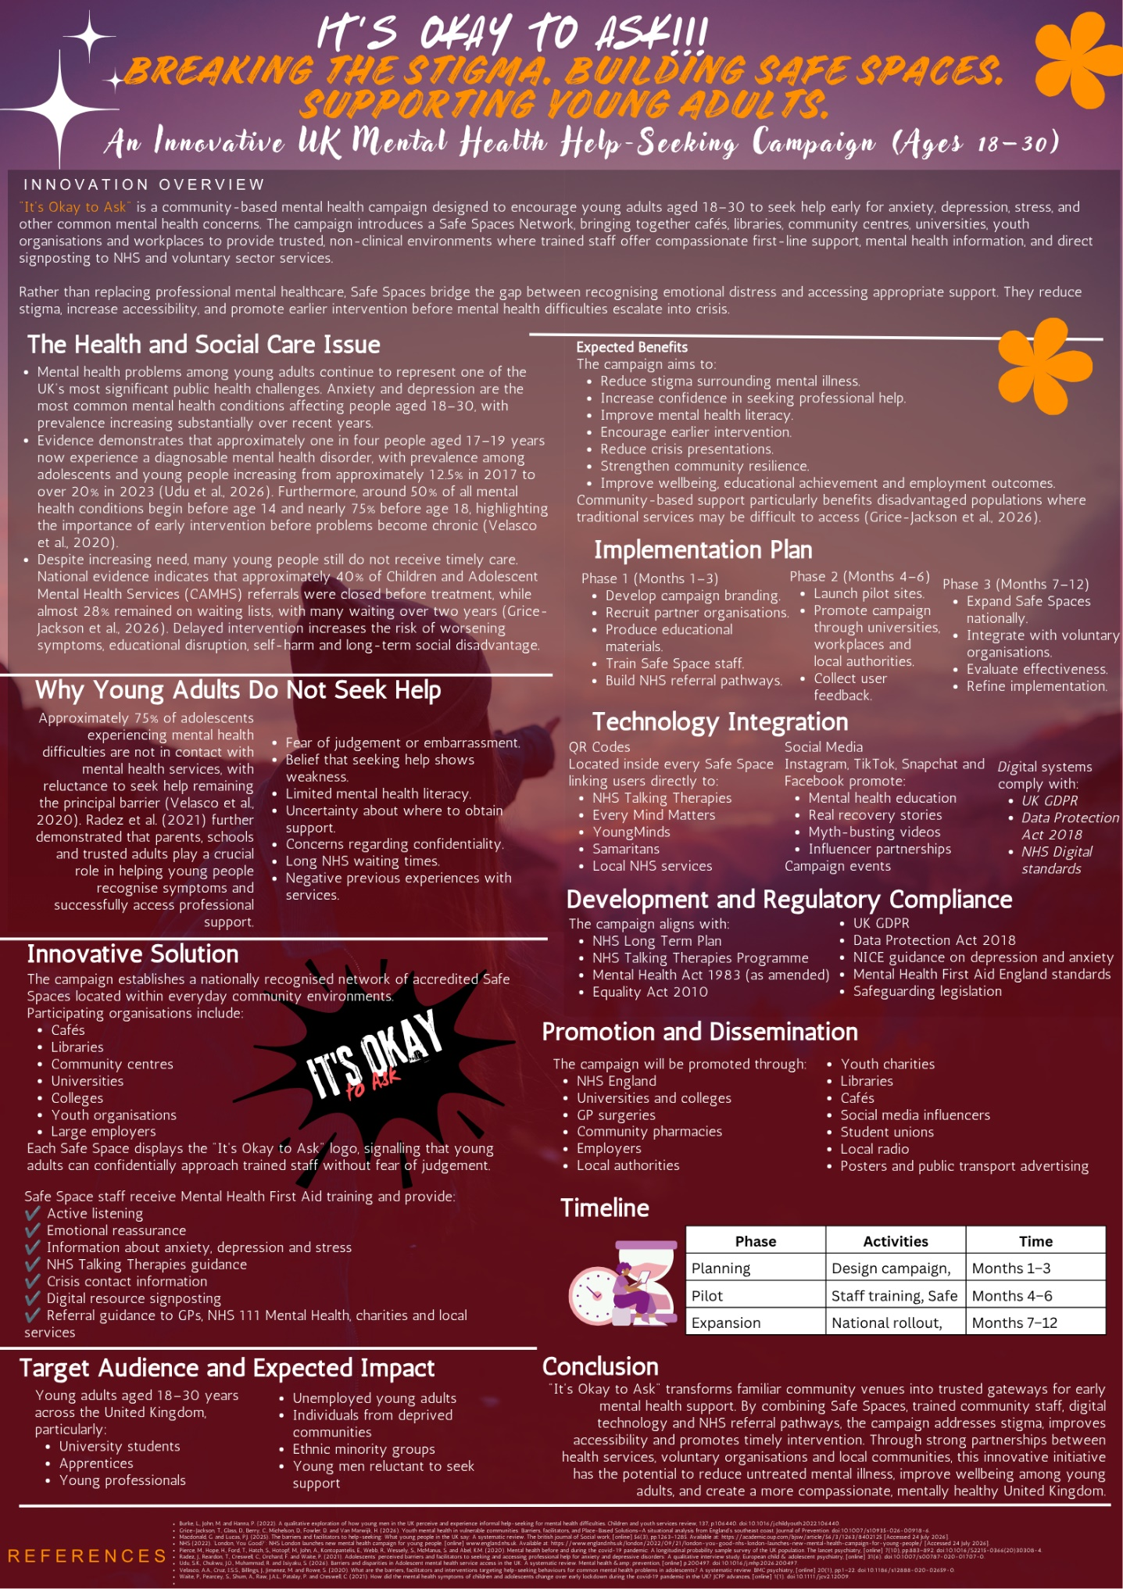
Poster
Pitch
Mental health is one of the biggest public health problems facing the United Kingdom. Most young people who are students at a university face various kinds of life transitions, changes regarding their career prospects and a lot of financial and living conditions pressure. Even though anxiety, depression and stress are becoming more frequent conditions among youth, they often delay seeking out a professional until their situation gets dangerously out of hand. The young who wait until they are so bad that they are completely overwhelmed end up being placed a lot of additional burden on themselves, their close relatives, their employers and especially, NHS mental health services. The proposed "It's Okay to Ask" campaign aims directly at the problem, the campaign proposes a nationwide Safe Spaces Network. In this model, community settings such as cafés, libraries, youth organizations and community centers become places that provide young adults with safe and inviting facilities. These facilities enable young adults the opportunity of having someone to talk to whom they trust, to get accurate mental health information and also receive direction as to which services, NHS or voluntary ones, will be the most appropriate to reach out to at that point.
The campaign mainly targets adults aged 18 to 30 years who are particularly vulnerable. They are a population group that shows very high anxiety and depressive disorder rates. In contrast, this group also has the lowest percentage of individuals who get timely mental health services from professionals. There are reports from some researchers indicating that about half of all mental health disorders that we suffer from in our lives begin before we hit the age of 15, while three-quarters happen before one enters adulthood. This means that the time period when a person goes from childhood to adulthood is a very crucial period for early intervention or even prevention of mental health problems (Udu et al., 2026). The psychological impact was significant at the time COVID-19 was at its peak. Young people were among the groups having the greatest mental health issues as lockdowns caused upheavals in education, financial status, jobs, and social relationships (Pierce et al., 2020). Waite et al. (2021) highlighted that during lockdown, emotional and behavioural symptoms among children and young people got worse, thus confirming worries that many were stepping into adulthood with some unresolved mental health issues.
The proposed campaign has been deliberately based on what young people have identified personally as being crucial for help-seeking effectively. Research consistently points out that adolescents and young adults usually look for support when they come across trusted adults who listen without prejudice, value confidentiality and show genuine concern in their interactions. Radez et al. (2021) discovered that adolescents often find it hard to recognise symptoms, are afraid of being judged and have confidentiality as one of their main worries whereas at the same time, they usually rely on supportive adults’ parents, teachers and community professionals to access the mental health services. Velasco et al. (2020), on the other hand, found that the most important barriers are stigma, wrong and often negative beliefs about help-seeking and lack of emotional skill; while very satisfying previous interactions with professionals and enhanced mental health knowledge significantly increase the desire for finding a professional support system. Those research results are the very reason why the Safe Spaces model was developed. Employees and volunteers will obtain a certificate by means of Mental Health First Aid training in order to have a better picture of their emotional health through identification of signs; giving initial compassionate support, evaluating safety concerns and guiding individuals without hesitation to services such as NHS Talking Therapies, GPs, mental health clinics and local voluntary organisations.
The campaign further acknowledges that people's access to healthcare for mental illness is affected differently across society due to various reasons. For example, young persons coming from socially deprived areas, ethnic minorities, the seaside areas in a state of deprivation and other excluded groups generally have structural disadvantages that delay their getting treatment that is suitable to the level of their mental state in the community, resulting in further delay. Barriers to mental health services access identified by Udu et al., 2026 include inadequate psychological knowledge, cultural differences between professionals and patients, poverty, excessive waiting periods and regional differences in mental health provisions as the most severe causes of inequality in mental health services availability in the UK. On the other hand, Grice-Jackson et al. (2026) reported that young people regularly described existing help as fragmented, hard to navigate and youth-centred, while at the same time they strongly preferred trust and community support that could come from volunteer agencies and non-professionals who are properly trained. These discoveries align with the campaign's place-based strategy. Working with local-level organisations that have deep connections with communities, Safe Spaces will be able to get help to those potential patients who out of fear, negative past experiences or not being aware of the services, would not walk into clinics and hospitals even by themselves. Moreover, the campaign will focus on young males as they are not adequately involved in mental health service provision, although young males face the same type of mental disorders as young females.
Getting this project off the ground will involve teamwork from health, education, local government, and the voluntary sectors all the time respecting the laws and regulations of the UK as well as professional standards. This campaign will support the NHS Long Term Plan's objective of developing community-based mental health services and early interventions at the same time following the requirements of the Equality Act 2010, Data Protection Act 2018, UK GDPR, Health and Safety at Work Act 1974, the safeguarding requirements, and the applicable NICE guidance for anxiety and depression. Technology has increased accessibility in this way by putting up a QR code that links straight to NHS Talking Therapies, Every Mind Matters, crisis helplines, and local support services together with an interactive web page that identifies Safe Spaces close by and shows a list of evidence-based self-help resources. Dissemination will be carried out by universities, GP surgeries, employers, libraries, charities, and social media platforms using real-life stories that demonstrate how stigma could be reduced and how talking about issues can be brought forward sooner.
This approach is a copy of some successful NHS programmes, including "London, You Good?" which highlights the importance of early support after Emergency Department visits. Statistics from NHS England show that amongst 16- 25-year-olds with mental health diagnoses, the proportion of those receiving support after their first attendance increased by over 7%. The campaign, It's Okay to Ask, goes much deeper than a mere fundraising event; it is an ongoing public health effort that teaches people how to spot signs of distress, initiate compassionate conversations, and link young people with professional help in a timely manner. Public involvement is the most important factor here because stigma breaking has to be a community effort. Each conversation, each Safe Space area and each onward referral carries the potential to prevent a breakdown, to aid in a person's recovery, and to develop communities that are overall less stressed and better able to cope with change.

Bibliography
Burke, L., John, M. and Hanna, P. (2022). A qualitative exploration of how young men in the UK perceive and experience informal help-seeking for mental health difficulties. Children and youth services review, 137, p.106440. doi:10.1016/j.childyouth.2022.106440.
Grice-Jackson, T., Glass, D., Berry, C., Michelson, D., Fowler, D. and Van Marwijk, H. (2026). Youth mental health in vulnerable communities: Barriers, facilitators, and Place-Based Solutions—A situational analysis from England’s southeast coast. Journal of Prevention. doi:10.1007/s10935-026-00918-6.
Macdonald, G. and Lucas, P.J. (2025). The barriers and facilitators to help-seeking: What young people in the UK say: A systematic review. The british journal of Social work, [online] 56(3), pp.1263–1285. Available at: https://academic.oup.com/bjsw/article/56/3/1263/8402125 [Accessed 24 July 2026].
NHS (2022). ‘London, You Good?’: NHS London launches new mental health campaign for young people. [online] www.england.nhs.uk. Available at: https://www.england.nhs.uk/london/2022/09/21/london-you-good-nhs-london-launches-new-mental-health-campaign-for-young-people/ [Accessed 24 July 2026].
Pierce, M., Hope, H., Ford, T., Hatch, S., Hotopf, M., John, A., Kontopantelis, E., Webb, R., Wessely, S., McManus, S. and Abel, K.M. (2020). Mental health before and during the covid-19 pandemic: A longitudinal probability sample survey of the UK population. The lancet psychiatry, [online] 7(10), pp.883–892. doi:10.1016/S2215-0366(20)30308-4.
Radez, J., Reardon, T., Creswell, C., Orchard, F. and Waite, P. (2021). Adolescents’ perceived barriers and facilitators to seeking and accessing professional help for anxiety and depressive disorders: A qualitative interview study. European child & adolescent psychiatry, [online] 31(6). doi:10.1007/s00787-020-01707-0.
Udu, S.K., Chukwu, J.O., Muhammad, R. and Isiyaku, S. (2026). Barriers and disparities in Adolescent mental health service access in the UK: A systematic review. Mental health &amp; prevention, [online] p.200497. doi:10.1016/j.mhp.2026.200497.
Velasco, A.A., Cruz, I.S.S., Billings, J., Jimenez, M. and Rowe, S. (2020). What are the barriers, facilitators and interventions targeting help-seeking behaviours for common mental health problems in adolescents? A systematic review. BMC psychiatry, [online] 20(1), pp.1–22. doi:10.1186/s12888-020-02659-0.
Waite, P., Pearcey, S., Shum, A., Raw, J.A.L., Patalay, P. and Creswell, C. (2021). How did the mental health symptoms of children and adolescents change over early lockdown during the covid‐19 pandemic in the UK? JCPP advances, [online] 1(1). doi:10.1111/jcv2.12009.

