Organisational Culture
Name: Catalin Alexandru Boghiu
Student ID: 2333790
Module code: LCLM 5005
Table of Contents
Introduction 3
Main Body 3
Tesco Organisational Culture 3
Culture, Structure & Decision-Making 5
Application of Theoretical Frameworks 6
Culture and External Environment Adaptation 7
Culture and Organisational Effectiveness 8
Culture and Organisational Performance Evaluation 9
Conclusion 11
References 12

List of figures
Figure 1:'Tesco PLC 3
Figure 2: Schein Model of organisational culture 6
Figure 3: Hofstede’s Cultural Dimensions 8

Introduction
The organisational culture is defined as the joint values and beliefs and norms of behaviour in which organisations are guided by norms of behaviour around which things are conducted to affect the organisational processes like decision-making, coordination and employee behaviour. According to Mullins and Christy (2016), culture is endemic in organisations, and it directly influences structure, motivation, job satisfaction, and management control in an ever more complex and globalised business environment. Tesco PLC is a large global retail company that conducts business in the UK and global groceries industry that is very competitive. Being one of the biggest European retailers it operates within a low-margins high-volume business where efficiency, costs management, and responsiveness to customers are key factors to remain competitive. Its activities are marked by massive store chains, well-developed supply chains and data-driven technologies in retail. This report critically looks into the choices in which the organisational culture at Tesco affects its structure, the decision making process, how it responds to the outside pressures in the environment, and performance of the entire organisation. This analysis is based on the perspective that culture is neither a soft organisation aspect nor a strategic control mechanism but is rather a control mechanism that influenced the operation behaviour as well as strategic results. On the whole, the report suggests that the organisational culture of Tesco is both a powerful facilitator of efficiency and performance within the company, as well as a limitation to innovation and flexibility, as the company tends to be structurally inflexible and subject to market pressures.
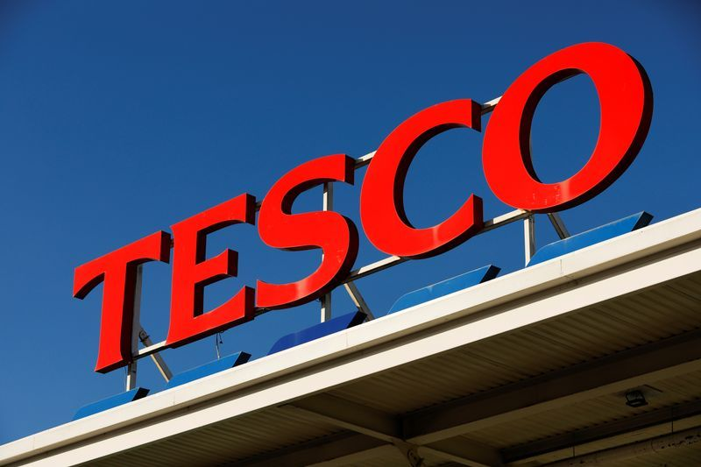
Figure 1:'Tesco PLC
Source: (MarketScreener, 2023)

Main Body

Tesco Organisational Culture
The organisational culture may be seen as a system of common assumed beliefs, values and behavioural guidelines used by people in an organisation to contextualise and react to internal and external pressures. Culture has ceased to have a symbolic sense in modern organisational theory but other way around as a system of control and influences the pattern of decision making, performance standards and employee behaviour (Bogale and Debela, 2024). At Tesco, a value system that is highly customer oriented, operational efficiency and competitive pricing is an organisational culture that guides the company. The customer-first philosophy of the organisation will be enabled in the service delivery expectations, store layout design and the availability of products. But this customer-focused story is tightly connected on the one hand with the cost leadership agenda, implying that customer value is most frequently sought after in terms of efficiency, as opposed to rational service quality per se. This influences a two cultural identity where the customer satisfaction would not only be a strategic goal but also business tool of retaining the market share.
A significant cultural characteristic is that Tesco has a significant stress on cost-effectiveness and value maximisation. And it is embodied in the strict regulation of supply chain systems, and performance monitoring systems and standardised operations store-wise. This standardisation not only renders uniformity on things but also reduces the leeway of the managers working at the bottom levels of an organisation which enhances a disciplined and process based workplace. Additionally, Tesco has developed a highly data-oriented culture as they already use the Clubcard analytics and digital tracking systems to the full extent. This imparts real time consumer insight in decision making, it sets the price, inventory and promotional offers. Despite the increased level of responsiveness and accuracy in operations, it also substitutes the decision-making process with more algorithmic procedures, making doubtful the learning of fewer human controls in operational processes.
The leadership plays a critical role in reinforcing such cultural attributes through performance goals, KPI and integrated operational policies. As a result, there will be a tendency towards employee efficiency, compliance and consistency in realisation, limited deviation of the established processes. However, above all, there are tensions of Tesco culture. Even at the offering of it as being customer led, it could be said to be more profit orienting, where the value of customers is not inherent but more a tool. In addition, its broad global and domestic business presents an issue since it is not bound to be culturally coherent in the multicultural contexts of retailing. The fact that more data based systems are increasingly used is also a paradox; it is more efficient, enhances the quality of the decisions made, but it is also another limitation on the discretion of the employee and may also be a feature of a more mechanistic organisational set up rather than an empowering organisational set up. This aligns with Mullins and Christy (2016), who argue that culture is pervasive and shapes organisational processes.

Culture, Structure & Decision-Making
Tesco organisation is characterised by a hybrid organisation structure which means that it has both hierarchical corporate governance structure and partial store level decentralisation. Decisions remain on the highest leadership levels, particularly the decision-making on areas that involve corporate strategy, pricing system, digital transformation, and the supply chain design. It suggests traditionally top-down type of governance that ensures continuity in a big and geographically dispersed organisation (Crossey and Weber, 2023). Nevertheless, at operational level, very limited discretion is accorded to responsiveness to local consumer demand, labour demand and stock adjustment by store managers implying that there is a limited degree of decentralisation as compared to a total empowerment. Tesco is increasingly being affected by data analytics and artificial insights relying on Clubcard data frameworks and sales monitoring appliances. This has resulted in driving decision authority towards the managerial judgement which is driven by intuition and the one which is driven by evidence and systems driven processes. Even though this increases the accuracy of demand predicting and optimisation on inventory, it reduces the chance of discretionary decisions being made by the middle management. But above all the extent of decentralisation in Tesco, can be interpreted to refer to something symbolic rather than substantive. Store level autonomy occurs on operational implementation terms but the strategic parameters are closely articulated by the corporate headquarters hence limiting the actual local innovation. This will create a disciplined model of flexibility where autonomy is not a de-facto decision maker but rather to work within a set of limits.
Moreover, data-driven governance brings forth efficiency and cognitive bottlenecks. However as much as it enhances uniformity and reduces uncertainty in the decision making process, it may also limit management consideration as the manager may be overly quantitative, to the extent of losing the opportunity of making judgments based on the context. This leaves the question whether a better quality in decisions is achieved or is just standardised. Tesco structure as a whole suggests the deliberate hybridisation between the culture and the control systems as the culture of efficiency, standardisation, and accountability is directly transferred to the hierarchical, albeit partially decentralised structure. Culture and structure are combined to create an environment of culture that is more efficiency oriented and risk minimization but could reduce the responsiveness and local reaction to the fast changing stores.

Application of Theoretical Frameworks
Schein Model of organisational culture
Schein models the organisational culture in to three levels: artefacts, espoused and underlying assumptions (Schein, 2020). At Tesco, artefacts can be seen within the form of the enormous retail store chains, its standardised branding, its extensive digital infrastructure and its supplies chains that are well organized. All these obvious features depict an indication of a much standardised and operationally disciplined organisation with an ambition to ensure that there is consistency in different markets. On the espoused values level, Tesco has a promotion of the principle titled Every Little helps which conveys a customer-based and incremental value creation philosophy. This is an indicator of focusing on low cost, accessibility and continuous enhancement in services.
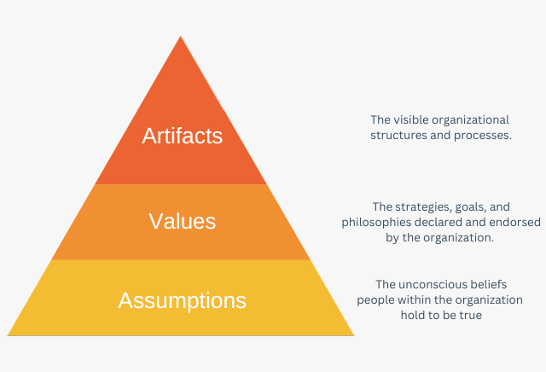
Figure 2: Schein Model of organisational culture
Source: (Denis, 2022)
However, most importantly, this value statement is also, within a dynamic of strategic branding, a kind of positioning the customer perception at an end in the direction of cost-efficiency rather, of course, a service-based value. The underlying assumptions are the culture of Tesco on the bedrock level and these are efficiency, control and data oriented in making decisions. These assumptions affect the organisational behaviour since they would favour performance outcomes that are more quantifiable, operation predictability and cost efficiency rather than experimentation or arbitrary decision making. This propagates a culture of being controlled as opposed to creative.
Hofstede’s Cultural Dimensions
Applying the Hofstede model, Tesco possesses a reasonably average power distance, with hierarchical systems, but they have an equal measure in an operational autonomy on a store level (Vonk and Vasco Freitas Silva, 2024). However the senior leadership retains the power needed in the firm which however means that in fact, the power distribution should be highly centralised. The preference is to use the structured processes, standard operating procedures and data-based forecasting systems, which is quite characteristic of Tesco because of relatively high uncertainty avoidance. This can increase the clarity in decision making; but can suppress flexibility whenever uncertain or rapidly changing market conditions occur. Tesco provides a moderate situation in terms of individualism/collectivism. Whereas in store networks there is high emphasis on teamwork and co-ordination of operations, performance measure and KPI-based evaluation systems enables individual accountability, and hence creates a tension between the overall organisational goals and the necessary accountability to perform at individual levels.
Despite their utility, there are weaknesses of the two models. The framework by Hofstede is more focus nationally as opposed to being specific to individual organisations with internationally diversified operations such as Tesco. The model by Schein is comprehensive; however, could not be empirically measured particularly on the depths of underlying assumptions which are not directly empirically measured, but rather inferred.
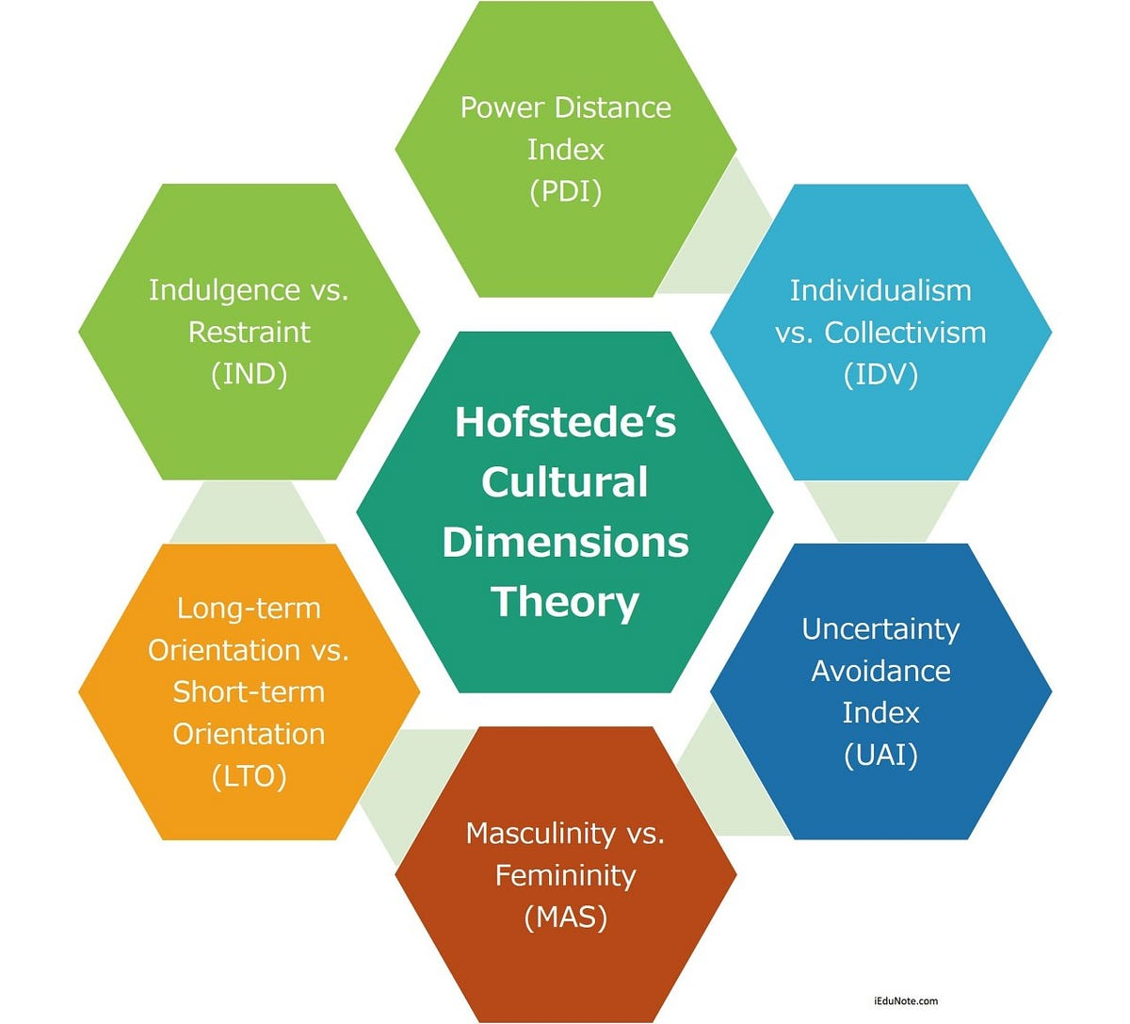
Figure 3: Hofstede’s Cultural Dimensions
Source: (Cheng, 2020)

Culture and External Environment Adaptation
External Environmental Pressures
This Tesco environment is highly competitive and volatile and many forces depend on each other through which the environment is determined. The rising price wars with the low cost retailers such as Aldi and Lidl have highly concerned the manner in which consumers are considering value and Tesco is not able to sustain its market share due to its pricing strategies and operational efficiency. At the same time, inflationary pressures and the cost-of-living crisis in general suppress disposable income in households, ensuring low prices and promotion of the cheap and personal sale goods (Beth, 2024). The technological disruption also adds to the complexity of the environment, with the digital transformation appearing to transform retail with artificial intelligence, automation, and the expansion of e-commerce. The above changes require Tesco to continue to enhance their operations systems in a bid to compete physically and online in the retailing sectors. Besides, the increasing pressures of governments, consumers and investors towards being more sustainable and environmentally responsible place strain on Tesco to ensure that the environmental impact of the logistics, packaging and supply chains is put in check.
Organisational Response
All these external pressures greatly impact Tesco reaction as they are really influenced by Tesco internal culture of cost-efficiency and control over its operations. So as not to fall behind in the race to its own prices and be smothered by rival organisations that rely on discounting, the organisation focuses on the optimisation of its supply chains, purchasing power based on large volume and effectiveness of logistic systems. It is also increasing its online retailing. Capabilities through using data analysis and AI-powered forecasting and online trade system, to become more responsive and efficient. Furthermore, Tesco has equally established sustainability initiatives that seek to realise carbon reductions, food waste, sustainable sourcing in a bid to tone organisational behaviour with ESG expectations without putting cost efficiency within the fray of priority.
Critical Evaluation
What is more important is that this is due to Tesco strategy of adaptation being more reactive in the sense that the actions are undertaken in response to the forces prevailing in an external setting rather than proactively in the form of market shaping. This means that its internalized culture of cost-efficiency may hamper greater level of innovation particularly when it comes to issues that rely on long-term strategic experimentation. (Magnusson, Koutsikouri and Päivärinta, 2020)
The cost leadership strategy, on the one hand, renders the firm powerful in the industries in which prices are highly sensitive, but on the other hand, may also diminish the chances of Tesco to implement disruptive innovation that are not pegged on the optimization of the operations, but their enhancement. This makes it a normal occurrence that organisational adaptation is mostly triggered by the needs to survive and compete and not out of strategic foresight therefore raising long-term concerns on the of its culture and strategic structure.

Culture and Organisational Effectiveness
Work efficiency and productivity
An efficient culture in Tesco, which embraces standardisation and cost minimisation are potent factors which encourage the efficiency of its retail and supply chain operations. The organisation of work processes, performance measurements and data-driven systems enable providing a significant degree of work coordination, particularly in the organisation of stock management, logistics, and the implementation of stores. This efficiency culture ensures that resources are allocated wisely and wastage of operations is minimized and hence large operations are carried out at a constant level.
Motivation, Retention and Behaviour of Employees
But when employee motivation has been conditioned within an extremely controlled performance environment, the maximisation of efficiency is achieved (Johnstone and Beusch, 2025). The use of key performance indicators (KPIs), monitoring systems, and offering employees with systematic distribution of the tasks are some of the strategies that can offer this approach but may limit the independence of employees. This poses a conflict between dominating and empowering, the employees will be objective driven instead of being self-motivated. As a result, it may be regular performance, but long-term commitment and retention may be at risk as a result of the perceived lack of autonomy and high performance pressure.
Performance/Results and Service of the Customer
The culture of standardisation in Tesco has not only bestowed on it a very high percentage of coherent services within its network of stores, but also gave it a high percentage of consistent services as well. Customer experience variability is minimized by the consistency of the processes, web-based surveillance and block of regulations to promote trust in a brand (Pires, Perestrelo and Santos, 2025). In addition, it may also maximize customer satisfaction by effective inventory availability, homogenous pricing practices and responsive supply chain systems that support data analytics.
Critical Evaluation
More significant is the fact that Tesco has efficiency that is characterized by a trade-off between the operational efficiency and the sustainability of structured human. Although standardisation increases uniformity and predictability, it stifles flexibility in the decision making process of the employees and responding to the challenge at store level becomes difficult. Furthermore, the digital monitoring systems increase the performance and accountability tear, and even bring down the autonomy portrayed by the employees which, consequently, can also lead to a more restrictive and, therefore, less empowering working environment.
Overall, Tesco culture has a significant contribution to the success of the processes and service delivery; however, at the cost in form of fairly mundane concerns of human sustainability particularly to the autonomy of those working on it, their motivation, and long-term involvement. It gives a balance but a straining efficiency model in which organisational effectiveness is achieved based on the benefits of efficiency and not the empowerment of the workforce.

Culture and Organisational Performance Evaluation

Positive impacts:
The Tesco organisation culture offers a lot of work performance advantages largely due to its highly-structured cost leadership and cost efficiency. The tight-cost culture, standardisation culture and process optimisation culture enable the organisation to offer competitive prices, in a retail market that is very price sensitive. It is also supported by extremely effective logistics and supply chain management that minimizes the loss of speed in operation and enhances product availability in shops that directly enhances their financial and performance operation. In addition, Tesco has a privilege of good brand homogeneity, a direct result of its own standardised, cultural and operation practice. This similarity instills confidence among the consumers and ensures uniformity in experience in every retail outlet (Bruckberger et al., 2023). Also, combining data-based decision making with Clubcard analytics, Tesco will receive much competitive advantage because it will be able to make precise predictions regarding the demand and offer individualised promotion, and control stocks. In line with Mullins and Christy (2016), culture significantly influences organisational performance through its impact on control, coordination, and employee behaviour

Negative impacts:
All these strengths are combined with the fact that Tesco has also structural constraints that are influenced by its culture that influence long-term performance. Reduced innovation capability is also one of its flaws since efficiency and control is so crucially regarded in the organisation, the trend tends to be anchored more into linear changes and less towards the discontinuous innovation. This may restrict the ability of Tesco to be creative to deal with the rapidly changing retail landscape (Wood, Watson and Teller, 2021). Also, the performance-based ethos might present a significant strain to the employees, which could lead to their de-motivation, reduced job satisfaction and high turnover. Over reliance on quantitative decision making that is highly reliant on analytics and performance measures that inhibits managerial intuition and context-driven judgment in an extremely complex retailing environment can also be developed. Moreover, Tesco already has a very efficient model which can become its weakness in the presence of more nimble competitors that are more flexible and inclined towards quicker experimentation and are not concerned by the rigorous optimisation.
In most cases, the organisational culture in Tesco is highly effective in meeting the operational excellence, cost effectiveness as well as consistency in the market. However, it is also this culture, however, that curtails the ability to be agile and innovative in strategy. In such a way, one can conclude that Tesco has a strong operationally stable and strategically constrained culture that leads to a dual-performance picture with short-term performance efficiency at the expense of long-term flexibility and competitiveness.

Conclusion
Having a clear emphasis on cost efficiency, standardisation, and decisions based on the data is the core of the organisational culture of Tesco. These cultural attributes are extremely vital factors influencing how the organisation is to be structured, how decisions will be made or how the organisation will respond to the external environmental forces such as competition, inflation and technological change. Tesco culture as the analysis has revealed sustains a cohesive operation and a high-rate of efficiency throughout its entire supply chain and the processes involved in retailing which is highly assisted by orderly process and advanced analytics. However, the analysis also adds that on the one hand, this culture leads to performance improvement and stability of operations, however, on the other hand, it decreases the possibility of organisations to be flexible and innovative. Overreliance on the standardization and efficiency-oriented practices undermine the responsiveness to change of market conditions, which vary dynamically (Gudergan, Gudergan and Ambrosini, 2025). Overall, they could reveal the organisational culture of Tesco as the great contributor of efficiency and performance, yet, it could also be described as the hindrance of innovation and flexibility in a highly dynamic and competitive environment of retail.

References

Beth, B. (2024). Updating ‘stockpiling as resilience’ in the context of the cost-of-living crisis: Tracking changes in resilience strategies in the U.K. Food, Culture, and Society, pp.1–23. doi:10.1080/15528014.2024.2329441.
Bogale, A.T. and Debela, K.L. (2024). Organizational culture: A Systematic Review. Cogent Business & Management, 11(1), pp.1–23. doi:https://doi.org/10.1080/23311975.2024.2340129.
Bruckberger, G., Fuchs, C., Schreier, M. and Osselaer, van (2023). Retailing Groundedness: How to improve customer experience, brand perceptions, and customer loyalty through feelings of groundedness. Journal of Retailing, [online] 99(4), pp.594–604. doi:10.1016/j.jretai.2023.11.004.
Cheng, E. (2020). Designing for different cultures — Hofstede’s cultural dimensions. [online] Medium. Available at: https://medium.com/@eviecheng/designing-for-different-cultures-hofstedes-cultural-dimensions-5d5a369e99ee.
Crossey, N. and Weber, F. (2023). Borderlands of Governance – Multilevel Cross-border Governance and Trajectories of Local Cross-border Ties in the Franco-German Moselle-Saarland Region. Journal of Borderlands Studies, pp.1–21. doi:10.1080/08865655.2023.2276458.
Denis (2022). Edgar Schein’s Organizational Culture Model. [online] Expertprogrammanagement.com. Available at: https://expertprogrammanagement.com/2022/09/edgar-schein-culture-model/.
Gudergan, G., Gudergan, S. and Ambrosini, V. (2025). Dynamic capabilities-enabled servitization: The role of exploitative quality management. Production Planning &amp; Control, pp.1–17. doi:10.1080/09537287.2025.2476649.
Johnstone, L. and Beusch, P. (2025). Motivating sustainable behaviour in the workplace through control. Journal of Management Control. doi:10.1007/s00187-025-00390-z.
Magnusson, J., Koutsikouri, D. and Päivärinta, T. (2020). Efficiency creep and shadow innovation: Enacting ambidextrous IT Governance in the public sector. European Journal of Information Systems, 29(4), pp.1–21. doi:10.1080/0960085x.2020.1740617.
MarketScreener (2023). Tesco PLC : Results above expectations -April 17, 2023 at 10:05 am EDT | MarketScreener. [online] Www.marketscreener.com. Available at: https://www.marketscreener.com/quote/stock/TESCO-PLC-4000540/news/Tesco-PLC-Results-above-expectations-43522567/.
Mullins, L. and Christy, G. (2016). Management and Organisational Behaviour (11th ed.). Pearson Education Limited.
Pires, P.B., Perestrelo, B.M. and Santos, J.D. (2025). Unpacking Customer Experience in Online Shopping: Effects on Satisfaction and Loyalty. Journal of Theoretical and Applied Electronic Commerce Research, 20(3), p.245. doi:10.3390/jtaer20030245.
Schein, E.H. (2020). The Levels of Culture. Routledge eBooks, 1(1), pp.135–143. doi:10.4324/9781315881201-15.
Vonk, A. and Vasco Freitas Silva (2024). The Hofstede Model: Understanding a Multicultural Environment. Cultural Confluence in Organizational Change, pp.47–76. doi:10.1007/978-3-031-45403-5_4.
Wood, S., Watson, I. and Teller, C. (2021). Pricing in online fashion retailing: Implications for research and practice. Journal of Marketing Management, [online] 37(11–12), pp.1–24. doi:10.1080/0267257x.2021.1900334.

