Computer system component specification
Hayley Prosser 2108352
Computer system fundamentals
Digital skills
Redhwan Al-amri

Table of Contents
Task 1 …………………………………………………………………………………………………………………………………………….. 3
Task 2 ……………………………………………………………………………………………………………………………………………. 10
Bibliography 12

Task 1
My senior relative will not be playing games, but they do want a low-cost desktop PC with a tiny form factor, a full-size keyboard, and a decent-sized display to help with their failing eyesight. Their sole software requirements will be to run word processing programmes, check emails, and browse the internet; they do, however, want to be able to watch YouTube videos and make basic video conversations, such to those on Skype, with family members who live overseas. They also want to enrol in a course to learn how to use Windows. To start I will need a suitable processor (CPU) I have chosen to go with the Intel core i3 as this processor would be sufficient for word processing, checking emails and web surfing. £55.99

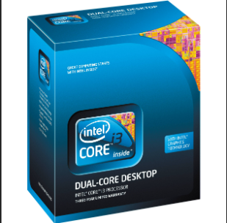[1]

Next, I needed to find a compatible Motherboard. The motherboard is like the nervous system of the computer, connecting all the components, however it has to be compatible with the chosen CPU. The suitable option I picked was the ASUS Prime H410M-A. This motherboard is budget friendly, that offers the necessary features for the basic tasks like word processing, checking emails and web browsing. It should be a good fit for my relatives low cost desktop pc with a small form factor. £87.99
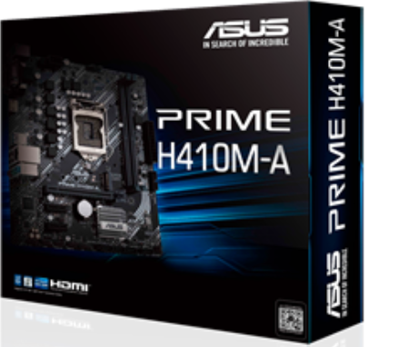[2]

Next, I am in need of a memory (RAM) This helps the computer run smoothly. I do not require a lot of (RAM) as this desktop pc will not be used for intensive tasks like video editing or gaming. A suitable option I have found is 8GB of DDR4 RAM. It’s a good balance between cost and performance for everyday tasks like web browsing, emails, and word processing. This amount of RAM should provide a smooth and everyday tasks like web browsing, emails, and word processing. This amount of RAM should provide a smooth and responsive experience for my elderly relative's needs. £15.53
[3]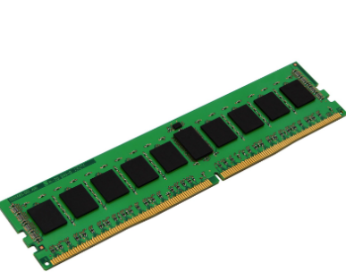

Next, I will need a suitable type and size of non-volatile storage. I have chosen a solid-state drive (SSDs) with a capacity of 256GB SSDs are faster and more reliable compared to traditional hard disk drives (HDDs) which makes them a great choice for everyday computing tasks. £16.98
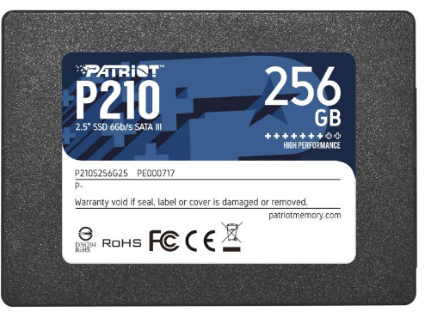[4]

The input/output features/ports needed will be multiple USB ports (preferably USB 3.0 or higher) to connect peripherals like a keyboard, mouse, printer, or external storage devices. Display ports such as HDMI to connect a monitor or other display devices. Audio ports to connect headphones, speckers, or a microphone. Ethernet port in case my elderly relative prefers wired internet connection. SD card reader, having a SD card reader built into the pc can be handy for transferring photos and other files from cameras or other devices. USB £4.99. HDMI £6.78
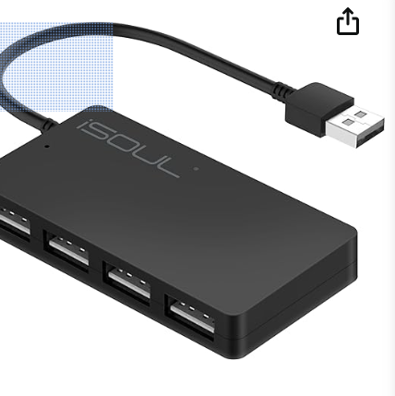
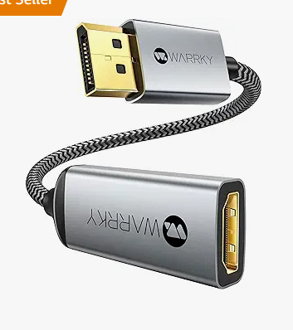

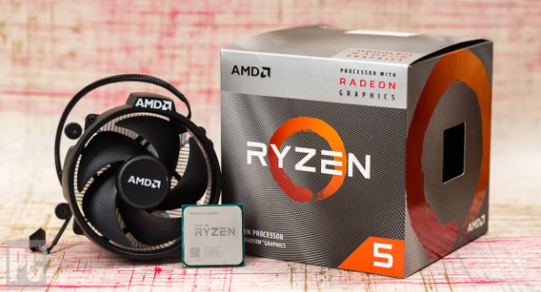[5]
Next, iv added an integrated graphic card, it helps with smooth video playback, web browsing and general visual tasks. It ensures a better overall experience when using the computer. I have chosen the AMD Ryzen 5 3400 GI because it offers a good balance of performance and affordability. It has powerful intergrated graphics, which means it can handle everyday tasks like wed browsing, video streaming, and even some light gaming without needing a separate graphics card. It provides a smooth and responsive experience. Plus its a cost effective solution since it eliminates the need to purchase a dedicated graphic card. £87.50

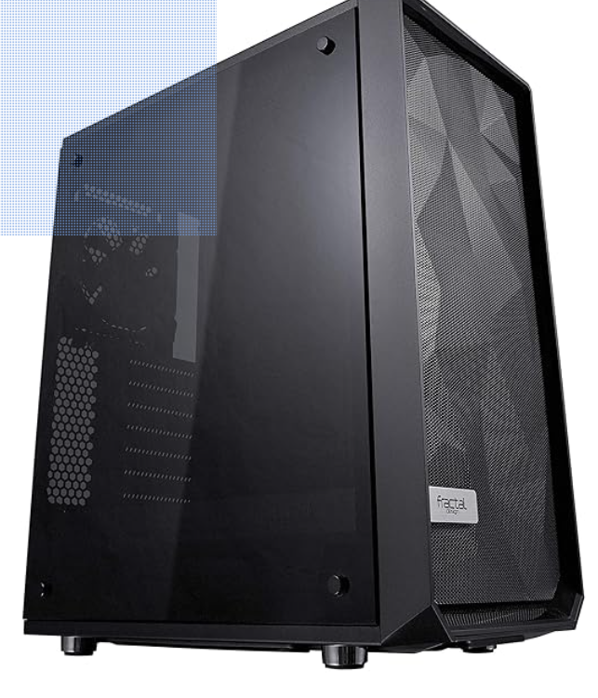[6]
For the case iv chosen the fractal design meshify C as it is a great choice because it offers high performance airflow and cooling. With two included fans and a mesh front panel, it helps keep your components cool and running smoothly. The PSU shroud and modular interior make cable management easier, resulting in a cleaner build, plus the USB 3.0 ports and tempered glass side panel add a touch of modernity and convenience. Overall its a solid case with all the features you need for a powerful and cool running PC. £79.99

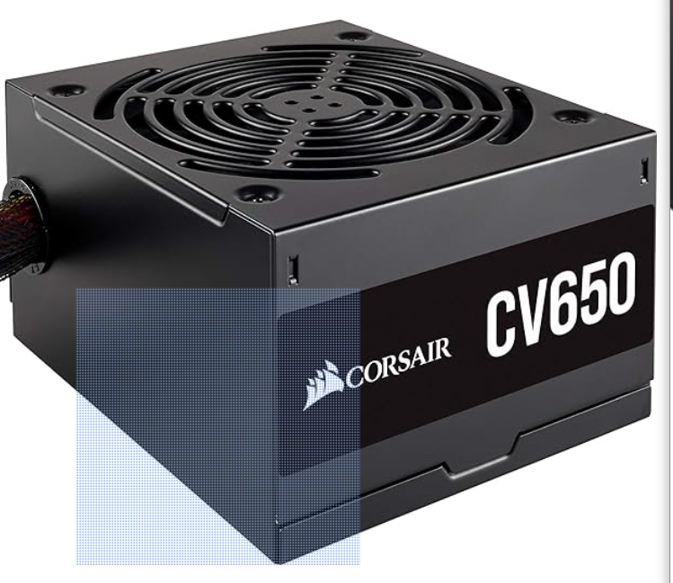[7]
For the power supply iv choosen to go with the corsair power supply, with a wattage of 650. They have a solid reputation for reliability and performance. 650 wattage is sufficient for most mid-range set ups. £80.21

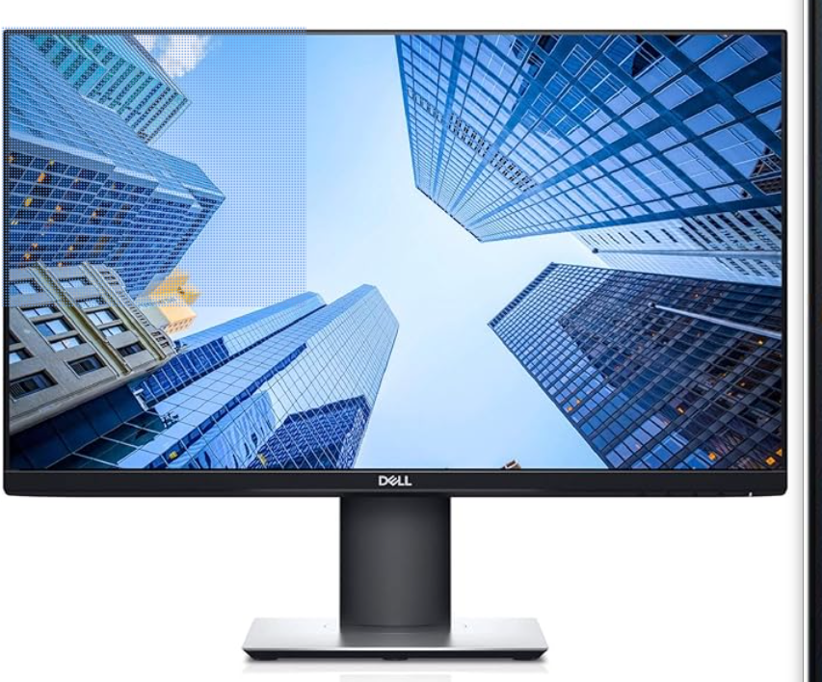[8]
For the monitor ive chosen the Dell P2419H. Its a 24-inch monitor with full HD resolution, which would be great for my elderly relatives eyesight. It has an IPS panel, which means it offers great color accuracy and wide viewing angles. The monitor also has an adjustable stand so they can find a comfortable viewing postion. Overall, its reliable and budget freindly. £101.85 Refurbished, £234.99 New.

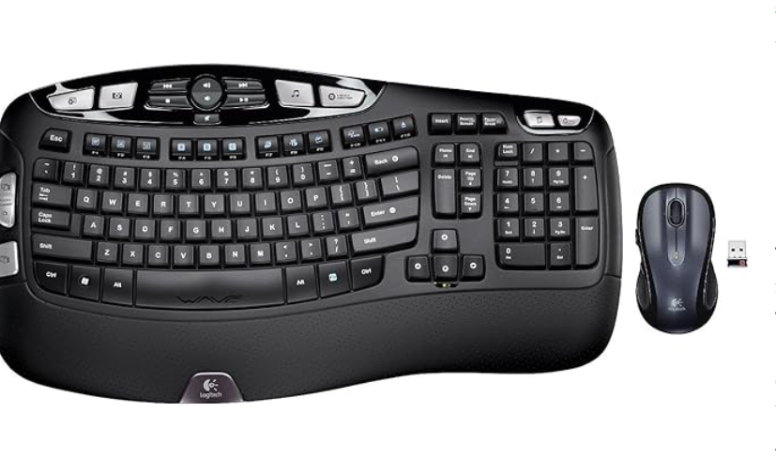[9]
For the full size keyboard to go with the DELL P2419H monitor ive chosen the Logitech MK550 wireless keyboard and mouse combo. It has a comfortable and ergonomic design, which would be great for my elderly relative. The keys have a nice feel to them and it offers a reliable wireless connection. Plus the combo includes a wireless mouse as well. £160.00
[10]
To complete the pc build i have chosen to install a reliable antivirus software Avast. It has been a popular choice for many users and offers robust protection against various online threats. Avast also provides additional features like Wi-Fi inspector and a password manager. £27.99
Shopping list
Processor (CPU) - Intel core i3 £55.99
Motherboard – ASUS prime H410M-A £87.99
RAM – Integral RAM 8GB 3200MHz - £15.53
SSDs with capacity of 256GB £16.98
USB port - £4.99
HDMI port - £6.78
Integrated graphic card - £87.50
Case – Meshify C £79.99
Power supply - Corsair £80.21
Monitor – Dell P2419H – Refurbished £101.85
Keyboard – Dell P2419H £160.00
Antivirus software – Avast one £27.99
Total cost £725.80

Task 2
In depth analysis of my current main personal computer
At the moment my current computer is the Acer swift 1 that comes with intel Pentium silver. It is a great laptop for everyday use and productivity tasks. special features its thin, light and premium: the stylish pink aluminium body weighs just 1.3kg and is less than 15mm thin, so i can carry it with me all day. When i bought this product, it came with a 12-month Microsoft 365 subscription included in the price giving me word, excel, powerpoint plus 1TB of OneDrive cloud storage.
CPU- The acer swift 1 comes with an intel pentium processor, which offers decent performance for every day tasks like web browsing, document editing, and multimedia consumption. The intel pentium silver CPU provides the ideal balance of power and efficiency, so everything keeps running smoothly in such a slim device.
RAM- The swift 1 comes with 4GB providing sufficient memory for smooth multitasking and running mulitple applicatons.
Storage capacities and types- The swift 1 offers SSD storage. SSD offers faster read and write speeds compared to eMMC resulting in quicker boot time and application loading.
I/O Devices- The swift 1 includes various I/O ports such as a USB-C, USB3.2 GEN 1, HDMI, and an SD card reader allowing me to connect external devices and expand my connectivity options.
OS- The swift 1 comes with window 10, providing a user friendly interface and access to a wide range of software and applications.
Installed applications- The swift 1 comes with Full HD 1920X1080, wide viewing angles, microsoft office 365, window 10, fingerprint reader.
Internet connectivity- The swift 1 supports Wi-Fi connectivity allowing me to connect to my home wireless network to access the internet.
Standing screen display size – 14 inches
Screen Resolution – 1920 X 1080 pixels
CPU speed – 1.1
Processor count - 4
Memory technology – LPDDR4
Maximum memory supported – 4GB
Hard drive size – 128GB
Audio details – speakers
Graphic coprocessor – intel HD graphic 620
Graphic card description – integrated
Number of USB 3.0 ports – 2
Average battery life – 16 hours
Item weight – 1.3kg
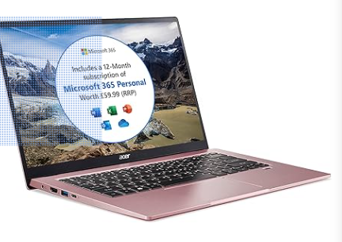
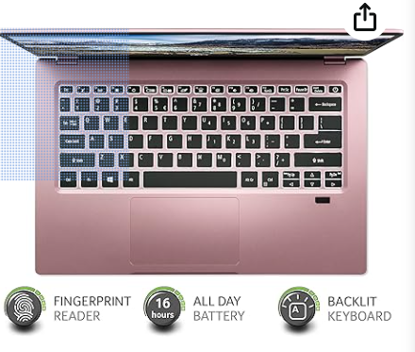
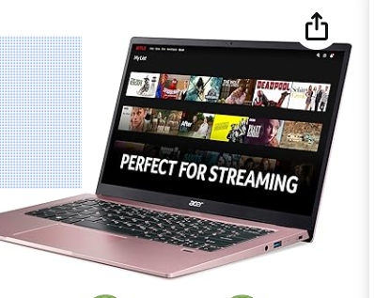
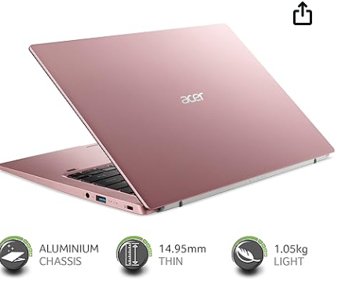[11]

Bibliography
[1]
M. Passingham, “Intel Processors Explained: What Is Core I3, I5, I7 And Pentium?,” Which? https://www.which.co.uk/reviews/laptops/article/intel-processors-explained-what-is-core-i3-i5-i7-and-pentium-av6235O66IQP

[2]
Bhphotovideo.com, 2024. https://www.bhphotovideo.com/images/images2500x2500/Intel_bx80623i32120_CORE_I3_2120_3_30_GHZ_867117.jpg (accessed Jan. 02, 2024).

[3]
Etilize.com, 2024. https://content.etilize.com/1500/1030241332.jpg (accessed Jan. 02, 2024).

[4]
“Patriot P210 256GB 2.5" SATA III SSD,” Ebuyer.com. https://www.ebuyer.com/1535249-patriot-p210-256gb-2-5-sata-iii-ssd-p210s256g25 (accessed Jan. 02, 2024).

[5]
“AMD Ryzen 5 3400G,” PCMag UK, Sep. 27, 2019. https://uk.pcmag.com/sound-cards/122798/amd-ryzen-5-3400g (accessed Jan. 02, 2024).

[6]
Ssl-images-amazon.com, 2024. https://images-na.ssl-images-amazon.com/images/I/91zUa%2B-t1RL._AC_SL1500_.jpg (accessed Jan. 02, 2024).

[7]
Computeralliance.com.au, 2024. https://www.computeralliance.com.au/InventoryImages/27497.jpg (accessed Jan. 02, 2024).

[8]
Media-amazon.com, 2024. https://m.media-amazon.com/images/I/81JRJMAsmjL._AC_SX679_.jpg (accessed Jan. 02, 2024).

[9]
Catch.com.au, 2015. https://s.catch.com.au/images/product/0002/2035/58d49711161bd656808536.jpg (accessed Jan. 02, 2024).

[10]
“Avast One | Stay Safe Online with Protection For Your Life Today,” www.avast.com. https://www.avast.com/en-gb/avast-one?ppc_code=013&ppc=v&gclid=ea59eb41cc2b127d6ab98ecc9c49cea8&gclsrc=3p.ds&msclkid=ea59eb41cc2b127d6ab98ecc9c49cea8&utm_source=bing&utm_medium=cpc&utm_campaign=en-gb_mix_pla_nas_nau_bng_dtp&utm_term=4577266908012204&utm_content=all%20products#pc (accessed Jan. 02, 2024).

[11]
Cloudfront.net, 2024. https://d5bm31en4blvo.cloudfront.net/uploads/prodimg/DNJNt_8nfEePzXDfw3RU9w.c-r.jpg (accessed Jan. 02, 2024).

[12]
R. B. Thompson and B. F. Thompson, Building the Perfect PC. “O’Reilly Media, Inc.,” 2004. Accessed: Jan. 02, 2024. [Online]. Available: https://www.google.co.uk/books/edition/Building_the_Perfect_PC/sg4O8HzNbZIC?hl=en&gbpv=0

[13]
A. J. Bohara, The Ultimate Guide on Building a PC: MYP Personal Project. Aman Jain Bohara, 2015. Accessed: Jan. 02, 2024. [Online]. Available: https://www.google.co.uk/books/edition/The_Ultimate_Guide_on_Building_a_PC/FR62BgAAQBAJ?hl=en&gbpv=1&dq=building+a+pc&printsec=frontcover

