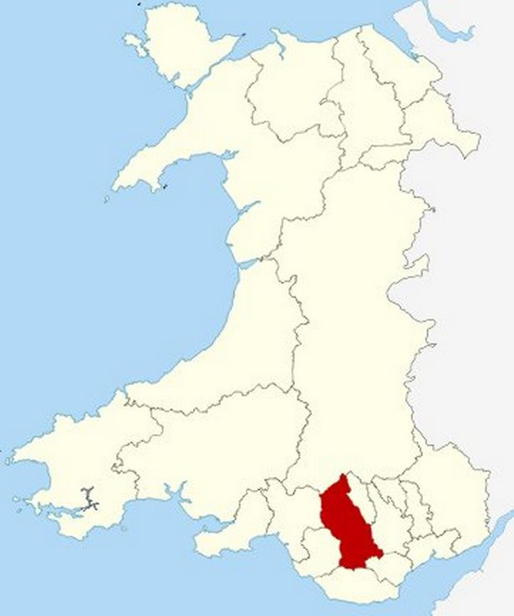

Assessment 2 Distinctiveness and Regeneration

The Rhondda Valley, located in South Wales, played a significant role in the Industrial Revolution. The valley’s abundant natural resources and the foresight of enterprising individuals helped to transform the Rhondda from an agricultural area into a thriving industrial hub in a few short decades.

The valley’s transformation is often attributed to the mining of coal, which provided power for the steam engines that powered the machinery in mills and factories. The coal mines, however, were not the only factor in the region's industrialization. There were ironworks, copper mines, brickworks and quarries that helped to provide employment for the locals.

Coal mining in the Rhondda started in the seventeenth century when coal was transported to Cardiff by river. Several factors contributed to the rise of the Rhondda coal mining industry, including the growing demand for coal and the discovery of new seams that were easier to mine. By the late nineteenth century, the region was experiencing a period of unprecedented growth, with many collieries employing hundreds or even thousands of workers. The coal that was mined in the Rhondda valley was transported to other parts of the country, fueling industrial growth across Britain.


As the coal industry grew, so too did the population of the region. The number of towns and villages in the Rhondda increased, and more people moved there in search of work. The population boom led to the construction of new houses, schools, churches and other buildings to accommodate the growing population. The infrastructure of the valley also underwent an enormous transformation. New roads and railways were built to transport coal and other goods, while canals were constructed to ferry goods to Cardiff port.

However, the industrialization of the Rhondda came at a great cost. The mining industry, for example, posed significant health and safety risks. The miners worked in appalling conditions and were exposed to numerous health hazards, including breathing in dangerous chemicals and dust. They were also at risk of accidents and injury. As the population of the Rhondda grew, the pollution from the factories and mills had disastrous environmental effects, with air and water pollution becoming major issues.

In conclusion, the Rhondda Valley played a major role in the Industrial Revolution, thanks to the abundance of natural resources and the genius of its people who saw the potential for growth and development. The region’s coal, iron, and copper mines, brickworks, and quarries provided employment for thousands of people, transforming the region from an agriculture-based economy into an industrial hub. However, with great economic growth also came many challenges, including safety and health issues, and environmental degradation. These challenges must be addressed to ensure the continued growth and prosperity of the Rhondda Valley.

urbanization
The Industrial Revolution was a period of profound economic and social change that swept across the world in the 18th and 19th centuries. One of the most significant features of this revolution was the rapid urbanization that occurred as people moved from rural areas to the cities in search of work and better living conditions. The urbanization of the Industrial Revolution brought about many challenges and opportunities, and its effects are still felt today.

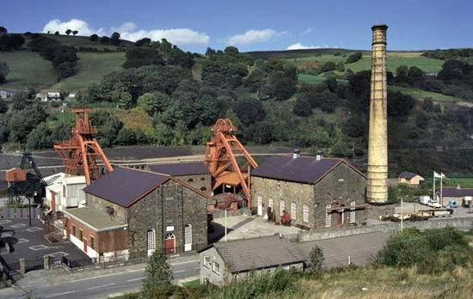
The Industrial Revolution began in Britain in the late 1700s and spread to other parts of Europe and America in the early 1800s. This period saw the creation of new industries, such as textiles, iron, and coal, and the rise of capitalism and the factory system. As the demand for labor grew, people began to migrate from rural areas and small towns to the cities, where they could find employment in the factories.

The growth of cities during the Industrial Revolution was unprecedented. Cities like London, Manchester, and Birmingham swelled with people, and new cities were built to accommodate the influx of workers. Many of these new cities lacked proper sanitation, housing, and infrastructure, leading to overcrowding, disease, and poverty. In many cases, entire families lived and worked in one room.

Despite these challenges, the urbanization of the Industrial Revolution also brought about significant benefits. People were able to find work and earn higher wages than they could in rural areas. The growth of cities also led to advancements in transportation, communication, and technology, which helped to fuel further economic growth.

The urbanization of the Industrial Revolution also had a profound impact on society. As people from different regions and backgrounds came together in the cities, new social and cultural practices emerged. The rise of the middle class, made up of factory owners, businessmen, and professionals, created a new social hierarchy. At the same time, the working-class began to organize and fight for better working conditions and wages.

In conclusion, the urbanization of the Industrial Revolution was a complex and multifaceted phenomenon that had both positive and negative effects. The growth of cities brought about new opportunities for work and economic growth, but it also created social and economic challenges. Today, the legacy of the Industrial Revolution and its urbanization can still be seen in the layout, architecture, and culture of our cities.

Poverty

The Industrial Revolution brought significant changes to society, economy, and lifestyle in Europe and America. However, while some groups experienced unprecedented prosperity and growth, many people, especially the working classes, were trapped in a cycle of poverty. The poverty of the Industrial Revolution was influenced by various factors, including wage inequality, poor working conditions, and inadequate social welfare systems.

One of the most significant contributors to poverty during the Industrial Revolution was the unequal distribution of wealth. Factory owners and capitalists made enormous profits from their businesses, but their workers' wages remained low. The accumulation of wealth among the wealthy elites while leaving the workers with little reward exacerbated the gap between the rich and the poor.

A significant factor contributing to poverty was the brutal working conditions in the factories. Workers working long hours, often 12-16 hours a day, were exposed to dangerous machinery and hazardous chemicals. Dangerous working conditions caused high rates of injury, disability, and even death. Such hazardous conditions left the workers' families in poverty, especially when the breadwinner was injured or killed at work.

The working-class people also faced inadequate social welfare systems, as there were no established social safety nets, welfare programs, or minimum wage. There was little to no support for those who were unemployed or too sick or too old to work. As a result, the poor had little ability to protect themselves against destitution, which led to a continuous cycle of poverty that spanned generations.

In addition to these factors, families were often left without basic resources such as clean water and nutritious food. This deprivation of essential services contributed to the high child mortality rate, and the poor lived shorter lives than the wealthy. The poverty of the Industrial Revolution was infectious, as it could lead to a lack of education, thus reducing the opportunities for the poor to rise from their social status.

In conclusion, the poverty of the Industrial Revolution was deeply entrenched in the inequalities of wealth distribution, poor working conditions, and inadequate welfare systems. The impact of poverty was fully realized as standards of living among the working-class people degraded during this era. This led to a generational poverty cycle that restricted the development of society and hindered progress towards a fully inclusive and equitable society.

Pollution

The Industrial Revolution, which took place between the 18th and 19th centuries, marked a significant change in the way civilization lived, worked, and interacted with the environment. It transformed the way goods were produced, and introduced a new era of economic prosperity, urbanization, and technological advancements. However, the Industrial Revolution also came with a dark side- pollution. The environmental degradation caused by industrialization had lasting effects that we are still dealing with today, and it is important to explore how the pollution of the Industrial Revolution came to be.

One of the significant causes of pollution during the Industrial Revolution was the mass production of goods in factories. Textile mills, coal mines, railroads, and heavy machinery were all examples of the machines that were built, and they rapidly consumed massive quantities of coal, oil, and other fossil fuels. The production, transportation, and use of these fuels resulted in the emission of large amounts of smoke, dust, and other pollutants into the air, soil, and waterways.

The pollution from the factories was especially toxic in urban areas since many factories and power plants were located close to cities. The smoke and fumes from the factories created the infamous smog that severely impacted the residents of the industrial cities. The physical environment in these cities was visibly degraded, and the air pollution caused respiratory problems for those living in these areas. The rivers and lakes were heavily polluted with the toxic chemicals that were released as part of the industrial process. The industrial waste often contained hazardous materials such as mercury and lead, which could cause severe health problems if ingested.

The pollution caused by the Industrial Revolution did not just affect human health, but it also had a significant impact on the natural environment. The use of fossil fuels and the resulting emissions contributed to the acceleration of climate change. Moreover, the pollutants released by the factories contributed to acid rain, which had catastrophic effects on the forests, waterways, and soil ecosystems.

The Industrial Revolution marked a significant moment in human history, and it cannot be denied that this era sparked significant technological advancements that led to economic growth and new ways of life. However, with these advancements came new challenges, and it was these challenges that contributed to the rapid pollution of the environment. Although pollution continued to be a problem for many years following the Industrial Revolution, this period was the significant starting point for air, soil, and water pollution, which we still face in the present day.

In conclusion, the pollution of the Industrial Revolution had a lasting impact on the environment and the quality of life. The rapid industrialization brought about in this era resulted in the overconsumption of fossil fuels, which polluted the air, water, and soil. It was clear that humans paid an environmental price for this era's significant technological advancements, and it sheds light on the need to address the current and continued effects of pollution on the planet. The Industrial Revolution's pollution problems initially seemed productive but ultimately demonstrated the environmental problems we face are not as easy to "solve

Economy

The Industrial Revolution had a profound impact on the economy of countries worldwide, transforming their manufacturing, agriculture, and transportation sectors. The development of machines and steam power, along with the growth of the factory system, helped to increase production, improve efficiency and reduce costs, ultimately paving the way for mass production and making consumer goods more affordable.

One of the most significant economic changes to emerge from the Industrial Revolution was the rise of the factory system. Previously, most goods were produced in homes or small workshops, but the use of machines in factories allowed for large-scale production, making it possible to meet the growing demand for goods.

Another major development was in agriculture. New technologies, such as the seed drill and improved the way the seeds get placed in the grown, led to higher crop yields, meaning fewer farmers were needed to produce food for the same number of people. This freed up labor for other industries and helped to fuel urbanization.

The revolution also saw the development of steam power, which led to immense improvements in transportation. The steam engine made it possible to transport goods over long distances at a much faster pace than ever before. This allowed goods to be shipped more cheaply and efficiently, which helped to open up new markets and drive economic growth.

The Industrial Revolution also had significant impacts on labor. As factories became more common, many people left rural areas to work in the new manufacturing centers. This led to the growth of cities, and the rise of the working class. These workers often faced difficult and dangerous conditions, with long hours and low pay. However, the growth of industry also brought new opportunities for workers, as new jobs were created in factories, mines and other industries.

Overall, the economy of the Industrial Revolution was marked by rapid growth, thanks to new technologies that enabled large-scale production, improved transportation systems, and the growth of cities. This period of economic expansion paved the way for the modern economy, and many of the foundational technologies of the time continue to be used today. However, this growth also led to significant social and economic challenges, as workers struggled to adapt to new working conditions and the displacement of traditional industries led to significant economic disruption in some regions.

homeless

The Industrial Revolution period saw an increase in the use of technology, the emergence of factories, and the growth of industries, which led to significant changes in many areas of life, including urbanization, population growth, and the economy.

One of the primary impacts of the Industrial Revolution on homelessness was the shift from an agrarian to an industrial economy. This shift meant that many people, especially those from rural areas, moved to urban centers in search of work. However, the industries could not provide enough jobs for everyone, and those who were unable to find work were left homeless. As a result, urbanization contributed significantly to homelessness during the Industrial Revolution.

Another significant impact of the Industrial Revolution on homelessness was the increase in housing prices. As a result of the population growth, the demand for housing increased, leading to an increase in prices. This price increase made it difficult for low-income workers to find affordable housing, either forcing them onto the streets or to live in overcrowded and unsanitary housing conditions.

The Industrial Revolution also led to the growth of the factory system. The factories required cheap and efficient labor, contributing to the growth of child labor, which left many children homeless. These children were forced to live on the streets or in workhouses, which were overcrowded and unsanitary.

In addition to the above, the Industrial Revolution led to the breakdown of the traditional family structure. As industrialization grew, workers had to move around the country in search of work. This movement made it tough for families to stay together, with many children becoming homeless and neglected.

References:
By: Joanne Ridout Date: 5, 9, 2016 Link: https://www.walesonline.co.uk/lifestyle/welsh-homes/moving-county-rhondda-cynon-taf-10513068

By: Mihai Andrei, Date: 02, 02, 2023, Link: https://www.zmescience.com/other/feature-post/how-coal-is-formed/

By: Chris Allen. Date: 26, 03, 2023. Link: https://www.britannica.com/place/Rhondda#/media/1/501759/155472

Huntley, D. (2022, December 23). When coal was king in the welsh valleys of the Rhondda. Retrieved January 12, 2023, from https://britishheritage.com/history/coal-mining-wales-rhondda-valley

Link: https://hwb.gov.wales

