MA Children and Young People Mental Health
ECCY7006 - Research Methods for Children and Young People
Carrie Needs – 0100928 04/05/2026
‘Research report: A qualitative report using thematic analysis on teaching assistants’ experiences working with children with ADHD’.
AI acknowledgement:
- I have not used AI in this research report.
I confirm that I have not presented any AI-generated text as my own work.
I confirm I have copies of my drafts, notes, and other resources that I used before and after the use of AI tools, which I may be asked to provide in evidence.
I acknowledge the use of Grammarly (https://www.grammarly.com/) on 25/04/2026, 26/04/2026 and 28/04/2026 check my work using the prompt(s):
- Please check the following text for readability, grammar and syntax.
I confirm that I have not presented any AI-generated text as my own work.
I confirm I have copies of my drafts, notes, PDF files (literature saved with notes/highlighted sections), bookmarks in textbooks and other resources I used before and after the use of AI tools, which I may be asked to provide in evidence.
I confirm that I have not used any AI tools in the research and creation of this assignment. I confirm that I have not presented any AI-generated materials as my own work. I confirm I have copies of my drafts, notes, and other resources I used, which I may be asked to provide in evidence.
Signed: Carrie Needs  Dated: 04-05-2026

ABSTRACT
The prevalence of ADHD in children is rising, with increased access to information and social media prompting earlier identification of behavioural difficulties. Teaching Assistants’ roles in supporting children with or without a diagnosis remain underrepresented in research. Using reflexive thematic analysis, this study explored six primary TAs’ experiences, focusing on their feelings about their work and the facilitators and barriers they encounter. Three themes emerged: relational, emotional and practical, showing that while TAs are deeply invested in supporting children with ADHD, most lack formal training and rely on self‑directed learning. Support varies widely depending on individual motivation and the understanding of ADHD among school leaders and teachers, shaping the quality of support children receive and influencing their engagement with education.

Introduction
ADHD is an entirely ‘stigmatised, heritable, heterogenous syndrome’ that ‘impairs functioning across essential life domains (Hinshaw and Scheffler, 2018)’. ADHD can be defined as ‘a neurodevelopmental disorder characterised by developmentally inappropriate levels of inattention, hyperactivity, and impulsivity that cause functional impairment across settings (Banaschewski, Coghill and Zuddas, 2018)’. Merrell and Sayal (2018) further confirm that diagnostically, ‘ADHD symptoms must be present in more than one setting’ and so obtaining a deeper understanding of TAs perspectives on working with children with ADHD is entirely judicious.
Teacher (including TA), parent and pupil attitudes towards children with ADHD are cited in the international literature as being significantly correlated with educational outcomes for those children with ADHD (Sayer et al 2015; Woolraich et al, 2005., Sayal et al, 2010; Tymms and Merrell, 2006; Sherman et al 2008; Tymms et al, 2011; Dypaul and Eckert, 1997). Merrel and Sayal (2018) assert that ‘teacher attitudes towards children with (ADHD) behavioural difficulties and knowledge of ADHD vary and are shaped by previous experience, initial/in-service teacher training (ITT) and media reports of ADHD’. According to Danckaerts and Coghill (2018), ‘teachers can provide helpful information’ that can contribute to the identification, assessment, diagnosis and support of children with ADHD’; however, ‘the reliability of their contribution depends on the level of involvement with the child, their personal attitudes towards ADHD, and a possible ‘halo-effect’ caused by other conduct problems’ (Jackson and King, 2004). According to data obtained by ‘freedom of information requests’, into ADHD referral/waiting lists for each UK Health Board (“or equivalent”) carried out by ‘ADHDUK (accessed 15-04-2026)’, there are approximately 980 children in Wales waiting for an ADHD assessment (131,724 across the UK). ‘Those children who are on the ‘pathway to assessment’ and ‘approximately 3,000 children (around 1 to 2%) in Welsh schools have an official diagnosis of ADHD (Wales Healthcare, 2019, cited in Greenway and Edwards, 2021)’. Critically, however, that figure excludes all children who have been screened by their school and referred to their Neurodevelopmental teams for consideration of being accepted ‘onto the pathway’ for an assessment. Of further importance, this figure does not consider or represent those children who do remain in school who are experiencing the debilitating disorder of ADHD and who are not recognised, supported, who are stigmatised and labelled as ‘naughty’ and ‘disruptive’.
There is considerable data providing the impact and contribution that teachers have on the identification and assessment of, support for and experiences of children with ADHD in the classroom (Aldabbagh et al, 2023; French et al, 2024; Joyce et al, 2026; McDougal et al, 2022; Ward et al, 2021); however, the research considering the perspectives, and contributions of TAs who support children with ADHD is an emerging are in the research literature (Greenway and Edwards, 2019 in Greenway and Edwards 2021; Ward, Krovshoff and Kreppner, 2021; Russel et al, 2019). Greenway and Rees Edwards (2021), give that ‘research that examines the role of the TA or their feelings about their job is scarce’. Therefore, it is imperative to conduct a narrative analysis to achieve a thorough understanding of what TAs believe to be the factors which hinder their role, those which facilitate it and how they feel about their roles.
Broadly, the themes and issues arising in the existing literature include; TAs feeling that misunderstandings of the condition create barriers to relationships between teachers, children with ADHD and their peers., that labelling, stigmatisation and negative regard towards children with ADHD impacted teaching practice, relationships with and between children and relationship-based practice boosted positive wellbeing and attainment outcomes., TAs feel unsupported, unappreciated and not recognised/respected for their role., the importance of the relationships between TAs, teachers, management and parents and its impact on planning, intervention., the need for a strategic approach to responding to children’s needs., and partnership working (Greenway and Rees Edwards, 2021).
‘Students with ADHD symptoms have poor social experiences at school (Joyce et al, 2026’), and when teachers have a good understanding of ADHD and believe that a child’s ADHD-related behaviours are not the child’s ‘fault’ and that the teacher has a responsibility to support them, children tend to report better relationships with their teacher and with their peers. Relative to their neurotypical peers, they are ‘less liked and more disliked by classmates’, are at ‘higher risk of being socially neglected’, have ‘fewer friendships’, and are at ‘risk of being victims and/or perpetrators of bullying (Miller, Montiel and Mikami, 2026)’. Interventions that involve parents and teachers/TAs as well as the children, have an impact on symptoms, externalising behaviours, and social impairment (Miller et al, 2026).
Key themes from the literature that underpin the research question of this report include:
- Practical (and Structural): TAs working with children with ADHD have a lack of training around ADHD and of appropriate interventions., behaviour management challenges (Greenway and Rees Edwards, 2021), with personal responsibility being taken on by the TAs in conducting their own research to be able to do/feel like they do their job effectively (Ward, Kovshoff and Kreppner (2021). Furthermore, a lack of professional accountability or recognition coupled with higher expectations around their role due largely to ineffective understanding or ‘endorsement from teachers and school management, due to a myriad of potential reasons (lack of understanding/training, stress, large class sizes); lack of funding, resources and an inconsistent approach to managing ADHD support needs., limited access to specialist services (Vardy et al, 2025., Ward et al, 2021., Aldabbagh et al, 2024).
- Emotional: TAs experience stress and exhaustion due to their role, particularly where there is a perceived lack of support, supervision, collaboration, respect or feedback., feeling undervalued or unsupported (Greenway and Rees Edwards, 2021., Aldabbagh et al, 2024).
- Relational: There are further relational and emotional impacts with TAs feeling that they need to advocate for children with ADHD, mediate between the children they support with other children, their teachers and parents., poor communication with teachers (Greenway and Rees Edwards, 2021., McDougal et al, 2022).
The research exploring the experiences of TAs supporting children with ADHD remains somewhat limited, and the existing UK literature presents several methodological and ethical challenges that warrant critical examination. Although recent studies offer valuable insights into the barriers faced by school staff, much of this work relies on small, self-selecting samples, with largely England-centric datasets, and cross-sectional qualitative designs that restrict the generalisability and depth of findings. Furthermore, TAs are often included within broader ‘school staff’ categories rather than being the primary focus, which dilutes the specificity of their perspectives and obscures the unique complexities of their role, reflecting the criticisms of the ‘new’ legislation, as they are not explicitly detailed in the ALNET W Act (2018) or accompanying Code of Practice (CoP), which further highlights the expressed issue of a ‘lack of recognition’.
Ethical considerations, including power dynamics within school settings, the emotional risks associated with discussing challenging behaviour, and the difficulty of ensuring anonymity in small educational contexts, also shape the reliability and authenticity of participants’ accounts. Taken together, these limitations highlight the need for a more rigorous, context-sensitive evidence base, particularly within the Welsh ALN system, where TAs play a central but under-researched role in supporting learners with ADHD.
Despite their limitations, these studies demonstrate methodological strengths through their use of rich qualitative designs that foreground participant voice, employ systematic thematic analysis, and generate nuanced, practice‑based insights that would be inaccessible through quantitative approaches.
The existing literature provides a useful conceptual foundation for the two current research questions by highlighting both the emotional experiences of TAs and the factors that shape their work with children with ADHD. Studies such as Greenway and Rees Edwards (2021) and Vardy et al. (2025) demonstrate that TAs often feel undervalued, under‑trained, and emotionally stretched, directly informing the first question about ‘how TAs feel about their role in working with children with ADHD’. Similarly, research by Ward et al. (2021), Aldabbagh et al. (2024), and McDougal et al. (2022) identifies clear barriers and facilitators, including training, collaboration, behaviour management, and whole‑school consistence, which align closely with my second question exploring ‘what TAs believe helps or hinders their practice in this role’. Together, these studies justify the need for focused research that centres TA perspectives, particularly within the Welsh ALN context where their voices remain under‑represented.
Methods
The study drew on six semi‑structured interviews (see appendix 2) selected from a larger dataset provided by the module tutor, comprising six female Teaching Assistants aged 22 to 48 years (M = 35.33, SD = 9.83). Participants varied in both general TA experience (1-14 years; M = 8.67, SD = 4.80) and specific experience supporting children with ADHD (8.5 months–10 years; M = 5.07, SD = 3.66), with each TA working simultaneously with between two and eight children (M = 4, SD = 2.10). Recruitment was facilitated through emails sent to headteachers of primary schools in West Wales, who were asked to disseminate the study information to their TA staff; a purposive sampling strategy was employed to ensure participants had direct experience of supporting children with ADHD. Data were generated through semi‑structured interviews consisting of seven core questions, supplemented by probing informed by existing ADHD literature to elicit rich accounts of one‑to‑one support experiences. Interviews, lasting between 20 and 40 minutes, were audio‑recorded with informed consent, anonymised through ID allocation, and transcribed for analysis. The data were analysed thematically following Braun and Clarke’s (2022) reflexive thematic analysis framework, enabling a systematic yet flexible approach to identifying patterns in TAs’ perceived barriers and facilitators in their work with children with ADHD.
The University ethics panel granted ethical approval. Participants were informed on the information sheet that participation in the study was voluntary and that they could withdraw at any time. The information taken at the beginning of the interview (age, years of service, etc.) required only the necessary demographic information to ensure anonymity and confidentiality.
Reflexive Thematic Analysis (RTA) (Braun and Clarke, 2022), was utilised because its qualitative, flexible, explorative approach enables a rich, flexible exploration of TAs subjective experiences and meanings, through the narrative enquiry as the TAs make meaning of their experiences. The RTA facilitated the TAs subjective experiences, allowing themes to be generated inductively while acknowledging the researcher’s active role and influence in meaning‑making. Semi‑structured interviews complemented this approach by providing a balance of structure and openness, enabling participants to describe their feelings, challenges, and practices in depth while allowing the researcher to probe emerging ideas. Together, these methods supported a rich, nuanced understanding of the emotional, relational, and contextual factors shaping TAs’ work with children with ADHD.
Results: Three key themes were identified, relevant to TAs experiences of supporting children with ADHD in the classroom: practical, emotional and relational.
The purpose of using RTA (Braun & Clarke, 2022), is to generate a rich, interpretive understanding of TAs experiences and perspectives by identifying meaningful patterns across their accounts. Rather than simply describing what participants said, the analysis aims to explore the underlying assumptions, emotions, and contextual factors shaping their work with children with ADHD. A six-phase reflective thematic analysis aims to achieve analytic sensibility (Braun and Clarke, 2013 in Braun and Clarke, 2022, p44). The research was primarily inductive because the themes were generated from the TAs own accounts rather than being imposed from pre‑existing theories or frameworks as imposed by the researchers. RTA emphasises meaning‑making, flexibility, and researcher interpretation, which aligns with an inductive approach where patterns arise from the data itself.
Results
Coding data:
Below are initial descriptive codes.
Table 1a:
Transcript | Initial codes- “How do they feel?”
1 | Feeling rewarded, loves their job, satisfied seeing children develop, have learned a lot including patience, making a difference, empathy for the children.  Exhausted, stressed, burnt out, blames themselves if a child gets ‘kicked out’ of class, ADHD isn’t taken seriously enough, lack of praise in role, defensive of children with ADHD.
2 | Developed patience, Satisfied seeing children improve, rewarding, building relationships with the children.  Stressed, stressful, frustrating when unable to help, difficulty understanding their emotions, physically draining, feel “on pins”, hypervigilant.
3 | “I love it”, love the challenge, satisfied seeing the child’s progress, passionate, feel protective, empathy, “it’s a disability”, inclusion over segregation.  Stressful, tiring, physically and emotionally exhausting, negative impact on the other children, challenging, hard work, negative impact on the other children, feeling like a failure (as a TA),
4 | “I love my job”, “I’ve learned a lot”, improvement in own teaching, “everyone should work with children with ADHD”, developed patience and tolerance, connection with the children (“e is important to me”).  Frustrating, “it’s hard”, tiring, lack of peer support, the lack of support is emotionally impactful, it can be upsetting, feeling unsupported.
5 | “I love it”, “I’ve learned a lot”, satisfaction at seeing children’s progress, satisfaction in their achievements, feeling achieved, positive regard for the children, ‘education = improved capability = respect from peers’, rewarding, (TA) praised by teachers.  Stressed, exhausted, lack of guidance, poor support, drained, lack of breaks, feeling isolated, initially few rewards, lack of positive feedback, lack of training, emotional impact (“I couldn’t sleep”),
6 | Satisfied seeing the children’s progress, improved self-esteem (as TA), encouraged by this, job satisfaction, empathy, improved understanding of ADHD, positive regard for the children (with ADHD), happy re: inclusivity, ‘increased understanding = improved tolerance’, desire to ensure the children (with ADHD) do well in KS3/4, a voice for children with ADHD to garner understanding/empathy.  Exhausted, tiring, burnt out (”ten round with Mike Tyson”), teachers negative views (“makes me sad”), “have to battle for kids (with ADHD)”, negative perceptions of parents of children without ADHD trickles to those children which causes comments/division/isolation (lack of wider parental education/understanding).
Table 1b:
Transcript | Initial Codes – “Facilitators”
1 | Supportive parents, positive relationship with parents, parents who have the best interests of the children in mind, parents who trust TAs, the ‘team effort approach’ between parents and TAs, communication between TAs and parents, good communication between parents and school, home: contact book.  Supportive Head Teacher (HT), the backing/respect of HT, supportive class teacher.  Personal interest in ADHD (despite poor/lack of ADHD training), passionate, improved knowledge of ADHD (with experience or independently pursued ADHD education).
2 | Supportive parents.  Supportive HT/ALNCo, an available and approachable Educational Psychologist who provides hints/tips/strategies.  Supportive colleagues.  Flexible approach.
3 | Empathy time, patience, flexibility (“trial and error approach”), Personal drive to learn, inquisitive TAs, keen to understand/learn more, team approach, solution-focussed approach, multi-agency approach, interventionist approach, support.
4 | Supportive HT, supportive teachers, ‘TA as the resource’.  Good relationships with parents, supportive parents (“fantastic mother”), collaborative approach with parents, home: school= a joined-up approach, apt use of online platforms (communication).
5 | Commitment, TA as facilitator, understanding of the importance of education re: ADHD (“the more I learn, the better I am “).
6 | Helpful/ experienced “SENCo (ALNCo)”, provision of updated strategies/information, school is supportive of the ALNCo. ALNCo supports TAs with parents.  Emotionally supportive ALNCo, ALNCo supports the TAs.  HT is supportive of the role/process/progress and actively monitors in a supportive manner, boosts morale.

Table 1c:
Transcript | Initial codes- “Hindrances”.
1 | Lack of ADHD training, lack of funding poor support for the school (“less equipment”), lack of resources, support capability of the school, classroom barriers.  Teachers’ ‘nonverbal communication signifying their dissatisfaction with the children’, teachers becoming angry with the disruption, teachers ignore TA/children with AD”, “it’s your job (referring to the TA role to solely deal with child with ADHD)”, teachers undermining TA.  Argumentative/demanding parents, parents wanting extra classes/TAs, complex needs at home, other parents complaining about children with ADHD (raises pressure), lack of empathy by others, labelling of parents (“the naughty kids”)  Children laugh at children with ADHD/lack of understanding by children, children with ADHD are excluded by teachers and other children, barriers between non-ADHD children and children with ADHD.  Playing “piggy in the middle” re: parents and teachers, misconceptions about the job role (of the TA),  Trying to please all, “bad press (children with ADHD)”.
2 | Lack of ADHD training.  Lack of understanding by Teachers and TAs, naivety of teachers, negative views of teachers towards children with ADHD, giving children with ADHD “rows”, poor relationships between teachers and children with ADHD, judgemental teachers, responsibility placed on the child to change; “when the child improved, the teachers ‘lightened’”, the behaviours of the teachers break trust of the children with ADHD, teachers descriptions of the children with ADHD creates barriers, negative language used.  HT doesn’t want to understand,
3 | Lack of ADHD training, lack of understanding by professionals, lack of knowledge impacts paperwork/documentation, lack of empathy, lack of diagnosis is unhelpful, negative perceptions and the presence of misconceptions about children with/ADHD.  Teachers are ill-equipped and “pass the buck”, tokenistic teacher input/behaviour.  TAs need to ask for help, needing more than 1 TA to manage a child/outburst, lack of guidance from teachers.  An uneducated ALNCo.  Descriptions around ‘physical violence’.  Parents who create further problems and who need support themselves.
4 | Lack of ADHD training, TAs feeling like “piggy in the middle”, lack of support for TAs, TAs become unpopular because they fight for children with ADHD.  Teachers who undermine TAs, lack of patience with ADHD, teachers as barriers, indifference from teachers, intolerance from teachers, negative attitudes.  Lack of understanding of ADHD by management, denial of responsibility, management as barriers, managers negative attitudes, intolerance from managers, negative attitudes.  The classroom itself, children are misunderstood.
5 | Lack of ADHD specific training, TA feels on their own, lack of support, poor funding, lack of training.  1:1 all day is isolating/exclusionary for the child.  Poor family support, family’s poor perception of the child.  Disjointed home: school support.
6 | Lack of ADHD training, lack of understanding re: ADHD, lack of training for teachers.  Negative views of ADHD by teacher, teachers negatively speak of ADHD – ‘disruption = naughty behaviour’, negative attitudes trickle to the children which impacts how the other children respond to/treat children with ADHD, teachers need more training,  Parental interference, expectations that are too high, parents make negative comments and this permeates to the other children who then make negative comments.  Lack of training for children about ADHD, children don’t understand ADHD and therefore are less sympathetic, non-ADHD children withdraw from children with ADHD = isolated children with ADHD.

Table 2a:
After collating and grouping codes with shared meanings, the following themes and sub-themes emerged:
Themes | Sub-Themes | Examples codes
Emotional | TAs love their job and they describe it to be rewarding. | “I love my job”., “oh my god, I’ve made a difference”., “I enjoy it, you see the gains and its rewarding”., “my first week, I was on pins”., “”(It’s) physically draining”., “happy emotion to see him progress”., “it’s so rewarding”.
Emotional | They find their job at times to be frustrating and exhausting. | “It’s frustrating”., “two steps forward, ten steps back”., “It’s exhausting, I have to concentrate more”., “I get home exhausted”., “I used to cry at night, but this was because I was exhausted”., “emotional some days with frustration”., “it’s very draining”., “you go home some days and cry”.
Emotional | TAs have developed empathy and patience. | “It makes me cross (people saying ADHD isn’t real)., these children try their best under some difficult conditions”., “they (teachers) get cross if my child disrupts the class”., “oh off he goes again”., “giving him a row when he physically couldn’t stop himself doing it”., “only a few have an understanding”.
Relational | The TAs relationships with the children (with ADHD) and stakeholders are key. | “I got to know him, I didn’t just see him as Joe Bloggs with ADHD”., “they don’t always make friends”., “this doesn’t look good in front of the other children”., “my child notices and says sorry for getting you in trouble”., “they’re so supportive”., “they made it difficult, they wanted more and more”., “piggy in the middle”., “the child couldn’t gel with any of the teachers so he couldn’t go to them, there was only me he could go to, his trust”.
Relational | Inclusion: Communication with parents, teachers, other children are key. | “Some teachers don’t interact with me or the children with ADHD”., “it can be hard to keep the teachers happy”., “piggy in the middle”., “I spent most of my time worrying about pleasing the class teacher and parents”., “If you’ve got them on board, that’s half the battle”., “communication seems to be easier thee days”., “we do a home contact book”., “they didn’t understand his reactions, they’d take it to heart”.
Relational | Advocacy: TAs positive regard for the children with ADHD is key to relationships formation and achieving progress. | “My child”., “he’s not just a naughty child, there’s reasons behind it”., “there’s obviously something in that child to make them react that way”., “I will always, always defend those children”., “it’s also unfair on the child with ADHD and what they are going through”., “you cant just take the ADHD child out of the environment”.
Practical | Lack of training for ADHD. Lack of funding into training, resources, staffing. | “I just wish I knew more about ADHD”., “Teachers need to be educated more on it”., “more people are gaining knowledge of ADHD”., “Schools don’t have much spare cash for extras”., “everyone in schools need to go on training about ADHD”., “I was blind going into this”., “it’s not fair on him”., “teachers are naïve to the disorder”., “I thought it was naughty syndrome”., “let’s get them out of mainstream and inti a nurture group, that’s fine but you do you sort it out”.
Practical | Lack of support/guidance from professionals including teachers, ALNCo, management. | “They say it’s your job to deal with him”., “they make it clear they’re not happy, which undermines me”., “their needs are too complex for us”., “brilliant, supportive, always asking if I need anything (HT)”., “you do need to have a supportive class teacher and HT”., “no one will tell you (you’ve done well)”., “no one will tell you well done, you’ve kept that child in mainstream”., “when Ed. Psych’s come in and say wow, this child is different now”.
Practical | Attitudinal: Lack of respect for and understanding of the condition. | “If someone with medical problems came to the school, we’d all have to go on training”., “there’s that naughty child”., “they think it’s just my job to calm him down”., “why can’t he just sit down, why can’t he just do this”., “they either don’t understand or don’t want to”., “teachers not understanding the behaviour until it improved, then the negativity lightened”. “I was quite intimidated”., “I thought it was naughty syndrome”., “some children who didn’t have the diagnosis were perceived as naughty”.

Theme 1: Emotional
The TAs described forming close, trusting relationships that often positioned them as a consistent emotional anchor for the children, particularly when classroom experiences appear to be negative. These relationships were experienced as both rewarding and demanding, requiring patience, attunement, and ongoing emotional availability. Simultaneously, the TAs highlighted relational tensions within the wider school system, including inconsistent communication with teachers and limited support and intervention planning, which shaped how effectively they could support the children. Overall, relational dynamics were central to how the TAs understood and felt about their role.
From a Braun and Clarke (2022) RTA perspective, the TAs attempted to actively making meaning of their experiences rather than simply reporting facts. Their accounts reflect how they interpret the challenges, emotions, and relational dynamics involved in supporting children with ADHD, shaped by their professional identities, school contexts, and personal beliefs. The analysis therefore focuses on how TAs construct and communicate these meanings, how they frame difficulties, attribute causes, describe relationships, and position themselves within the wider school system as well as with each individual child. This approach recognises that participants’ interpretations are subjective, situated, and influenced by broader cultural and organisational discourses surrounding ADHD and the TA role.
Overall, the TAs reported that love their job and find it rewarding. The TAs consistently reported feeling passionate about their job, taking great satisfaction in seeing the progress of the children and knowing they have a significant role in ensuring this, when otherwise, outcomes would likely be dire.
“I love my job”., “oh my god, I’ve made a difference”., “I enjoy it, you see the gains and its rewarding”., “my first week, I was on pins”., “”(It’s) physically draining”., “happy emotion to see him progress”.
A firm passion for working with children with ADHD seems to compensate to an extent for a lack of education and training on the topic. The TAs spoke about feeling that they needed to advocate for the children, to bridge the communications between those surrounding the child to protect them and ensure fair treatment. The TAs spoke about the importance of understanding and being empathetic to the causes of behaviour and understanding the needs of the child.
The TAs reported that the job can be frustrating, challenging and they are impacted emotionally and physically, particularly when there is an absence of support or education/training.
“It’s frustrating”., “It’s exhausting, I have to concentrate more”., “it’s draining”., “you go home some days and cry”.
TAs have a great sense of empathy, and this appears to be key to undertaking the role effectively.
Theme 2: Relational
This captures how the TAs understood their work as fundamentally rooted in building and sustaining close, trusting relationships with children with ADHD, which they saw as essential for emotional regulation, engagement, and effective behaviour support. The participants made sense of these relationships as both a source of fulfilment and a significant responsibility, often describing the children as “my child”, signifying a primary emotional anchor when classroom demands became overwhelming. Sub-patterns revealed variation in how the TAs navigated this relational closeness: some experienced a deeper need to protect and advocate for the children, while others felt they were positioned as a substitute for inconsistent teacher relationships. Some contradictions also emerged in how the TAs interpreted their relational role; valued by children yet sometimes overlooked and diminished by teachers, which created tension between their emotional investment and their professional status. At a deeper level, the theme reflects how relational labour shaped the TAs’ identities, highlighting the invisible emotional work required to maintain stability for children within systems that do not always recognise or support this relational expertise, nor that fit the complex needs arising from ADHD.
The TAs raised issues of ineffective training and the absolute importance and impact of improving education, knowledge and accessing training around ADHD. Each TA had not received any formal training but had independently sought out their own information and strategies. Wherever there were supportive, engaged and motivated colleagues, confidence and support were greatly impacted, self-esteem and confidence in their own role improved and outcomes for children appears correlated.
Support from colleagues and other professionals was highlighted to be of absolute significance and this also seemed to reflect the culture within the school as well as overall job satisfaction and a sense of respect for their undertakings.
Adequate funding and supervision were notably listed as important factors for achieving positive outcomes, as well as a ‘whole team approach’, where TAs could actively seek out support from colleagues to ensure team cohesion and a shared objective to support the children.
The TAs raised that inclusivity, good communication with and between the children, parents, teachers, management and professionals were key to working effectively and absences of this were linked to a fragmented, isolated, disjointed approach where TAs felt alone in their roles and where consequences for behaviour were prevalent as opposed to harnessing the capabilities of the children (with ADHD) and recognising deficits, strengths and needs.
“Some teachers don’t interact with me or the children with ADHD”.,
“they didn’t understand his reactions”.
The TAs identified a relationship-based approach seemed a natural consequence of the manner with which they had undertaken their role, but that this had immeasurable positive/vital consequences for not only the children with ADHD but in facilitating TAs to be able to remain in their roles despite having poor support and inconsistent education/knowledge into ADHD initially.
“They don’t always make friends”., “my child notices and says sorry for getting you in trouble”., “piggy in the middle”.
The TAs conveyed that they had a positive regard for the children signalling that the relationships were mutually caring and vested. The TAs expressed significance in the relationship-based approach to understanding and developing the empathy that is needed for working with children with ADHD.
“My child”., “he’s not ‘naughty’, there’s reasons behind it”., “I will always, always defend those children”.
Theme 3: Practical

The practical theme reflects how the TAs interpret the systemic conditions that shape, and often constrain, their ability to support children with ADHD. The TAs consistently made sense of their challenges as rooted not in the children themselves, but in wider organisational shortcomings such as limited training, inconsistent guidance, insufficient funding, and a lack of collaborative input from teachers or leadership. Sub-patterns revealed variation in how the TAs navigated these constraints: some described developing their own strategies in the absence of formal training, while others felt disempowered by unclear expectations and poor attitudes from colleagues.
Contradictions also emerged, with the TAs positioned as central to children’s daily regulation yet excluded from decision-making processes, highlighting a power dynamic in which responsibility was high, but influence was low. Contradictions across the data set were also seen largely where there either was or wasn’t active support from the teacher, the HT and where the school culture appears to be one of support, care and a positive respect and clear understanding of the condition.
At a deeper level, this theme exposes how structural neglect becomes normalised within school cultures, leaving the TAs to bridge systemic gaps through personal effort rather than institutional support, revealing the hidden labour required to compensate for organisational failings.
The TAs consistently felt strongly that a significant lack of training greatly hindered their initial approaches to working with the children and at times was correlated with attitudinal barriers from the school broadly, or the individual class teachers. Feeling like they were not conducting their important roles well enough because of this appears to have spurred the TAs on to independently broaden their own knowledge to ensure improvements in their role undertakings.
“I wish I knew more about ADHD”., “Teachers need to be educated more on it”.
A lack of guidance/input from professionals/teachers further hindered progress for the children, affected classroom experiences including the regularity with which negative teacher responses were felt by those children. A negative impact on the classroom generally is expressed, due to ineffective responses and interventions being implemented by TAs who are without formal training or guidance, yet who have the closest relationships with those children and arguably know them best.
“They say it’s your job to deal with him”., “they make it clear they’re not happy, which undermines me”.
Seemingly disengaged, disinterested and perhaps overwhelmed teaching and management create scenarios where the TAs feel they must advocate for the children with concerning regularity, and without the respect or support for their role and with at times very little understanding of ADHD by ‘superiors’ or of how TAs can best support those vulnerable children.
Furthermore, teachers, management and parents who have poor understanding of ADHD and therefore lack of empathy further contribute to diminished drive to support the TAs to undertake their roles effectively, much less to ensure a holistic approach is used to supporting the children with ADHD in the classroom settings.
The TAs reported that overall, the negative attitudes from teachers, management, other pupils and parents created the biggest barriers to effective working with children with ADHD. This negativity forged a lack of empathy which drove non-verbal, verbal and behavioural consequences which further created negative overall classroom and social experiences for the children in the school setting, further diminishing any opportunities to perform well, remain on task and not disrupt further.
“If someone with medical problems came to the school, we’d all have to go on training”., “there’s that naughty child”., “they think it’s just my job to calm him down”., “why can’t he just sit down, why can’t he just do this”., “they either don’t understand or don’t want to”., “teachers not understanding the behaviour until it improved, then the negativity lightened”., “naughty-syndrome”.
Misconceptions around behaviour further created a lack of empathy for the children which was interpreted as lack of trust, damaging relationships, contributing to feelings of isolation. A lack of understanding about ADHD behaviours coupled with poor investment to the issue from school further created barriers for the TAs to effectively work with children with ADHD.
Together, these themes reveal that the role of the TA, while central to the outcomes for children with ADHD in educational settings is under appreciated, poorly respected and poorly supported. The themes raised, capture the complexity of Teaching Assistants’ experiences in supporting children with ADHD.
Relationally, the TAs described forming meaningful, trust-based connections with children, often becoming their primary source of stability and emotional regulation. These relationships were profound but demanding, shaped by inconsistent collaboration with teachers and limited involvement in decision-making.
Emotionally, the TAs’ accounts revealed significant emotional labour: feelings of responsibility, burnout, stress, and exhaustion sat alongside moments of fulfilment when children made progress or responded positively to support. The TAs made sense of the emotional demands as an inevitable part of their role, although some felt overwhelmed by the intensity of children’s needs or by the lack of recognition for their work.
Practically, the TAs highlighted systemic barriers such as insufficient training, unclear/inconsistent or absent guidance, limited funding, and hierarchical power dynamics that left them responsible for complex behaviour without adequate support. Sub-patterns showed variation in how the TAs coped; some developed personal strategies, while others felt constrained or undervalued. Taken together, these themes reveal how the TAs’ experiences are shaped not only by their direct work with children but by the emotional and structural conditions of the school environment, exposing the hidden labour and systemic gaps that underpin their everyday practice.
DISCUSSION:
This report set out to explore TAs experiences of supporting children with ADHD, addressing the gap identified regarding the limited attention given to TAs’ perspectives within UK ADHD research (highlighted by Greenway and Rees Edwards, 2021). The analysis offers a central insight: TAs’ work is shaped by a dynamic interplay of relational, emotional, and practical factors that collectively influence how they understand and enact their role.
Across the three themes highlighted, this analysis both aligns with and extends existing research on ADHD support in schools. Consistent with Greenway and Rees Edwards (2021) and Vardy et al. (2025), the findings reaffirm the centrality of relational connection, with the TAs positioning trust and attunement as essential to supporting children with ADHD. This relational emphasis also echoes McDougal et al. (2022), who highlight the importance of understanding children’s lived experiences but also of the TAs as agents of change. The emotional labour described by the TAs supports wider evidence that school staff experience heightened stress when working with ADHD (Joyce et al., 2026; French et al., 2024), yet this report extends prior work by showing how emotional strain is intensified when structural support is lacking. The practical barriers, limited training, inconsistent guidance, and hierarchical power dynamics, mirror longstanding concerns raised by Aldabbagh et al. (2024), Ward et al. (2021), and Merrell and Sayal (2018), but the present findings challenge deficit‑focused narratives by illustrating that difficulties often stem from systemic shortcomings rather than from the child. A notable contradiction emerges where the TAs are viewed as essential to daily regulation yet excluded from planning and decision‑making, reinforcing Greenway and Rees Edwards’ (2021) argument about the undervaluing of TA expertise. Situated within relational and socio‑ecological frameworks, this analysis contributes a more integrated understanding of how emotional, relational, and practical forces interact to shape TA practice, offering a nuanced scholarly contribution that moves beyond individual‑level explanations of ADHD‑related challenges.
This report offers a distinctive contribution by foregrounding TAs voices in a field where research has predominantly focused on teachers, parents, or clinical perspectives (Aldabbagh et al., 2024; McDougal et al., 2022). Unlike previous studies that treat relational, emotional, and practical factors as separate issues, this analysis reveals how these dimensions interact to shape TAs’ daily practice, exposing new tensions, such as being emotionally central to a child’s regulation while structurally marginalised in school decision‑making. The findings extend earlier work by Greenway and Rees Edwards (2021) by showing not only the barriers TAs face but how they actively interpret, negotiate, and compensate for systemic shortcomings. Using RTA also uncovers deeper, latent patterns that have been overlooked in more descriptive studies, including the hidden emotional labour and identity‑work involved in sustaining relationships with children with ADHD. By focusing specifically on TAs’ meaning‑making, this report provides a richer, more nuanced account of their role, offering insights that challenge deficit‑based narratives and highlight the need for structural reform rather than individualised solutions.
A key strength of this study is the use of RTA, which enabled a rich, interpretive exploration of the participants ‘meaning‑making (Braun and Clarke, 2022)’, rather than descriptive accounts. Semi‑structured interviews provided depth and flexibility, allowing participants to foreground what mattered most to them. However, the subjective, researcher‑active nature of this approach means the themes represent one situated interpretation rather than a definitive account, and findings are shaped by my positionality. The sample, TAs from a single, West Walian educational and cultural context, recruited on a voluntary basis, also limits transferability, though this focused, information‑rich group strengthens the contextual relevance and coherence of the analysis.
The findings highlight several practical implications for schools and policymakers, suggesting an urgent need for consistent ADHD‑specific training, clearer role guidance, and more collaborative structures that meaningfully include TAs in planning and decision‑making, echoing calls made by Aldabbagh et al. (2024), Ward et al. (2021), and Merrell & Sayal (2018). Strengthening whole‑school approaches and improving communication between teachers and TAs could reduce the relational and emotional burden currently carried by TAs, while investment in training (including during ITT) and staffing would address the structural gaps repeatedly identified across the literature. Theoretically, the report reinforces socio‑ecological and relational models of ADHD support by showing how children’s experiences are shaped not only by individual characteristics but by the emotional and structural conditions surrounding the adults who support them. It also extends existing qualitative work by demonstrating how relational, emotional, and structural factors interact rather than operate in isolation, offering a more integrated framework for future research exploring the complexity of TA practice in ADHD contexts.
Future research should explore in greater depth how relational, emotional, and practical factors interact over time, particularly through longitudinal or multi‑informant designs that include TAs, teachers, children, and families. Given repeated calls in the literature for improved training and whole‑school consistency (Aldabbagh et al., 2024; Ward et al., 2021., Greenway and Rees Edwards, 2021), studies could examine the impact of structured, evidence‑based ADHD training programmes, improved ITT focusing on ADHD and collaborative models of practice. Methodologically, participatory or co‑produced approaches may offer richer insight into how TAs interpret and negotiate their roles, addressing the current imbalance in whose voices shape policy and practice. This report also raises questions about how school systems can better support the emotional labour of TAs, suggesting a need for research into supervision models, workload structures, and leadership practices. Policymakers should prioritise system‑level reforms, clearer role definitions and inclusion into the ALNET (W) Act 2018 and accompanying CoP, as well as protected collaboration time, and sustainable staffing, to address the structural issues consistently identified across the literature. Together, these directions direct research that not only deepens conceptual understanding but informs practical improvements in how schools support both children with ADHD and the staff who work most closely with them.
Conclusion
This report offers a meaningful contribution by illuminating how relational, emotional, and practical forces shape TAs experiences of supporting children with ADHD. The thematic insights provide a deeper, more integrated understanding of the role, highlighting complexities often overlooked in existing research. By centring TAs’ perspectives, the report challenges individualised explanations of difficulty and emphasises the need for systemic change.
Word Count: 4,716

References:
Aldabbagh, R.; Daley, D.; Sayal, K.; Glazebrook, C. Exploring the Unmet Needs of Teachers of Young Children with ADHD Symptoms: A Qualitative Study. Children 2024, 11, 1053.
Greenway, C and Rees Edwards, A. (2021). Teaching assistants’ facilitators and barriers to effective practice working with children with ADHD: a qualitative study. British Journal of Special Education.
French, B., Nalbant, G., Wright, H., Sayal, K., Daley, D., Groom, M. J., Cassidy, S., & Hall, C. L. (2024). The impacts associated with having ADHD: An umbrella review. Frontiers in Psychiatry, 15, Article 1343314.
Jackson DA, King AR. Gender differences in the effects of oppositional behaviour on teacher ratings of ADHD symptoms. Journal of Abnormal Child Psychology. 2004:32(2) 2015:91-9
Joyce, L., Karasavva, V., Owens, J.S. et al. Associations Between Teacher Attributions and Stress with the Social Experiences of Students at Risk for ADHD and Peer Problems. School Mental Health (2026).
McDougal, E., Tai, C., Stewart, T. M., Booth, J. N., & Rhodes, S. M. (2022). Understanding and supporting attention deficit hyperactivity disorder (ADHD) in the primary school classroom: Perspectives of children with ADHD and their teachers. Journal of Autism and Developmental Disorders, 53 (9), 3406–3421.
Merrell, C., and Sayal, K. (2018). ADHD and school. In The Oxford textbook of ADHD (pp. 408-414). Oxford University Press.
Sayal K, Owen V, White K, Merrell C, Tymms P, Taylor E. Can early school-based screening and intervention programs for ADHD improve children’s outcomes and access to services? Age-10 follow up of a school-based trial. Archives of paediatric and Adolescent Medicine. 2010: 164(5): 462-9
Sayal K, Merrell C, Tymms P, Kasim A. Academic outcomes following a school-based RCT for ADHD: 6-year follow up, Journal of Attention Disorders. 2015. P1-7
Sherman, J, Rasmussen, C. Baydala L. The impact of teacher factors on achievement and behavioural outcome of children with attention deficit/hyperactivity disorder (ADHD): a review of the literature. Educational Research. 2008: 50 (4): 347-60
Tymms P, Merrell C, Thurston A, Andor J, Topping K, Miller D. Improving attainment across a whole district: school reform through peer tutoring in randomized control trial. School Effectiveness and School Improvement. 2011; 22 (3): 265-89
Tymms P, Merrel C. The impact of screening and advice on inattentive, hyperactive, impulsive children. European Journal of Special Educational Needs. 2006: 21 (3) 321-37
Vardy, E. J., Wood, C., Johnson, H., & Vousden, J. I. (2025). Teaching assistants’ experiences in delivering additional support to pupils in UK primary schools. British Journal of Learning Support.
Ward, R. J., Kovshoff, H., & Kreppner, J. (2021). School staff perspectives on ADHD and training: understanding the needs and views of UK primary staff. Emotional and Behavioural Difficulties, 26(3), 306–321.
Woolraich ML, Bickman L, Lambert EW, Simmons T, Doffing MA. Intervening to improve communication between parents, teachers, and primary care providers for children with ADHD or at high risk for ADHD. Journal of Attention Disorders. 2005:9(1) 354-68
Websites:
NHS ADHD Assessments Waiting Lists Report
Bibliography:
Banaschewski, T., Coghill, D, Zuddas, A. (2018). Oxford Textbook of Attention Deficit Hyperactivity Disorder. Oxford Textbooks in Psychiatry. Oxford.
Braun, V. and Clarke V. (2022). Thematic Analysis: A Practical Guide. Sage.
Danckaerts M. and Coghill D (2022) Children and Adolescents: Assessments in everyday clinical practice. Chapter 32,. Pp297-300 in The Oxford Dictionary of ADHD. Oxford University Press.
Miller, C.E., Montiel, A.E., Mikami, A.Y. (2026). Peer Relationships of Children and Adolescents with Attention-Deficit/Hyperactivity Disorder (pp 281-314). In: Wiener, J. (eds) Family and Peer Relationships of Children and Adolescents with Neurodevelopmental Disorders. Springer, Cham.
Smith, J. (2024). Qualitative Psychology: A Practical Guide to Research Methods. 4th Edition. Sage.
Appendix 1:

- You have experience with ADHD in the classroom – do you see any benefits of working with ADHD children? Please give examples

- Do you see any disadvantages of working with ADHD children? Please give examples

- Thinking of your experiences – do you see any barriers to working with ADHD children?
  - Prompts: support - school, knowledge, training, parents, peers

- Have your experiences relating to the barriers you discuss changed overtime?

- Thinking of your experiences – do you see any facilitators that help you to work with ADHD children?
  - Prompts: support - school, knowledge, training, parents, peers

- Have your experiences relating to the facilitators you discuss changed overtime?

- What impact does working with ADHD children have on you?
a. Prompts: positive, negative (emotional, physical)

Appendix 2a: 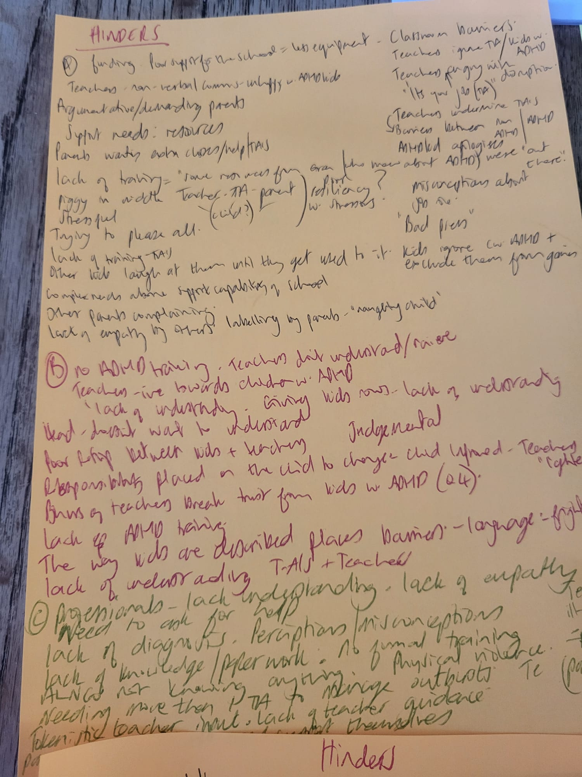

Appendix 2b:
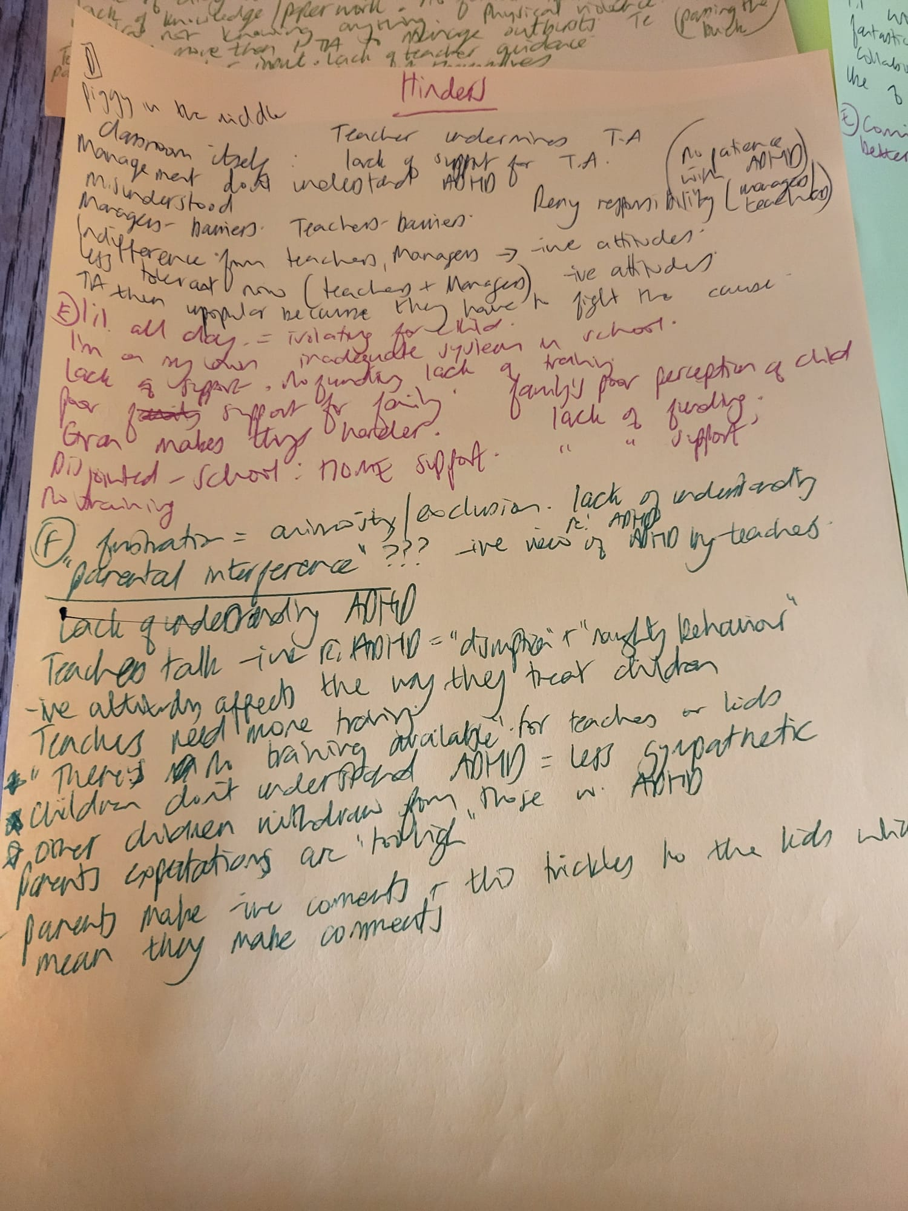

Appendix 2c:
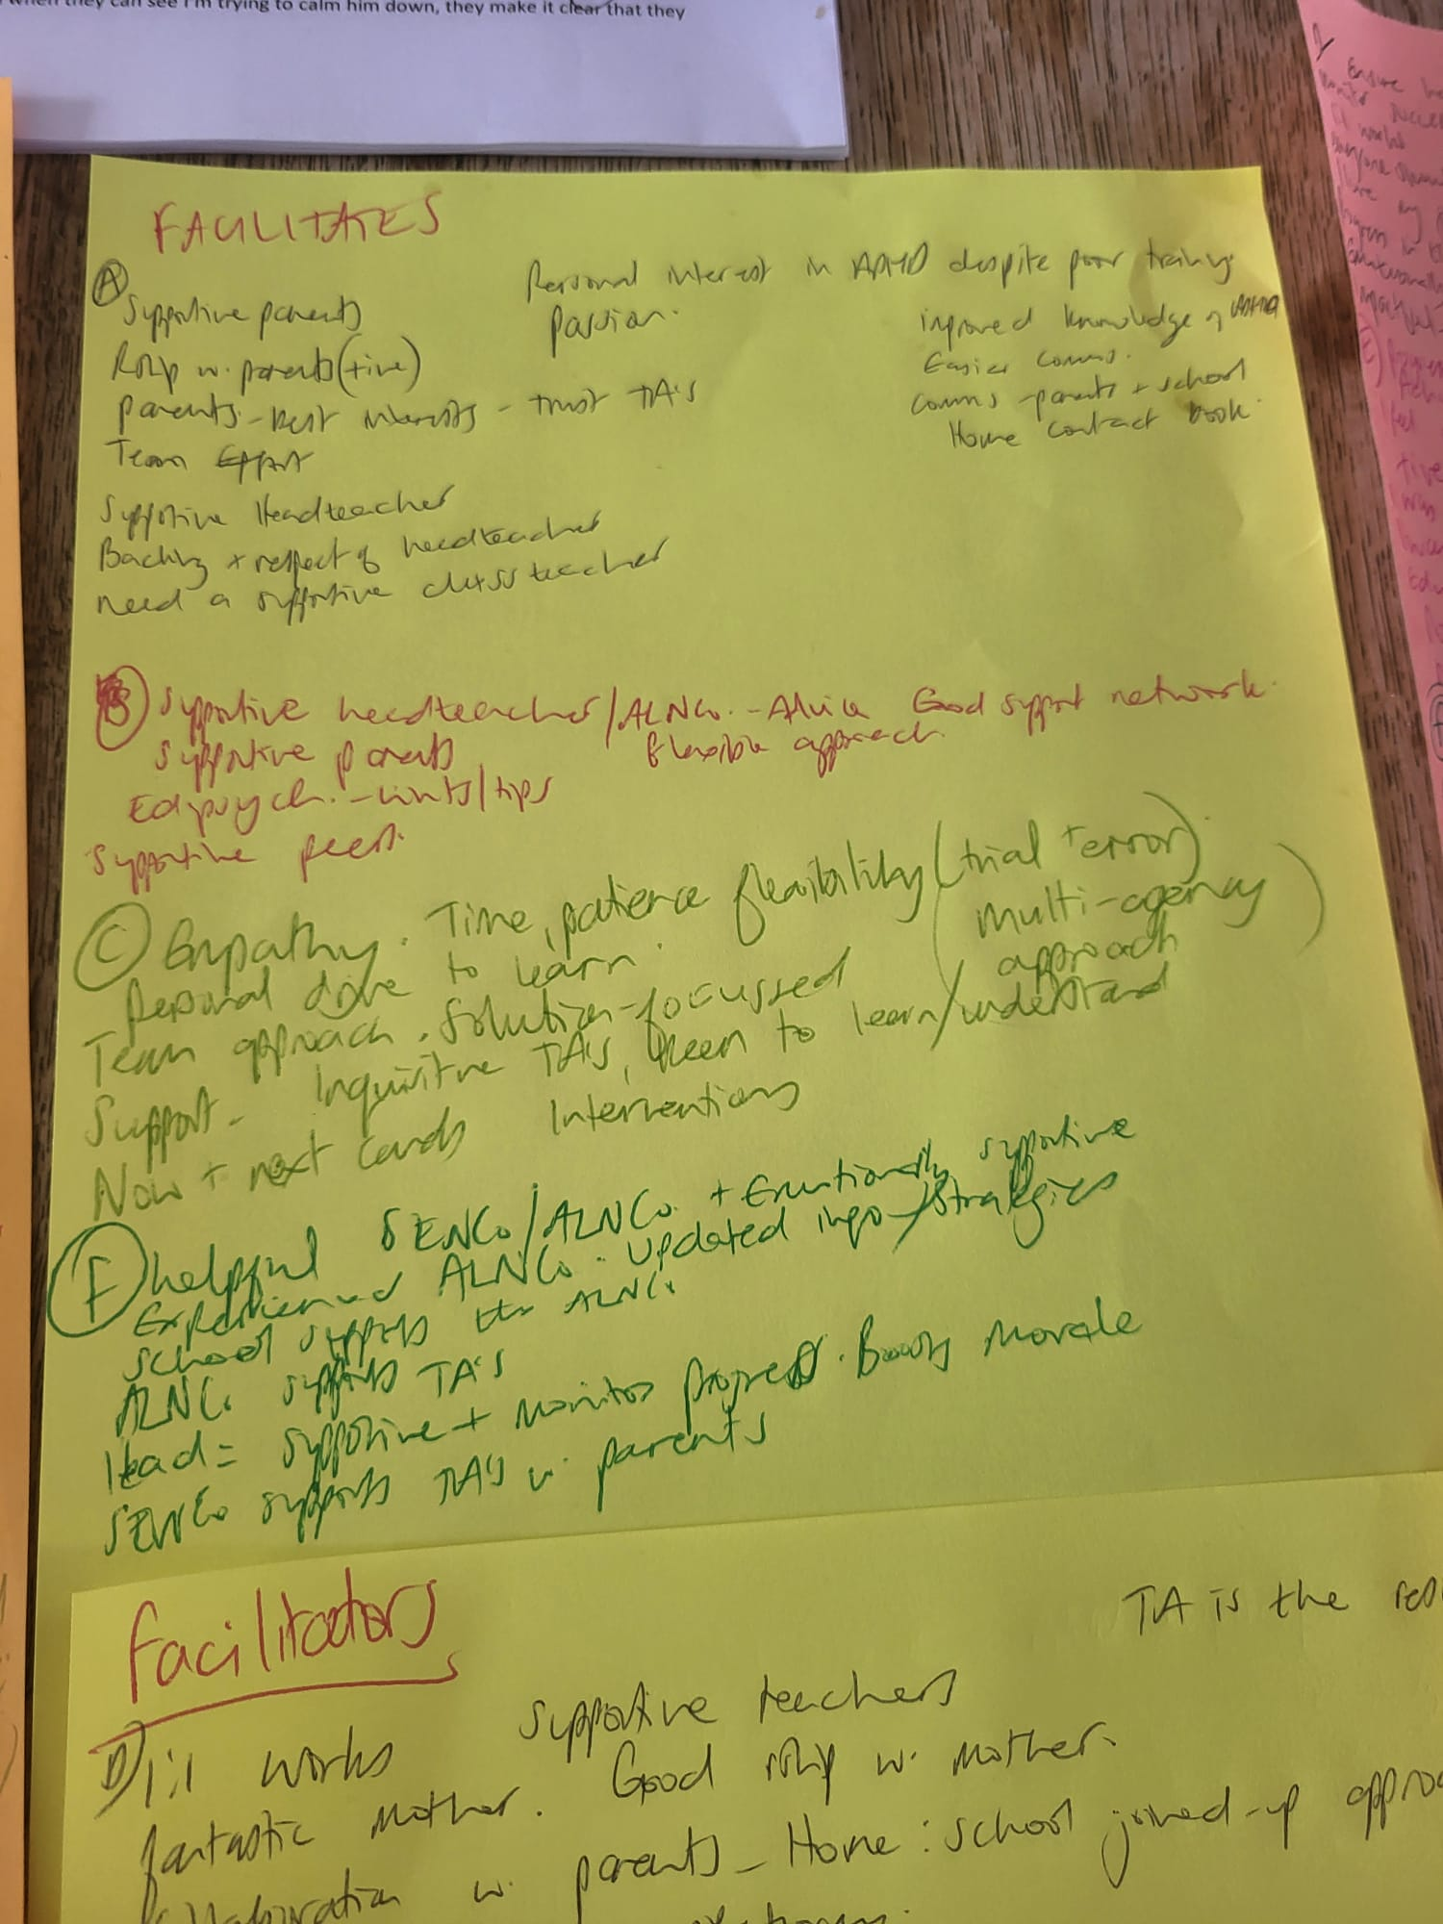

Appendix 2d:
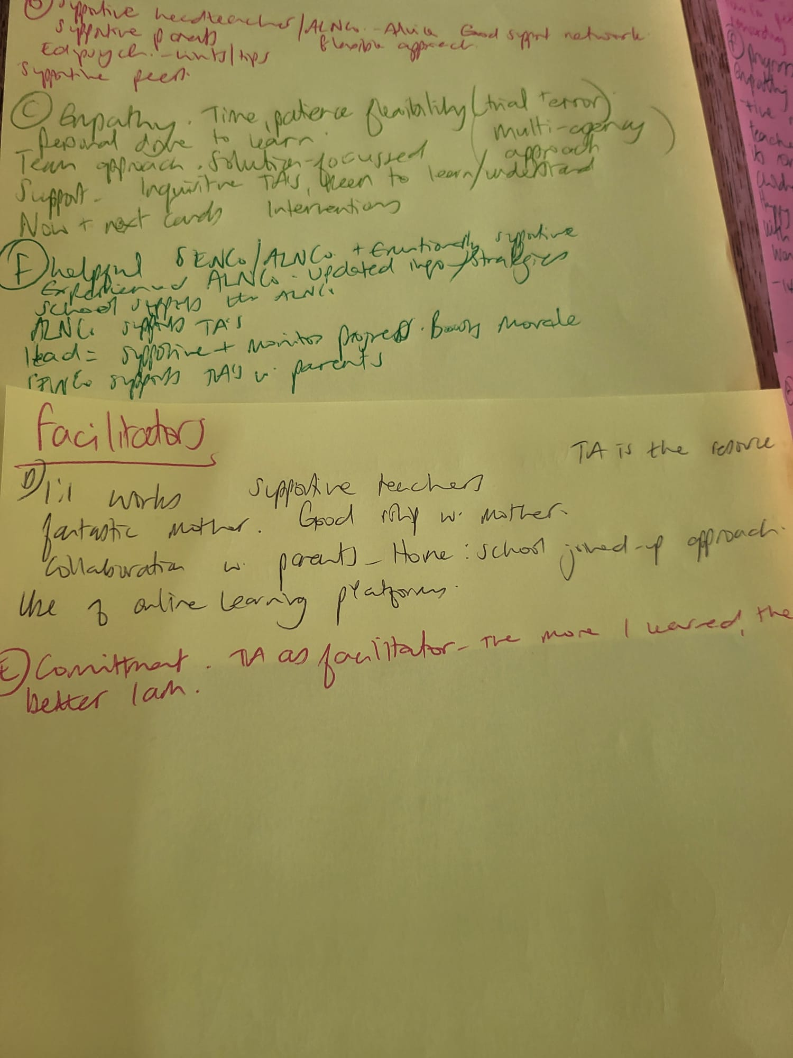

Appendix 2e:
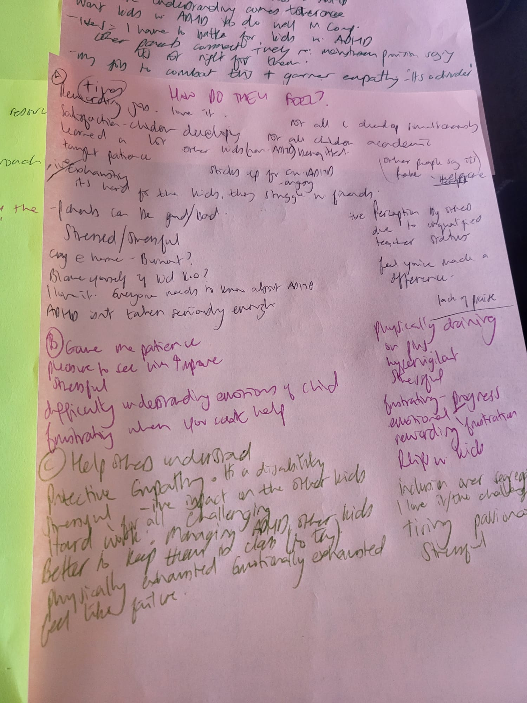

Appendix 2f:
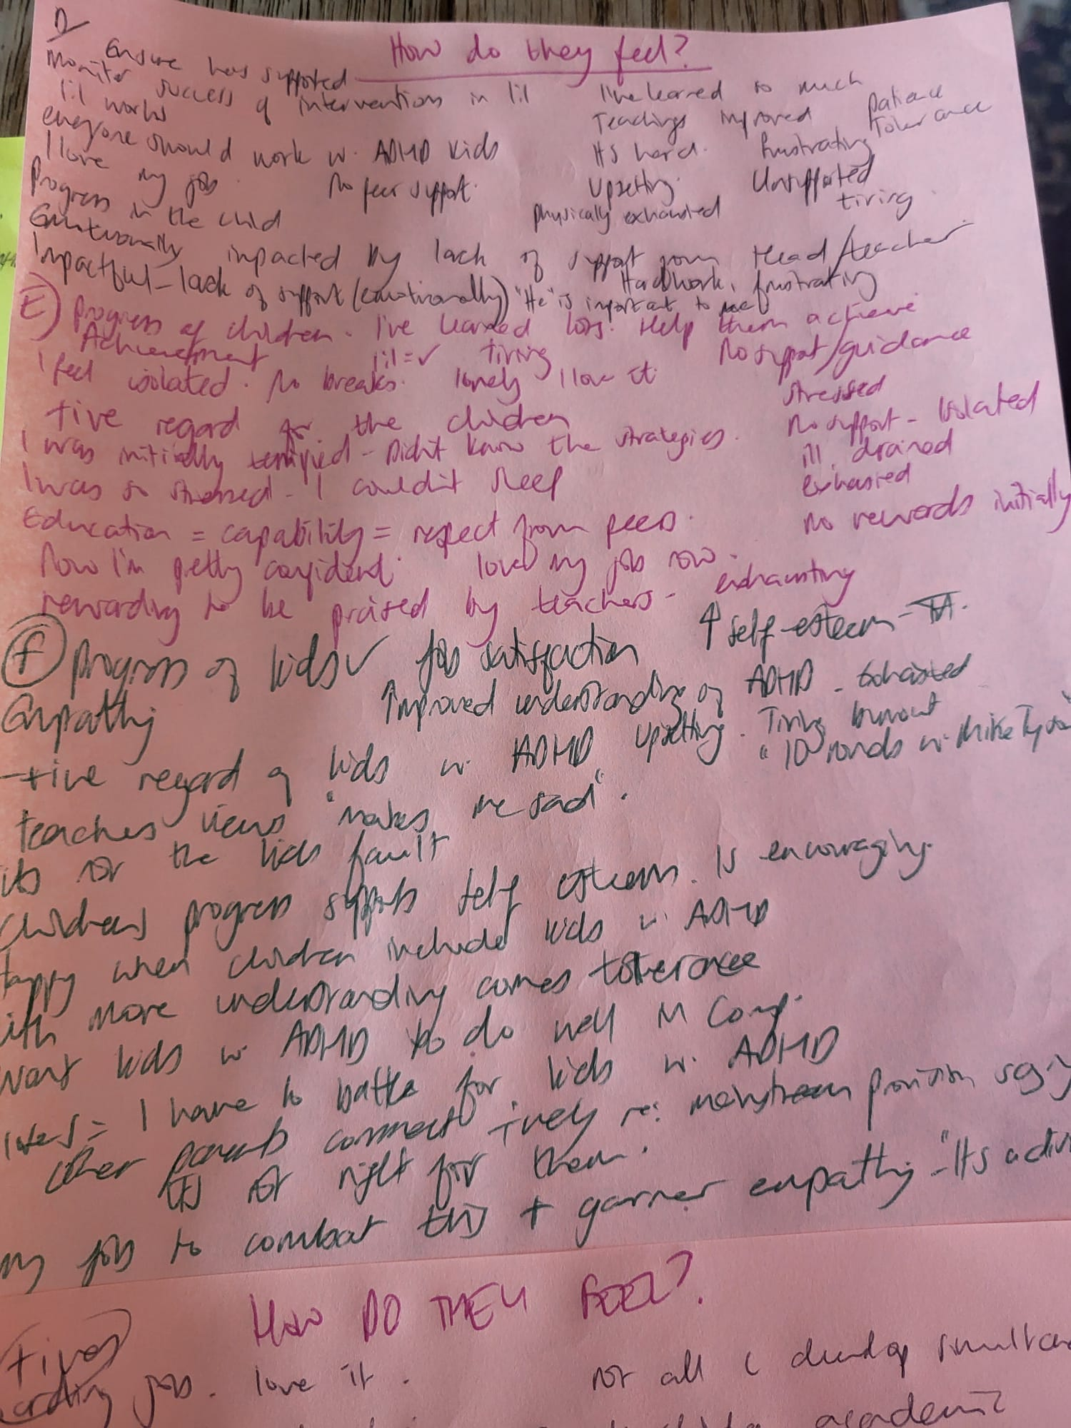

Appendix 3a:
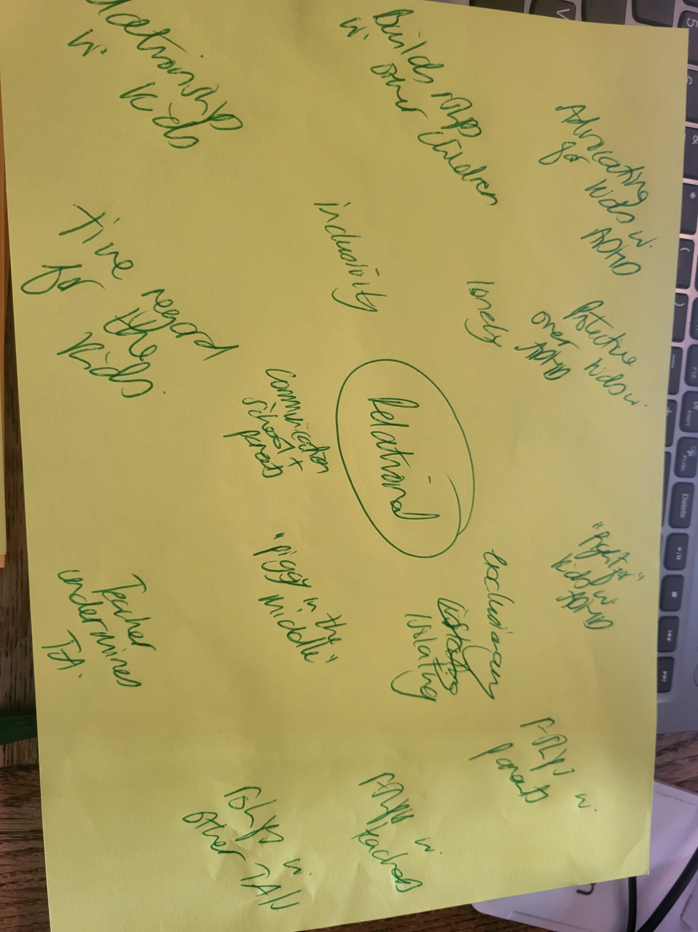

Appendix 3b:
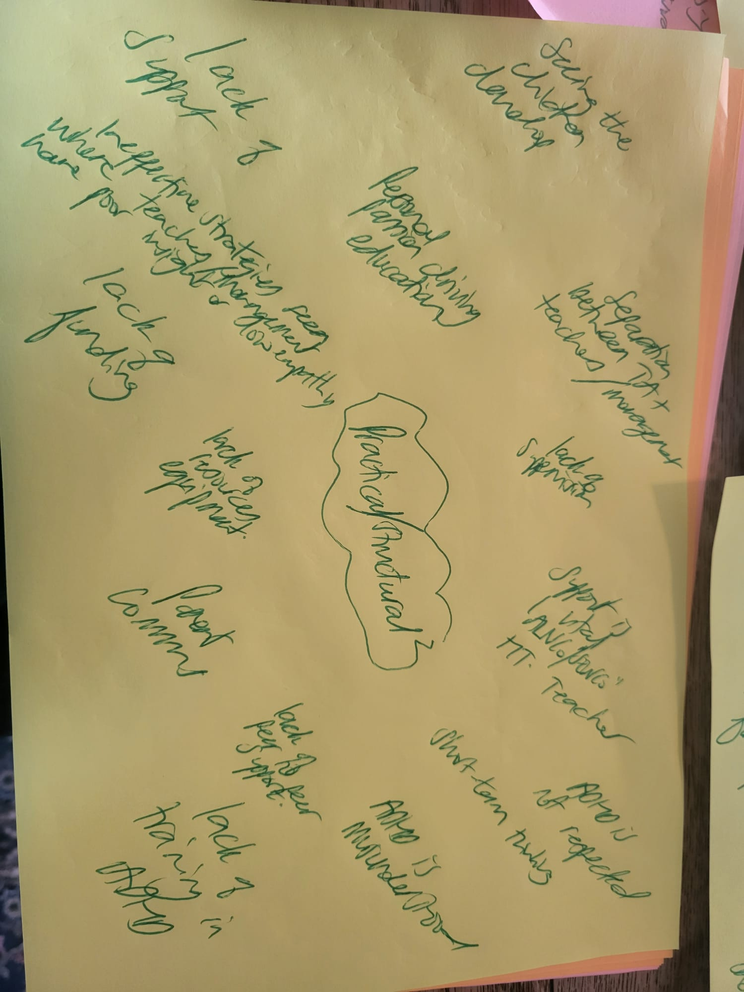

Appendix 3c:


