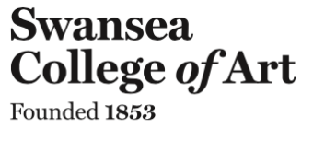


Independent Inquiry

What is waste: An Investigation into key societal understanding of ‘broken’ objects and the role of the designer in the cycle of consumerism.

Anita Madan
1702280

Submitted in partial fulfilment of the requirements for the degree of
BA (Hons) Surface Pattern Design
University of Wales Trinity Saint David, Swansea
18th December 2019

Word Count: 6476

Julia Lockheart

Table of Contents Pages

List of Illustrations 3

Summary of Topic 4

Introduction 5

Waste and broken 5
What is a Consumer? 13
Mindful Consumption 18
Creative Upcycling 22

Conclusion 26

Bibliography 29

List of Illustrations

Figure 1: Lifelikeminepoet (2015) Sustainable Materials and Products in a Cradle-to-Cradle Life Span [image]. Available at: https://environmentallysustainableclutterfreeliving.wordpress.com/2015/08/02/sustainable-materials-and-products-in-a-cradle-to-cradle-life-span/ (Accessed: 11 December 2019)

Figure 2: Jobson, C. (2014) Kintsugi: The Art of Broken Pieces [image]. Available at: https://www.thisiscolossal.com/2014/05/kintsugi-the-art-of-broken-pieces/ (Accessed: 13 December 2019).

Figure 3: Open Access Government (2019) What are the alternatives to landfill? [image]. Available at: https://www.openaccessgovernment.org/what-are-the-alternatives-to-landfill/53719/ (Accessed: 12 December 2019).

Figure 4: Upcycling Furniture Business (2019) Upcycled Furniture [image]. Available at: https://www.bing.com/images/search?view=detailV2&id=D5E63B6029B2EE4A7842080741AB3828DD3B195D&thid=OIP.-ZJe2VeQbk8_saIxP22dXQHaFj&exph=720&expw=960&q=upcycling+furniture&selectedindex=3&qpvt=upcycling+furniture&ajaxhist=0&vt=0&sim=11 (Accessed: 16 December 2019).

Figure 5: Wood Guide (2019) Screen printing on wood [image]. Available at: http://www.woodguide.org/guide/screen-printing/ (Accessed: 16 December 2019).

Summary of Topic
This independent inquiry will identify the cultural and societal understanding of waste and broken in western culture, in terms of the waste that is being produced as a result and the major world and environmental issues that are being created. The objective of this essay is to examine the different reasons behind the waste cycle that exists in contemporary culture; the role of the unconscious and conscious consumer will be considered and the decisions they make regarding ‘broken’ objects. An in depth analysis of the impact the consumer has both positive and negative will take place with possible solutions for a waste free future.

Introduction
This independent inquiry will investigate how the societal understanding of ‘broken’ and ‘waste’ influences individuals into becoming mindless consumers, impacting on the number of things bought and the decisions made regarding unwanted items. The role of western society as a wasteful culture will be considered with regards to discarding objects readily and will be compared to other cultures, whereby the ethos is to repair and mend in turn making the object more desirable.

Positive consumerism is the process of not throwing things away, reusing and reimagining objects to extend their lifespan and reduce waste. To achieve this, we need to change the mindset of modern consumers and this where the role of the designer comes into the cycle of consumerism. A Surface Pattern designer has the knowledge to show consumers how their ‘broken’ objects can be upcycled and once again become desirable; this inquiry will reflect on the skills and different techniques available to help achieve this and how this in turn can positively change the mindset of consumers.

Waste and broken
This independent inquiry will focus on the societal understanding of waste and what attitudes to ‘broken’ objects mean in culture. This is arguably a determining factor for the cycle of buying but not using and the throwaway society that is apparent within contemporary western culture, and arguably across the world.
At its deepest foundation, the industrial infrastructure we have today is linear: it is focused on making a product and getting it to the customer quickly and cheaply without considering much else (Braungart and McDonough, 2009, p.26).

Within a contemporary context products are produced on a mass scale to be consumed by the customer quickly but this is often without thought or understanding. Objects are able to be obtained easily but also discarded; the lifespan of a product is arguably no longer the main concern as a new product can replace the last creating a lifespan of waste instead.
The stigma around waste in Western culture has created a cycle of buying and throwing away with no real concern for the use of the product or its lifespan. According to the Official Cambridge Dictionary waste is,
unwanted matter or material of any type, especially what is left after useful substances or parts have been removed: to use something without care or thought: left after what is valuable has been used, and no longer needed (2019).

What the individual discards on a societal scale is waste; an individual’s understanding of the worth behind an item dictates what is thrown away and the ultimate transformation of this into waste will be integral to this discussion.

An individual is able to determine the worth of an object therefore through their own desire for it. If everything is considered as rubbish, as can be conceived through these definitions, then it is questionable as to how worth can be decided and whether any products do actually survive and why? For the purpose of this dissertation waste will be considered in terms of the above definitions. Individual understanding of waste has stemmed from society and each person arguably responds to this differently according to personality. Modern culture has become a largely consumerist society through the belief that objects can lose their worth immediately and can be rebought. This has developed a society of mindless consumers whereby purchasing is no longer a necessity but instead a want or desire, arguably a cultural fashion, and a product’s worth or use is not the context for buying. This will be considered in more detail in later chapters.
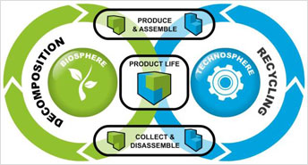
Figure 1: Sustainable Materials and Products in a Cradle-to-Cradle Life Span.

Martinez and Jackson define waste in terms of the person; “Put simply, we are what we throw away.” (Damron-Martinez and Jackson, 2017, p.152). This raises the concept that a person or consumer can be understood through the waste they discard. This is further supported by the US term ‘Garbology’, a new institution within education in America. “Garbology is an exercise designed to give students hands-on experience on how to read consumers on the basis of items they toss in the garbage” (Damron-Martinez and Jackson, 2017, p.153); students are taught they can understand consumers through their waste. As a society, we consume readily, arguably with little interest or concern in what is consumed. The role of the consumer feeds directly into a person’s personality arguably part defining them and creating an intrinsic connection between the things consumed and their identity. “Students are astonished at how accurately they can discern someone’s personality simply as a by-product of the things they throw away” (Damron-Martinez and Jackson, 2017, p.153). Through understanding garbology and being educated about it, this could arguably change how people view their own waste. This can be seen as a new language of the world of reduce, re-use and re-cycle, enabling others to recognise an identity through an individual’s consumption or overconsumption. It is increasingly visible that with the amount of waste each individual household throws out, it’s easy to identify them and their consumer habits. It can be a new approach to consumer identification in modern society, becoming part of our human nature, identified through the traces we leave behind. “Garbage is a mirror on our society. What you are is often what you break” (Schwartz, 2006, p.1). If we can see how the past was built up we can discover practical and effective methods that can be introduced into modern society to combat the waste and throw away culture. Garbage is theoretically a very pervasive element to human society and is associated with every human activity. Garbology is confronting the importance of turning the perishable into imperishable through recycling.

Waste and broken are linked together because broken objects are discarded like waste instead of being repaired. Broken is “damaged, or no longer able to work” (Cambridge English Dictionary, 2019). A broken object is deemed as no longer of any use due to its damage just as waste is what is left after the valuable parts have been removed. Both are consistent with an understanding of an object’s worth. Arguably our understanding of waste has evolved over time due in part to societal change. A changing mindset has evolved whereby a broken item is to be thrown away; opportunities for repair are costly and the urgency has disappeared, with buying a replacement becoming a cheaper option. Societal understanding of the concept of broken is evaluated as quite complex for different generations. For instance, within older generations the idea of clothes or furniture upholstery having a tear or rip is then assessed as needing to be mended or replaced. But what has come to light now is that broken or torn items are now being sold for a considerable amount of money and are deemed desirable. This is removed from the past idea of broken to now it being fashionable for younger generations to desire and pay for. There is a disagreement between the two voices of different generations and it is hard to find a middle ground of understanding. The individual consumer makes a conscious decision to consign with the trend or go against it; many younger consumers can see past peer pressure in order to re-evaluate the purchase and whether fitting in with the latest trends in society will make them happier. “We live in a throw-away society, where world cities generate about 1.3billion tonnes of solid waste per year” (Hoornweg & Bhada-Tata, 2012, VII).

The confusion that exists regarding the understanding of waste and what a broken item is, is in part due to the underlying beliefs that exist within consumerism and the way products are made; a consumer’s understanding of the product. A wave of production has entered the market in which products are created with a limited lifespan. This means that they will inevitably break down encouraging the consumer to replace the item as sometimes repairing is more expensive than buying a new one. Understanding of waste and broken can differ across cultures however with it often being ingrained that recycling and use of broken items should be encouraged, until they can no longer be used, effectively reducing the risk of being a society that creates waste. We can learn and implement this concept into modern society to help reduce the extensive amount of waste that is accumulating on land and in the sea. “[O]ne object, broken or not, was converted into another, permanent or not” (Schwartz, 2006, p.21). Upcycling an object after its primary use is no longer needed or functional, is a first point of action within Jewish culture, enabling the object to be converted into another use for as long as possible. There is such a thing as breaking on purpose in ancient Jewish culture; it is seen through the archaeology of the remains left behind that important interior possessions were constantly being damaged, inflicted with breakages due to their constant use but were always repaired to serve their purpose.

Within Jewish culture items would be made in such a way that they were able to be repaired easily and this meant that furniture that may be damaged didn’t need to be discarded (Schwartz, 2006); this arguably is a custom we seem to have lost in translation in the ever developing and modern world that our society lives in. Within past decades furniture was valued more within society and by the individual, not thrown away so easily. This arguably part originated from a hierarchical class structure where for the poorer classes, furniture was made an expensive object to own and only the wealthy had the choice to buy new. A broken item in Jewish culture holds an alternative role not being seen as unusable but rather a project to be mended. “what is broken is essential but is repaired…every effort is made to ‘save’ these beds, to repair them and to avoid discarding them” (Schwartz, 2006, p.18). The beds were still made as they are today by having joints and each part being able to slot into place, it’s just now when a part of the bed breaks or is damaged then the whole thing is deemed broken and discarded. In ancient Jewish culture it is constantly stated that parts of the bed as such were damaged and replaced to bring it back up to its status of ritual purity. This was made easy by how the bed was constructed; “Basic assembly would be considered, e.g., attaching a new or replacement leg to a chair or bed” (Schwartz, 2006, p.26). The ability to put together and dismantle the bed and many other items of furniture was a key part in being able to replace parts of the object without it being noticeable. As stated in the Kelim Corpus, a tractate discussing ritual purity of objects in Jewish culture, “Sometimes it was more important to what extent the components were ’fastened’ to the bed than whether the bed continued to function as a bed” (Schwartz, 2006, p.4). This shows that there was actual consideration into the construction and design of the components to the furniture so that discarding the entire piece was not a first option.

Similarly, in Japan the cultural ethos is that objects that break aren’t simply discarded but are found a new purpose. Kintsugi is the ancient Japanese method of mending broken ceramic objects using pure gold to join back together the pieces of an object. From its story of creation Kintsugi’s allure was most sort after in ancient Japanese society. Compared to ancient Jewish society, broken is seen as mendable and having a second life with the ethos of not throwing away; this is a very practical view on broken and the consideration that objects can be mended. In ancient Japanese culture, the use of Kintsugi was considered aesthetic mending and on mainly broken ornaments that were to be discarded; Kintsugi became so revered however adding value to an object that vases of decoration were broken on purpose to then be mended in the Kintsugi way. An example of this within western culture can be seen in fashion and highstreets as people are buying jeans that are ripped, which is a form of broken demonstrating that the desire for fashionable broken still exists now in different forms. The concept of broken could arguably be reinvented into society, as seen in the Kintsugi tradition, whereby consumers could start to see broken furniture and/or garments as more desirable and valuable. Clothes that are able to be mended as in the Kintsugi tradition could become part of a high fashion trend with clothes designed in a way like Jewish furniture is made, so that parts can be easily replaced; they could be mended easily or recreated in a more desired and valued way. Making the impressionable generation part of this and be the forefront of it would ultimately change the societal mindset towards waste and broken, viewing them as opportunities rather than discarding them. “That is, it is possible that consumers make purchase decisions based on potential alternative uses of a product.” (Wilson, 2016, p.398) The understanding that a product has multiple purposes changes the consumer’s perception and understanding of it. Consumer society has the potential to reintroduce or make prominent, the importance of the Kintsugi way and the meaning it has when the method is used.
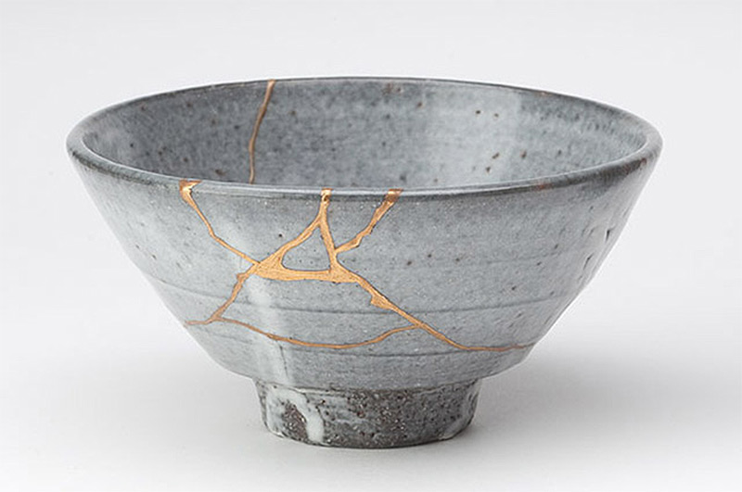

Figure 2: Kintsugi: The Art of Broken Pieces.

The reintroduction of Kintsugi could in turn change the mindset of the consumer, enabling them to engage in a more positive mindset when purchasing. The opportunity to mend an object and for this to be socially acceptable could ultimately stop the waste cycle of discarding after a product is considered ‘broken’. The important lessons of Kintsugi in Japanese culture could in effect change the role of the consumer.

What is a consumer?

A consumer is “someone who buys goods or services for personal use” (Cambridge English Dictionary, 2019). Consumers make conscious and unconscious decisions when purchasing goods that can make a positive or negative impact on waste consumption. Cradle to Cradle’s views on consumption as a consumer, is actually not consuming much of what is bought.
Think about it: you may be referred to as a consumer, but there is very little you actually consume- some food, some liquids. Everything else is designed for you to throw away when you are finished with it. But where is ‘away’? Of course, ‘away’ does not really exist. ‘Away’ has gone away (Braungart and McDonough, 2009, p.27).

Arguably the actual product ceases to exist because of the amount of unnecessary packaging around it; for consumers, it is almost the desire to unwrap it, the feeling is attached to the process not the product. “Away” is arguably a perception of an out of mind state that all consumers are guilty of when they discard purchased items (Braungart and McDonough, 2009, p.27). This kind of consumer is acting upon a cycle of mindless consumption; this is a consumer that purchases a lot of items that may be unnecessary at that time. Mindless consumption is an integral part of the modern consumer and the impact it has on the environment, sustainability and waste thrown away. “a major determinant of consumption-induced problems is mindlessness” (Bahl et al., 2016, p.1). Modern society has become mindless; as Nisbett and Wilson argue “decision makers often have limited insight into the determinants of their own judgments and decisions” (Simonson, 2005, p.211). Societal manipulation by companies and underlying consumerism means the consumer can be brainwashed to buy because they have been told to, while not using much of their thought process.

Consumers tend to ignore or place the knowledge of what’s happening with the waste crisis to the back of their minds and this arguably is the position an unconscious consumer upholds within society; the mindless or unconscious consumer buys for the sake of buying without responsibility. “Hundreds of people will be protesting outside Primark's Oxford Street store in London today in response to claims that the retailer has been using child labour” (Hopkins, 2008). Despite having this information provided and protests being apparent consumers will still shop there. They are taking this information and hearing it on a conscious level, then consciously placing it into their subconscious; this arguably could be because they do not have the mental faculty to understand, the empathy to deal with it or they simply do not want to hear, because it complicates a situation that is clear in their own head. The physical absence of sweat shops means you can ‘pretend’ they do not exist; ‘out of sight out of mind’. Designers can use theoretical methods that have been designed in the past by peers such as Bernays who has used his knowledge of unconscious consumers to sell them ideas they did not need. Bernays showed American corporations and retailers how they could sell products that people didn’t necessarily need “by linking mass goods to their unconscious desires” (The Century of the Self, 2002). This is now defined by mindless consumption and how it can be in relation to continuous buying for short term happiness and instant gratification in not just the 20th century but continuing and increasing in the 21st century. Bernays taps into this by saying that it is part of our natural selfish instincts to consume but within psychoanalytic terms; it brings us short term joy but makes us docile and easier to keep under control as a consumer of society. This is a great step in understanding psychology but has made extreme negative impact on everything outside the consumer purchasing. Ebay consumption is an example of some of this natural instinct in play as it becomes more about the competition and selfish desire to win rather than the actual product; through the race to win the bidding war you lose sight of the product becoming an unconscious process working on our animalistic instincts. Another example can be seen when you shop with others. It can be negative and positive having another person with you when you shop as this can help you make a decision but sometimes the wrong one; often this supplements another’s gratification making you buy something you don’t like which can be a blockade to becoming a conscious consumer. The consumer is not totally responsible for the amount of product that is thrown away as it can be considered that the company producing it has the power to reduce the amount of unethical packaging used. The consumer can take responsibility and be more mindful through taking ownership of the decisions they make but this arguably comes with a greater understanding which in turn is the responsibility of the company. A designer can enable positive consumption through increased information and ensuring sustainable production methods.

Products arguably lose all value, ceasing to exist in terms of being a product and the consumer loses the purpose of buying/ purpose behind the product as it becomes about gratification and not needing anything. Another issue arising with mindless consumption is that it is linked to fast fashion that is a main contributor to the environmental disasters that surround this industry, with more countries being engrossed by this trend. “Although certain trade agreements have been established with the aim to sustain a fair and balanced production, the popularity of fast fashion retailing has shown continual growth in both developed and developing countries” (Deschamps, et. al. 2016, p.1). It is good to see that before the damage is done that systems and agreements are in place to tackle the problems of fast fashion ahead of it hitting new countries, for instance Mexico. It is challenging however to keep at bay the pressure that fast fashion has on trying to create a system of unsustainable consumption.
Our desire for fast fashion, fuelled by advertising, social media and a supply of cheap garments, means we are disposing of over a million tonnes of clothes every year in the UK. Under the UN Sustainable Development Goals, the UK is committed to ensure sustainable consumption and production (House of Commons, 2019).

The success of other countries in reducing the progression of fast fashion could in effect have a huge role in changing the nature of consumerism, ultimately reducing the amount of clothes that go to landfill (see figure..).

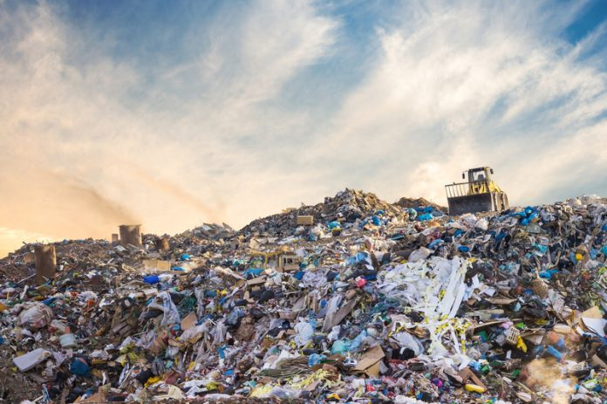
Figure 3: What are the alternatives to landfill?

This is a difficult measure however as fast fashion is fuelled by the ever-developing social media and this increased advertising space means that the consumer is inundated with cheap clothes and products that provide the immediate gratification required in this ever fast modern society. For this negative impact to be changed, a positive message of eco conscious consumerism would need to be advertised. Increased positive information across social networks would in effect create a new culture of mindful consumption as the individual is able to determine what is and isn’t sustainable and what that means to the environment.

Mindful consumption is defined as the ongoing practice of paying attention, with acceptance, to internal stimuli (bodily sensations, emotions, and thoughts) and external stimuli and their effects on the consumption process. Langer views “mindfulness as a heightened state of involvement and wakefulness, with an emphasis on awareness of external stimuli” (Bahl et al., 2016, p.199). The act of mindfulness can in effect allow the consumer more control over the consumption process but it is essential that this happens during purchasing; for “consumers to fully benefit from mindfulness, it is vital that they are able to direct and sustain their awareness during consumption” (Bahl et al., 2016, p.200) to achieve a positive outcome and mood elevation. “[T]he practice of mindful consumption should heighten awareness of the marketplace stimuli on consumers’ preferences and experiences, thereby enabling them to make more informed choices” (Bahl et al., 2016, p.201). The consumer’s mental state plays a large part within the consumption process and through more conscious processing of internal stimuli, a better set of conscious decisions regarding purchasing can be made. “With consumers’ increased awareness in particular, of their bodily sensations—can guide them toward mindful choices that are not directed by unconscious pursuits of pleasure and avoidance of pain” (Bahl et al., 2016, p.201). Awareness of consumption needs to be re-taught in order for consumers to increase positive choices; the weight of bad decisions on a consumer can have a negative impact and this will arguably lead to a decline in mindful consumption, with consumers taking longer to become eco-aware in their purchasing habits. The role of the designer is to make sure that mindful and positive consumption can be implicated within social media and advertising.
We include compassion as an integral attitude with which consumers pay attention to self and others in the mindful consumption process. […] [W]e assert that for consumers to make choices that are beneficial to all beings, attention needs to be accompanied with compassion toward self and others. (Bahl et al., 2016, p.200).
Taking things into account is essential for a person to become a mindful consumer; the negative input of consumerism for many becomes established in their unconsciousness to the detriment of the individual. If this is the case that consumers aren’t able to make changes for themselves; the most effective way to guide consumers into a better system of less waste is to let them buy the product but for it to be without the extra plastic packaging around it. Consumers follow the crowd mentality allowing there to be change with little hesitation from consumers; a new system can be adopted that has better potential for recycling and being cleaner for the environment whilst still teaching the consumer this way is paramount to mindful consumption.

Mindful Consumption
A consumer’s ability to be ethical and sustainable can be supported through conscious decisions made by ethically aware retailers. Fuentes cites many examples of this within ‘Images of Responsible Consumers’. Companies such as Ahlens have “[made] sustainable shopping easier by including sustainable items in their product lines, clearly marking them, and providing information about these products…it makes sustainable shopping easier by excluding certain products” (Fuentes, 2015, p.374). This creates a new experience consumers can be involved in and allows them to value the items they are purchasing whilst also knowing where they have come from. The consumer is able to understand they are making a difference buying sustainable products; bringing more value this allows there to be more increase in demand for sustainable products that have a job of being easy to reuse and recycle. The more customers start valuing a certain brand that accommodates sustainability in their products such as the producing and then manufacturing stages, this will start to give these brands a very favourable image which benefits companies to extend and push for more sustainable and ethical business. Having this marketed on social media cannot only help their corporate image but it may engage other companies to do the same if there is going to be any change to the way society consumes. This is not helped as companies regularly look for the cheapest way to produce as much as possible. It is not just the consumer that has to change but the suppliers/retailers as well. This should also be approached by how the information of sustainability is handed or displayed to consumers. “merely providing more information is not enough to offset the messages that induce consumers to behave irrationally” (Bahl et al., 2016, p.200); there needs to be a plan of action rather than messages of loose instruction. One way of approaching and reaching out to consumers is through social media marketing ads. With social media, it can be difficult to get the message across as consumers tend to see ads as a nuisance and have also been warned not to click on ads due to people scamming them through the link and receiving viruses on their laptops and phones. With the right sign posting and friendly advertising, retailers are able to sell ethical products to eco-conscious consumers; “At its department stores, these products are highlighted and clearly marked using signs and labels.” (Fuentes, 2015, p.372). Clear information for the consumer can arguably change their mindset enabling them to make conscious decisions regarding their purchasing habits. As Rosenberg argues, “The trained mind can sustain and easily return to this objective awareness, which facilitates deliberate choices and less susceptibility to persuasive messaging” (Bahl et al., 2016, p.199). Being persuaded by false advertising does not help the number of companies that are actually pushing sustainable and ethical production. On screen advertising can manipulate consumers onto a specific path with regards to consumption and if this can be changed to promoting sustainable products, then consumer habits can be changed and the nature of waste apparent could be impacted.

Consumers are easily manipulated into a negative or positive action so it needs to be the producer who makes the change with regards to packaging and the consumer will simply step into line. As agreed above this is possible and is being implicated into some corporate businesses. Lush and Bodyshop have a system in place that can allow the consumer to return the packaging to them and they will recycle/ reuse it; in Lush they give you a free facemask for each 5 pots returned. This becomes a positive mindset in buying and recycling your goods packaging as it gives you an instant feeling of accomplishment for your consumption not just physically but emotionally and starts to engage your consciousness. There has to be a system of conscious questioning considered before buying something. Having more information on the products you are buying and where they have originated, can ultimately create more empathy in the consumer as suggested by Mick et al. “empowering consumers to have greater agency in making conscious consumption choices [can] promote individual, social, and ecological well-being” (Bahl et al., 2016, p.199). This creates a more positive attitude to the consumer’s choices and consumption without added regrets and denial of purchases, so the whole experience becomes positive. The confidence to think differently when purchasing can make sure that mindful consumption becomes a routinely habit rather than an ‘on-the-spot’ decision.

The emergence of a new ‘B’ list for companies enables consumers to make ethical choices when it comes to purchasing goods. The certified ‘B’ corporations are “businesses that meet the highest standards of verified social and environmental performance, public transparency, and legal accountability to balance profit and purpose” (bcorporation.uk, 2019). The ethos behind this list is the understanding that government alone cannot change the world’s most pressing issues and that this must be challenged at a grassroots level. Considered a community of companies, including Bodyshop they “work toward reduced inequality, lower levels of poverty, a healthier environment, stronger communities, and the creation of more high quality jobs with dignity and purpose” (bcorporation.uk). This enables consumers to make environmentally sound decisions in terms of product choice through being a conscious consumer and checking this list for appropriate companies. A trusting relationship can be built between consumer and company through the understanding that the information is factual and accurate due to its place on this list. Many companies and products claim to be ethically friendly yet this is untrue and in effect is responsible for making the conscious consumer into an unconscious one through no fault of their own. For consumerism to effect positive change products cost more to be eco-conscious and this needs to become an understanding between consumer and retailer. The perception and understanding behind the cost of a product needs in many cases to be re-evaluated in order to stop the fast consumerism system that society currently revolves around. This arguably requires changing the consumer’s mindset which in turn will alter the trend; buying less but paying more for items has a more positive effect on the production of objects and clothing and in turn can enable the conscious consumer to change the society we live in, in line with the ethos of the B Corporation. The understanding that an item once bought is to be kept forever needs to be reintroduced for change to be effected; the conscious consumer needs to understand that items can in turn be updated, mended and upcycled and this will create a positive mindset of purchasing.

Creative upcycling
Wilson defines creative upcycling as “when consumers repurpose waste rather than throw it away. Through upcycling, consumers transform old products into objects with new uses – transforming or creating new products and technologies in the process” (Wilson, 2016, p.394). A creative consumer has the knowledge or the want to make a product have a longer lifespan than that of its original purpose. “upcycling is the practice of refashioning something useless into something useful” (Wilson, 2016. p 395). Similar to the previously mentioned Kintsugi and ancient Jewish traditions, an old or broken item is not ‘waste’ it is simply in need of some re-fashioning.

Wilson describes the next generation as very eco-conscious and sees them as the younger generation that are faced by many obstacles. “Public concerns about the state of the environment are growing, which can influence consumer’s purchasing behaviour, especially among younger generations” (Wilson, 2016. p.395). As a result of the struggles the younger generation encounter now, they have become more creative in order to achieve the same aesthetic that brand-new items provide you with; upcycling has become a trend in recent difficult economic times. “This manifests itself in purchasing behaviour, as research suggests that the purchasing behaviour of Generation Y is driven in part by environmental conscientiousness” (Wilson, 2016. p 395). If generation Y have this behaviour, then it allows for a trend of upcycling to become a part of a consumer’s natural consciousness. Creative upcycling can be a part of a new wave of transitioning a hobby into everyday practice in order to extend the lifespan of existing products.
Upcycled furniture, such as a chair that has been reupholstered using belts, or a dresser with suitcases for drawers, are popular at flea markets and online sites like Etsy.’ go green (Wilson, 2016, p.396).

These are some ways that creative upcycling has become popular with creative consumers. This idea of upcycling furniture has been around for longer, (explained in Jewish culture section) but now it has become part of the modern western culture, as consumers are upcycling and reinventing furniture that has withstood decades of use and non-use but because it’s made to a high quality it does not break down like furniture is made by today’s standards. Essentially now what we want is older furniture but with modern styling.
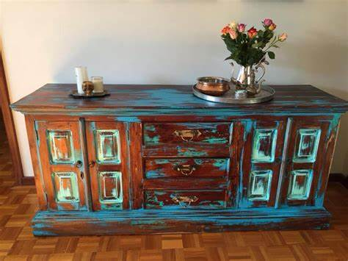
Figure 4: Upcycled Furniture.

In the past furniture was seen with a purpose to store things. It also showed the owner’s status through design and embellishment. Creatively upcycling old furniture is now part of a fashionable trend and lifestyle that appeals to the modern consumer and younger generation. “To these consumers, the visual appearance of an upcycled item may be superior to an equivalent new item. That is, this type of consumer may appreciate the look of the end product” (Wilson, 2016, p.396). Another main trend at the moment is making furniture look old when it’s not called ‘distressing’; this questions the creative desire of making the unwanted wanted again as if it looks old surely that would make it unwanted and an arguably ‘broken’ item. Mending or upcycling furniture should be the role of the owner as it is through this process that they learn the importance of maintaining the upkeep of their possessions and the process ultimately makes them a mindful consumer. The benefits of upcycling and especially in a creative way can provide people with more of a purpose as it benefits the environment from re-consuming items but in a way desirable to the consumer. It also creates a more conscious consumer as they have engaged in the creative process themselves and upcycled their own furniture.

Through a designer’s eyes, there is a lot of potential to make old furniture more unique and desirable though processes that are learned and produced by textile and surface pattern designers, who have a knowledge of the processes that can be used such as screen printing on a variety of materials, laser engraving, embellishment, and decoupage to name a few.
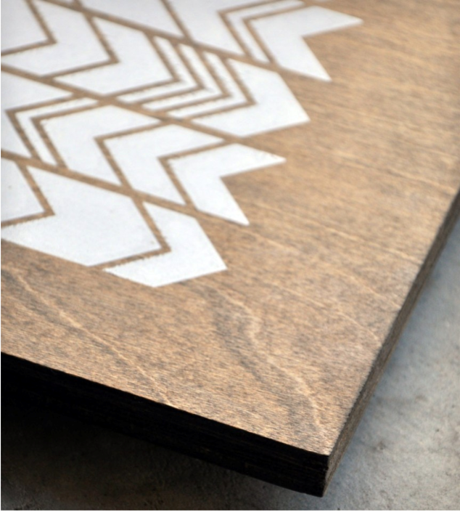
Figure 5: Screen printing on wood.

Conclusion
The understanding of broken and the concept of waste that originates from this, is determined through societal influence and arguably manipulation. The role of companies in teaching individuals to become consumers creates a mindset that understands the role of a product and when to decide the value of this has ended; this however is the conscious decision of the company producing the object and often has more to do with making money than teaching a society to be economical. An increase of knowledge on consumers and their choices can be evidenced through the new study of Garbology; this could enable companies to understand which products are consumed most. The designer can arguably then use this knowledge of understanding consumer’s waste to then change the product to being recyclable.

Mindless consumption is one of the main causes that allow the amount of waste to exist; learning from other cultures will enable a greater understanding of re-using or assembling broken items rather than discarding them, in turn lowering the amount of consumption that takes place. Consumers need to be taught to see the value the object still holds and this will enable a want to keep it; its upkeep should be the responsibility of the consumer and this practice would make them mindful and give the product a longer lifespan. This can be learned from the methods of other cultures such as ancient Japanese and Jewish traditions who both assert positive and mindful ways of understanding broken and how this can be resolved without discarding it. In Jewish culture products are designed to be disassembled which means the consumer understands this when purchasing the object; the designer thereby is able to have more control over the amount of waste created by modern consumerism. The designer’s role is to implicate strategic methods through the design process to enable consumers to purchase in a conscious way. Designers are to an extent in control of what we see on social media but are normally advised by the retailer to promote certain things. This can be negative or positive as a result as the consumer buys what they’re shown.

The more creative upcycling there is the less consumption of products however due to the fast fashion nature of contemporary society products are now being made to a lower quality which allows for damage to happen. It should be the designer’s job or purpose to get consumers to change the way they shop through producing more ethical products or branding sustainable shops better. The shift in paying more for quality instead of buying more product less quality, has to be addressed and to shift consumer habits that don’t sustain this cycle. The emergence of creative upcycling needs to be supported by retailers and consumers alike in order for a positive cycle to be created; for this to become the ‘norm’ within society the amount of waste would ultimately be reduced. A positive relationship with the retailer could communicate upcycling as essential to maintain the upkeep of the product and additionally to allow the individual to make their own creative mark upon it; if this was promoted it would become routine for consumers. Furniture in this way can become more individual to the owner making the item stand out and be more desirable; there is an underlying natural instinct to have something others don’t in order to feel superior and to show off and this links back to the competitive nature of purchasing as seen with eBay consuming. Through upcycling your own furniture the possibility of being the same as others is greatly reduced and if competitive, then this can enable a person to continually have ‘new’ furniture. This being promoted as a positive and beneficial change would lead to more consumers doing this, unconsciously making a difference for the environment whilst benefiting them and creating happiness and a sense of achievement. This is a method that moves forward the understanding we have of waste and how we can reduce it in a more creative way.

Ultimately for the amount of waste we produce we need to engrave into society’s mindset through positive action with retailers and consumers alike. Actions can help reduce the amount of waste that is produced and discarded by implicating some of the solutions that are discussed in this essay. For the waste cycle to change retailers must change what they produce and the mindset they create through this. Mindful consumerism can be created through increased information but this must be a joint understanding with positive contributions made to our society through media and up-cycling, with the support of retailers trying to achieve the same as creative up-cycling consumers.

Bibliography
Bahl, Shalini. (2016) ‘Mindfulness: Its Transformative Potential for Consumer, Societal, and Environmental Well-Being’. Journal of Public Policy & Marketing, 35(2), pp.198–211.

Braungart, M. and McDonough, W. (2009) Cradle to Cradle Re-making the way we make things. London: Vintage Books.

Damron-Martinez, D. & Jackson, K.L., (2017). ‘Connecting Consumer Behavior with Marketing Research through Garbology’. Marketing Education Review, 27(3), pp.151–160.

Deschamps, T., Carnie, C. & Mao, B., (2017). ‘Public consciousness and willingness to embrace ethical consumption of textile products in Mexico’. Textiles and Clothing Sustainability, 2(1), pp.1–16.

Fuentes, C., (2015). ‘Images of responsible consumers: organizing the marketing of sustainability’. International Journal of Retail & Distribution Management, 43(4/5), pp.367–385.

House of Commons (2019) Fixing Fashion: clothing consumption and sustainability (HC 1952). Available at: (Accessed: 10 December 2019).

Schwartz, J. (2006) ‘“Reduce, Reuse and Recycle” Prolegomena on breakage and repair in Ancient Jewish Society: Broken beds and chairs in Mishnah Kelim.’ pp1-34.

Simonson, I. (2005) ‘In Defense of Consciousness: The Role of Conscious and Unconscious Inputs in Consumer Choice’. Journal of Consumer Psychology, 15(3), pp.211–217.

Wilson, M. (2016) ‘When creative consumers go green: understanding consumer upcycling’. The Journal of Product and Brand Management, 25(4), pp.394–399.

Cambridge Dictionary (2019) Waste.[website]. Available at: https://dictionary.cambridge.org/dictionary/english/waste (Accessed: 11 December 2019).

Cambridge Dictionary (2019) Consumer.[website]. Available at: https://dictionary.cambridge.org/dictionary/english/consumer. (Accessed: 11 December 2019).

Cambridge Dictionary (2019) Broken.[website]. Available at:
https://dictionary.cambridge.org/dictionary/english/broken?q=Broken. (Accessed: 9 December 2019).

Hopkins, K. (2008) ‘Child labour: Primark caught out’, The Guardian, 23rd June. Available at: https://www.theguardian.com/business/2008/jun/23/primark.children (Accessed: 8 December 2019).

Other reading material

Bridgens, B. et al. (2018). ‘Creative upcycling: Reconnecting people, materials and place through making’. Journal of Cleaner Production, 189, pp.145–154.

Girak, Sue. (2019). ‘Creative reuse: The impact artmaking has on raising environmental consciousness’. International Journal of Education through Art, 15(3), pp.369–386.

Scott, K.A. & Weaver, S.T. (2018). ‘The Intersection of Sustainable Consumption and Anticonsumption: Repurposing to Extend Product Life Spans’. Journal of Public Policy &
Marketing, 37(2), pp.291–305.

Szmigin, I. (2009). ‘The Conscious Consumer: taking a flexible approach to ethical behaviour’. International Journal of Consumer Studies, 33(2), pp.224–232.

Documentary

‘Happiness Machines’ (2002) Century of the Self, Episode 1.BBC 2, 17 March. Available at: https://www.bbc.co.uk/programmes/p0720m7r (Accessed: 12 December 2019).

