

Programme: Certificate of Higher Education Skills for the Workplace (Health & Social Care)
Module: Digital Skills and Research Methods
Module code: LCHS4007

Research Report: Addressing the Impact of Workforce Shortages in the UK Health and Social Care Sector

Table of Contents
Introduction 3
Research Topic Identification 3
Identifying the Issue 3
Justification for the Research 4
Information Sources Selection. 4
Research Methodologies 6
Summary of the Quantitative and Qualitative Research Methods. 6
The selected research methodology is the interactionist approach. 6
Data Collection 7
Summary of Primary and Secondary Data Collection 7
Selected Method of Data Collection(Secondary Data) 8
Conclusion 9
References 10

Introduction
The health and social care sector in the UK is already facing a serious issue of workforce shortage, which has been heightened by the COVID-19 pandemic. The lack of qualified specialists, such as doctors, nurses, and social care workers, contributed to the overload of working employees, poor-quality services and poor services. The objective of this report is to discuss the causes and effects of the workforce shortages in the UK health and social care sector and evaluate the possible measures that can be used to mitigate this problem. The study will be based on the secondary sources of data to single out the underlying factors and compare the proposed strategies concerning the workforce expansion and retention.

Research Topic Identification

Identifying the Issue
Staffing gaps in the UK health and social care system have turned into an urgent problem in terms of patient care, employee welfare, and healthcare organisations. Many professionals have been quitting the industry because of burnout, low wages, poor working conditions, and ineffective support. Meanwhile, there is a shortage in the number of qualified professionals who enter the labour market, which is not enough to support the growing demands of the ageing population and rising health issues (Anderson et al., 2021). The current pressure of the COVID-19 pandemic has contributed to this staffing crisis and added additional pressure on the already overburdened service. The mismatch of care demand and supply of the staff has resulted in increased waiting time, poor quality of care, and stress among available workers (Zou et al., 2024).
Effect on Patient: The effect of workforce shortages on patients is direct. The NHS Confederation (2021) argues that a decrease in staff levels leads to a rise in waiting times to receive treatments, less access to specialised care, and higher levels of patient dissatisfaction (Wang, 2018). The reduced number of healthcare professionals reduces the quality of care provided and leads to poor patient outcomes.
Influence on Healthcare Workers: Healthcare workers are highly pressured by the effects of staff shortage, which creates an additional workload. Research revealed that this pressure causes burnout, mental health problems, and increased staff turnover (Health Foundation, 2021). Consequently, the industry has difficulty in retaining skilled employees, thus compounding the situation.
Implications on Organizations: To organisations within the UK health and social care industry, the shortage of workforce leads to workforce inefficiencies, increased costs of recruitment and financial pressure (Shemtob et al., 2023). Recruitment and training of new employees may be quite expensive, and insufficient staffing may cause the disruption of operations and a reduction in the quality of services. To counter these pressures, organisations have been forced to hire talented employees and enhance working conditions.

Justification for the Research
The problem of labour shortage in the health and social care sector needs to be researched to find out the underlying causative factors and to devise strategies on how to improve recruitment and retention. Age-related changes, the pressure of direct work, and insufficient training perspectives have led to the increased demand for skilled professionals, and it has become essential to come up with sustainable workforce strategies. This study is required to assess the efficiency of the current policies and give recommendations that can be implemented in the industry (Lamont et al., 2024).
Moreover, the study will be useful in indicating the greatest impediments to attracting and retaining skilled employees, including low salary, burnout, and poor career development prospects. The knowledge of such factors will be essential in the process of formulating specific interventions and policies that can lead to the reduction of workforce shortages, in addition to enhancing job satisfaction and retention rates.

Information Sources Selection.
NHS Confederation Report (2021)
- Relevance and Content: NHS Conf. offers detailed information about the workforce shortage, with statistics on vacancy rates and the increasing demand for healthcare professionals. The report shows the implications for patient care and the sustainability of the healthcare system in the long run.
- Justification for Selection: The report is important because it provides actual information on the extent of workforce deficit within the NHS, and is one of the primary sources of information on the topic in terms of the healthcare system (Hanney and Karagic, 2019).
Health Foundation Report (2021)
- Content and Relevance: The Health Foundation concentrates on what causes the workforce shortages, such as financial limitations, staffing issues, and the health of the healthcare professionals (Gershlick and Charlesworth, 2019). It also talks of the effect of these shortages on patient care and general service delivery.
- Justification for Selection: The source is essential to learn more about the comprehensive causes of workforce shortages, with the elements of organisations and their structures that should be considered.
Care Quality Commission (CQC) Annual Report (2021).
- Content and Relevance: The annual report of CQC evaluates the quality of care services in the UK, such as the capacity of staff and recruitment. It offers information on the impact of workforce scarcity on the quality of services, patient safety, and compliance with regulations.
- Justification for Selection: The CQC report is priceless when it comes to the impact of staffing shortage on service delivery and patient safety, and thus, it will be a valuable asset to the study.


Figure and Source: Selection of a Research Topic (Carson et al., 2024).

Research Methodologies

Summary of the Quantitative and Qualitative Research Methods.
- Quantitative Research: Quantitative research is a research method that entails the gathering of numerical data, which can also be statistically analysed to establish the trends and patterns (Coy, 2019). Usually, it is applied to a hypothesis or to quantify the phenomenon. Typical ones are surveys, experiments, and statistical analysis.
- Qualitative Research: Qualitative research is concentrated on the cognition of experience, views, and actions by means of non-numerical information. It gives an understanding of the cause and the motivations of phenomena. They are in-depth interviews, focus groups, and case studies.

The selected research methodology is the interactionist approach.
In this study, quantitative research is to be considered. The use of this methodology is most suited when addressing the issue of workforce shortages on a large scale, since it will enable the gathering and use of numerical data, including vacancy rates, turnover rates, and how workforce shortages affect patient care (Coe et al., 2025). This data will be obtained by using secondary data in the form of reports like those released by the NHS Confederation and the Health Foundation.
Quantitative research would be acceptable in this case as it would be able to give some measurable information regarding the proportions of the issue, the reasons behind the lack of workers, and the consequences of current plans. Moreover, it can be compared with other healthcare settings and regions.
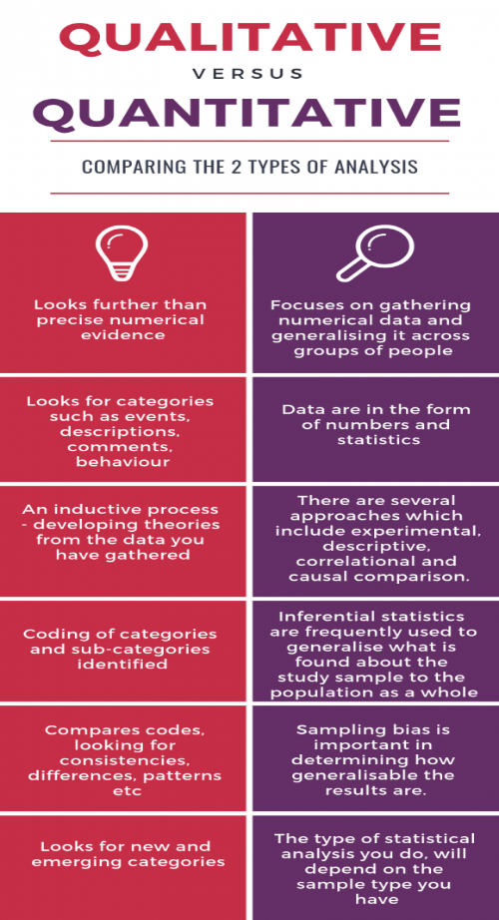

Figure and Source: Research Methodology Qualitative vs Quantitative (Wang, 2018).

Data Collection

Summary of Primary and Secondary Data Collection
- Primary Data: Primary data can be gathered directly at the source and may be in the form of a survey, an interview, or even an observation. It is specific to the requirements of the research and gives comprehensive information on the research problem.
- Secondary Data: Secondary data refers to the information that is already ready, and has been gathered and analysed by others. These involve reports, academic articles, governmental statistics and publications within the industry (Carson et al., 2024). The secondary data will be very useful in terms of offering background and contextual understanding, thus enabling the researchers to augment prior knowledge and helping to substantiate their results.

Selected Method of Data Collection(Secondary Data)
In this study, secondary data will be involved. The secondary data is the best choice when analysing the workforce shortages in the UK health and social care sector because a lot of organisations, such as the NHS Confederation, the Health Foundation and the Care Quality Commission, publish reports on the staffing levels, the problems with the recruitment and the effects of the low level of staffing on the quality of the provided services (Barrett and Twycross, 2018).
The use of secondary data is suitable since it gives comprehensive and current information about the level of workforce shortages without necessarily collecting primary data, which would require time. It will also enable an in-depth review of the available research and reports, which will give a wider perception of the problem and its effects in various sectors and regions.
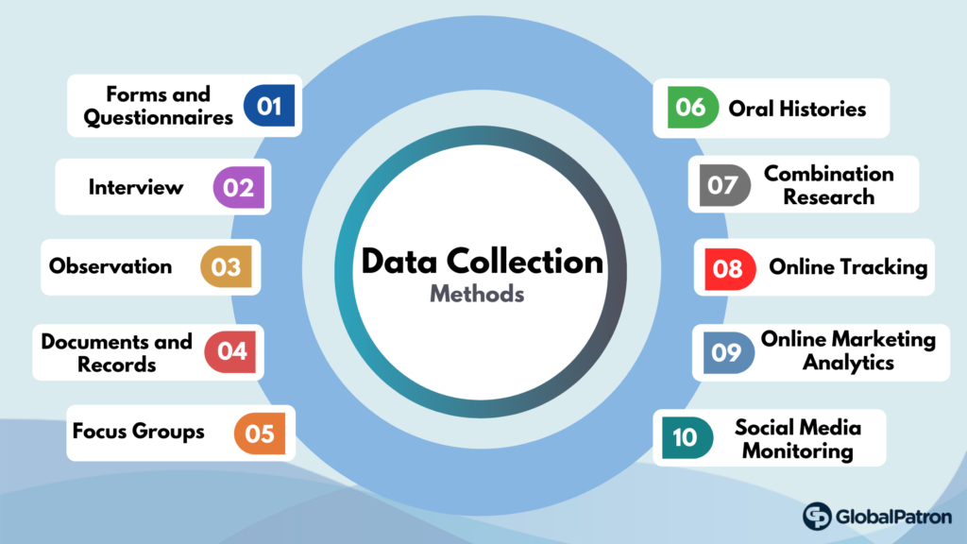

Figure and Source: Data Collection Methods (Lamont et al., 2024).

Conclusion
The given study will address the problem of workforce shortage in the UK health and social care sector, which carries important consequences regarding the way of patient treatment, healthcare practitioners, and organisational performance. The research will use secondary sources of data to determine the level of the problem, zero in on the root causes, and examine the effect on service delivery. The research will be used to make policy changes and organisational strategies to enhance recruitment and retention in the industry. To enable the sustainability and quality of the UK health and social care system, it has been necessary to address the shortages of the workforce, especially with the ageing population and the need to provide more services to the population. The report will also add to the current debate regarding workforce development and be very instrumental to the healthcare providers, policymakers, and other stakeholders in the industry.

References
Anderson, M., O'Neill, C., Clark, J.M., Street, A., Woods, M., Johnston-Webber, C., Charlesworth, A., Whyte, M., Foster, M., Majeed, A. and Pitchforth, E., 2021. Securing a sustainable and fit-for-purpose UK health and care workforce. The Lancet, 397(10288), pp.1992-2011.
Barrett, D. and Twycross, A., 2018. Data collection in qualitative research. Evidence-based nursing, 21(3), pp.63-64.
Carson, D.B., Johansson, A.B., Schaumberg, M. and Hurtig, A.K., 2024. Addressing the workforce crisis in (rural) social care: A scoping review. The International Journal of Health Planning and Management, 39(3), pp.806-823. https://doi.org/10.1002/hpm.3774
Coe, R., Waring, M., Hedges, L.V. and Ashley, L.D. eds., 2025. Research methods and methodologies in education. SAGE Publications Limited.
Coy, M.J., 2019. Research methodologies: Increasing understanding of the world. International Journal of Scientific and Research Publications, 9(1), pp.71-77. DOI: 10.29322/IJSRP.9.01.2019.p8511
Gershlick, B. and Charlesworth, A., 2019. Health and social care workforce. The Health Foundation. https://www. health. org. uk/publications/long-reads/health-and-social-care-workforce.
Hanney, N. and Karagic, H., 2019. Responding to the NHS and social care workforce crisis: the enhancement of opportunities through collaborative partnerships. Higher Education, Skills and Work-based Learning, 9(2), pp.175-188.
Lamont, T., Chatfield, C. and Walshe, K., 2024. Developing the future research agenda for the health and social care workforce in the United Kingdom: Findings from a national forum for policymakers and researchers. The International Journal of Health Planning and Management, 39(3), pp.917-925. https://doi.org/10.1002/hpm.3775
Shemtob, L., Asanati, K., Pahl, N. and Majeed, A., 2023. What needs to be done to address staffing shortages in health and social care?. The British Journal of General Practice, 73(728), p.102. doi: 10.3399/bjgp23X732045
Wang, Q., 2018. A bibliometric model for identifying emerging research topics. Journal of the association for information science and technology, 69(2), pp.290-304. https://doi.org/10.1002/asi.23930
Zou, T., Guo, P., Li, F. and Wu, Q., 2024. Research topic identification and trend prediction of China's energy policy: A combined LDA-ARIMA approach. Renewable Energy, 220, p.119619.

