Module Title: Problem Solving and Decision Making
Code: BMSW4004
Student Name: Zainab Sesay
ID: 2119599
Lecturer name: Charles Nimoh

Contents
Introduction 2
Nature and impact of complex problems 2
PESTLE analysis of the macro-environmental factors 3
Cause-and-effect analysis 3
Alternative solution to absenteeism 4
A plan to implement the decision 5
Success indicators to measure the effectiveness 6
Conclusion 6
Reference list 7

Introduction
Problem solving refers to solving multiple problems and facts such as finding issues, identifying causes, finding reasons and analyzing about efficient solutions (Marsiske and Margrett, 2006). Problems are the issues that can reduce, stop or decline the development and growth of a business or organization. Decision-making is a process of selecting the best possible solution among many and finding better options based on one's own perceptions and wishes. In this report it will be discussed about problem solving and decision making of shortage employees in a hospital. Then it will be analyzed the nature and impact of complex problems. What is complex problems and how is it impact on organization especially on shortage of employees in an organization. Then it will be discussed about macro environmental factors according to PESTLE analysis because PESTLE analysis is very important to analyze anything properly (Klein and Crandall, 2018). After this, it will be analyzed on cause and effect analysis according to Fishbone diagram. Fishbone diagram is very important to analyze cause and effect. At the end of this report, it will be given some alternative solution of employee absenteeism.

Nature and impact of complex problems
Nature of complex problems: Complex problems are those problems which have multiple problems and multiple solution. It means complex problems are many in numbers. Complex problems are difficult to define but what problems actually are. Complex problems are difficult to solve, but are easy to define. It is also very confusing to define (Fischer, et all, 2011). There are four characteristics of complex problems: definability, reducibility, predictability and solvability. It is discussed about definability. Complex problems are easy to define but difficult to solve. Complex problem also can refer to the closed system that exist in a system, if it can be broken then it is easy to define every parts of it. Complex problems are also predictable. Sometimes, it is easy to predict what is going to happen and what will be happen (Beers, et all, 2006). Solving a complex problem is a key to many organizational success. Complex problems are difficult to control. Complex problems are easy to solve.
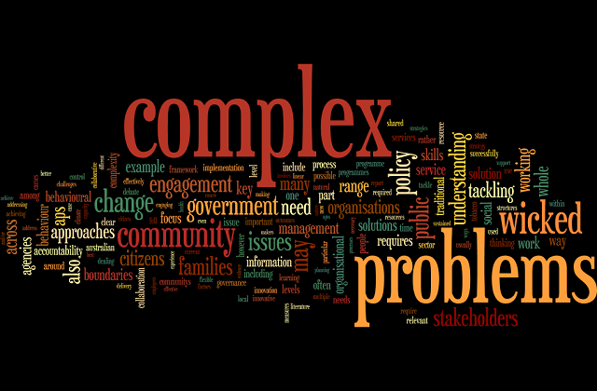
Impact of complex problems: Complex problems is difficult to solve, so it have so many impact everything. Especially on healthcare it is very impactful. Complex problems can impact on health and care (Douthwaite, et all, 2003). Nurses are very important in a hospital but it can be difficult to care patient for complex problems. There are several issues related to illness and injury. Especially risk management and the rate of nursing which can be complex problems. It has an impact patients because if complex problems can’t be solved quickly, it will be difficult to care and to give proper health services immediately (Fischer, et all, 2011). Complex problems also impact on staffs of hospital.

PESTLE analysis of the macro-environmental factors
PESTLE analysis is a broad fact finding activity around the external factors of an organization. It could on organization’s decisions. By word PESTLE refers to some external factors. These are: political, economic, sociological, technological, legal and environmental factors (Yüksel, 2012). These factors are impactful for an organization. These factors contribute to the complex problems.
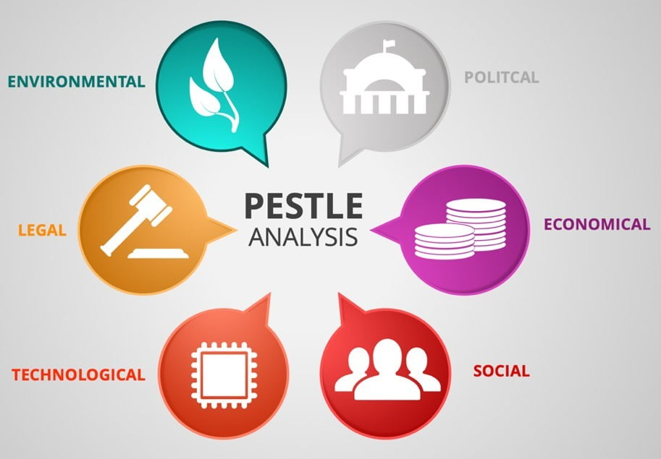
There are several factor that influence to complex problems in healthcare and other hospital’s issues. Political factor is very important factor that is very impactful. Political factors are tax policy, environmental regulations, trade restrictions and reform, tariffs, political stability etc. (Achinas, et all, 2019). are very important macro environmental factors those are contribute to the complex problems. Secondly, economic factor is very important because economic growth or decline, interest, exchange, inflation, wage rates, minimum wage, local and international unemployment, working hours, cost living and credit availability are influential for health sector. Especially in the given scenario of task-1, the shortage of employees and staffs and nurses are the economic problem for a hospital (Hood and Perlmutter, 2004). Thirdly, business or organization can face complex sociological problems such as; culture, language, religions, consumer choice, health consciousness, population growth rates, age distribution, career attitudes etc. These sociological or socio-cultural problems are the factors for an organization those influence in various ways.
Technological complex issues are very essential to the business because each and every business can rely on technology for better outcomes. By internet, digital media and social media are very essential to impact in organization and all kinds of business. There are many complex issues that can be solved by technology such as production, information gathering, marketing, and E-commerce. Then there have some legal problems that business should be face. Changing legislation impact on employment, import or export and taxation are also legal factor (Achinas, et all, 2019). Finally, it is easy to say that businesses need to deal with multiple legal complex problems such as employment laws, safety laws, trade laws, license laws, government laws, and so on.

Cause-and-effect analysis
Cause and effect analysis is a technique that help to identify the causes of a problem. It means that by it’s applying, anyone can find the problem and can find causes of the that problem. Everyone apply the fishbone diagram to identify the cause and effect of a problem (Rösslein, et all, 2015). The fishbone diagram is known as the cause and effect diagram. Its lokk like the skeleton of a fish. This fishbone diagram technique was developed by Professor Ishikawa in the 1960s. it is very popular diagram to identify the cause and effect of a problem.
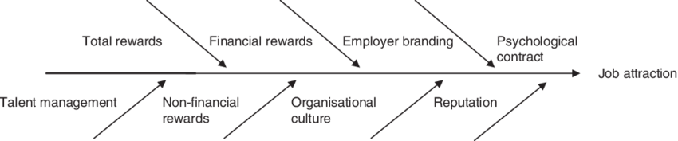
In the health care sector, it is used for identifying the problems. Especially complex problems are identifying for any targets (Biały and Ružbarský, 2018). Main target of using the fishbone diagram is for better understanding of patients’ all kinds of conditions. Fishbone diagram helps to identify how proper care can manage the employee shortage problems. First of all, it is very important to count and find all the rewards in order to disburse them among the employees and all kinds of staffs and nurses. Then the financial reward needs to provide for attracting employees to the company. After these, branding good healthcare and hospital is also an important element to bring a positive impact on consumers and employees (Ilie and Ciocoiu, 2010). Especially in this case it should be focused on the choice of employees. Finally, the company’s reputation is very important element that creates a positive impact among upcoming nurses who will be motivated to join.

Alternative solution to absenteeism
Absenteeism is that when an employee absent regularly for no apparent good reason. It is not for paid leaving or unpredictable personal issues. Employee are absent for various reason. Illness and mental distress are the minor causes of the absenteeism (King, et all, 2020). Major problem is the interesting of job. If an employee lost his interest from hospital job he can’t stay here. Mental health and long term medical conditions are also the major reason of absenteeism.

There are some basic elements of employee which can reduce absenteeism and can inspire to work properly and effectively. These are; flexible working, mental support, high remuneration, better communication. Employees leave the workplace or get demotivated which causes absenteeism in the workplace, for the lack of motivation, mental training and mental relaxation such as tour, party are the parts of relaxation. Proper care health providers can motivate their employees by following these stated strategies. When the workplace is flexible and friendly, employees get the opportunity to work precisely without stress which can reduce absenteeism (Navarro and Bass, 2006). Another important reason for absenteeism is mental dissatisfaction. When employees are satisfied mentally they can work without stress and complexity, even they can work effectively and productively. Communication is a key to success of any organization and of any business corporation. If the communication between nurses and employers is good then the absenteeism can be reduced. Above all, a good remuneration is needed for retaining all kinds of employees in the workplace.

There are other some operation those can reduce employees absenteeism. It should be followed by healthcare organization to reduce operational costs, improving employee welfare and workplace wellbeing, assessment services, taking coordination and management. Healthcare organization can explore flexible schedule and remote work (Fernandez and Cardenas, 1976). They should provide to employee balance, reward and recognition. Flexible working and mental health support and good communication to the employees are very essential elements to reduce absence of employees. These are analyzed above. Taking tour and party or dinner festive are also important to recede employees from health care.

A plan to implement the decision
The decision to solve the complex problem is analyzed above. There have several reason of shortage of employees in hospitals and mental health care center. It has discussed about cause and effect analysis according to fishbone diagram. Then it has given some alternative solution to reduce absenteeism of employees. There is plan to implement the decision we take above analysis that is, at first, hospitals and health care center must follow these solution to reduce the absenteeism of employees. They should manage the reducing from absence (Navarro and Bass, 2006). They can offer and take advertisement for recruiting employees. They should build up better communication to the employees. If they follow this plan they can easily solve the complex problems of shortage of employees.

Success indicators to measure the effectiveness
There have several success indicator that measures the effectiveness of my decision that has made above. There are some success indicators; revenue growth, revenue per client, profit margin, client retention rate and consumer satisfaction etc. If the hospital management can follow the decision they can satisfy the employees. If employees satisfy then they will provide good activities (Fernandez and Cardenas, 1976). At the result, hospitals will get effective profits.

Conclusion
There has given an analysis of the problem solving and decision making. The complex problems were about shortage of employees in the hospitals for various reason. It has discussed about complex problems and its impact according to PESTLE analysis. Then it has given some solution for reducing absenteeism of employees (Marsiske and Margrett, 2006). Flexible working, mental support, better communication to employees are the very important elements those are helpful for reducing absenteeism of employees from their workplace.

Reference list
Achinas, S., Horjus, J., Achinas, V. and Euverink, G.J.W., 2019. A PESTLE analysis of biofuels energy industry in Europe. Sustainability, 11(21), p.5981.
Beers, P.J., Boshuizen, H., Kirschner, P.A. and Gijselaers, W.H., 2006. Common ground, complex problems and decision making. Group decision and negotiation, 15(6), pp.529-556.
Biały, W. and Ružbarský, J., 2018. Breakdown cause and effect analysis. Case study. Management systems in production engineering.
Douthwaite, B., Kuby, T., van de Fliert, E. and Schulz, S., 2003. Impact pathway evaluation: an approach for achieving and attributing impact in complex systems. Agricultural systems, 78(2), pp.243-265.
Fernandez, E. and Cardenas, M., 1976. Absenteeism: Is There a Solution?. NASSP Bulletin, 60(403), pp.87-91.
Fischer, A., Greiff, S. and Funke, J., 2011. The process of solving complex problems. Journal of Problem Solving, 4(1), pp.19-42.
Hood, L. and Perlmutter, R.M., 2004. The impact of systems approaches on biological problems in drug discovery. Nature biotechnology, 22(10), pp.1215-1217.
Ilie, G. and Ciocoiu, C.N., 2010. Application of fishbone diagram to determine the risk of an event with multiple causes. Management research and practice, 2(1), pp.1-20.
King, A.T., Gontarz, J. and Wei, H., 2020, July. Employee engagement and absenteeism: a step towards improving patient care. In Nursing Forum (Vol. 55, No. 3, pp. 356-361).
Klein, G. and Crandall, B.W., 2018. The role of mental simulation in problem solving and decision making. In Local applications of the ecological approach to human-machine systems (pp. 324-358). CRC Press.
Marsiske, M. and Margrett, J.A., 2006. Everyday problem solving and decision making. Handbook of the psychology of aging, pp.315-342.
Navarro, C. and Bass, C., 2006. The cost of employee absenteeism. Compensation & Benefits Review, 38(6), pp.26-30.
Rösslein, M., Elliott, J.T., Salit, M., Petersen, E.J., Hirsch, C., Krug, H.F. and Wick, P., 2015. Use of cause-and-effect analysis to design a high-quality nanocytotoxicology assay. Chemical Research in Toxicology, 28(1), pp.21-30.
Srdjevic, Z., Bajcetic, R. and Srdjevic, B., 2012. Identifying the criteria set for multicriteria decision making based on SWOT/PESTLE analysis: a case study of reconstructing a water intake structure. Water resources management, 26(12), pp.3379-3393.
Yüksel, I., 2012. Developing a multi-criteria decision making model for PESTEL analysis. International Journal of Business and Management, 7(24), p.52.

