RESEARCH INTO CYBER SECURITY ATTACKS AND PENETRATION TESTING FOR A VIRTUALISE SIMULATED COMPANY WEBSITE

Table of Contents
Section 1 — Abstract 3
Section 2 — Introduction 3
Section 3 — Task 1: Strategic Threat Analysis 4
Section 4 — Task 2: Red Team Engagement 12
Conclusion 19
References 20

Section 1 — Abstract
The pharmaceutical sector is becoming an increasingly appealing target of sophisticated cyber-attacks because of the dependence on interrelated research environments, cloud environments, and digital supply chains. Attackers sponsored by the state and financially oriented threat actors aim to attack pharmaceutical organizations and steal sensitive research information or cause havoc to the operations that are vital to global healthcare. The present report reviews the case of the NotPetya attack on Merck in 2017, one of the most disruptive cyberattacks in the industry. The report charted the lifecycle of the attack by mapping tactics, techniques, and procedures (TTPs) employed in the attack using the MITRE ATT &CK Framework. The most important elements of the network segmentation, patch management, and identity access controls introduce severe weaknesses that allowed the quick dissemination of the malware. Moreover, the report provides strategic suggestions on how to enhance the defenses with Zero Trust Architecture, Multi-Factor Authentication (MFA), and better incident response capacity. The report also shows how red-team exercises, e.g., Operation IP Shield, can be applied to make the defenses more resilient to future cyber threats.

Section 2 — Introduction
Pharmaceutical industry is now one of the most targeted industries in the global cyber-threat environment because of its stake in high-value intellectual property, digitally connected research settings, and digitally integrated supply chains. With more organisations in the industry adopting cloud platforms, automated production, and international collaboration research platforms, there has been a huge exposure to advanced cyberattacks. Threat actors who are sponsored by a state and other financially driven groups often target pharmaceutical companies and seek to steal sensitive research information or disrupt major operations that contribute to the provision of healthcare in the world. The recent years have seen the growth in the number of attacks, both destructive malware programs and espionage operations targeting vaccine developers, which demonstrates how the enemies that previously resorted to simple techniques of intrusion have developed to use complex multi-stage attack patterns based on privilege escalation, lateral movement, endpoint manipulation, and network-wide disruption. It is within this context that this report is aimed to analyse the NotPetya attack on Merck in 2017, which can be considered one of the most disruptive cyber-attacks on the pharmaceutical industry. The discussion looks at the way the attack happened, the methods employed by the attacker, the operational and financial implications, and the overall organisational susceptibility that enabled the malware to propagate very fast through the global network of Merck. The ATT&CK Framework is applied to the incident to correlate every phase of intrusion with the known behaviour and tactics of an attacker. Such a systematic method allows gaining a better idea of the way the threat actor has advanced through the attack lifecycle and why the current controls were not effective to prevent the proliferation of the malware.
Based on the understanding of this strategic assessment, the second section of the report gives an example of a red-team simulation, Operation IP Shield, intended to reproduce the methods in the Merck case in a controlled hybrid setting. The simulation is aimed at identity compromise, privilege escalation, cloud exploitation, and lateral movement, which allows identifying the weak points of detection and the prospects of improving the defensive position of the organisation. The two tasks together are expected to establish the feasibility of real-world attack intelligence in transforming into practical security enhancements of high-value sectors like pharmaceuticals.

Section 3 — Task 1: Strategic Threat Analysis
3.1 Attack Scenario
The case that we will be analysing is the nontypical attack on Merck and Co. one of the largest pharmaceutical organisations on the globe in 2017 by NotPetya. It took place on 27 June 2017 and was launched with the help of a malfunctioning software update sent using the Ukrainian accounting software M.E.Doc. Merck did not specifically deploy this application in any of its international facilities, but one of its subsidiary workstations in Ukraine was still subjected to the malicious update and thus, the malware was able to infiltrate the corporate network of Merck. NotPetya first emerged as ransomware, but later forensic examination revealed that it was a wiper that solely attempted to overwrite data permanently and not to recover any of it (Kinnunen, 2022). With the help of a mix of credential theft, SMB exploitation and remote execution tools, the malware spread quickly through the Merck Windows world, causing a massive system failure in hours after the first infection.
It was reported to be caused by the Sandworm Group, a Russian GRU-associated threat actor whose campaigns often targeted Ukrainian infrastructure at the time. NotPetya relied on the EternalBlue vulnerability (MS17-010) and the PsExec to have a lateral movement, which allowed it to compromise over 30,000 devices in the global operation of Merck, including, but not restricted to, domain controllers, laboratory systems, and manufacturing equipment. The attack had a massive effect on the vaccine manufacturing lines of Merck, which halted the production of important biologics, including Gardasil HPV vaccine, temporarily. It had a major impact on the operational services, such as clinical trial coordination and international logistics (Al-Sada, Sadighian and Oligeri, 2023). The losses reached over USD 1.3 billion and Merck then found itself in a big legal tussle with insurers regarding coverage exclusion. The incident showed critical flaws in network segmentation, patching, and disaster recovery preparedness in the infrastructure of the entire organisation.
3.2 MITRE ATT&CK Mapping
A systematic analysis of the NotPetya attack in the MITRE ATT&CK Framework shows how the attacker executed every stage of the intrusion lifecycle. The first access level goes with the Execution and Initial Access strategies. The malware was introduced into Merck by a compromised M.E.Doc update, which is associated with the method of supply chain compromise (T1195) and script execution (T1059). After the malware was run, it dumped credentials by accessing LSASS memory, which is consistent with the Credential Access technique T1003. Right after harvesting user hashes, NotPetya utilized the lateral movement with SMB exploitation (T1210) with the EternalBlue vulnerability and remote service execution via PsExec (T1569). These methods allowed the malware to bypass the flat network structure at Merck, and increased privileges as it flowed through the devices (Georgiadou, Mouzakitis and Askounis, 2021).
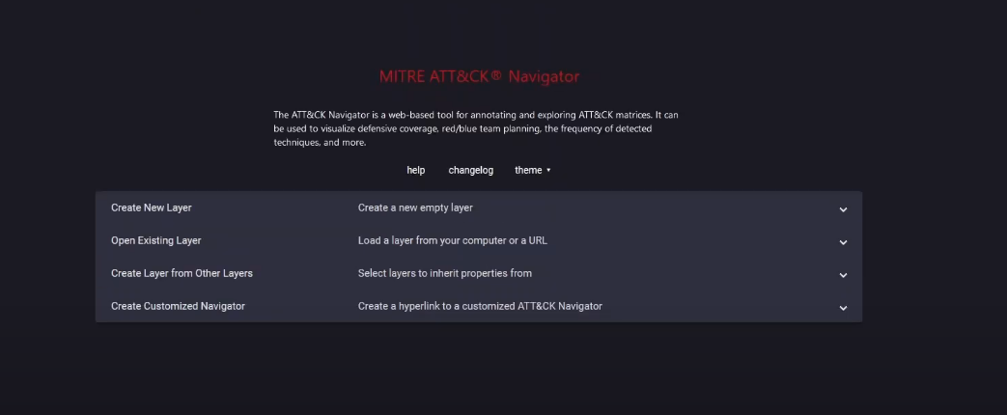
Figure 1: MITRE ATT&CK Framework
The MITRE ATT &CK Framework lists adversary tactics, techniques, and procedure (TTPs) in a matrix. The framework assists in mapping out every phase of an attack in the case of the NotPetya in the context of finding initial access (through compromised software update) and subsequent lateral movements (through SMB exploitation and PsExec). The flat network structure of Merck gave quick lateral flow, which is denoted by T1210 (Exploitation of SMB) and T1569 (Remote Service Execution) (Shewale, 2025). Combining these techniques with the attack will enable the defenders to know the possible vulnerabilities and how attackers can use these techniques in a hybrid infrastructure.
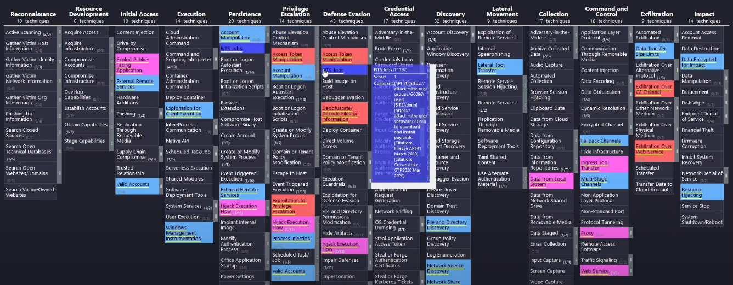
Figure 2: All Details
This above figure probably depicts the entire process of attack on the case of Merck that involves the different types of tactics, techniques, and tools employed in the attack. Starting with access by virtue of the M.E.Doc software vulnerability (supply chain compromise) and then credential dumping (T1003), and lateral movement via EternalBlue and PsExec. The malware NotPetya propagated on the Windows platform of the Merck company by infecting more than 30,000 computers. This number shows that the malware was transferred to privilege escalation, data destruction and complete network compromise, similar to the multi-stage nature of advanced attacks such as NotPetya (Roy et al. 2023).
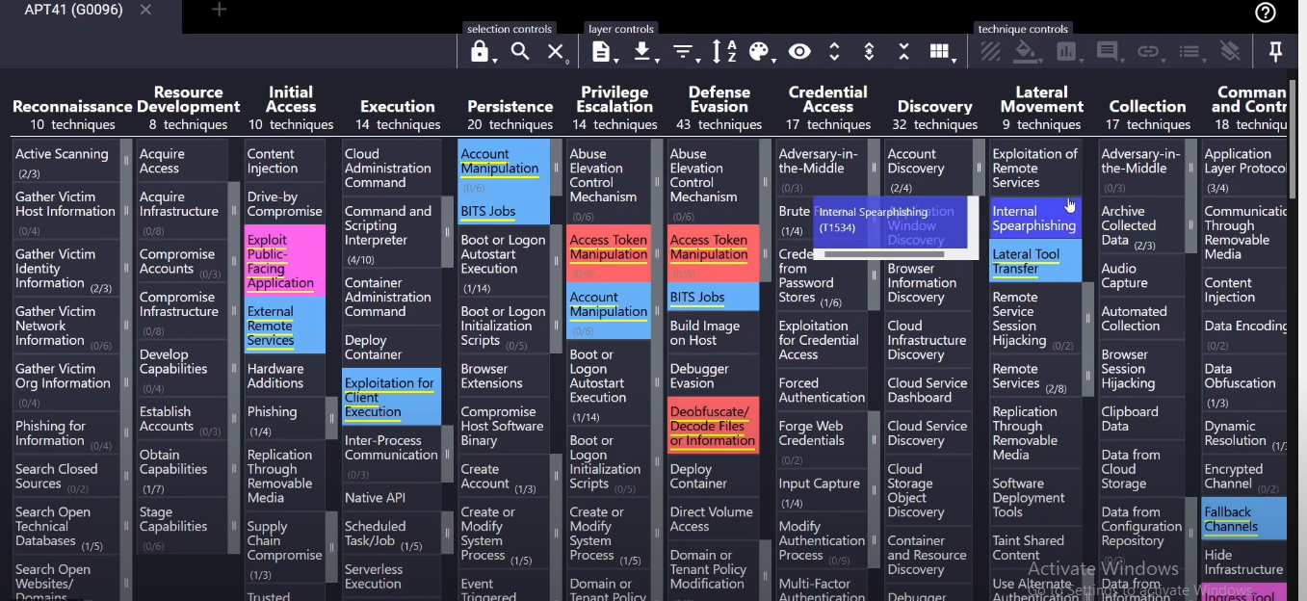
Figure 3: APT41 Framework
The APT41 Framework symbolizes the strategies, techniques and equipment utilized by the APT41 threat actor that has committed the NotPetya attack. The figure can be used to match the tactics applied during the attack with those of APT41, especially supply chain attacks, credential dumping, and lateral movement. Overlaying the techniques used by APT41 on the Merck attack allows this figure to show how state-sponsored threat actors can use organizational vulnerabilities and inflict enormous damage, as with the spread of NotPetya across the entire network of Merck without any segments, including in its manufacturing lines and research data (Kareem et al. 2024).
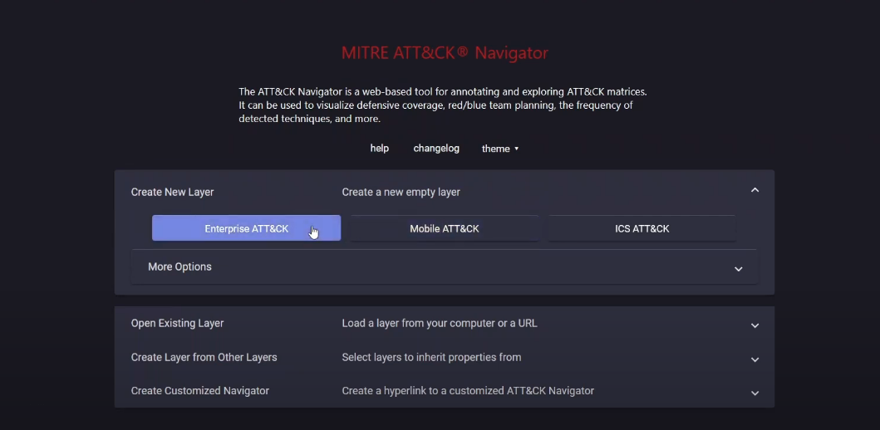
Figure 4: Different Attacks
This number can be used to draw comparisons of various forms of attacks which could have been used to portray NotPetya against other advanced persistent threats (APTs). Through the case study of the destructive payload of NotPetya, it demonstrates how malware such as NotPetya can be deployed through compromising the supply chain (e.g., M.E.Doc) and spread very rapidly by means of lateral movement and credential theft (Vlajic, Sarai and Novkovic, 2025). This was an attack against critical infrastructure such as the manufacturing and clinical trial coordination of Merck, and this indicates how focused attacks take advantage of the gaps in the network as a whole, particularly where segmentation and patching controls are poor, as indicated on Figure 4 comparison.
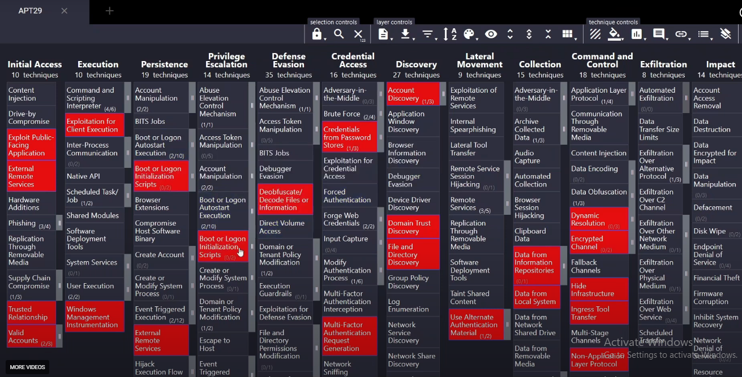
Figure 5: Mapping
Each stage of the attack of the NotPetya is probably associated with the MITRE ATT&CK Framework by the Mapping figure. It gives a visual representation of the sequence of attack using each technique, beginning with the initial access (compromised M.E.Doc update), to credential theft (T1003), lateral and data destruction (T1210 and T1490). This mapping plays a significant role in determining the areas of the Merck infrastructure that were prone such as the flat network architecture and systems that had not been patented (Ramage, Lebea and Sithungu, 2025). It also highlights those TTPs to which attackers have easy access, and this comes in formulating effective defensive strategies.
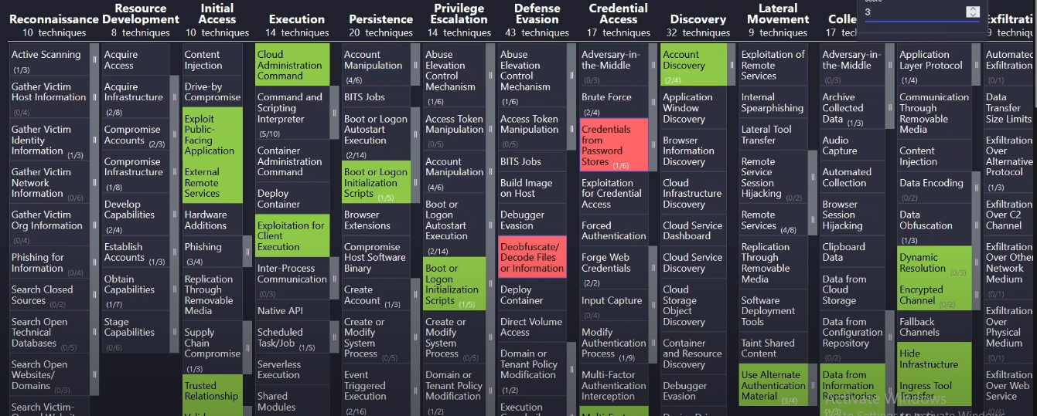
Figure 6: T1082 Host
T1082 (System Information Discovery) puts emphasis on the fact that the attacker used tools to collect information on the system and network topology. In NotPetya, it was essential in identifying vulnerable hosts, finding network shares and identifying attack vectors. In the NotPetya malware, this method was used to run privileges and propagate the malware throughout the global network of Merck, including domain controllers and manufacturing equipment. It is illustrated in the number that attackers have intimate understanding of the inside world, and it is no wonder that with no network segmentation, they moved swiftly in every direction across the unsecured systems of Merck.
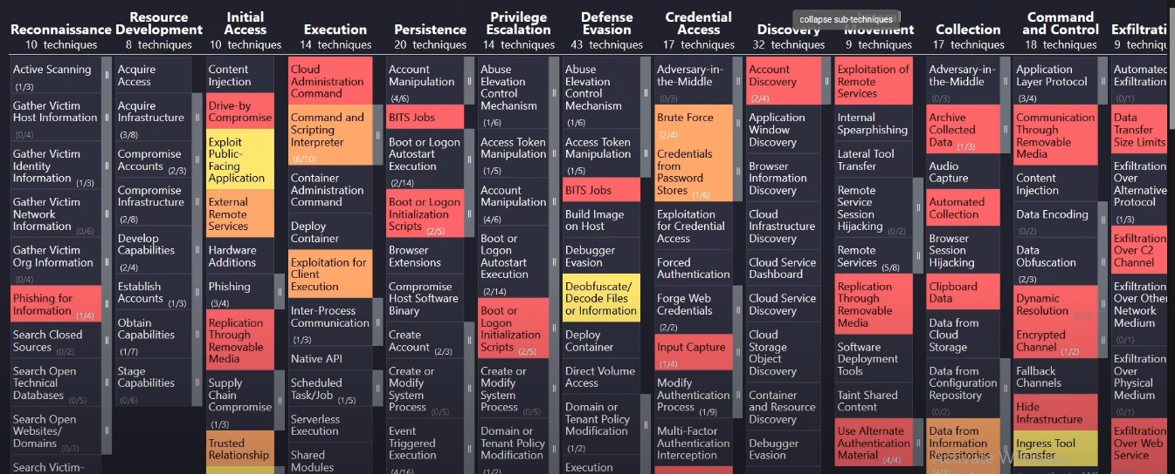
Figure 7: Successful Detection
This number is probably an answer to the gap in detection of security measures in Merck in the case of the NotPetya attack. Although this was a widespread effect, detection tools were not able to detect early malware execution and lateral movement. The number illustrates that the use of PowerShell-based tasks, stealing credentials, and remote executable (through SMB and PsExec) remained unseen so that the spread of the NotPetya malware was not stopped (Virkud et al. 2024). It highlights the significance of good detection and entry systems that should have detected an abnormal behavior and prevented the attack earlier, especially in the unsanctioned and poorly partitioned setting of Merck.
Persistence and privilege escalation behaviours, like altering processes in the system and with stolen credentials, were also present in the attack (T1078). NotPetya conducted system discovery (T1082) to determine the hosts that it can reach, network shares accessible, and vulnerable systems. To be effective, the malware encrypted the files (T1486), deleted the Master boot record (T1490), and intentionally made it incapable of restoring the system in a manner that led to irretrievable loss of data (Amro, Gkioulos and Katsikas, 2023. The credential theft and subsequent lateral movement and destructive payload execution indicate that a multi-stage attack sequence was well-related to the MITRE framework, indicating that the adversary had the ability to capitalize on vulnerabilities on identity, endpoint, and network layers. This mapping shows that it is important to learn about the behaviour of adversaries to predict how analogous attacks would manage to use hybrid cloud-enterprise networks.
3.3 Root Cause Analysis
Analysis of the internal environment of Merck reveals that there are a number of systemic factors which facilitated the high spread of NotPetya. The organisation had a big network and the network was global with little segmentation between research, corporate and manufacturing environments. The malware had the freedom to move around after it obtained initial access through this flat architecture (Makoshi, 2025). Moreover, the attack made use of the EternalBlue vulnerability that implies that several systems were not patched against the MS17-010 security update that was issued several months previously. This vulnerability reflects the weaknesses in the life cycle management and patch management.
The problems of identity and access management also added to the magnitude of the compromise. The use of credential dumping and pass-the-hash features of NotPetya implies that privileged accounts were ubiquitous in the network and multi-factor authentication (MFA) was not used in uniformly applying internal administrative operations. Merck detection and response would also have gaps. Correlation of logs was not adequately conducted; PowerShell action was not well observed and endpoint protection software was not able to identify the malware at an early stage to limit the propagation. This also affected the disaster recovery systems in the organisation which means that there were no isolated or safeguarded backup networks against lateral movement. These failures in combination indicate that the failure was not the result of one area of weakness but rather a mixture of architectural vulnerabilities, mismanagement of identity, inadequate monitoring and inadequate segmentation of mission critical environments.
3.4 Strategic Recommendations
In order to avoid such incidents and increase cyber resilience, a set of strategic actions are to be taken in terms of identity management, infrastructure design, detection capabilities, and governance. Prioritisation should be laid on a Zero Trust Architecture where strict verification must be carried out before access to an internal or cloud-based resource is made available. Segmentation of the network should also be enhanced where research environments, manufacturing systems, and corporate networks are separated to block large-scale lateral mobility in case of future attacks. Patch management operations should be updated with automated vulnerability scanning, centralised compliance reporting and schedule remediation window to avoid exploitation of vulnerabilities which are generally well known.
The enhancements to identity security should involve the use of mandatory MFA on all privileged accounts, reduction in the administrative token control, and use of Privileged Access Management (PAM) tools. It is necessary to improve logging and monitoring with improved SIEM correlations, behavioural analytics, endpoint detection and response (EDR), and ongoing PowerShell auditing. In the case of cloud environments, the AWS GuardDuty, IAM least-privilege policies, and VPC flow logs controls must be turned on to identify potential suspicious behaviour at the earliest stage. Backup networks should be segregated, immutably stored and periodically tested to be in recovery mode. Last but not least, red-team activities and purple-team operations should be scheduled in periodical intervals to confirm that the controls are effective and that defensive teams are able to identify, contain and eliminate advanced adversary behaviours (Presekal et al. 2024). These recommendations create a multilayered defensive stance in line with MITRE ATT&CK framework and NIST Cybersecurity Framework.

Section 4 — Task 2: Red Team Engagement
4.1 Rules of Engagement
The Rules of Engagement (RoE) specify the approved limits, goals and safety standards of the exercise of Operation IP Shield red-team. These rules are meant to ensure that all the simulated offensive activities are performed in controlled, ethical and legally accepted ways. The interaction is approved by the top management of the organisation and is restricted to the specialised test environment that has been established in this project i.e. no production systems, actual patient or clinical data or vital business processes are touched in any way (Alshra'a, Al Sardy and German, 2024). The scope approved by the authorization policy encompasses the on-premise Active Directory environment, chosen windows workstations, a research server subnet, the cloud infrastructure on AWS, and the CI/CD pipeline in combination with the test application server. These elements are the most viable avenues on which an enemy may breach a hybrid pharmaceutical space.
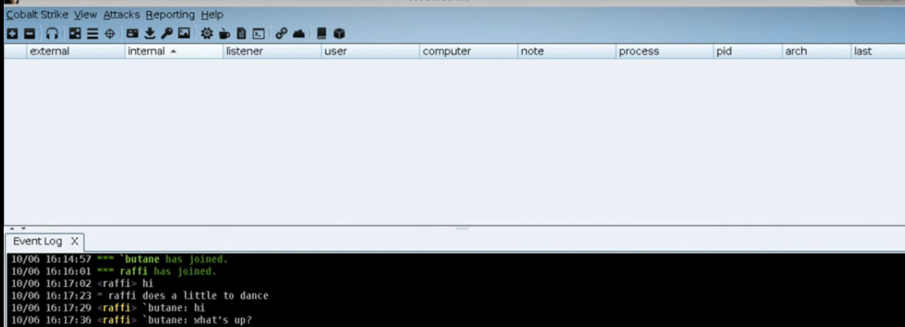
Figure 8: Cobalt Strike Red-Team Interaction and Event Log
The above figure depicts the Cobalt Strike interface, which is utilized in the activities of the red-team. It shows a chat log in which two users, butane and raff converse during a simulated attack. Their activity is recorded in the event log, probably organizing after-exploitation activities, including sideways movement or privilege enhancement in an already compromised system.
Simultaneously, a clear definition of out-of-scope assets will make sure that the simulation does not involve the needless operational risk. Systems which include the HR platform, payroll database, compliance records, and live laboratory control networks are not even considered at all. The red team must use various non-destructive methods, which may be phishing simulations, password spraying, PowerShell-based command execution, credential access simulation, privilege elevation through misconfigurations, SMB/PsExec-based lateral movement, and cloud IAM enumeration, safe file transfer to emulate exfiltration (Zaydi and Maleh, 2025). The deployment of destructive malware, encryption tools, real ransomware, data corruption, or denial-of-service are highly forbidden, though. Independent of the nature of production data, no method that has been introduced in order to crash services or alter production data is permitted.
The safety of operation is ensured by the constant communicational channel and the emergency stop mechanism. The red team records all the actions as they happen and informs the exercise coordinator in case unforeseen behaviour is noted. Each of the teams may call a mandatory stop phrase (RED STOP) and immediately pause all operations, making sure that the risks are mitigated in time. In order to maintain the authenticity of the assessment, the blue team gets knowledge of the occurrence of an exercise but is not informed of the timing, order or nature of the stages of the attack (Wang et al. 2024). The engagement ends when the red team has reached major goals, including getting privileged access throughout the domain, moving off-prem to cloud platforms, or simulating the extraction of benign data. All the findings are documented, analysed and reported in the post engagement debrief to enable modification in the detection capabilities and defensive posture of the organisation.
4.2 Threat Emulation Plan
Operation IP Shield threat emulation plan will have the capability to mimic in a controlled yet non-destructive way the tactics, techniques, and procedures that defined the 2017 NotPetya attack on Merck. This imitation involves no application of actual malware; instead, it recreates every step of the original adversary behaviour in the form of safe, ethical and academically suitable approaches. The idea of the plan is to determine the performance of a hybrid pharmaceutical network when it is subjected to multi-stage attacks sequences (Diogenes and Ozkaya, 2022). A reconnaissance stage is the first step of the simulation, which deals with information about the state of the environment available publicly and the identification of possible attack vectors. The actions of determining users, domains, misconfigured endpoints, and externally accessible clouds resources enable the red team to build a realistic attack path. This reconnaissance is similar to the initial phases of NotPetya when the attacker’s used knowledge of the connected systems and trust relationships despite the fact that the red team does similar steps without the use of live external resources.
The first access stage will be used to mimic the way a malicious payload might be run in the environment. A benign PowerShell-based payload is instead dropped inside a carefully-controlled phishing simulation of a specific user named a test user as opposed to deploying a destructive wiper. This is a testament to how NotPetya gained access to the system by means of a compromised software update and at the same time being entirely safe. Upon successful implementation, the payload creates restricted command execution functions permitting the red team to move on with the successive phases. The implementation is done either through PowerShell, scheduled tasks, or script interpreters; this is a reflection of script-based implementation that the actual attackers use to implement and spread malware. It focuses on examining the ability of defensive systems to identify or prevent such activities.
The second step is the credential access, where the red team applies safe techniques to imitate the retrieval of stored credentials, including reviewing credential managers, listing of listed hashes, or showing how LSASS memory might be exploited without necessarily dumping sensitive data. The stage is used to assess the presence of sufficient limitations on credential storage within the environment and the alerting of suspicious credential usage behaviors by endpoint monitoring devices (Peiris et al. 2021). The lateral movement phase with usable credentials is simulated, resembling the behaviours of rapid propagation that were observed in the Merck incident. SMB probing, use of psExec-like remote process execution and use of PowerShell Remoting are employed as techniques that would prove how an attacker may use a flat network. This stage is important as the destructive dissemination of NotPetya was aided by unpatched SMB vulnerabilities and ineffective segmentation that are safely emulated to pinpoint similar weaknesses.
The plan also includes privilege escalation which takes advantage of misconfigurations, token impersonation or weak administrative controls to gain more privileges as a privileged user starting with a standard user. This provides a realistic domain pathway of compromise that the exercise can continue into the hybrid cloud domain. After administrative access is simulated on-premises, the cloud pivot stage shows how attackers can use lax IAM settings, stored API keys, or overly generous policies to acquire control of cloud-based resources including EC2 instances and S3 buckets. The cloud resources are enumerated using safe AWS CLI commands, which further supports the fact that identity bridging between on-prem and cloud becomes a high-value target.
The last step of emulation plan will be to simulate data exfiltration with innocent test files through an encrypted channel. This stage evaluates whether network surveillance technology, SIEM guidelines, or cloud logging applications identify outbound transfers or suspicious access trends. At all the stages, the plan aligns activities to corresponding MITRE ATT&CK techniques to have a structured and validated methodology, which is aligned to industry-accepted adversary modelling models.
4.3 Hybrid Lab Architecture Explanation
The hybrid lab setting created as part of Operation IP Shield was specifically aimed at replicating the design typical of the pharmaceutical organisations of the time with the hybrid on-premises environment and the public cloud services. The physical part of the lab entails a small and realistic Active Directory domain, constructed in either VirtualBox or VMware. This domain contains a dedicated domain controller, which is used to provide authentication, DNS and Group Policy as well as a single standard workstation which is closer to an employee endpoint and a research server that contains high value data like in the case of pharmaceutical research which is similar to intellectual property repositories. They have these machines in an isolated virtual network that has its own IP addressing space to enable them to safely run the simulated credential, identity and subsequent lateral movements without any danger to any production infrastructure. Minimal segmentation is used in the virtual network, but gaps are purposefully left to enable the red team to show the effects of poor internal boundaries, which is among the main weaknesses that were utilised in the case of the Merck incident.
The element of the hybrid lab that is cloud-based relies on Amazon Web Services to reflect the growing trend of moving pharmaceutical computing computations to cloud environments. The AWS environment consists of a Virtual Private Cloud (VPC) consisting of public and privately networked subnets, a small EC2 server to serve as an externally-accessible application server, and an S3 bucket to symbolize the kind of confidential research information that is often of interest to attackers. A number of IAM users and roles are set with different levels of privileges to recreate real access control patterns, containing some misconfigurations that may be used to gain higher privileges. The red team can evaluate the potential of identity bridging, poorly defined policies, and poor access key management to enable an attacker to pivot to cloud resources after an on-prem entry point in this cloud setup, which represents the interdependent risks experienced by hybrid organisations.
The lightweight CI/CD pipeline is also added to the environment to make it more realistic, using GitHub Actions or Jenkins. This pipeline installs application updates to the EC2 instance and also leaves access tokens or configuration credentials in its workspace, which forms a possible attack route as well as the real-life situation with a pharmaceutical company where the development and research are dependent on automated deployment systems. The VPN-like configuration or peered networks simulates connectivity between the on-prem domain and AWS, and proves that attackers can use trust relationships to traverse environments. The hybrid lab architecture, in general, offers a controlled and yet realistic environment in the comparison of identity compromise, lateral movement, and cloud exploitation occurring under the conditions of modern enterprise systems, allowing to test detection capabilities and architecture resilience comprehensively.
4.4 Attack Execution Narrative
The attack implementation stage of Operation IP Shield is adopted in a systematized process that reflects the actions exhibited during the Merck NotPetya attack, which applied only harmless and managed strategies in the closed hybrid laboratory. The practical starts with the red team having an initial presence by a simulated phishing email message sent to a specific test account in the Active Directory domain. The email carries an innocuous macro-enabled document which on being voluntarily opened by the test user runs an innocuous PowerShell task that pretends to be a first-stage payload. This initial execution serves as a simple command execution on the workstation which is similar to the initial steps of a foothold without any malware. This access assists the red team in confirming the information within the system, inspecting running processes, and checking the detection or logging of scripting-related behaviour by the endpoint monitoring solutions.
The red team now goes into the local privilege escalation since the foothold has been already obtained. The misconfigurations, unprotected services, and weak administrative controls are listed as enumerated on the workstation itself. An unprotected misconfiguration of the service is detected in which the red team is able to elevate privileges by impersonating the token to gain access to the endpoint at SYSTEM-level. The step imitates how an actual adversary might manipulate the weaknesses of the Windows privileges to gain control and circumvent endpoint limitations. After acquiring high privileged privileges, the red team initiates the credential access stage. The team demonstrates that attackers can gain access to authentication material using such safe methods like the inspection of stored credentials, the review of cached hashes, and demonstration of LSASS access techniques without removing the live secrets. This is similar to the way in which NotPetya deployed credential harvesting to spread internally quickly.
Lateral movement is subsequently run to replicate the manner in which the Merck attack spread in the network. The red team determines the research server as part of the virtual subnet and employs remote execution and the use of PowerShell remoting that is similar to PsExec to pivot off the workstation that has been compromised. Effective movement proves that there is an inadequacy of segmentation existing between workstations of the user and the research property. With the help of the credentials gathered earlier, the red team successfully breaches the research server and lists its data storing directories, which proves the fact that intellectual property repositories become extremely vulnerable once an attacker gains internal mobility.
Once the red team has gained control of the on-prem environment, it tries to make a pivot to the AWS cloud environment. By looking at the CI/CD pipeline, there are tokens that are stored with programmatic access to cloud resources. With the AWS CLI, the team will list the IAM roles, S3 buckets, and a weakly policy that will permit the escalation of privileges. This foothold of the cloud provides simulated access to sensitive research storage reflecting the dangers of identity bridging between on-prem infrastructure and cloud systems. The final step of the execution stage is a safe exfiltration test, which is conducted by moving a non-damaging text file using an encrypted channel, where it is possible to evaluate whether network and cloud monitoring tools can identify outbound streams of data.
4.5 Detection Gap Analysis
The red-team exercise indicated that there were a number of significant detection gaps in respect to the on-premises and the cloud aspects of the hybrid environment. The low visibility of endpoint activity around the execution of PowerShell and privilege escalation was one of the most noticeable ones. The first payload execution did not produce any meaningful alerts, which proves that script-based activity was not monitored on a deep level. In the same way, the privilege escalation attempt that was based on the misuse of a service misconfiguration did not generate any behavioural and integrity-based alerts by the endpoint detection tools. These flaws replicate issues that occur in real life scenarios like in the case of the Merck attack where script-based propagation had gone uncontrollable.
The activity of lateral movement was also not much noticed. SMB-based probing and PsExec-like execution did not produce correlated events in the SIEM, which demonstrates the absence of rules developed to detect the anomalies of authentication or frequent administrative relationships among the internal systems. Monitoring gaps in the cloud environment were evident in the form of missing GuardDuty alerts, the lack of VPC Flow Logs, and highly liberal IAM policies that allowed the escalation of privileges to go unnoticed. Moreover, the finding of stored CI/CD credentials showed the absence of secret-management controls and lack of alerting to programmatic access. Taken together, these gaps demonstrate how attackers may transverse between hybrid systems with limited resistance, and thus, enhanced log collection, correlation, and continuous identity-based threat detection are necessary.

Conclusion
Finally, when analyzing the 2017 NotPetya attack on Merck, it is important to note that the vulnerabilities in the pharmaceutical industry appear to be quite low, especially in terms of network architecture, patching, and identity access controls. Its attack that was mainly caused by a compromised software update proved the advanced level of the current cyber threats and their capability to attack multiple layers of the infrastructure of an organization. The incidence of the MITRE ATT&CK Framework to the incident gives a transparent insight on how attackers can move within, increase privileges, and eventually create massive havoc, even in a multinational company such as Merck. This report not only outlines why there should be better cybersecurity hygiene, including the implementation of Zero Trust Architecture and Mandatory Multi-Factor Authentication (MFA), but also makes a case of a more proactive and sophisticated way of detecting threats and responding to them. The case of Merck can be used as a lesson to other organisations to segment their networks, maintain timely patches, and are ready to recover in case of disaster. Through these exercises of simulated red-team attack, like the Operation IP Shield, companies will have a better picture of vulnerability and harden their defenses. Finally, strategic suggestions based on such frameworks as MITRE ATT&CK will help organizations to enhance resilience to emerging and advanced cyber threats that can signify the safety of vital assets and information.

References
Al-Sada, B., Sadighian, A. and Oligeri, G., 2023. Analysis and characterization of cyber threats leveraging the MITRE ATT&CK database. Ieee Access, 12, pp.1217-1234.
Alshra'a, A.S., Al Sardy, L. and German, R., 2024. Penetration testing in agile cybersecurity environments. In Agile Security in the Digital Era (pp. 126-161). CRC Press.
Amro, A., Gkioulos, V. and Katsikas, S., 2023. Assessing cyber risk in cyber-physical systems using the ATT&CK framework. ACM Transactions on Privacy and Security, 26(2), pp.1-33.
Diogenes, Y. and Ozkaya, E., 2022. Cybersecurity–Attack and Defense Strategies: Improve your security posture to mitigate risks and prevent attackers from infiltrating your system. Packt Publishing Ltd.
Georgiadou, A., Mouzakitis, S. and Askounis, D., 2021. Assessing mitre att&ck risk using a cyber-security culture framework. Sensors, 21(9), p.3267.
Kareem, K., Naik, N., Jenkins, P., Grace, P. and Song, J., 2024, July. Understanding the Defence of Operational Technology (OT) Systems: A Comparison of Lockheed Martin’s Cyber Kill Chain, MITRE ATT&CK Framework, and Diamond Model. In The International Conference on Computing, Communication, Cybersecurity & AI (pp. 605-624). Cham: Springer Nature Switzerland.
Kinnunen, J., 2022. Threat Detection Gap Analysis Using MITRE ATT&CK Framework.
Makoshi, S.M., 2025. The Evolving Cyber Battlefield: A Comprehensive Analysis of State-Sponsored APTs, TTPs, and Strategic Cyber Defense Mechanisms. Authorea Preprints.
Peiris, C., Pillai, B. and Kudrati, A., 2021. Threat Hunting in the Cloud: Defending AWS, Azure and Other Cloud Platforms Against Cyberattacks. John Wiley & Sons.
Presekal, A., Ştefanov, A., Rajkumar, V.S., Semertzis, I. and Palensky, P., 2024. Advanced persistent threat kill chain for cyber-physical power systems. IEEE Access, 12, pp.177746-177771.
Ramage, X., Lebea, K. and Sithungu, S., 2025, June. Cyber Warfare and Critical Infrastructure. In European Conference on Cyber Warfare and Security (pp. 566-575). Academic Conferences International Limited.
Roy, S., Panaousis, E., Noakes, C., Laszka, A., Panda, S. and Loukas, G., 2023. Sok: The mitre att&ck framework in research and practice. arXiv preprint arXiv:2304.07411.
Shewale, V., 2025. Demystifying the MITRE ATT&CK Framework: A Practical Guide to Threat Modeling. Journal of Computer Science and Technology Studies, 7(3), pp.182-186.
Virkud, A., Inam, M.A., Riddle, A., Liu, J., Wang, G. and Bates, A., 2024, August. How do Endpoint Detection Products use the MITRE ATT&CK Framework?. Proceedings of The 33rd USENIX Security Symposium (USENIX Security).
Vlajic, N., Sarai, J. and Novkovic, G., 2025, June. Comprehensive Study of ICS Malware Attacks & Prioritizing Critical Defenses Using MITRE ATT&CK. In 2025 International Conference on Communication, Computing, Networking, and Control in Cyber-Physical Systems (CCNCPS) (pp. 262-269). IEEE.
Wang, Z., Li, S., Zhang, L., Hu, C. and Yan, L., 2024. A Red Team automated testing modeling and online planning method for post-penetration. Computers & Security, 144, p.103945.
Zaydi, M. and Maleh, Y., 2025. Empowering red teams with generative AI: Transforming penetration testing through adaptive intelligence. EDPACS, 70(2), pp.41-66.

