Student name: | Kate Igbinigie
Student number | 2334466
Module code | BMHP5015
Module | Changemakers: Building your Personal Brand for Sustainable Employment
Programme | BSc Health and Social Care

Report Title
Career Development Report: Preparing for a Career as a Digital Health Officer in the UK Health and Social Care Sector

Introduction
The increasing use of digital technology within the UK health and social care sector has transformed the way healthcare services are delivered, improving patient outcomes, service efficiency, and access to care. As the NHS continues to invest in digital transformation, professionals with the knowledge and skills to support the implementation and management of digital healthcare systems are becoming increasingly important (NHS England, 2023). One such role is that of a Digital Health Officer, who plays a key part in supporting digital innovation, improving healthcare processes, and ensuring that technology is used effectively to enhance patient care.
I have chosen to pursue a career as a Digital Health Officer because I am interested in the ways digital technologies can improve healthcare delivery and address current challenges within the NHS. Throughout my studies in Health and Social Care, I have developed an interest in digital health, particularly its role in promoting better health outcomes and supporting evidence-based practice. This career aligns with my strengths in communication, organisation, and digital literacy, while also providing opportunities for continuous professional development.
This report will analyse the employability skills required for the role of a Digital Health Officer, evaluate my current skills and qualifications against the job requirements, and present a five-year action plan for developing the knowledge, experience, and professional identity needed to achieve this career goal (Department of Health and Social Care, 2022; World Health Organization, 2021).
2. Job Description and Person Specification
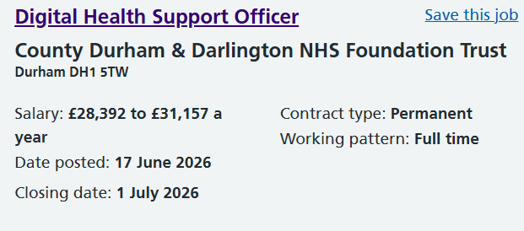
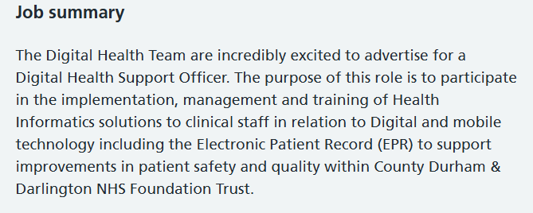
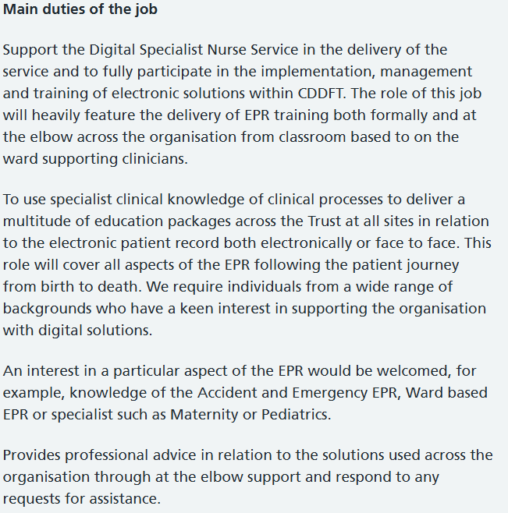
Figure 1. Current Digital Health Officer vacancy (NHS Jobs, accessed June 2026). Job Advert

The Digital Health Officer role is an exciting opportunity to contribute to the ongoing digital transformation of health and social care within the NHS. Based on the current job advertisement (Figure 1), the role involves supporting the implementation of digital technologies that improve healthcare delivery, enhance patient experiences, and increase organisational efficiency. Key responsibilities include assisting with digital projects, maintaining electronic health systems, analysing, and reporting data, providing training and support to healthcare staff, and collaborating with multidisciplinary teams to ensure digital solutions meet both clinical and organisational needs (NHS England, 2023).
The person specification highlights the need for a combination of technical knowledge and strong people skills. Employers typically seek candidates with a relevant degree or equivalent experience in health, information technology, or digital health, alongside excellent communication, organisational, and critical thinking skills. Experience of using Microsoft Office applications, managing digital information, and understanding data protection legislation are also considered essential. In addition, applicants are expected to demonstrate adaptability, professionalism, and the ability to manage competing priorities within a fast-paced healthcare environment (Department of Health and Social Care, 2022).
What particularly attracts me to this role is the opportunity to combine my interest in healthcare with my enthusiasm for digital innovation. Rather than providing direct clinical care, a Digital Health Officer supports healthcare professionals by ensuring that digital systems operate effectively, contributing to safer, more efficient, and patient-centred services. As the NHS continues to expand its digital capabilities, this role offers meaningful opportunities to improve healthcare delivery while developing specialist knowledge in an area that is becoming increasingly important for the future of health and social care. The role also encourages continuous learning, collaboration, and innovation, making it well suited to my career aspirations and commitment to improving patient outcomes through technology (World Health Organization, 2021; NHS England, 2024).
3. Analysis of the Employability Skills Required for a Digital Health Officer
A Digital Health Officer requires a combination of technical expertise and transferable employability skills to support the successful implementation of digital technologies within health and social care. As the NHS continues to expand digital services, employers increasingly seek professionals who can work effectively with technology while maintaining a patient-centred approach (NHS England, 2023). Among the many competencies required, communication, digital literacy, and teamwork are particularly important.
Firstly, effective communication skills are essential because Digital Health Officers work with a wide range of stakeholders, including clinicians, managers, IT specialists, and patients. They must be able to explain technical information clearly, deliver training, prepare reports, and support staff during the introduction of new digital systems. Effective communication also helps to reduce resistance to change and promotes the successful adoption of digital technologies within healthcare organisations (Skills for Care, 2024; NHS England, 2024).
Secondly, digital literacy is a core requirement of the role. Digital Health Officers are expected to use electronic patient record systems, analyse healthcare data, and support digital platforms that improve the quality and efficiency of care. A good understanding of information governance, cybersecurity, and data protection legislation is equally important to ensure that patient information is managed securely and ethically (Department of Health and Social Care, 2022; World Health Organization, 2021).
Finally, teamwork and collaboration are fundamental because digital transformation depends on effective multidisciplinary working. Digital Health Officers regularly collaborate with healthcare professionals, technical teams, and external partners to implement and improve digital services. Being able to build positive working relationships, solve problems collectively, and contribute to shared organisational goals helps ensure that digital initiatives improve both staff experiences and patient outcomes (NHS England, 2019; Chartered Institute of Personnel and Development, 2024).
Evaluation of My Current Skills Against the Role (SWOT Analysis)
Evaluating my current skills against the requirements of a Digital Health Officer has helped me identify both my strengths and the areas I need to develop. One of my strongest attributes is my communication skills. Through my Health and Social Care studies, I have developed the ability to communicate clearly in written assignments, presentations, and group discussions. These skills are important for a Digital Health Officer, who must work effectively with healthcare professionals, technical teams, and other stakeholders to support the implementation of digital systems (NHS England, 2023).
I have also developed good digital literacy through regular use of Microsoft Office applications, online learning platforms, and digital research tools. My academic work has improved my ability to locate, evaluate, and apply evidence from reliable sources, enabling me to make informed decisions and support evidence-based practice. These skills align with the increasing use of digital technologies and data within the NHS (Department of Health and Social Care, 2022).
In addition, studying Health and Social Care has strengthened my organisational, time management, and teamwork skills. Working on individual and collaborative projects has taught me how to meet deadlines, manage competing priorities, and contribute effectively within a team. Although I have not yet gained practical experience using Electronic Patient Record systems or working in an NHS digital environment, I recognise these as areas for further development. I plan to address these gaps through professional training, work placements, and continuous learning to ensure I meet the expectations of the role (Skills for Care, 2024; World Health Organization, 2021).

Personal Brand and Professional Identity
Building a strong personal brand and professional identity is essential for progressing into a Digital Health Officer role, as employers within the NHS increasingly value candidates who can demonstrate professionalism, digital competence, and a commitment to continuous development. My personal brand will reflect my interest in digital health, my academic development in Health and Social Care, and my ambition to contribute to improving patient outcomes through technology.
A key element of my personal brand will be my LinkedIn profile, which I will use to present my skills, achievements, and career interests in a professional manner. This platform will allow me to connect with healthcare professionals, follow NHS organisations, and engage with digital health content, helping me stay informed about industry developments (NHS England, 2024). Alongside this, I will develop a professional CV that clearly highlights my education, transferable skills, and relevant experiences such as coursework, group projects, and any placements.
In addition, I will create a digital portfolio to highlight evidence of my learning, including assignments, certificates, reflective work, and any digital health-related training. This will help demonstrate my ongoing commitment to professional development and lifelong learning, which is highly valued in the NHS workforce (Skills for Care, 2024).
My professional identity will also be shaped by my behaviour and values. I aim to demonstrate NHS values such as respect, compassion, and commitment to quality care in both academic and professional settings. Maintaining professionalism in communication, using appropriate digital etiquette, and protecting confidentiality will further strengthen my credibility as a future healthcare professional (Department of Health and Social Care, 2022; World Health Organization, 2021).
Overall, by combining a strong online presence, a well-structured CV, and consistent professional behaviour, I can build a personal brand that reflects my suitability and enthusiasm for a career in digital health.
My Value to the Organisation
In a competitive healthcare job market, my unique value as a future Digital Health Officer lies in my ability to combine strong academic understanding of health and social care with a developing interest in digital innovation. This combination allows me to approach healthcare challenges with both analytical thinking and a patient-centred mindset, which is essential in modern NHS services that increasingly rely on technology to improve efficiency and outcomes (NHS England, 2023).
One of my key strengths is my ability to communicate complex information in a clear and accessible way. This is particularly valuable in digital health environments, where staff and service users may have varying levels of digital confidence. By bridging this gap, I can support smoother implementation of digital systems and encourage positive engagement with technology across multidisciplinary teams (Skills for Care, 2024).
In addition, I bring a strong willingness to learn and adapt, which is crucial in a rapidly evolving digital healthcare landscape. My academic background demonstrates my commitment to continuous development, while my interest in digital health shows my motivation to contribute to innovation in care delivery. This adaptability ensures that I can respond effectively to new systems, policies, and technologies as they appear (World Health Organization, 2021).
Overall, my value lies in being a motivated, adaptable, and communication-focused individual who is committed to improving healthcare through digital transformation while upholding NHS values of quality, care, and collaboration (Department of Health and Social Care, 2022).
Five-Year Action Plan
Year | Goal | Action | Resources | Outcome
Year 1 | Finish degree | Achieve good grades | University | Graduate
Year 1 | Improve digital skills | NHS online learning | NHS Learning Hub | Certificates
Year 2 | Gain experience | Volunteer/placement | NHS Trust | Practical experience
Year 3 | Develop leadership | Lead projects | University | Leadership skills
Year 4 | Build network | Conferences, LinkedIn | NHS events | Professional contacts
Year 5 | Apply for Digital Health Officer jobs | Update CV and portfolio | Careers Service | Employment
Over the next five years, my action plan will focus on progressively developing the skills, experience, and qualifications required to become a Digital Health Officer. In the first year, I will complete my degree while improving my digital literacy through NHS e-learning platforms and university modules. In years two and three, I aim to gain practical healthcare experience through placements or volunteering, while developing communication and teamwork skills in real settings. By years four and five, I will focus on
Conclusion
In conclusion, the role of a Digital Health Officer requires a balanced combination of technical, communication, and teamwork skills to support the effective use of digital systems within the NHS. Throughout this report, strong digital literacy, problem-solving abilities, and the capacity to work collaboratively are essential for success in this profession. Reflecting on my own abilities, I have identified strengths in communication, academic research, and basic digital skills, which provide a solid foundation for entering this field. These strengths align well with the expectations of the role and demonstrate my potential to contribute positively to digital healthcare environments.
However, I also recognise areas for improvement, particularly in gaining practical experience with NHS systems such as Electronic Patient Records and developing confidence in project management and leadership. Addressing these gaps will be essential for my future employability and professional growth. My action plan supports this development by focusing on placements, training, and continuous learning opportunities, ensuring that I build both competence and confidence over time.
Overall, while I already possess valuable transferable skills, ongoing development and commitment to lifelong learning will be key to achieving my goal of becoming a successful Digital Health Officer within the evolving NHS digital landscape.

References
Alwashmi, M.F. (2020) ‘The use of digital health in the detection and management of COVID-19’, International Journal of Environmental Research and Public Health, 17(8), pp. 1–10.
Bohr, A. and Memarzadeh, K. (2020) ‘The rise of artificial intelligence in healthcare applications’, Artificial Intelligence in Medicine, 106, pp. 1–10.
Chartered Institute of Personnel and Development (CIPD) (2024) Employability Skills and Career Development. London: CIPD.
Department of Health and Social Care (2022) A Plan for Digital Health and Social Care. London: DHSC.
European Commission (2021) Digital Health Strategy. Brussels: European Union.
Greenhalgh, T. et al. (2021) ‘Beyond adoption: a new framework for digital health implementation’, The Lancet Digital Health, 3(2), pp. e66–e73.
Health Education England (2022) The Topol Review: Preparing the healthcare workforce to deliver the digital future. London: HEE.
Kruse, C.S. et al. (2020) ‘Security techniques for the electronic health records’, Journal of Medical Systems, 44(3), pp. 1–9.
Meskó, B. and Görög, M. (2020) ‘A roadmap for digital health education’, Journal of Medical Internet Research, 22(7), e16396.
National Institute for Health and Care Excellence (NICE) (2023) Digital Health Technologies Guidance. London: NICE.
NHS Digital (2024) Data Security and Protection Toolkit. Leeds: NHS Digital.
NHS England (2019) The NHS Long Term Plan. London: NHS England.
NHS England (2023) NHS Long Term Workforce Plan. London: NHS England.
NHS England (2024) What Good Looks Like: Framework for digital transformation. London: NHS England.
O’Connor, S. et al. (2021) ‘Digital health interventions in chronic disease management’, BMJ, 372, m4820.
Patel, V. et al. (2021) ‘Digital transformation in healthcare systems’, Health Policy, and Technology, 10(4), pp. 1005–1015.
Public Health England (2021) Whole Systems Approach to Obesity. London: PHE.
Skills for Care (2024) Developing the Adult Social Care Workforce. Leeds: Skills for Care.
WHO (2020) Global Strategy on Human Resources for Health. Geneva: World Health Organization.
World Health Organization (2021) Global Strategy on Digital Health 2020–2025. Geneva: WHO.

