Student Name Dan-Gheorghe Filimon

Student number 1909419

Module Teacher
Dr Kenny Tang
Module Name

Global Business Environment LCBB4005

Global Business Environment- A 2

Of all the fuel consumed in Europe, road transport accounts for the biggest proportion constituting 73% of the total demand in 2017. Passenger vehicles further accounts for 70% of transportation fuel (eea.europa.eu, 2019). There is an increasing demand globally for passenger cars from countries like India and China where there is rising middle class and this is further increasing demand for oil. This kind of increasing demand opens up both opportunity and challenge to optimise on the alternate source of transportation fuel electric-vehicle technology that will lead to sustainable economic development and benefit. Switching to electric-vehicle will not only create job opportunities but will also lead to better quality of life, decrease in energy spending and country dependence on import of oil.
a) There has been great policy support by European-government by supporting both supply side and demand side incentives for boosting the demand for electric-vehicle. European-government gives assistance to manufacturers and suppliers of electric-vehicle by funding research and development through vehicle manufacturing loans which can help the manufacturers in covering manufacturing expenses to a great extent. The European-government also provides assistance to the suppliers of electric-vehicle in exporting to other countries (Bayram and Tajer, 2017). The main factor influencing the growth of electric-vehicles in Europe is the battery and fuel cost factors. Battery cost is around one third of electric-vehicle cost. Batteries with high efficiency and power are expensive driving the overall cost of electric-vehicle upward and because of the depreciation in battery life the resale value of electric-cars are also uncertain. The operational cost of electric-vehicle as compared to tradition cars is low which is one of the competitive advantages against volatile fuel prices (Denton, 2016). Therefore going forward battery cost and fuel cost will be the main determinant for growth and expansion of electric-vehicle market.
The electric-car market is growing at a fast pace and along with opening several opportunities for other business related to electric-vehicle to bloom with it. There is an emerging business opportunity for electric-vehicle servicing garage as the main component in electric-vehicle is battery and inverter repair their servicing would be quite different from tradition engine vehicle (Nieuwenhuis and Wells, 2015). Another electric-vehicle related existing opportunity is investing in electric-vehicle charging station. There is shortage of charging facility in Europe and government is keen for setting proper infrastructure and providing incentives to companies interested in this business. There is huge opportunity for entrepenture for developing private charging station. Electric-car rental services will also yield good returns for business entrepreneurs as more people are opting for environmental friendly cars and this business model will be new and early entrant will get the benefit. Electric-car battery shop will be a profitable business requiring limited capital with the battery replacement required after every 5 years (Narins, 2017). With the increase in number of electric-vehicle, Electric-car reselling business will also have a good market and there will be good opportunity to resell electric-car to those who are interested but cannot afford new electric-car due to high cost.
Product life cycle defines the stages through which a product travels from introduction in the market until it declines and moves away. Electric-vehicle will go through life cycle of four stages introduction, growth, maturity and decline (Strong, Kresojevic and Viki, 2018).
Product life cycle
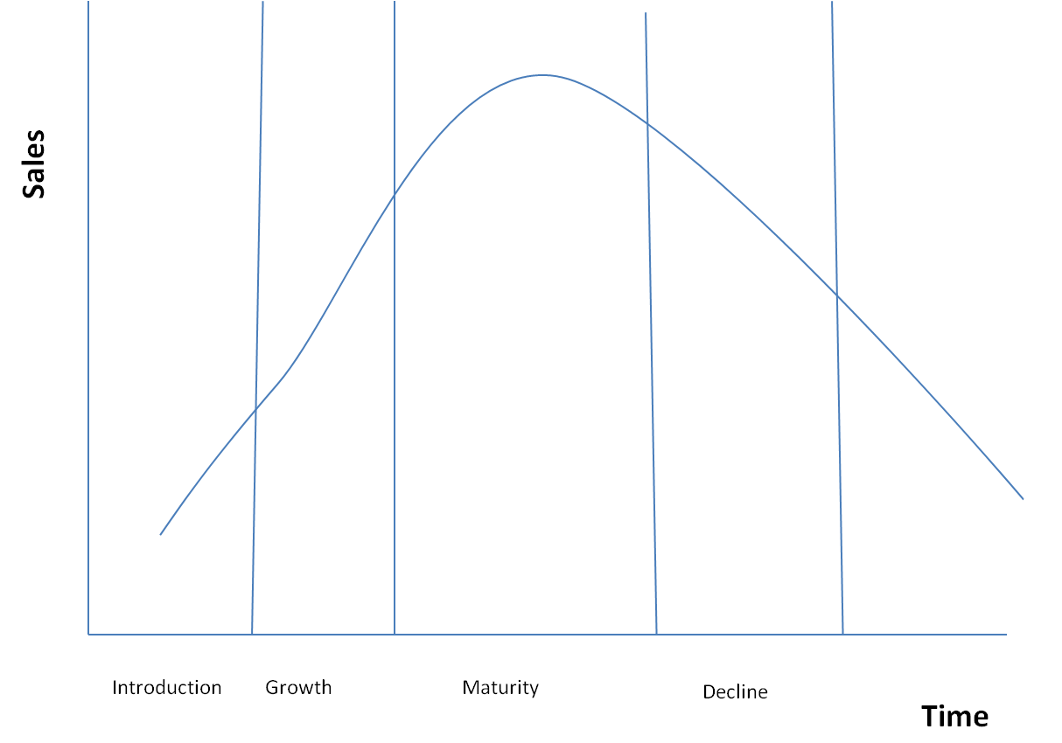
Figure 1: Source (Muneer, Kolhe and Doyle, 2017)
Introduction Stage- European electric mobility is in the initial adoption phase, introduction stage is the stage where the motor manufacturers like Volvo will develop the electric-car and release it to the market pointing out to the public the benefits and trade off of owning an electric-vehicle. In this stage Volvo is facing the challenge of convincing the consumers to buy the car at its most expensive point as at this stage Volvo has not achieved economies of scale as the production is low due to demand uncertainty. This stage provides Volvo to opportunity to make the consumer aware of the benefits of electric-car as against the conventional car and show them the benefit of switching (Denton, 2016). Volvo has the benefit of European people early adoption to electric-vehicle concept and consumer understanding the environmental and fuel efficiency benefit of electric-cars. Presently the share of electric-vehicle in total car sales in Europe is just about 1% but there are encouraging data coming in from Toyota, Nissan and Tesla that has sold 6 million, 1 million and 25,000 units of fully battery electric-car in Europe in 2013. This shows the unlimited opportunity for Volvo to grow due to consumers increasing demand for electric-vehicle.
Growth Stage- In the growth stage Volvo will open up the market for wider audience. This phase will mark the increase in customers and competition for Volvo. The critical factor for success for Volvo in growth stage would be to differentiate the product features of Electric-vehicle by improving the efficiency of battery life and quick recharge time (Scrosat, Jurgen and Tillmetz, 2015). This stage will show that almost all the manufacturers are bringing in similar features and therefore pricing will play an important determinant for a consumer to buy a particular brand.
Maturity stage- This stage will mark the saturation of market with slower growth for Volvo. Volvo will have to enter into promotion and competitive pricing war to increase sales in this stage there by effecting profit margin (Bayram and Tajer, 2017). This stage will force Volvo to indulge in innovative repositioning strategy and redefining market segmentation.
Decline stage- In this stage the consumer of Volvo will start losing interest in electric-vehicle and may get interested in some other new technology. Volvo will have to slash prices of electric-vehicle or off deep discounts to keep the product alive and may have to contemplate with the option of closing the line of production if manufacturing electric-vehicle result in loss.

b) Global automobile industry works with the collaboration of various partners from the manufacturing stage to supplying the end product to the customers. Automotive industry is evolving and passing through radical changes with the help of advanced innovation technology. Conventional vehicles for its manufacturing in the initial stage requires supply of raw materials for components and parts like steel, copper, plastic, carbon fibers, aluminium. There is a well developed market that supplies these raw materials to automotive industry and each motor manufacturing company has various suppliers for each component required both nationally and globally (Crisostom, Robert and Stüdli, 2017). The supply of raw materials business is crucial to automotive industry and any delay or disruption will adversely impact the capacity of a manufacturer to meet the demand. Another business linked to automobile industry that is thriving is car insurance business which is mandatory for every car operating in Europe. Automotive industry also has tie-up business with various Banks and finance companies to provide Loans to customers for buying cars (Un-Noor and Hossain, 2017). This is again a growing business as more and more people prefer to purchase cars on loan and make payment of it on monthly basis. With advancement of technology automotive industry is coming up with innovative technology that is giving way to new business that are now linked to this industry. Automotive Software Management System is a growing business in automotive industry that uses various software systems to manage various functions like mechanical garage which sends out notification to customers when the servicing is due along with digital forms, inspection forms, job scheduler and real time vehicle status. This business is very important with everything getting digitalised people will prefer this mode of communication in future and investing in it will have long term benefit. Artificial intelligence (AI) automotive technology is an aligned automotive business with the increase in self driven cars. AI is becoming a major element in new innovative vehicles like use of Global Positioning System (GPS), Wi-Fi, Bluetooth plays crucial role in mobility-on-demand solutions and has potential to grow in future due to consistent demand for it (Pagliarini and Lund, 2017). Another business directly linked to automobile is the dealer network that helps in giving supply-push. These dealer network help in holding inventory and service and support existing and potential customers. Despite the longevity of tradition dealer in the business of selling traditional cars this business model is not viable in long run and may reduce the already shrinking dealer margin because of the arrival of electric-vehicles. Earlier people used to go to the motor dealers to gather information on cars but now with the rapid growth of advanced internet services that allows customers to collect all the information online and in some cases also negotiating price and conduction transactions. The increase in the demand for electric-cars will also move the business away from traditional cars in times to come. It is time for conventional dealership to change and adapt itself to facilitate the supply of electric-car and upgrade their facility accordingly.
Volvo has been a leading player in motor manufacturing industry since 2019 Volvo have fully embraced electrification of car and has decided to launch every Volvo from 2019 with electric motor. This not only helps Volvo in catering to the increasing demand for electric-cars from consumers but also in reducing their carbon footprint. Volvo has always been a technologically forward company with focus on innovation and has the latest technology like autonomous driving technology and always aims to give their loyal customers happy driving experience (Crisostom, Robert and Stüdli, 2017). Volvo has a great supply chain and production network focusing on European market that has increasing demand for electric-cars. Volvo is concentrating on their value chain to achieve higher efficiency and provide greater satisfaction to the customers in Europe and other parts of the globe. Porter’s Value Chain defines the stages from the procurement of raw materials to after sales services and how Volvo can analyse the value chain to optimise the operational efficiency to achieve desired results and gain competitive advantage.

Porter’s Value Chain management
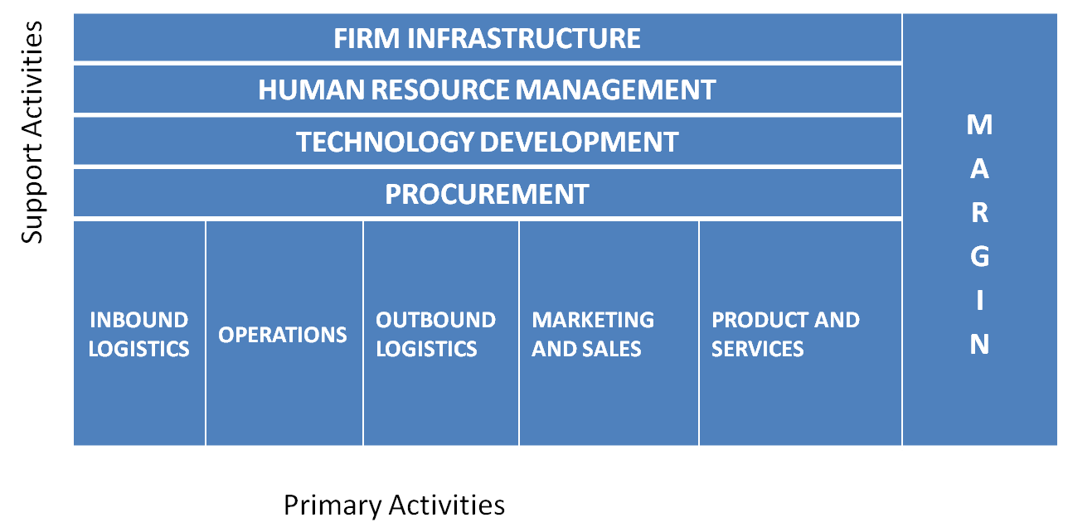
Figure 2: Source: (Henry, 2018)
Value chain for Volvo cars will include two activities- Primary activities and support activity.
Primary Activities
The activities that are directly involved in creation of electric-cars will be primary activities for Volvo.
Inbound logistics- These activities will reflect how the raw materials will be received from the suppliers and include functions liked transport, storage and delivery. Volvo is a well established motor manufacturer and has large number of warehouse in Europe. The main production facility of Volvo Company owned is in Gothenburg, Sweden. It is 55 years old and is used for storing and delivering cars to other global locations (Cano and Chen, 2018). At these units Volvo’s product development takes place and focus is distribution and storing of raw materials to make sure transformation to final product is as per the present demand and inputs are available for future expected demand.
Operations- Operational activities at Volvo starts once the raw materials arrive at the warehouse and Volvo setup is prepared to make the end product for the market. Operational activities at Volvo consist of both manufacturing and servicing operations like assembling parts, machining, packing, equipment repair, maintenance and testing (Denton, 2016). Volvo has to ensure it has upgraded facility for production of electric-car and must time to time keep a check on it to ensure productivity, efficiency and competitive advantage to the brand.
Outbound logistics- Outbound logistics for Volvo will be to ensure the delivery of electric-vehicle to distribution centres, retailers, wholesalers or directly to customers. Volvo has also warehouses in several parts of the world like Asia, North America and Europe. This great networking of warehouse can be further used by Volvo in the supply of electric-cars that will give competitive advantage to Volvo in the early stages of electric-car life cycle to meet the initial demand and secure a market share in this segment (Muneer, Kolhe and Doyle, 2017). Volvo has to ensure timely management of these activities for optimising cost, customer satisfaction and increasing growth.
Marketing and sales- Volvo has to strategically plan the marketing of electric-vehicle to make consumer aware of the features, benefit and differentiation point from the competitors. Volvo already has a huge loyal customer base and through concentrated marketing and promotional activity it can easily generate interest among existing customers for electric-vehicle.
Product and service- Through their customer care service in the purchase process from pre-sale to post-sale stage Volvo can win the confidence and loyalty of their customers (Pagliarini and Lund, 2017). Volvo must have good support activities that will help in gaining customer confidence and help in spreading positive word of mouth and increase Volvo’s brand value.
Supporting Activities
Firm infrastructure- It shows how effective Volvo is managing its internal affairs with regards to legal matters, planning, accounting, quality management, financing and strategic management. A good hold on infrastructure management will help Volvo in achieving efficiency in the value chain and increase their competitive advantage.
Human resource management- Volvo has an effective Human resource team that is capable of recruiting and selecting the right candidate and also experienced to reduce competitive pressure on employees by motivating and developing skill sets as required of the workforce (Henry, 2018). Volvo has heavy dependence on their employees to keep having competitive advantage and is an important component of value chain support activity.
Technology development- Electric vehicles are the result of technological advancement and all value chain activities in Volvo from manufacturing, marketing, distribution are dependent on automation software and data analytics.
Procurement- Volvo procurement would refer to keeping inventory for machinery, equipment, raw materials and all important components required for manufacturing electric vehicles.
Value chain analysis helps and supports Volvo in understanding the importance and alignment of both primary and supporting activities in production and bringing the end product to market. Volvo has the benefit of early entrant in the market and has the production capacity with existing factory, plants and human resource (Henry, 2018). However it should work on procuring raw materials at competitive price to achieve cost efficiency and work on technology to create differentiation in electric cars product features.

References
Bayram, I.S. and Tajer, A. (2017) Plug-in Electric Vehicle Grid Integration, London : Artech House.
Cano, Z.P..B.D..Y.S..H. and Chen, Z.. (2018) ' Batteries and fuel cells for emerging electric vehicle markets. ', Nature Energy, vol. 3, no. 4, pp. 279-289.
Crisostom, E., Robert, S. and Stüdli, S. (2017) Electric and Plug-in Hybrid Vehicle Networks: Optimization and Control, London: CRC Press.
Denton, T. (2016) Electric and Hybrid Vehicle, Oxon: Routledge.
eea.europa.eu (2019) eea.europa.eu, December, [Online], Available: https://www.eea.europa.eu/data-and-maps/indicators/transport-final-energy-consumption-by-mode/assessment-10 [May 2020].
Henry, A.E. (2018) Understanding Strategic Management, London: Oxford University Press.
Muneer, T., Kolhe, M. and Doyle, A. (2017) Electric Vehicles: Prospects and Challenges, London : Elsevier.
Narins, T.P.. (2017) 'The battery business: Lithium availability and the growth of the global electric car industry.', The Extractive Industries and Society, vol. 4, no. 2, pp. 321-328.
Nieuwenhuis, P. and Wells, P. (2015) The Global Automotive Industry, West sussex: John Wiley & Sons.
Pagliarini, L. and Lund, H.H. (2017) 'The future of robotics technology.', Journal of Robotics, Networking and Artificial Life, vol. 3, no. 4, pp. 270-273.
Scrosat, B., Jurgen, G. and Tillmetz, W. (2015) Advances in Battery Technologies for Electric Vehicles, London: Woodhead Publishing.
Strong, C., Kresojevic, S. and Viki, T. (2018) The Lean Product Lifecycle: How to Make Products People Want, London : Pearson UK.
Un-Noor, F..P.S..M.-P.L..M.M.N. and Hossain, E.. (2017) ' A comprehensive study of key electric vehicle (EV) components, technologies, challenges, impacts, and future direction of development. ', Energies, vol. 10, no. 8, p. 1217.

