Oprah Winfrey is a relevant hero in the 21st century, Oprah.com described Oprah Winfrey as ‘Television Pioneer, Magazine Founder & Editorial Director, Producer/Actress, Online Leader, Philanthropist, Television Programming Creator, Satellite Radio Programmer, Broadway Producer’ (Oprah.com, 2011). Oprah, has a very humble background, an illegitimate child, she overcame poverty, sexual abuse, racism to become one of the most influential and wealthiest person of our generation. See fig 1
Fig 1
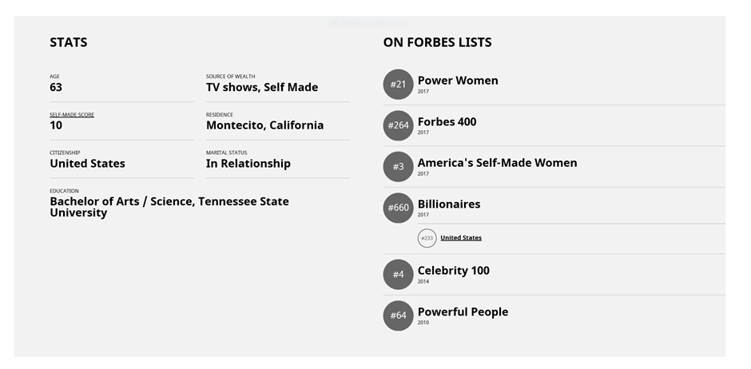
(Forbes, 2017b)
Oprah attributes her success as well to her disciplinarian father for transforming her life. She said her father’s love for education showed her the right path, he gave her believe that she could be great. But it was her grandmother that forged her reading and public speaking between the age of 2 and 3. Furthermore, because of her personality and by being herself, she innovated or reinvented the broadcast talk show. Schumpeter (2000) proposed that the entrepreneurs are responsible for a nation’s innovation and technological change. He called it “gale of creative destruction”.
Oprah was born in 1954, it was in Baltimore her story began, Oprah was the first African American woman to anchor a newscast in Nashville, and for many years, Winfrey co-hosted "Baltimore Is Talking," and then she went to Chicago to host "A. M. Chicago". which later became "The Oprah Winfrey Show", the Show aired between 1986-20011. She founded Harpo Productions Inc. in 1986 and in 2011 she launched Oprah Winfrey Network (OWN TV) (Biography.com Editors, 2017).
Oprah has a natural soft spot for people and a penchant for following her instincts. By launching her companies, she became an entrepreneur. Hisrich (1990) concluded that entrepreneurs create something different with value, they devote necessary time and effort, and they take risks. She also became of change (Wickham, 2006), she brought innovation to TV market, she identifies with her market, she applied her expertise, provides leadership and manages.

Fig 2
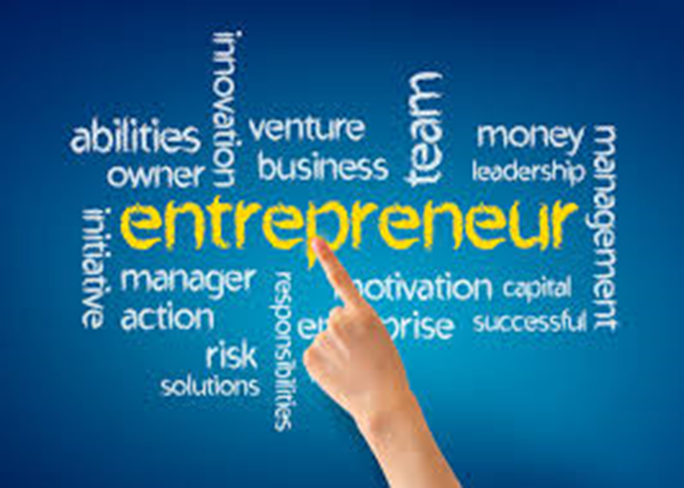
(Emmanuel, 2017a)
For over 25 years Oprah used her show to not only to entertained, but to enlighten and uplift millions of viewers. Oprah used the power of media to connect with people everywhere. Eventually she became an Iconic media leader and philanthropist whom most people have come to respect and admire (Henstra, 2008). Haag (1993) suggested that there was an element of Intimacy in her talk show, Oprah connected with the audience like no one ever did. Llie (2001) argues that, Oprah’s shows were semi-institutional in nature, it looks casual and yet, it can be a discourse because of the participant’s role in the talk.
Oprah’s uniqueness was her special ability to connect intellectually and emotionally with her audience. (Louwney, 2004) affirms Illouz argument that Oprah provided a social change. Oprah has a warm-hearted style that won over100,000 more viewers that Phil Donahue her main competition in Baltimore, which now gave her nationwide fame and TV syndication in 120 cities (Entrepreneur, 2008).
This opportunity made her launch her first company, the Harpo TV, in 1985, her show Oprah Winfrey show, gross over$125 million, with over 10 million viewers. She took the ownership of the programme from ABC into her newly formed company called Harpo Productions. She grabbed the opportunity presented to her (Biography.com Editors, 2017).

Fig 3
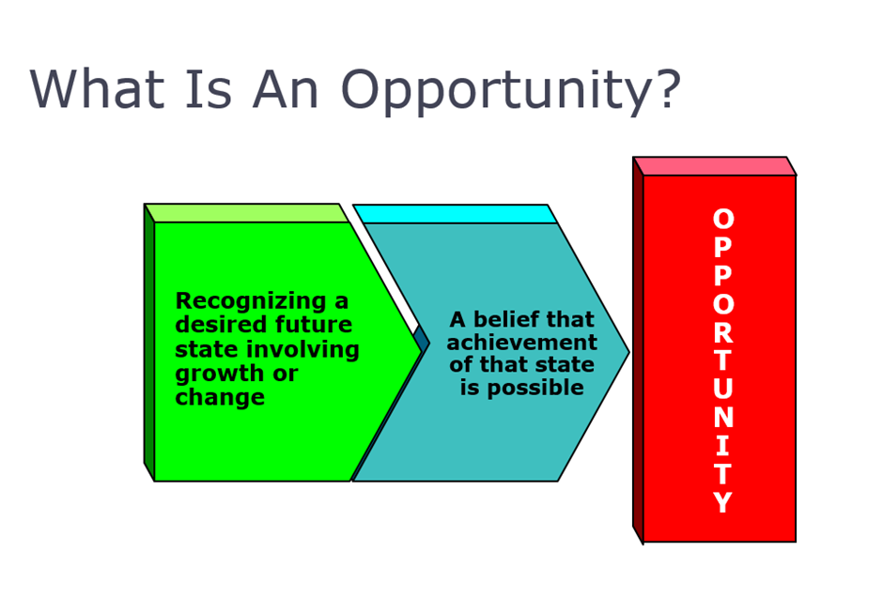
(Emmanuel, 2017b)
Prelude to this was the producer Quincy Jones offering her a role in the movie ‘the Color Purple’. The success of her acting played a crucial role in her popularity, with nominations for both a Golden Globe and an Academy Award, and it catapulted her to national stardom, and her show debut nationally in 1986, and within five months became the third-highest rated show in syndication and the No. 1 talk show. Her talk show was different, she disrupted the talk show business (Schumpeter, 2000).
Oprah did not have a business plan, resources, neither a management team, but she took full advantage of the opportunity afforded her. She fully utilised her creativity, leadership and talent as suggested in Timmons Model in fig 4 below.
Oprah has storytelling gift like no other, she proffers practical solutions to society’s problems, her message of empathy, support, and love was a constant feature of her talk show. OECD (1980) argued that ‘The transformation of an idea into a new or improved saleable product or operational process in industry or commerce’, Her heartfelt honesty, empathy resonated with millions of people.

Fig 4

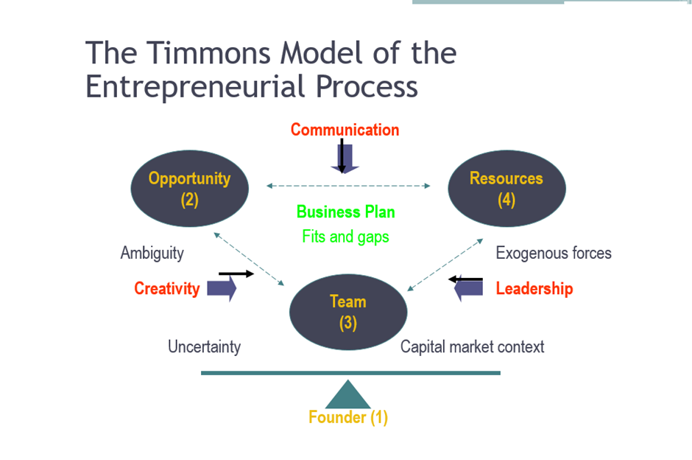
(kimberlymoises, 2012)
Oprah, broke new grounds, she freely discusses her personal troubles, and that resonated with a lot of people especially women. Oprah proposed topics such as divorce, depression, alcoholism, child abuse, adultery, incest that were never publicly discussed, but she discussed these topics with empathy on television. Furthermore, being a victim herself, the show reflected her life.
After 10 years of the show, whereby the show followed a recovery model where her guest and viewers were encouraged to build up their self-esteem and loving themselves as a recipe to overcoming their problems. Critics pointed out that she turned suffering into a desirable experience as suffering can induce a situation for self-improvement (Oppenheimer, 2011). In 1994, Oprah changed her show’s format from recovery model that is “victimization” and negativity “to lift people up” (The Guardian, 2015). Drucker, (2007) defines entrepreneur as someone that is always searching for change, responds to it, and exploits it as an opportunity and that was what Oprah did.
As Oprah became popular so was her influence, she became an influencer and shaper of American culture. Whatever product or idea she supported became an instant success. Books, e-books she supports became bestsellers, music she endorses tops the charts, any diets she presents through her personal cook influenced millions of people (Entrepreneur, 2008).
Oprah is among very few people in the world that is recognised by her first name alone, and she is considered as a friend to the world and a role model for all people, gender or race. In 1998, she was voted as the second most influencer in America. At the age of 44, she received an Emmy Lifetime award, and within that period her show had won 30 Emmy awards (Lowe, 1998).
Fig 5
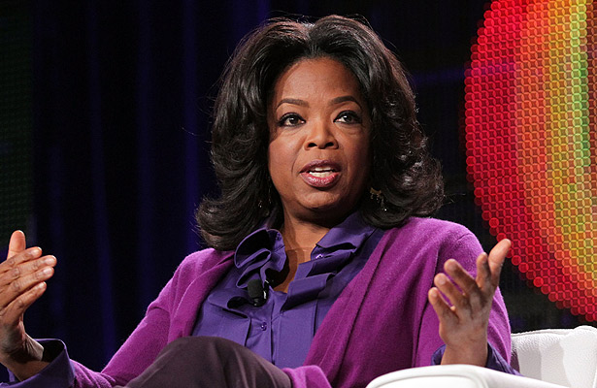
(jobstreet.com.ph, 2014)
More so, in 2013, Forbes, (2017b) ranked Oprah Winfrey among the top 15 powerful women in the world, and she is worth about $2.9 billion. She is the highest paid person in the media industry, she is the richest self-made woman in America, and the richest African-American in the 20th century (jobstreet.com.ph, 2014).
In 2011, Oprah was name among the Time’s 100 Most Influential People. Ted Turner, (2011) suggested that Oprah is a pioneer, she took risk, did not cared more about profit, but ideas and innovation, and she was determined on bettering the world along the way. She has won numerous awards and she has been nominated for Oscar, and in January 2018, she will receive the top Golden Globe honour for being a role model for women and young girls (BBC News, 2017).
In 2013, she was awarded the Presidential Medal of Freedom (Slack, 2013), for her involvement in reviving Americans interest in reading, and this was one of the reasons for the Presidential award. Oprah founded the Oprah Book Club, which is often credited with reviving Americans’ interest in reading, When Oprah pitches for anything, it becomes a best seller. As a social entrepreneur, she effected a social change.
Dees (1998) suggested that a social entrepreneur plays the role of a social change agent by creating a sustained social value, by recognizing and relentlessly pursuing new opportunities to serve that mission, by engaging in a process of continuous innovation, by adapting, and learning, with accountability to the served.
Fig 6
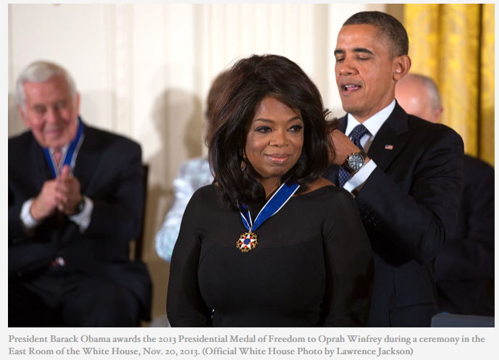
(Jackson, 2013)
Since Oprah Winfrey launched her campaign to get America reading on Sept. 17, 1996, Her book club has produced more than 38 consecutive best-selling and she has been credited for reviving the publishing industry and she got America reading. As a Social Entrepreneurs, Oprah is rare breed. Every book she has chosen has sold more than a million copies. However, there was a case whereby the author lied about the authenticity of the book and this led Oprah to openly rebuke the author live on TV. Nonetheless, the American National Book Foundation honoured her with a gold medal for her contribution to reading and books (Peck, 2002).
Furthermore, she relaunched her book club on 4th June 2012 and called it Oprah's Book Club 2.0. This is an interactive, multi-platform reading club that utilise the power of social media (Discover Press Web, 2012). In her book, ‘reading with Oprah’ The Book Club That Changed America, Rooney, (2008) describes Winfrey as
"a serious American intellectual who pioneered the use of electronic media, specifically television and the Internet, to take reading, a decidedly non-technological and highly individual act, and highlight its social elements and uses in such a way to motivate millions of erstwhile non-readers to pick up books."
Her generosity and philanthropic efforts are exceptional. Oprah with her Angel Network has raised more than $51,000,000 for charitable programs.
Furthermore, in 1994, Oprah proposed to the US congress to create a database of convicted child abusers which President Clinton signed into law (African American Registry, 2000 to 2013). She has invested over $ 40million in her school in South Africa, she is involved in the school, she teaches a class at the school via satellite (Samuels, 2007), but critics considered the school luxury as unnecessary.
Fig 7
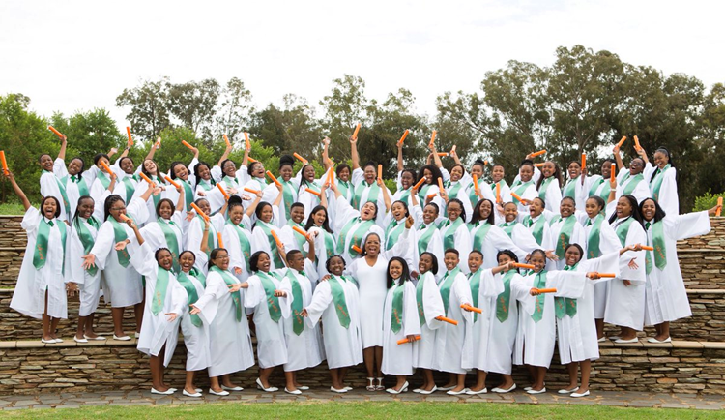
(Twitter.com, 2017)
OWN: OPRAH WINFREY NETWORK
Oprah always dreamt of having a television network, and in 2011 she launched OWN, her target market was women of 25-54, and OWN is a joint venture between Harpo Inc. and Discovery Communications (Discovery Press Web, 2017). Oprah is the first black woman to own both studio and production companies (Garson, 2011).
VAN DE YEN (1986) suggested an innovation is a new idea, it might be a recombination of old ideas with new ideas, that may challenge the present unique approach or method. Oprah ‘s network found their niche market in a crowded TV market. She developed unique programmes for her demographics and she is giving opportunities to countless talents. Discovery channel has now increased their share in OWN T.V.
In acquiring another 24% stake of OWN, Discovery TV said, OWN has become the leading destination for African-American women and one of the strongest super fan brands across all screens and services. Discovery paid $70 million to acquire 24.5 percent stake in OWN (Castillo, 2017).
She has other businesses such as the O magazine that was first published in 19th April 2000. The magazine reaches a diverse market, 57% white women, 37% Black/African women, 9% Hispanic and 7% Asian/American Indian/other (Omediakit.com, 2017).

“The Opera effect”
Fig 8
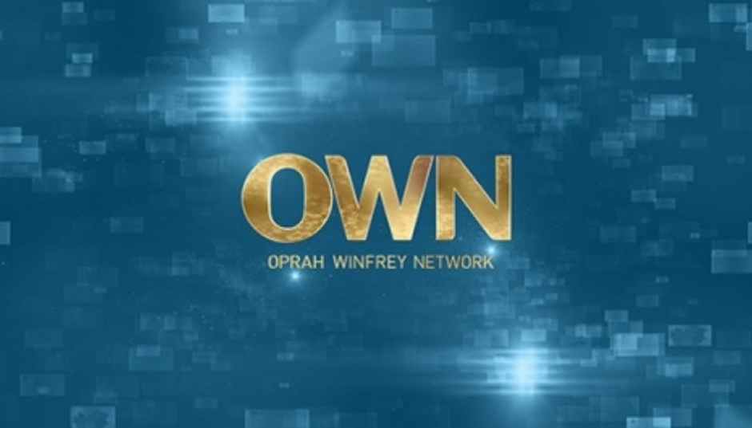
(RenewCancelTV, 2016)

The Opera effect is real, many companies, Authors, Politicians, Musicians, movies etc. have benefited from the term “Opera effect”. From President Obama, to Amazon Kindle in 2008 etc., have experienced huge success. (CNBC, 2009). Oprah is also a star maker, she nurtured and developed the careers of her protégés such as Dr Phil, Rachael Ray, Dr Oz. she gave them their breakthrough through her talk show.

Fig 9
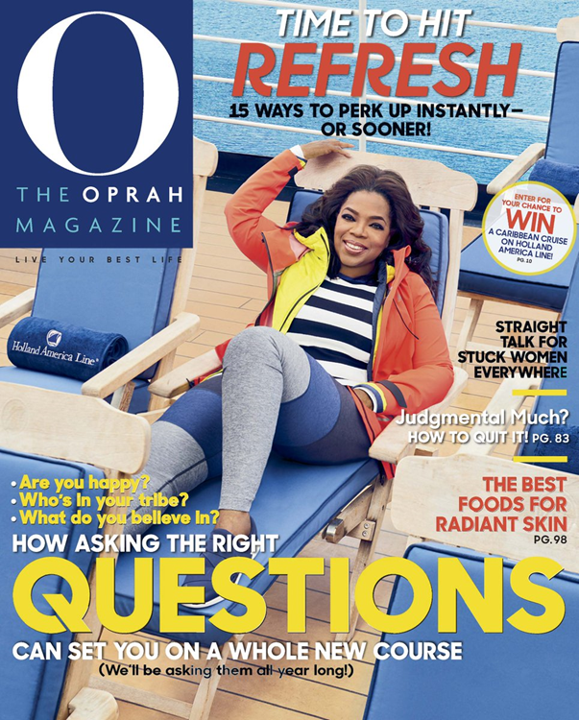
(Oprah.com, 2017e)
Oprah's effect on consumers mostly women was worth over $7million as at 2013. Weight Watchers benefited from 'Oprah effect', and Oprah eventually bought a 10% stake in 2015 and acts as a brand ambassador (Jackson & Darrow, 2005). Many people benefited by association including, Robyn Okrant, a blogger, Livingoprah.com, and media coach Susan Harrow (NBC Universal, 2009).
Fig 11
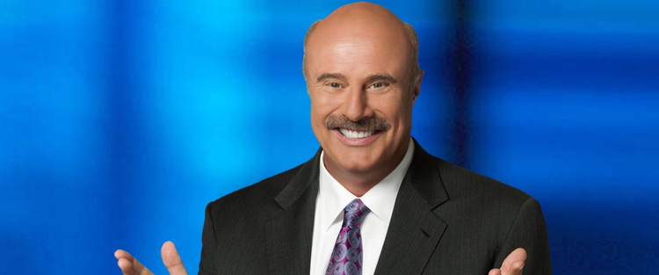
(Oprah.com, 2017d)

Fig 12

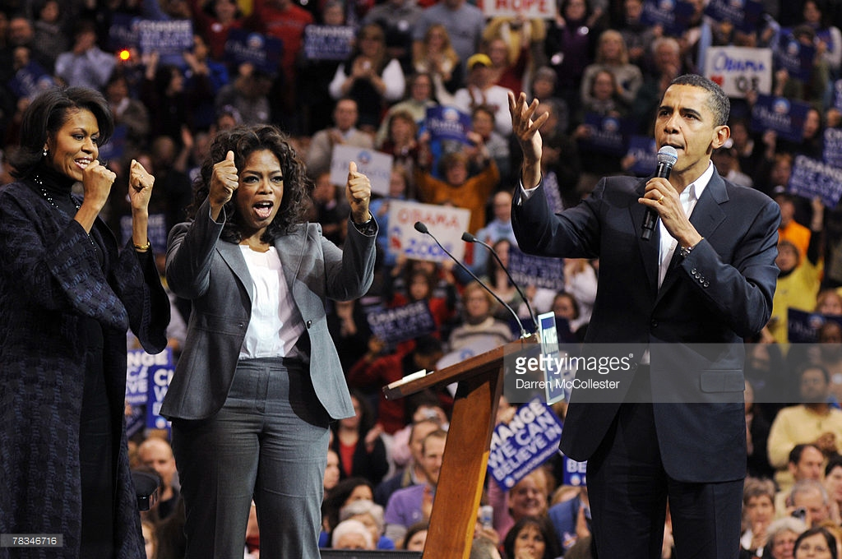
(McCollester, 2007)

When a Networks have a problem, Oprah is the Go to person. Discovery US replaced Sir David Attenborough, the Iconic Zoologist with Oprah, Discovery suggested that Oprah has that iconic voice, and after hearing a bit of the read, the Discovery team just simply said, 'We think this is the person who can bring Life to life, because they knew Oprah would open up the editorial opportunity for the show in a very different and unique way (Oswald, 2010).
Moreover, Oprah brings credibility and trust to the table. In her new role as the moderator for CBS new programme the “Divide” Oprah Winfrey affirmed, "There is a certain level of credibility and trust that I bring to the table, because regardless of who I voted for or didn't vote for, I'm gonna try to be fair" (CBS, 2017).
The mission of the programme was to hear from both sides of American Politics, CBS hopes she can encourage Americans to talk politics and to listen to those who disagree with them.

Fig 13
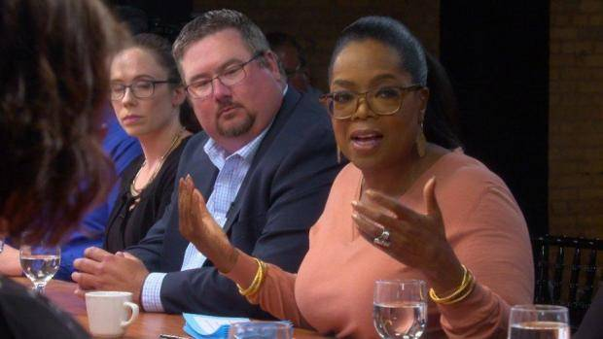
(CBS, 2017b)
Conclusion
She is an entrepreneur, a social entrepreneur, a philanthropist, an opinion and culture leader, she brought innovation to TV market, she identifies with her market, she applied her expertise, provides leadership to all.
Oprah is more influential than most politicians are, University Professors, nonetheless, she worked hard to succeed and a great show-woman, the the number 1 talk show host. She is a remarkable woman that cut across all boundaries gender, race. She has and still impacting a generation.in receiving a lifetime award from the Golden Globes’ Cecil B. DeMille Award she still used the platform to speak against corruption and injustice and sexual harassment against women worldwide (Russonello, 2018). What a remarkable woman.

Reference
African American Registry, 2000 to 2013. Oprah Winfrey A multi-media Icon. [Online]
Available at: http://aaregistry.org/historic_events/view/oprah-winfrey-multi-media-icon
[Accessed 15 12 2017].
BBC News, 2017. Oprah Winfrey to receive top Golden Globe honour. [Online]
Available at: www.bbc.co.uk/news/entertainment-arts-42350747
[Accessed 15 12 2017].
Biography.com Editors, 2017. Oprah Winfrey. [Online]
Available at: https://www.biography.com/people/oprah-winfrey-9534419
[Accessed 14 12 2017].
Castillo, M., 2017. Discovery takes majority stake in Oprah Winfrey's network. [Online]
Available at: https://www.cnbc.com/2017/12/04/discovery-communications-takes-majority-stake-in-own-cable-network-it-co-owns-with-oprah-winfrey-report.html
[Accessed 4 12 2017].
CBS, 2017. Oprah's first 60 Minutes story "felt like coming home. [Online]
Available at: https://www.cbsnews.com/news/oprahs-first-60-minutes-story-felt-like-coming-home/
[Accessed 13 12 2017].
CBS, 2017b. Oprah's first 60 Minutes story "felt like coming home. [Online] {photograph}
Available at: https://www.cbsnews.com/news/oprahs-first-60-minutes-story-felt-like-coming-home/
[Accessed 13 12 2017].
CNBC, 2009. The Oprah Effect. [Online]
Available at: https://www.cnbc.com/2009/05/08/The-Oprah-Effect.html?slide=1
[Accessed 16 12 2017].
Dees, J. G., 1998. The Meaning of “Social Entrepreneurship”, Stanford : Graduate School of Business Stanford University .
Discover Press Web, 2012. Oprah's Book Club 2.0. [Online]
Available at: https://press.discovery.com/us/own/programs/oprahs-book-club-20/
[Accessed 25 11 2017].
Discovery Press Web, 2017. OWN: OPRAH WINFREY NETWORK. [Online]
Available at: https://press.discovery.com/us/own/programs/own-oprah-winfrey-network/
[Accessed 25 11 2017].
Drucker, P. F., 2007. Innovation and Entrepreneurship: Practice and Principles. Revised Edition ed. Butterworth-Heinemann 2007: London.
Emmanuel, L., 2017a. Entrepreneurship. {image}Carmarthen: UWTSD.
Emmanuel, L., 2017b. Entrepreneurship. {image}Carmarthen: UWTSD.
Entrepreneur, 2008. Oprah Winfrey Founder of Harpo Productions Inc. Founded: 1986. [Online]
Available at: https://www.entrepreneur.com/article/197558
[Accessed 23 11 2017].
Forbes, 2017b. Oprah Winfrey. {image}[Online]
Available at: https://www.forbes.com/profile/oprah-winfrey/
[Accessed 12 12 2017].
Forbes, 2017c. The Black Billionaires 2017. [Online]
Available at: 15
[Accessed 12 2017 2017].
Forbes, 2017. Oprah Winfrey. [Online]
Available at: https://www.forbes.com/profile/oprah-winfrey/
[Accessed 23 11 2017].
Garson, H. S., 2011. Oprah Winfrey: A Biography, 2nd Edition: A Biography, Second Edition. Second ed. Califonia: Greenwood Publishing.
Haag, L. L., 1993. Oprah Winfrey: The Construction of Intimacy in the Talk Show Setting. The Journal of Popular Culture, 26(4), pp. 115-122.
Henstra, S., 2008. The Politics of Talk: The Oprah Interview as Narrative. Studies in Popular Culture, 30(2), pp. 59-78.
Hisrich, R., 1990. Entrepreneurship/Intrapreneurship. The American Psychologist, 2, 45(2), p. 209.
Images, M. N., 2015. Oprah Winfrey: one of the world's best neoliberal capitalist thinkers {image}. [Online]
Available at: https://www.theguardian.com/tv-and-radio/2015/may/09/oprah-winfrey-neoliberal-capitalist-thinkers
[Accessed 13 12 2017].
Jackson, D. j. & Darrow, T. . I. A., 2005. The Influence of Celebrity Endorsements on Young Adults’ Political Opinions. Harvard International Journal of Press/Politics, 10(3), p. 80–98.
Jackson, L., 2013. President Obama Honors Presidential Medal of Freedom Recipients. [Online] {photograph}
Available at: https://obamawhitehouse.archives.gov/blog/2013/11/20/president-obama-honors-presidential-medal-freedom-recipients
[Accessed 15 12 2017].
jobstreet.com.ph, 2014. Oprah Winfrey, The Most Influential Talk Show Host in History {image}. [Online]
Available at: https://www.jobstreet.com.ph/career-resources/oprah-winfrey#.WjEiRuS7JNY
[Accessed 13 12 2017].
kimberlymoises, 2012. ” Entrepreneurship”. [Online] {image}
Available at: https://kimberlymoises.wordpress.com/2012/08/
[Accessed 15 12 2017].
Llie, C., 2001. Semi-institutional discourse: The case of talk shows. Journal of Pragmatics, 33(2), pp. 209-254.
Louwney, K., 2004. Oprah Winfrey and the Glamour of Misery: An Essay on Popular Culture. American Journal of Sociology, 110(3), p. 839.
Lowe, J., 1998. Oprah Winfrey Speaks, Insight from World's most Influential voice. New York: John Wiley.
McCollester, D., 2007. gettyimages. [Online] {photograph}
Available at: http://media.gettyimages.com/photos/democratic-presidential-hopeful-sen-barack-obama-addresses-the-crowd-picture-id78346716
[Accessed 16 12 2017].
NBCUniversal, 2009. Access Holywood. [Online]
Available at: http://www.accesshollywood.com/articles/the-oprah-effect-how-oprahs-endorsement-helps-companies-71717/
[Accessed 31 10 2017].
Omediakit.com, 2017. Women worth talking to. [Online]
Available at: http://www.omediakit.com/r5/home.asp#audience
[Accessed 24 12 2017].
Oppenheimer, M., 2011. The Church of Oprah Winfrey and a Theology of Suffering. [Online]
Available at: http://www.nytimes.com/2011/05/28/us/28beliefs.html
[Accessed 15 12 2017].
Oprah.com, 2011. Oprah Winfrey's Official Biography. [Online]
Available at: http://www.oprah.com/pressroom/oprah-winfreys-official-biography/all
[Accessed 25 11 2017].
Oprah.com, 2017d. Dr phil. [Online]{photograph}
Available at: http://www.oprah.com/search.html?q=Dr+phil
[Accessed 16 12 2017].
Oprah.com, 2017e. O, THE OPRAH MAGAZINE. [Online] {photograph}
Available at: http://www.oprah.com/index.html
[Accessed 13 12 2017].
Oswald, B., 2010. Yes, she's Queen of all Media, but to Discovery, she's Life itself Oprah replaces Attenborough as narrator for U.S audience. [Online]
Available at: https://www.winnipegfreepress.com/opinion/columnists/yes-shes-queen-of-all-media-but-to-discovery-shes-life-itself-82678662.html
[Accessed 13 12 2017].
Peck, J., 2002. The Oprah Effect: Texts, Readers, and the Dialectic of Signification. The Communication Review, 5(2), pp. 143-178.
RenewCancelTV , 2016. For Peete’s Sake Cancelled Or Renewed For Season 2?{image}. [Online]
Available at: https://renewcanceltv.com/for-peetes-sake-cancelled-or-renewed-for-season-2/
[Accessed 13 12 2017].
Rooney, K., 2008. Reading with Oprah : the book club that changed America. 2 ed. Arkansas: Fayetteville: University of Arkansas Press.
Samuels, A., 2007. Oprah Goes to School. [Online]
Available at: https://web.archive.org/web/20110913121426/http://www.thedailybeast.com/newsweek/2007/01/07/oprah-goes-to-school.html
[Accessed 16 12 2017].
Schumpeter, J. A., 2000. Entrepreneurship as Innovation. Entrepreneurship: The Social Science View, pp. 51-75 .
Slack, M., 2013. awarded the Presidential Medal of Freedom. [Online]
Available at: https://obamawhitehouse.archives.gov/blog/2013/11/20/president-obama-honors-presidential-medal-freedom-recipients
[Accessed 15 12 2017].
Ted Turner, 2011. Time 100 Oprah Winfrey. [Online]
Available at: http://content.time.com/time/specials/packages/article/0,28804,2066367_2066369_2066094,00.html
[Accessed 15 12 2017].
The Guardian, 2015. Oprah Winfrey: one of the world's best neoliberal capitalist thinkers. [Online]
Available at: https://www.theguardian.com/tv-and-radio/2015/may/09/oprah-winfrey-neoliberal-capitalist-thinkers
[Accessed 13 12 2017].
Twitter.com, 2017. Oprah Celebrating our 7th Graduation and 10th Anniversary at OWLAG!{photograph} #ProudMomO, s.l.: Oprah Winfrey Verified account.
VAN DE YEN, A. H., 1986. Central problems in the Management of Innovation. Management Science, 32(5), pp. 591-606.
Wickham, P. A., 2006. Strategic entrepreneurship. 4 ed. Harlow: Pearson Education.

