Business Plan
For a Chai Culture Café

Programme: BA (Hons) Business Management:
Module: Entrepreneurship
Module Code: LCBB5013
Lecture: Vasillios Tavlaridis

INTRODUCTION
Small businesses are increasingly looking for creative methods to stand out from the competition and provide distinctive customer experiences in the highly competitive hospitality industry of today. This business plan introduces Chai Culture Café, a planned Asian-inspired café in Aston, Birmingham, that aims to provide a fusion of contemporary café ambiance with traditional South Asian tea culture. The growing popularity of experiential eating and the UK's diverse population, which values social connection, community, and authenticity, has influenced the concept (Mintel, 2023).
Through a thorough examination of the concept, market, and operational structure, this business plan aims to show the viability and strategic direction of Chai Culture Café. There are four primary components to the plan's structure:
The business concept, goals, and unique selling proposition (USP) are presented in Element 1. Porter's Five Forces Model is used in Element 2 to analyse the business environment and evaluate competition in the café sector. To determine the target audience and strategy, Element 3 uses the 4Ps of marketing in conjunction with market segmentation and internet marketing techniques. The legal, managerial, and financial structure is described in Element 4, which guarantees operations that are realistic and long-lasting.
In addition to showcasing Chai Culture Café's financial potential, this strategy provides a critical understanding of how small businesses may prosper in the dynamic UK market by utilising well-established business models and marketing ideas.

PROJECT PURPOSAL
Chai Culture Café is a modern, Asian-inspired café concept located in Aston, Birmingham — an area known for its vibrant multicultural community and strong South Asian presence. The café aims to combine the traditional warmth of South Asian chai culture with a contemporary café experience, offering customers a relaxing social space to enjoy authentic teas, snacks, and fusion meals. The concept is inspired by the rising popularity of tea houses and experiential dining among young adults in the UK, particularly within urban, ethnically diverse areas (Mintel, 2023).
The business will operate as a limited company, allowing for shared financial risk and professional credibility when seeking funding and partnerships. The café’s mission is to create a welcoming environment where cultural heritage meets modern hospitality — a place where students, professionals, and families can connect over a cup of chai.
Products and Services
Chai Culture Café will offer a focused yet diverse range of products that celebrate South Asian flavours and contemporary trends. The menu will include:
- Specialty teas: Traditional chai (Karak, Kashmiri, Masala, and Bombay cutting chai), iced chai blends, and premium loose-leaf options.
- Snacks and light meals: Samosas, pakoras, wraps, parathas, and fusion bites (e.g., masala fries, tandoori paninis).
- Desserts: Gulab jamun cheesecake, kulfi, and other modernised Asian desserts.
- Beverages: Lassis, bubble chai, and ethically sourced coffee alternatives.
In addition, the café will provide free Wi-Fi, loyalty programs, and online ordering via a mobile app for takeaways and pre-orders, appealing to tech-savvy and convenience-oriented customers.
The business will prioritise local sourcing of ingredients and adopt sustainable practices, such as recyclable packaging and ethically sourced tea leaves, to align with environmental expectations and appeal to socially conscious consumers (Statista, 2024).
Business Objectives
Short-term objectives (Year 1–2):
- Establish a loyal customer base within the local community and nearby universities.
- Achieve monthly sales growth of 10% after the first six months.
- Build a strong social media presence with at least 5,000 local followers within the first year.
- Break even within the first 18 months of operation.
Long-term objectives (Year 3–5):
- Expand operations to additional Birmingham areas such as Alum Rock and Small Heath.
- Introduce a franchising model targeting other UK cities with large Asian populations.
- Develop a branded product line (e.g., packaged chai blends and snacks) for retail and online sale.
- Achieve recognition as Birmingham’s top Asian café brand by 2030.
Unique Selling Point (USP)
Chai Culture Café’s USP lies in its authentic cultural experience combined with modern café aesthetics. While many coffee chains (e.g., Costa, Starbucks) focus on Western-style drinks, Chai Culture differentiates itself through:
- Authenticity: Traditional South Asian recipes served in a modern environment.
- Community focus: Hosting cultural nights, poetry events, and student meetups.
- Fusion innovation: Blending traditional flavours with modern café trends.
- Ambience: A blend of South Asian design elements with contemporary décor, offering a sense of belonging and nostalgia.
This hybrid positioning appeals to both British Asians seeking cultural connection and non-Asian customers eager for new experiences, giving Chai Culture Café a strong competitive edge in a saturated café market.

Element 2: Business Environment & Competitor Analysis (Porter’s Five Forces)
Industry Overview
The UK café sector is valued at approximately £4.5 billion, with steady annual growth driven by changing consumer lifestyles and increased demand for premium experiences (British Coffee Association, 2024). However, niche and cultural cafés are now emerging as key disruptors, particularly those offering unique concepts such as bubble tea, matcha, and chai cafés.
Porter’s Five Forces Analysis
1. Competitive Rivalry — High
The café market in Birmingham is highly competitive, with major chains (Costa, Starbucks, Café Nero) and independent shops. However, most focus on coffee-based offerings. Chai Culture Café differentiates itself by specialising in authentic South Asian teas and fusion snacks, appealing to a culturally specific yet growing market segment. Competitors such as Chaiiwala, Karachi Chai, and Chai Green offer similar products but often lack the localised community focus that Chai Culture will emphasise through events and student partnerships.
2. Threat of New Entrants — Moderate
The café industry has relatively low entry barriers, but brand loyalty, start-up costs, and location availability can deter new entrants. Chai Culture’s differentiation, combined with its limited company status, will help secure financial credibility and potential investor interest. Building strong branding and customer experience early will create barriers for future competitors.
3. Threat of Substitutes — Moderate to High
Substitutes include fast-food outlets, coffee shops, and at-home tea consumption. However, Chai Culture’s focus on experience, community, and authenticity makes it difficult to replicate at home. Its offering is not just about tea, but the cultural and social environment.
4. Bargaining Power of Suppliers — Low to Moderate
Tea leaves and spices can be sourced from multiple UK and Asian suppliers, reducing dependency on a single source. By forming partnerships with ethical suppliers, Chai Culture can ensure both cost efficiency and product consistency.
5. Bargaining Power of Customers — High
Consumers have many café options, making price and experience critical factors. To counter this, Chai Culture will use loyalty programmes, consistent quality, and social engagement to enhance customer retention.
Conclusion
While competition in Birmingham’s café market is strong, the niche positioning, cultural authenticity, and experiential model of Chai Culture Café create a distinct competitive advantage. With a well-defined community focus and local brand identity, it can carve out a loyal customer base in a growing niche.

Element 3: 4Ps, Market Segmentation & Marketing Strategies
Market Segmentation
Chai Culture Café will segment its market based on demographics, psychographics, and behaviour:
- Demographic: Young adults (18–35), students, working professionals, and local families — primarily within the South Asian community but inclusive of all cultural backgrounds.
- Psychographic: Individuals who value social connection, cultural identity, and premium experiences.
- Behavioural: Frequent café visitors, social media users, and those seeking authentic, affordable food experiences.
The target market includes students from Aston University, local Asian families, and non-Asian customers interested in cultural cuisines.
Marketing Mix (4Ps)
Product
The café’s core product is authentic South Asian chai in various blends, complemented by fresh snacks and desserts. The augmented product includes free Wi-Fi, comfortable seating, loyalty cards, and online ordering. Packaging and branding will reflect modern South Asian art styles, enhancing cultural appeal.
Price
A value-based pricing strategy will be adopted, balancing affordability with quality. Average prices:
- Tea: £2–£3
- Snacks: £3–£6
- Combo meals: £7–£10
Student discounts and bundle offers will encourage repeat visits.
Place
Located in Aston, near universities and residential areas with high Asian populations, ensuring consistent footfall. Distribution will include in-store sales, takeaway, and online ordering via a mobile app and delivery partners such as Uber Eats or Deliveroo.
Promotion
Promotional strategies will combine digital and community marketing:
- Social media campaigns on Instagram, TikTok, and Facebook featuring influencer collaborations.
- Cultural events and student nights to build engagement.
- Loyalty cards and referral programmes.
- Online marketing tools such as SEO, Google Ads, and email newsletters.
Online Marketing Strategy
Chai Culture will implement an integrated digital marketing strategy to attract and retain customers. Key initiatives include:
- Instagram & TikTok Reels showcasing drink preparation and ambience.
- Google My Business for local search optimisation.
- Online ordering and reward app for convenience and loyalty.
- Customer feedback and engagement loops to improve retention.
This strategy combines content marketing with relationship marketing, ensuring long-term brand loyalty.

Element 4: Legal, Management & Financial Planning
Key Terms (UK Context)
- Limited Company: A legal entity separate from its owners, providing limited liability for shareholders.
- Sole Trader: An individual who owns and runs a business, personally liable for all debts.
- Partnership: Two or more individuals share ownership and responsibility.
- Franchise: A business operating under an established brand in exchange for fees.
- Online Enterprise: A business operating primarily through digital platforms.
- Social Enterprise: A business with social or environmental objectives reinvesting profits for community benefit.
Legal Structure
Chai Culture Café is ideally positioned for stability and future growth by selecting a Private Limited Company (Ltd) form. It creates a formal governance structure with well-defined ownership, decision-making, and profit-sharing in addition to restricted liability. Accountability among shareholders and sustainable growth are supported by this clarity.
Furthermore, because the café wants to grow throughout Birmingham and potentially franchise, the Ltd structure makes it easier to issue shares or attract additional investors without having to completely restructure the company. Long-term scalability depends on this flexibility (Companies House, 2024).
From the standpoint of risk management, the limited company form shields private assets from corporate debts, which is an essential defence in a sector vulnerable to shifting customer preferences and growing operating expenses (Mintel, 2023). Additionally, since corporation tax rates are frequently lower than sole proprietors' personal income tax rates, incorporating improves tax efficiency.
Finally, conducting business as a Limited Liability Company exudes professionalism and trust, which will increase creditworthiness when negotiating partnerships or commercial leases, draw in ethical investors, and develop supplier relationships.

Management Structure
Organisational Chart:
Managing Director (Owner)
│
┌────────────────────────┼────────────────────────┐
│ │ │
Operations Manager Marketing Manager Finance & Admin Officer
│ │ │
│ │ │
Kitchen Supervisor Social Media Executive Accounts Assistant
│
│
Kitchen Staff & Baristas

Descriptions of Roles
Owner/Managing Director: In charge of overall financial management, business growth, and strategic direction. In charge of alliances, long-term planning, and brand strategy.
Operations Manager: Oversees daily activities, inventory, quality assurance, and supplier relationships. guarantees a smooth service flow and adherence to health and safety regulations.
Marketing Manager: Creates and carries out marketing campaigns, coordinates offline and internet advertising, and supervises brand messaging.
Finance and Admin officer: To maintain regulatory compliance, the finance and administrative officer oversee flow management, payroll, budgeting, and financial reporting.
Kitchen Supervisor: The kitchen supervisor oversees the effectiveness, quality, and preparation of the meals. answers to the manager of operations.
Social Media Executive: Under the direction of the marketing manager, the social media executive oversees the company's online presence, social media content, and digital marketing statistics.
Kitchen Staff & Baristas: Baristas and kitchen staff oversee serving customers, preparing meals, and keeping the café's ambiance friendly.

Financial Planning
Start-up Costs (Estimated):
Category | Amount (£) | Percentage
Leasehold & Renovation | 25,000 | 38%
Equipment & Furniture | 20,000 | 31%
Initial Stock | 5,000 | 8%
Marketing & Branding | 5,000 | 8%
Licences & Insurance | 2,000 | 3%
Working Capital | 8,000 | 12%
Total | 65,000 | 100%

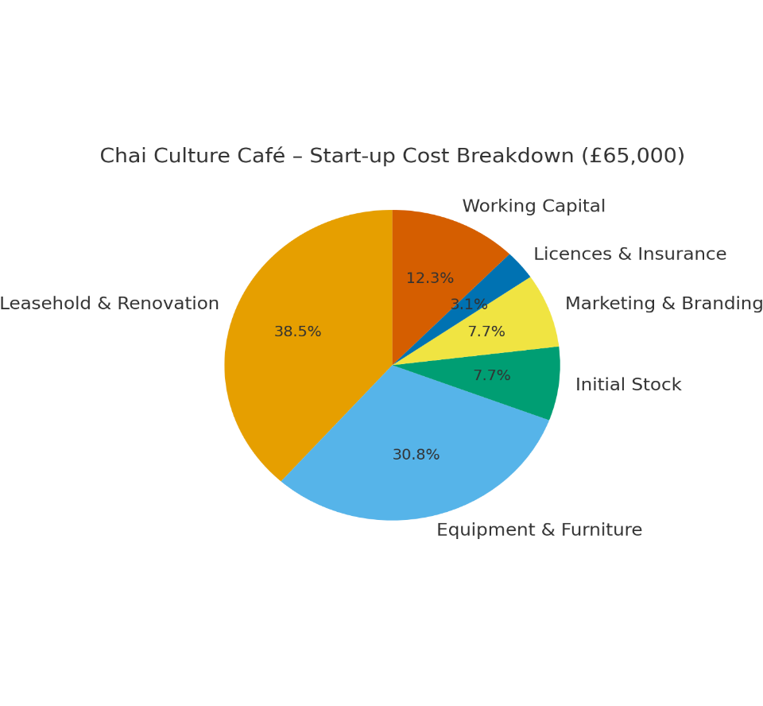
(Source Author's Own)

Funding Sources:
- Owner’s equity: £20,000
- Small business loan: £30,000
- Start-up grant or crowdfunding: £15,000
Break-even is projected within 18 months, assuming steady sales growth and local marketing success.

Integrate Sustainability or Social Responsibility
Furthermore, Chai Culture Café is committed to adopting responsible business practices aligned with the UK Companies Act 2006 Section 172, which encourages directors to consider social and environmental impacts in their decision-making. The limited company structure allows the café to embed sustainability policies—such as ethical sourcing and eco-friendly packaging—within its governance framework, reinforcing both brand reputation and long-term stakeholder trust.
Conclusion
With strong community positioning, a clear value proposition, and sound financial structure, Chai Culture Café has the potential to become a successful and sustainable brand within Birmingham’s café scene. Its limited company structure ensures financial security, while its authentic yet modern approach meets evolving customer demands.

References (Harvard Style)
- British Coffee Association (2024) UK Coffee Market Report 2024.
- Mintel (2023) Café Culture: Consumer Trends in the UK.
- Statista (2024) Ethical Food Consumption in the UK 2024.
- Porter, M. (1980) Competitive Strategy: Techniques for Analysing Industries and Competitors. Free Press.
- Kotler, P. and Keller, K. (2016) Marketing Management. 15th edn. Pearson Education.
- Chaffey, D. and Ellis-Chadwick, F. (2019) Digital Marketing. Pearson UK.
- BBC News (2024) The Growth of Independent Cafés in Birmingham.

