Effective Team Working and Communication
Student Name:
Student ID:
Module Name:
Submission Date:
Table of Contents
1. Introduction 3
2. Communication Models 3
2.1 Shannon and Weaver (1948) 3
2.2 Schramm (1954) 4
2.3 Berlo (1960) 5
3. Skills of Communication 5
3.1 Verbal Communication 5
3.2 Non-Verbal Communication 6
3.3 Listening Skill 7
4. The Disadvantages of Modern Technology 7
5. Conclusion 9
6. References 10

1. Introduction
Effective communication is very important for any stream of academic and professional career. It is also very crucial for every sector of the world. Many models explain the communication process. The models explain what factors can affect the communication process. It is also very important to develop communication skills. People should always work on their communication skills to improve them. The communication process includes two vital elements that are sender and receiver. The sender is the person who sends the message and the receiver is the person who receives the message. Sender always needs to choose the right words so receiver can interpret the message correctly. Many misunderstandings can happen if the sender did not send the message correctly. There are also other factors than choosing the right words. The body language, posture, facial expression and tone of voice can express many things without saying words. There are many advantages of technology as well as many disadvantages. This report has focused on effective communication. For that reason, models of communication have been elaborated. Moreover, communication skills have been described in this report. Furthermore, the disadvantages of modern technology have been discussed.

2. Communication Models

2.1 Shannon and Weaver (1948)
This model was proposed by Shannon and Weaver in 1948 and the name of the model was "Shannon-Weaver model of communication". The communication model aimed for creating communication between receiver and sender effectively. The theorists also suggest about a factor that can affect communication is called “Noise”. They developed this model to enhance technical communication (Kuznar and Yager, 2020). It was applied in the world of communication later. This model was based on many concepts like encode, decode, channel, information destination, message, receiver, Noise and transmitter information source. Sender means the person sends the original message to others. Encoder means the person who changes the original information into signals. The sender’s message is converted into signals such as Binary data. This is closely-packed to transmit the original message via satellites or cables. The decoder is like the reverse process of encoding (Kubota, 2019). In this part, the signals are converted into messages. The receiver means the destination of the sender’s message. The message can be diverted by noise and impact the communication flow. The noise means any type of physical noise like crowd noise, thunder or horn sound.
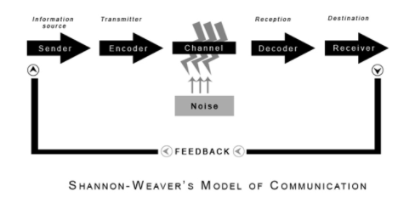
Image 1: Shannon and Weaver Model of Communication
(Source: communicationtheory, 2022)
Maria called Pedro on the telephone to talk about the work they do together. In this case, Maria was the sender, the encoder was the telephone, the channel was the cable, the reception was the telephone and the receiver was Pedro. There was a noise or error in transmission and their communication was affected. Pedro did not fully understand Maria’s message due to crowd noise.

2.2 Schramm (1954)
This communication model was well-known as the Osgood-Schramm model and it was proposed in 1954. This model explained that communication is not linear but it is circular. This model explained that it is a two-way path. The information or message is passed in the receiver and sender continually. This model is based on the topic that the message is to be understood by the receiver and sender (Timony, 2020). The elements of this model are message, Interpreter, Receiver or Decoder, Sender or Encoder. This model stated that the message passes from Encoder to Decoder. However, when the Decoder sends the message the role is reversed. According to this model, there are elements that are necessary to send information. The two elements are receiver and sender. Both of them need to decode and encode the information. It is very important to correctly and effectively interpret the message.

2.3 Berlo (1960)
SMCR communication model was proposed by David Berlo in the year 1960. The acronym SMCR means Sender, Message, Channel and Receiver. This model explained various components that create communication’s basic process (Kalogiannidis and Papaevangelou, 2020). This model emphasises decoding and coding message so it is used for much effective communication. The sender of this model means who created and send the message. The message means the information sent by the sender. The channel explains the way that is utilised to send the information. The receiver receives the message and disrupted communication can damage the communication.
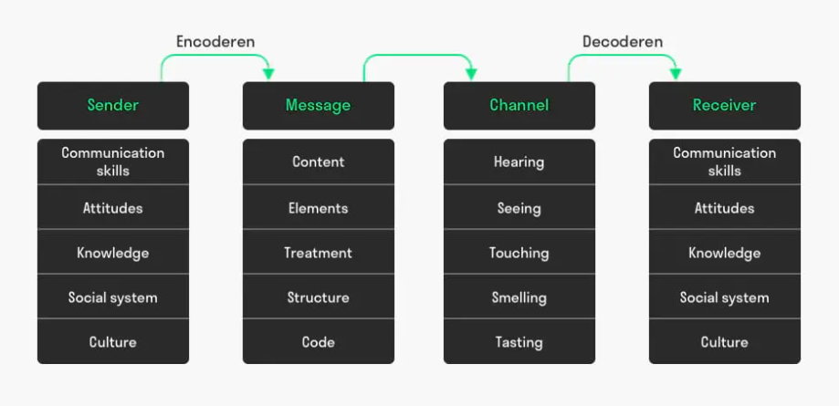
Image 2: Berlo’s Model of Communication
(Source: toolshero, 2022)

3. Skills of Communication

3.1 Verbal Communication
The communication that is verbal means using words to communicate with others. It includes both written and spoken communication. This term is mainly used to express spoken communication. The words are very important in verbal communication as they are listened to and interpreted. Verbal communication needs a speaker and a listener to send and receive messages (Hirsch et al., 2018). Verbal communication cannot be fully separated from non-verbal communication. They are facial expression, tone of voice and body language. Choosing correct words is very important for communication. Only the words are heard by others and the others interpret the words. It is also important to say the words properly as it affects the transmission. The listeners understand the intention of the speaker by the words. People need different words to express themselves in different situations. The listeners can understand if the speaker is feeling nervous or confident with their expressed words. Listening is also very important in verbal communication. Any communication means not only speaking but also listening (Round and Isherwood, 2021). The person should have an open mind and be ready to listen. The listener must concentrate on the speaker’s message. The listeners should avoid distractions and be very objective.
Workplace communication is very important to work efficiently. In my workplace communication is not very efficient. We are working from home for a very long time and could not know each other properly. So we cannot speak with hesitation with each other. We need to communicate more and choose the right words when we interact with each other. We also need to set the right tone and pitch to express ourselves in a better way.

3.2 Non-Verbal Communication
A good part of effective communication is non-verbal communication. It includes gestures, facial expression, body language, and so on. According to many experts, every person responds to many nonverbal behaviours and cues. People can understand many unspoken words by facial expressions like happiness, sadness or anger. Much information can be passed with a frown or smile. The first thing that can be seen is the facial expression of others before any communication. Gestures are also very important in nonverbal communication. Gestures like pointing or waving are very common to use. Posture and body language are also very crucial parts of nonverbal communication (Sutiyatno, 2018). Postures include leg-crossing, arm-crossing and defensive postures to express different messages. These nonverbal behaviours express attitudes and feelings. According to many studies, body language is less defensive and more subtle. The eye gazes are also another important part of nonverbal communication. The pupils dilate and the rate of blinking increases when people see things they like. Gazing can express many emotions like attraction, interest and hostility. Eye gaze is also important to decide if someone is being honest. Steady and normal eye contact can express the truthfulness and trustworthiness of people.

3.3 Listening Skill
Listening skill means the capacity to correctly receive a message and interpret that. Listening skill is very important in communication procedure and it is main key of effective communication. Messages can be misunderstood without good listening ability. The communication process can break down with misunderstanding and the sender can become irritated or frustrated. Individuals must improve their listening skills if they want to improve their communication skills. Many organisations arrange listening training for their employees to improve their skills. Good listening skills also can satisfy more customers, have fewer mistakes and have greater productivity (Egamnazarova and Mukhamedova, 2021). There will also be more innovative and creative work with sharing information. Many successful entrepreneurs and leaders believe their success is for their effective listening skills. Effective listening skills also can improve personal relationships with humans. Listening is not the same as hearing because hearing is the sound that enters people’s ears. Listening means a concentrated effort and focus.

4. The Disadvantages of Modern Technology
Technology has been developed remarkably over the years. There are many organisations like corporate sectors banks that are operating their daily work with the help of modern technology. However, every invention has its advantages and disadvantages. Modern technology also brought many benefits and some problems. Some of the disadvantages of modern technology have been discussed below.
- Identity Theft: Identity theft is a very common problem in the modern world with the help of technology. People view their many important documents via smartphones, tablets or computers. The usage of these modern technology increases the risk of identity theft. Many reports prove that identity theft has increased with the advancement of technology. Identity theft happens mainly on social networking sites, emails and banking websites. People put important and sensitive information in those places (Labong, 2019). It is easier for thieves to steal identities and much important information from those sites as most of them do not have strong protection. The thieves also hack personal computers to steal the identity of people. People set weak passwords in their important accounts such as banking apps. The thieves get benefit from these and hack the accounts. Sometimes thieves get personal information from stolen smartphones of people. People have many important data including their banking information on their phones. Thieves steal information with phishing attacks that lead to identity theft. This problem is increasing rapidly every day. Many organisations are now facing major data breaches over the years (Piquero et al., 2021). They also become the victim of fraud with data breaches. People need to install security software on their digital devices like computers and phones. They should also lock their devices with strong passwords and turn off the Wi-Fi and Bluetooth when they are not needed. They should not open any suspicious links from random emails. People should also give minimum information on their social networking sites. They also should change their passwords after data breaches to prevent further fraudulent activity.
- Cyber Bullying:Cyberbullying is one of the crucial problems that are faced mainly by the young generation. Cyberbullying is mainly happening on social networking sites. People on the internet can be harsh with their opinions. Many people harassed other people without thinking as they are behind anonymous accounts. They do not reveal their true identity and comment harshly on other people’s activities. Many celebrities and public figures also face cyberbullying. People also give threats to other people who they believe doing something wrong. People judge very quickly and express their everyday frustration with others. People also try to intimidate others with their comments on social media (Talpur, Yuhaniz and Amir, 2020). Most of the cyberbullying are done by children and young adults as they have very early access to the internet. Cyberbullying can seriously harm a person’s mental health. The person can develop depression, anxiety or stress. People can also develop low esteem and act out violently.
- Social Interaction: People who spend more time on social media can lose their ability to socially interactions. They also can lose social skills and increase isolation. People cannot communicate properly in society with more social media interaction (Mustafaoğlu et al., 2018). People who spend more time on social media can lose connection with the real world. They can also develop anxiety or depression.

5. Conclusion
In order to conclude, this can be mentioned effective communication is very crucial in every industry of the world. Communication is based on the sender and the receiver. The sender must send the messages correctly to express the information. It is also important to correctly express nonverbal communication like facial expressions and body language. The messages can be misunderstood and misinterpreted if the sender does not send them correctly. This report has been focused on effective communication. So, some models of communication have been described in this report. The communication models by Shannon and Weaver, Schramm, and Berlo have been discussed. Moreover, the communication skills have been elaborated. The communication skills such as verbal communication, nonverbal communication and listening skills have been described. Furthermore, the disadvantages of modern technology have been illuminated. The disadvantages like identity theft, cyberbullying and social interactions have been discussed in this report.

6. References
communicationtheory, 2022. Shannon and Weaver Model of Communication. [online] Communication Theory. Available at: <https://www.communicationtheory.org/shannon-and-weaver-model-of-communication/> [Accessed 1 April 2022].
Egamnazarova, F.A. and Mukhamedova, M.S., 2021. Improving english language listening skill. Academic research in educational sciences, 2(Special Issue 1), pp.28-32. Available at: https://cyberleninka.ru/article/n/improving-english-language-listening-skill
Hirsch, J., Adam Noah, J., Zhang, X., Dravida, S. and Ono, Y., 2018. A cross-brain neural mechanism for human-to-human verbal communication. Social cognitive and affective neuroscience, 13(9), pp.907-920. Available at: https://academic.oup.com/scan/article/13/9/907/5077585
Kalogiannidis, S. and Papaevangelou, O., 2020. Impact of Business Communication on the Performance of Adult Trainees. International Journal of Academic Research in Progressive Education and Development, 9(3), pp.213-222. Available at: https://www.researchgate.net/profile/Stavros-Kalogiannidis/publication/348199192_Impact_of_Business_Communication_on_the_Performance_of_Adult_Trainees/links/5ff9db9d92851c13feffb3a6/Impact-of-Business-Communication-on-the-Performance-of-Adult-Trainees.pdf
Kubota, M., 2019. What is “Communication”?―Beyond the Shannon & Weaver’s Model―. International Journal, 13(1), pp.54-65. Available at: https://jaems.jp/contents/icomej/vol13/06_Kubota.pdf
Kuznar, L.A. and Yager, M., 2020. The Development of Communication Models, Quick Look. Joint Staff J39, Strategic Multi-layer Assessment Washington, DC United States. Available at: https://apps.dtic.mil/sti/pdfs/AD1118283.pdf
Labong, R.C., 2019. Identity Theft Protection Strategies: A Literature Review. Journal of Academic Research, 4(2), pp.1-12. Available at: https://jar.ssu.edu.ph/index.php/JAR/article/download/1/1
Mustafaoğlu, R., Zirek, E., Yasacı, Z. and Özdinçler, A.R., 2018. The negative effects of digital technology usage on children’s development and health. Addicta: The Turkish Journal on Addictions, 5(2), pp.13-21. Available at: https://www.researchgate.net/profile/Rustem-Mustafaoglu/publication/325263798_The_Negative_Effects_of_Digital_Technology_Usage_on_Children's_Development_and_Health/links/5b027b564585154aeb061acf/The-Negative-Effects-of-Digital-Technology-Usage-on-Childrens-Development-and-Health.pdf
Piquero, N.L., Piquero, A.R., Gies, S., Green, B., Bobnis, A. and Velasquez, E., 2021. Preventing identity theft: perspectives on technological solutions from industry insiders. Victims & offenders, 16(3), pp.444-463. Available at: https://research.monash.edu/files/334019011/333799780_oa.pdf
Round, M. and Isherwood, P., 2021. Speech intelligibility in respiratory protective equipment-Implications for verbal communication in critical care. Trends in Anaesthesia and Critical Care, 36, pp.23-29. Available at: https://www.ncbi.nlm.nih.gov/pmc/articles/PMC7428718/
Sutiyatno, S., 2018. The effect of teacher's verbal communication and non-verbal communication on students' English achievement. Journal of Language Teaching and Research, 9(2), pp.430-437. Available at: http://www.academypublication.com/issues2/jltr/vol09/02/28.pdf
Talpur, K.R., Yuhaniz, S.S. and Amir, N.N.B., 2020. Cyberbullying detection: Current trends and future directions. Journal of Theoretical and Applied Information Technology, 98(16), pp.3197-3208. Available at: http://eprints.utm.my/id/eprint/90501/1/SitiSophiayatiYuhaniz2020_CyberbullyingDetectionCurrentTrendsAndFutureDirections.pdf
Timony, K., 2020. Say What You Mean to Say: Unpacking the Complexities of Communication Between Patients and Their Providers. Available at: https://scholarworks.arcadia.edu/cgi/viewcontent.cgi?article=1013&context=galileo
toolshero, 2022. Berlo's SMCR Model of Communication. [online] toolshero. Available at: <https://www.toolshero.com/communication-skills/berlos-smcr-model-of-communication/#:~:text=David%20Berlo's%20SMCR%20Model%20of,the%20basic%20process%20of%20communication> [Accessed 1 April 2022].

