LCBB5005

Bee House Project

Made for
Molly Jack
Made by
Evelina Emilova
1818673

Table of Contents
Introduction 3
Project management 3
Life cycle of the Project 4
Different methodologies used in project management 4
Benefits of different project methodologies 6
Limitations of different project methodologies 7
Application of project management in real world scenario 8
Project management plan (PMP) 8
Time needed 9
Cost and benefit realization 10
Involvement of risks 10
Challenges in project execution 11
Concern of stakeholders 11
Knowledge areas 11
WBS 11
Critical analysis of the project 12
Conclusion 12
Reference 14

Introduction
Project management is a very important part of any business organisation. In order to expensive business the management of the business organisation is needed to invest in different project. It is important for the management of the business organisation to analyse and evaluate the proposal of them project properly before investing in the project. With the help of different project and investment appraisal technique, the managers and the management of the business organisation can evaluate the proposal of the project. After investing in the project, it is important for the project manager to use the proper methodology for successful completion of the project. There are various risks and uncertainties are always involved in the project. With the help of proper planning and execution of strategies, the project manager can complete the project successfully. In this document a real world scenario of the project management has been discussed with the help of a brief project management plan (PMP).

Project management
The term project management can be defined as the method or procedure of achieving the success with the help of a particular group of people by following some particular criteria within a specific period of time (What is project management?, 2020). The person who is responsible for successful completion of the project is known as the project manager. It is important for the project manager to achieve all of the variables and criteria in order to complete the project successfully. The budget of the project should not be exceeded for successful completion. In order to complete the project successfully a wide range of skills and knowledge (both of the technical and theoretical) is required (What is project management?, 2020). In order to overcome the difficulties of project management and for successful completion of the project management plan (PMP) should be prepared by the project manager.

Life cycle of the Project
Life cycle of a projct refers to the whole time used for making the project starting at the initiation phase followed by planning and execution phase and ending at the project closure phase. The concerned project took 16 weeks including all these four phases.
Project goals and objectives:
The main goals of the concerned project are to sell quality honey products in the market and maximise profit of the company.
Objectives of the project are as follows:
- To sell quality honey products among customers
- To distribute honey products in different other market regions for increasing customer base
- To maximise profit and revenue o the company

Different methodologies used in project management
In order to complete the project successful if there are several methodologies which are used in the project management. The project manager can decide to use the appropriate and most suitable method as per the requirement of the project(Muslihat and Team, 2020). This is why the project manager should be aware about the concept as well as the application of different methodologies of project management. Some of the most common and popularly used methodologies of project management has been discussed below along with their benefits and limitation.

Agile
Agile is one of the most important methodology which is used in the project management. This methodology is used mainly where the project required a high range of flexibility. In case of the handling the project page has a high range of complexity or uncertainty involved, this method is best suited(Muslihat and Team, 2020).

Scrum
Scrum is also another very popular method of project management. This method is used when flexibility is needed for delivering the project. In this methodology 5 different values are involved. These values are - commitment, courage, focus, openness and respect(Muslihat and Team, 2020). This project methodology helps in delivering the project bike collaboration.

Kanban
Kanban is also useful for the project which is needed to be handled by small groups or team and need a higher flexibility for delivering. In case of personal productivity purpose, this methodology is highly useful. This methodology was first used by the Toyota factories in the decade of 1940s.

Lean
Lean production is also another important methodology in the project management which is also started its journey from the Japanese manufacturing industry. This methodology is best suited where diffident manufacturing work is going on and needed to be reduced the mistakes(Sunder, 2016). This methodology can help the business organisation and the project manager in reducing the amount of waste.

Waterfall
The waterfall model is one of the most traditional and oldest model in the project management methodology. This model uses a linear and sequential approach for conducting the activities in the project(Muslihat and Team, 2020). The project where deadline matters the most, the waterfall model is the most helpful for those projects.

Six sigma
The six sigma methodology is comparatively new in the field of project management. This methodology was introduced by the Motorola company at the year of 1986(Anbari, 2018). The project where standard and quality is needed to be focused above anything else, application of six sigma methodology is most appropriate. The six sigma methodology is better applicable in the larger business organisation.

PMI / PMBOK
PMI stand for Project Management Institute while PMBOK stand for Project Management Body of Knowledge. Both of the methodology is used by the project manager, when a particular set of terminology and guidelines are needed to be followed(Muslihat and Team, 2020). PMI and PMBOK are the guidelines which can be applied in any project for improving the practice of the project management.

PRINCE2
PRINCE2 is one of the most useful and widely used project management method in the world. Different range of organisation and individuals from different industries and sector uses this method for achieving the success in project management(Jamali and Oveisi, 2016). The PRINCE2 methodology is a combination of the four most useful and important element which is needed for successful completion of the project management. These three elements are - principal, theme, process, and the project environment.
A detailed project management plan for the concerned project has been prepared in the following section:
Tasks of Project | Scheduling for Communication | Resources required for completing the tasks | Initiator of Tasks for Project | Time span
Selection of beekeeping area | Within first 2 weeks of initiation of project | Human and capital resources | Project Manager | 2 weeks
Nourishing of bees | Next 3 weeks from the starting day of project | Human resources | Responsible team workers | 3 weeks
Production of honey | Next 5 weeks after nourishment of bees | Production equipments/ machinery and human labour | Assistant project manager and labourers | 5 weeks
Collection of honey | 3 weeks | Production equipments/ machinery and human labour | Labourers | 3 weeks

Processes of Prince 2 in a project plan have been justified in the following section:
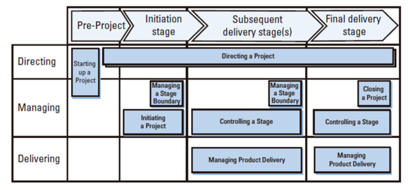
Figure 1: Processes of Prince2
(Source: Simplilearn.com. 2020)

Pre Project stage- In this phase, project planners of this concerned planning work have focused on selection of appropriate beekeeping area. Project managers along with assistant managers have directed other laborers for initiating such task in order to meet goals on time.

Initiation stage- For initiation, bees is properly nourished so as to extract honey and manufacture products (Naik and Jenkins, 2019).
- Subsequent delivery stage- Production works are well controlled and appropriate technologies will be used for extracting honey from bees. Also, quality of products will be scrutinized prior in proceeding with delivery stage.
- Final delivery stage- Prior in closing of the project, processes of collecting honey and effective market segments will be identified.
Thus, through directing, managing and delivering, the whole project will be completed within scheduled time period.

Benefits of different project methodologies

Agile
- Agile method can help the project manager in deploying the software faster(Olic and Hische, 2020).
- Also the amount of wastage can be minimised with the help of this method.
- The method agile help in better adaptation in case of any change. Also it responds faster than any other method in case of any change(Olic and Hische, 2020).
- This method helps in detecting and fixing different issues in the project very quick.
- Immediate feedback can be found in this method.

Lean
- The lean model under project management help the manager in decreasing the overall cost of the project(Status Articles, 2020).
- Also this method can help the project team in improving the interaction with the customers.
- The quality and standard of the project become better because of the lean management.
- The employee engagement can be improved by improving the model of the employee with the help of this model(Status Articles, 2020).
- Also the culture of the project team can we improve face can help in improving the overall performance of the project team.

Waterfall
- One of the most important benefit of waterfall model under project management is this method used is a clear structure for completion of the project. Because of following each and every step properly and based on a suitable sequence, the completion of task become easier(Lucidchart Content Team, 2020).
- Also this method determines the goals of the project at the starting of any activity. This is my completion of the project become easier.

Six sigma
- The method of Six Sigma can help in ensuring the quality of the output in the manufacturing product and process of the business.
- Also this method can increase the customer satisfaction by optimising the supply chain process(Muhoro, 2019).
- The six sigma method can help the management of the business organisation in solving the problem in a simple and effective manner(Anbari, 2018).
- Also Six Sigma is a proactive methodology which can help in identifying and providing recommendation to the manager to prevent the loss or any difficult situation(Anbari, 2018).

PRINCE2
- PRINCE2 help the project manager in ensuring the best practices in the project management.
- The use of PRINCE2 method is generic. This is by any project from any industry or sector can use this method(Buehring, 2020).
- It also helps in maintaining a better communication.
- The method of PRINCE2 has a better accountability than any other method(Buehring, 2020).
- Also PRINCE2 focuses on the output or the deliverable element of the project for the better result.
- Adopting the method of PRINCE2 can you help the organisation by saving the time(Jamali and Oveisi, 2016).
- Also this methodology has an inbuilt mechanism for continuous improvement which help the project manager in maintaining the standard and quality of the project.

Limitations of different project methodologies

Agile
- Because of high documentation responsibility, the speed of this project cannot be higher(Olic and Hische, 2020).
- This method needs more time and energy from the workers because of the constant interaction with the customers and developer.

Lean
- In case of using the lean model, conducting any change in case of necessary can become difficult because of the rigid nature of this model(Status Articles, 2020).
- This model has a high implementation cost which can reduce the profit of the project.

Waterfall
- Because of the traditional and rigid approach of this model, the scenario become critical in case of any changes is needed to be conducted.
- The opinion and the feedback from the client or the end user is not considered under this model(Lucidchart Content Team, 2020).

Six sigma
- The method of Six Sigma inspects each and every procedure of business organisation which can create a higher amount of empirical data(Muhoro, 2019).
- The use of Six Sigma method is time consuming as well as has several complicated procedures.

PRINCE2
- One of the most important disadvantage of PRINCE2 is this method does not have many Tools and techniques(Buehring, 2020).
- In order to apply and use the method of PRINCE2 proper experience and knowledge is required(Jamali and Oveisi, 2016).
- Also this method has a heavy documentation requirement.
- This method does not support any other method other than waterfall model(Buehring, 2020).

Application of project management in real world scenario
Project management is one of the most practical approach which is used by the project manager for completion of the real world project. In this document of a project regarding the beekeeping has been considered for explaining the benefit of project management. In this project, the beekeeper is needed to extract the honey from the beehive for selling and earning the profit.

Project management plan (PMP)
The project management plan also known as the project plan is a formal document who is help the project manager in providing the guidance for execution of the project to complete the project successfully. It is important to remember that the project manager should complete the project within the scheduled timeline and within the budgeted amount(The Project Management Plan (PMP), 2020). The project management plan is a document which has a set of strategies for guiding the project by fulfilling the required criteria. The project management plan must include several components including - the concern regarding the stakeholders, cost benefit analysis of the project, risk analysis, the guidance regarding the timeline of project(The Project Management Plan (PMP), 2020). The project friend regarding the above mentioned project has been prepared below.

Time needed
In order to complete the project successfully it is important for the project manager to achieve the objectives of the project within the specific time. In this business of beekeeping, it is important for the project manager to find out the time line which is needed for producing the product (honey), collection of the product as well as distributing the product among the customers in the target market. The main aim of preparing ad maintaining project timeline is to complete all the tasks of the project on time and meet customers’ expectations in market. Also, timely completion of the project will help in focussing on other aspects of business expansion. The timeline of this project has been projected with the help of Gantt chat in below.
Activities | Weeks
Activities | 1 | 2 | 3 | 4 | 5 | 6 | 7 | 8 | 9 | 10 | 11 | 12 | 13 | 14 | 15 | 16
Choosing the area for beekeeping
Setting the bee house
Purchasing the adequate number of bees
Nourishing the bees to complete the honeycomb
Production of honey
Collecting the honey
Distribution of honey in the market
Collecting the profit

Cost and benefit realization
The budget of the project is £ 50000.
The estimated budget of this project has been attached below.
Particulars | Amount (£)
Purchase of bees | £ 10000
Purchase of bee house | £ 5000
Necessary equipment | £ 5000
Honey collection tools | £ 20000
Protective gears | £ 5000
Total | £ 45000

The expected sales of honeyfrom this project has been attached below.
Particulars | Amount (£)
August | £10000
September | £12000
October | £17000
November | £21000
December | £24000
January | £28000
Total | £ 91000

Involvement of risks
Any business or project includes several risks which cannot be eliminated completely but it can be minimised. In this business scenario, it can be said that the target market of the product should be understood properly in order to avoid the unnecessary risk. Also both of the supply and distribution channel for raw material and product should be prepared properly to avoid the hindrance. Another important risk of beekeeping is maintaining a financial source for fund. Proper investment should be ensured by the project manager in order to continue the business smoothly.

Challenges in project execution
One of the most important challenges in beekeeping business is Colony Collapse Disorder (CCD). TheColony Collapse Disorder(CCD) can create a huge problem for the beekeeper in continuing the business without any hindrance(Solomon, 2020). Also this problem can spread very fast. Another important challenge for beekeeping business is the warm weather. In the high warm weather majority of the categories of bees fails to survive. This is why maintaining the weather around the beehive is also very important challenge for the beekeepers. Also several challenges regarding the virus, lack of drought and forage et cetera can create difficulties for the beekeepers (Solomon, 2020).

Concern of stakeholders
The stakeholders of the business organisation include all of the employees, workers, suppliers and the shareholders and investors of the organisation. From the perspective of the stakeholders of the business organisation it can be said that the planning of the project should be conducted after concerning with all of the stakeholders of the organisation. Also the profitability of the stakeholders should be ensured while preparing the strategies of the project. The investors and shareholders of the business organisation should be insured about the profitability of the project and a proper communication with all of the stakeholders must be maintained from the end of the project manager.

Knowledge areas
For managing the present project, the concerned knowledge aspects included knowledge regarding equipments needed in the whole process, region-specific knowledge from professional beekeeprs, knowledge regarding markets for earning profit from this project, etc. Moreover, knowledge regarding project management was also used, such as executing plans as per the time schedules, organizing the plans, etc.

WBS
The Work Breakdown Structure (WBS) of the concerned project is as the following:
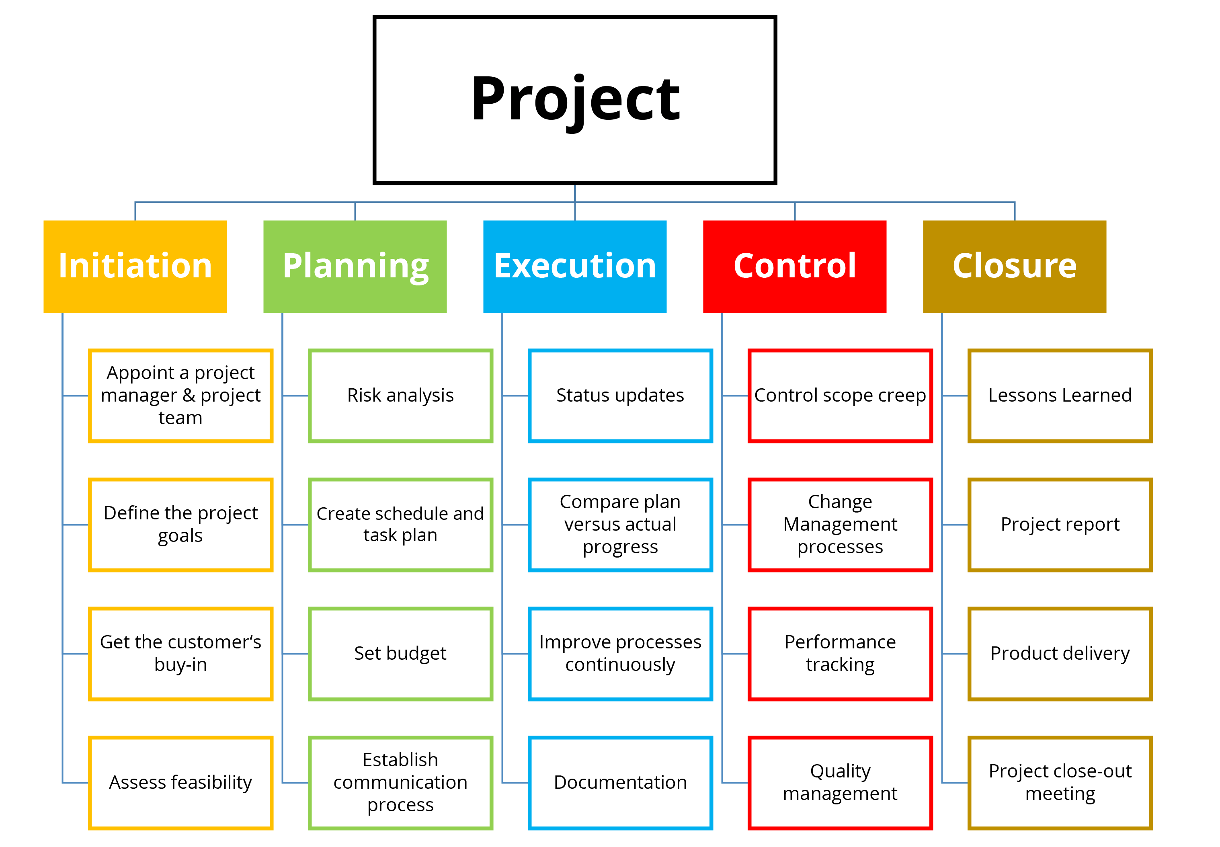

Critical analysis of the project
The successful aspects of the project were timely implementation of the project plans followed by timely delivery of the aimed product. However, on the other side, limited knowledge regarding the business in such short time was a critical issue to be managed for the present project.

Conclusion
In the conclusion of this document it can be said that it is important for any business organisation or any individual who is starting a project or business to have a proper idea and knowledge regarding the procedure of successful completion of the project. In order to complete the project successfully it is important for the project manager to achieve the objective of the project within the scheduled timeline and estimated budget. Also it is important to remember that there are several methodologies which can be used in a project. The project manager should choose the appropriate and suitable methodology for completion of the project successfully. In the given case scenario, it can be said that there are various risks and challenges are involved in the project of beekeeping. With the help of proper planning and execution of the strategies the project manager can complete the project in a successful way.

Reference
2020 Project Management. 2020. The Project Management Plan (PMP). [online] Available at: <https://2020projectmanagement.com/resources/project-planning/the-project-management-plan-pmp> [Accessed 21 August 2020].
Anbari, F.T., 2018. Innovation, project management, and Six Sigma method. Current Topics in Management: Volume 10.
Apm.org.uk. 2020. What Is Project Management?. [online] Available at: <https://www.apm.org.uk/resources/what-is-project-management/#:~:text=Project%20management%20is%20the%20application,a%20finite%20timescale%20and%20budget.> [Accessed 21 August 2020].
Buehring, S., 2020. PRINCE2 Benefits. [online] Knowledge Train. Available at: <https://www.knowledgetrain.co.uk/project-management/prince2/prince2-benefits> [Accessed 21 August 2020].
Jamali, G. and Oveisi, M., 2016. A study on project management based on PMBOK and PRINCE2. Modern Applied Science, 10(6), pp.142-146.
Lucidchart Content Team, 2020. The Pros And Cons Of Waterfall Methodology. [online] Lucidchart.com. Available at: <https://www.lucidchart.com/blog/pros-and-cons-of-waterfall-methodology> [Accessed 21 August 2020].
Muhoro, N., 2019. Advantages & Disadvantages Of Six Sigma. [online] Small Business - Chron.com. Available at: <https://smallbusiness.chron.com/advantages-amp-disadvantages-six-sigma-43963.html> [Accessed 21 August 2020].
Muslihat, D. and Team, Z., 2020. 7 Popular Project Management Methodologies | Zenkit. [online] Zenkit. Available at: <https://zenkit.com/en/blog/7-popular-project-management-methodologies-and-what-theyre-best-suited-for/> [Accessed 21 August 2020].
Naik, N. and Jenkins, P., 2019, October. A Web Based Method for Managing PRINCE2® Projects Using Trello®. In 2019 International Symposium on Systems Engineering (ISSE) (pp. 1-3). IEEE.
Olic, A. and Hische, J., 2020. Advantages And Disadvantages Of Agile Project Management [Checklist] · Activecollab Blog. [online] ActiveCollab. Available at: <https://activecollab.com/blog/project-management/agile-project-management-advantages-disadvantages> [Accessed 21 August 2020].
Simplilearn.com. (2020). Seven Processes Of PRINCE2®. [online] Available at: <https://www.simplilearn.com/prince2-processes-article> [Accessed 27 November 2020].
Solomon, G., 2020. [online] Beesfordevelopment.org. Available at: <http://www.beesfordevelopment.org/media/2742/chapter-15.pdf> [Accessed 21 August 2020].
Status Articles, 2020. 6 Benefits Of Lean Management (And 4 Disadvantages) - Status Articles. [online] Status Articles. Available at: <https://status.net/articles/lean-management/> [Accessed 21 August 2020].
Sunder M, V., 2016. Lean six sigma project management–a stakeholder management perspective. The TQM Journal, 28(1), pp.132-150.

