

Student name: Yuliia Silman
Student ID: 2431446

Module name: Introduction to Physiology
Module code: BMHP5023
Lecturer name: Shaila Hussain

Assessment: Type 2 Diabetes Management and Blood Glucose Monitoring (Case study report)

Table of Contents
1. Introduction 3
2. Blood Glucose Regulation 4
3. Cellular Metabolism 6
4. Monitoring and Recording Blood Glucose Levels in Type 2 Diabetes 7
5. Recommendations 8
6. Conclusion 9
References 10

1. Introduction
Diabetes is one of the most significant and fastest-growing health issues that affects millions of individuals worldwide. According to the International Diabetes Federation (IDF) (2025), around 589 million adults are currently living with the condition globally. The prevalence in the United Kingdom is also concerning, with over 5.8 million individuals affected by diabetes in 2023-24, including undiagnosed cases, representing the highest recorded prevalence to date (Diabetes UK, 2024).
Diabetes develops when the body is unable to control blood glucose (blood sugar) levels appropriately, either by not producing enough insulin or by using insulin ineffectively (World Health Organization, 2024). Insulin is secreted by the pancreas, which is part of the endocrine system responsible for regulating blood glucose levels. If this process is disrupted, glucose accumulates in the bloodstream, which over time can lead to serious health complications (Figure 1).
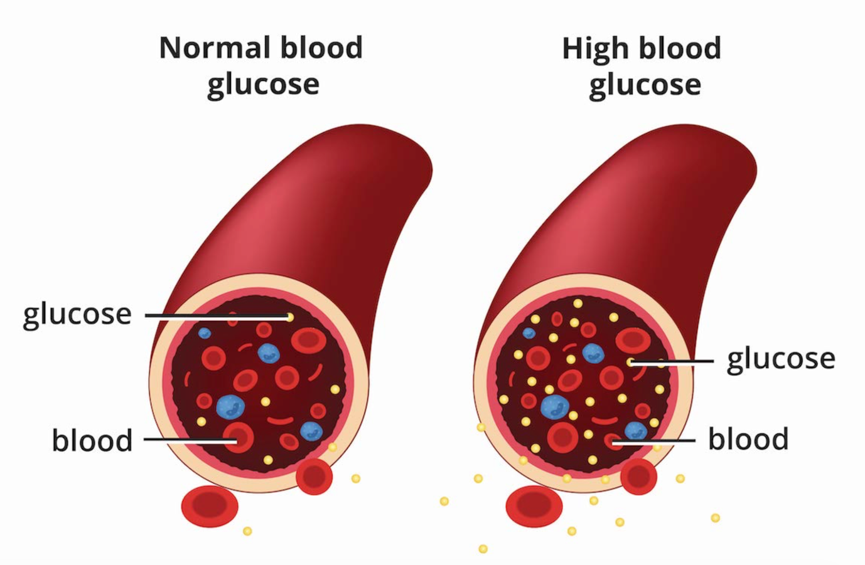
Figure 1. Comparison of normal and high blood glucose levels in the bloodstream (National Institute of Diabetes and Digestive and Kidney Diseases, 2023).
Diabetes can develop in different forms; however, the majority of cases are classified as type 1 and type 2. Type 1 diabetes is an autoimmune condition characterised by insulin deficiency, which requires lifelong insulin therapy. In contrast, type 2 diabetes is more commonly linked to lifestyle and metabolic factors such as excess body weight, lack of physical activity and unhealthy diet, as well as other risk factors including higher age, ethnicity and family history (IDF, 2025). As many of these factors are related to lifestyle and behaviour, the condition is therefore more closely associated with prevention and long-term management strategies.
This report will examine the processes of blood sugar regulation, how cellular metabolism contributes to producing energy, and how monitoring and lifestyle changes can support individuals in managing type 2 diabetes.

2. Blood Glucose Regulation
Regulating blood glucose levels is an important physiological process that maintains glucose concentrations in a normal range to ensure the body receives the necessary energy. The endocrine system, particularly the pancreas, controls this process by releasing hormones including insulin and glucagon, which take a part in the regulation of blood glucose levels. Maintaining stable blood glucose levels is necessary for normal cellular function. This is particularly important for organs such as the brain, which require glucose as a main energy source.
One of the key hormones involved in this process is insulin. In response to increased blood glucose levels, for example after food intake, the pancreas releases insulin, specifically from beta cells in the islets of Langerhans. Insulin helps glucose enter cells, particularly in muscle and adipose tissue, while also promoting the conversion of glucose into glycogen in the liver. As a result, blood glucose levels decrease, which helps prevent hyperglycaemia. In addition, insulin reduces glucose production in the liver, further supporting the regulation of blood glucose control (Rahman et al., 2021).
In contrast, during fasting, when blood glucose levels decline, glucagon is released by the pancreas from the alpha cells. Glucagon primarily works on the liver by breaking down glycogen into glucose (glycogenolysis) and promoting the production of new glucose (gluconeogenesis). This raises blood glucose levels and helps provide the body with a continuous energy supply, particularly during periods without food intake. Glucagon counteracts the effects of insulin, maintaining a balanced system that supports stable blood glucose levels (Gylfe and Gilon, 2014). Through this mechanism, blood glucose is maintained within a normal physiological range of approximately 70–110 mg/dL, as shown in Figure 2.
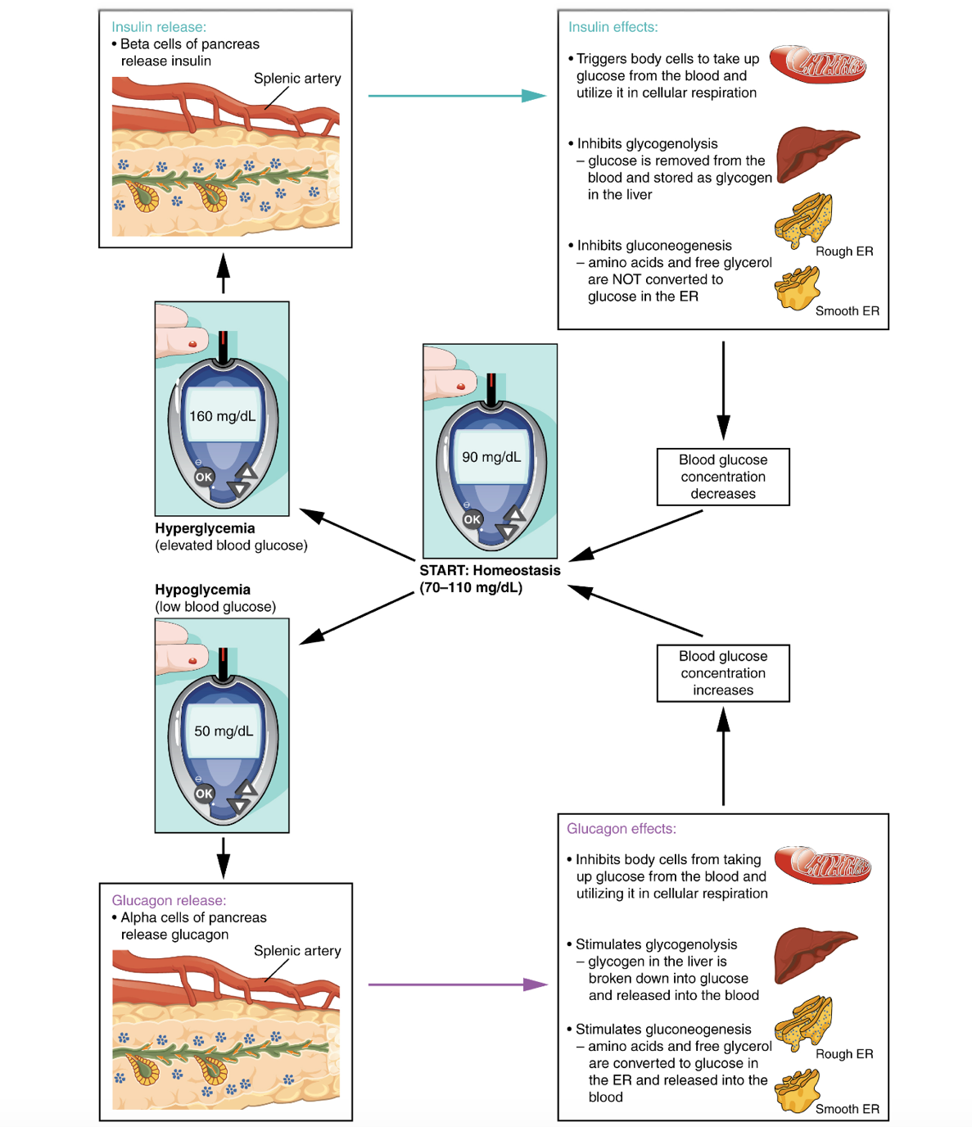
Figure 2. Homeostatic regulation of blood glucose levels (OpenStax, 2023).
This interaction between insulin and glucagon works through a negative feedback mechanism, essential for maintaining homeostasis in the body. However, this system fails to function effectively in individuals with type 2 diabetes. In this condition, cells in the body develop insulin resistance, resulting in reduced glucose absorption despite the presence of insulin. Consequently, blood glucose levels remain increased, leading to chronic hyperglycaemia. Additionally, an imbalance in hormonal response further contributes to the development of the condition and its associated complications (Holst, Gasbjerg, and Rosenkilde, 2021).
Overall, blood glucose regulation is a complex but well-coordinated process involving the contrasting actions of insulin and glucagon through hormonal control and feedback mechanisms. The imbalance seen in type 2 diabetes highlights the importance of maintaining effective glucose regulation to reduce the risk of long-term complications.

3. Cellular Metabolism
Once blood glucose levels are regulated in the bloodstream, glucose must be effectively used by cells to support energy production. Cells are the basic structural and functional components of the body and require a continuous supply of energy to perform their functions. Cellular metabolism involves the processes by which cells produce and use energy to maintain normal physiological functions. This energy is primarily supplied by glucose, which is transported into cells and used in metabolic processes to maintain life (Minett and Ginesi, 2020).
Glucose acts as the main source of energy for cells. After entering the cell, it goes through a series of metabolic processes to produce energy. To produce energy in the form of adenosine triphosphate (ATP), glucose is broken down using oxygen in a process known as aerobic respiration. ATP is essential as it provides the energy required for functions such as movement, growth, and transport within cells. This highlights the importance of efficient energy production for maintaining normal cellular activity.
Mitochondria play a key role in cellular metabolism by producing most of the cell’s energy. The number of mitochondria in a cell is related to its energy requirements; for example, highly active cells, such as liver cells, contain a greater number of mitochondria (Minett and Ginesi, 2020). This also shows their importance in supporting cellular function, particularly in cells with higher energy requirements.
Processes such as active transport require ATP, as they involve the movement of molecules across the cell membrane against their concentration gradient. This means that cells need a continuous supply of energy from glucose to perform essential functions. Insulin supports this process by helping glucose enter cells. In individuals with type 2 diabetes, this process is disrupted due to insulin resistance, meaning glucose remains in the bloodstream while cells do not receive enough energy. This affects normal cellular function and contributes to the development of symptoms and related complications (Rahman et al., 2021). These changes are not always immediately noticeable, which can delay diagnosis and management.
As a result of impaired cellular metabolism, consistently high blood glucose levels can damage multiple body systems. It is linked to a range of complications, such as cardiovascular disease, as well as damage to the nerves (neuropathy), kidneys (nephropathy), and vision problems (retinopathy). These conditions often develop gradually and may not be recognised in the early stages. (IDF, 2025).
Cellular metabolism is essential for producing energy from glucose. Disruption of this process, as seen in type 2 diabetes, can significantly affect cellular function and overall health.

4. Monitoring and Recording Blood Glucose Levels in Type 2 Diabetes
Effective blood glucose level monitoring plays an important role not only in individual health but also for reducing the wider impact of diabetes. In the United Kingdom, diabetes is estimated to cost the National Health Service (NHS) around £10.7 billion per year, with a significant amount of this spending connected to complications (Diabetes UK, 2024).
Individuals diagnosed with type 2 diabetes are required to monitor and record their blood glucose levels. This helps them keep their levels within a healthy range and track changes in their condition. Over time, insulin resistance develops, which can lead to consistently elevated blood glucose levels without obvious symptoms. As a result, self-monitoring of blood glucose (SMBG) helps identify changes that may not be obvious and supports ongoing management of the condition.
Monitoring blood glucose is essential for effective control. Regular measurements help individuals identify patterns in their levels and understand how factors such as diet, physical activity, and medication affect them. This helps individuals adjust their daily behaviours and treatment based on their blood glucose levels. Monitoring can also help detect episodes of hyperglycaemia and hypoglycaemia, allowing timely action to prevent further complications (Klonoff, 2007).
Monitoring also supports self-management and increases patient awareness. Individuals who regularly track their blood glucose levels develop a better understanding of their condition and are more likely to notice changes early. This can encourage positive behavioural changes and improve engagement with treatment plans. In addition, recorded data can be shared with healthcare professionals, supporting more personalised and effective care.
However, the effectiveness of self-monitoring in individuals with type 2 diabetes, particularly those not using insulin, can vary. In some cases, regular monitoring does not lead to clear improvements in blood glucose levels. Therefore, SMBG is often used based on the patient’s needs and treatment plan (Klonoff, 2007).
If blood glucose levels are not regularly monitored, individuals may not recognise long periods of hyperglycaemia. Over time, a lack of monitoring can increase the risk of developing significant health complications, including kidney damage, cardiovascular disease, and neuropathy. In addition, episodes of hypoglycaemia may not be recognised, which can lead to serious health risks. Poor control of blood glucose levels can negatively affect quality of life.
Overall, monitoring and tracking blood glucose levels is an important part of managing type 2 diabetes. It supports early detection of changes, helps individuals adjust their behaviours and treatment, and reduces the risk of both short and long-term complications.

5. Recommendations
Effective management of type 2 diabetes requires lifestyle changes, regular monitoring, and personalised healthcare support. According to the National Institute for Health and Care Excellence (NICE) (2022), care should be individualised and supported through structured education to help individuals manage their condition more actively.
Dietary changes are essential in improving health outcomes. Individuals are advised to maintain a balanced diet that includes whole grains, vegetables and fibre, while reducing the sugar intake and saturated fats, which are commonly found in processed and high in fat foods. Weight management is another important part of diabetes management, and NICE recommends a gradual weight loss of approximately 5–10% of body weight, which can enhance insulin sensitivity and lower the risk of complications.
Regular physical activity is also important. According to the NHS (2025), individuals are recommended to complete a minimum of 150 minutes of moderate physical activity each week, for example walking or cycling, alongside strength-based activities at least twice a week. These changes can help lower blood glucose levels and support overall cardiovascular health.
Individuals should also attend regular health check-ups, follow medical advice, and receive ongoing support from healthcare professionals. Smoking cessation and reducing alcohol intake can further improve long-term outcomes. Overall, combining personalised care with consistent lifestyle changes can improve quality of life and support effective diabetes management.
However, the effectiveness of these strategies may vary depending on individual circumstances. Some individuals may find it difficult to make or maintain lifestyle changes due to factors such as limited access to healthcare, lack of support, or personal motivation. This shows that managing type 2 diabetes requires a personalised approach rather than relying only on general advice.

6. Conclusion
Type 2 diabetes is a complex condition affecting the body’s ability to regulate and use glucose. This report has shown that maintaining stable blood glucose levels depends on the coordinated actions of hormones such as insulin and glucagon. When this balance is disrupted, as seen in type 2 diabetes, glucose remains in the bloodstream, increasing the risk of serious health complications.
The discussion of cellular metabolism highlighted the importance of glucose as a main energy source and how reduced glucose absorption can affect normal cell function. In addition, monitoring blood glucose levels plays an important role in identifying changes early and supporting ongoing management of the condition.
Overall, effective management of type 2 diabetes requires a combination of regular monitoring, lifestyle changes, and personalised support. As many risk factors are linked to lifestyle and behaviour, early intervention and effective prevention strategies are essential in reducing the long-term impact of the condition on both individuals and healthcare systems.

References
- Diabetes UK (2024) How many people in the UK have diabetes? Available at: https://www.diabetes.org.uk/about-us/about-the-charity/our-strategy/statistics (Accessed: 16 March 2026)
- Gylfe, E. and Gilon, P. (2014) ‘Glucose regulation of glucagon secretion’, Diabetes research and clinical practice, 103(1), pp. 1–10. Available at: https://doi.org/10.1016/j.diabres.2013.11.019 (Accessed: 17 March 2026)
- Holst, J.J., Gasbjerg, L.S. and Rosenkilde, M.M. (2021) ‘The Role of Incretins on Insulin Function and Glucose Homeostasis’, Endocrinology (Philadelphia), 162(7), p. 1. Available at: https://doi.org/10.1210/endocr/bqab065 (Accessed: 20 March 2026)
- International Diabetes Federation (IDF) (2025) IDF Diabetes Atlas 11th Edition. Available at: https://international-diabetes-federation.s3.eu-west-1.amazonaws.com/media/uploads/sites/3/2025/10/IDF_Diabetes_Atlas_11th_Edition_2025_WEB.pdf (Accessed: 15 March 2026)
- Klonoff, D.C. (2007 ‘Benefits and Limitations of Self-Monitoring of Blood Glucose’, Journal of diabetes science and technology, 1(1), pp. 130–132. Available at: https://doi.org/10.1177/193229680700100121 (Accessed: 23 March 2026)
- Minett, P.M. and Ginesi, L. (2020) Anatomy & physiology: an introduction for nursing and healthcare. Banbury: Lantern.
- . National Health Service (NHS) (2025) Treatment for type 2 diabetes. Available at: https://www.nhs.uk/conditions/type-2-diabetes/treatment/ (Accessed: 24 March 2026)
- National Institute for Health and Care Excellence (NICE) Type 2 diabetes in adults: management. Available at: https://www.nice.org.uk/guidance/ng28/resources/type-2-diabetes-in-adults-management-pdf-1837338615493 (Accessed: 25 March 2026)
- National Institute of Diabetes and Digestive and Kidney Diseases (2023) What is diabetes? Available at: https://www.niddk.nih.gov/health-information/diabetes/overview/what-is-diabetes (Accessed: 14 March 2026)
- OpenStax (2023) Anatomy and physiology, 2e. 2e. Houston, Texas: OpenStax.
- Rahman, M. S., Hossain, K. S., Das, S., Kundu, S., Adegoke, E. O., Rahman, Md. A., Hannan, Md. A., Uddin, M. J., & Pang, M.-G. (2021) ‘Role of Insulin in Health and Disease: An Update’, International Journal of Molecular Sciences, 22(12), 6403. Available at: https://doi.org/10.3390/ijms22126403 (Accessed: 17 March 2026)
- World Health Organization (2024) Diabetes. Available at: https://www.who.int/news-room/fact-sheets/detail/diabetes (Accessed: 14 March 2026)

