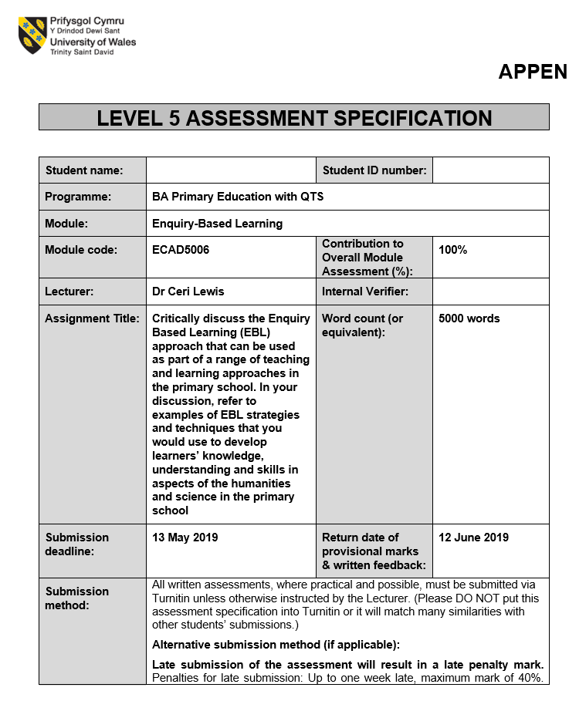
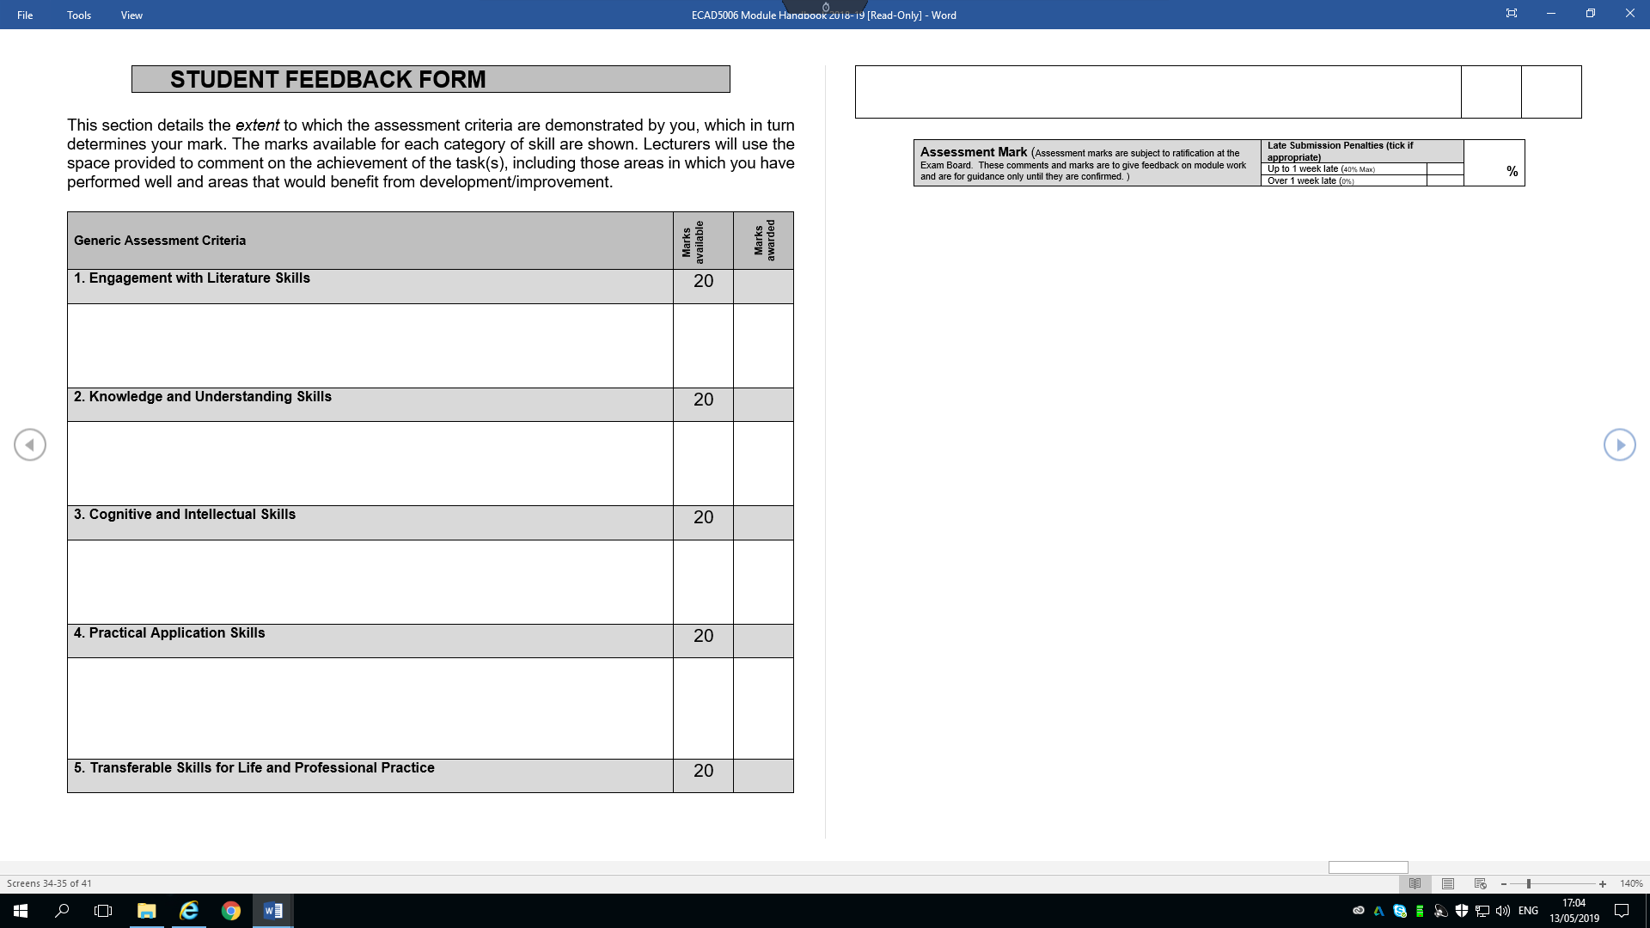

This assignment aims to develop knowledge, understanding and critical awareness of Enquiry Based Learning (EBL). Once this is achieved, the teacher will then be able to critically identify specific enquiry skills and how they can be developed with children aged 3-11 years old through a geographic, historical, religious or scientific context. EBL is defined as a teaching strategy “compatible with the constructivist approach, which emphasizes the idea that knowledge is not transmitted directly from the teacher to the student, but actively developed by the student” (Zion, Mendelovici, 2012, p.383). EBL can also be known as Inquiry Based learning or Inter-enquiry-based learning; however, all terms have the same definition. It is based around a child-centred approach to promote discovery, problem solving, and questioning. EBL can be used as an umbrella term for these terms. There are several theorists who support the use of EBL in the classroom to develop a range of different skills. EBL is a constructivist approach, as the children are actively involved in their learning. Constructivism is a learning theory, which says that children construct their understanding and knowledge of the world through experience. As his theory supports the foundation of constructivism, Vygotsky (1962) suggests that social interaction and critical thinking are a crucial part of learning. He also suggests that EBL can enhance children’s learning. Social interaction and critical thinking are two skills promoted by EBL, by using it in the classroom can help to maximise children’s potential. The Donaldson Report, ‘Successful Futures’ (2015), has highlighted Wales’ range of ‘wider skills’ which he claims are “necessary for modern-day life and work” (Donaldson, 2015, p.42). One of the most essential skills is critical thinking and problem-solving, as children and young people are required to; “analyse and understand situations and develop responses and solutions.” (Donaldson, 2015, p.42). The use of EBL in the classroom will lead to promoting Donaldson’s report of the curriculum, Successful Futures. This will also provide children and young adults with the skills they require for work and modern-day life. EBL is also widely promoted by the teaching strategy; scaffolding. Scaffolding is a technique used to move children progressively to a stronger understanding of the subject they are learning about using an independent learning process. It is considered by many teachers to be an essential part of learning and is most commonly used to bridge learning gaps, which is the difference between what children know and what they need to know. Scaffolding can encourage the use of EBL as the learning is child lead, however the level of support given by the teacher will vary depending on the needs of the pupil. They discover what knowledge they require and what questions need to be answered to enable them to progress, the teacher is simply used as a support model to lead them in the right direction. EBL “is a major tool for students’ curiosity and imagination. Investigation into problems or issues using essential questions” (Wallace, Husid, 2016, p.9), which is supported by Bloom’s Taxonomy. Bloom’s Taxonomy is a hierarchy ordering of cognitive skills. Bloom’s suggests that children cannot move onto the next step in the hierarchy until they have overcome the one pervious. For example, they will be unable to apply their knowledge until they fully understand. Evaluating, analysing, and creating are the top three skills of Bloom’s Taxonomy hierarchy. These are considered the most valuable skills which can be developed by using EBL in the classroom. These skills can be developed through EBL. Knowledge, comprehension and application are at the bottom section of the hierarchy. Although, these skills are just as valuable, without them children will be unable to reach the top of the hierarchy.
EBL often starts with a question or a stimulus to spark curiosity. However, in order for “the child to actually aim to solve a problem, the problem needs to have a meaning to the child, and he or she needs to have taken part, to whatever extent possible, in developing it” (Saltiel, year not available, p.1). Finding a question or stimulus to suit all the learners in the class can be challenging. Despite many theorists being in favour of EBL, it is not supported by everyone and may not be suitable for all teachers. “A 2018 OECD report found that “enquiry-based learning in Australia is associated with significantly lower science scores in schools with a poor disciplinary climate” (Joseph, 2019). He generally favours teacher-led activities opposed to student-centred enquiry-based learning due to the evidence he has gathered. As mentioned previously, finding a stimulus to suit all learners’ interests can be challenging. Their curiosity and interests are the foundations of EBL. If a child has little interest in the topic or the question, the teacher will be leading the learning which is not promoted by EBL. Even though EBL can be beneficial for children, it can be difficult to implement into the Foundation Phase. Children in the Foundation Phase are less independent than those in KS2 and will require more support from their teacher. EBL is predominantly child led, if the children are not independent enough to investigate and enquire possible solutions to problems EBL may not be a suitable method of teaching for them. Although EBL might not always be a suitable learning tool, Ofsted state that “a productive balance between instruction and independent enquiry marked out the most successful lessons” for effective teaching (Ofsted, 2010, p.24).
The Humanities subjects are defined by The Schools Council as a; “group of subjects which is predominantly concerned with men and women in relation to their environment, their communities and their own self-knowledge” (Schools council, 1965, p.14). The humanities remain compulsory throughout the national curriculum for children aged 3-11. Despite this, reviews and reports have gathered that the “status of the humanities subjects…has declined” (Grigg, Hughes, 2013, p.xi). It has been suggested that this is due to lack of teacher knowledge, and children spending too much time sitting at desks focusing on numeracy and literacy. EBL can be promoted in each of the humanities subjects in different ways. Both Geographers Historians share the enquiry approach. Historians should use EBL to investigate and evaluate evidence they have gathered to come to a possible solution. Whereas geographers will use EBL to analyse data by classifying, ranking trends and sequencing. Both of which can be child led to support EBL. Religious Education (RE) can sometimes be separated from the humanities as it’s aims, and purposes are different. The aims of RE focus on teaching children to respect different cultures and religious traditions. This will equip them with the right knowledge they need to make their own decisions. EBL can also be promoted during RE through discussions and debates about religious traditions.
Furthermore, when promoting EBL through science, some believe that ‘Scientific enquiry is what children do in order to answer scientific questions about the world around them’ (Turner, et al. 2011, p.11). There have been recent reforms of pedagogy in science education in hope to improve children’s lack of interest in the topic. An enquiry-based approach has been adopted in science in many different countries around the world. If well executed, EBL in science “involves children working in a similar way to that of scientists, developing their understanding by collecting and using evidence to test ways of explaining the phenomena they are studying” (Harlen, 2010, p.3). Different models have been developed to allow children to progress in science through EBL. Developing ideas through inquiry is a process used develop scientific skills. Appendices 1 shows the model of the process: learning through enquiry. The process begins with a problem or a new experience, which encourages the children to ask questions. “A relevant finding is that ideas that are connected are more readily used in new situations than unconnected ideas” (Harlen, 2015, p.5). This suggests that the new experience should lead on from a previous topic or be linked into a term theme to encourage information to be retained. Once the children have linked their idea from a previous experience with their new experience, they will be able to; communicate, report, reflect, leading them onto a bigger idea. This is then followed by a prediction, gathering data, comparing results and sharing of evidence. By not giving firm instructions and ensuring that there is not a lack of involvement, the teacher can use this model to make the activities enquiry-based and child-led. Another method used to promote EBL in science is; the skills progression grid which is implimented across all phases of the school. This idea breaks down the stages into three main sections; plan, do, and review. This model will allow teachers to evaluate progression in enquiry skills as the children move through school. Turner describes the importance of progression, as; “essentially the same whatever the age and maturity of the children, but the skills that they use when doing science enquiry should develop as they move through school“ (Turner, 2011, P.140) This can be achieved by using the progression grid. KWHLAQ is a model also used to support EBL during science. This is an acronym which stands for; Know, What, How, Learn, Apply and Question. This is a structured chart which helps to organise ideas and keep track of progression. It can also be applied to lots of other lessons, which will promote EBL through a cross-curricular approach. Research carried out by SPACE led to curriculum materials being made for schools. The SPACE approach aims to “start where children are…building on the ideas children bring with them to the lessons.” (Nuffield Foundation, 2019). By starting where children already are and asking them what they already know can be achieved by applying the KWHLAQ model.
The theme chosen for this assignment is Space. KWHLAP will be used as the frame to show how EBL can be promoted through science in a KS2 classroom. The children will be analysing and evaluating data they have gathered based on fair tests that they have carried out. These tests will be carried out on rockets that the children will be making. Prior to this, EBL will be used to promote engagement and to activate any prior knowledge that the children might have on the topic.
EBL can often start with a stimulus such as; a school trip to the local area, a visitor coming to school etc. This activity will use a stimulus to promote EBL in science. The children will be sent outside to investigate something that had fallen from the sky late last night. Outside, a small rock will be on the ground, chalk art will be on the school yard will make it appear that the rock has fallen from a long distance. The rock will be surround by ‘crime scene’ tape with a note from a detective/policeman. *see appendix 2*. The note tells the class that it is an asteroid from an unknown planet. They then tell the children that they want to send the asteroid back to space and they require their help. This leads onto the ‘Know’ section of the KWHLAQ model. The children will be given mini-white-boards to write down their ideas about what they already know about the asteroid. This will take place outside as they can look around the school yard for other ideas they might have. At this point of the investigation, the teachers roll is to raise questions for those who may be struggling during the inquiry process, however this activity is child-led. Fisher (2005) believes that during EBL the teacher should have three different roles: a participant, a facilitator, and a philosophical expert. To encourage children to “contribute to the dialogue not just the listening” (Dunlop et al, 2013, p.465). On the other hand, the teacher acting as the facilitator can have its disadvantages. By giving the children the control children during EBL can result in discussions over unexpected questions, meaning these “may not fit in with specific curriculum objectives, yet stimuli are selected in anticipation of particular responses” (Dunlop et al, 2013, p.466). Therefore, a specific stimulus was selected, to initiate a selective feedback. This is an example of guided inquiry as the children are investigating information that has been presented to them by the teacher. They have also been provided with the guidelines of what is required from this task, such as; finding out where the asteroid is from and how to get it back there. It is said that guided enquiry “helps students learn science content, master scientific skills, and understand the nature of scientific knowledge” (Zion, Mandelovici, 2012, p.385). However, this type of enquiry can have limitations. Educators who prefer open enquiry suggest that this can result in more positive outcomes, such as; improvements in critical thinking and comparison skills leading to a more positive attitude towards science. Once the children have gathered their evidence using the mini white boards, they will put their ideas forward onto a shared spider-diagram on the interactive smartboard. Inside the body of the spider-diagram will read; ‘What I know about the asteroid’. Some ideas might range from; it fell from the sky, it is red, it looks like a rock etc. Following from this, will lead onto what the children want to know.
Finding out what the children want to know is the next step of KWHLAQ. This step will come shortly after finding out what their prior knowledge is. Although, by using guided enquiry they have been given ideas of what types of information they need. However, to find out if there are any new ideas or new information that the children want to know about the asteroid each child will be given a posted note to write down three ideas that they have. If the children ask for help, the teacher’s role is to challenge and encourage them to decide for themselves what type of information they would like to know. Based on the cognitive ability of the child, some may need more support than others. The Zone of Proximal Development should always be considered using EBL as some children may require more guidance than others. The Zone of Proximal Development (ZPD) determines the difference in development when a child completes a problem individually or if they complete it with guidance from a teacher or a more skilled partner. This theory was developed by Lev Vygotsky (1962), who believed that a child in the ZPD should be provided with the appropriate amount of assistance from their teacher to allow them to progress. He defined it as; “The intellectual potential of an individual when provided with assistance from a knowledgeable adult or more knowledgeable peer.” (Jones and Brader-Araje, 2002, p.6). The teacher needs to consider the different types of abilities in the class when using EBL in science lessons. Once the information has been gathered on what information the children already know, both the children and the teacher can decide what the next step of progression will be. This can be carried out as a group discussion. At this point, the teacher will be able to assess the children’s prior knowledge and address any misconceptions. Despite stages one and two of the KWHLAQ model appearing to be informal and based around group work; these stages only aim to activate children’s prior knowledge though EBL and using guided enquiry, lead them onto the next step. Some of the idea’s children may come up with might be: what planet is the asteroid from? What is an asteroid? How do we get it back there?
The next step to the KWHLAQ model is; how and where the children will search for the answers for the questions that they have developed. During this step, they must decide how they will organise their time, how they will report their answers and what resources they will use to carry out their investigation. At this point, the children will decide on one question they would like to carry their investigation out on. For example, they may decide that their question will be: how do we send an asteroid back into space? As a result of this, the children will be challenged to question how rockets work and possibly test and make some themselves to improve their problem solving skills. Learners will then have to develop a hypothesis for their investigation. A possible example might be: The more air is in the balloon rocket, the further it will travel. NASA teaching guidelines suggest that EBL in science allows children to “take increasingly responsibility for his/her learning” (Exline et al. 2006, p.v). By allowing the children to select their own hypothesis gives them this responsibility. However, there is no guarantee that the children will choose a curriculum-based topic. Learners must also choose how they will report the data they have gathered. After deciding what they are going to investigate, the children will decide how to carry out their tests. This can be done by using balloon rockets and measuring how far they go, allowing the children to think about how much energy would be required to send an asteroid back to space. The resources will be placed on the table for the children to make the balloon rocket. They will be given; five different sized balloons, a thin straw (launcher) a thicker straw (rocket body), 2 wings, a card circle and 1 role of tape. Despite the children being given the resources, they will not be given instructions. EBL and trial and error will enable learners to create the most effective design for the test. The teacher’s role at this point is to provide minimal amounts of support to overcome any misconceptions. Scaffolding is a term used to describe a “process that enables a child or novice to solve a problem, carry out a task or achieve a goal which would be beyond his unassisted efforts” (Wood et al. 1976, p.90). At this point, unnecessary support should not be given to children who are capable of learning through EBL independently. Support should be given to those who are not in the ZPD or if confusion occurs.
What the children expect to learn, followed by what did they learn is the next stage of the KWHLAQ model. At this point, the children will develop their knowledge about scientific investigations. They will learn about; predictions, variables, and fair testing. Each child will make a prediction about which rocket they predict will fly the furthest. They will do this by writing their name onto a table displayed on the whiteboard. The table will be split into five columns for each of the balloons. Learners will then be told that as they carry out their test, they will be able to change their prediction, however they must write their name in a different colour pen. This will act as an assessment for learning strategy. The teacher will be able to indicate if a child has learnt that their prediction is incorrect after carrying out their own research. The strands in progression poster for science in KS2 states that children aiming to achieve level 4 should be able to “recognise, with support, the variables to change and measure and those to keep the same” (WAG, 2009). This suggests that, with support from the teacher the children should be able to recognise what variables need to be changed or kept the same to make this a fair test. By using a fair test, the children will be able to see how other variables change when you keep one the same. Examples of the variables include; the independent variable is the balloon size, the controlled variable is the size of the straws, and the dependent variable is the height that each rocket reaches. Thinking about their own variables gives the children the opportunity to carry out their investigation as a scientist would which is promoted by EBL. This also allows the children to develop other enquiry skills such as pattern seeking. The Mathematics Programme of Study in Wales for children in KS2 states that, when collecting data children should; collect, report, and analyse the results of their findings. This can be achieved by using a bar chart to present their findings after completing the investigation. The bar graph will have; the height the rocket travelled on the Y-axis, and the different sized balloons on the X-axis. The children may require more support from the teacher at this point in comparison to the testing stage. Following this, a comparison will be made between the class predictions and the results. Questions will be asked such as; did you expect that balloon rocket to fly the highest? Do you notice a pattern in the results? Does this mean that we would need a lot of energy to send the asteroid to space? Differentiation within the classroom can come from different wording of questions. Potentially, the more able children will notice the trend in results. Fist-for-five will then be carried out to evaluate if the children found this investigation difficult. Depending on results the children might be asked why they found it difficult or easy. However, the children should understand that during EBL, the process of the learning is just as important as the final product.
Following this, the learners should consider how they will apply what they have learnt throughout these activities to other topics, this is the 5th stage of the KWHLAQ model. These skills include; collecting data, scientific enquiry, contributing to group discussions etc. This stage also questions if the skills the children have learnt can be used in their personal lives or link to future projects. There are a range of cross-curricular skills that the children have developed throughout this process. These skills include; collecting data, scientific enquiry, contributing to group discussions etc. Despite the curriculum-based skills, developing science through EBL also allows the children to improve personal skills. Understanding the world around them, such as the natural environment and the envrionment created through the application of science for example; learning about rockets. This helps to “stimulate curiosity but helps individuals in their personal choices affecting their help and enjoyment of the environment, as well as for their choice of career.” (Harlen, 2010, p.7). This is how the children will apply both; what they have learned to other subjects, and to their personal lives. For following projects, the teacher may decide to move from guided to open enquiry. Opposed to guided enquiry, open enquiry “demands high-order thinking capabilities…critical and logical thinking and reflection.” (Zion and Mendelovici, 2012, p.384). Open enquiry is considered to be the highest level of inquiry. This enquiry is student directed and requires independence and decision making, although, this does not separate the teacher from the pupil.
The final stage of the KWHLAQ model is to ask what questions we have after our enquiry. This investigation was based around a question chosen by the children. However, as part of EBL the teachers roll is to “introduce questions in a way that students identify them as their own” (Harlen, 2015, p.12). EBL is not about the teacher asking direct questions to students. By using the scaffolding strategy, the children will eventually be able to question and reflect independently. At the end of the investigation, the children will have developed their questioning stills through EBL. Questions might be asked such as; how do we change the direction of the rocket? How else could we send something to space? How often to asteroids hit earth? EBL will allow children to further develop their questioning skills in all subjects.
To conclude, the EBL would have been used alongside the KWHLAQ model to successfully develop children’s scientific knowledge. However, as previously mentioned other models such as; generic enquiry where the children plan, develop and reflect on their ideas. During this investigation, EBL was used to develop knowledge on problem solving, group work and questioning skills using balloon rockets. As previously mentioned, EBL can have several benefits on learning. Fundamentally, learning through EBL gives children freedom and independence to organise their own learning. EBL also means that subject knowledge is more relevant to the learners, as the question and hypothesis was chosen by them, leading to increased motivation and enthusiasm. The Donaldson Report; Successful Futures, considers Science and Technology to be a skill that “involves acquiring knowledge through observation and experimentation” (Donaldson, 2015, p.50). This can be achieved through an EBL approach. However, EBL can have its disadvantages. Giving the children more independence can mean that lessons are more time consuming. As a result, “implementing inquiry effectively is time consuming and so there has to be a choice of those topics and activities that make best use of limited and precious learning time” (Harlen, 2015, p.4). By allowing the children to decide on their own questions or hypothesis, there is no guarantee this will fit with the current curriculum. Despite some disadvantages, EBL can be very useful not only for developing skills in science and humanities, but in other areas of learning through a cross-curricular approach.

References
Donaldson, G. (2015) Successful Futures.
Exline. J.D, (2006) Meteorology: An Educator’s Resource for Inquiry-Based Learning for Grades 5-9.
Saltiel, E. (year not available) [Inquiry-Based Science Science Education: Applying it in the Classroom Methodological Guide] Available at: file:///C:/Users/molly/OneDrive/Documents/guia.pdf (Accessed: 04/05/19)
Grigg, R. and Hughes, S. (2013) Teaching Primary Humanities.
Harlen, W. (2010) Principles and big ideas of science education.
Harlen, W. (2015) Working with Big Ideas of Science Education.
Jones M.G., & Brader-Araje L. (2002) The impact of constructivism on education: Language.
Joseph, B. (2019) [Inquiry-Based Learning isn’t evidenced based] Available at: https://www.cis.org.au/commentary/articles/enquiry-based-learning-isnt-evidence-based/ (accessed at: 10/05/19)
Dunlop, L. et al. (2015) Child-led enquiry in primary science, Education 3-13, 43:5, 462-481, DOI:
10.1080/03004279.2013.822013.
Nuffield Foundation (2019) [Nuffeild Foundation] Avaliable at: http://www.nuffieldfoundation.org/primary-science-and-space Accessed at: 05/05/19
Ofsted (2010) Learning: Creative approaches that raise standards.
Schools Council (1965) Working paper 2. Raising the School Leaving Age: A cooperative programme of research and development, London: HMSO.
Turner, J. et al. (2011) It’s not fair, or is it? Sandbach. MHE.
Wallace, V. and Husid, W. (2016) Collaborating for Inquiry-Based Learning: School Librarians and Teachers Partner for Student Achievement, 2nd Edition.
Zion, M. and Mendelovici, R. (2012) Moving from structured to open inquiry: Challenges and limits.
Vygotsky, L. S. (1978). Mind in society: The development of higher psychological processes. Cambridge, MA: Harvard University Press.
Wood, D., Bruner, J and Ross, G. (1976) The Role of Tutoring in Problem Solving.
WAG (2009) Science: Guidance for Key Stages 2 and 3.

Appendix 1
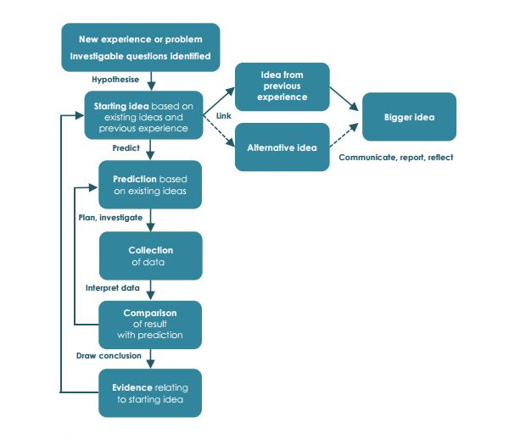
A model of learning through enquiry

Image by: Harlen, W. (2015) Working with Big Ideas of Science Education.

Appendix 2
Note from ‘police/detective’
***** DO NOT ENTER******
No staff or children are permitted beyond this point for 24-hours. This is an extremely dangerous asteroid from an unknown planet. We need your help to send it back into Space, but we do not know where it is from or how to get it back.
Can you help us?

