Conner Griffiths P142255

[Dissertation]
Research Proposal - M3X9083
Table of Contents
1.0 Introduction 2
1.1 Rationale 2
1.2 Background 2
1.3 Literature Review 2
1.4 Aims and Objectives 3
2.0 Research Design 3
2.1 Methodology 3
2.2 Research Philosophy 4
2.3 Research Approaches 4
2.4 Research Strategy 5
2.5 Research Choices 5
2.6 Research Time Horizon 5
2.7 Data Analysis 5
2.8 Ethical Considerations 5
2.9 Reliability and Validity 6
3.0 Resources and Planning 6
3.1 Resources 6
3.2 Gantt Chart 6
Reference List 8

Introduction
“A critical analysis of how social media advertising affects consumer’s energy drink preferences”

1.1 Rationale
In the final year of study at university, there is an obligation to conduct a research project of 10,000 words on a chosen area. With huge interest in advertising as well as the energy drink industry, it has paved the way for a research project looking into the two areas in a lot of detail.
In recent years the energy drink industry has been booming, making it a very popular industry for consumer’s around the world. Companies operating within the industry have now taken to social media to enhance their reach, to attract new customers as well as taking them from rival competitors (myclever , 2017 ). The study will look at how social media is benefiting the energy drinks industries awareness, as well as finding out whether or not these companies are attracting consumer’s away from their rivals though social media activity on Facebook, Instagram and Twitter.
Since these companies are looking to make their social media as spectacular as possible, sponsoring extreme sports and events allows them to deliver a slightly different perception of their brand and products (Vermes , 2015). This study will examine if these factors are changing the way consumers are viewing the brand and products as a number of people around the world look to experience the same sorts of feelings that extreme sport athletes are without doing the sport.

1.2 Background
Advertising has become an important aspect for companies globally as they look to attract consumers to their brand, but as technology has grown it has enabled companies to extend the reach of their brand to incorporate a larger demographic (Johnston , 1994). Social media advertising has become a powerful tool that 92% of marketers claim to be important to their business, as well as 80% indicating that the effort being put into social media advertising has directly increased traffic to their website, illustrating the massive impact it is having (DeMers, 20014).
The energy drinks industry has sustained growth since 1997 when Red Bull first launched, now to leader the energy drinks market which saw an increase of 500 new energy drinks being launched worldwide in 2006 (Malinauskas , 2007). Now the energy drinks industry is worth $43 billion in 2016 and is expecting high growth as consumers need the instant energy for their hectic lifestyles as these energy drinks provide mental and physical stimulation, as well as providing a status symbol, mainly in younger audiences. In the U.S. almost 60% of males and 40% of females are addicted to these products (Grand View Research, 2017), indicating the high demand for products that are providing consumers with extra energy.

1.3 Literature Review
Social media marketing is defined as a ‘form of Internet marketing that utilizes social networking websites as a marketing tool. The goal of SMM is to produce content that users will share with their social network to help a company increase brand exposure and broaden customer reach’ (Tech Target , 2017). Social media marketing has become an essential tool for any company around the world and can differentiate them from others that are operating within that industry.
Throughout this report current literature from marketing theorist will be accessed to identify the key areas of the study. Advertising is a subject that has been heavily examined and has had a lot of theorists draw up conclusions on how best to market products and services. Two main theories in advertising are Ansoff’s matrix (Harding & Long , 1998) and the marketing mix (Perreault Jr & McCarthy , 2000). Both of these theories identify the key aspects that need to accessed when a product or service being marketed, detailing While both of these theorists have studied marketing as a whole they do not look at how
A recent study by (Patient & Retumetse, 2017) identifies the implications of social media advertising on energy drink preferences and consumption of mainly younger generations. This study has some key points but does not identify how the growth of social media is growing the marketing platform as it a much cheaper and easier way of getting campaigns seen and heard but a large population

1.4 Aims and Objectives
The aim of this dissertation is to examine the perceptions of the energy drink industry through social media advertising through a variety of perception so that a critical analysis can be conducted to understand how consumer habits are affected by social media advertising.
A) Review and analysis the existing literature on energy drink advertising on social media
Looking at pre-existing literature will give a broader understanding of the subject areas and how leading theorists look at social media advertising and the energy drinks industry, as well as seeing how other research projects have been conducted in these areas.
B) To gather and analyse consumers opinions on social media advertising of energy drinks
This will be achieved by conducting questionnaires/ survey’s as well as interviews. This is an important aspect to the dissertation to see if consumers take notice of social media advertising of energy drinks and if it influences their preferences and consumption
C) Examine the energy drink industry in great detail and examine one of the company’s techniques in current use in their social media advertising.
The energy drink industry will be analysed in great detail to understand the excessive lengths that companies go through to increase their social media adverts. For this to be achieved, academic research will be conducted on the energy drinks industry as well getting questionnaires completed by employees working for the these energy drink companies who are working on social media advertising. By doing this it will give a greater understanding of why companies are increasing their social media advertising.
D) Draw conclusions on how social media advertising influences consumer preferences and consumption and how it could be improved
Identify the areas in which these companies are strong, but also identify where they lack reach over consumers and how they can improve to new levels.

Research Design

2.1 Methodology
Research is defined as “The systematic investigation into and study of materials and sources in order to establish facts and reach new conclusions” (Dictionary , 2017). This definition shows how there needs to system in place to achieve the best possible outcome so that conclusions can be made and facts are presented.
When conducting a research project there needs to be a path that is followed to provide effective research, something that (Saunders et al 2009) has developed with his model, “the Research onoin”. This model consists of six lays that must be considered when conducting research, as each layer has an aspect that must be chosen to order to tto create an effective pathway. The research onions six layers consist of philosophies, approaches, strategies, choices, horizons as well as techniques and procedures. Figure 1 illustrates what the research onoin looks like in a visual sense, as well the chosen pathway which will be taken in the research project.
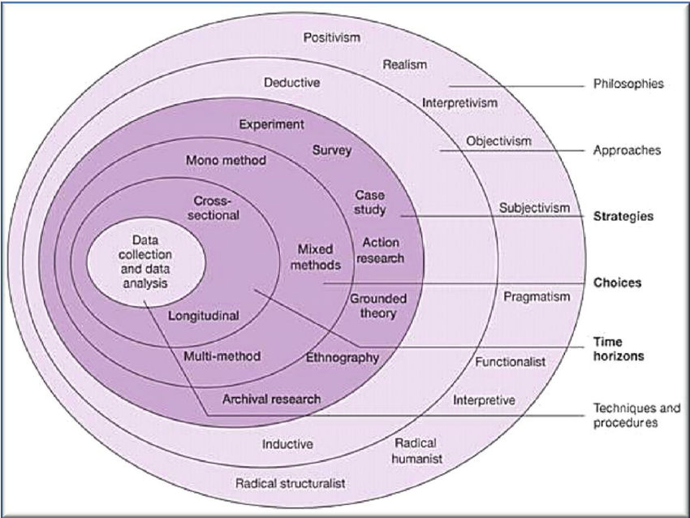
Figure 2.1 The Research Onion (Saunders et al, 2009)

2.2 Research Philosophy
The outer layer of “onion” forms the Philosophy layer. This section is vital to the research project as it will support the research strategy and the methods that are used (Saunders et al, 2009). This study will use the philsophy of interpretivism as human elements are involed, for example emotions, meaning that it is not an exact sceience with clear answers (Hall , 2014). (Saunders et al, 2009) also agrees that interpretivist should be used when business and marketing research is being conducted as business scenarios can become difficult and distinctive due to the individuals involvement.

2.3 Research Approaches
There are two researches approaches that can be used, deductive or inductive. The deductive approach develops a theory and hypothesis so that the research strategy is designed around testing the hypothesis, whereas the inductive approach collects data and then a theory is developed as a result of direct analysis of the data (Saunders et al, 2009). Having a research is an important aspects to a research project as (Easterby-Smith et al, 2008) examines. It enables a reasearcher to better decisions about how the research is desgined as well as choosing better strategies that will inevitably work or not. This research will use the inductive approach as it is gathering data and forming a theory once the data has been analysed.

2.4 Research Strategy
The research strategy is used to choose the methods that will enable for the best method for collecting primary data, with the most widely used method being surveys; as they are the best way to gather people’s opinions and attitude towards a certain subject area (Kotler & Armstrong , 2006). This research project will use surveys as they offer a variety of perceptions from a large number of samples. This study will use two different types of survey methods, questionnaires and interviews. The questions in both elements of the research will be aimed at social media advertising of energy drinks and how well they are perceived by consumers, as well as questions being aimed at consumers preferences and consumption based on companies social media activity.

2.5 Research Choices
The two forms of surveys that will be used in this research project will be questionnaires and interviews as they provide different forms of research. Questionnaires are an efficient way of collecting data, they are able to collect large quantities of information over a short period of time as well as provide scope for closed and open ended questions (Debois & S, 2016). Interviews are a useful tool for obtaining detailed information that contains personal feelings, perceptions and opinions as more detailed questions can be asked. The research choice that will be used in this research project is multi method because the study will be using questionnaires and interviews as (Saunders, Lewis , & Thornhill, 2009) explains that these are the best methods to use when collecting qualitative primary data.

2.6 Research Time Horizon
Research time horizon can come in two forms, cross sectional or longitudinal time horizon. Cross sectional research data is gathered just once of a set period of time, for example over a number of days, weeks or even months. Whereas longitudinal research consists of collecting data a numerous amount of times that are taken over different periods of time (Desrosiers et al, 1998). This study will use then cross sectional time horizon method as this study has time constraints, making it the best method to use for the research.

2.7 Data Analysis
Once the data has been collected and inputted into Microsoft Excel the findings will be analysed through the use of a spreadsheet, tables and figures to illustrate the key areas that should be examined future. By using this type of method it enables the researcher and the audience to see clear and concise information that is both useful and accurate.

2.8 Ethical Considerations
This research project is unlikely to cause any form of psychological of physical harm to any participant but the research will be conducted by persons over the age of 18 years only. This topic area is looking into marketing and branding on social media, with no examination into ethical suggestions.

2.9 Reliability and Validity
Throughout the research project it is imperative that the data gathered from both the surveys and desk research is both valid and reliable as it ensures that the execution of the project is at the highest possible manner. By conducting the research is a fair and appropriate way that is consistent it ensures the best possible results collected and analysed so that the best results possible are published and concluded on.

3.0 Resources and Planning

3.1 Resources
Throughout this dissertation the literature will comprise of academic journals, reports, books, handbooks, articles and websites. The literature will be gained by using online databases and the library that is provided by the University as well as internet search engines. The literature that is found to be relevant to the topic and provides insights will give the project its backbone as it is key to the understanding of all areas. These pieces of information will help form the literature review and provide material for secondary data within the Dissertation.
Specific Resources Needed:
- Computer system with Microsoft Word – to produce the dissertation document and surveys
- Computer system with Microsoft Excel – to analyse the results from the survey and draw conclusions
- Recording equipment – to record the interviews for analysis at a later date

3.2 Gantt Chart
A Gantt chart is a toll which provides details specific to tasks that need to be completed and sets dates for each task so everything is completed in the end. The Gantt chart is used specifically to keep the project on track over long periods of time so that it does not get behind, so by having a timeline in place is keeps a checklist of everything that needs to be done. (Gantt, 2017)

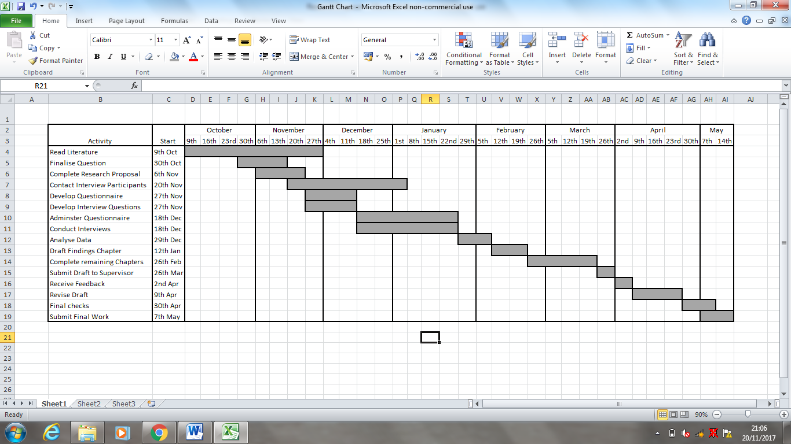

Reference List
Debois, & S. (2016, March 16). 9 Advantages and Disadvantages of Questionnaires. Retrieved November 20, 2017, from Survery Anyplace : https://surveyanyplace.com/questionnaire-pros-and-cons/
DeMers, J. (2014, August 11). The Top 10 Benefits Of Social Media Marketing. Retrieved November 20, 2017, from Forbes : https://www.forbes.com/sites/jaysondemers/2014/08/11/the-top-10-benefits-of-social-media-marketing/#40ef2a861f80
Desrosiers , J., Hebert , R., Bravo , G., & Rochette , A. (1998). Comparison of Cross-Sectional and Longitudinal Designs in the Study of aging of Upeer Extremity Performace . Journal of Gerontology.
Dictionary . (2017). English Oxford Living Dictionaries . Retrieved November 20, 2017, from Oxford Dictionary : https://en.oxforddictionaries.com/definition/research
Easterby-Smith , M. R., Jackson , P., & Lowe, A. (2008). Management Research (3 ed.). London: Sage.
Gantt. (2017). Welcome to Gantt.com. Retrieved November 19, 2007, from Gantt.com : http://www.gantt.com/
Grand View Research. (2017, July ). Energy Drinks Market Analysis By Product (Alcoholic, Non-Alcoholic), Product Type (Non-Organic, Organic, Natural), Target Consumer (Teenagers, Adults, Geriatric), Distribution Channel (On-Trade, Off-Trade & Direct Selling) And Segment Forecasts, 2014 - 20. Retrieved November 20, 2017, from Grand View Research : http://www.grandviewresearch.com/industry-analysis/energy-drinks-market
Hall , I. (2014). The Promise and Peril of Interpretivism in Australian Internal Relations. Australian Journal of Public Administration, 73(3), 307-316.
Harding , S., & Long , T. (1998). MBA Managament Models. Aldershot: Gower Publishing Limited.
Johnston , W. J. (1994). The importance of advertising and the relative lack of research. The Journal of Business and Industrial Marketing, 9(2), 3.
Kotler , P., & Armstrong , G. (2006). Principles of Marketing (11 ed.). New Jersey: Prentice Hall.
Malinauskas , B. M. (2007). A survey of energy drink consumption patterns among college students. Nutrition Journal , 1.
myclever . (2017 ). Why Energy Drinks Rule Social Media. Retrieved November 20, 2017, from myclever : https://www.mycleveragency.com/blog/2014/06/energy-drinks-rule-social-media/
Patient, R., & Retumetse, J. J. (2017). Impact Of Social Media Advertising On High Energy Drink Preferences And Consumption. Journal of Applied Business Research, 33(4 ), 653-668.
Perreault Jr, W. D., & McCarthy , J. E. (2000). Basic marketing. London: McGraw-Hill.
Saunders, M., Lewis , P., & Thornhill, A. (2009). Research methods for business students (1 ed.). Harlow: Prentice Hall.
Tech Target . (2017). social media marketing (SMM). Retrieved November 20, 2017, from Tech Target : http://whatis.techtarget.com/definition/social-media-marketing-SMM
Vermes , K. (2015, February 27). Do Energy Drinks Pop Social Media Engagement? Retrieved November 20, 2017, from Data-Driven Marketing: https://www.rivaliq.com/blog/energy-drinks-social-media-engagement/

