UNIVERSITY OF WALES - TRINITY SAINT DAVID

LONDON CAMPUS

Bsc Cloud Computing – Level 5
Term 2

ACCC5003 – NETWORK OPERATING SYSTEMS AND SECURITY
MODULE TUTOR – Terry Walcott

Silviu-Iulian Surel ---1807050---

Contents
1.Worksheet 1, Building the NOS infrastructure using Active Directory
1.1 Task 1: Configure Virtual Networking and use the dcpromo tool to upgrade a Member server to a Domain Controller
1.2 Task 2: Installing Client Computers and Basic Object creation in the Active Directory
2. Worksheet 2: Resource Management in Active Directory: Users, Computers and Groups.
2.1 Task 1: Creating an Organisational Unit Hierarchy.
2.2 Task 2: Creating and Managing Active Directory User and Computer accounts
2.3 Task 3: Investigating the use of Group Objects in Active Directory.
3. Worksheet 3. Resource Management in Active Directory – Managing Access to Files and Folders, and Controlling Domain User Environments
3.1 Task 1: Managing local access and Network Access to files and folder objects in Active Directory.
3.2 Task 2: Controlling ‘domain resources’ using Organisational Units and Group Policy.
4. Worksheet 4: Network Administration using DHCP
4.1 Task 1: Installing and configuring the DHCP Service.
5. Worksheet 5: Planning and Deploying DNS in the Network Infrastructure
5.1 Task 1: Understanding DNS operation; Planning and deploying DNS
5.2 Task 2: Storing and Maintaining DNS Data.
5.3 Creating a Virtual Directory

Network Operating Systems and Security Worksheet 1: Building the NOS infrastructure using Active Directory.

Task 1: Configure Virtual Networking and use the dcpromo tool to upgrade a Member server to a Domain Controller
We also need to add the Active Directory Domain Services role
- In the Server Manager window, open the Roles directory and in the Roles Summary section, click Add Roles
On the Before You Begin page of the Add Roles Wizard, click Next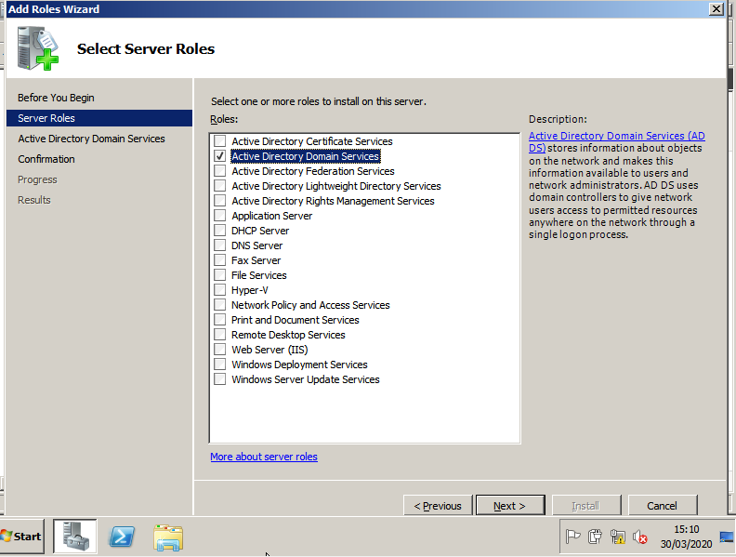

- On the Select Server roles page, select the Active Directory Domain Sevices check box, and the click Next on this page and the Confirmation page
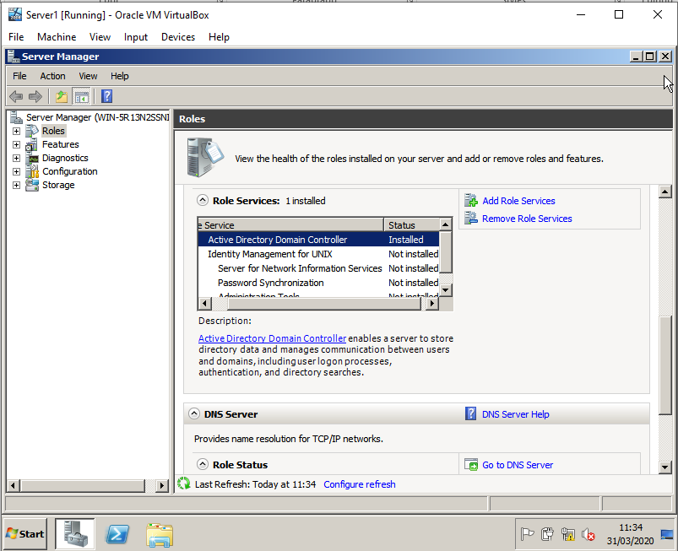
- On the Installation Progress page click Install
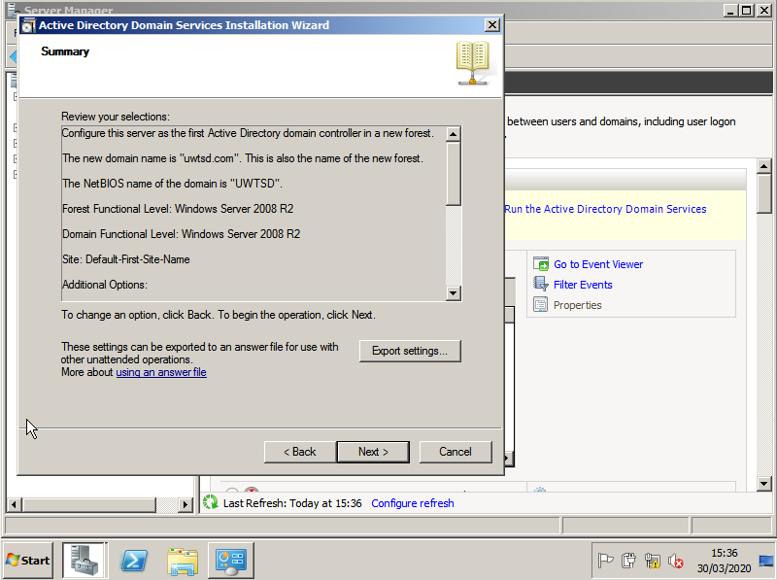

- On the Results page after the role is successfully added, click Close

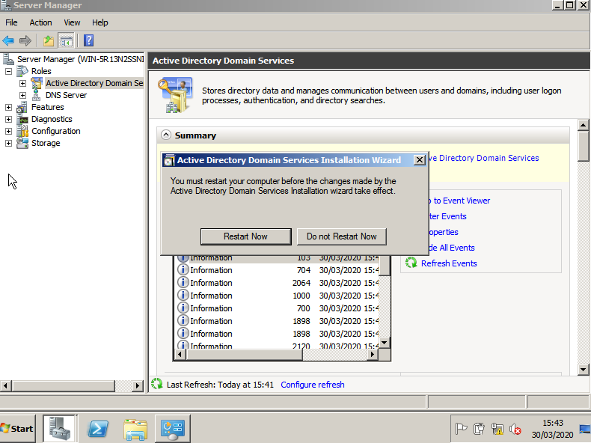

- Open the Internet Protocol Version 4 (TCP/IPv4) Properties window for the appropriate network adapter on your server
- Click Use the following DNS server addresses:
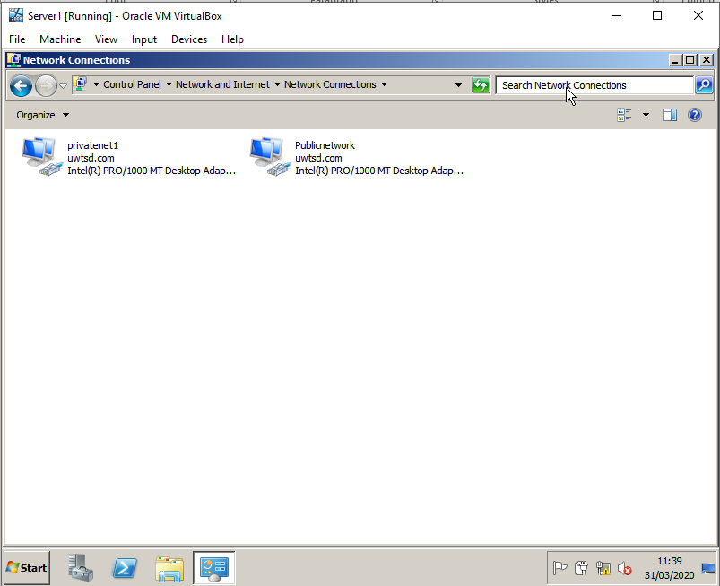
- Set the Preferred DNS server to the IP address of this network adapter
ADAPTER 1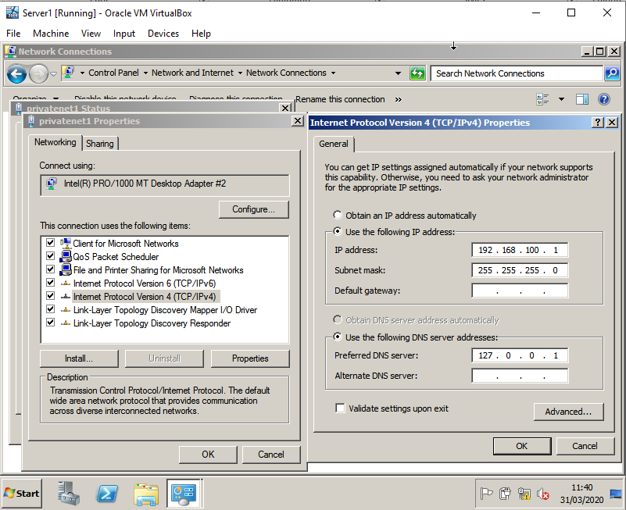

Adapter 2
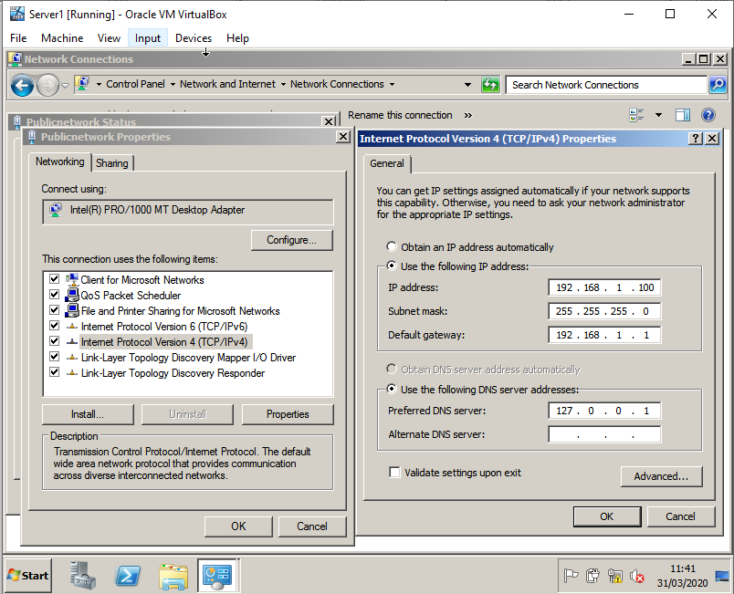
- Click the Start button, point at Programs, point at Administrative Tools, and
then click Configure Your Server. (or you could click Start, Run, type dcpromo
]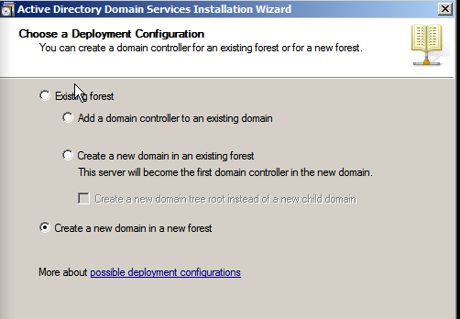
).
- Click the Active Directory link on the left side of the window and then click Start the Active Directory wizard (you may have to scroll down a little to find the Start command). The Active Directory Wizard appears. Click Next to advance beyond the wizard's introductory screen.
- On the next screen, you are asked if you want to create a domain controller for a new domain or an additional domain in the existing forest. Choose the first option.

- Use an appropriate domain name (e.g. uwtsd.com).

- On the next screen you are asked to specify a folder on the computer that will hold the Active Directory database and the Active Directory log (the database holds all the information; the log holds the usage statistics). A default folder is specified for both the database and the log, so why mess with it? Go with the defaults by clicking Next.
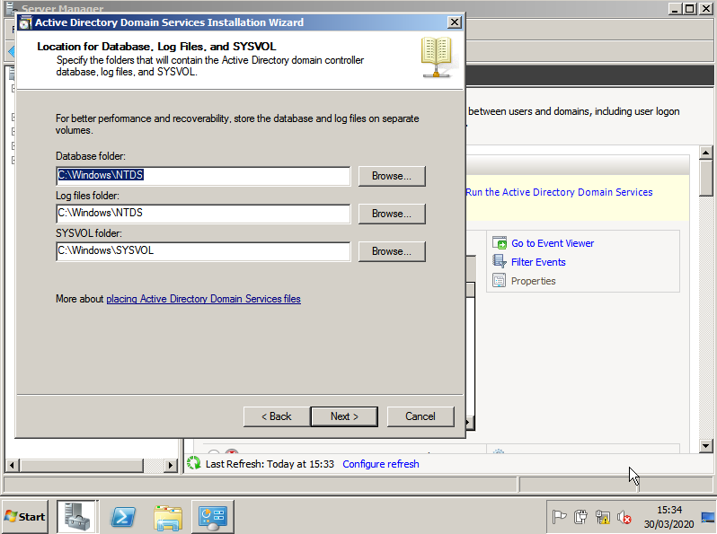
- You are then asked to provide a folder for the Sysvol. This folder holds all the public files for the local Active Directory (which you want to make available to the Active Directory running on all other domain controllers in the tree). Again, a default folder is provided. Let's go with it. Click Next to continue.
- The next screen, shown below, wants to know if you want permissions set up so that they are backward compatible with any older version of windows. Choose Next to accept the defaults

- On the next screen, provide the password (and confirm it) that you want to use for the Administrator's account on this new domain controller. Use P@ssw0rd as the password associated with the administrator account

- After entering the info, click Next.
- The next screen provides a summary of the information that you provided on all the other wizard screens. Look it over (if you need to change anything, click the Back button) and then when you're ready, click Next.
- A screen pops up letting you know that the Active Directory Wizard is configuring the computer as a domain controller for your new domain. This may take a few minutes (but probably less time than it took to answer all the questions from the wizard!)
- When the wizard has completed its job, a screen appears letting you know that the Active Directory is good to go. Click Finish on the message screen and then click Restart on another box that pops up to complete the installation.
- After your server has rebooted, log on using the password you specified during that whole routine with the wizard and you're logged into the domain controller.

Task 2: Installing Client Computers and Basic Object creation in the Active Directory
To create domain objects we must first be in the right place within the directory. Click the domain icon (e.g. uwtsd.com) to expand it.

Click the Computers node to open it. Any servers or workstations that have already been added to the domain appear in the Details pane.

To add the new computer (the Windows 7 Domain client) to the domain, right-click the Computers container and point at New on the shortcut menu. Now select Computer from the cascading menu. The Create New Object - (Computer) dialog box appears, as shown in the diagram below.
To specify the computer that you will add to the domain, type the name of the computer in the Computer Name box.

Give the computer an appropriate name (e.g. Domainclient1).

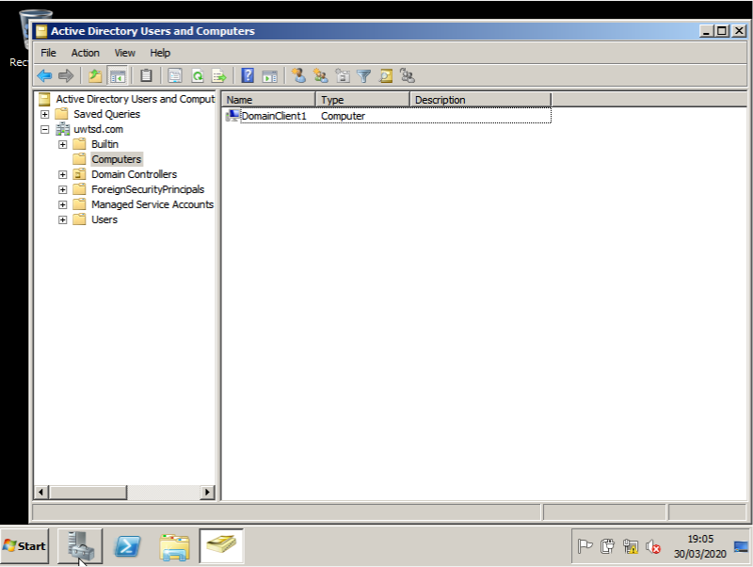

Installing/Connecting a Windows 7 client to the domain
- Install Windows 7 on the client Virtual machine in your domain
- You will need to open network and sharing center and then find the change adapter settings link. Right click on the adapter choose properties.
- Now choose the IP Version 4 settings and click properties. Here you will need to ensure an appropriate IP address from the 192.168.100. class c subnet is provided (e.g. 192.168.100.2. Furthermore you will need to enter the DNS address (this is the IP address of the Domain Name Server against which you wish to authenticate this client membership). So it is important to ensure Primary DNS is set to the right IP address.

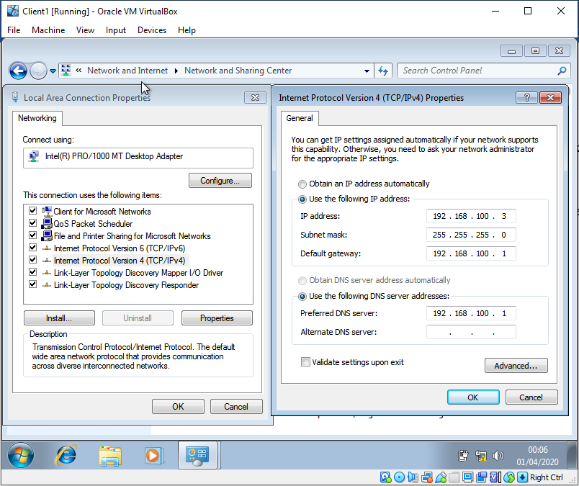
Do not enter any parameters for Alternate DNS.
- To add the machine to the domain, right click on Computer (Note you will need to be logged in with an admin account).
- Choose Properties
- Then choose advanced system settings.
- Click on the Computer Name tab (top of the window)
- Click change
- In the domain textfield type uwtsd.com (or whatever you called your domain).
- You will be asked to authenticate using an appropriate uwtsd domain account. This will be the administrator account you used to setup Active Directory earlier.

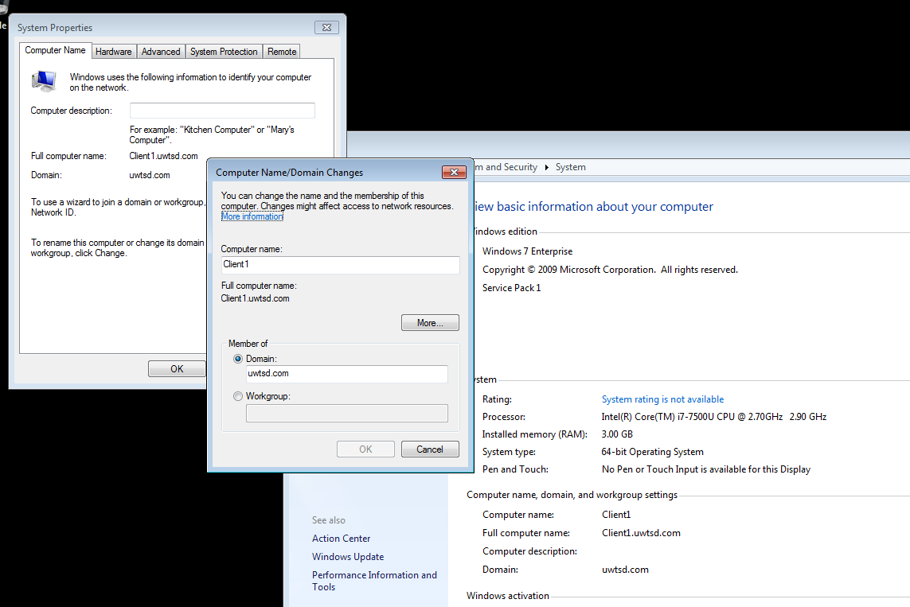

Worksheet 2: Resource Management in Active Directory: Users, Computers and Groups

Task 1: Creating an Organisational Unit Hierarchy.

- In Active Directory Users and Computers – (we want to create our first set of OU’s at Domain Level, e.g. within our Admin, Sales, Purchase domain etc, so right click domain.smu.com – New – Organisational Unit.
- In the Name field Type in (Your dept name) e.g. Sales Dept.
- Within our OUs we will manage a vast amount of various types of AD objects (users, computers, groups) so we will need a better way to manage a hierarchy of objects.
- Right click on [Your dept name] OU, New – Organisational Unit – in the name field type [your dept name e.g. admin] Users.
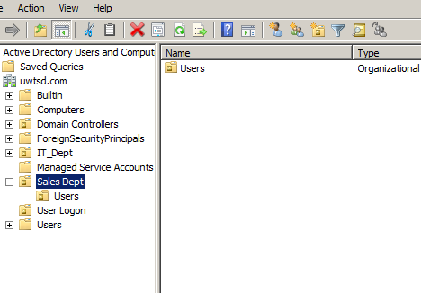
- Repeat this process to create two further OUs, 1 for [your dept name] Computers and another for [your dept name] Resources.
- You already have your Workstations created in a group called Computers, but to have better
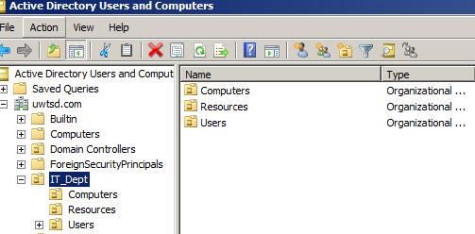
- Take the Computer objects created in the default Computer OU and drag it into the SalesComputers OU
- There will be several subsets of users in every dept for now, we will just assume that each of our domains users are stored in one of two organisational units, Within the [your dept name] Users OU you have already created, create one OU called All Staff and create another called Technical Support Staff.
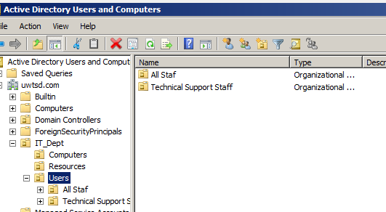

Task 2: Creating and Managing Active Directory User and Computer accounts
- Choose Start – Administrative Tools - Group Policy Management

- Expand the uwtsd.com icon.
- Select Default Domain Policy – this is where the top level of hierarchy in our domain is designated. Policies here are cascaded down and implemented at all levels of the Active Directory structure (so sub-ordinate OUs and their corresponding objects) also pick up settings from here

- Right click on Default Domain Security Policy

- Here we are concerned with Accounts (User/Computer) so expand Computer Configuration Settings - Policies – Windows Settings – Security Settings – Account Policy – Password Policy.
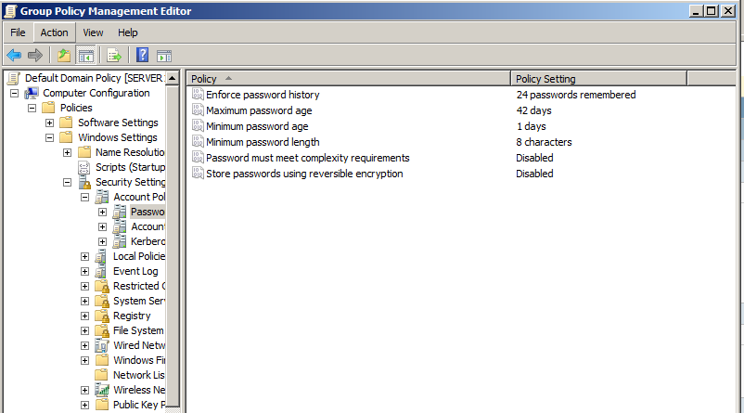

- The information you see here is the password policy settings that apply to this domain, we have a list of settings

- Right Click on the minimum password length – click properties – set the’ password must be at least value to 8 characters:
- Right click on the Password must meet complexity requirements field, check the disabled option.
- Under the security settings pane – expand the ‘Account Lockout Policy’ – right click on the Account Lockout Threshold value – Within the account will lock out after pane – set a suitable value for the invalid logon attempts (e.g. 5 or 3 or if you’re really security conscious set a lesser value).
- You are invited to tweak more settings HOWEVER IT IS VERY IMPORTANT TO NOTE THAT ONCE THESE SETTINGS ARE APPLIED THEY WILL AFFECT MOST OF THE OBJECTS IN YOUR ACTIVE DIRECTORY, BE PARTICULARLY VIGILANT OF ANY CHANGES MADE TO USER PASSWORD SETTINGS.
- Save settings and close all Windows.
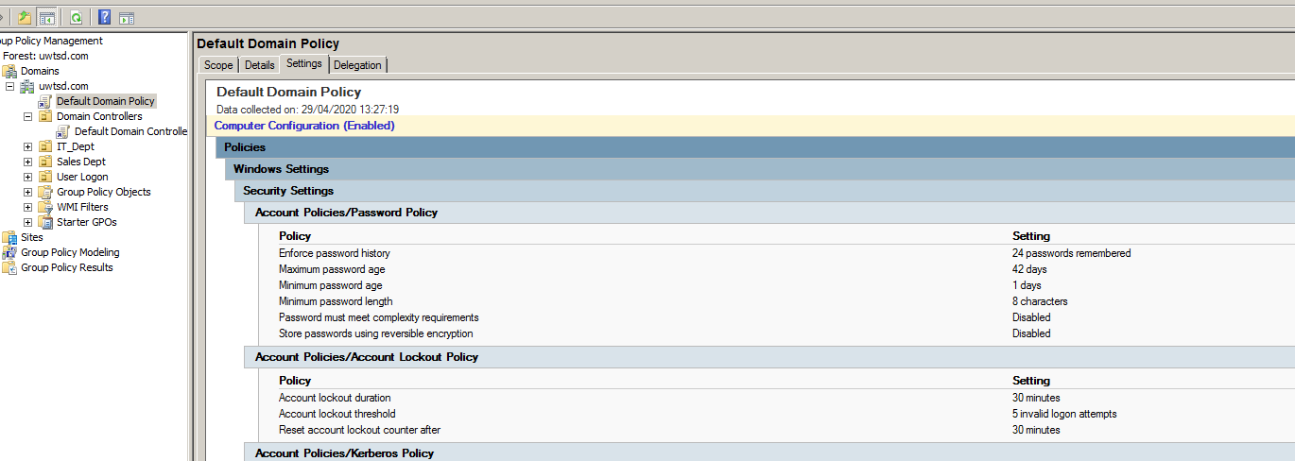

3.Creating User/Computer Accounts and Managing their properties

Here we will begin to populate our Active Directory database by creating User and Computer Account Objects
- Start – Administrative Tools – Active Directory Users and Computers
- Within your domain tree find the OU you have created for staff.
- Right click on the All Staff OU and select New User
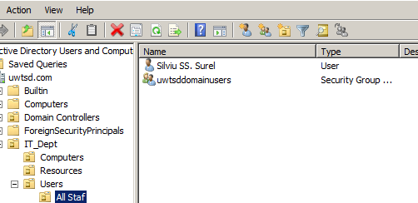
- Create each of your domain members a user account, note that it is the User Logon name field that we use to log onto any of the workstations in our domain.
- When you have done this, right click on the Technical Support Staff OU, create three additional users (use Adm- before your name, e.g adm-bill), note these two sets of users will belong to what we call different Groups.
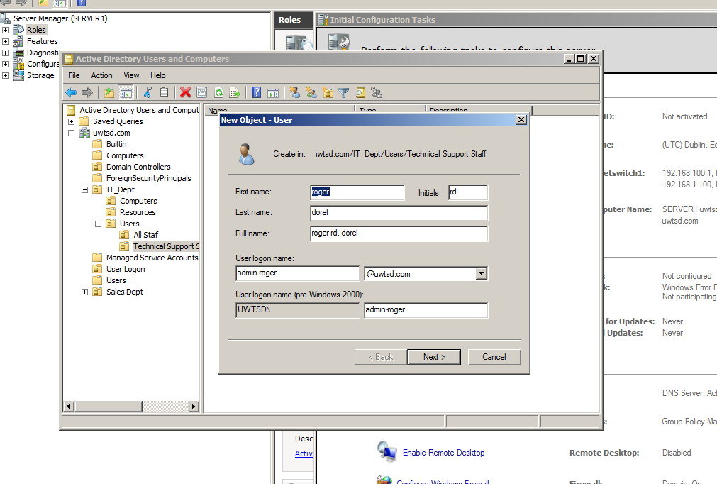

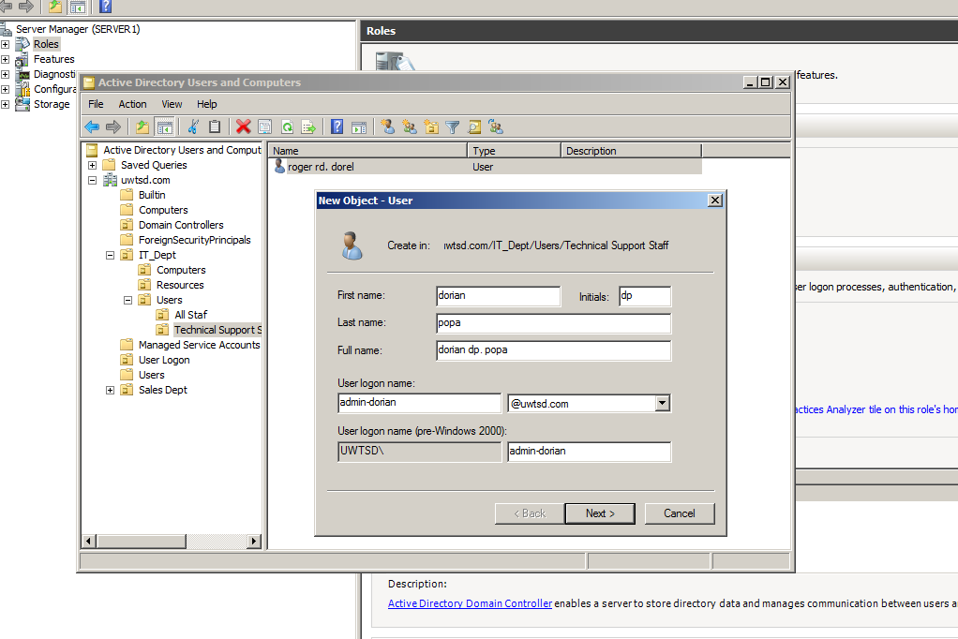
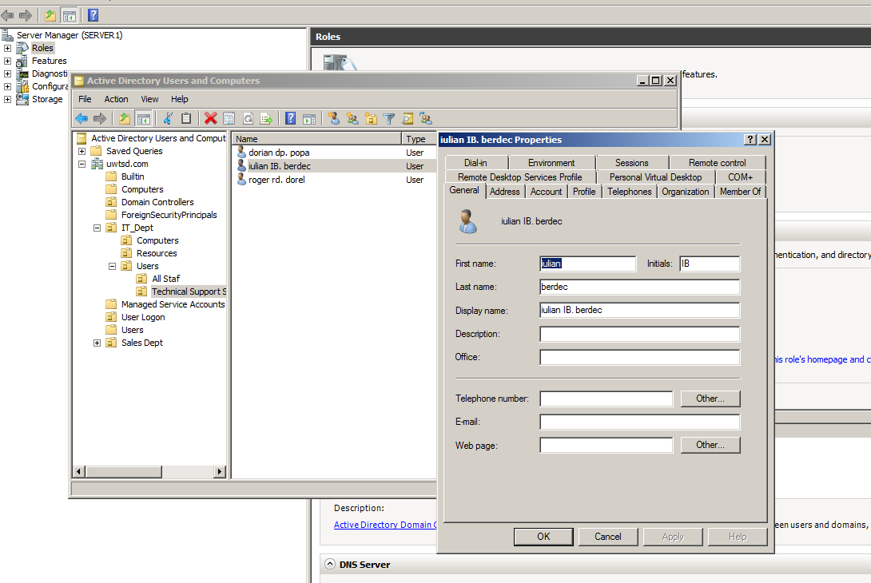

User account properties: Disabling Accounts, Re-setting Passwords and Querying Active Directory
- Right click on the domain name in Active Directory, choose Find.
- Ensure that the type of object you are looking for is set to Users, Contacts and Groups (its stated next to Find).
- Type in the name of a user account you wish to locate in the active directory.
- Click Find Now.
- From the displayed result in the bottom pane, right click on the user account and choose Properties, select the Member of Tab.
- Note in the Member of field there is a list of information in regards to what groups in the Active Directory domain this user is a member of. Note the domain users group is present in the list.

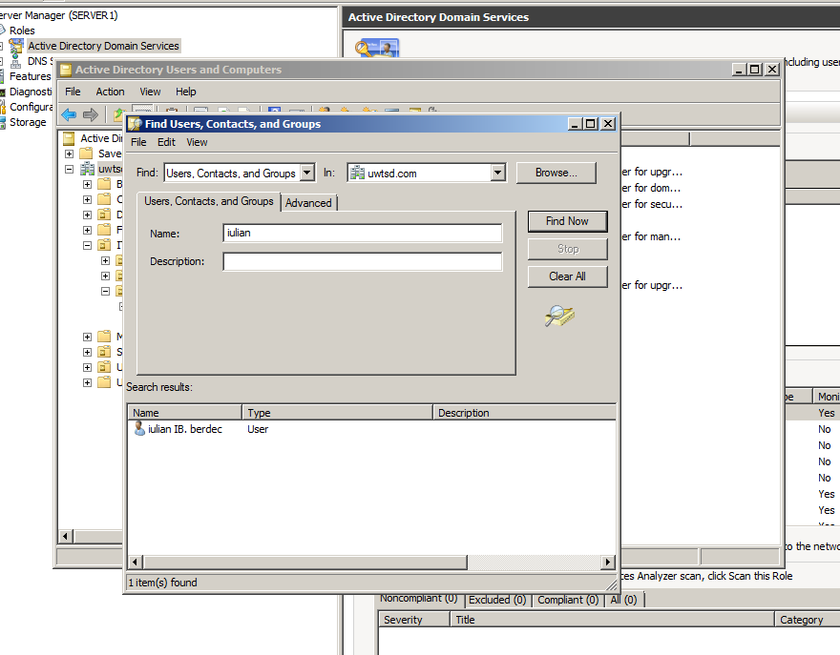

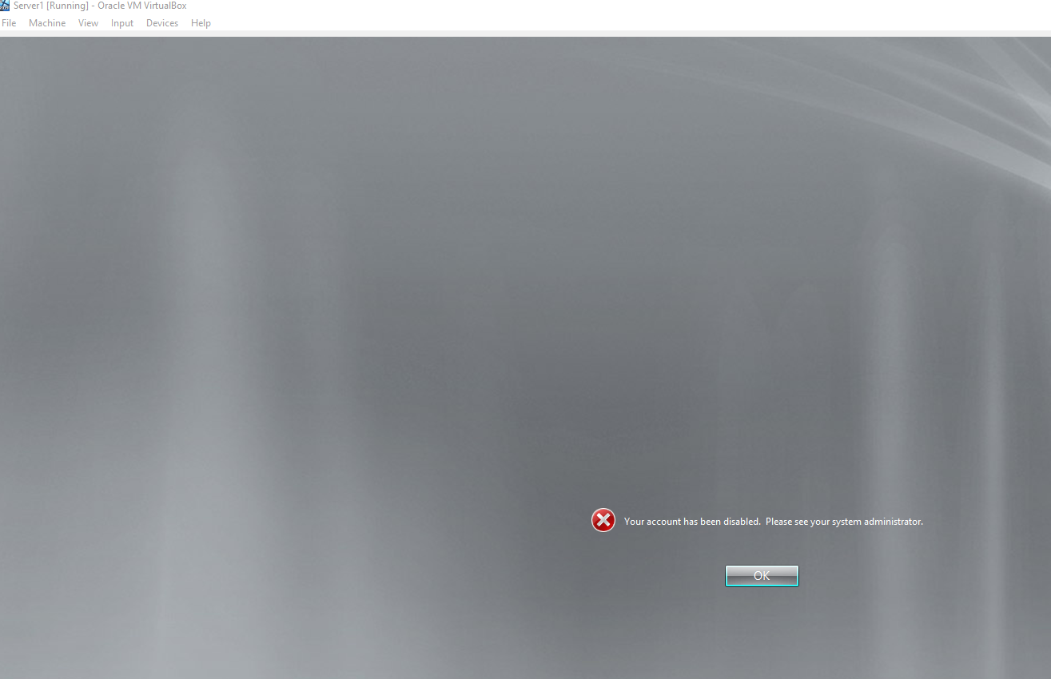
Sometimes users may forget their passwords so they may require the attribute to be reset. Again select a user account in your domain, right click on it and choose Reset Password. Now try accessing a workstation in your domain with the old password and then the new password

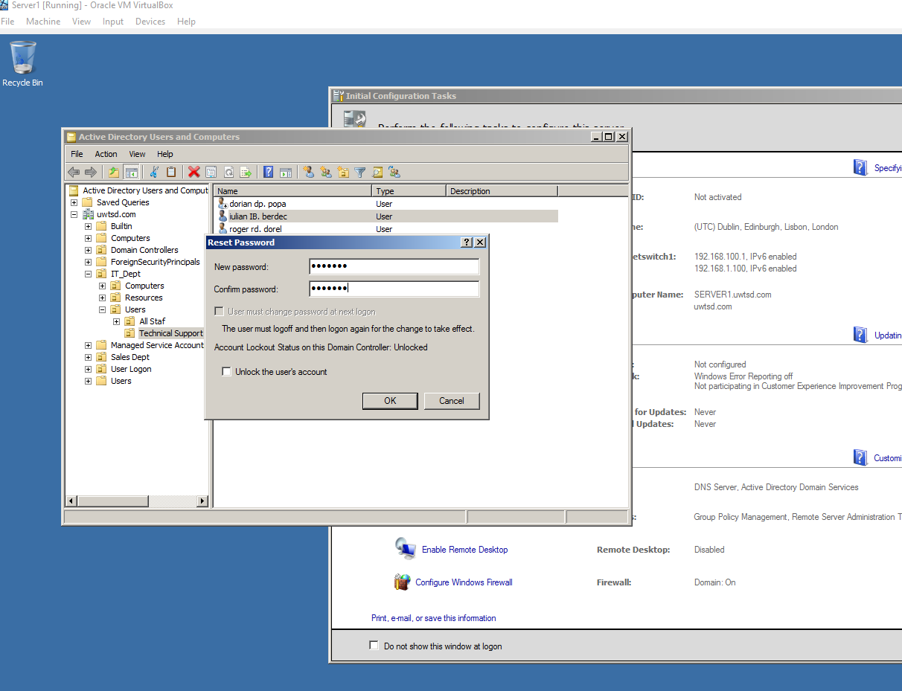

If we want our users to have ultimate control over our domain and its resources we simply add them into the default group Domain Administrators. This is the most privileged group inside an Active Directory and can participate in any type of administrative activity (such as starting network services, removing objects, changing network settings, remotely connecting to servers etc, etc).

- Select the Domain Admins group in Active Directory
- Right click – choose properties.
- Choose the Members tab and click Add.
- Now enter the name of a user you have created within the Technical Support Staff OU, you will need to use the Find/Search button to do this.
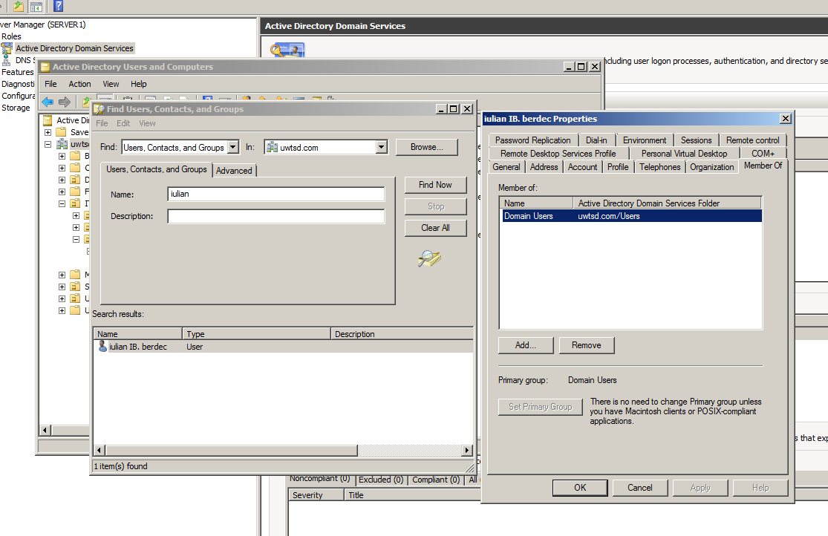

Creating a Group – Group Scope in Active Directory.
- Within the all staff OU for your domain; right click in the whitespace and select New – Group.
- Call the group xxxxdomainusers (where xxxx is the name of your domain)
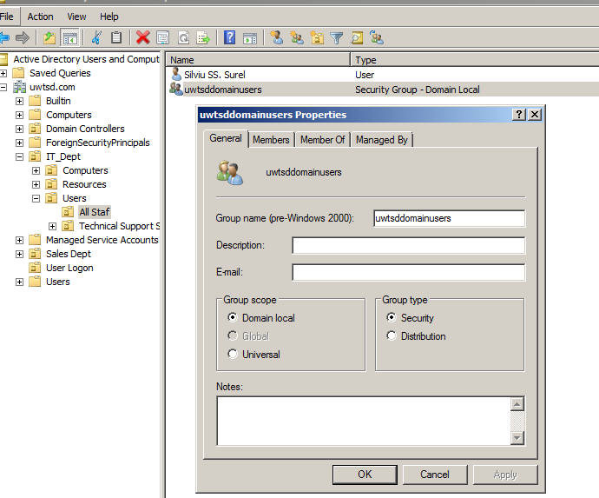

- Ensure the group scope is set to Domain Local.
- Add the users in the all staff group into this group.
- Once this is done, move to the Technical Support Staff OU, within this OU right click on the whitespace and choose New Group.
- This time make this group scope a global group
- Add in the users of the Technical Support Staff OU.
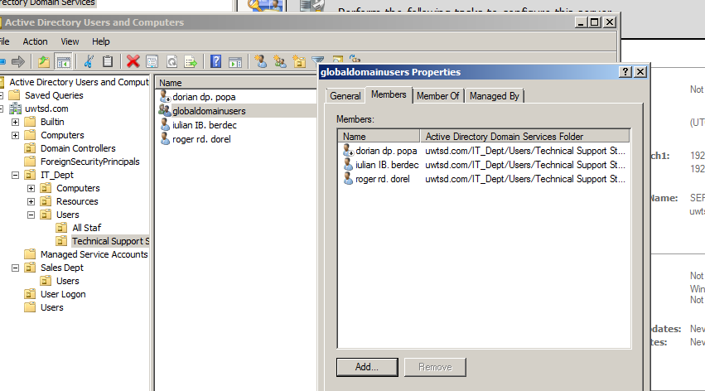

Worksheet 3
Resource Management in Active Directory – Managing Access to Files and Folders, and Controlling Domain User Environments
Task 1: Managing local access and Network Access to files and folder objects in Active Directory.
Creating a shared folder on the domain and configuring share permissions.
- Go to the Server/Domain Controller and logon as Administrator (if you are not already logged in).
- Create a new folder, call it Dept Database.
- Within the Dept Database folder, create a text file containing some names or other data (use Notepad if you don’t have a preferred text editor).
- Name the file Salesdatabase (Notepad will give it a .txt file type by default; Word uses .doc)
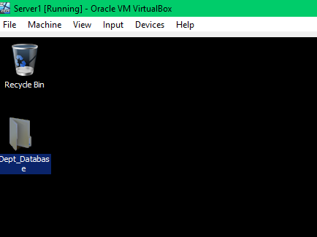

- In this scenario we are going to assume that General users group should see this database but that they should not be allowed to make changes to it. This will be the responsibility of technical staff. However we now have a problem, because domain user staff (with limited access) cannot log onto a domain controller (in fact only people who belong in the ‘Domain Admins’ group can log into the Domain controller)
- We need to therefore publish this file as a ‘Share’ over the network so that users can access it from a different Server or Workstation.

- To configure ‘Share permissions’ to publish the folder right click on the folder and choose properties, click on the Sharing tab. Click on the advanced sharing tab and check on share this folder. Notice that by default once the sharing is enabled we have a default group of everyone that is allowed read access. This can be a security concern so remove this group. Now add the General group you created earlier and give this group read permissions, do the same with the technical staff group, but instead give this group full access permissions.

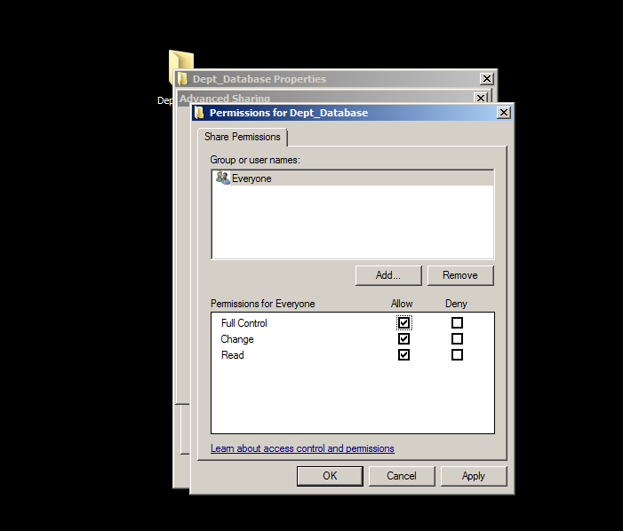

- We therefore need to also configure NTFS permissions on the folder so that members accessing the share have appropriate writes to view the content.
- Right click on the Dept Database file, click on the Security tab and add the general users group to the access control list. Give this group read permissions. Give the Technical support group full control over the folder

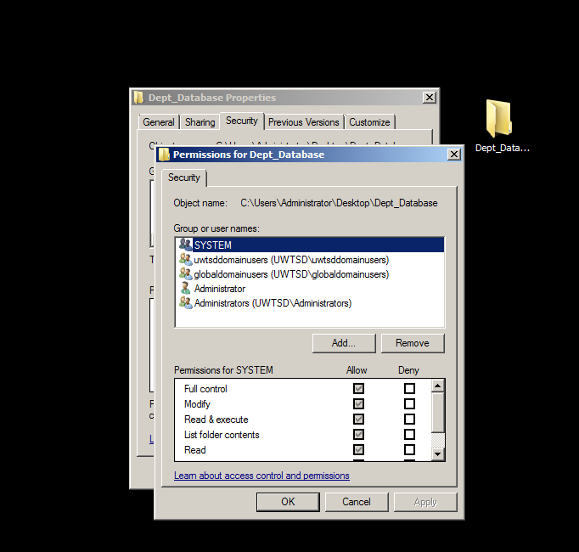

- To Map a Network Drive – Right click on My Computer – choose Map Network Drive – if you choose Browse you should see your domain controller listed, if you cannot type the following
- \\servername\sharename
- For example uwtsd.com\DeptDatabaseFolder then just click Ok/Finish
- If you can see the server from the browse operation, just click on the share name.
- Within the shared folder attempt to (i) create new files or (ii) delete the existing database file as members of both of the groups you configured share permissions for. What happens? Record your observations.
Remember you will need to log off as a general user and log in as a higher privileged member of the technical staff group to test the different scenarios.

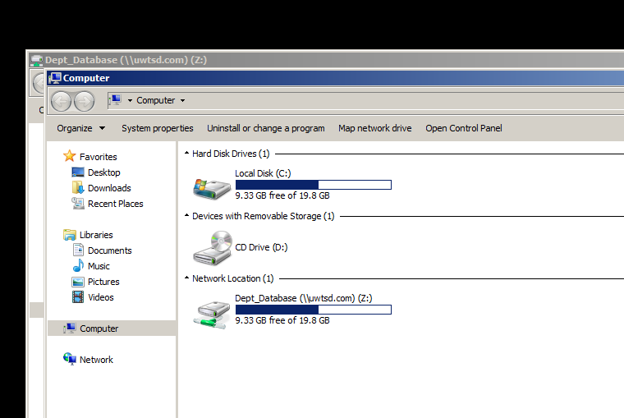

Task 2: Controlling ‘domain resources’ using Organisational Units and Group Policy.
Task: Delegating Administrative Authority.
a). Here we will configure our OUs so that the administrative users we have in each of our Parent and Child domains will be delegated authority to manage the appropriate OU and all the resources it contains. Remember there are three components to this task (a). Establishing a user or group of users who should be granted access to manage the OU itself and the resources it contains (b). Establishing what objects it is that you want them to manage (c). What specifically this user or group of users should be able to change in terms of the attributes and properties about this object (e.g. Should they be able to lock users out, should they be able to delete and create new computer objects?).

- If you haven’t already, create an OU called generalstaff (Remember this OU will contain lower level users/privileges)
- Add the generalstaff group into this OU.
- Likewise if you haven’t created an OU called technicalstaff do this now as well (Remember this OU contains higher level users/privileges). Add the technicalstaff group to this OU.

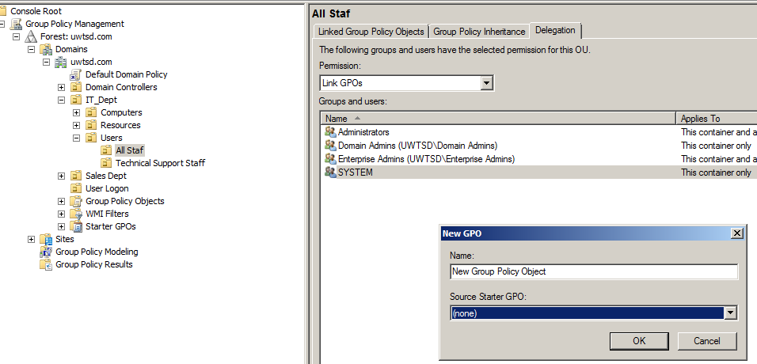

Task: Configure Group Policy.

b). Group policy objects provide us with a vast range of control over a vast amount of attributes associated with the objects/resources in our domain. We saw previously that there are mainly two ways to implement Group policy within our domain and OUs. Group Policy Object editor is the default tool installed on domain controllers for managing group policy objects. A more powerful and informative utility is the Group Policy Management Console tool (default in Post 2003 Windows Server O/S) that gives us far more control and information about our active directory domains policy objects.

- Choose Start – Administrative Tools – Group Policy Management
- Expand the smu.com forest in the left console window.
- Expand domains and then expand your domain (e.g. smu.com)
- Here you can see the ‘hierarchical layout of objects in your domain.
- You should see both of the OUs you have created in the previous step (Technical and General)
- Remember there are objects (groups/users) inside these ‘containers’ at the moment so by applying policies of the right type to them, we can affect their ‘experience’ within our domain environment.
- Right click on the general staff OU and choose Create and Link a GPO in this domain and link it here.
- Give the policy the name No Right Click Access.

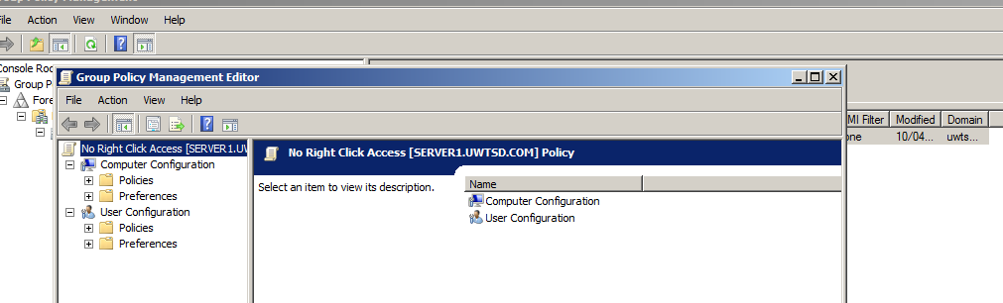
- In the right hand window of the console, you will notice a small scroll like object (the GPO) has been created called No Right Click Access, right click on this gpo and choose edit
- The group policy management editor window has opened. Now this is where we need to ensure that we are creating the right type of GPO configuration. If we are dealing with settings for a computer we choose Computer configuration, however because in this specific instance we are dealing with users we choose the User Configuration options. Note that computer policies when applied affect the PC irrespective of who accesses, whereas User policies will always apply to the users in the OU being affected.
- Choose User Configuration >Administrative Templates > Start Menu and Taskbar
- In the right hand console window – choose Remove access to the context menus for the taskbar double click this setting.

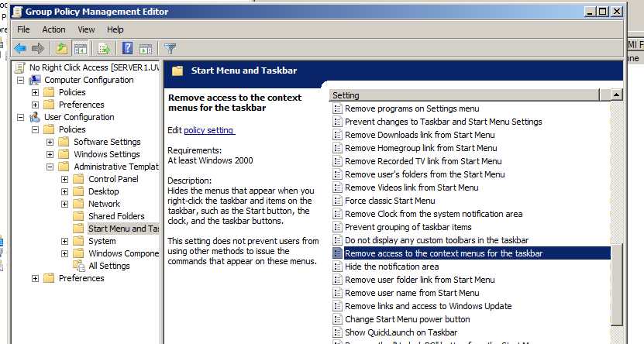

- Now choose Start – run – cmd
- In the command window type gpupdate/force (This usually forces recent changes in the domain to all of its members).
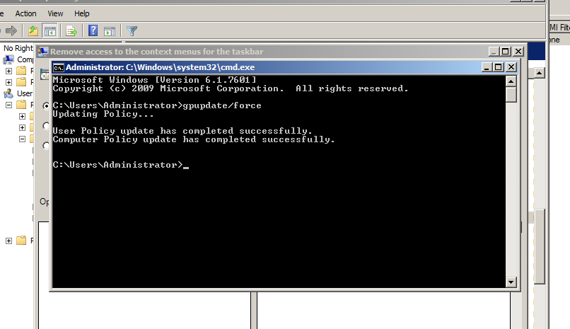
- Choose enabled and apply.

- Close down GPO editor and log onto the WORKSTATION (WINDOWS 7) as a member of the General staff OU, we may need to restart the machine before this policy takes effect.
- We should find we are unable to right click on the desktop, the start menu or windows explorer.
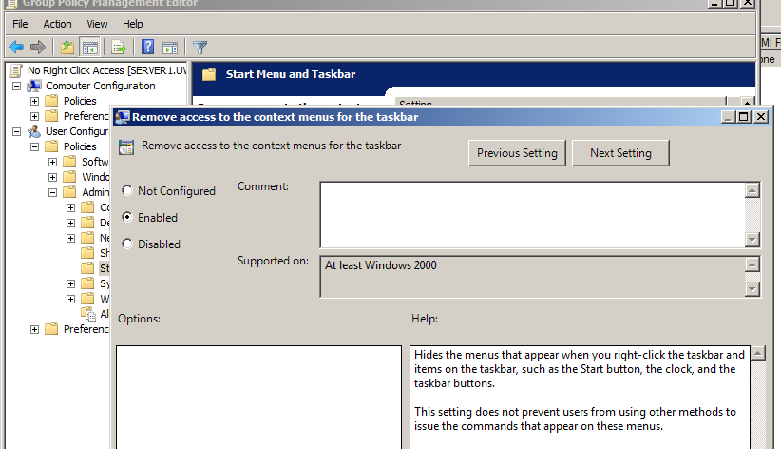
Implement 2 or 3 additional policies of your choice and test them. Ensure that you record your test results/evaluations using appropriate screen captures and narrative.

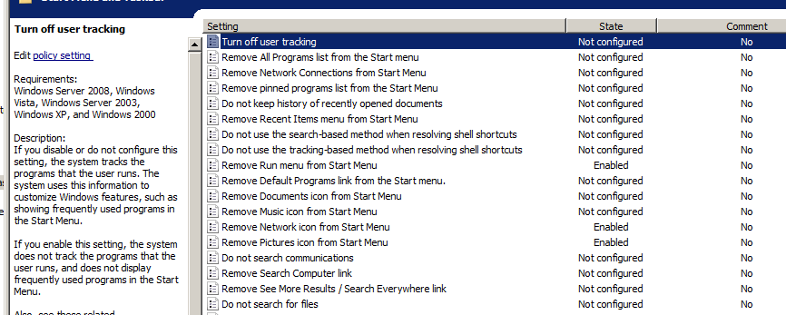
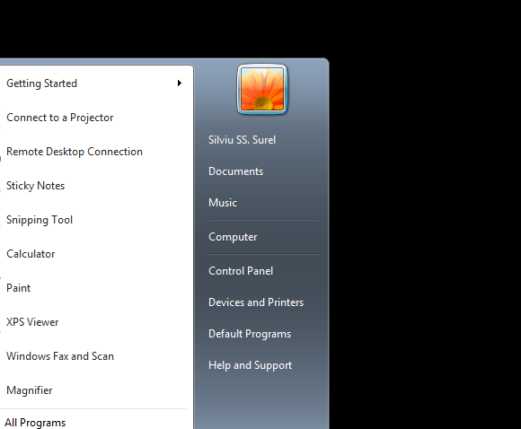

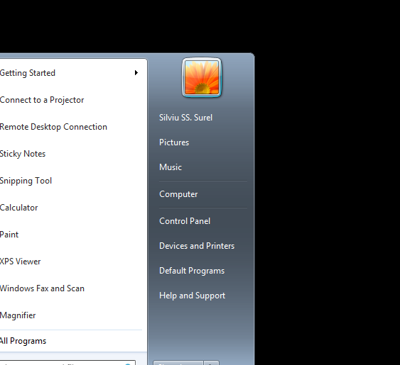

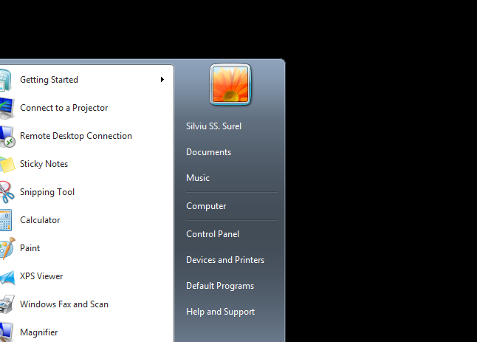
Worksheet 4: Network Administration using DHCP
Task 1: Installing and configuring the DHCP Service.
Part A: INSTALL / AUTHORISE THE DHCP SERVICE.

Please note your client needs to be connected to the domain before you begin. Also all your Virtualbox network settings should be correctly configured (e.g. Internal network mode on client and server)

[Complete this task from the Server Machine]

[PART A: INSTALL / AUTHORISE THE DHCP SERVICE].

- Start – Administrative Tools – Server Manager
- Click on Roles and then choose Add Role from the top menu
- Choose next and the default screen
- From the list of available services to install check on DHCP Server
- Choose Next at the next notification page.
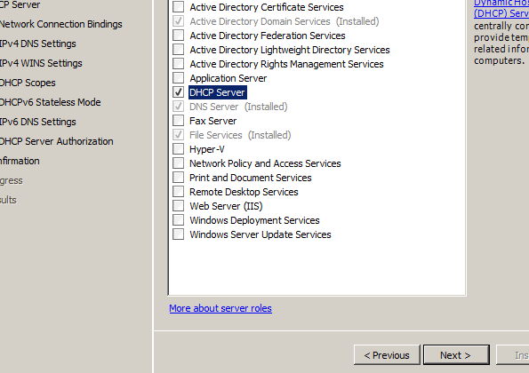

- At the Select Network Connection Bindings screen choose the available network connection (it is shown along with the IP address).
- Accept the defaults and choose Next at the Specify IPV4 DNS Server Settings page.
- Choose WINS is NOT REQUIRED FOR APPLICATIONS ON THIS NETWORK.
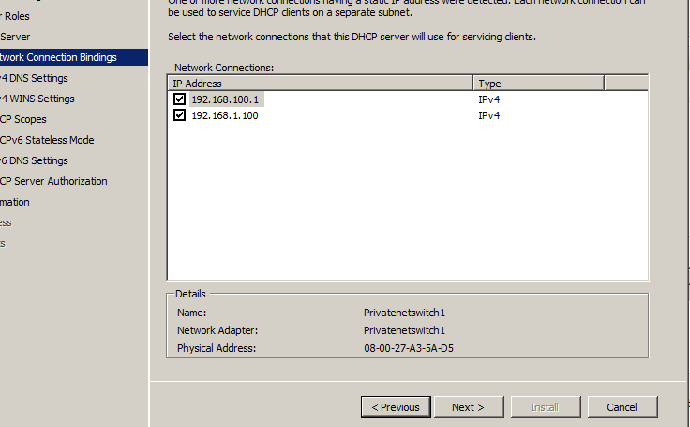

Choose Next at the Add or Edit DHCP Scopes page.
- At the Configure DHCPV6 Stateless Mode screen choose – Disable DHCPV6 Stateless Mode for this Server – choose Next
- At the Authorise DHCP Server page choose Use current credentials.
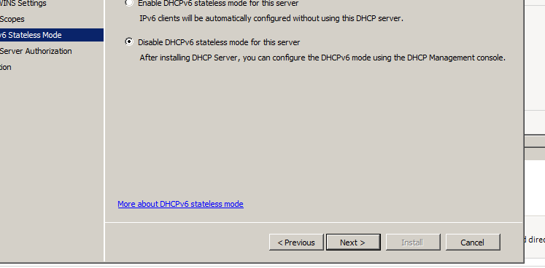
- Choose Install - the Service will begin installing
- You should restart your server when the install is complete.
- To activate the scope, in the console tree, right click the Scope you’ve just created and click Activate.
- The scope should be active (next to the scope you have created you should see a small green tick/light. This informs the DHCP service the scope is active and is ready to lease IP addresses to clients.

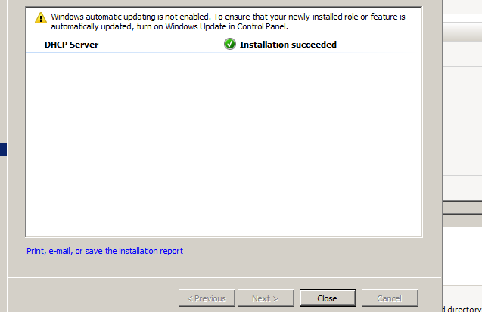

[PART B: CREATING A DHCP SCOPE FOR LEASING IP ADDRESSES TO DHCP CLIENTS ON THE PRIVATE NETWORK]

Task:

- Start – Administrative Tools – DHCP Console
- In the Console tree – click the Server
- On the Action Menu – choose New Scope
- At the New Scope Wizard window – choose Next
- Scope Name: SalesClient
- Start IP Address: the IP address of the client, Go to the client machine and verify this address, whilst here you must set the client adapter to ‘Obtain IP address automatically and do the same with the Obtain DNS Server address automatically option.
- End IP Address: the same address as above
- Subnet Length: 24
- Lease duration: accept defaults
- Options: None (If asked say No to configuring options at this stage).
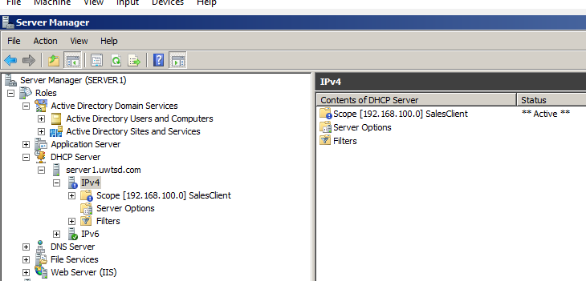

[PART C: TESTING DHCP LEASES]

[Complete this task from the Windows 7 client]

- Log in to the CLIENT with the following credentials:

User Name: Administrator
Password: P@ssw0rd
Domain: SALES or SMU this purely depends on which domain Server you have completed the previous tasks.

- Start – Run – cmd

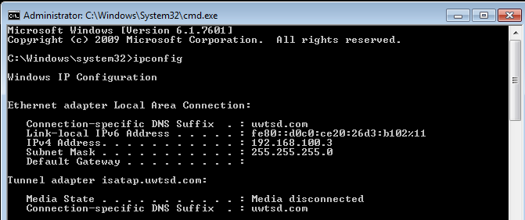
- Type: ipconfig /release
- Type: ipconfig /renew (to obtain an IP address from DHCP Server)
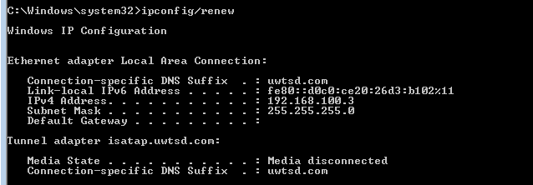
- Type: ipconfig /all
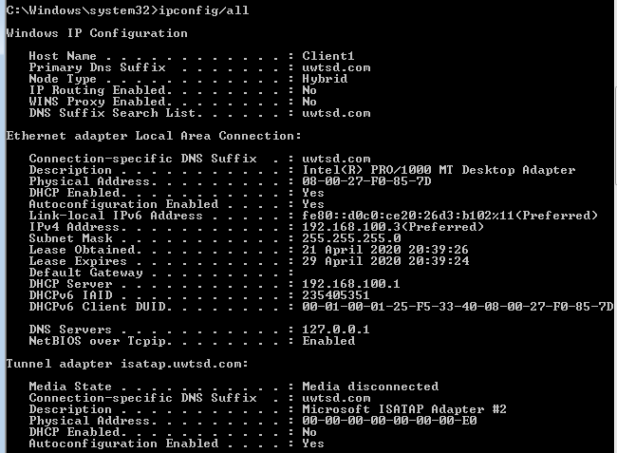

NOTE: Verify that the DHCP server IP Address is the IP address of the Server we have installed DHCP and created Scopes on.

[PART D: CONFIGURING DHCP OPTIONS]

[Complete this task from the Server]

- Start – Administrative Tools – DHCP Console
- In the console tree - Click Address Leases, verify that the Computer Name displayed is that of the client.
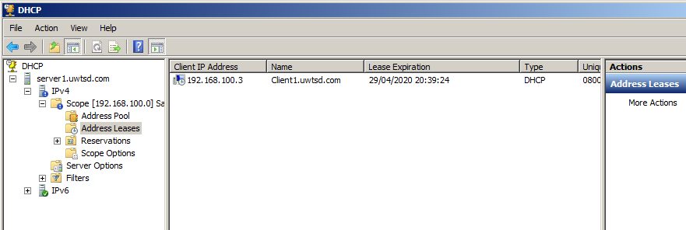

Configuring DHCP options with DHCP Server Service.

Another vital stage in the process of setting up/configuring the pools of IP addresses that the DHCP server will hand out is managing DHCP options.

3 Common Management options:
- Server Options: Options that will apply to all the DHCP clients for the particular DHCP Server.
- Scope Options: Assigns values to just clients that get IP addresses from a particular scope
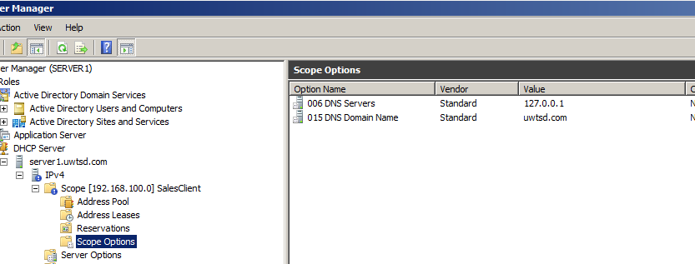
Client Options: Assigns values to only those computers that have a client reservation

Part A: Configuring DHCP Scope Options.

- Open DHCP console
- In the console tree, under the server name click Scope Options
- In the Action menu – click Configure Options
- Option Level: Scope
- Option: 003 Router
- Option IP address: IP address of the Server (this would usually be the address of the Router device or the ‘default gateway to our network.
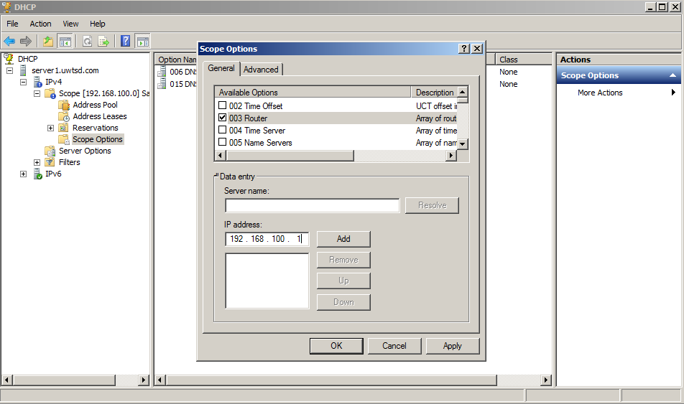

Part B: Testing DHCP Options.

[Complete this task from the client].

- Start – Run – cmd
- Type: ipconfig /renew (to obtain IP address from DHCP server)

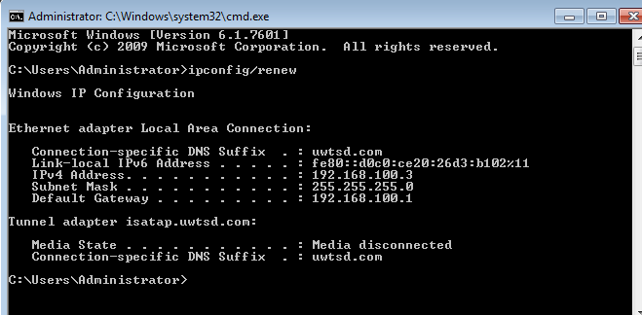

- Type: ipconfig/ all (verify that default gateway IP address for the connection Connection is the IP address of the Server.

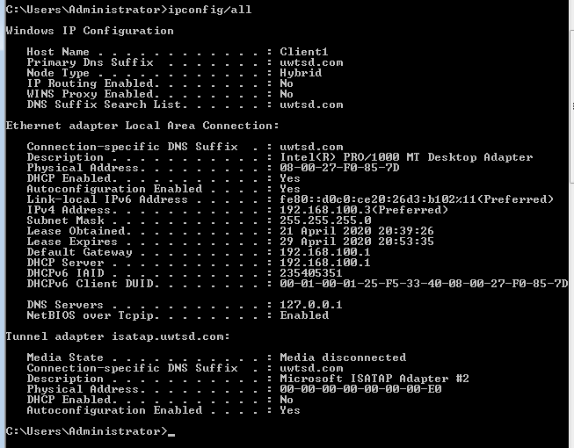

Worksheet 5: Planning and Deploying DNS in the Network Infrastructure
Task 1: Understanding DNS operation; Planning and deploying DNS

Complete this task from both servers]

Task (A). Check the Host Name and Fully Qualified Domain Name of your Server.
To better visualize the concept of how the domain name system breaks down host names/fully qualified host names we have 2 methods available to us.

To check the host name

- Start – run – cmd
- At command prompt, type hostname (Note the result)
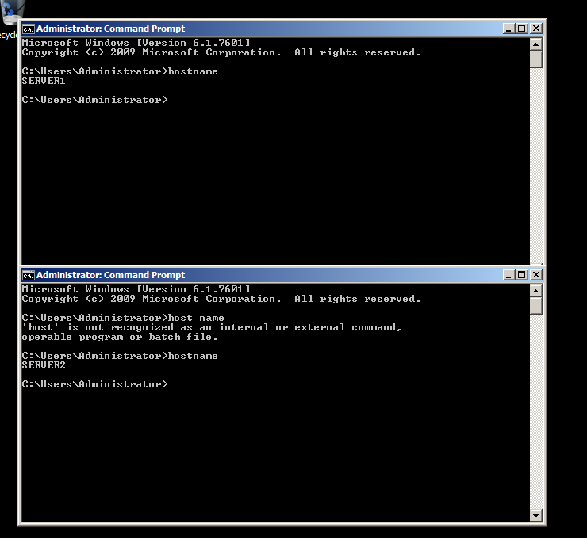

To check the Fully Qualified Domain Name

- Start – right click on My Computer – choose Properties
- Click on the Computer Name tab
- Note the full computer name provides the Fully Qualified Domain Name.
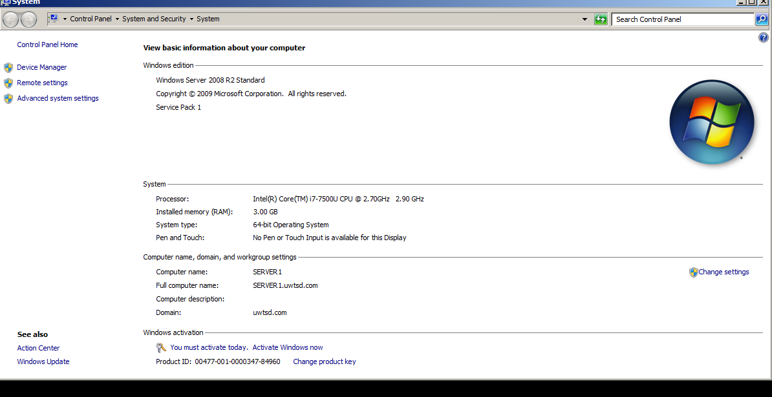
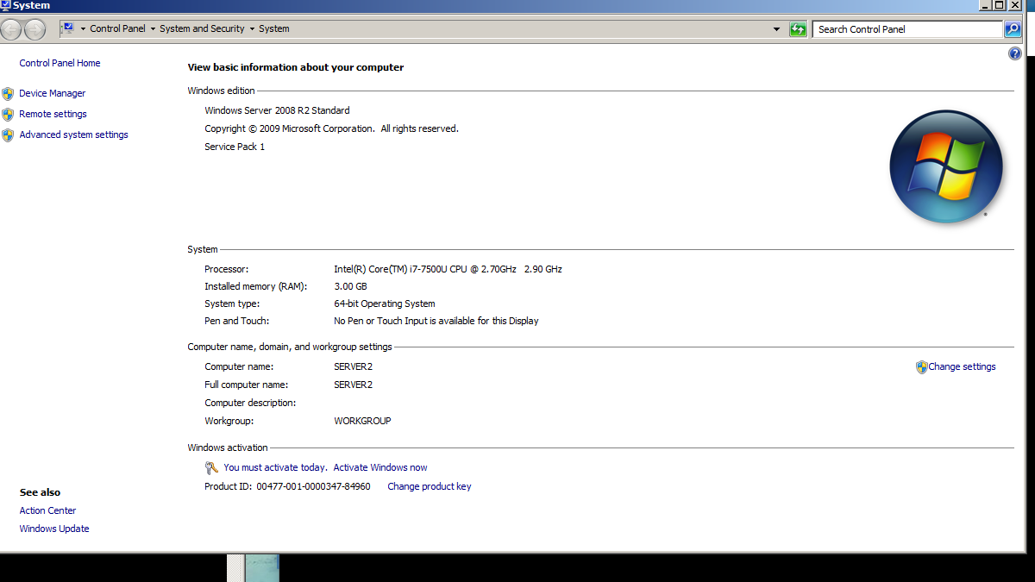

[Complete this task from the low number server]

Login using an administrative account; (User Name – Administrator, Password: P@ssw0rd
Domain: NWTRADERS).

- Start – Settings – Control Panel – Add/Remove Programs
- Add/Remove Windows Components
- From the Windows Components dialog – choose Networking Services.
- Click Details – Check on Domain Name System (DNS) choose Ok. The Service will now install.
- The DNS Console is now available by choosing Start – Administrative Tools – DNS.

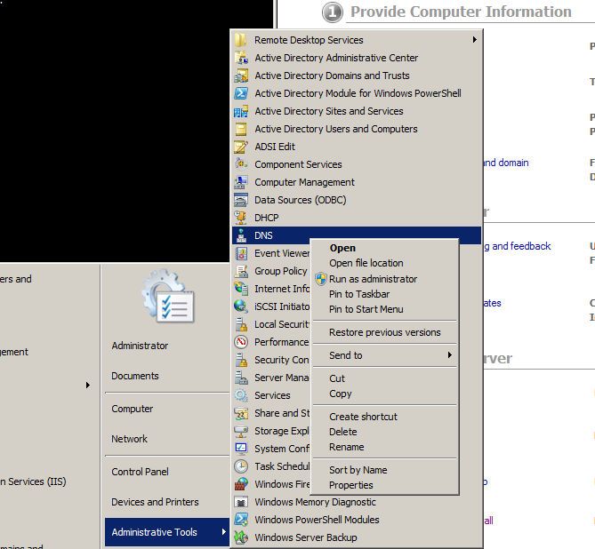
Task 2: Storing and Maintaining DNS Data.
[Complete this Task from the low number server]

- Open DNS Console
- Expand the Server and then Expand Forward Lookup Zones.
- Select the Primary Zone.
Verify the records you have for the hosts in your network (screen shot the details
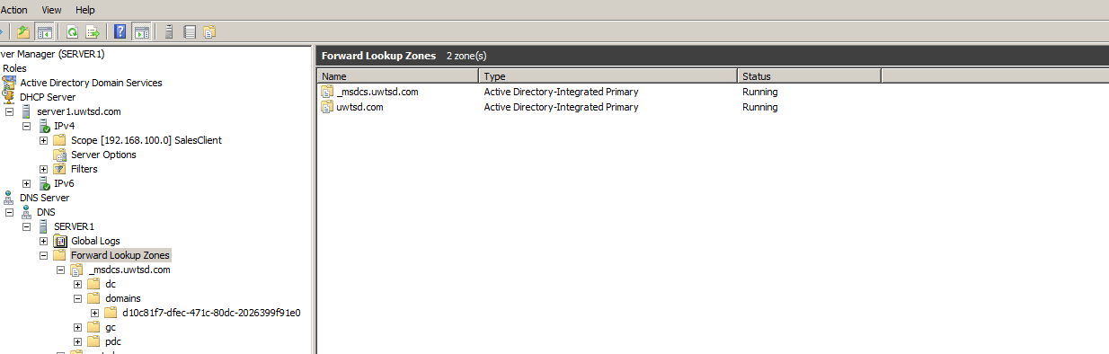

Task 3. DNS Application.
Complete this task from the high number server]

Installing a Web Server (IIS)

- Start – Control Panel – Add Remove Programs.
- Add/Remove Windows Components
- From the Windows Components dialog – choose Application Server – details
- Check on IIS.
- Next – Finish.
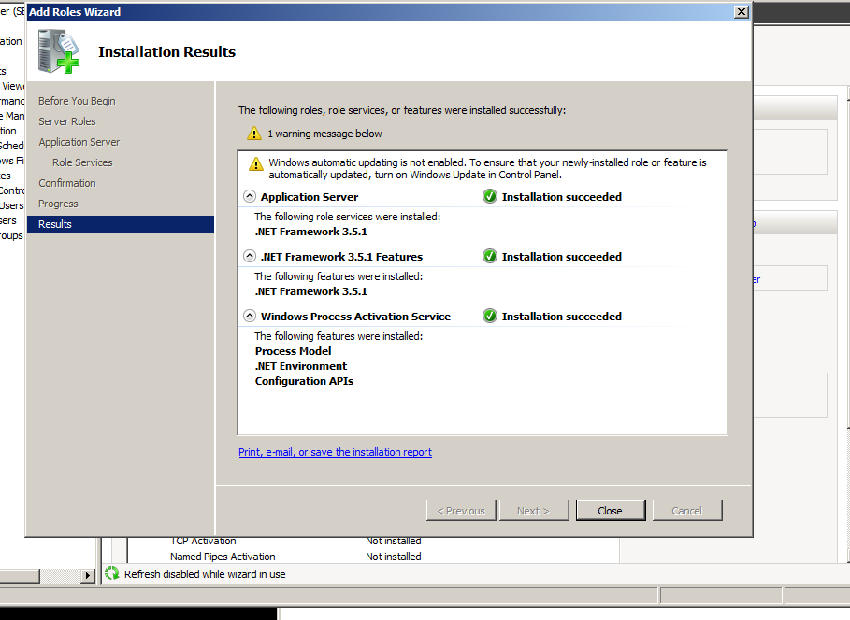
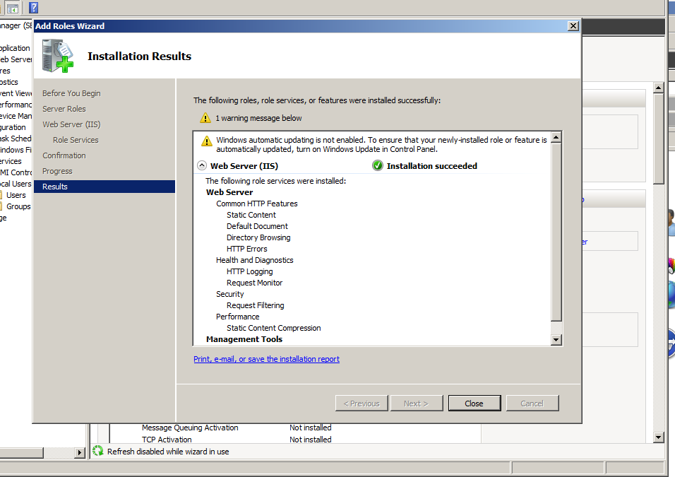

Creating a Virtual Directory
- Start – Administrative Tools – IIS (Internet Information Services).
- In the console view, expand the local computer, expand the web sites folder, right click on Default Web site and choose New – Virtual Directory.
- Click Next on the Welcome screen
- Give the virtual directory an Alias name. This name is what remote users will insert into their browsers to find the files that live locally on your machine. Ensure the name is relevant to the application you are hosting – choose Next.
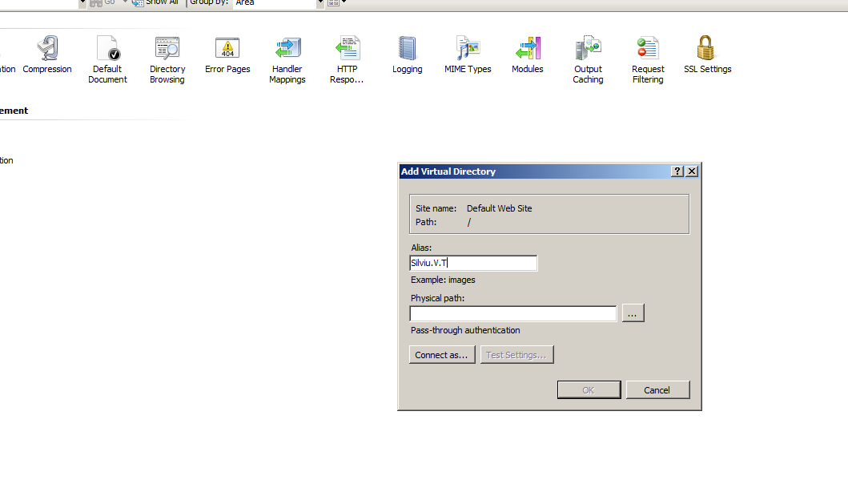
- At the web site content directory page you will need to point the alias to the local directory where you web site content will be stored. This is usually within the Inetpub/www directory within your local disk (e.g. C:\Inetpub\wwwroot). This is the default web folder for websites in Microsoft windows operating systems. Choose Next
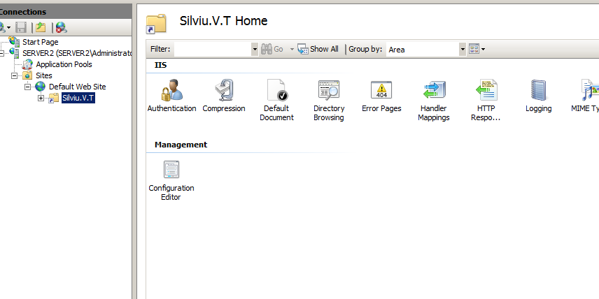
- At the permissions page, ensure that your application has permissions to read files and run scripts. Choose Next and Finish to complete the wizard.
- There are a few more steps to complete to ensure that content is visible from this directory.

- Go into My Computer – C:\Inetpub and right click on the wwwroot folder, ensure that the Internet Guest Account user has at least read permissions.

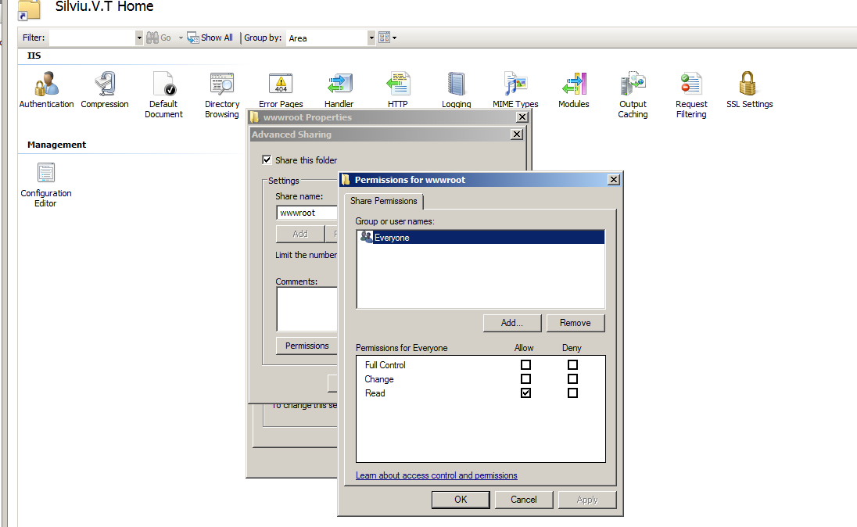
- Finally go to Start – Administrative Tools – Internet Information Services Management.
- Expand the server name and the default web site folder – right click on the Virtual Directory you have just created and choose properties.
- Click on the documents tab – click Add – select the page you just created and ensure it is at the top of the list. This is the only way your page will be set as the default IIS page.
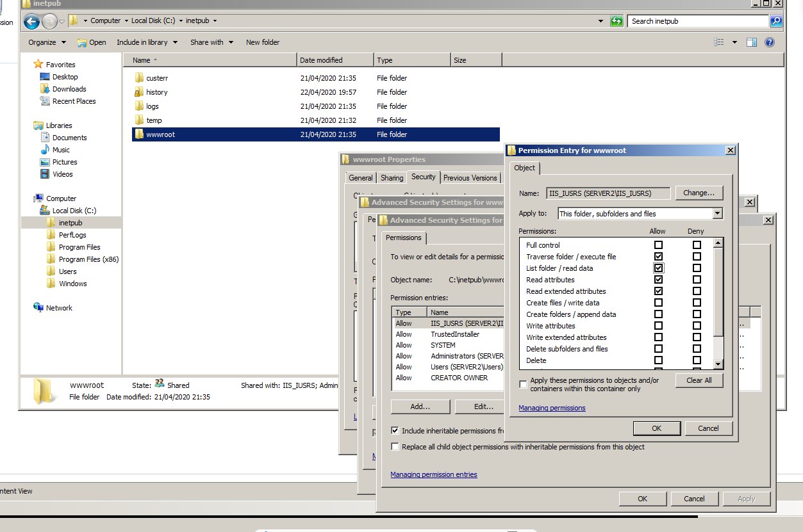
- We now need to create some simple web content for publishing. To do this we need to create a simple html file and place it within the C:\Inetpub\wwwroot local directory on the web server.



