

SERVING EXCELLENT COFFEE WHEREVER PEOPLE ARE

BUSINESS PLAN FEB 2026
BRUM BREW COFFEE - MOBILE TRUCK
BY RYAN REHMAN 2309123
CERTIFICATE IN HIGHER EDUCATION
LCLM4006 ENTERPRISE & ENTREPRENEURSHIP
LECTURER: SYAFIQ BIN ZOLKEPLY



Executive Summary
My business seeks to earn a reputation by selling coffee made from speciality beans sourced directly from Africa. This mobile coffee truck, named Brum Brew Coffee is a venture designed to deliver high-quality coffee beverages sourced directly from Kenya bringing coffee indulgence directly to the customer. Brum Brew Coffee aims to bring a rich flavour into the market using authentic Bastian beans sourced directly.
The area of operation will be in Central Birmingham, in high-traffic urban, and event-based locations. By combining premium coffee, efficient mobile operations.
The business will operate from a fully equipped coffee truck, serving espresso-based drinks using Bastian beans, brewed coffee, cold brew, and a limited selection of pastries. The mobile model significantly reduces overhead costs compared to traditional cafés while allowing the business to adapt quickly to demand patterns, seasonal trends, and special event locations.
The target market segments commuters, office workers, students, event attendees, and local communities. The business will emphasize ethically sourced beans from Kenya, consistent product quality, friendly customer service, and strong brand identity. Revenue will be generated through daily street sales, private catering, corporate events, sporting events, festivals, and partnerships with local businesses.
After liaising with local startup businesses my startup requires an initial investment of £85K–£120K covering the truck purchase and build-out, equipment, permits, initial inventory, and marketing. The business expects to reach break-even within 12–18 months and generate strong profit margins due to low fixed costs and high product markups. Brum Brew Coffee is positioned for scalability through additional trucks, branded merchandise, and wholesale partnerships.
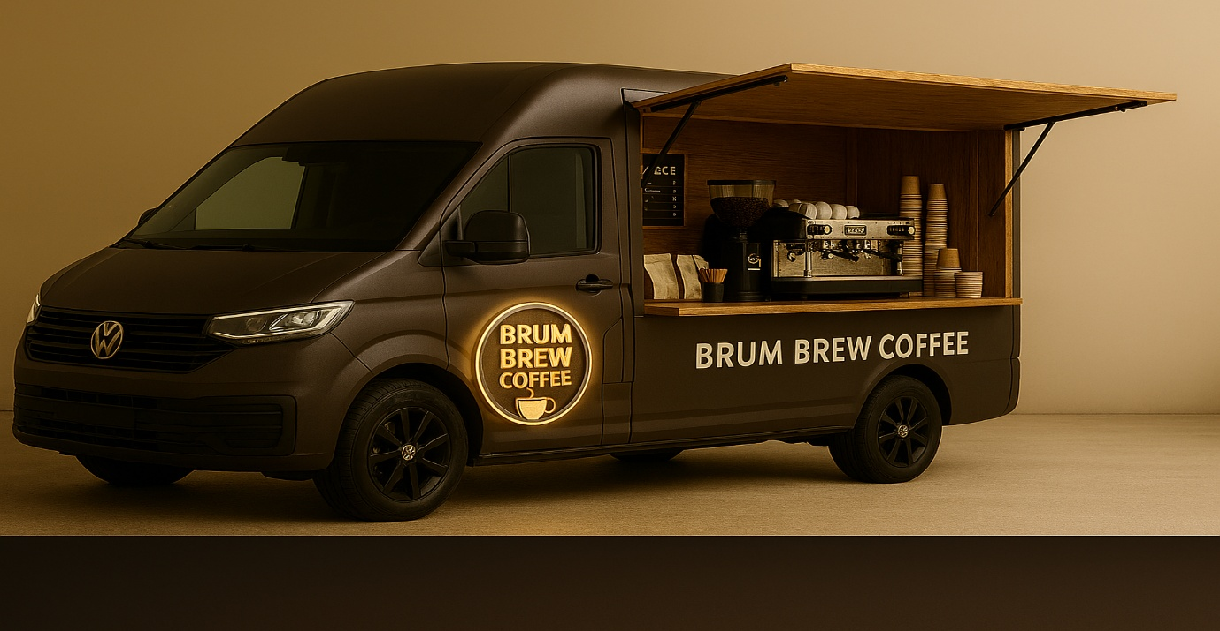

Contents Page
- Title Page
- Executive Summary
- Contents Page
- Company Description. Market Comparison. Prices v Retailers
- Target Market. Competitive Analysis.
- PESTLE Analysis. Products & Services.
- Pricing. RPI Chart.
- Market & Sales Strategy. Branding Strategy. Promotion Strategy
- Sales Channel. Operation Plan. Equipment. Suppliers. Permits & Compliance. Suppliers. Permits & Compliance. Management & Organisation.
- Start Up Cost. Revenue Projection. Expenses & Profitability.
- Risk Analysis. Conclusion.
- References

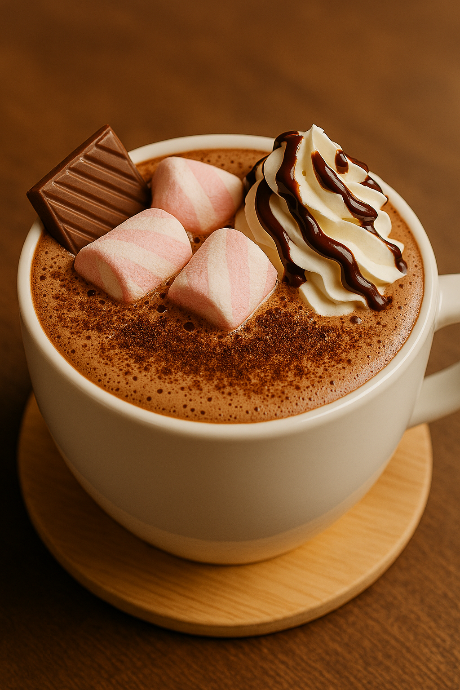

Company Description
This business Brum Brew Coffee is a mobile specialty coffee business operating from a custom-designed food truck. In accordance with Lawhive, the company will be structured as a Limited Liability Partnership (LLP). An LLP is a business structure that offers the flexibility of a traditional partnership with the added protection of limited liability, (Brown, 2025).
The business will be owned and managed on a day-to-day basis by the founder, with part-time or full-time baristas hired as demand grows.
The mission for Brum Brew Coffee is to serve exceptional coffee wherever people are, creating meaningful daily rituals through quality, consistency, and connection. The USP is to become a recognizable and trusted mobile coffee brand in the local market, known for premium beverages, community engagement, and innovative mobility.
Key business objectives include:
- Achieving profitability within the first 18 months of operation
- Building a loyal customer base through repeat sales and brand recognition
- Establishing strong partnerships with local roasters, suppliers, and event organizers
- Expanding operations through additional trucks or pop-up units within 3–4 years
The mobile coffee truck model allows the business to operate with lower risk than a brick-and-mortar café while maintaining high revenue potential and operational flexibility.
Market Comparison – Brum Brew Coffee prices vs other coffee retailers
BRUM BREW COFFEE  WWW.BRUMBREWCOFFEE.CO.UK  Located in central Birmingham  Coffee Menu Pricing  ∙Americano** £4.00*  ∙Cappuccino** £4.00*  ∙Espresso** £3.00*  ∙Flat coffee B/W** £4.00*  ∙Latte** £4.00*  ∙Mocha** £4.40*  ∙Hot chocolate £4.00* | COSTA  www.costa.co.uk  Several locations throughout the city  Coffee Menu  ∙Americano £3.80  ∙Cappuccino £4.40  ∙Espresso £1.95  ∙Flat coffee B/W £4.35  ∙Latte £4.40  ∙Mocha £4.60  ∙Hot chocolate £4.50 | CAFFE NERO  www.philpotts.co.uk  4 locations in the city  Coffee Menu  ∙Americano £3.60  ∙Cappuccino £4.10  ∙Espresso £N/A  ∙Flat Coffee W £4.25  ∙Latte £4.10  ∙Mocha £4.30  ∙Hot chocolate £4.25
*Extra cost for adding syrup, marshmallows, chocolate bits, fresh cream, extra chocolate.  Latte syrups: Toffee, Mocha, Vanilla, Caramel.  **All coffee subject to price increase APR 2026. | (Costa Menu, 2024) | (Caffe Nero Menu, 2025)
Target Market Segments
- Commuters and Office Workers: Morning and afternoon coffee consumers in business districts
- Students and Young Professionals: Individuals seeking affordable, quality coffee with modern branding
- Event Attendees: Sporting events, festivals, farmers markets, concerts.
- Corporate Clients: Office parks, meetings, and employee appreciation events
- Local Communities: Neighbourhood pop-ups and weekend markets
Every customer values convenience, quality, and a personalized experience is willing to pay a premium. As the expert BritWealth outlines, the UK market is undergoing a customer experience (CX) revolution. Companies that prioritise exceptional customer experience are seeing increased customer loyalty, higher revenues, and stronger brand reputation, (Willy, 2025).
Target Market
Competitive Analysis
Competition includes brick-and-mortar cafés, chain coffee shops, convenience stores, and other mobile vendors. However, Brum Brew Coffee differentiates itself through:
- Mobile operation with strategic location placement
- Building a strong team
- Customer reviews and feedback
- Engaging with customers on preferences/feedback/suggestions
- Quick service and lower wait times without losing product/service quality
- Unique branding to set apart from competitors
- Ever present social media engagement/interaction
- Specialty-grade beans and handcrafted beverages

PESTLE Analysis, (Bush, 2019).
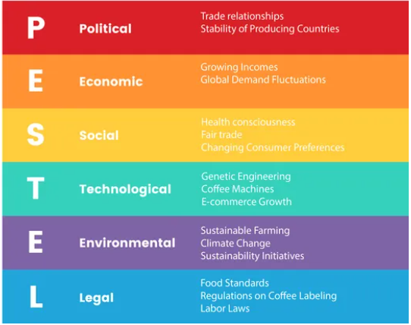
Products and Services
Brum Brew Coffee will offer a focused but high-quality menu designed for efficiency and consistency.
Core Menu Items
- Americano
- Brewed Coffee
- Cappuccino
- Espresso
- Flat White
- Latte (including flavoured options)
- Mocha
Specialty Offerings
- Cold Brew Coffee
- Seasonal drinks (pumpkin spice, holiday flavours, Pink Kashmiri tea)
- Alternative milks (goat, oat, almond, soy)
Food Items
- Fresh pastries & cakes (sourced from local bakeries)
- Muffins, croissants, and cookies
Additional Services
- Private event catering
- Corporate coffee service
- Branded merchandise - cups, mugs, apparel, (Mr Bamboo Cup, 2025)
Pricing
Menu pricing will range from £3.00 to £4.50 per beverage, with strong gross margins averaging 65–75%. As per ONS, the price of coffee beans in the Retail Price Index was forecast at 6% for JAN 2026, the next update is late March 2026.
(www.ons.gov.uk, n.d.) RPI Chart
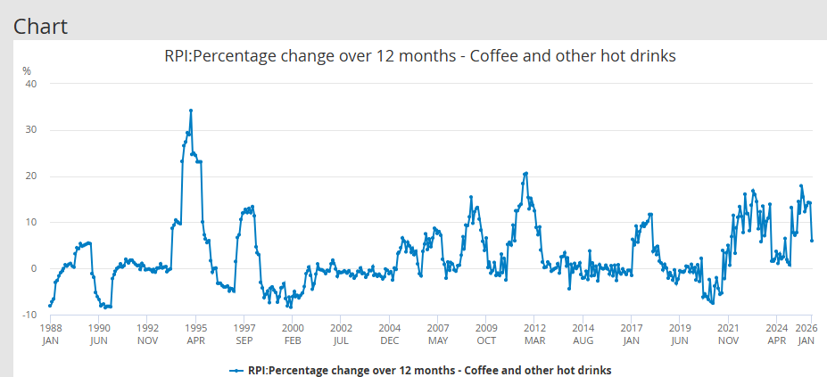

Marketing and Sales Strategy
Brum Brew Coffee will use a combination of advertising, combining digital marketing, strategic partnerships, and location-based selling to build brand awareness and drive sales. Advertising has evolved significantly in the recent few years, offering both traditional and digital avenues that adapt to our ever-changing consumer behaviours. Staying ahead has become a necessity for your business to thrive and grow, (Emir Haskic, 2025)
Branding
The brand will emphasize a clean, modern aesthetic recognisable logo and truck design. The visual identity will be consistent across the truck, uniforms, packaging, and social media platforms.
These judgments of warmth and competent staff/employees account for a huge amount of the variance in how much you like the person overall and vice versa. If you see them as warm and competent, then you’re good. If not, you’ll be wary, and won’t trust them. The same is true for brands. Applying this framework to brands, evidence in consumer neuroscience suggests that warmth and competence are the two most important traits when it comes to driving brand loyalty and predict key outcomes such as net promoter scores and likelihood to refer a friend. Luxury sectors aside, if you had to choose one over the other, warmth would be the choice. Research on the neuroscience of branding suggests that it is primary. So how can a brand exude warmth? Put simply, by demonstrating its good intentions for the customer’s well-being. This is a crucial element of long-term brand loyalty, (The, 2022).

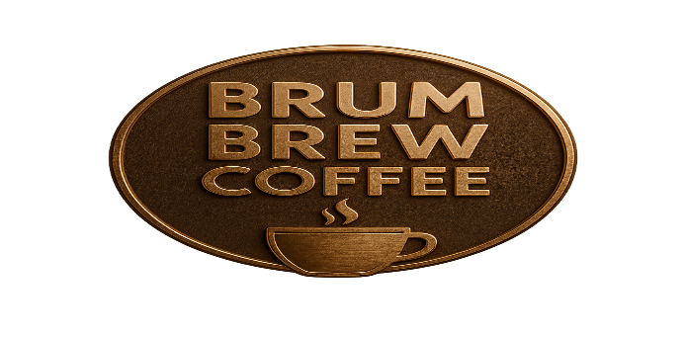
Promotion Strategies
- Social media marketing (Facebook, Instagram, Snapchat, TikTok,)
- Daily location updates and promotions
- Loyalty programs (digital/card punch cards)
- Collaborations with local businesses and events
- Introductory promotions and limited time offer

Sales Channels
- Street service in high-traffic areas
- Farmers markets and festivals
- Corporate bookings and private events
Operations Plan
The truck will operate 5–7 days per week, primarily during peak coffee hours (6:30 AM–2:00 PM), with extended hours for events. A typical day includes setup, inventory checks, service, cleaning, and closing procedures.
Equipment
- Coffee Brewer
- Coffee bean grinder
- Hot water filtration system and sink
- Generator, electric hook ups
- POS system
- Ice maker/freezer
- Refrigeration units
Suppliers
Coffee beans will be sourced from directly from Kenya. Pastries will be supplied by local bakeries. Milk, syrups, and consumables will be purchased from foodservice distributors.
Permits and Compliance
The business will comply with all local health department regulations, food safety standards, mobile vendor permits, and business licensing requirements, Birmingham City Council is the licensing authority responsible for considering applications for a range of activities that require a street trading consent under Schedule 4 of the Local Government (Miscellaneous Provisions) Act 1982 referred to in this policy as “the Act”, (Council, 2015). Staff hired in the near future will also be trained in food handling and safety procedures.
Management and Organisation
The practical skills needed to run this business are project management, time management, budgeting, communication, marketing skills and prove to be an all-rounder. Baristas will be trained to provide consistent beverage quality and excellent customer service.
As the business grows, responsibilities may expand to include:
- Operations manager
- Adequate staffing per location
- Marketing support
- Additional baristas
Employee training, scheduling, and performance standards will be documented to ensure consistency.
Staff will be paid minimum wage.

Startup Costs (Estimated)
- Coffee truck purchase and build-out: £50K–£75K
- Equipment: £20K–£30K
- Permits and licenses: £2K–£5K
- Initial inventory: £3K–£5K
- Branding and marketing: £3K–£5K
Total Estimated Startup Investment: £85K–£120K
Revenue Projections
- Average daily sales: £700–£1,200
- Monthly revenue (22 operating days): £15K–£26K
- Annual revenue: £180K–£312K
Expenses
- Cost of goods sold: ~30–35% of revenue
- Labor costs: ~20–25%
- Fuel, maintenance, and utilities
- Insurance and permits
Profitability
With controlled expenses and consistent sales, the business is expected to achieve net profit margins of 15–25% by year two.

Risk Analysis
Potential risks include weather dependency, equipment breakdown, regulatory changes, and competition. These risks will be mitigated through preventive maintenance, insurance coverage, diversified locations, and event bookings. Similar start-ups near my business, negative reviews and customer feedback on social media platforms. Informing customers about April price increase and advertising early to avoid complaints and loss of loyal customers.
Conclusion
Brum Brew Coffee is a viable, scalable, and profitable mobile coffee truck business that leverages strong consumer demand for specialty coffee and convenience. With strategic planning, high-quality products, and effective marketing, the business is positioned for long-term success and growth in the mobile food and beverage industry.

References
  - Brown, E.G. (2025). What is a Limited Liability Partnership (LLP) in the UK? [online] Lawhive. Available at: https://lawhive.co.uk/knowledge-hub/small-business/what-is-a-limited-liability-partnership-in-the-uk
  - Bush, T. (2019). PESTEL Analysis of the Coffee Industry. [online] PESTLE Analysis. Available at: https://pestleanalysis.com/coffee-industry-pestel-analysis/.
  - Caffe Nero Menu. (2025). Caffe Nero UK Menu Prices 2025 | Full Guide with Calories. [online] Available at: https://caffeneromenu.co.uk/price/.
  - Costa Menu. (2024). Costa Menu UK with Prices & Pictures | December 2025 Updated. [online] Available at: https://costamenu.uk/.
  - Council, B.C. (2015). Street trading policy | Street trading | Birmingham City Council. [online] Birmingham.gov.uk. Available at: https://www.birmingham.gov.uk/info/20150/markets_and_street_trading/274/street_trading/2.
  - Emir Haskic (2025). 25 Ways to Market Your Business in 2025. [online] Loop Digital Marketing Ltd. Available at: https://www.loop-digital.co.uk/marketing-insights-news/market-your-business-2025/.
  - Mr Bamboo Cup. (2025). Branded Coffee Cups - UK’s #1 & Eco - Get A Fast Quote & Mockup Now. [online] Available at: https://mrbamboocup.com/branded-eco-coffee-cups/
  - RPI:Percentage change over 12 months - Coffee and other hot drinks - Office for National Statistics
  - The (2022). Neuroscience Of. [online] Neuroscience Of. Available at: https://www.neuroscienceof.com/branding-blog/neuroscience-of-brand-warmth-for-loyalty.
  - Willy, S. (2025). Customer Experience Revolution: Winning Loyalty in the UK Market. [online] BritWealth. Available at: https://britwealth.com/uk/business/business-insights-uk/customer-experience-revolution-winning-loyalty-in-the-uk-market/

