University of Wales
Trinity St David

Site Investigation Case Study

Leigh Potts

Fundamentals of Construction Technology ACBA4001

Allan Nantel

17 November 2020
Table of Contents
Introduction 3
Preliminary Desktop Study 4
Introduction 4
Site Details 4
Topography 5
Site Walk Over 5
Rights of way 6
Access for future investigations 7
Services & Utilities 8
Historical Study 9
Brief History of Swansea 9
History of Site 9
Geology 11
Bedrock 11
Hydrogeology 11
Hydrology 11
Ground Data 11
Environmental 13
Contaminated Ground 13
Ecology 14
Radon 14
Unexploded Ordinance 14
Flooding Risk 14
Appendix 15
Conclusion 31
Load Bearing Capacity of strata 31
Contaminated Ground 31
Geophysical survey 31
Underground Service & Utilities 31
Seawall 32
Recommendation for Foundation 33
Reference list 36

Introduction

This Assignment will take a close look at a parcel of brownfield land adjacent to the Swansea promenade. This parcel of land is currently used as car parking by the County Hall building and Marriot hotels in the Maritime Quarter of Swansea. Through a preliminary desktop study following British Standard BS 5930 2015, recommendations will be made to a specialist geotechnical contractor for a detailed ground investigation in line with British Standard BS EN 1997 -1/2. Taking the data gathered from the preliminary desktop study, referring to building regulations, a suitable recommendation for an economical foundation detail will be made.

Preliminary Desktop Study

Introduction
The City and County of Swansea with Marriot Hotels have instructed Leigh Potts to undertake a preliminary desktop study with the view to erect a 300m² two-storey restaurant and ice-cream parlour with managers apartment on a parcel of land approximately 2,625m². This study will rely on data available from various sources as well as a planned site reconnaissance visit to assemble enough information to move forward with the next stage of the project.

Site Details
- Address – Land between Swansea County Hall and Marriot Hotel Swansea SA1 3SS accessed via Dunvant Place, Maritime Quarter, Swansea. SA13SS.

- Grid Reference SS 65392 92297

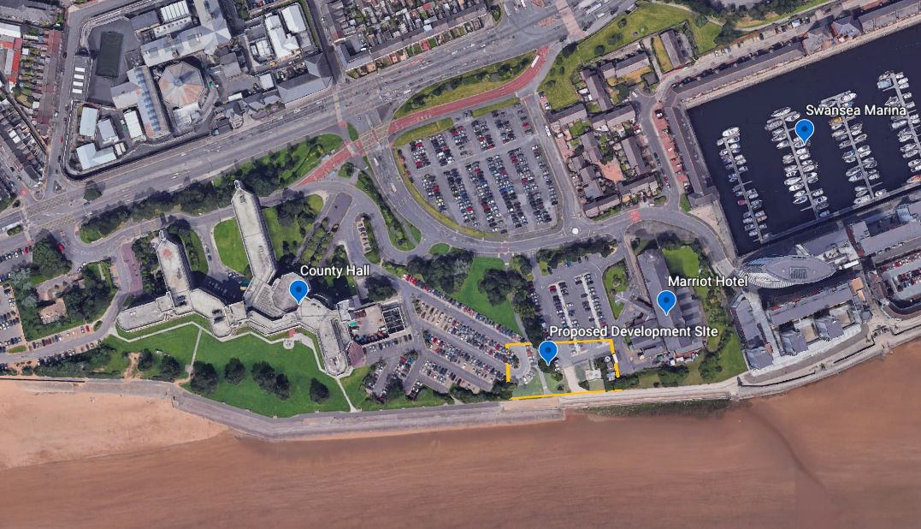
Fig. 1 (Google Earth, 2020)

Topography

The site defined within the red lines in Fig.1 is located on the Southern edge of Swansea. It is predominantly used as a separate car parking area for the Marriot hotel which is situated to the East of the site and for the Swansea County Hall which is situated to the West of the site. Bordering to the South is the Swansea Promenade and Beach separated by large retaining sea defence wall. To the North Dunvant Place; a mix of low rise buildings and Car parking and beyond the City Centre.

The Northern half of the site which sits at 7m AMSL is a tarmacked area with a row of trees and footpath dividing the carparks from north to south. The South East Section currently houses brick-built out buildings 7m AMSL and raised timber deck seating area 9m AMSL with the South East Section mainly raised banks of grass shrubs and ivy (9m AMSL) with 2 lower-level paths giving access to the promenade (Free Map Tools, 2020)

Site Walk Over

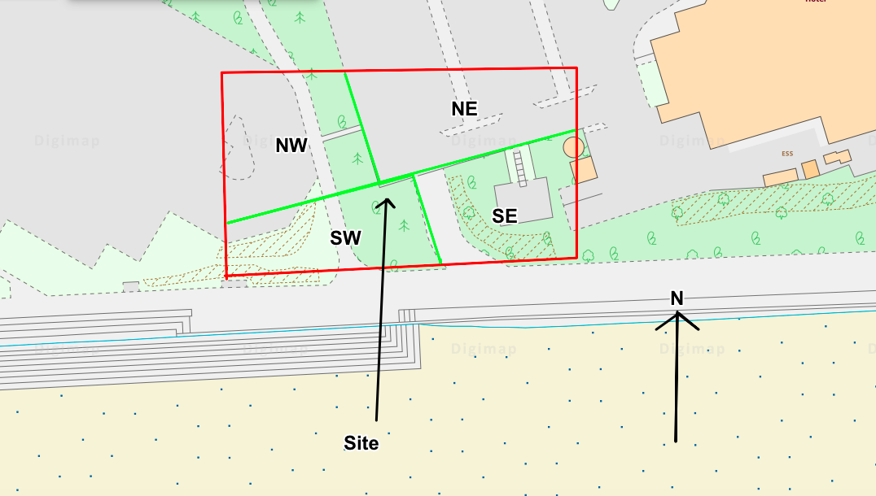
Fig. 2 Sections of the site divided by lime line. (Ordinance Survey, 2019)

A site visit was conducted on a rainy day on November 14th 2020, I divided the site into four sections as seen in Fig 2. Access was gained through the Marriot Hotel car park. Figures 3 – 10 & 12 are photos from the visit.

The Marriot carpark which represents the NE section of the site is well maintained with a tarmacked surface, adequate surface water drainage throughout with no signs of flooding. The area is well lit with lighting spaced 15m apart in the car park and pathways. Parking metres and cctv cameras are also dotted around. Access to the neighbouring County hall carpark (NW section of the Site) was gained via a small path between a line of shrubbery and trees marked private right of way (see fig 3). The small path led to the larger pathway running between the carparks north/south connecting Dunvant Place with the promenade. The County hall car park is also a well maintained surface with no signs of flooding, adequate surface water drainage and some lighting. A mature Cedar tree sits near the paths. Taking the path South towards the promenade the SW section of the site is a raised bank sitting approximately 2m higher each side of the path. A mixture of grass and shrubbery is planted on the banks with evidence of 1 access chamber on the path and 3 access chambers on the bank. Walking along the promenade to the SE of the site this section houses a pathway running North/South joining the Marriot Hotel with the Promenade, with a banked area to the East of the path mainly grass and ivy. Sitting on top of the banked area is a run down decked area with steps leading from the Marriot Hotel car park although they seem to be intentionally blocked off at present. Just to the East is a lower level tarmacked area accessed from the car park with several out houses assumed to be storage and possible utilities. To the South of the site, the Promenade is a busy pedestrianised path running along the bay with lighting spaced out. Separating the Promenade from the beach is a large retaining wall. A walk to the beach shows drainage holes and some damage to the outer stone face of the retaining wall.

Rights of way
No rights of way are listed on the council website however during a site visit a short path between the County hall and Marriot approximately 2 metres long had a plaque noting a private right of way. (Fig. 3)

Access for future investigations
A good access point could be gained from Dunvant Place via what is currently used as the Marriot car park exit, a temporary cordoned off area and restructure of traffic flow to the current car park would provide a safe option with minimal disruption to the hotel. Temporary restrictions to some of the paths connecting the Marriot to the Civic Centre to each other and the promenade would be advised for public safety. Fig.11
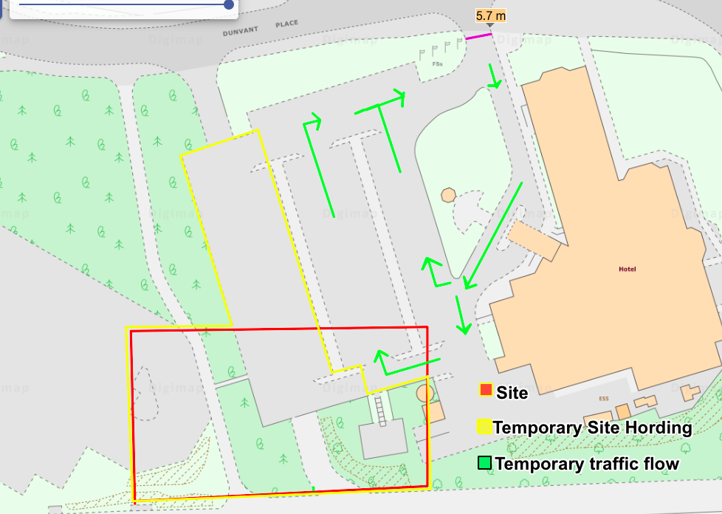
Fig.11 Temporary Works Access (Ordinance Survey, 2019)

Services & Utilities

A visual inspection of the site identifies carpark lighting with presumed underground cables covering the majority of the site, surface water drainage is evident particularly in the tarmacked areas and service chambers in the SW section. The retaining wall shows evidence of surface water drainage running from the site direction. Other notable observations are parking meters dotted around the car park, cctv, masts and multiple inspection chambers along with stop cocks near Dunvant place on the Marriot hotel land although these are not thought likely to under run the site. (See Fig 28)

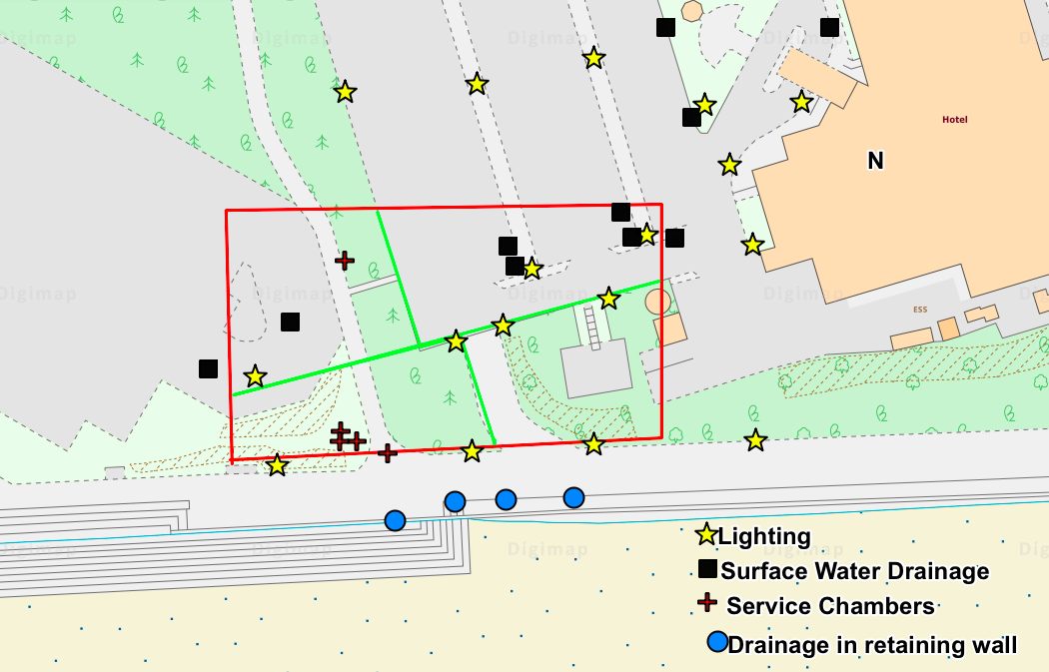
Fig. 28 Services noted on site visit (Ordinance Survey, 2019)

Historical Study

Brief History of Swansea
For the majority of the nineteenth century Swansea was at the forefront of the Worlds copper production. This led to the Swansea Valley and surrounding areas being heavily industrialised and the docklands expanded as it struggled to keep up with the demand. Swansea Docks had to expand to meet the need and in 1859 the South Dock was completed (Newell, July 1990). The large docklands area of Swansea made it a target of Germany during World War 2 and as a result the then Town centre and surrounding area were heavily bombed (Swansea Museum, 2020).

History of Site
The following is a list compiled from various maps of uses for the land at the particular time the map was drawn. It should be noted that the locations may have had other uses between the publication of maps and some industries may not have been categorised and are therefore not listed.
No ancient monuments listed withing 500m
Date of Map | Notable Industry on Site | Notable Sites Nearby upto 250m | Map Reference (Department of Environment, 2020)
1870  (Fig. 13) | The South Dock Branch Line | Gasworks 250m North  South Dock 125m East | (Digimaps, 1870)
1890  (Fig. 14) | The South Dock Branch Line  Timber Yard | Gasworks 250m North  South Dock 125m East  Engine Shed 125m West | (DigiMaps, 1890)
1910  (Fig. 15) | The South Dock Branch Line  Timber Yard  Cannister Works | Gasworks 250m North  South Dock 125m East  Engine Shed 125m West | (DigiMaps, 1910)
1940  (Fig. 16) | The South Dock Branch Line  Cannister Works  Paint Factory | Gasworks 250m North  South Dock 125m East  Engine Shed 125m West | (DigiMaps, 1940)
1950  (Fig. 17) | The South Dock Branch Line  Cannister Works  Timber Yard  Wagon Repair Works | Gasworks 250m North  South Dock 125m East  Engine Shed 125m West | (DigiMaps, 1950)
1960s  (Fig. 18) | Unnamed Depot and Works | Gasworks 250m North  South Dock 125m East | (DigiMaps, 1960)
1970s  (Fig. 19) | Warehouses  Mill  Disused Railway | Gasworks 250m North | (DigiMaps, 1970)
1980s  (Fig. 20) |  | Gasworks 250m North | (DigiMaps, 1980)

Geology

Bedrock
The site sits on the South Wales Middle Coal Measures Formation, comprised of grey, (productive) coal-bearing mudstones/siltstones, with seatearths and minor sandstones formed between the Duckmantian Sub Age and the Bolosovian Sub Age at a thickness of 240m. Fault lines run North to South at a distance of 420m to the East and 412m to the west of the site. There is a coal seam 720m to the North and a fossil horizon marine band 655m also to the North. (British Geological Survey, 2020) Fig.24

Hydrogeology
The South Wales Middle Coal Measure is a medium vulnerability secondary aquifier. Fig. 25 Borehole data near the site shows ground water present at 5.7m below surface (British Geological Survey, 2020)

Hydrology
The car parking areas of the site are serviced by surface water drainage. The areas of the site which have been landscaped would drain naturally through the ground into the lower Swansea bay.

Ground Data
A Borehole Sample from 1975 reveals made ground for 4.95m, sandy gravel up to 7.95m, stiff boulder clay to a depth of 18.5m and grey mudstone until the discontinuation of the hole at 22m. Fig.20, 21, 22, 23 (British Geological Survey, 2020)

The Ground itself is almost entirely made ground (Undivided) – Artificial Deposit MGR – ARTDP) Holoscene Epoch except for the North East Corner which is Landscaped
Ground (Undivided) Unknown/Unclassified Entry (LGSR _Unknown) Holoscene Epoch (British Geological Survey, 2020) Fig. 26

Historical Maps show buildings on the site giving the possibility of old foundations below the surface.

Environmental

Contaminated Ground
Name of Industry | Potential Contaminants | Reference
Timber Yard | Metals and metalloids  Inorganic compounds  Acids/Alkalis  Asbestos  Organic solvents  Preservatives  Polychlorinated biphenyls  Dioxins  Fuel | (Department of Environment, 2020)
Paint Factory | Metals and metalloids  Inorganic compounds  Acids/bases  Asbestos  Organic compounds  Fuels  Effluent treatment chemicals | (Department of Environment, 2020)
Docklands | Metals and metalloids  Sulphates/sulphides  Cyanides  Fuel  Pesticides/Preservatives  Hydraulic Fluids  Cleaning agents  Arsenic | (Department of Environment, 2020)
Railway line  Engine shed  Wagon works | Fuel oils  Lubricating oil  PCBs  PAHs  Solvents  Ethylene glycol  Creosote  Herbicides  Ferrous residues  Metal fines  Ash  Sulphate | (Department of Environment, 2020)
Gasworks | Ammoniacal liquors  Coal tar  Spent oxide  Foul lime  Metals  Coal dust | (Department of Environment, 2020)
The table on Page 13 shows the potential ground contaminants from nearby industry as taken from the Department of Environmental data.

Ecology
From the site walkover, no evasive plant species are evident, the site isn’t in a conservation area and has no records of protected plant or animal species. No Tree protection orders.

Radon
1-3% of properties in the area are above the Radon action level. (UK Radon, 2020)

Unexploded Ordinance
The area is listed as being high risk area for bombs and shows several nearby sites which were Luftwaffe targets during World War 2 (Zeticauxo, 2020)

Flooding Risk
While the site itself is shown as not being a flood risk, the land to the South of the Sea wall is at high risk of Coastal Flooding and land to the north at low risk of River flooding (Natural Resourses Wales, 2020) Fig.27

Appendix

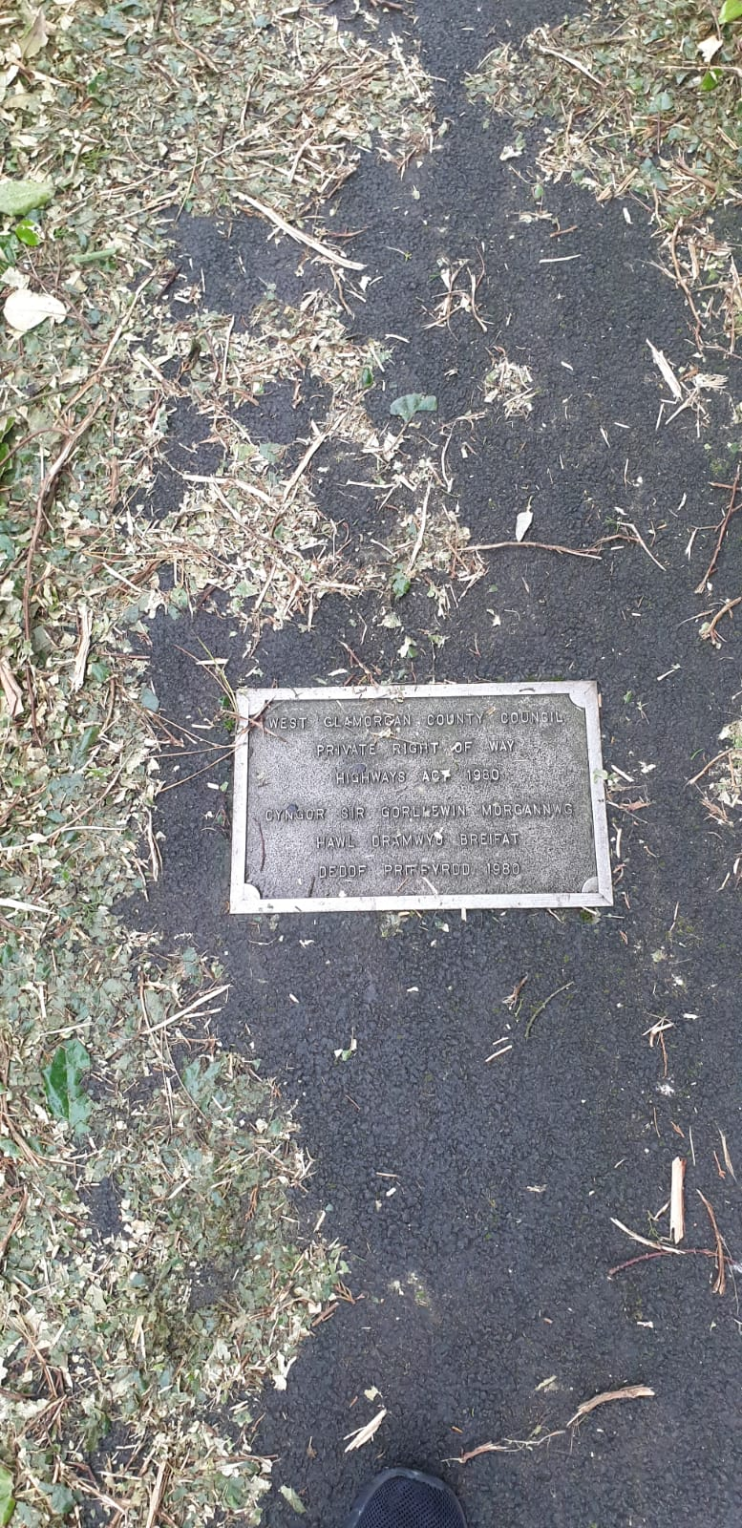
Fig. 3 Photo of plaque declaring “Right of way” (Author, 2020)
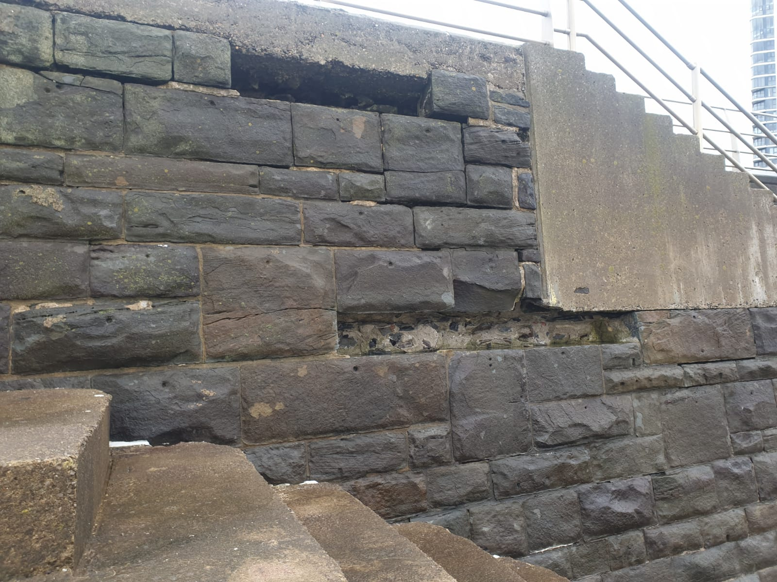
Fig. 4 Damage to retaining wall (Author, 2020)
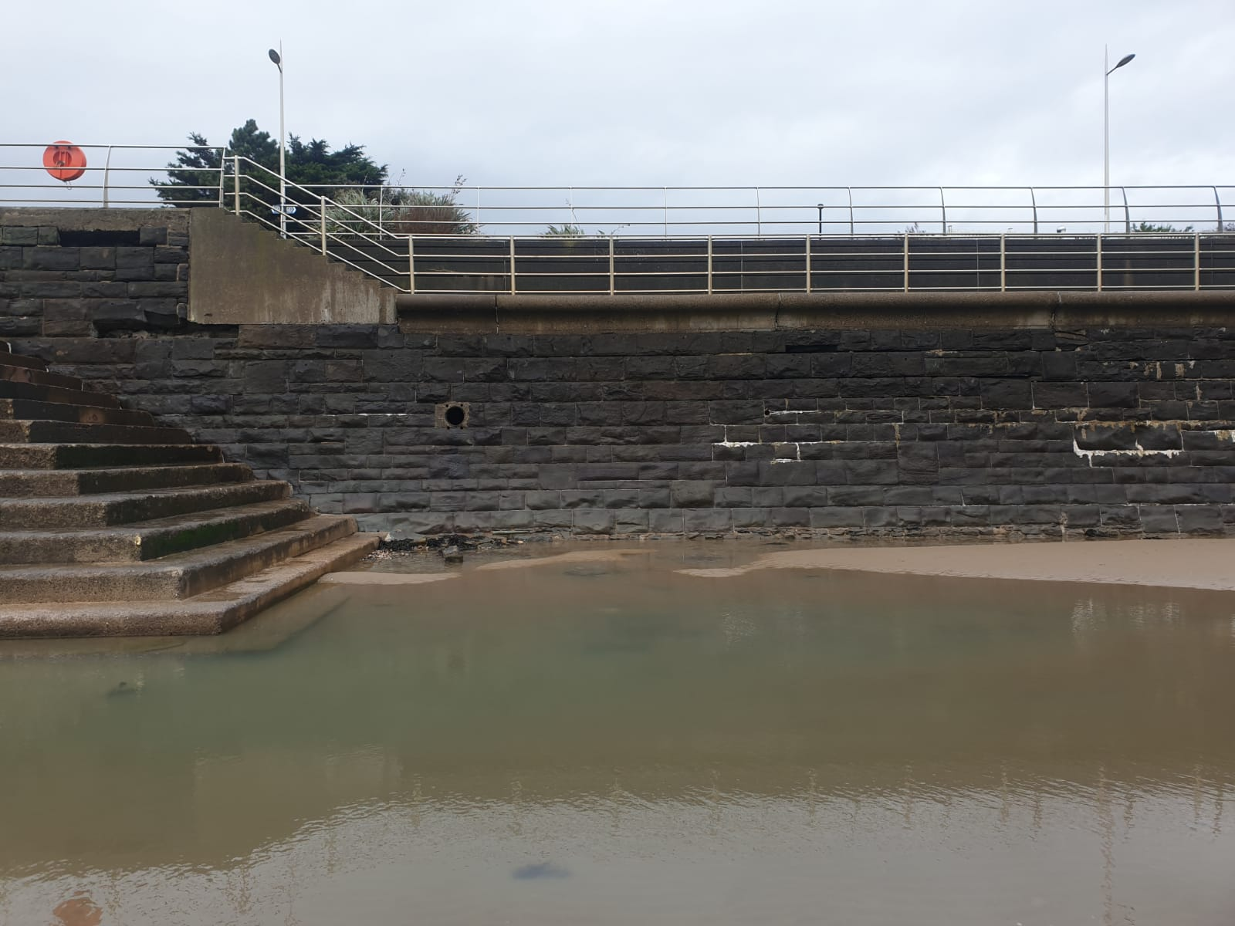
Fig. 5 Drainage in retaining wall (Author, 2020)
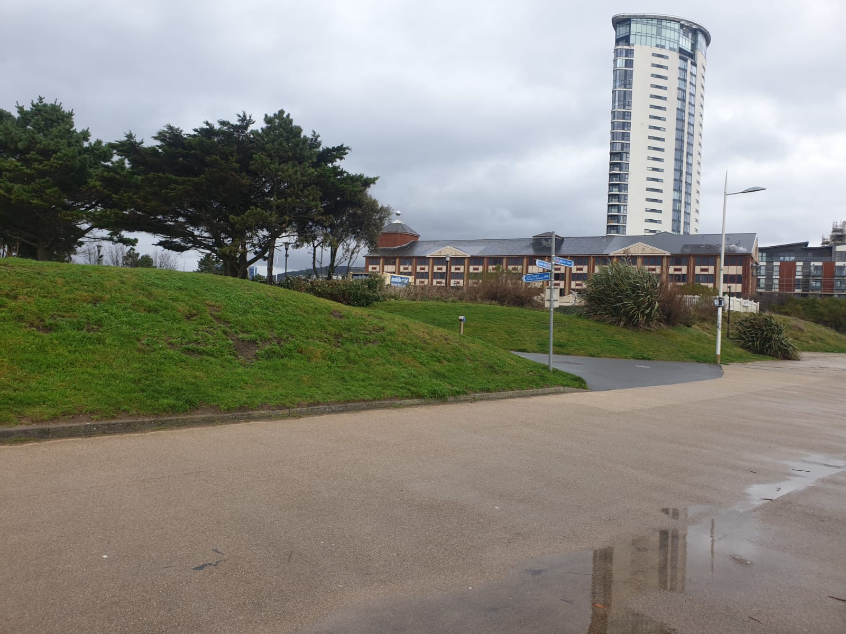
Fig. 6 View of the site from promenade (Author, 2020)

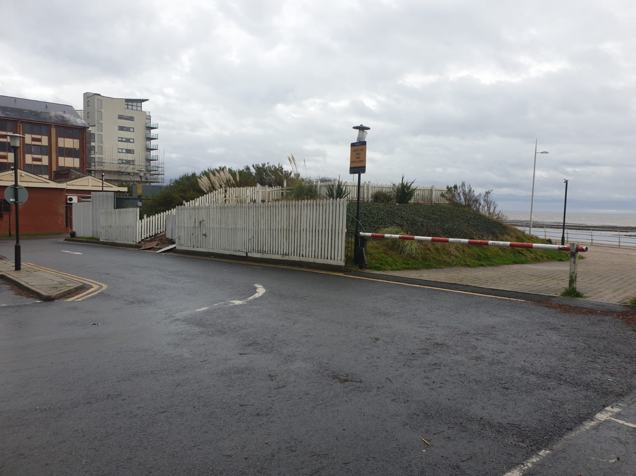
Fig. 7 A View from the NE looking SE (Author, 2020)

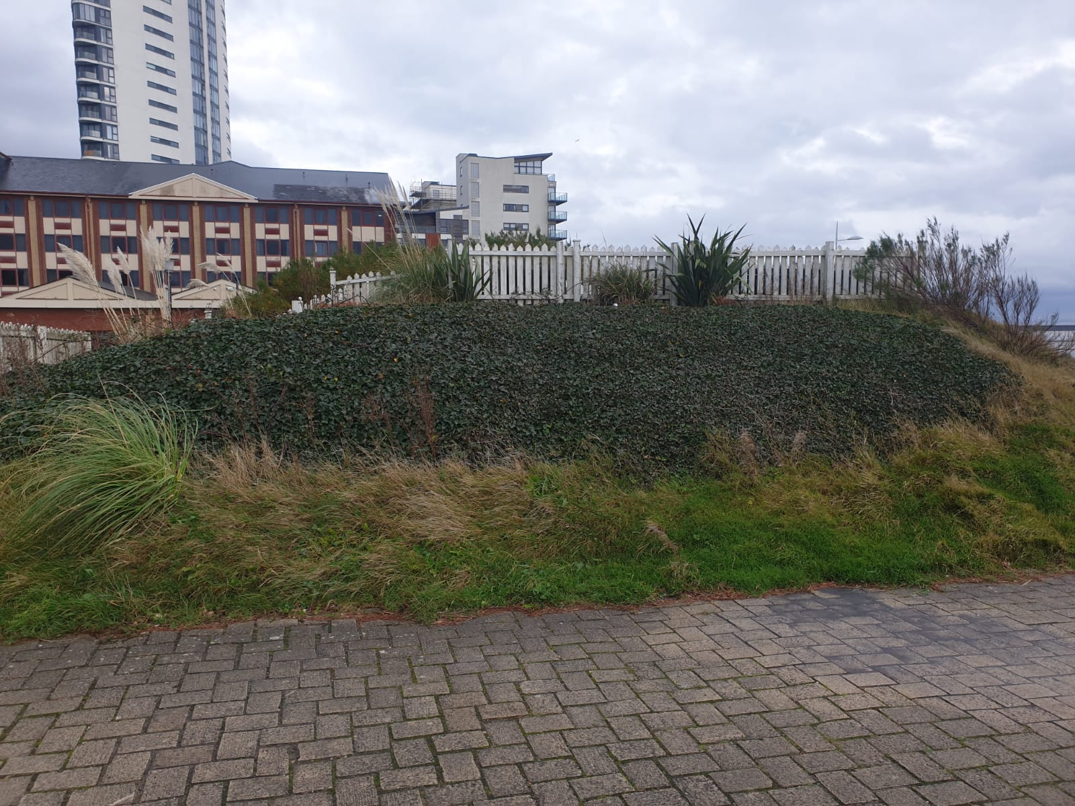
Fig 8 Looking at the SE of the site (Author, 2020)
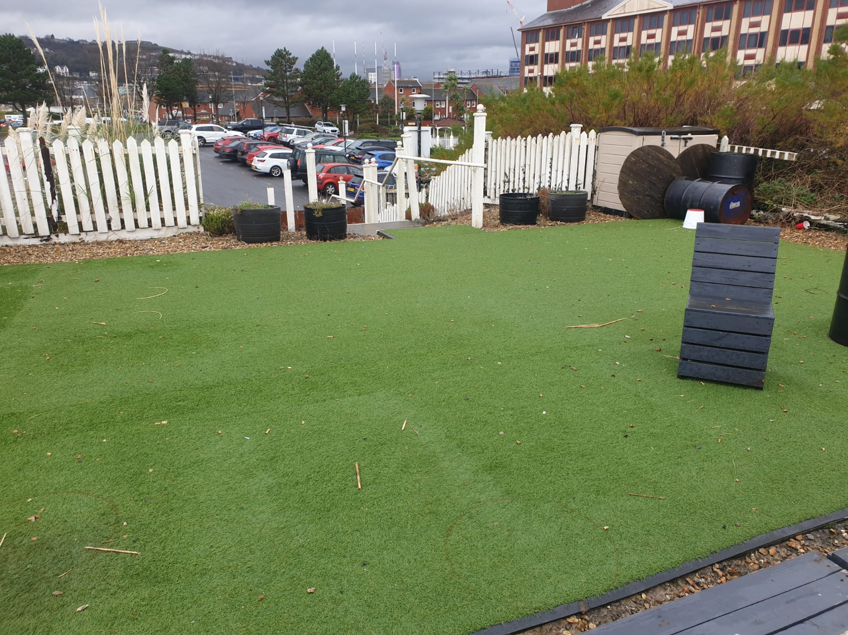
Fig. 9 The raised deck area (Author, 2020)

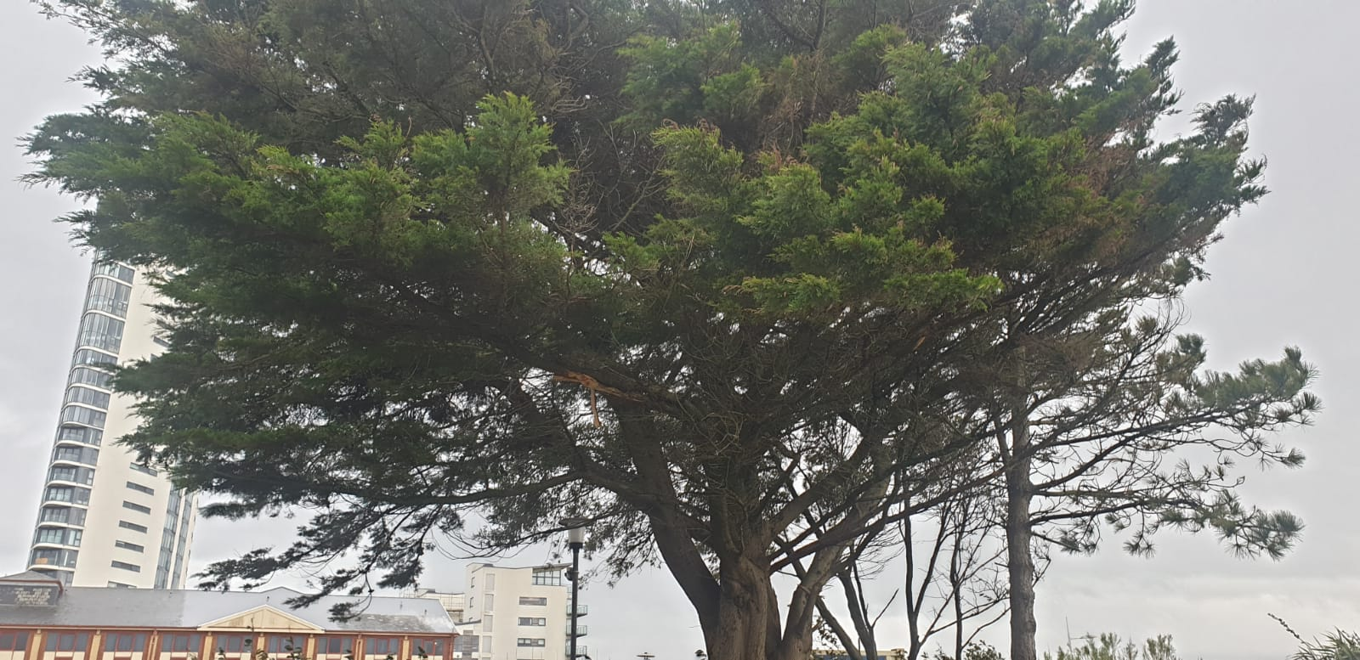
Fig. 10 The Cedar Tree (Author, 2020)

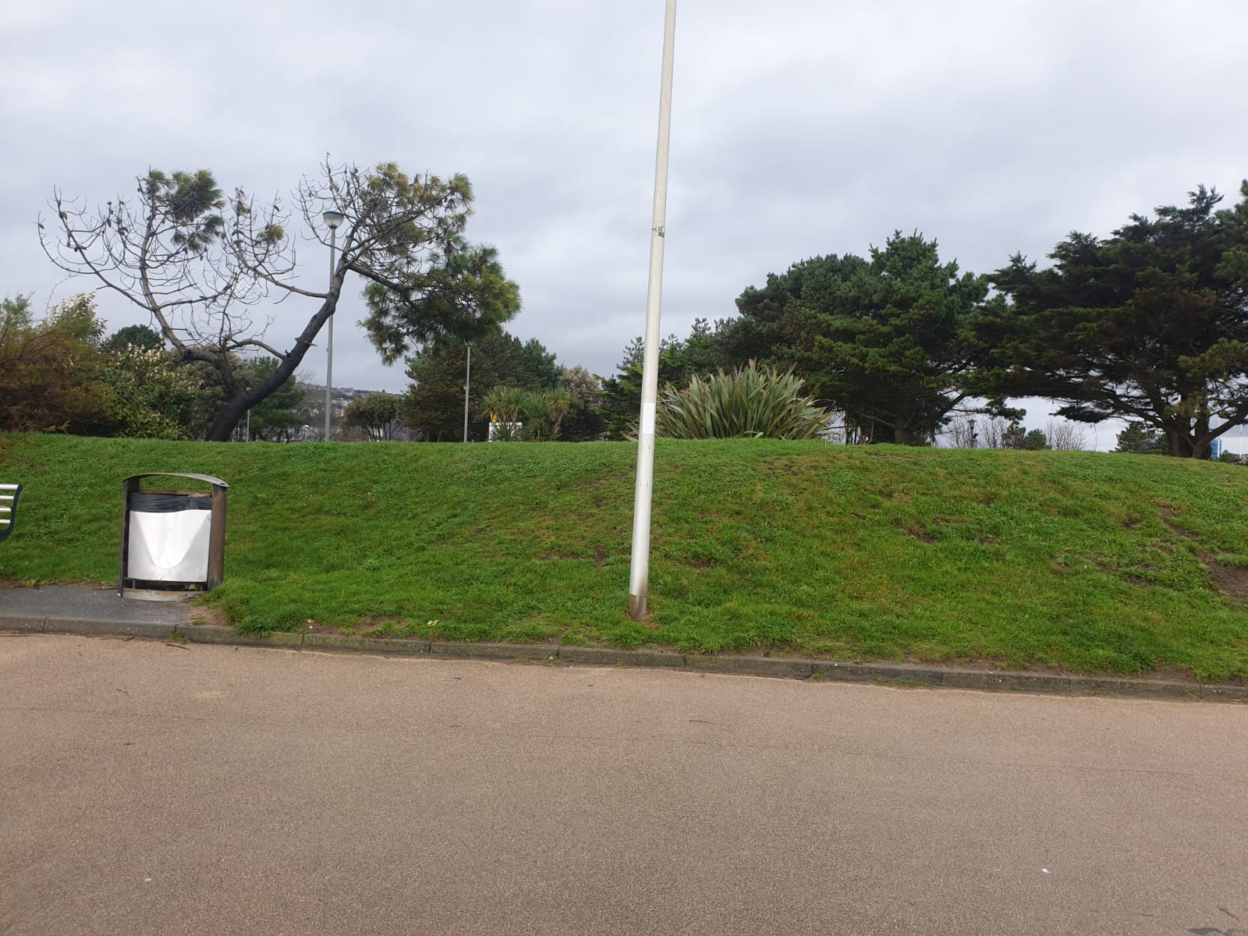
Fig. 12 The SW section of the site (Author, 2020)

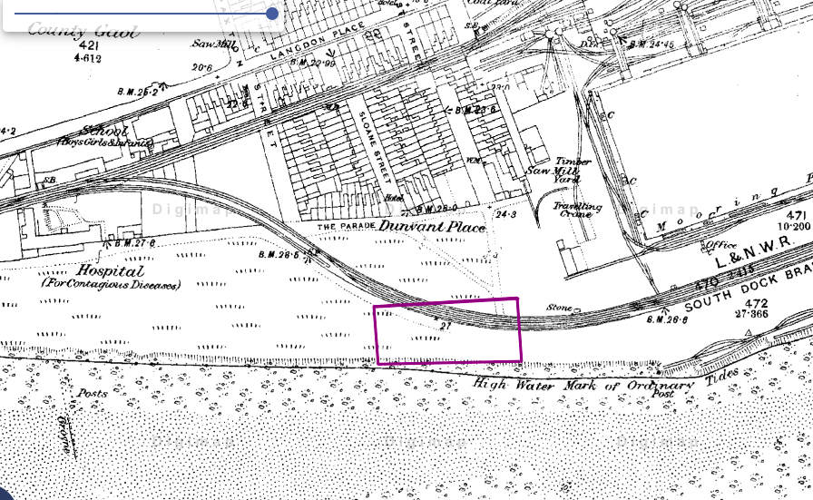
Fig.13 Showing 1870 Map of area (Digimaps, 1870)

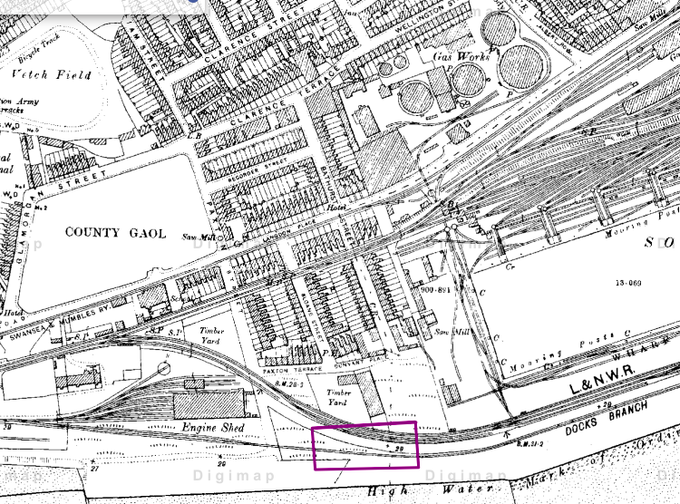
Fig 14 Showing 1890 Map of Area (DigiMaps, 1890)

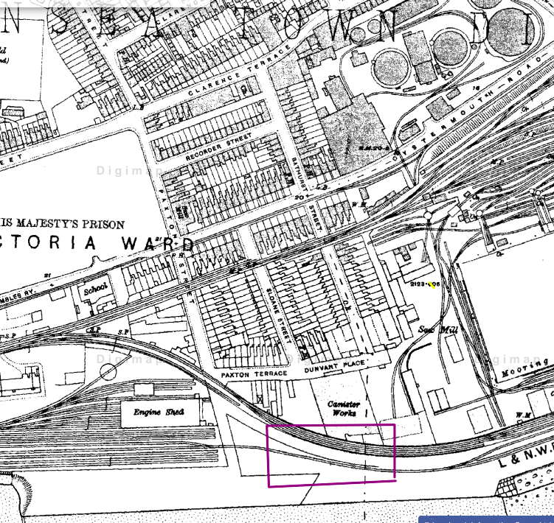
Fig. 15 Showing 1910 map of the Area (DigiMaps, 1910)

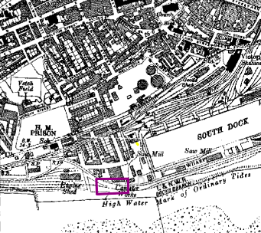
Fig.16 Showing 1940 Map of Area (DigiMaps, 1940)

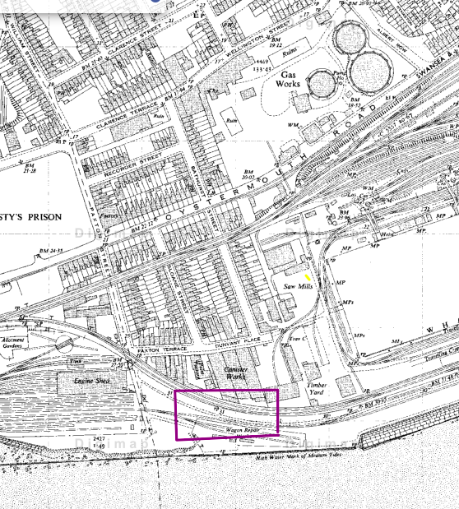
Fig.17 Showing 1950 Map of Area (DigiMaps, 1950; DigiMaps, 1960)
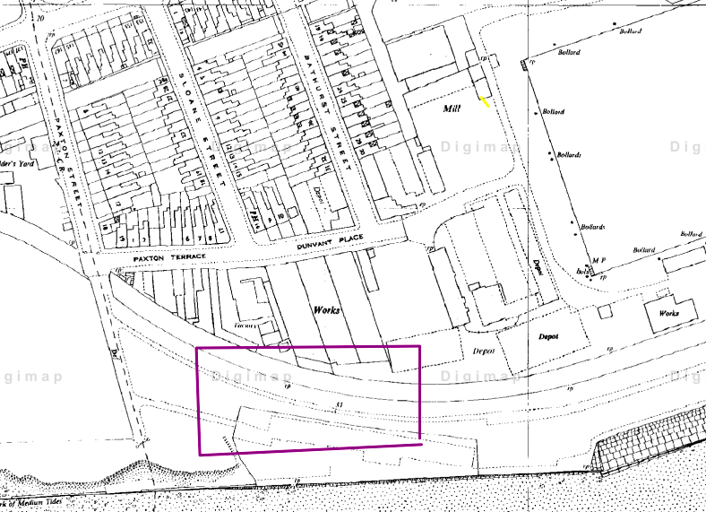
Fig.18 Showing 1960 Map of Area (DigiMaps, 1960)

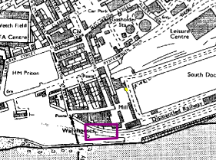
Fig.18 Showing 1970 Map of Area (DigiMaps, 1970)

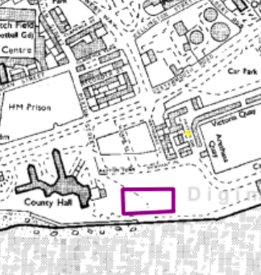
Fig.19 Showing a 1980 Map of Area (DigiMaps, 1980)

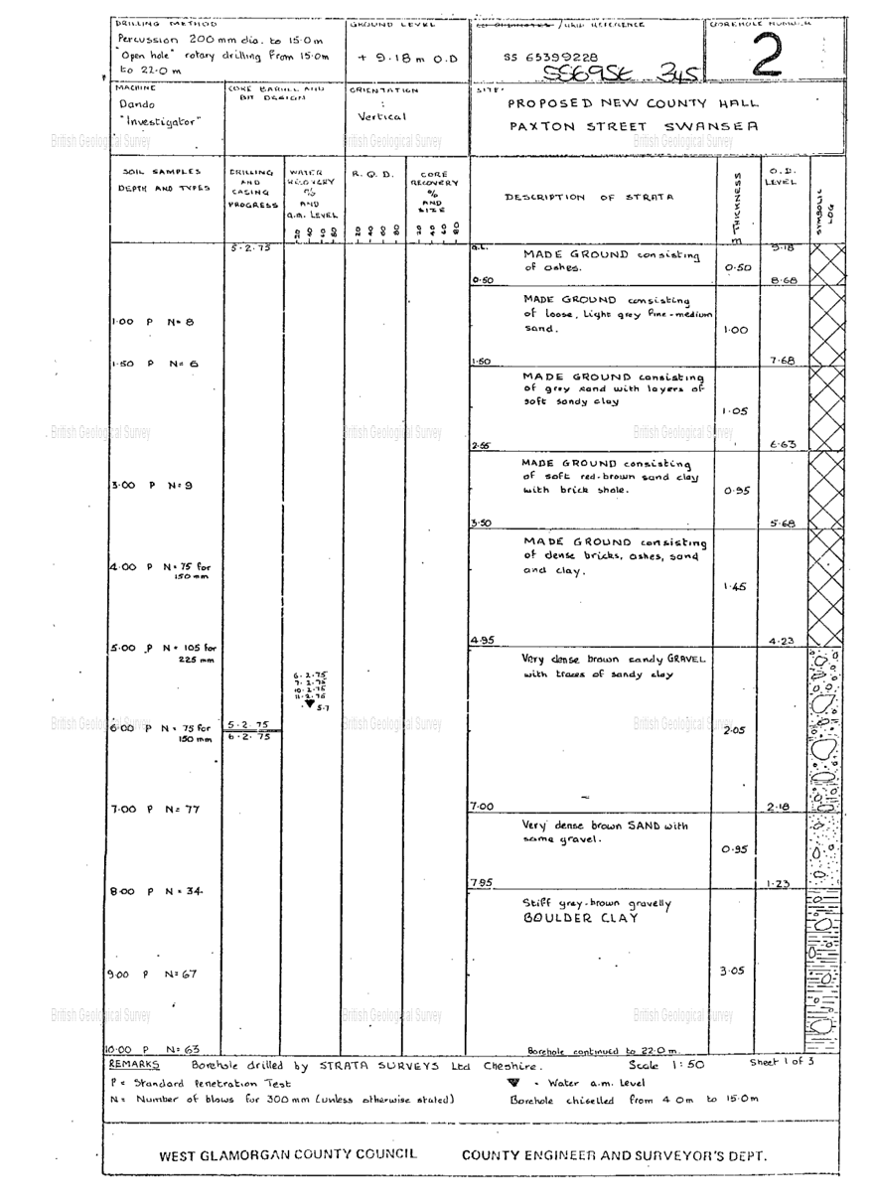
Fig. 20 Borehole Sample 1/3 (British Geological Survey, 2020)

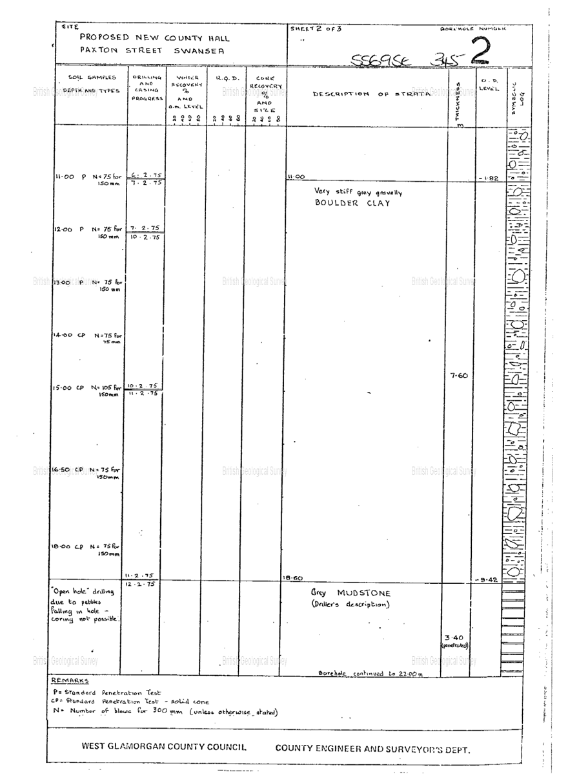
Fig. 21 Borehole sample 2/2 (British Geological Survey, 2020)
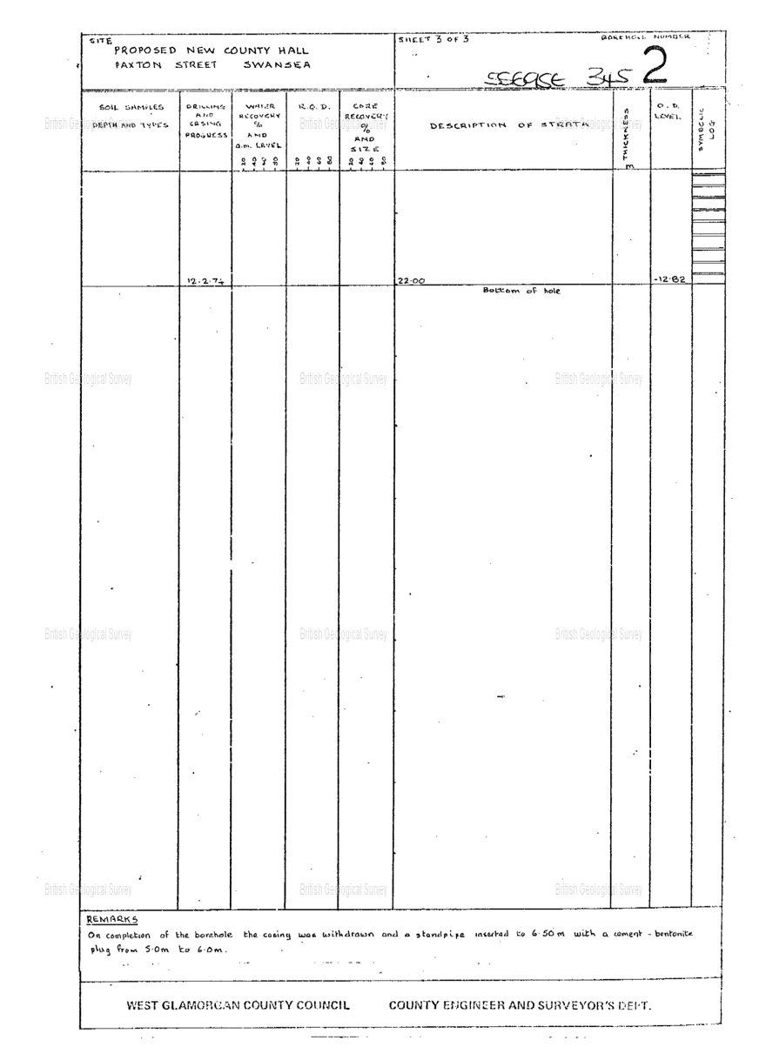
Fig. 22 Borehole sample 3/3 (British Geological Survey, 2020)
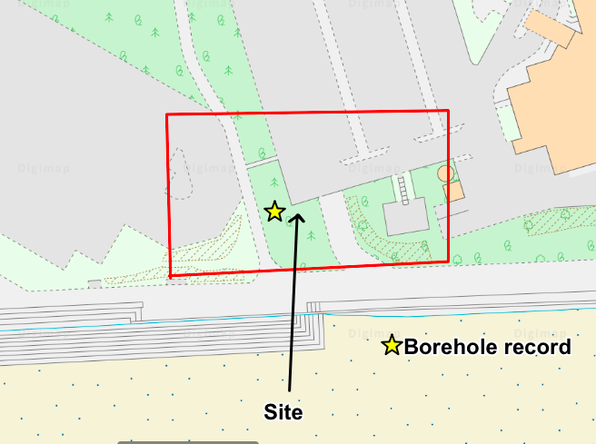
Fig.23 Borehole position (Ordinance Survey, 2019)

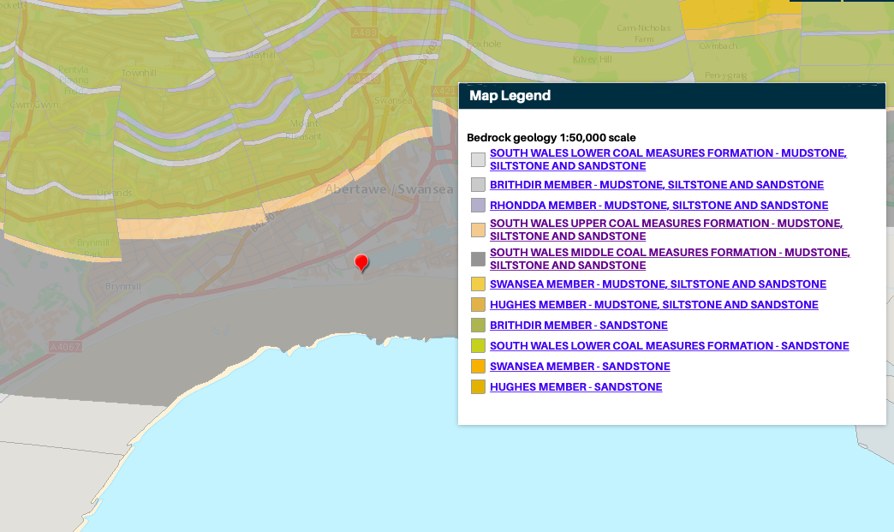
Fig. 24 Bedrock (British Geological Survey, 2020)
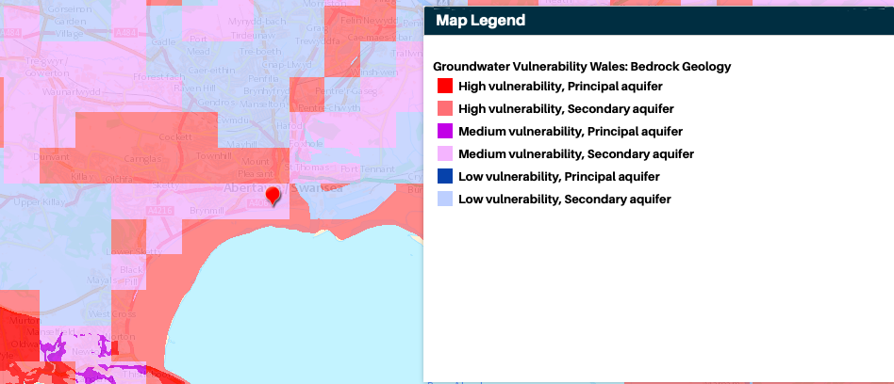
Fig.25 Aquifier (British Geological Survey, 2020)

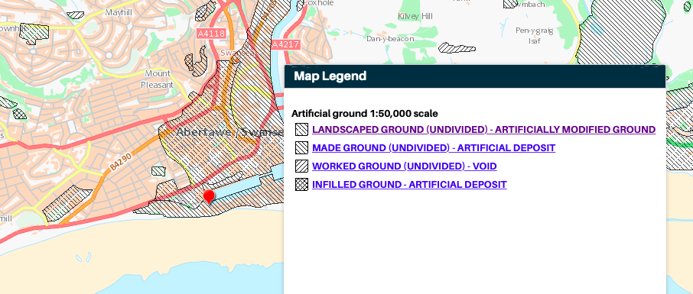
Fig. 26 Made Ground (British Geological Survey, 2020)
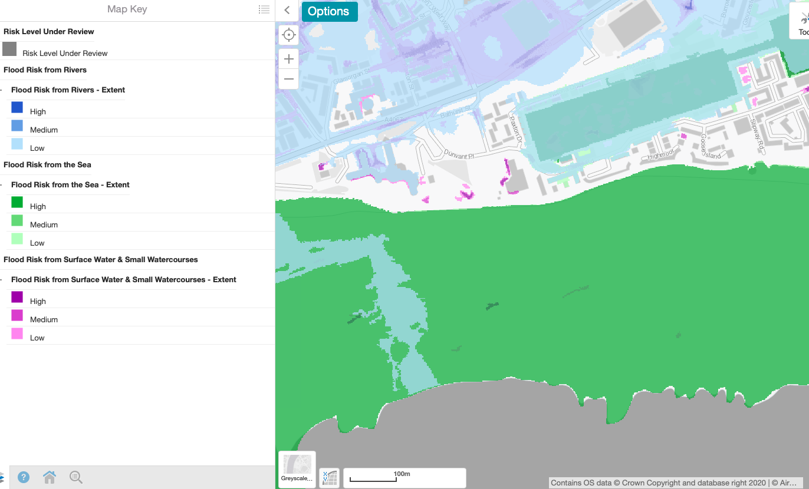
Fig.27 Long term flood risk (British Geological Survey, 2020)

Conclusion

On conclusion there are several areas I believe phase 2 of the investigation will need to focus on.

Load Bearing Capacity of strata
The most significant area to focus on during Phase 2 of the Geotechnical investigation is the load bearing capacity of the ground. The land at and around the site for a depth of 4.95 metres is made ground. This could undermine any building with unsuitable foundation due to the unknown fill material and risk of subsidence (Greeno, 2008). A suitable foundation will have to be designed in compliance with Part A of the building regulations.

Contaminated Ground
The South dock area was home to many different industries from the mid 19th century. This would have led to both accidental and intentional contamination of the ground both directly on the site and nearby which potentially may have leached through the ground.
Part 2A of the Environmental Protection Act (1990) outlines the developer is responsible for securing safe development. Soil samples should be taken from various locations on the site and tested in accordance with British stand BS10175 to determine to what extent the contamination is. Refer to Part C of the building regulations for guidance.

Geophysical survey
The docklands area was a target during World War 2 and as a result Swansea was heavily bombed, I would recommend a Geophysical Survey to be undertaken prior to any intrusive work to eliminate the risk of Unexploded Ordinance underlaying the Site. As well as unexploded ordinance, the survey would map underground services and utilities.

Underground Service & Utilities

The site walkover has identified both underground electric and surface water drainage running under the site. A full survey of underground services would be required to access further the feasibility of building at the site and gaining permissions.

Seawall
A Structural Engineer should be consulted to calculate the effect of a new structure on the existing seawall.

Recommendation for Foundation

The foundation will need to transfer the load of the building onto a suitable bearing layer (Greeno, 2008). After viewing the borehole data from the site it is reasonable to make an assumption of very similar ground underneath the proposed building. From this data we can see that the top 4.95 metres is made ground containing loose brick filled in a manner that points to little consolidation. A further 3 metres of gravelly strata and a water table at 5.1 metres. This data would rule out all types of shallow foundation due to the depth, unstable ground and also the water table. Another consideration is the added affect a shallow foundation could have on the nearby retaining wall. This leads me to recommend a deep foundation and in particular a pile foundation. Pile Foundations are a series of columns constructed or inserted in the ground. (Greeno, 2008)

Firstly, the ground would have to be levelled adhering to any guidance issued on completion of the contaminated ground testing. On concluding the desktop study, I believe a good position for the building taking into consideration of the outbuildings, presumed underground services, pathways and location for business would be the SE section of the site.

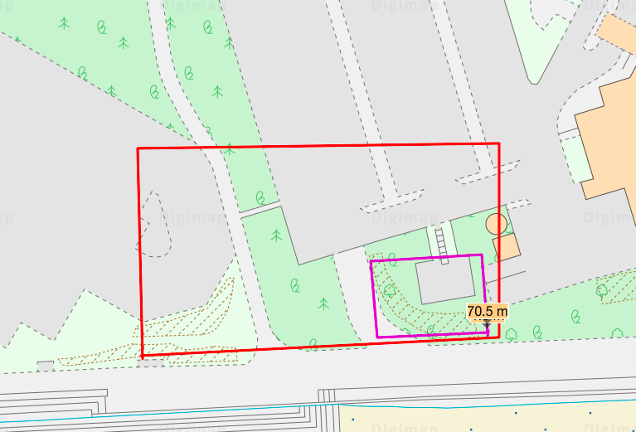
Fig.29. (Author, 2020)

At 22 metres deep the bedrock is at a reachable depth for an end bearing pile. An end bearing pile will transmit the weight of the building directly down onto the bedrock (Smith, 2020). Due to the close proximity to the Marriot hotel, most notably the outbuildings, the best method of piling would be a bored pile, this method would be a much quieter option compared to driven piling which could affect nearby buildings and retaining walls due to the vibration from the hammer blows. The anthroprogenic ground and loose gravelly sand soil layers would need to be supported as the hole is augered due to the likelihood of collapse. A temporary or permanent casing should be used to support the ground while the piling process takes place. When the hole is bored to the required depth a reinforced steel cage can be lowered into the hole and then the hole backfilled from the bottom using a tremie pipe to prevent and voids.
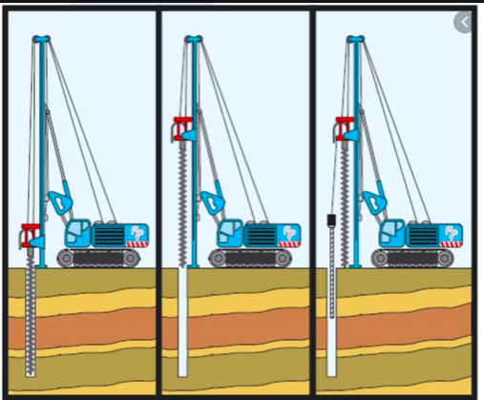
Fig. 30 (Unknown, 2020)

The piles would be spaced approx. 1800mm apart with a ring beam foundation which is a reinforced concrete foundation consisting of a preformed reinforced steel which can then be shuttered temporary with plywood and filled with a concrete mix to provide tensile strength and a flat foundation for the building.

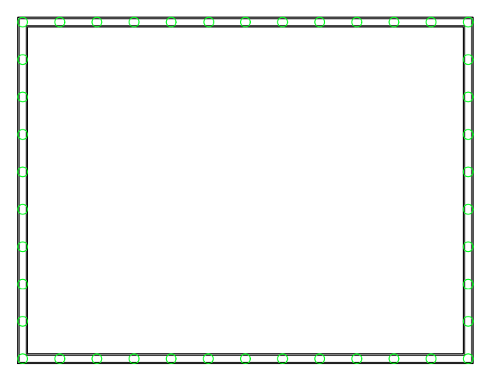
Fig.31 Pile layout (Author, 2020)
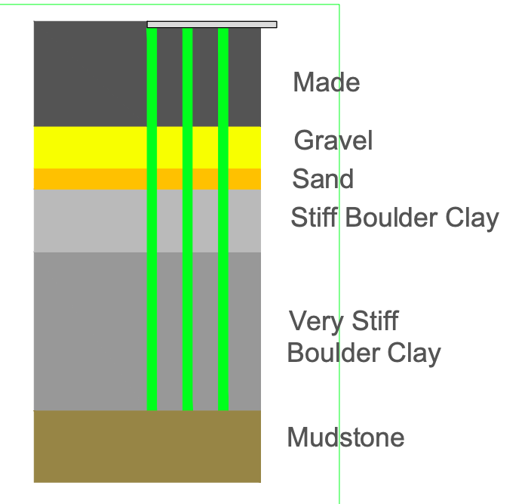
Fig.32 Section showing piles sitting on bedrock with a ring beam foundtion(Author, 2020)

Reference list
Author. (2020, Nov 14). Photo 1. Swansea, Wales, UK: Leigh Potts.
British Geological Survey. (2020). Borehole Scan Viewer. Retrieved from British Geological Survey: http://scans.bgs.ac.uk/sobi_scans/boreholes/370246/images/10677924.html
British Geological Survey. (2020). GeoIndex Onshore. Retrieved from British Geological Survey: http://www.bgs.ac.uk
Department of Environment. (2020). Chemical Works (Paint). Retrieved from National Archives: https://webarchive.nationalarchives.gov.uk/20140328160949/http://cdn.environment-agency.gov.uk/scho0195bjjy-e-e.pdf
Department of Environment. (2020). Docks & Docklands. Retrieved from National Archives: https://webarchive.nationalarchives.gov.uk/20140328161106/http://cdn.environment-agency.gov.uk/scho0195bjkm-e-e.pdf
Department of Environment. (2020). Gasworks. Retrieved from National Archives: https://webarchive.nationalarchives.gov.uk/20140328161147/http://cdn.environment-agency.gov.uk/scho0195bjkp-e-e.pdf
Department of Environment. (2020). Railway Land. Retrieved from National Archives: https://webarchive.nationalarchives.gov.uk/20140328161249/http://cdn.environment-agency.gov.uk/scho0195bjlb-e-e.pdf
Department of Environment. (2020). Timber Works. Retrieved from National Archives: https://webarchive.nationalarchives.gov.uk/20140328161314/http://cdn.environment-agency.gov.uk/scho0195bjlh-e-e.pdf
Digimaps. (1870). 1870s Historic Roam. Retrieved from DigiMaps: https://digimap.edina.ac.uk/roam/map/historic
DigiMaps. (1890). 1890 Map. Retrieved from DigiMaps: https://digimap.edina.ac.uk/roam/map/historic
DigiMaps. (1910). Retrieved from DigiMaps: https://digimap.edina.ac.uk/roam/map/historic
DigiMaps. (1940). 1940 Map. Retrieved from DigiMap: https://digimap.edina.ac.uk/roam/map/historic
DigiMaps. (1950). 1950s Map. Retrieved from DigiMaps: https://digimap.edina.ac.uk/roam/map/historic
DigiMaps. (1960). 1960 Map. Retrieved from DigiMaps: https://digimap.edina.ac.uk/roam/map/historic
DigiMaps. (1970). 1970 Map. Retrieved from DigiMaps: https://digimap.edina.ac.uk/roam/map/historic
DigiMaps. (1980). 198os Map. Retrieved from DigiMaps: https://digimap.edina.ac.uk/roam/map/historic
Free Map Tools. (2020). Elevation Finder. Retrieved from Free Map Tools: https://www.freemaptools.com/elevation-finder.htm
Google Earth. (2020). Retrieved from Google Earth: https://earth.google.com/web/@51.61390998,-3.94608031,11.0781139a,491.00872766d,30y,0h,0t,0r
Greeno, C. a. (2008). Building Construction handbook. Burlington: Elsevier Ltd.
Natural Resourses Wales. (2020). Long TermFlood Risk. Retrieved from Natural Resourses Wales: https://naturalresources.wales/evidence-and-data/maps/long-term-flood-risk
Newell, E. (July 1990). 'Copperoplis' : The Rise and Fall of the copper Industry in the Swansea District, 1861-1921. Business History.
Ordinance Survey. (2019, Nov). 1:1250 Map. DigiMaps. Crown.
Smith, A. A. (2020). Pile Foundation Design. Edinburgh: Napier University.
Swansea Museum. (2020). The Blitz. Retrieved from Swansea Museum : www.swanseamuseum.co.uk
UK Radon. (2020). UK Maps of Radon. Retrieved from UKradon: https://www.ukradon.org/information/ukmaps
Unknown. (2020). CFA Piling. Retrieved from Foundation Piling: https://foundation-piling.co.uk/piling-techniques/cfa-bored-piles
Zeticauxo. (2020). Risk Map. Retrieved from ZwticaUXO: https://zeticauxo.com/downloads-and-resources/risk-maps/

