- Design documentation
  - Context diagram
The context diagram provides key insights into the way the proposed database will work and gives a general overview of the way that external entities will interact with the database and its real-world implications.
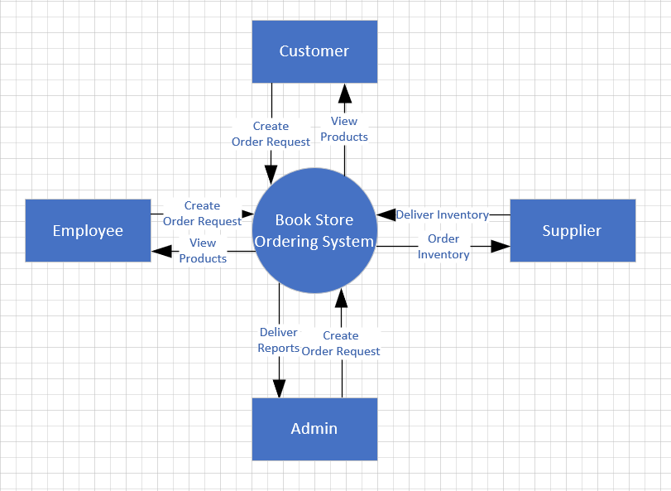

This context diagram details how the database will be used in the real-world. It gives a great insight to what the requirements of the database will be and helps to keep implementation straightforward.

  - L0 Dataflow Diagram
The dataflow diagram exposes the way data is intended to flow through the database and shows the processes that enable the flow of data through the database. This is a level zero DFD, it only indicates the topmost level of processes and interaction between generalised entities.
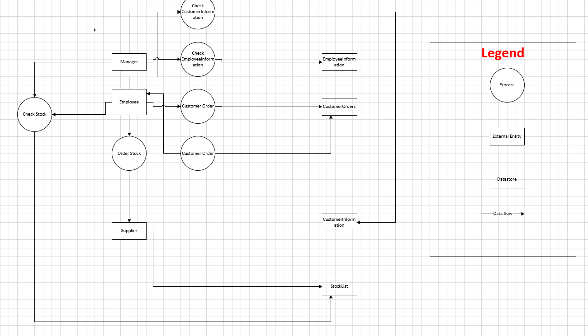

  - Entity Relationship Diagram
The final design document is the entity relationship diagram or ERD for short. This diagram proposes how the relationships between tables in the relational database will work. This will also detail the degree of the relationship and make implementation easier.
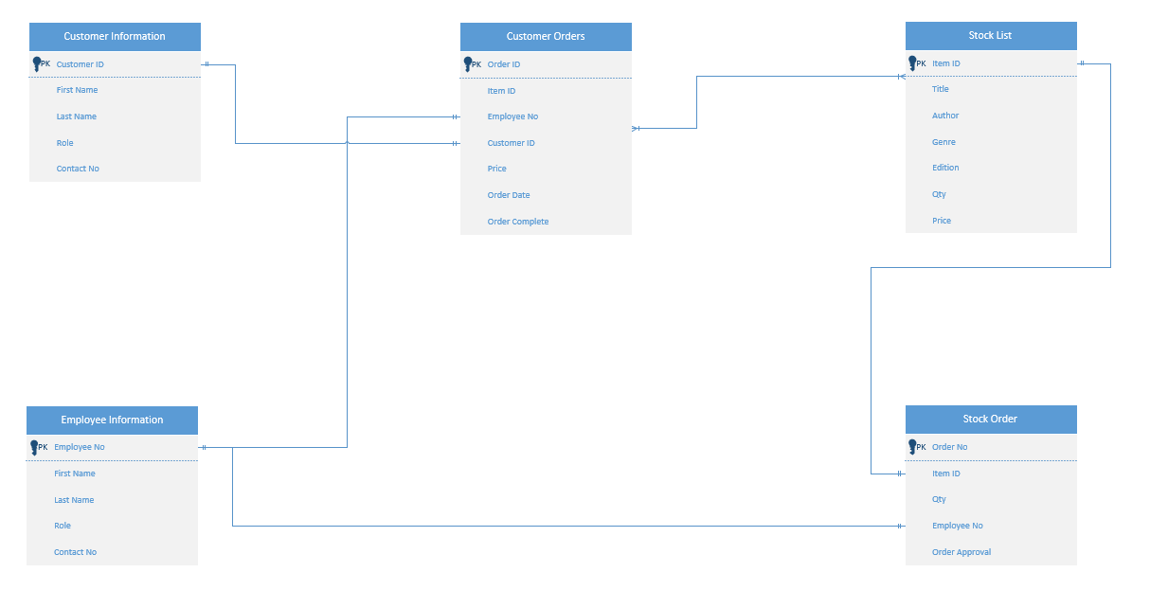

It can be seen above that the ERD details the relationships between each table in the relational database and provides information on each tables primary key. These primary keys are the unique identifiers of all dependant information in each table. E.g. CustomerID is the unique identifier that is tied to a single customers information including names, contact, and registration date. The same concept applies for each table. This initial ERD, however, does not contain any information on membership class. This may make reading the functional purpose of the database rather confusing.
Therefore, another ERD with the membership classes has been created below.
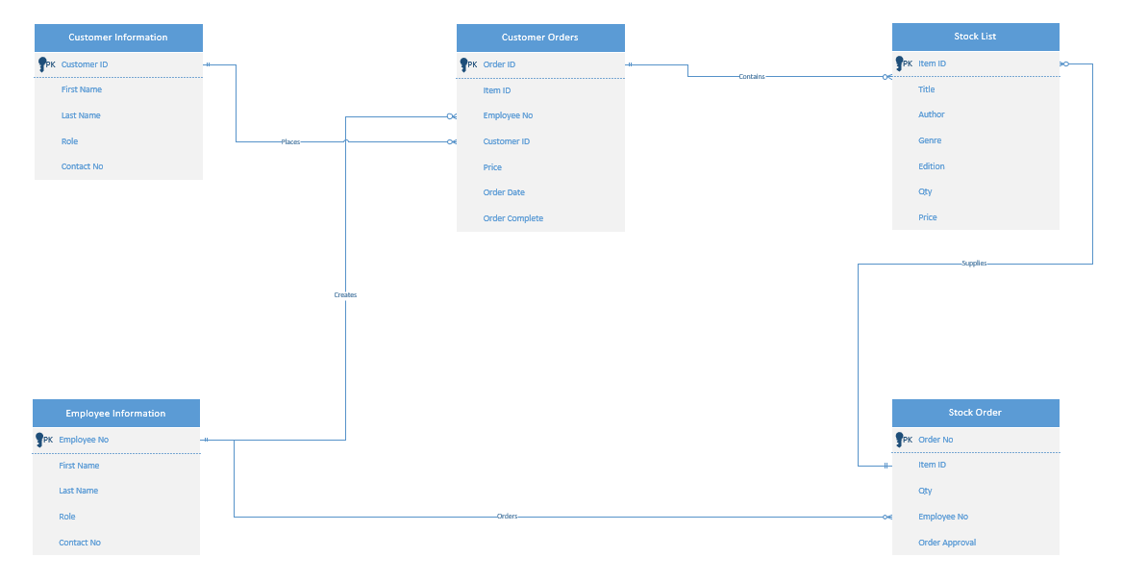

- Suitability of Database
  - Identification scheme
All tables, reports, forms, and queries are named following an identification scheme used by many industry leaders. Microsoft have developed a standard called the Leszynski/Reddick Guidelines [1]. This gives all objects a descriptive tag before the name. This is done so that users can easily identify the type of interface with which they are interacting as without this prefix tables, forms, reports and queries can be confused as they have similar or exactly the same names.
The identification scheme is as follows in the table below:
NAME | IDENTIFIER | EXAMPLE
Table | tbl | Tbl_EmployeeInformation
Report | rpt | Rpt_StockCheck
Form | frm | Frm_Menu
Query | qry | Qry_CustomerInfo

  - Tables
All tables are named after the type of information they contain, e.g., tbl_CustomerInformation is pertaining strictly to data regarding the customer. This is a great example of appropriate naming. Tables also include relevant fields. Sticking with the Customer Information table, it contains the following fields.
- Customer ID
- First Name
- Last Name
- Contact Number
- Email
- Registration Date
All the tables contain only the required information and there are no fields that pertain to irrelevant information such as age, hobbies etc.
Furthermore, all fields in the tables have relative data types. These are purpose driven and aim to collect only the information that is required for that field. For example, the Customer ID field requires that an ID be assigned with each new record. Instead of involving the risk of human error when entering a number that is meant to uniquely identify a specific record (i.e., two customers having the same ID due to accidental repetition by the employee, or miscommunication across the team), the customer ID value is deemed as an Auto Number. This completely removes the human error risk factor by automatically assigning a new, unique number in a sequential format to each record.
Each field has its own specified datatype that is relevant to the data desired to be entered by users. This reduces the risk of incorrect data.
As each table has relevant fields, it is constructed in a way that reduced data redundancy, or repetition. For example, if the customer’s first and last name are stored in the customer information, it would make no sense to then have this information stored in the customer orders table as well, as it takes up too much space, and is repeated unnecessarily. This can cause needless confusion and makes the entire database convoluted. This strict management of table design allows for reduction of data redundancy and an overall faster and more relevant database. There is another purpose to this explained in section 3.4.
  - Forms
This database also comprises of forms. These generally make data entry to the user more streamlined and focused as opposed to a datasheet view of the bare tables. “Forms are essentially collections of controls that either accept information or display information” [2]. Furthermore, using forms adds more functionality to the database from an end user’s perspective through the use of simple command buttons and data entry fields. This is purely so that those less experienced with database management can effectively manage the database through a more beginner, or end user friendly way.
The forms have been designed in a way that everything (various forms and reports) the end user will need to have access to can be accessed through one main form that will be the ‘user menu’. This way the database tables are all handled on the ‘back-end’ for lack of a better term. The end user would only ever need to use the forms, as these will have the functionality to view and print reports, access data entry forms for specific tables, from which they can add, search through, and delete records from without ever having to access the raw data tables.
  - Relationships
Relationships dictate how data in one table relates to data in another table, thus effectively linking the tables together. This is done through the use of primary keys (PK) and foreign keys (FK). These keys allow the database to identify the relationship between data in different tables. This then allows for the developer to then dictate the splitting and storage of data. The table below, taken from IBM [3]describes the types of relationships clearly:
Type of Relationship | Description
One to One | Both tables can have only one record on each side of the relationship.  Each primary key value relates to none or only one record in the related table.  Most one-to-one relationships are forced by business rules and do not flow naturally from the data. Without such a rule, you can typically combine both tables without breaking any normalization rules.
One to Many | he primary key table contains only one record that relates to none, one, or many records in the related table.
Many to Many | Each record in both tables can relate to none or any number of records in the other table. These relationships require a third table, called an associate or linking table, because relational systems cannot directly accommodate the relationship.

The relationships in this database are designed to connect relevant data in each table, allowing the table with the foreign key to reference the primary key held in its original table.
Defining a relationship also allows us to begin enforcing referential integrity. Referential integrity refers to ensuring data is the same throughout the database. i.e., not deleting related data in one table and not the other. This is done by checking the enforce referential integrity box in access relationships interface. There are then options to cascade delete records and cascade update related fields. This allows us to update data we change in one table to change across all related tables. [2]
This relationship also streamlines creating of queries from related tables. We can pull data from different fields in different tables to generate a result. For example, we can see how many active orders a customer has for the bookstore, and we can query a date and see all orders on that date. Queries are a very simple way of analysing the data in multiple tables and consolidating it intone interface.

- Analysis of User Requirements
The database is required to be able to support the running and management of the bookstore. The main objective in this section is to determine whether or not the final solution meets the user requirements.
To do this we first need to define the user requirements.
- The users must be able to effectively add or remove data from any table in the database.
- They must also be able to view the current stock, customer orders and customer details.
- They must also be able to query the system, and print out any relevant reports (i.e., stock reports, employee information)

The database meets all these requirements. Through the intuitive use of user-friendly forms, the database allows staff to easily help customers place orders, view and order stock, add or delete records from any table from inside of the forms. All of the tables are manged behind the scenes, making the final solution very user friendly.
Due to the developer’s lack of skills with database design, queries have not been included in this iteration of the database as they were finding difficulty with implementing a query that the end user can enter input to in order to gain relevant information.
All reports that end users can view are able to easily print these reports via the print function added into the main menu. It also allows for end-users to view updated forms each time they press the command button. From this main menu form they also have the ability to manipulate the database in Realtime, with peace of mind that duplicate entries can be removed at a moment’s notice.
However, there are small issues that do not impact the performance of the database within the scope of this project assignment. This issue is that the AutoNumber datatype used is incremental, and if an entry is removed then the new record after that will not increment from the previous value by one, for example if customerID 34 is removed, the next new record won’t become 34. It will simply carry on as 35, and the result is records that are not linear in sequence. (E.g., 33,35,36 etc.)
Aside from the functional aspects of the user requirements, we must also discuss if the database holds the correct type of information for the user.
The user’s demographic is a wide range of booklovers, and their business is moving into the digital-era, and thus requires their current paper/excel based database to be carried over to a relational database that ahs more flexibility over the data and more control over the validity and quality of the data. This is achieved through the use of the forms and reports to view, diagnose and repair any errors that may take place.

- Normalisation of the Database
There are many types of data normalisation, however, for the scope of this project, the third normal form is as far as is needed. Normalisation in this database requires three steps.
The first step is to change any data that does not have a unique identifier, e.g., a store has departments listed in one field comma separated as “Sales, Development” or “CEO, Finance” instead of uniquely having an ID such as 1,or 3. After normalisation a table will be more streamlined, and while it does result in some data being repeated, it is more accurate This is the First Normal Form.
The second step is to ensure that once the database is 1NF conformant, that all the non-key fields are dependent on the primary key in that table. This is the Second Normal Form.
The third and final step once 2NF conformity is satisfied is to ensure that there is no transitive functional dependency. This means that there are fields in the table that do not rely on the primary key, but on another field in the table to determine its value. This is only really an issue when there are composite keys involved. This database does not utilise any composite keys, and all fields in each table rely solely on the Primary keys.
The relationships in this database have been tested and data and referential integrity is upheld throughout the use of all forms and through manually editing the tables. Records are removed in each related table when the original data is removed. This same concept also applies to editing and adding data.
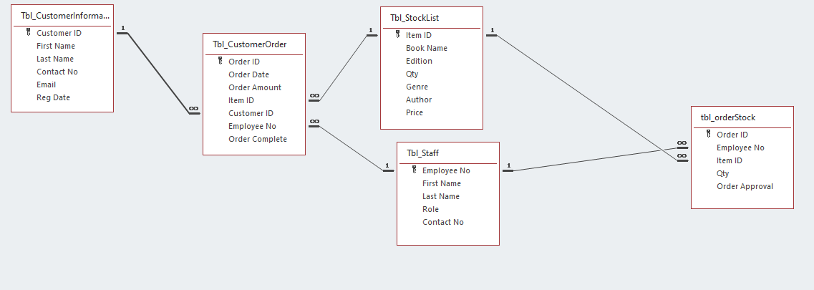Above is an example of the databases relational status. As previously mentioned, it can be seen that all relationships are appropriately applied.
- References
[1] databasedev.co.uk, "Microsoft Naming Conventions," 2015. [Online]. Available: http://www.databasedev.co.uk/naming_conv.html. [Accessed 2 05 2022].
[2] J. Cox and J. Lambert, "Microsoft Access 2013," in Step By Step, Redmond Washington, Microsoft Press, 2013, p. 50.
[3] IBM Control Desk, "Database relationships," 02 03 2021. [Online]. Available: https://www.ibm.com/docs/en/control-desk/7.6.0?topic=structure-database-relationships. [Accessed 03 05 2022].
[4] Custom Guide, "How to Enforce Referential Integrity in Access," 2022. [Online]. Available: https://www.customguide.com/access/enforce-referential-integrity. [Accessed 3 05 2022].

