Advanced Chemistry Lab Report – 3 – Synthesis of Methyl-3-nitrobenzoate and Nitroguanidine

Thomas Appleby (2217664)

Advanced Chemistry of OME (ACDA6020)

Wales Institute for Science and Art
University of Wales Trinity Saint David



Table of Contents
Table of Contents 2
Table of Figures 3
Table of Tables 4
1.0 Introduction 5
1.1 Objectives 5
1.2 Hypothesis 5
1.3 Variables 5
1.3.1 Methyl-3-Nitrobenzoate 5
1.3.2 Nitroguanidine 5
2.0 Theoretical Background 5
2.1 Synthesis of Methyl-3-nitrobenzoate 6
2.2 Synthesis of Nitroguanidine 6
3.0 Experimental Procedure 6
3.1 Methyl-3-nitrobenzoate 6
3.2 Nitroguanidine 7
4.0 Results and Data 7
5.0 Discussion 8
5.1 Reflection 8
5.2 Temperature Control 8
5.3 Safety Considerations 8
6.0 Conclusion 9
7.0 References 9

Table of Figures
Figure 1 - Nitroguanidine Sample 8
Figure 2 - Methyl-3-Nitrobenzoate Sample 8

Table of Tables
Table 1 - Methyl-3-Nitrobenzoate Variables 5
Table 2 - Nitroguanidine Variables 5
Table 3 - Results Table 7

1.0 Introduction
This report outlines the laboratory synthesis of two distinct compounds—methyl-3-nitrobenzoate and nitroguanidine—via electrophilic aromatic substitution and aliphatic nitration, respectively.

1.1 Objectives
- To synthesise methyl-3-nitrobenzoate from methyl benzoate.
- To synthesise nitroguanidine from guanidine nitrate.
- To understand the role of the "nitrating mixture" (sulphuric and nitric acid).
- To practice purification techniques, specifically recrystallisation.

1.2 Hypothesis
- The resulting synthesis of methyl-3-nitrobenzoate should produce solid white powder crystals that are odourless.
- The resulting synthesise of Nitroguanidine should produce solid white needle-like crystals that are odourless.
- Any variance of the above could suggest the existence of contaminants within the sample.

1.3 Variables
There are several variables (Independent, Dependent and Controlled) in the experiments to synthesis Methyl-3-Nitrobenzoate and Nitroguanidine which is summarised in the table below –

1.3.1 Methyl-3-Nitrobenzoate
 | Affects | Reason
Temperature | Yield and purity | High heat produces dinitration and side products
Nitrate Concentration | Yield | Insufficient HNO₃ leads to incomplete reaction
Solvent for washing | Yield | Using warm ethanol would dissolve product
Table 1 - Methyl-3-Nitrobenzoate Variables

1.3.2 Nitroguanidine
 | Affects | Reason
Temperature | Yield and stability | 30°C causes hydrolysis/decomposition
Water Content | Dehydration | Yield drops to near zero if acid is diluted
Cooling rate | Crystal size/shape | Rapid cooling creates small, irregular crystals
Table 2 - Nitroguanidine Variables

2.0 Theoretical Background
Nitration is a classic organic reaction that introduces a nitro group (-NO₂) into a molecule. The active species in both syntheses is the nitronium ion (NO₂), generated by the reaction between concentrated sulphuric acid (H₂SO₄) and concentrated nitric acid (HNO₃).

2.1 Synthesis of Methyl-3-nitrobenzoate
In this reaction, the ester group (-COOCH₃) on the benzene ring acts as a deactivating group and a meta-director [1]. This ensures that the nitronium ion attacks the 3-position (meta) of the ring. Nitric acid acts as a source for the nitro group (-NO₂), however is not reactive enough on its own to attack the Benzene ring. Sulphuric acid acts as a catalyst and dehydrating agent. It protonates the nitric acid, forcing it to lose a water molecule and generate the nitronium ion (NO₂⁺) [2]
HNO₃ + 2H₂SO₄ = NO₂⁺ + H₃O⁺ + 2HSO₄⁻
Methyl-3-Nitrobenzoate uses ethanol as a purification agent as it is highly soluble in hot ethanol but significantly less soluble in cold ethanol.

2.2 Synthesis of Nitroguanidine
Unlike the aromatic substitution above, this involves the dehydration of guanidine nitrate. Concentrated sulphuric acid acts as a powerful dehydrating agent, removing a water molecule to convert the salt into nitroguanidine.
[H₂N - C(NH₂)₂] + NO₃⁻ = H₂N - C(=NH) – NH - NO₂ + H₂O
In the synthesis of nitroguanidine, distilled water is not a reactant in the chemical transformation itself, but it is an essential processing agent used for precipitation, washing, and recrystallization. This is because the reaction involves concentrated sulphuric acid, the role of water is critical for safety and for achieving the final crystalline form.
After guanidine nitrate has been dehydrated by sulphuric acid, the resulting mixture is a thick, homogeneous solution of nitroguanidine dissolved in acid. Nitroguanidine is highly soluble in concentrated acid but very poorly soluble in cold water. This process causes the nitroguanidine to precipitate as a solid crude product.
The advantages in the practical field of OME are that the experiments are relatively –
- Repeatable
- Cost effective
- High yielding
- Safe (if carried out as per the safety instructions)

3.0 Experimental Procedure

3.1 Methyl-3-nitrobenzoate
- Preparation: Mix 5.0 ml of concentrated H₂SO₄ with 2.7g of methyl benzoate in a 25cm3 conical flask. Cool the mixture to 0°C in an ice bath. Carried out in the ducted fume cupboard.
- Nitration: Prepare a "nitrating mixture" of 2ml of H₂SO₄ and 2ml HNO₃. Cool the mixture to 5°C in the ice bath. Add this dropwise to the methyl benzoate solution, ensuring the temperature stays below 10°C to avoid dinitration and the formation of undesired products.
- Isolation: After 15 minutes, pour the mixture over 25g of crushed ice in a 100ml beaker. The crude methyl-3-nitrobenzoate will precipitate as a solid.
- Purification: Move the filtration equipment to the fume cupboard. Attach a Buchner funnel and flask. Place dampened filter paper in the funnel and connect to a high vacuum for 5 minutes. Poor the crude methyl-3-nitrobenzoate crystals from the beaker into the funnel and wash with distilled water (removing any excess water through the high vacuum. Transfer the crystals to a 50ml beaker. Measure 15ml of ethanol into a conical flask and warm in the hot water bath to 50°C. Place the beaker with the crystals on the water bath and pour over small portions of the warm ethanol, stirring with a glass rod until the crystals are dissolved. Remove from the water bath and leave to cool to room temperature, then immerse the beaker in the ice bath to allow the crystals to reform into pure methyl-3-nitrobenzoate. Set up a clean Buchner funnel and flask with dampened filter paper (use ethanol not water). Filter the crystals through under vacuum and then when dry after a few minutes transfer the pure product to a labelled and weighed sample bottle.

3.2 Nitroguanidine
- Dissolution: Measure out 5ml of concentrated H₂SO_{4,} dropping the temperature to below 5°C in an ice bath. Weigh out 4.0g of guanidine nitrate and add the cooled acid slowing ensuring the temperature doesn’t rise above 10°C. Leave for 2-3 minutes once all dissolved.
- Precipitation: Once dissolved, using a Buchner funnel and flask connect to a vacuum, insert dampened filter paper in the funnel. Pour the mixture into a 50ml beaker containing 30ml of water with a little ice stirring with a glass rod, repeat until all the mixture has been precipitated.
- Collection: Filter the white, needle-like crystals of nitroguanidine through the funnel.
- Purification: Add the filtered crystals to a 150ml beaker and add to the solid until the crystals dissolves, with the stirring and heating on the boiling water bath. Cool to room temperature, then place the beaker on ice. Using a clean filter paper in the Buchner funnel and flask apparatus. Filter the product again washing with a little distilled water and leave under the vacuum until dry. Transfer the finished sample to a weighed and labelled sample bottle.

4.0 Results and Data

 | Methyl-3-Nitrobenzoate | Nitroguanidine
Mass of labelled bottle | 8.547g | 83.854g
Mass of labelled bottle + sample | 10.147g | 85.732g
Mass of sample | 1.600g | 1.878g
Theoretical yield | 2.129g | 2.203g
Yield obtained | 75.15% | 55.08%
Table 3 - Results Table

5.0 Discussion

5.1 Reflection
The hypothesis outlined what the samples should look like once produced. As can be seen in the figures below, the two samples looked like what was to be expected once fully dried. This shows that during the experiment the steps were followed correctly by the students.
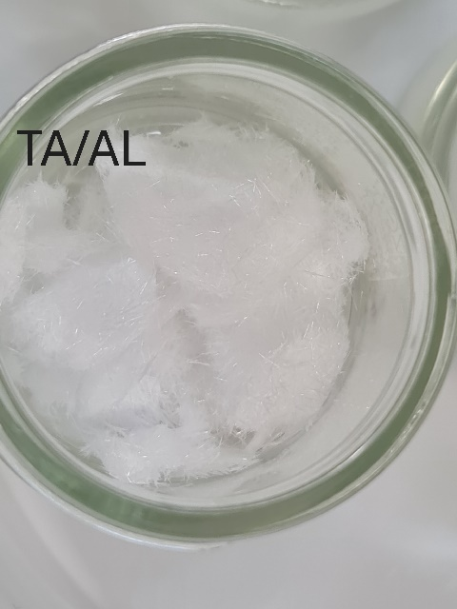
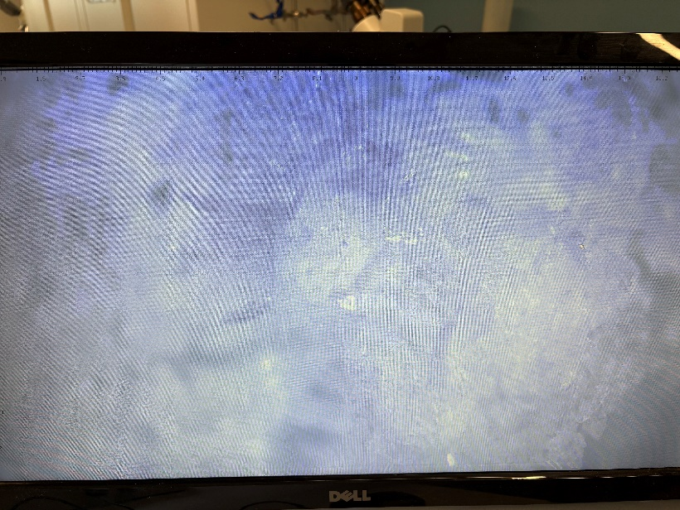
Figure 1 - Nitroguanidine Sample
Figure 2 - Methyl-3-Nitrobenzoate Sample

One way to improve the yield of the sample would be to further control the temperature of the reaction ensuring it stays under the limit of 15°C. Another solution would be to increase the purity and concentration of the nitric/ sulphuric acid solution.
For nitroguanidine control of purity is especially important as if contaminants affect the sample, then the stability of the substance is lowered, which can be unsafe for storage and handling.

5.2 Temperature Control
In both reactions, temperature is the most critical variable.
- For methyl-3-nitrobenzoate, if the temperature rises too high, the reaction may produce 3,5-dinitrobenzoate, reducing the purity of the desired product.
- For nitroguanidine, sulphuric acid is highly exothermic when mixed with water or salts; cooling prevents decomposition.

5.3 Safety Considerations
- Corrosives: Concentrated H₂SO₄ and HNO₃ cause severe chemical burns. Work inside a fume hood.
- Stability: Nitroguanidine is a known energetic material (explosive precursor). While stable in small lab quantities, it should be handled with care and never subjected to intense friction or heat.

6.0 Conclusion
The synthesis of methyl-3-nitrobenzoate and nitroguanidine demonstrates the versatility of the nitronium ion in both aromatic and aliphatic contexts. Success is measured by the formation of white/pale-yellow crystals and a melting point consistent with literature values.

7.0 References
[1] S. Zaitev, “Nitration of Methyl Benzoate Experiment,” UKEssays.com, May 18, 2020. https://www.ukessays.com/essays/chemistry/nitration-of-methyl-benzoate-experiment.php
[2] C. T. Wigal, “Nitrating Acetanilide or Methyl Benzoate: Electrophilic Aromatic Substitution,” 1998. Available: https://glaserr.missouri.edu/vitpub/teaching/212w00p/716.pdf
[3] M. W. Kirkwood and G. F. Wright, “MECHANISM OF GUANIDINE NITRATION: II. TETRAETHYLNITROGUANIDINE,” Canadian Journal of Chemistry, vol. 35, no. 6, pp. 527–540, Jun. 1957, doi: https://doi.org/10.1139/v57-074.

