Workplace Culture and its impact on Organizational Efficiency

Student Name: Ionut Dobrescu
Student Number: 1906349
Module Code: BMSW5105
Lecturer Name: Uju Ugochukwu

Table of Contents
Introduction 3
Company Overview (McDonald’s) 3
Main Body 4
PESTEL Analysis of McDonald’s 4
Key drivers for change in business environment 5
Cultural Web 7
Ethical Dilemma 9
Recommendation 12
Conclusion 13
Reference List 14
Appendix 15

Introduction
The essay mainly discussed workplace culture and its impact on business operations. It mainly applied PESTEL analysis which shows the competitive environment of fast-food industry. It is the most popular fast-food cafeteria in the UK. Apart from that, it explained the key drivers for change the business environment to gain competitive advantages. On the other hand, it also illustrates the culture web and culture of McDonald’s with the questionnaire. Furthermore, the essay demonstrates the ethical dilemma with the appropriate solution for gaining customer attention. The essay also highlights appropriate suggestions for cultivating the ethical corporate practice of the chosen association.

Company Overview (McDonald’s)
McDonald's is the largest fast-food restaurant in the UK. It mainly offers hamburgers, French fries, cheeseburgers, and pizza. McDonald’s is famous for its French fries (Wei and Davis-Ngatai, 2017). The company has 1300 restaurants in the UK. In the year 2020, McDonald's has around 12900 employees for serving good services to their potential customers. It is depicted that, the company mainly follows a low pricing strategy for attracting the customers of all the classes. In the recent year, the company generates profit revenue of approx. 4.73 billion dollars. The company mainly adopts AI technology for an increasing number of orders. McDonald's focused on people-centric culture. In the year 2018, the fast-food chain holds 21.4% of the market share.
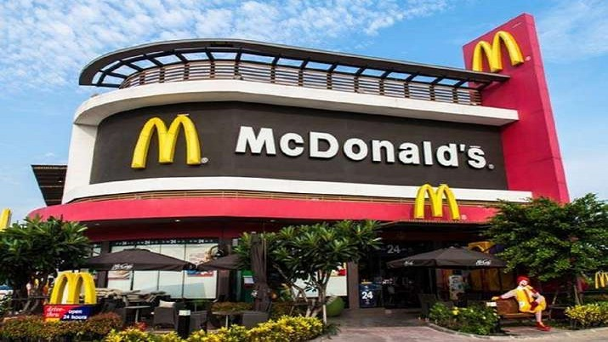
Source: Jogaratnam, 2017

Main Body

PESTEL Analysis of McDonald’s
This analysis mainly supports strategic management by identifying the external environment of the organization. PESTEL analysis also helps in determining the position of the organization in the competitive environment (David, 2019). The main purpose of this analysis is to detect the trends and opportunities. It mainly helps in making an effective decision for future growth and development. McDonald Corporation conducts this analysis for knowing the future challenges and opportunities. Apart from that, this analysis also helps in taking action against the treats for minimizing their impact. These factors are used by McDonald's for measuring market competition, profitability, and attractiveness. PESTEL framework consists of six factors which are elaborated below:
Political factors: It plays a significant part in the enactment of the company. The organization is always subjected to multiple health and hygienic regulation to operate in the country (Perera, 2017). The company is mainly serving fast food which causes health issues like obesity and heart attack. Apart from that, the tax imposed by the government harms the profitability of the fast-food restaurant. It is identified that cross-border tension and animosity harm McDonald's due to trade agreements. The company facing immense competition with their competitors likes KFC and Burger King. On the other hand, McDonald's brand is banned in Bermuda due to long-held laws against the foreign restaurant chain. During Covid-19, the supply chain of the fast-food industry is distorted and it leads to a decrease in the foreign reserve.
Economic factors: It plays an effective role in the growth and development of the organization. During the current pandemic, this factor is mostly affected by McDonald's. Poor employment rates and economic instability supposed to a decrease in the wealth of the organization (Frederick and Parappagoudar, 2021). At the time of Covid-19, the sale of McDonald's fell by 22%. On the other hand, the current trend of a youngster which prefers meal help in boosting the business operation of the company. Apart from that, the company has a chance to cultivate through extension in a high-growth emerging market. Thus, it helps the organization to acquire the brand image across the global marketplace.

Social factors: Health-conscious issue reduced the sale of the company and decreases the customer base. Due to this, customers are willing to eat a low-calorie and low-salt diet. During the global outbreak, the company offers home delivery to their potential customers for maintaining social distancing and Covid-19 preventions (Karim, 2020). On the other hand, the company used to offer good customer service at the workplace.
Technological factors: In the year 2019, the company mainly adopt Dynamic yield for delivering more responsive menus. It is depicted that, digital menus help customers by showing different items according to the weather and time (Warrick, 2017). During Covid-19, the online platform is an opening for McDonald's to enlarge its business and increase the sales revenue. The company also invested in automated voice technology for taking drive-through orders. Thus, technology help allows McDonald’s to open new mode of payment and order.
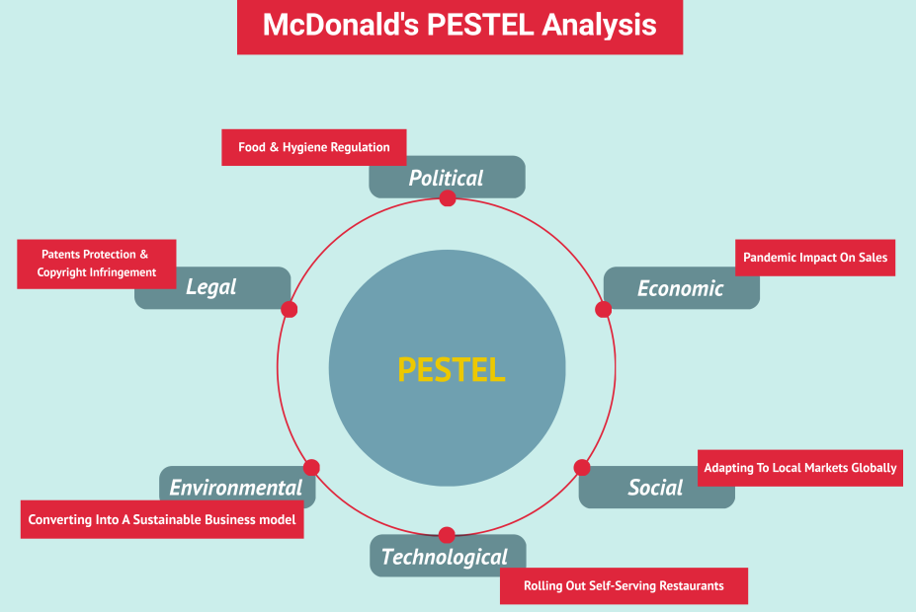
Source: Dastane and Fazlin, 2017
Environmental factors: It is identified that the company is mainly contributed to greenhouse gas emissions and deforestation due to the high demand for beef products. On the other hand, the company has an opportunity to position its brand by taking participating in corporate social responsibility (PAAIS and PATTIRUHU, 2020). Apart from that, the company mainly focused on recycling and reusing paper and plastic for maintaining its chain logistics and eco-friendly. Furthermore, the company reduces the electricity demand by using waste heat for heat water.

Legal factors: The Company was involved in many lawsuits and many of its related to trademark breach with a copycat restaurant using the 'Mc’ prefix in their branding products (Jogaratnam, 2017). For instance, McDonald’s follows the health and safety regulation act for offering healthy food to their customers.

Key drivers for change in a business environment

In a fast-food restaurant, many factors harm the performance of the business operations. McDonald's mainly focused on compete with their competitors based on healthy food with low-calorie (Dastane and Fazlin, 2017). In the competitive market, customer expectation and taste & preferences are the main drivers that change the business environment of the company. Some of the main key drivers are described below:
Intense Competition: The fast-food chain mainly focused on the customer to meet the requirement and expectations. The competition mainly focuses on price and healthy food. In the competitive environment, McDonald’s focused on its menu and fulfills the demand of its customers according to the changing trends (Robert et al., 2020). It is depicted that, McDonald’s provides an eco-responsive and fun-loving atmosphere to their customer that leads to maintaining a strong presence in the mind of the customers. It is identified that McDonald's mainly focused on health and low-calorie food for their customers. The company also fulfills the demand of kids by giving gifts with their orders. Therefore, it helps the company to increase its customer base.
Advanced Technology: It is the main driver for the fast-food chain industry that leads to change the business environment. Technological change is the opportunity for McDonald's to increase productivity as well as profitability (Reid et al., 2018). The company mainly focusing on digital menu boards & ordering loyalty programs, and CRM for the smooth functioning of the business. It is depicted that, the company offers McCafe a reward digital card that resides in the McDonald's app. On the other hand, Data from electronic wallets make it easier to personalized customer experience.
Sustainability: It is depicted that, most fast-food restaurants offer an inclusive range of products for maintaining longer sustainability in the competitive environment (Forrest, 2017). Therefore, McDonald’s mainly offers 145 items to increase the customer base and satisfy them.
McDonald's customers may attract to its workplace environment, employee service, and digitalization that has an impact on business performance. In the competitive environment, the company offers free WIFI in their campaign that helps in grabbing the attention of teenagers and businesses.
From the above key driver's analysis, it is concluded that an eco-friendly and technological environment is an important element for the success of McDonald's.
In a fast-food restaurant, health and safety help to gain a competitive advantage for the company.In company mainly focusing on training and development program of the employees so that they offer good services. On the other hand, the company offers vouchers, coupons, and attractive combo package to attract the attention of the customers and gain competitive advantages.

Cultural Web

Organizational culture mainly discusses about the principles and beliefs that subsidize to the growth and development of the business in a challenging situation (Batty and Gee, 2019). It mainly includes the expectation and knowledge that promote consistency and accomplishment of organizational goals. It is imperative because it impacts various performance procedures like customer facility, product superiority, customer gratification, and profitability. McDonald’s culture of obligation to employees is mainly considered by the expansion of esteem, faith, and the association between management and the staff members. It is identified that, this culture help in promoting a close relationship between manager and employees. McDonald’s shows its commitment to employees by providing proper career development training to their employees. For this purpose, the company educates its employees for enhancing their knowledge regarding business operations at Hamburger University. Apart from that, the company offers flexible working hours that allow employees to stability their work lives. On the other hand, the company offers rewards and recognition to their employees for achieving their financial goals. During the pandemic, the company paid sick leaves to the employees who are suffered from Covid-19. Additionally, the company offer facility of Blue Cross Blue Shield nurse line and responsive funding counseling session for the staff members and their family members. Apart from that, the company doubles the incentive for the frontline employees at the time of the global pandemic.

On the other hand, the company culture is also depending upon the customer experience and expectation by offering healthy fast-food products.
McDonald’s constantly focusing on enhancing the product and process quality by maintaining the supply chain, operating well-maintained facilities, and clean environment. The company also takes feedback or reviews to their customers and employees for maintaining the environment of the company (Batty and Gee, 2019). The company provides a free WIFI campaign and gifts to their potential customers. During the current pandemic, the company is focusing on the daily sanitization process in their working environment. It is depicted that, ordering from McDonald’s app is double during Covid-19. Apart from that, the company partnered with Mayo Clinic for providing checking services regarding hygiene, fitness, and protection to alleviate the spread of Covid-19. Moreover, the business installed protective barriers, wellness checkups, and adhering to social distancing for their customer and employees.
The Culture web is the tool that helps in mapping the culture of the organization (Robert et al., 2020). With the help of the culture web, McDonald's not only analyzed the organizational culture but also focused on values and beliefs. The main advantage of the cultural web is the aspects of the culture of the organization. On the other hand, the culture web has negative implications due to intense competition. It is depicted that, culture web help to explore the different aspect of McDonald’s that help to improve the experience of the customer as well as experience. The different elements of the culture web are discussed below:
Stories: This phrase mainly considered detailed information about McDonald’s and its success stories (Perera, 2017). Stories mainly tell concerning the development, main player, actions, problems, and solution to become successful in the fast-food industry. It mainly includes different types of menus, items, products, and brands.
Rituals and Routines: It includes behavior and actions of the people on the daily needs that serve the signals for the success of the organization (Frederick and Parappagoudar, 2021). For instance, McDonald’s has strict principles to follow when it comes to the application of management and services in the competitive advantages. Thus, McDonald's became a more widespread and popular brand in the competitive advantages.
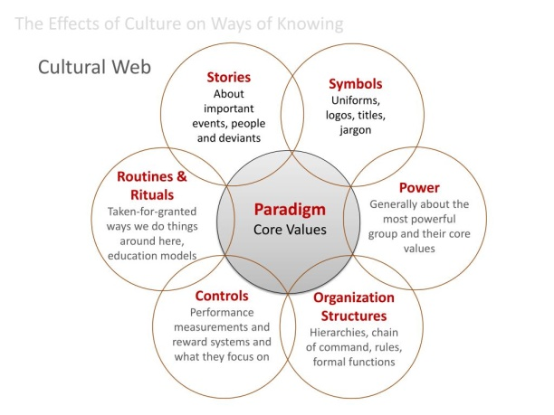
Source: Wei and Davis-Ngatai, 2017

Symbols: In the fast-food industry, symbols play an important role in recognizing the product from their rival competitors (David, 2019). McDonald’s logo, packaging, and design help to identify the product among their potential customers. Thus, internal and external factors may have a positive impact on the growth and success of the business organization.
Organizational Structure: McDonald’s mainly follows a divisional organizational structure to manage the business operations (Wei and Davis-Ngatai, 2017). The company can take an appropriate decision that helps in gaining competitive advantages. It is identified that the company follows the written and formal method for maintaining a relationship with faculty.
Control System: In this stage, the company mainly focuses on the performance management system to administrate the operations of employees and the management team (Karim, 2020). It is depicted that, McDonald's mainly focuses on product quality, time management, and recognition to improve the business performance.
Power Structure: It is identified that the company focuses on power structure to compete with the organizational culture of the rival’s competitors (Reid et al., 2018). This is the significant power for the manager to manage the different values, norms, and beliefs of the culture web. With the help of the culture web, McDonald's provides a pathway to motivate them for maintaining organizational culture.

Ethical Dilemma

An ethical dilemma is mainly referred to as the conflicts between the employees and management regarding various issues in the workplace (Frederick and Parappagoudar, 2021). It is identified that ethical dilemma forced employees to choose the appropriate decision and path of honesty or dishonesty. In McDonald's, an ethical dilemma not only help in decision-making but also foster a positive effect on the organizational culture. The main purpose of ethical dilemmas is to reinforce ethical behavior in the workplace. On the other hand, it is depicted that ethical dilemma is important because it is significant in professional life. In the modern era, it is noticed that most of the organization faced several ethical issues which affect the performance of the company in the competitive environment. For instance, the customer base of McDonald's is declined due to unethical practices in the workplace. As the company is mostly dependent upon customer feedback and reviews towards the workplace environment. At McDonald’s, the fast-food sector mainly determines the issues faced by the employees from the ethics and social factors. Therefore, ethical practice helps McDonald's to provide job satisfaction to their employees (Ahmed et al., 2021).
McDonald’s can improve ethical dilemmas for boosting the sale and maintain a good reputation in the challenging environment. On the other hand, ethical practice helps an organization in building a strong relationship with its employees. It can also help McDonald's in preventing ethical violence. The company must form an ethical committee that is CSR which helps in eliminating the ethical issues by providing appropriate solutions. The committee advised the company to conduct an ethical awareness program that helps employees to know more about the importance of ethical practice in the workplace. Thus, it can help in maintaining an effective and collaborative workplace environment. On the other hand, the company takes active participation in providing suggestions to the fast-food industry which is affected by ethical issues (Perera, 2017). On the other hand, ethical dilemma helps in resolving the present ethical conflicts in the workplace. It can help McDonald's in eliminating workplace conflicts between employees. It is also identified that it can also help in eliminating discrimination from the workplace. Thus, it can help McDonald's in maintaining a collaborative environment in the workplace and increased the customer base as compared to rival competitors (PAAIS and PATTIRUHU, 2020). The ethical dilemma has different types but the two most ethical dilemmas are elaborated below:
Discrimination: It is identified that workplace discrimination is the common issue that affects the employee’s behavior towards the job role (David, 2019). Workplace discrimination mainly happens for a variety of reasons like caste, age, gender, or class.
The organization used to punish or take strict against employees who are not performing well as compared to others. In McDonald’s, black employees faced racial discrimination which leads to cause depression or mental illness. Thus, these employees leave their job in the organization.
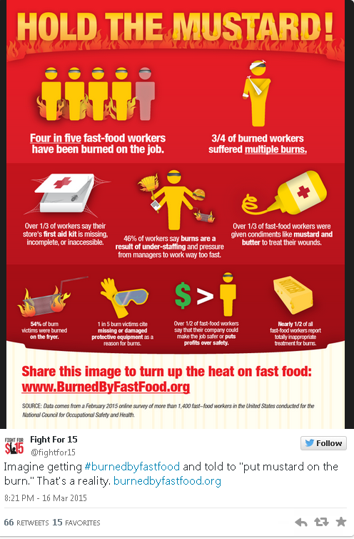
Source: Karim, 2020
Unhealthy working environment: According to the research, it is stated that 5250 workers are died due to accidental issues in the workplace. Unsafe and unhealthy working environments mainly provide job insecurity to the employees (Wei and Davis-Ngatai, 2017). It is identified that the complaint filed with OSHA claims that most of McDonald’s location lacks basic first aid and personal protection equipment. Due to this, the employees of the organization suffer from illness and physical disability. Thus, it also has negative implications for McDonald's customers in the challenging environment.

Recommendation

From the above analysis, it is suggested that McDonald’s must-have to formed a committee for handling the ethical issues or challenges faced by the employees as well as customers. On the other hand, the company can develop its CRM software for maintaining security and privacy. Thus, it can help in storing relevant information and data of their employees as well as customers. In this way, the rival company is not able to misuse the confidential data of the organization. Apart from that, the company must focus on conducting an ethical awareness program for determining the ethics of employees in the workplace. Thus, it can help in maintaining collaborative and ethical behavior in the organization.

Conclusion

The essay has concluded that PESTEL analysis of McDonald's help in determining the external factors that affect the performance of the organization. It also highlighted the key drivers which change the business environment. On the other hand, it is evaluated the organizational culture of the chosen organization which helps in identifying the whole atmosphere of the company. McDonald’s mainly follows divisional organizational culture for performing its role in the competitive environment. Apart from that, it has demonstrated the concept of ethical dilemma and its impact on the success of the organization.

Reference List
Wei, H. and Davis-Ngatai, P.S., 2017. How to gain a competitive advantage in the healthy fast-food industry?
David, J., 2019. PESTEL analysis of the UK. Retrieved October, 30, p.2019.
Perera, R., 2017. The PESTLE analysis. Nerdynaut.
Frederick, D.P. and Parappagoudar, S.K., 2021. A Descriptive Analysis on Sustainable Business Strategy of Online Food Service Industry.
Karim, N.A., 2020. Business Model Canvas (BMC): McDonald’s Corporation.
Warrick, D.D., 2017. What leaders need to know about organizational culture. Business Horizons, 60(3), pp.395-404.
PAAIS, M. and PATTIRUHU, J.R., 2020. Effect of motivation, leadership, and organizational culture on satisfaction and employee performance. The Journal of Asian Finance, Economics, and Business, 7(8), pp.577-588.
Jogaratnam, G., 2017. How organizational culture influences market orientation and business performance in the restaurant industry. Journal of Hospitality and Tourism Management, 31, pp.211-219.
Dastane, O. and Fazlin, I., 2017. Re-investigating key factors of customer satisfaction affecting customer retention for fast food industry. International Journal of Management, Accounting and Economics, 4(4), pp.379-400.
Robert, R., Kentish-Barnes, N., Boyer, A., Laurent, A., Azoulay, E. and Reignier, J., 2020. Ethical dilemmas due to the Covid-19 pandemic. Annals of intensive care, 10(1), pp.1-9.
Reid, A.M., Brown, J.M., Smith, J.M., Cope, A.C. and Jamieson, S., 2018. Ethical dilemmas and reflexivity in qualitative research. Perspectives on medical education, 7(2), pp.69-75.
Batty, R.J. and Gee, S., 2019. Fast food, fizz, and funding: Balancing the scales of regional sport organisation sponsorship. Sport Management Review, 22(1), pp.167-179.
Ahmed, M.N., Umrani, A.I., Mahar, F. and Shaikh, S., 2021. THE EFFECTS OF ETHICAL MARKETING ON JOB SATISFACTION, ORGANIZATIONAL COMMITMENT AND INTENTION TO QUIT OF MARKETERS IN FAST-FOOD INDUSTRY. PalArch's Journal of Archaeology of Egypt/Egyptology, 18(08), pp.452-465.

