Cybersecurity and Computer System Design Assignment
David Reynard
Student No: 2419240

L4 – Computer Systems Fundamentals
ACCA4028
Embedded Electronics Systems Engineering Degree Apprenticeship

Contents
Task 1 – Custom desktop computer design for an engineer 3
1 - Introduction 3
2 - Establishing minimum requirements 3
2.1 - SOLIDWORKS 3
2.2 - PSpice 3
2.3 - LabVIEW 3
3 - Hardware decision 4
3.1 – CPU 4
3.2 – GPU 4
3.3 – RAM 4
3.4 – Storage 4
3.5 – Coolant 5
3.6 – PSU 5
3.7 – Motherboard 5
3.8 – Case 5
3.9 – Monitor 5
3.10 - Peripherals & Additions 5
4 – Software Requirements 6
5 – Breakdown 6
Task 2 – Cybersecurity 7
1 – Current Risk Priority 7
1.1 - Highest risk: Lack of training 7
1.2 - Default passwords 8
1.3 – Outdated Software/Firmware 8
1.4 – Use of Less ‘Secure by design’ Products 8
2 – Security Strategy 8
2.1 – Training Plan 8
2.2 – Update Schedules 9
2.3 – Liability Systems 9
3 – Incident Response Plan 9
References 10

Task 1 – Custom desktop computer design for an engineer

1 - Introduction
A number of technical considerations need to be made when designing a custom build PC, all dependant on the system use case. In this case, the end-user is an engineer who has specified a number of application and security requirements that must be met. To best suit these requirements, they should be translated into technical specifications.

2 - Establishing minimum requirements
The customer has specified a list of CAD (computer aided design), collaborative and presentative software that will be required for their day-to-day work. CAD software is the most resource intensive category of item in the list, as such the bulk of hardware minimums should be established based off the software providers’ self-assessments.
Out of the list provided, the following were deemed to be the most demanding and a good representation of hardware minimums.

2.1 - SOLIDWORKS
SOLIDWORKS publishes limited requirements beyond RAM (Random Access Memory) requirements, and driver supported GPUs (Graphics Processing Unit), most of which are units made for industry.

2.2 - PSpice
Pspice also doesn’t provide minimum hardware specifications, however, FlowCAD recommends the following for PSpice:
- “Intel Core™ i7 4.30 GHz or AMD Ryzen™ 7 4.30 GHz with at least 4 cores
- 16 GB RAM
- 50 GB free disk space (SSD recommended)
- 1920 x 1200 display resolution with true color (at least 32-bit color)
- A dedicated graphics card supporting OpenGL, min 2 GB”
[1]

2.3 - LabVIEW
Labview provides a set of minimum requirements from 2019, but no set of optimal system requirements. They are quoted as follows:
- “Pentium 4 G1 (or equivalent) or later (64-bit)
- 1GB RAM
- 1024 x 768 pixels screen resolution
- Windows 10 (version 1809)/8.1 Update 1²/7 SP1³
- 5GB Disk space
- You must have Adobe Reader 7.0 or later installed to search PDF versions“
[2]

3 - Hardware decision
Minimums for the major components required for the build have been mostly covered, but minimum specification for a GPU is missing. In principle, the CPU will be more important than the GPU due to lesser requirement for on-screen graphics processing, this will be used to decide the GPU.
For benchmark equivalents, UserBenchmark [3] will be used, the score generated will also be used to choose above minimum spec by a relative amount. In order to help with compatibility and pricing comparison, PCPartPicker [4] will be used.

3.1 – CPU
The Intel Core i5-14600KF would satisfy our previously defined requirements, increasing performance above the minimum spec by 78%, at a cost increase of 58% for that component. Anything more would significantly drop the cost/performance coefficient.

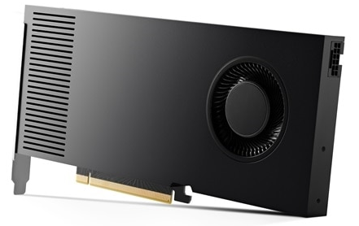
3.2 – GPU
The GPU only needs to support the engineering applications without causing the CPU to be bottlenecked. As per the SOLIDWORKS recommendation, an industrial card of medium spec. The RTX 4000 Ada generation (20GB VRAM) is a SOLIDWORKS supported card that will more than sufficiently support SOLIDWORKS and the rest of the system operation.

3.3 – RAM
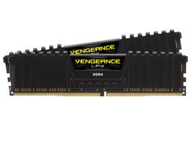
In line with the Pspice requirements, 32GB of RAM should provide sufficient memory to run the required engineering applications, as well as the background system and professional/presentative applications. Although DDR4 is not the most up to date standard, it will save on cost for the memory and the motherboard. The quantity of memory should make up for the quality.

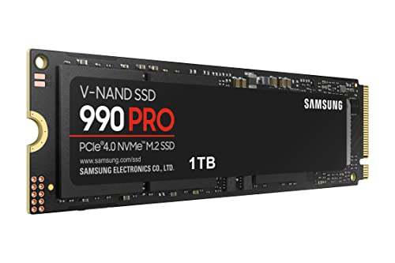
3.4 – Storage
A 1TB m.2 SSD should provide the speed and storage necessary to store the vast majority of applications, operating system and frequently accessed files. A larger 4TB HDD should be present to store project files and other documents to preserve the SSD.

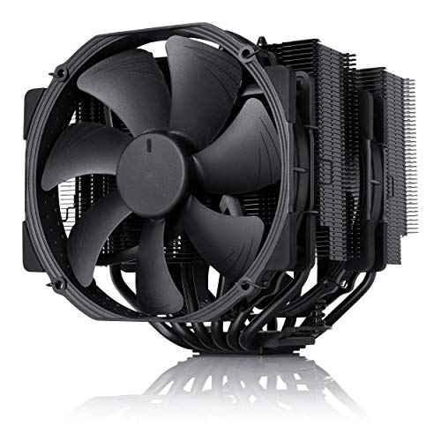
3.5 – Coolant
A CPU cooler, as well as some case airflow fans will be required. A Noctua NH-D15 is a well rated air based CPU cooler that mounts directly to the chip for optimum thermal transfer. The number and position of internal fans will be determined by the case.

3.6 – PSU
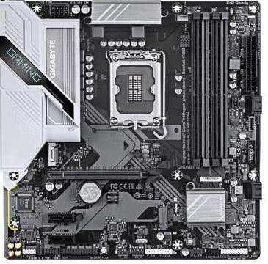
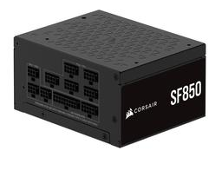
The PSU (Power supply unit) will provide power for system. PCPartPicker takes into consideration the system power requirement and will offer PSUs that fit the bill. As such, an 850w, 80+ platinum grade Corsair SF850 has been chosen as it is above the requirement for futureproofing. The reliable platinum grade is proof of high efficiency.

3.7 – Motherboard
PCPartPicker will also flag compatible motherboards for slots, RAM technology etc. The Gigabyte B760M offers a compact, high memory capacity board with built in WIFI capability at a reasonable price.

3.8 – Case
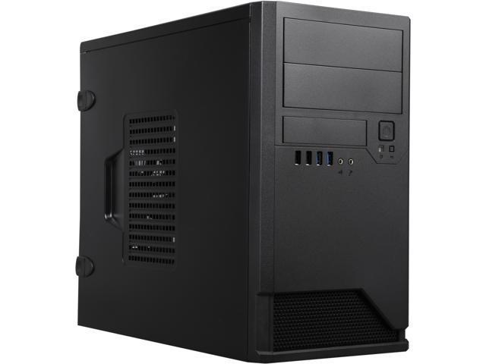
To fit the form-factor, the In Win EM048 will provide a MicroATX form factor, offering and input and an output airflow with dust filtering for optimised cooling. The case has a number of 3.2 USB A and C inputs for external connectivity.

3.9 – Monitor

For use with CAD software, a larger and more detailed monitor will help with the finer details of design work. It is also a good idea to enlist the use of a secondary monitor for interacting with the professional and presentative software, as well as reducing eye strain. 2x ViewSonic VX3276-2K-MHD will provide high quality display on a larger 32” screen. This monitor is supported by the GPU through the use of Mini-DisplayPort, which the GPU supports 4 of.

3.10 - Peripherals & Additions
A mouse, keyboard and webcam will be required for optimal use of the system. Ergonomic equipment should be used to reduce the risk of repetitive strain injury and other display screen equipment risks. The following are suitable, standard office ergonomic options:
- Logitech MX Master 3S - £99.99
- HP 960 Ergonomic Wireless Keyboard - £109.99
The Logitech BRIO 100 is an economic 1080p USB webcam with built in microphone for collaborative interactions as was requested in the requirements.
Although the motherboard has built in WIFI, a wired network should be used where possible for stability and security. The TP-Link TX201 will provide 1 RJ45 connection port to provide connection to the internet. A network switch can be employed where more direct connections are required.

4 – Software Requirements
Software additional to the CAD software previously mentioned will be required for team collaboration, presentation, and security as well as an operating system to allow interaction with the system.
The latest version of Windows 11 Pro will be appropriate for compatibility and security. It’s backwards compatibility will ensure legacy software will still function as intended, and being the latest instance of Windows will mean that security patches and system upgrades will be supported.
The SOLIDWORKS Standard with Cloud services pack is most suited to the customer requirements due to the already sufficient CAD tools and support.
A perpetual professional Labview license is recommended due to the further inclusion of extra tools such MS Office integration, database connectivity and advanced signal processing toolkits.
Microsoft 365 Business Premium will provide the majority of non-engineering software for a broad range of business collaboration through the use of MS Teams, Outlook, SharePoint and OneDrive as well as providing word processing, presentation and budgeting software like MS Word, PowerPoint and Excel. The package also provides access to Microsoft defender for an extra layer of security.
Malwarebytes is a good addition to security as a fall back option in a scenario where it is suspected the system may be infected.

5 – Breakdown
The following quoted from PCPartPicker is the full build:
https://uk.pcpartpicker.com/list/xjRvmC
The cost breakdown is as follows:
PC Hardware
- CPU: £180.47
- CPU Cooler: £106.46
- Fans: 2x £9.03 = £18.06
- Motherboard: £122.99
- RAM: £44.99
- Storage: £85.80 + £87.99 = £173.79
- GPU: £1,438.65
- Case: £160.68
- PSU: £169
- NIC: £27.24
Total: £2 442.33
Peripherals:
- Monitor: 2x £209.99 = £419.98
- Mouse: £99.99.
- Keyboard: £109.99
- Webcam: £49.99
Total: £679.95
Software:
- Microsoft 365 business premium: £238.80 /year
- Malwarebytes standard: £29.99 /year
- Solidworks: £2 820 /year
- Labview: £9 210
- Pspice: Free
- Windows 11 Pro: £178.45
Total: £9 388.45 flat + £3 088.79 /year
Grand total: £12 510.73 flat + 3 088.79 /year

Task 2 – Cybersecurity
The business in the provided scenario is, in its current state, is extremely vulnerable to cyber-attack through a number of different means. This due to a wide variety of existing hardware, training and general attitude/awareness problems. The solution lays in targeting specific deficiencies with business policy changes which should improve personnel risk-aversion and reduce system vulnerability.

1 – Current Risk Priority
Below is an evaluation of risk/impact severity, ranking from 1.1 being the highest and 1.4 being the lowest.

1.1 - Highest risk: Lack of training
Staff being unaware of what constitutes as a security risk is the subsequent cause of the majority of issues to be mentioned. Any single person within the business has the power to compromise it, through incompetence, complacence, or social engineering and is the number 1 cause of cyber-attacks. Lack of training has a high likelihood to result in an attack, and has the potential to affect any single protected asset within the company to a catastrophic level.

1.2 - Default passwords
Default passwords are often listed in software manuals, and will often allow user admin-level access said program, meaning should a bad actor have access to the internal software, they can manipulate the system in whatever way the developers have provided the highest level user. Use of default passwords has a high likelihood to result in an attack on any externally networked systems, providing high level permissions to the attacker on that system and the extended network.

1.3 – Outdated Software/Firmware
With outdated software/firmware, a bad actor can simply use previously discovered (and patched) exploits to damage, access or manipulate the systems in question without even coming up with their own ideas.
Firewall exploits can also be found online and can lead to traffic being overlooked, possibly allowing viruses, Trojans etc. to enter the system undetected. Due to the accessibility of these exploits, outdated software/firmware has a medium likelihood of resulting in a cyber-attack with the possibility to do a medium amount of damage, depending on what the exploit entails.

1.4 – Use of Less ‘Secure by design’ Products
Less secure products will more often have more possible exploits. Although suboptimal, it isn’t a critical downfall in this scenario due to the additional risks.
Similarly to firewall exploits, effort and skill is required for discovering new exploits, but for products they are less common to find. Additionally, the bad actor would have to possess knowledge and understanding of the systems used within the facility, which isn’t always easy to come by.
These combined points make less secure products a low causation risk by comparison. Should the system be compromised however, medium damage can be done through manipulation and further access to the network.

2 – Security Strategy
In order to amend these glairing issues, improvements must be made in policy to ensure these risks monitored and mitigated regularly.

2.1 – Training Plan
As previously mentioned, lack of staff training and awareness is the greatest risk to cyber integrity. A regular course, taken every 1-2 years should be provided ALL staff. This course should include basics on standard cyber-attack methods, such as phishing, malware and man-in-the-middle attacks, as well as signs the dangers and signs of social engineering.
A more advanced course should be present for system administrators, which should include more advanced detail of the ‘basic’ course mentioned, as well as content on their responsibilities when it comes to updating software, maintaining up-to-date system access and ensuring the presence and security of strong passwords. This should be completed every year.

2.2 – Update Schedules
System admins should be briefed on staying informed of critical and major system updates, and should be given time to check and complete any and all updates regularly every 2-4 weeks depending on the amount and size of systems in their jurisdiction.

2.3 – Liability Systems
Not much can be done retrospectively in regards to poorly secured/supported systems other than to purchase from reputable businesses that offer security assurances. Briefing staff on general awareness of possibly liable systems, paying extra care and attention to known exploits and system use.

3 – Incident Response Plan
In the case of a cyber-attack or security incident, it is crucial to have a premeditated standard operating procedure to avoid panic and execute a sound of mind plan.
The first thing to do once an incident has taken place, according to the NCSC (National Cyber Security Centre) is to report the incident to Action Fraud which will be further escalated to the (NFIB) National Fraud Intelligence Bureau [5]. Their advice should supersede all of the following steps.
If they are unable to help, isolate the suspected system from the network so as to prevent rapid spread. Then, attempt to run anti-virus and anti-malware to see if there is any malicious software present and if it can be quarantined. Built in operating system checks should also be completed to help find/resolve the issue. All passwords associated with the system should change, as well as duplicates. Expert help should then be sought before continuing to use the system if a factory reset isn’t viable.

Total body word count: 2134

References

[1] | SOLIDWORKS, “SOLIDWORKS Hardware Benchmarks,” 28th September 2008. [Online]. Available: https://www.solidworks.com/support/hardware-benchmarks. [Accessed 18th March 2025].
[2] | NI Emerson, “LabVIEW 2019 Readme for Windows,” March 2019. [Online]. Available: https://www.ni.com/pdf/manuals/374715l.html?srsltid=AfmBOoph2_q2tEkp0IOLe4ulelze7VH8LEbYSwl7s3oEIpuU2Cb9zMBq#requirements. [Accessed 18th March 2025].
[3] | ". t. o. s. a. engineers", “UserBenchmark,” [Online]. Available: https://www.userbenchmark.com/. [Accessed 03 2025].
[4] | PcPartPicker, “Pick Parts. Build Your PC. Compare and Share.,” [Online]. Available: https://uk.pcpartpicker.com/. [Accessed 03 2025].
[5] | National Cyber Security Centre (NCSC), “Small Business Guide: Response & Recovery,” [Online]. Available: https://www.ncsc.gov.uk/collection/small-business-guidance--response-and-recovery. [Accessed 10 04 2025].
[6] | FlowCAD, “Quick Start OrCAD PSpice,” 18th August 2020. [Online]. Available: https://www.flowcad.de/AN/PSpice_Quickstart_EN.pdf. [Accessed 18th March 2025].

