Student Name: Boris Kamarashki
Student Number: 1801643
Programme of Study: Automotive Design
Module: ADAD4010 Ways of Perceiving

Tutor’s name: Julia Lockheart
Word count: 1617 words exc. Bibliography

Ford exhibition in Goodwood, UK
I think the perfect place to hold a Ford Racing exhibition is at the grounds of the Goodwood Festival Of Speed. Located in Great Britain, West Sussex the Goodwood house hosts the world famous Festival Of Speed and it offers a thrill to the spectators with whole three different racetracks – rally stage, hillclimb, and a racing circuit.
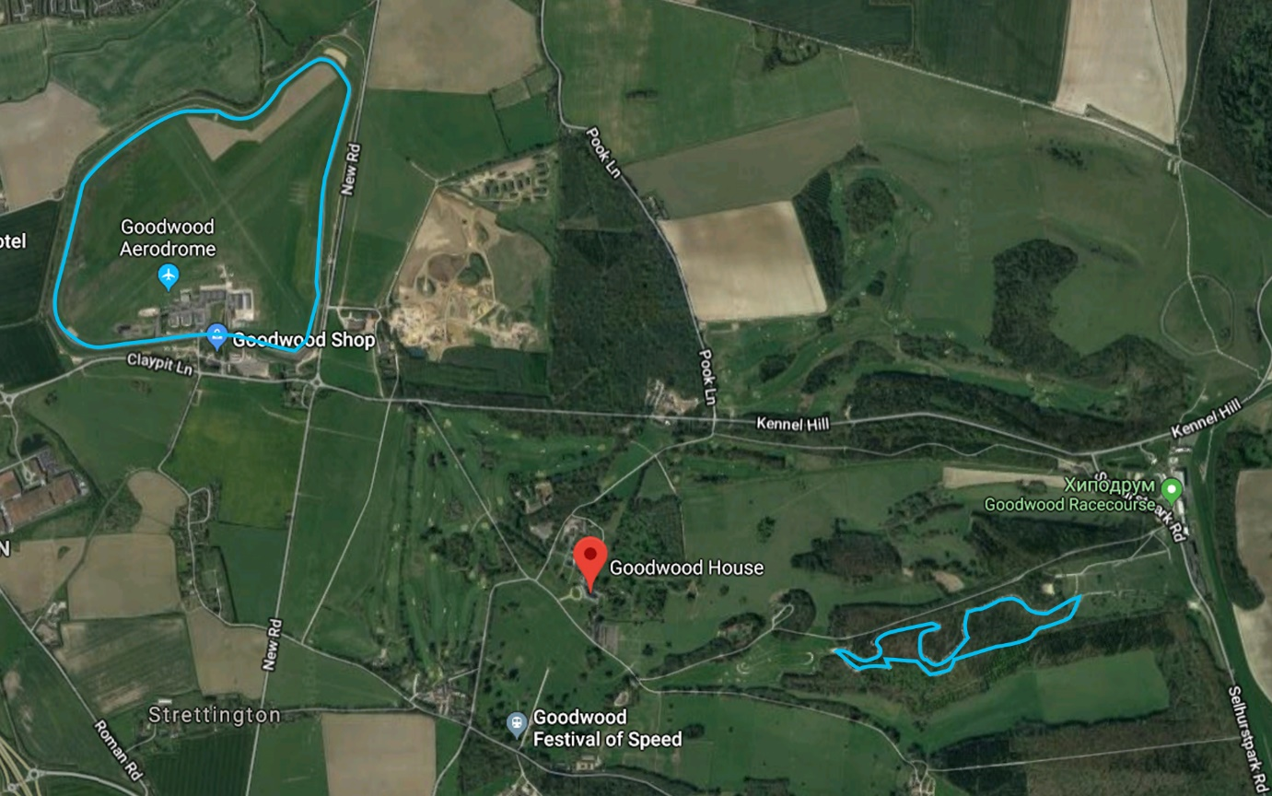Figure 1
Henry Ford is known as the father of cars as we know them today. In 1896 he introduced the 1st. combustion engine car to the world – the Quadricycle with an 4hp engine. In 1904 Henry Ford founded his own motor company – Ford Motor Company in Canada. In 1907 the famous Ford logo is trademarked and the rest is history.
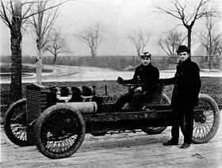
As a way to promote his car company, Henry Ford became actively involved in auto racing. Between 1901 and 1912, Ford's racecars, including the famous "999," broke records across the country and made legends out of drivers such as Barney Oldfield. In the 1st room stands this particular car – The “999” Racer in which Henry Ford himself set the landspeed record which stood for whole 8 years.
Figure 2

When you exit the first room you are taken to a big room with a dome roof which leads to two different paths. The two corridors represent two different categories of racing and each one of them takes you on a history trip down a different discipline of the Ford Racing heritage.
The path on the left side is the rally history hallway.
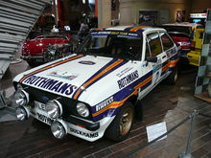
It all started in 1979 with the World Rally Championship winning Ford Escort RS1800 which is the 1st car presented in the hallway. Driven by drivers Hannu Mikkola, Björn Waldegård and Ari Vatanen , this was Ford World Rally team's first championship title. After winning the WRC title in 1979 Ford World Rally Team withdrew from the WRC.

Figure 3
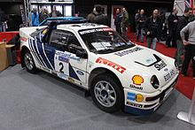 Figure 4
In 1986 Ford came back strong with the mighty RS200, which is the 2nd car displayed in the hallway. Ford's new RS200 featured four-wheel drive, a turbocharged 450 bhp engine and a new blue and white Ford Motorsport livery.Fifth place for Grundel on the Lombard RAC Rally marked the end of the road for the RS200, as Group B rallying was banned for 1987, Ford finished fifth in the manufacturers championship.
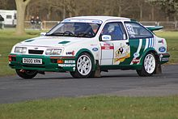
In 1987 after the Group B was cancelled, Group A rally was presented to the world. Ford Motorsport presented their new car in development – the Sierra RS Cosworth .The Sierra was a formidable car, particularly on tarmac events, wining 26 International rallyes and six National championships in 1987. It also dominated various Touring Car Championships around the world. All that racing heritage makes the Sierra RS a significant part of the Ford Racing history and that’s why it’s the 3rd car on display.

Figure 5
The year 1993 marked the introduction of the successor of the Sierra RS – the Escort RS Cosworth which is the 4th car on display. The rationale behind the Escort Cosworth's design was that it should win the World Rally Championship. It did not achieve that goal, but it did win eight events between 1993 and 1996 as a Group A car, and two more in World Rally Car guise in 1997-8, before it was replaced.

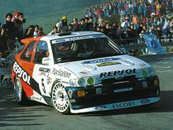
Figure 6
The Ford and M-Sport-built Ford Focus WRC replaced the Escort WRC for 1999. It debuted on the Monte Carlo Rally in January, with Colin McRae and Simon Jean-Joseph driving the two Martini Racing-liveried works machines. Ford’s Focus WRC stayed consistent by remaining in the top 5 every year in the early 2000’s but real success came in 2006. The all-Finnish team of 2000 and 2002 champion Marcus Grönholm, codriven by Timo Rautiainen, and the youngster Mikko Hirvonen brought back the manufacturers championship title to Ford and the drivers placed 2nd and 3rd in the driver’s championship in both 2006 and 2007. That’s why the 2006 Focus WRC is the 5th car on display.

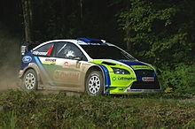
Figure 7

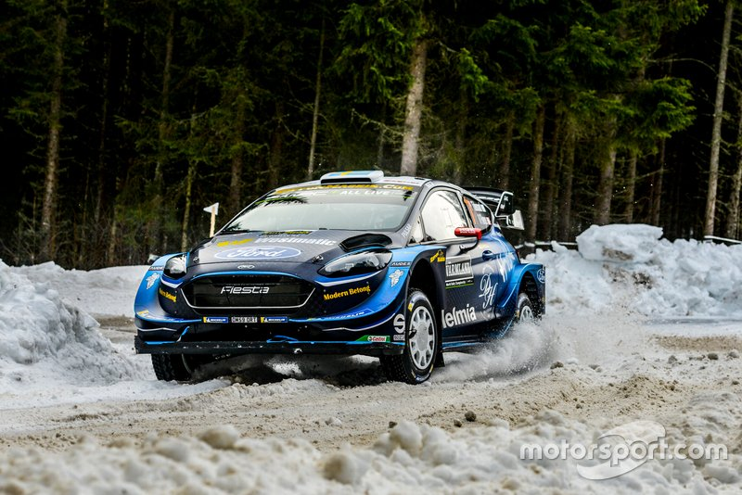
Ford stayed consistent in the next few years with the Focus WRC each year being 2nd in the manufacturers championship. The Focus was later on replaced by the shorter wheelbase Fiesta WRC in 2011 and the Fiesta platform is still used in 2019. The last car on the rally display is the all-new 2019 Fiesta WRC developed by M-Sport prepared for the WRC 2019 season packing 380hp and weighting only about 1190kg.

Figure 8

That’s it for the rally history hallway. The other path you can take from the main hall is the Le Mans Racing History hallway.
This hallway is dedicated to one of the most iconic racecars of the past century – the mighty GT40. It was born out of motorsport’s most infamous grudge. Ford was ready to do a deal with Enzo Ferrari to purchase his company. The Old Man, as wily as he was, knew he needed some major investment, and Ford wanted to go endurance racing. A deal was about to go down between Ford and Ferrari to create road cars and competition machinery. There was only one catch, the deal said that Ford gets all rights to the Ferrari Racing Division. When Enzo read that, he just left the pen on the table and left the building. Empty-handed on his return to Detroit, Ford’s point man, Don Frey, was told by Henry Ford II to ‘go to Le Mans, and beat his ass.’ Or so the legend goes. The result was the GT40, a car that most definitely is a legend. Everyone knows that the GT40 dominated 1960s sports car racing, but the fact that you’d probably struggle to name any of the winning drivers confirms the power of this particular car.
The Mk.I was the original Ford GT40 and it’s the 1st car on display at the hallway. The engineers at Ford were really pressured to make the Mk.I ready for Le Mans as they only had 10 months to make the car. However, none of the cars finished the 1964 Le Mans race and rivals Ferrari took the podium with a 1,2,3 finish. The first success came after their demise at the Nassau Speed Weekend Nov 1964 when the racing was handed over to Carrol Shelby. Shelby's team modified the Ford GT40 and the first win at Daytona February 1965 was achieved.

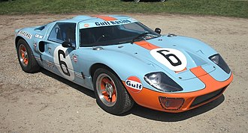
Figure 9
Henry Ford II was furious with the results of the 1964 Le Mans, so he ordered the team to put in whatever it takes to make a car to win the Le Mans. The 1966 Le Mans race was revenge time for Ford as the team of engineers came up with the GT40 Mk.II which was much more developed and an overall much more stable car and Ford entered the Le Mans race with confidence. The Fords scored a marvelous 1,2,3 podium finish at the 1966 Le Mans and also dominated the next 4 years. The Mk.II is one of the most important cars in Le Mans history ever, bringing Ford their 1st ever Le Mans win. That's why it's the 2nd car on display in the hallway.

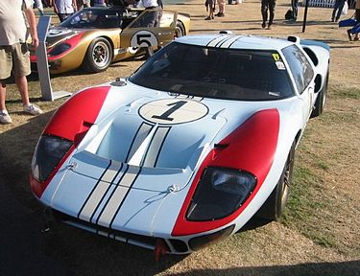
Figure 10
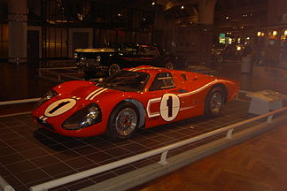
Next up in the exhibition is the Mk.IV GT40. The Mk. IV ran in only two races, the 1967 12 Hours of Sebring and the 1967 24 Hours of Le Mans and won both events. Only one Mk.IV was completed for Sebring; the pressure from Ford had been amped up considerably after Ford's humiliation at Daytona two months earlier. Mario Andretti and Bruce McLaren won Sebring, Dan Gurney and A. J. Foyt won Le Mans. The 1967 Le Mans remains the only truly all-American victory in Le Mans history — American drivers, team, chassis, engine and tires.

Figure 11
The Ford GT40 disappeared for a long time after the 1970’s but at the 2002 show, a new GT40 Concept was unveiled by Ford. The all-new Ford GT was officially presented as a production car in 2005. The racecar version of the 20-th century Ford GT was the Ford GT1 presented in 2009. This is the 4th car displayed in the hallway. Three Ford GT1’s developed by Matech Concepts competed in the 2010 24 Hours of Le Mans race. Unfortunately, the GT1 didn’t have as much success as all three cars retired in the race.

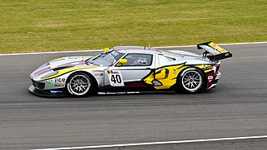
Figure 12
In 2016 the 2nd generation Ford GT was presented to the world. After another 10 years of absence the Ford GT was resurrected again. This time it packed a twin-turbocharged Ford EcoBoost V6 engine instead of the traditional 4-litre V8 in all the previous GT variants. Despite the smaller engine the car boosted more power peaking at 647hp which is more than any previous generation. In 2017 a racecar version was introduced – the Ford GT LM GTE which is the last car on display in the hallway. On June 19, 2016 the Number 68 Ford GT of Ford Chip Ganassi Racing finished 1st at the 24 Hours of Le Mans in the LMGTE Pro class; the victory marked 50 years after Ford won the 24 Hours of Le Mans in 1966, where they came in 1st, 2nd and 3rd with the GT40.

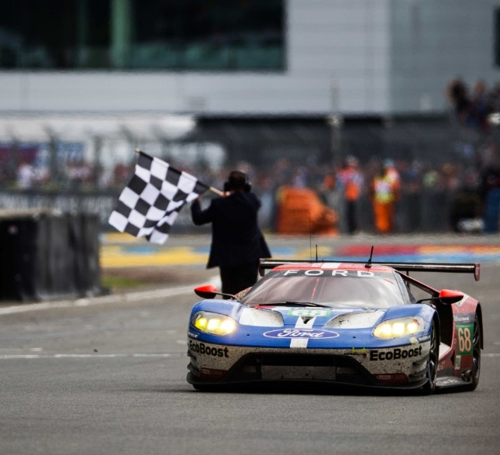
Figure 13

That’s it for the Le Mans history hallway. Both the paths of the Rally and Le Mans History hallways lead to the outer side of the exhibition where the two new models of the road versions of the cars await to be test-driven by spectators. The Focus RS can be driven on the dirt track for a rally-like experience and the Ford GT can be tested on the racing circuit to feel the thrill of Le Mans track racing. Also, outside the spectators can find catering services and toilets.

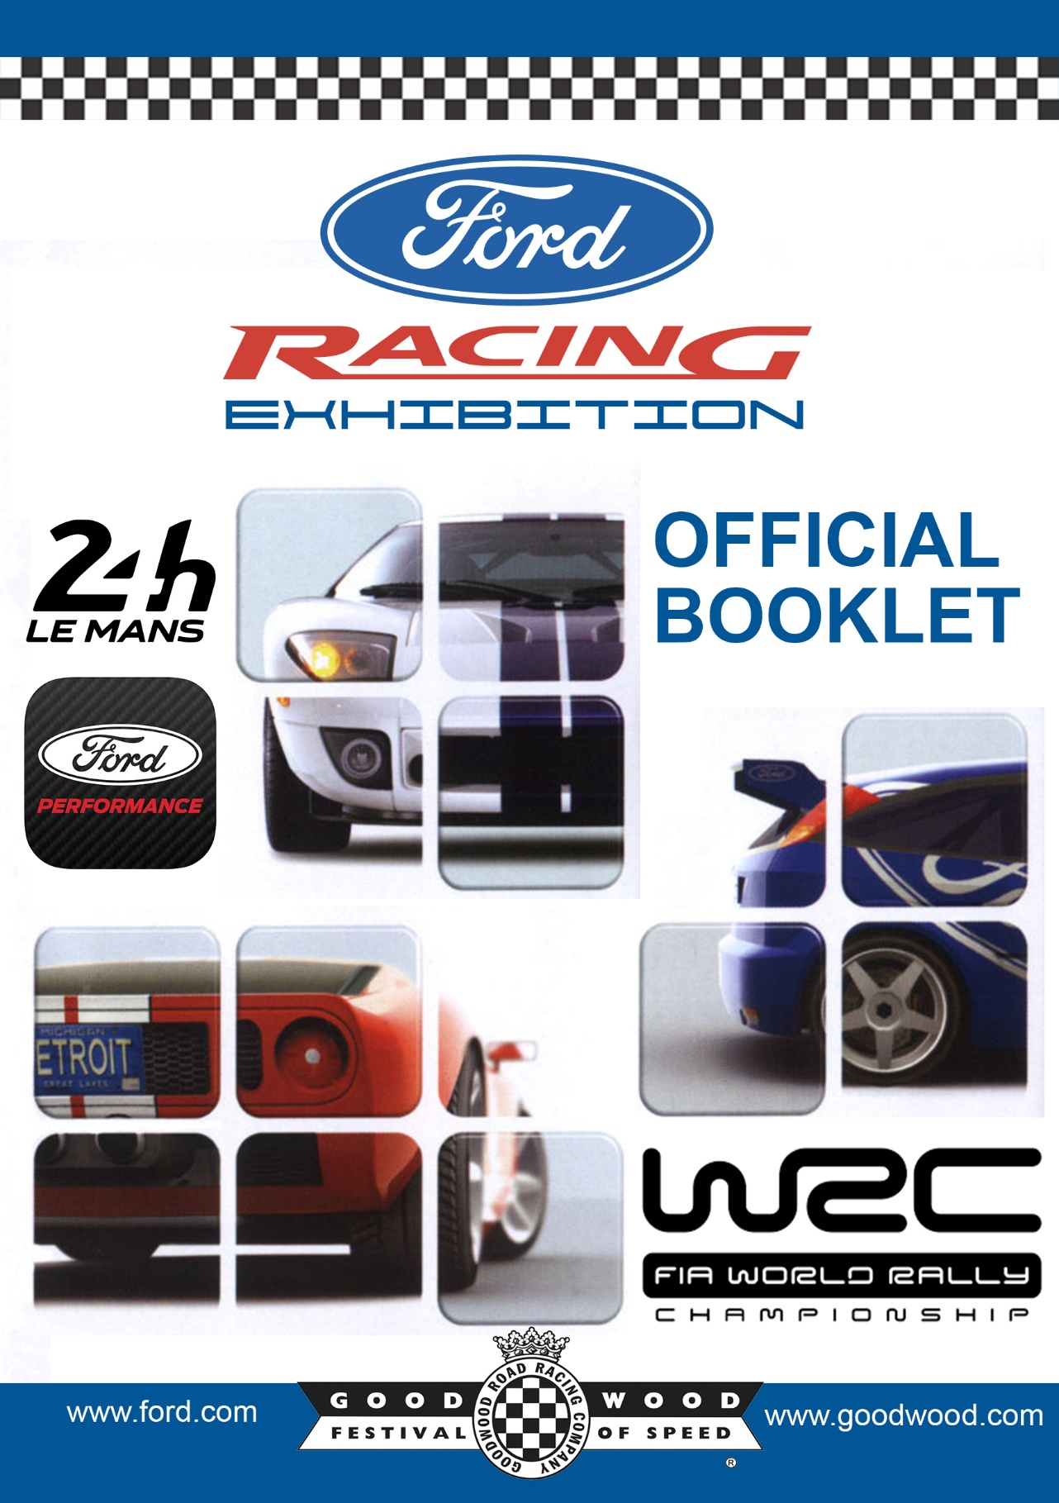

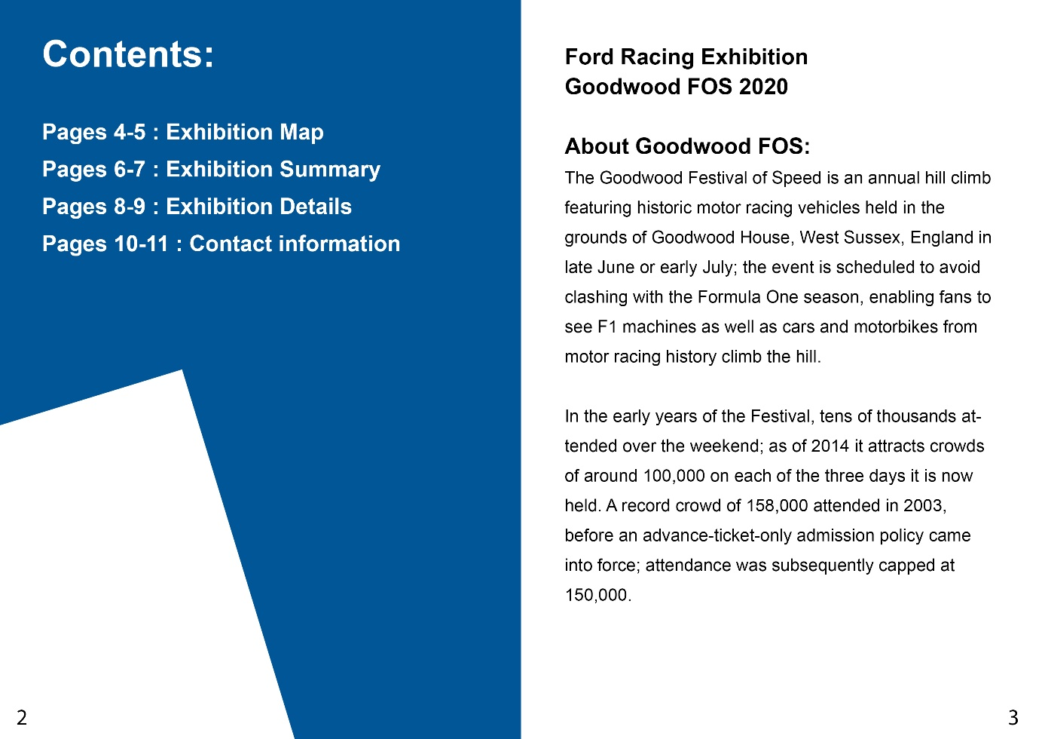
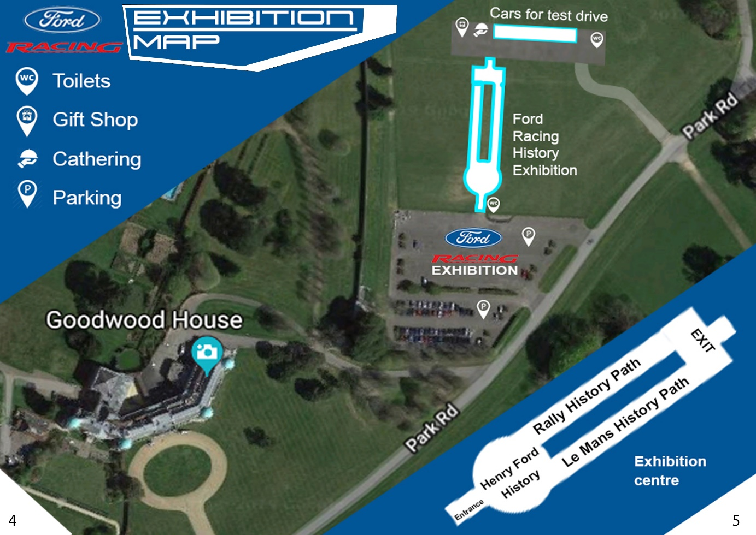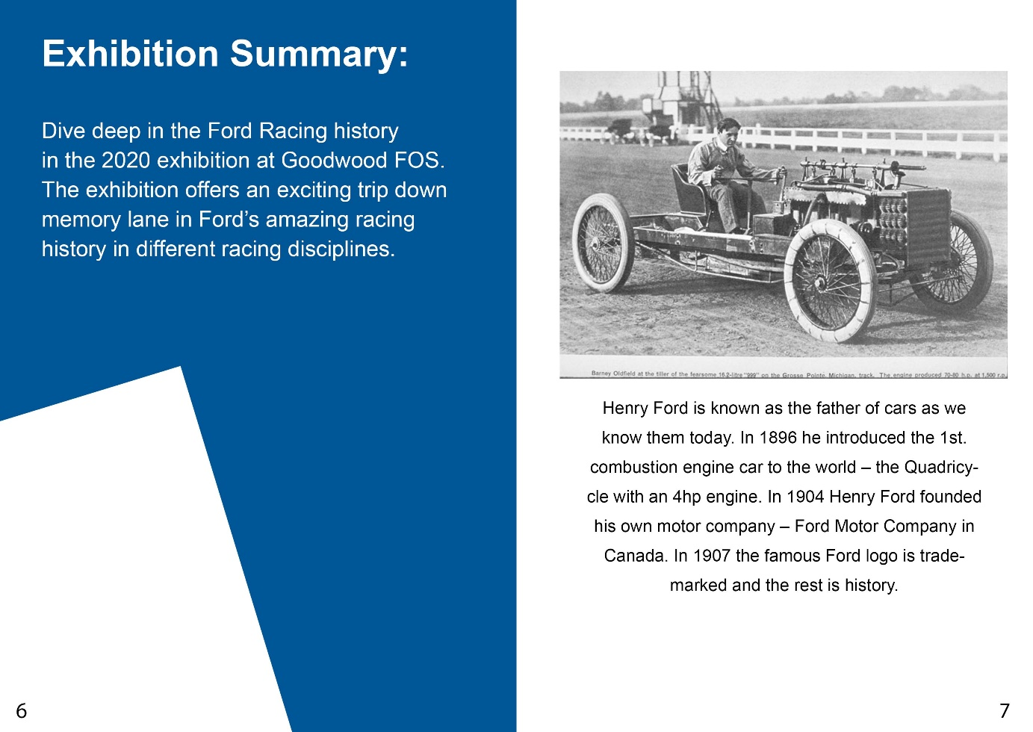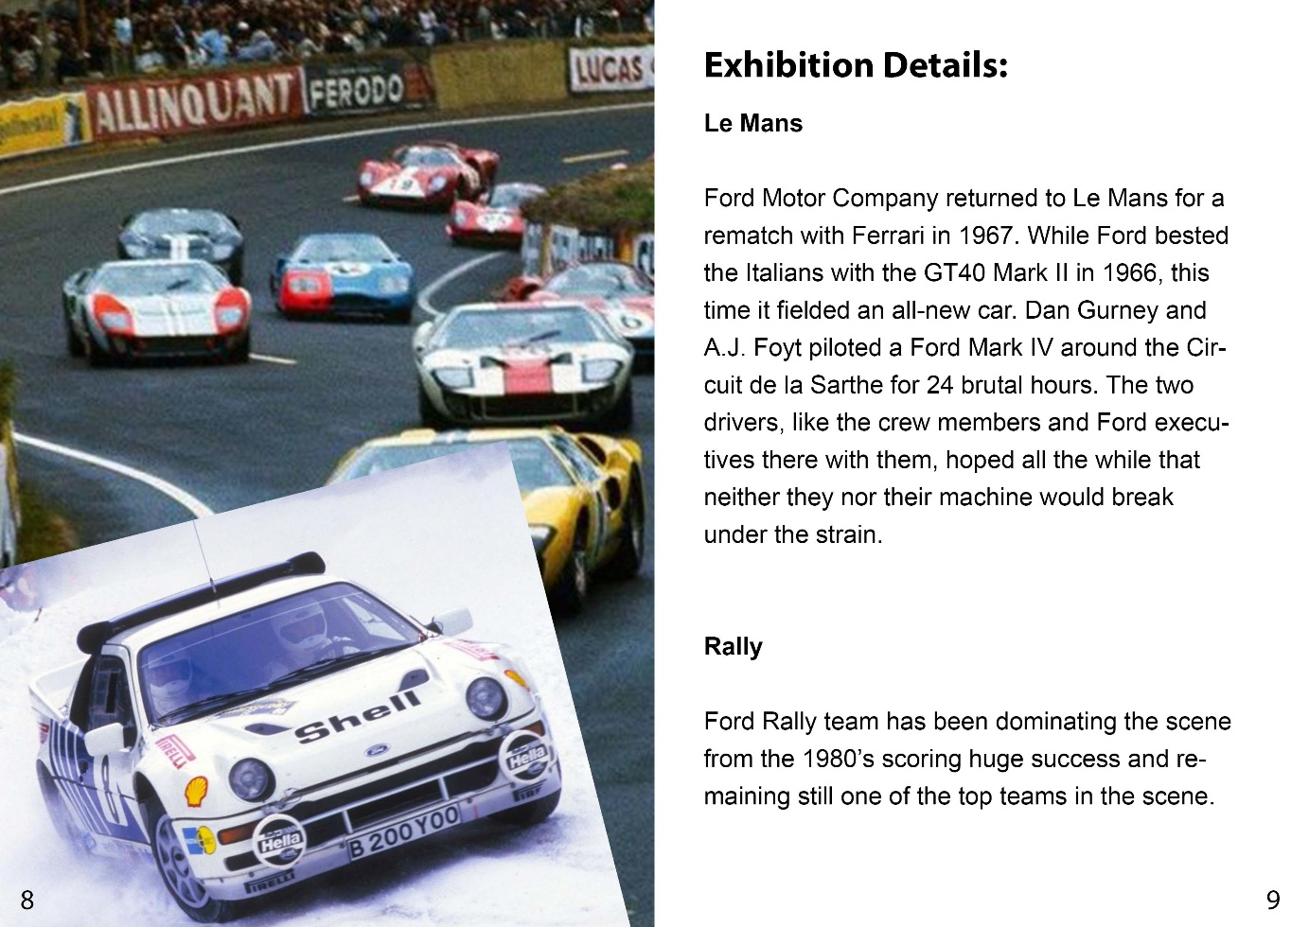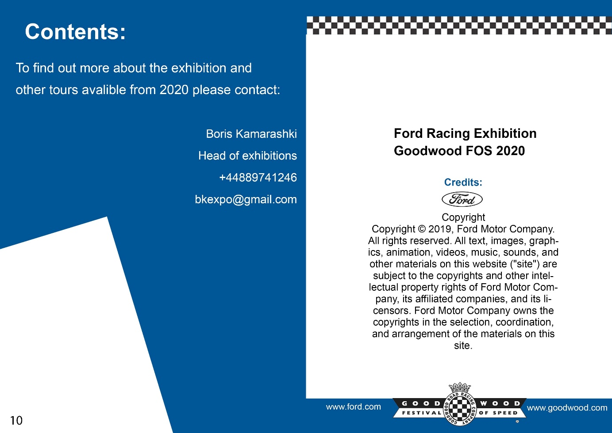

Bibliography References: Gilmorecarmuseum.pastperfectonline.com. (n.d.). 1998-002 - 1910 Ford Model T Race Car. [online] Available at: https://gilmorecarmuseum.pastperfectonline.com/webobject/2A84A278-C9C7-409F-91C9-124343352228 [Accessed 23 April 2019]. En.m.wikipedia.org. (n.d.). Ford World Rally Team. [online] Available at: https://en.m.wikipedia.org/wiki/Ford_World_Rally_Team [Accessed 23 April 2019]. Top Gear. (2017). Here's the real story behind the Le Mans-winning Ford GT40. [online] Available at: https://www.topgear.com/car-news/pioneers/heres-the-real-story-behind-le-mans-winning-ford-gt40-roy-lunn [Accessed 24 Apr. 2019]. Ford Corporate. (n.d.). Ford Motor Company Timeline. [online] Available at: https://corporate.ford.com/history.html [Accessed 23 Apr. 2019]. Castelos-ms.com. (n.d.). Ford Sierra RS Cosworth Group A, RHD, full spec – Castelos Group. [online] Available at: http://www.castelos-ms.com/en/producto/ford-sierra-rs-cosworth-group-a-rhd-full-spec/ [Accessed 23 Apr. 2019]. Wrc.com. (2019). Ford Fiesta WRC - About WRC - wrc.com. [online] Available at: https://www.wrc.com/en/wrc/about-wrc/rally-cars/ford-fiesta-rs-wrc/page/796-18667-796--.html [Accessed 23 Apr. 2019]. Forbes.com. (2019). Ford GT: Three Generations And 50 Years Of Le Mans Racing Heritage. [online] Available at: https://www.forbes.com/sites/kbrauer/2018/06/11/ford-gt-three-generations-and-50-years-of-le-mans-racing-heritage/#108902d776b7 [Accessed 24 Apr. 2019]. En.wikipedia.org. (n.d.). Ford GT40. [online] Available at: https://en.wikipedia.org/wiki/Ford_GT40 [Accessed 24 Apr. 2019]. En.wikipedia.org. (n.d.). Ford GT. [online] Available at: https://en.wikipedia.org/wiki/Ford_GT [Accessed 24 Apr. 2019]. Images: Fig. 1 - https://www.google.com/maps/place/Goodwood+House/@50.8722869,-0.751357,5922a,35y,270h/data=!3m1!1e3!4m5!3m4!1s0x48744d32d45dde09:0xa33361d7e006c60f!8m2!3d50.872389!4d-0.738866 Fig. 2 - https://en.wikipedia.org/wiki/Ford_999 Fig. 3 to Fig. 7 - https://en.m.wikipedia.org/wiki/Ford_World_Rally_Team Fig. 8 - https://www.motorsport.com/wrc/photos/pontus-tidemand-ola-floen-m-sport-ford-ford-fiesta-wrc-2019-42904594/42904594/ Fig. 9 to Fig. 12 - https://en.wikipedia.org/wiki/Ford_GT40 Fig. 13 - https://www.hemmings.com/blog/2015/06/12/ford-returns-to-le-mans-in-2016-with-an-all-new-gt/

