
Community Engagement Assignment 2 – Reflective report
COMMUNITY ENGAGEMENT (LCBB4002)


uNIVERSITY OF BIRMINGHAM tRINITY SAIN DAVID

Lecturer: DR. OLU ADGEBITE
Student: Sava Daniela
Student Number: 2028792
Contents
Introduction 1
Gibbs reflection model 1
Kolb’s Experiential Learning Theory 3
Conclusion 4

Introduction

It is generally agreed today that reflection is part of our life. First off all I want to define two main terms from this assignment:
- Reflection - is a cluster of skills and different abilities to indicate a position of critic thinking regarding problem-solving or state of mind (Moon, 2000)

- Reflective Practice – is reflecting about every event that have been through the day, trying to take wisdom from everything, a good reflective practitioner for example will use this thought process to solve problems and find a way to sort out any problems. Being reflective will impact positively also the team cause the outcome of reflecting together will help a lot. Trying to get community implicated in a reflective dialogue will help to sort out the main ideas and subjects and will bring a larger spectrum of details and ideas, plans how to solve some problems. (Moon, 2006)

In this report I want to discus about Gibbs reflection model and Kolb experiential learning theory in the context of community engagement, explaining from my experience how Gibbs reflective model and Kolb experiential learning theory helped me in my community engagement. Also, I will talk about skills that I have accrued during this module and how academic theories helped me creatively to solve problems during the term and at my workplace.

Gibbs reflection model
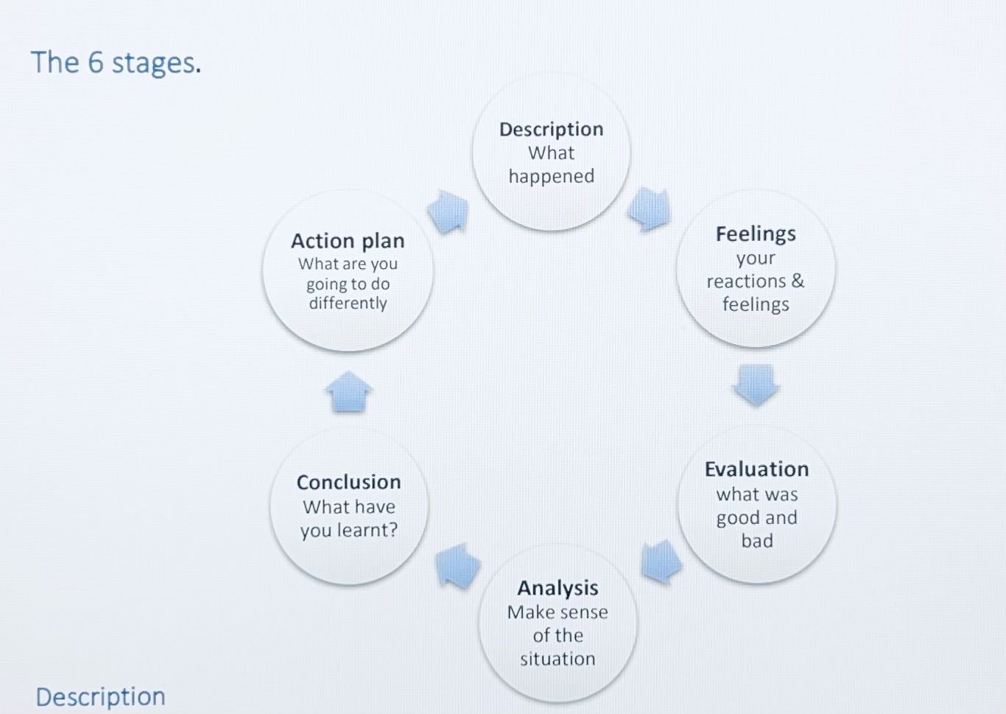

At this stage I want to use Gibbs reflecting model and reflect about one of my community engagement experiences. It was a while ago, but I can remember it like it if was yesterday. I have engaged in a programme called “Clean city, clean conscience” this program was in my birth country Republic of Moldova.
- Description- every spring in our country everyone is cleaning our environment. I have been cleaning in a parc near my school with my class and other classes from my school. It was an interesting day through which we have been engaging in cleaning our city and we have spend time together working in a big team. We were listening to music cheating and doing a good job.

- Feelings- I was feeling good because above the good impact on environment working with my friends in a team and spending time in such a way was very exciting and sincerely, I miss those days a lot. Secondly, I was feeling proud of me, feeling that I am doing something important for my community.

- Evaluation- this event had certainly a positive outcome but in the working process was also things about management and because our teacher had two classes to manage it was a bit of uncertain plan of actions, and we sometimes get on a point when we where waiting for what is next and because of that I was nervous and stressed because of that I have done a lot of mistakes. Even if I new why we are in this situation my inability to manage my feelings and control them made me to make a lot of errors.

- Analysis- I was reflecting about that situation and tried to understand why I had that reaction and what I can do next time when I will be in a similar situation to avoid some problems that I can make to myself because of my reactions at external factors that are disturbing me. Cause if I wouldn’t get nervous or if was able to manage my feelings, I could avoid those mistakes.

- Conclusion- I can say that certainly next time I will be prepared for such situations because I have been researching methods of calming in stress situation like breath techniques and changing your thinking from negative to positive, focus on positive thinking.

Emotions are the central island of reflective process and our own processes that are happening in us. Understanding yourself is very important cause if you know yourself you now how to protect yourself. Reflective thinking is also important for mental health, but some people are not able to reflect. (Moon, 2006)

Kolb’s Experiential Learning Theory

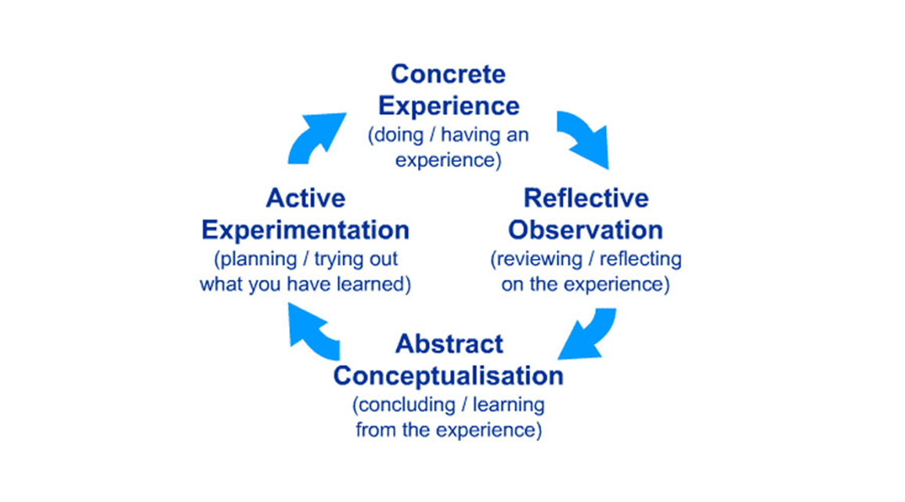
“Learning is the process whereby knowledge is created through the transformation of experience” (Kolb, 2015)

Kolb’s theory is based on knowledge acquired from personal experience it can be from first experience when you have deducted some information from your last experience, or it can be from several times when you have experienced on the same situation and every time going through process of deducting information you are updating your old knowledge. (Kolb, 2015)

The first stage of Kolb’s theory is acquiring concrete experience, so to learn you need to do something from what you will learn. That is why experiencing and doing new things everyday is so important. The second stage is reflective observation at this stage the learner based on his existing knowledges is reflecting about his experience. The bound between experience and understanding is very important if at this stage the learner can’t make this bound then it may result in poor learning. The third stage is abstract conceptualisation at this stage learner is learning from experience this is the stage where in the process of reflecting learner is deducting a new idea or concept or updating a old one now learner have acquired new information. The fourth stage is active experimentation, at this stage learner is putting in application the new information that he have acquired and follow the outcome. (Kolb, 2015)

Everyone who is trying new things and experiment with anything new for themselves, or maybe something that they know already but in a new way is learning conform Kolb’s theory. That mean that in daily life we are using this theory at instinctive level. So am I and the simplest example of learning conforming Kolb’s theory is when I came for the first time at university. When I came for the first-time at university, I didn’t know the campus, so I started to walk and explore it through walking on every floor and seeing where toilets are, where is reception, where are classrooms and other rooms. After that experience I have understanded the location of rooms and deducted important information for me like where and what I can find in campus next time when I will come. For me personally Kolb’s theory is more likely than learning something first and after that based on what you have learned from books starting to apply in real life. Because I find learning through experimentation easier. Another time when I have used this theory was at my work and I used it intentional to learn something new. I am working waitress in a restaurant so sometimes we have big events of 100 and more people and my manager asked me to prepare tables I haven’t done before that but I decided to try to do it after preparing them when people arrived I noticed that spoons that I decided to put on tables are not the right ones cause customers have n their menu soup and I have changed them and a lot of other things. At the end of that experience I deducted a lot of information that is helping me in my work position.

Conclusion

Reflective thinking is one of important side in our life not just in a life of practitioner and through reflective thinking we can understand what have been wrong in our communication or behaviour and what have caused an negative reaction of a person. Thinking in a reflective and critic way about yourself can help you to perfectionate yourself. I have learned from this module a lot of things and the first that come to mind right now is that we should ask right questions to solve a problem. But to ask this wright question we should think reflective and critically about the situation and find that right question.
Reflecting is equal with learning cause through reflecting people are understanding a lot of things and acquiring a lot of new information that will help them in future that is why reflecting is so important.

Reference List

Moon, Jennifer A. (2000)
Reflection in learning & professional development: theory & practice
Published: London; New York: Routledge Falmer, 2000

Benefits of becoming a reflective practitioner (2019)
A joint statement of support from Chief Executives of statutory regulators of health and care professionals
Available at: https://www.hcpc-uk.org/globalassets/news-and-events/benefits-of-becoming-a-reflective-practitioner----joint-statement-2019.pdf Accessed on: 1st of August 2022

- Michigan Journal of Community Service Learning (Spring 2015, pp. 49-63)
Reflective Practice that Persists: Connections Between Reflection in
Service-Learning Programs and in Current Life
Available at: https://files.eric.ed.gov/fulltext/EJ1116316.pdf Accessed on: 03/08/2022

- Gibbs’ reflective cycle
Available at: https://my.cumbria.ac.uk/media/MyCumbria/Documents/ReflectiveCycleGibbs.pdf
Accessed on: 03/08/2022

- Gibbs, G. (1988) Learning by Doing
Available at: https://thoughtsmostlyaboutlearning.files.wordpress.com/2015/12/learning-by-doing-graham-gibbs.pdf Accessed on: 05/08/2022

- Driscoll J (2000) Practising Clinical Supervision. Balliere Tindall, London

- Moon, Jennifer A. (2006)
Learning journals : a handbook for reflective practice and professional development, second edition
Published: London; New York: Routledge, 2006

- Kolb, David A. (2015)
Experiential Learning: Experience as the Source of Learning and Development, second edition
Published: Pearson Education Limited, 2015

