Through my observations of the material provided regarding the topic of ‘study and employability skills’, I believe that I have come to understand the basics of maintaining the correct mindset for a studying environment, as well as one suitable for a work-based environment. According to ‘targetjobs.com’, some key skills needed to pursue a career in animation include ‘creativity’ and ‘attention to detail’, which are usually common knowledge, however, ‘prospects.ac.uk’ also recommends having ‘communication skills’ and ‘an ability to work with others’, as those in animation studios are more than often required to work within teams of people, as well as collaborate with other divisions within a singular project. Both The National Careers Service and Indie Education suggest that ‘digital literacy’ could help in obtaining a role at a studio, especially in the modern age. Other skills that could be used within creative jobs, as well as jobs of other areas include ‘planning and organising’, ‘learning’ and ‘problem solving’, as stated in YOUTH CENTRAL’s article titled ‘8 job skills you should have’. The images below from Study 365 and The Labour respectively attest to several of the skills that I have previously mentioned thus far:

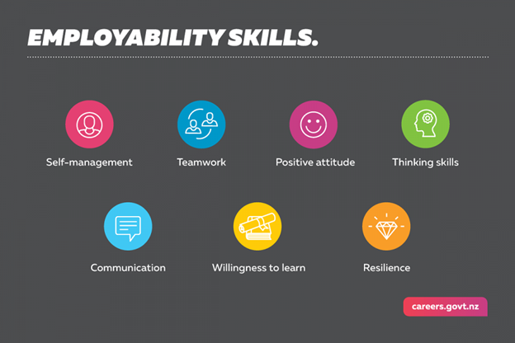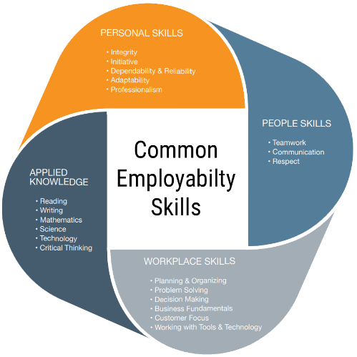

References:
Alison_TARGETjobs (2012). Animator: job description. [online] TARGETjobs. Available at: https://targetjobs.co.uk/careers-advice/job-descriptions/277551-animator-job-description.
Prospects.ac.uk. (2014). Animator job profile | Prospects.ac.uk. [online] Available at: https://www.prospects.ac.uk/job-profiles/animator.
nationalcareers.service.gov.uk. (n.d.). Animator | Explore careers | National Careers Service. [online] Available at: https://nationalcareers.service.gov.uk/job-profiles/animator [Accessed 7 Dec. 2020].
www.indiaeducation.net. (n.d.). What Skills So You Need To Be An Animator, Qualities Of An Animator. [online] Available at: https://www.indiaeducation.net/animation/animator-qualities.aspx.

