DS 1 Template

Screenshots 1 the Coo-operative Bank
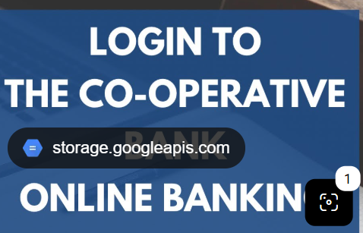
The picture shows a Cooperative Bank branch; they provide financial services to customers.
The online banking app is important to me because I can see and control my money inflows and outflows.


In this picture I can see the Job & Talent App, it is an App for finding jobs.
I use this App to search for job opportunities using my digital skills.

Screenshot/3Time Gate
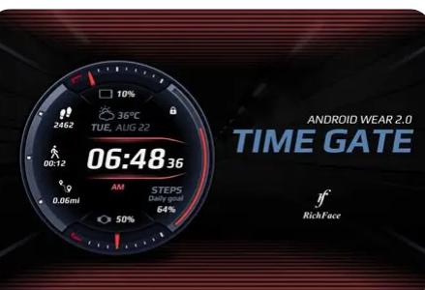
My observation in this picture, is my Time Gate App.
I’m using this app to note every day when I get IN and OUT from my work place, also to book my holyday and read about the company policy.

Screenshot/4 UBER

This picture shows the Uber App, I use this App to book a taxi to the bus station because every weekend, I’m travel to one place to another.
I use my digital skills to book and pay for my journeys.

Screenshot5 Tiktok
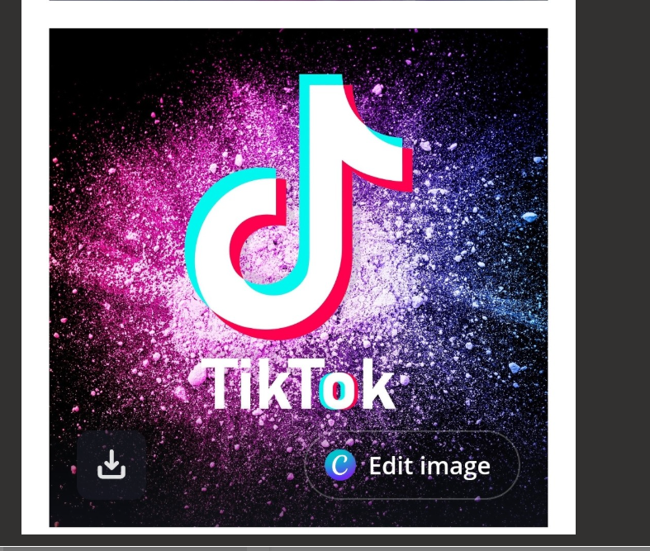
I use this App for entertainment, watch videos and sort films.
Sometimes I use this app to buy in TikTok shop.

Screenshot/6 Facebook
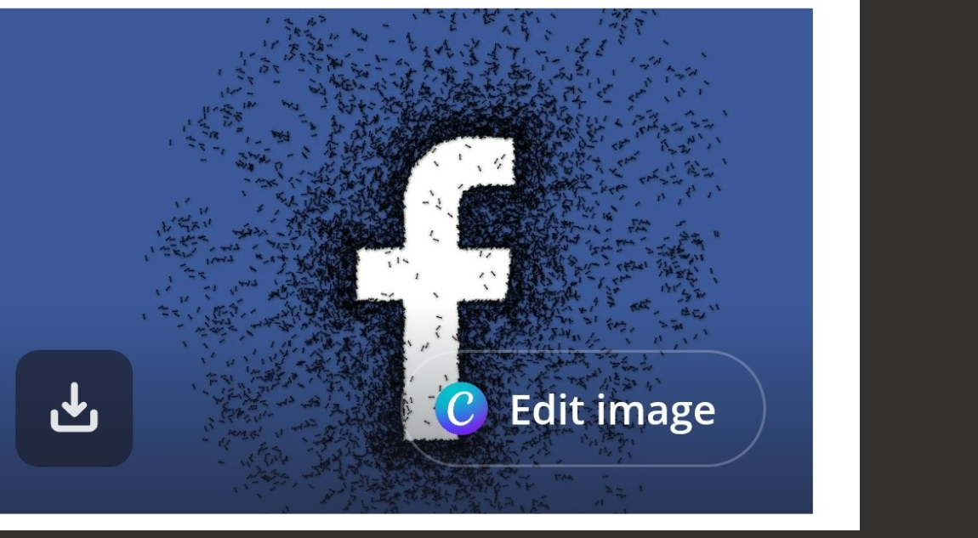
I’m using this App to connect with my family and friend, I also use this App especially Facebook Market Place to find good deals,

My Short Reflection
I use digital tools to shop online.
I feel confident when I make videos and share photos.
I want to improve my digital skills. Using the internet to find information.
I often use these tools to be shopping, making transactions and connecting with family and friends.
In my daily routine I use my digital skills, because this App makes my life more easier and solve ay difficult moment in my daily routine.

Sentence starters
- I use digital tools to …
- I feel confident when I …
- I want to improve …
- I often use these tools: …
- I sometimes feel nervous about …
- I hope this module will help me …
- Digital skills are important for me because …
You can write more if you want.

