ECEY4001
Portfolio three parts
Part 1 – Infographic on Maslow Hierarchy of Needs – Word count - 1093
Part 2 –
Part 3 –

AI Cover Sheet

I acknowledge the use of Grammarly for grammar and spell check.
I acknowledge the use of Canva to help create a template for my briefing paper.

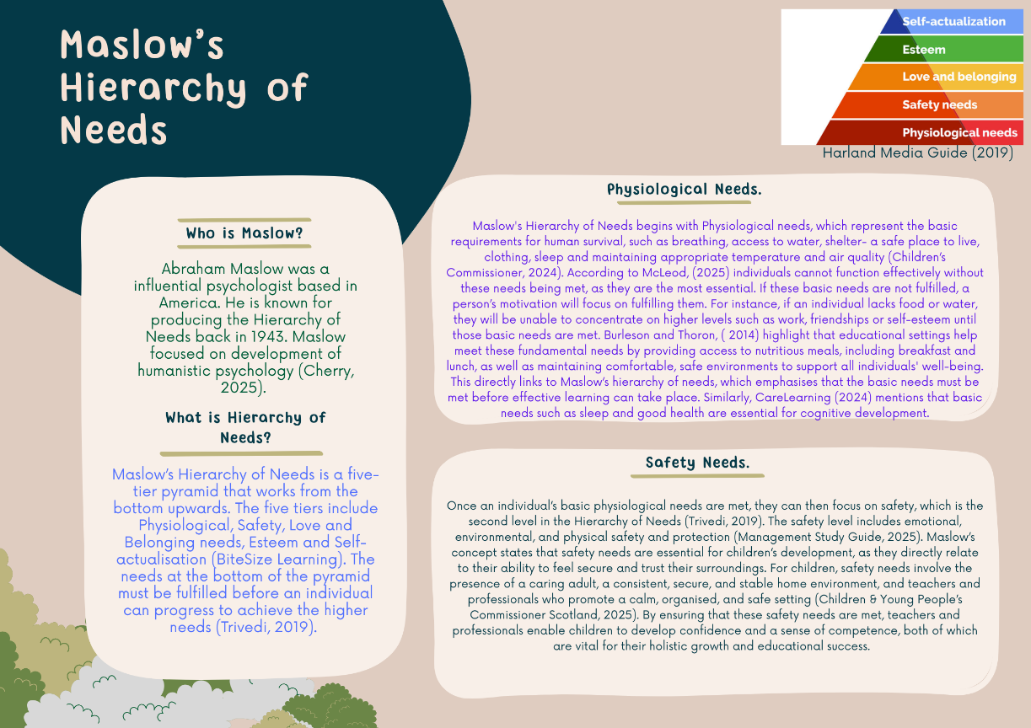
Part 1
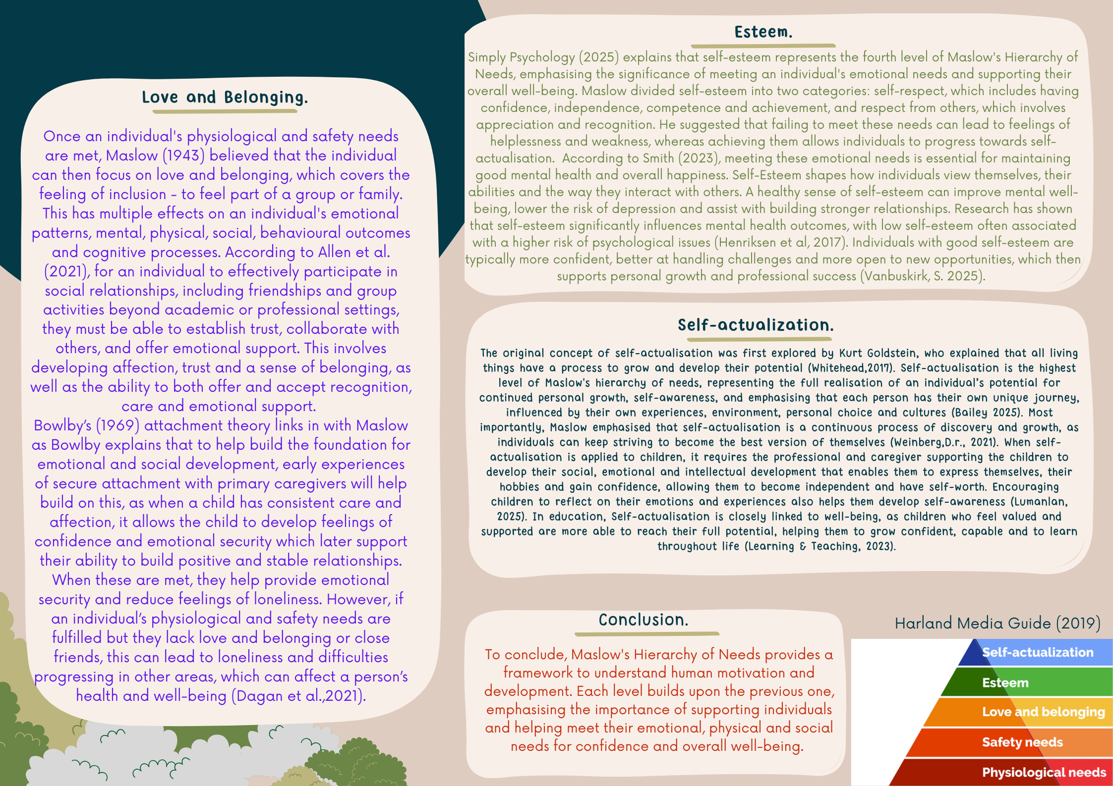

Reference List Part 1
Allen, K.-A., Kern, M.L., Rozek, C.S., McInerney, D.M. & Slavich, G.M., 2021. Belonging: a review of conceptual issues, an integrative framework, and directions for future research. Australian Journal of Psychology. https://doi.org/10.1080/00049530.2021.1883409
Bailey, A. (2025) Maslow’s Hierarchy of Needs. Available at: Maslow’s Hierarchy of Needs: Purpose and Examples (Accessed: 09th November 2025).
BiteSize Learning. Maslow’s hierarchy of needs, explained. Available at: Maslow’s Hierarchy of Needs Explained + Pyramid Diagram — BiteSize Learning (Accessed: 04th November 2025).
Bowlby, J. (1969) Attachment and Loss: Volume 1 – Attachment. London: Hogarth Press.
Burleson, S.E. and Thoron, A.C. (2014) Maslow’s Hierarchy of needs and its relation to learning and achievement. University of Florida, Institute of Food and Agricultural Sciences (EDIS Publication). Available at: https://journals.flvc.org/edis/article/download/131587/135186/236583 (Accessed: 5 November 2025).
CareLearning. (2024) Examples of Maslow’s Hierarchy of Needs in Early Years. Available at: Examples of Maslow’s Hierarchy of Needs in Early Years – Care Learning (Accessed 6th November 2025).
Cherry, K. (2025) Biography of Abraham Maslow (1908-1970). Available at: Abraham Maslow: Life and Contributions to Psychology (Accessed 11th November 2025).
Children & Young Peoples Commissioner Scotland. (2025) UNCRC Simplified Articles. Available at: UNCRC Article 19 - I have the right to be protected from being hurt or badly treated - The Children and Young People's Commissioner Scotland (Accessed 7th November 2025).
Children’s Commissioner, (2024) Hierarchy of needs for care experienced young people. Available at: *CCO-Hierarchy-of-needs-for-care-experienced-young-people.pdf (Accessed on 04th of November 2025).
Dagan, O., Groh, A. M., Madigan, S. & Bernard, K. (2021) ‘A lifespan development theory of insecure attachment and internalising symptoms: integrating meta-analytic evidence via a testable evolutionary mis/match hypothesis’, Brain Sciences, 11(9), p. 1226.
Harland Media Guide, (2019) Theories: Maslow’s (Basic) Hierarchy of Needs. Available at: Theories: Maslow's (Basic) Hierarchy of Needs (Accessed 11th November 2025).
Henriksen, I. O., Ranøyen, I., Indredavik, M. S., & Stenseng, F. (2017) ‘The role of self-esteem in the development of psychiatric problems: a three-year prospective study in a clinical sample of adolescents’, Child and Adolescent Psychiatry and Mental Health, 11(1), Article 9.
Learning & Teaching. (2023) Embracing the Humanistic Approach to Learning: towards Self-Actualization. Available at: Embracing the Humanistic Approach to Learning: Towards Self-Actualization • Teachers Institute (Accessed: 09th November 2025).
Lumanlan, J. (2025) 6 Strategies for teaching emotional awareness to children. Available at: 6 Strategies for Teaching Emotional Awareness to Children | Psychology Today (Accessed: 09th November 2025).
Management Study Guide. (2025) Maslows Hierarchy of Needs Theory. Available at: Maslows Hierarchy of Needs Theory - Management Study Guide (Accessed: 7th November 2025).
Maslow, A.H. (1943) ‘A theory of human motivation’, Psychological Review, 50(4), pp. 370–396.
McLeod, S. (2025) ‘Hierarchy’ Maslow’s Hierarchy of Needs. Available at:DOI:10.5281/zendo.15240897.
Simply Psychology (2025) ‘Maslow’s Hierarchy of Needs’. Available at:https://www.simplypsychology.org/maslow.html (Accessed: 8 November 2025).
Smith, M. (2023) Self-Esteem Needs: Understanding Maslow’s Hierarchy. Available at: Self-Esteem Needs: Understanding Maslow's Hierarchy - Self-Esteem Generator (Accessed 8th November 2025).
Trivedi, A, J. (2019) ‘ Maslow’s Hierarchy of Needs’ Theory of Human Motivation. 19(7), pp. 2321-2853.
Vanbuskirk, S. (2025) Why it’s important to have a high Self-Esteem. Available at: Why It's Important to Have High Self-Esteem (Accessed 8th November 2025). #
Weinberg, D.R., (2012) Montessori, Maslow, and Self-Actualization. Montessori Life, 23(4), pp.16-21.
Whitehead, P. M. (2017) Goldstein’s self-actualization: A biosemiotics view. The Humanistic Psychologist, 45(1), 71-83. https://doi.org/10.1037/hum0000047.

Part 2
Introduction
This assignment explores the concept of holistic child development, focusing on how it contributes to overall growth and links to Maslow’s Hierarchy of Needs, alongside other key developmental theories.
Main Body
McLlory (2024) states that holistic development in the early years is the overall growth of children in different areas, including physical, emotional, social, cognitive, moral, and spiritual development. When a practitioner uses a holistic approach, it involves recognising all different areas of development to ensure the child is supported, as each child's development occurs at a different stage and is unique for each child (Early Education, 2021). To ensure the practitioner provides a holistic approach, they need to ensure that the children have access to learning opportunities that focus on all five aspects of development.
Education Endowment Foundation (2025) Physical development refers to a child’s growth and changes, focusing on strengthening sensory development, gross motor skills, and fine motor skills, as well as ensuring all their physical needs are met to a high standard. NewHorizon25 (2024) states that there are four main stages of physical development. The first is infancy, from birth to 1 year, which is crucial for developing gross and fine motor skills, including activities such as lifting the head, sitting up, rolling over, crawling, and taking their first steps. The next stage is Early Childhood, covering ages 1 to 3 years, during which children learn to jump, run, and participate in more diverse activities. The third stage is preschool age from 3 to 5 years, and this is where children aim to develop balance and coordination, which then encourages them to hop, skip and throw. The fourth and final stage is school age, and this is from 6 to 12 years, and this is enhancing their development by increasing strength and more advanced motor skills. NewHorizon25 (2024) mentions that it is crucial for parents, professionals and caregivers to understand each stage to be able to support the child with appropriate measures in place and that each stage is a stepping stone to the child's adulthood. Holistic development links to Bronfenbrenner as he believes a child’s development is shaped by different processes that link together considering each aspect to complete the child’s development (Guy-Evans, 2025).
Queen University Belfast (2017) states that physical development, such as height, weight, and brain development, all depends on the nutrition and health that the child receives as if a child is lacking food and rest this can delay their motor development and weakened immune function as a child who has a balanced diet and sleeps well is going to have plenty of energy for the growth. While physical development provides the foundation for a child’s growth, social and emotional development are equally important. Physical development links to Maslow’s Hierarchy of needs as a child requires their basic physiological needs (University of Central Florida).
Department for Education, (2023) describes social development as a way children learn how to communicate, work together, take turns and share. It is developed through play, interaction and daily routines. In an early year setting, this can include things like circle time, role play, which, with these experiences it encourages the child to understand social cues, interact, as during circle time the children learn songs and how to wait their turn. Estyn, (2021) states that with positive interaction, children will develop an understanding of different backgrounds and boundaries. Parents and practitioners can help children develop and learn how to communicate effectively by creating a safe environment, with positive role modelling and routine. This connects to Maslow’s love and belonging level, as Egersdoff and Mundy (2017) states this refers to the child’s need for social connection, and for a child to develop this effectively, it comes down to their basic and emotional needs being met before this.
Bowlby’s theory explained that emotional development is significant for early emotional bonds, as he believed these bonds are vital for survival and emotional development. Department for Education (2023) states that children’s ability to learn is based on their emotional security and supportive relationships with parents, caregivers or professionals. Emotional development is the way children understand, manage and express their emotions. In early years settings, emotional development is produced by having positive relationships and role models, as when a child feels secure and cared for, they are then able to build confidence, which helps the child deal with challenges and have a good mental well-being. Maslow’s Hierarchy of Needs and Emotional Development are connected as both emphasise the need for human needs and emotions to develop the overall behaviour and growth. Children who are brought up in a caring environment are helped to support their development as when parents/caregivers comfort, cuddle, talk, play, praise the child and celebrate, it helps the child have a positive development with social and emotional development, children who are not used to this will struggle more to connect with others.

Fennies nurseries (2024) explore that cognitive development is a child’s growth, thinking, problem-solving and memory skills which involves the brain to process information; all this is important for future development and learning. Piaget mentions that cognitive development is split into four stages, the first stage being birth to 2 years which is a key development as they learn through sensory experiences, then the second stage is preoperational stage ages 2 to 7 years and this is where a child starts using language more, thinking, expression there feelings and imaginative play, The third stage is concrete operational stage ages 7 to 11 years and the final stage is formal operation stage ages 12years and up (Nortje,A, 2021). Cognitive development is influenced by social interaction, environments and supportive relationships, which enhance the growth. Parents and professionals can support a child’s cognitive development by providing exploration, hands on experience, asking questions, and another way to help is by creating a stimulating learning environment with age-appropriate activities, including books, games and puzzles, which helps grow the thinking and problem-solving skills (Fennies nurseries, 2024).
The development of Morals and values include spiritual development, self-view, any religious beliefs and personality development and understanding the concepts of right and wrong, children don’t tend to understand this until around 2 years old (TeachKloud 2023). Moral development is crucial in early years as it enables the child to develop ethical choices and responsible behaviour later on in life, Lawrence Kohlbery agrees with this and mentions moral reasoning is the children learning the difference between right and wrong (McLeod,S 2024). Maslow and Piaget are both theorists who concentrate on development but have different views regarding this, as Maslow believes that children can't develop to the higher stages until the basic stages are met (McLeod 2025), whereas Piaget believes that children’s development continues to develop even if the basic needs are not met.

Conclusion
To Conclude Malsow’s Hierarchy of Needs provides a foundation of understanding ochildre’'s basic and psychological needs these needs, where theories from Piaget, Vygotsky, Erikson and Bronfenbrenner further our understanding on child holistic development, together highlighting the importance of their full potential.

Reference List Part 2
Mcllroy, T. (2024) What is Holistic Development in Early Childhood?. Available at: What is Holistic Development in Early Childhood? - Empowered Parents (Accessed 11th November 2025).
Eadrly Education Coalition. (2021) Birth to 5 Matters: Guidance by the sector for the sector. London: Early Education. Available at: Birthto5Matters-download.pdf (Accessed: 12th November 2025).
NewHorizon25. (2024) Physical Development In Children: The 7 Stages. Available at: Physical Development In Children: The 7 Stages (Accessed 12th November 2025).
Queen’s University Belfast. (2017) Understanding the Association between Stunting and Child Development in Low- and Middle-income Countries: Next Steps for Research and Intervention. Available at: Stunting_SSM.pdf (Accessed 12th November 2025).
Education Endowment Foundation. (2025) Physical Development. Available at: EEF | Physical Development (Accessed 12th November 2025).
University Of Central Florida. (No Date) Maslow’s Hierarchy Of Needs. Available at: Maslow’s Hierarchy of Needs – General Psychology (Accessed 12th November 2025).
Guy-Evans, O. (2025) Bronfenbrenner’s Ecological systems theory. Available at: Bronfenbrenner's Ecological Systems Theory (Accessed on 12th November 2025).
Department for Education. (2021) Development Matters. London: Department for Education. Available at: Development Matters - GOV.UK (Accessed 12th November 2025).
Estyn. (2021) Developing Pupils’ social and emotional skills. Available at: Developing pupils’ social and emotional skills - Estyn (Accessed 12th November 2025).
Egersdff, S and Mundy, P. (2017) A Model for living: Maslow’s Hierarchy of needs in children’s development: Exploring eating, sleeping, playing and learning as key elements. Available at: Maslow’s hierarchy of needs in children’s development | Community Playthings (Accessed 12th November 2025).
McLeod, S. (2025) Maslow’s Hierarchy of Needs. Available at: Maslow's Hierarchy of Needs (Accessed 13th November 2025).
Department for Education. (2023) Statutory Framework for the Early Years Foundation Stage. Available at: EYFS statutory framework for group and school-based providers (Accessed 13th November 2025).
Nortje, A. (2021) Piaget’s Stages: 4 Stages of Cognitive Development & Theory. Available at: Piaget's Stages: 4 Stages of Cognitive Development & Theory (Accessed 13th November 2025).
TeachKloud. (2023) Moral Development in Early Childhood Education: A Comprehensive Guide for Educators. Available at: Moral Development in Early Childhood Education: A Comprehensive Guide for Educators – TeachKloud (Accessed 13th November 2025).
McLeod, S. (2024) Kohlberg’s Stages of Moral Development. Available at: (PDF) Kohlberg's Stages of Moral Development (Accessed 13th November 2025).

Part 3
Understanding children’s development is more than observing their growth, it involves recognising their different needs. This section will explore three examples from early years education, including how to support children through transitions.
The first example that will be focused on is a child’s basic needs, as ensuring these are met is crucial in helping the child feel safe and ready to learn/play (Oat National Academy NO DATE). Kusuma and Naimah (2021) believe that children's basic needs must be met to enable them to develop and grow. Meeting a child’s basic needs includes providing meals, snacks, and drinking water, as well as ensuring the environment is a safe, comfortable, and clean space. Department for Education (2023) In an early year setting, the practitioner may notice that a child appears withdrawn or less engaged and realise the child might be hungry, this could occur for several reasons, such as the child not having time to eat breakfast at home, or if the child is living in a household where there is a lot of conflict and instability, making mealtimes hard. Fitzgibbon and Canale (2024) Children’s at a younger age often cannot communicate to the practitioner to make them aware of tiredness or hunger, so with the practitioner observing they can then identify the child’s behaviour might be linked to lack of sleep or food, unusual behaviour can be a sign that something isn’t right, for early years settings to offer breakfast, this ensures all children who come in have a safe environment to eat a nutritious breakfast. This concept is linked to Maslow’s Hierarchy of Needs, as Maslow believes that a child’s basic physiological needs must be met before they can progress to the next level (Narvaez and Noble, 2018). Family Action (2019) conducted research which showed that early year settings and schools providing breakfast have seen a positive effect on a child's cognitive function, even up to four hours after. Studies also showed that a child who had eaten breakfast demonstrated improved cognitive function, academic outcomes and an increase in behaviour (Family Action, 2019).

Transitions are not events, they are a process of moving to a new situation or environment, which can include new rooms, adapting to different routines, and meeting unfamiliar staff (Birth to 5 Matters) NO DATE. In young children and early years settings, transitions are a vital moment, as they can impact a child’s emotional, social, and cognitive development (Better Start, 2023). These transitions can occur when moving from home into a nursery setting, starting meithrin for the first time, going from part-time school to full-time school, or progressing into a new class each year (Clarke, 2022).
A child-centred approach that supports holistic development is an important part during transition, to do this, this practitioner needs to consider the children’s interests and developmental stages, making sure their individual needs are recognised, It is essential that parents, caregivers and professionals work together to support the child, helping to ensure that each transition is as smooth and positive as possible (Department of Education and Youth, 2024).
Department of Education and Youth (2024) believes there are three main steps involved in effective transition. The first step is planning and preparation, and this includes effective planning and preparation for the transition to be a positive experience. This includes sharing relevant information between parents, caregivers and professionals, as well as arranging room or setting visits so staff members can meet the child and parents, and the child can get familiar with the environment (Leicester City Centre).
The second step is implementation, which is when the transition takes place, this includes settling-in sessions and providing consistent reassurance and support to ensure that both the parent and child feel safe, understood and supported (Department of Education, 2025).
The third step in transition is the follow-up, which focuses on observing the children’s well-being after the transition has happened, and maintaining regular communication between parents about how the child Is managing, the practitioner needs to be observant and aware of any children with additional learning needs, as transitions can be extremely challenging for a child who may not fully understand what is happening. It is important to recognise that each child is different and will react differently to each transition (Cambridgeshire County Council, no date).
Transition in early years settings can closely link to Maslow’s Hierarchy of Needs, as successful transitions require meeting a child's psychological and emotional needs (Egersdoff and Mundy, 2017). According to Drew, (2024) on Maslow's hierarchy of Needs safety is the second stage of the hierarchy. Birth to 5 Matters (NO DATE) During transition, some children are vulnerable during these times and may feel uncertain or nervous, so making sure they feel secure and safe is an important part of a positive transition.
In addition, Maslow's Love and belonging needs also link closely to transition, as in early years settings, as it's important that children connect with the staff and other pupils, as relationships support the feeling of belonging and help build confidence (Dimiterllou, E, 2017).
Another important example in an early year setting is having a stable and supportive environment, as these are fundamental to Maslow’s love and belonging stage of development. Maslow implies children need to feel accepted, connected and valued before developing confidence. To ensure this stability, the practitioner can take several steps, firstly, the practitioner needs to build a positive relationship with the child as if the child is upset, the practitioner can communicate with them to help the child feel secure and belonging within the setting. when a child feels safe and emotionally secure, they are more open to exploring the environment and interacting with other children in their setting. When the practitioner is supporting a child's emotional needs, they are also following Maslow's esteem level. Practitioners can provide this by praising the children for positive behaviour and work, encouraging independent tasks such as putting on shoes, tidying up. Geo et al (2024) Research indicated that if children are given encouragement and positive opportunities, their confidence will motivate them to grow and develop further.
The first is providing a child-centred approach that supports holistic development. To do this, the practitioner needs to consider the children’s interests and developmental stages.

Reference list part 3
Family Action. (2019) The impact of breakfast on learning children. Available at: The impact of breakfast on learning in children - Family Action (Accessed 13th November 2025).
Fitzgibbon, S, and Canale, N. (2024) Understanding and Responding to Children’s Behaviour in the Early Years. Available at: Understanding & Responding to children’s behaviour in the early years English (Accessed 13th November 2025).
Department for Education. (2023) Mental health for early years children. Available at: Help for early years providers : Mental health for early years children (Accessed 13th November 2025).
Oak National Academy. The things we need to feel safe and happy. Available at: Lesson: The things we need to feel safe and happy | Oak National Academy (Accessed 13th November 2025).
Egersdorff,S. and Mundy,P. (2017) A model for Living. Available at: Maslow’s hierarchy of needs in children’s development | Community Playthings (Accessed 14th November 2025).
Narvaez, D. and Noble, R. (2018) The Notion of Basic Needs: Fulfilling Human Potential. Available at: (PDF) The Notion of Basic Needs: Fulfilling Human Potential (Accessed: 14th November 2025). DOI:10.1007/978-3-319-97734-8_1
Kusuma, Y. and Naimah, N. (2021) The needs of children: Multiperspective study. Available at: (PDF) The needs of children : Multiperspective study (Accessed: 14th November 2025). DOI:10.26555/jecce.v4i2.6549
Department of Education and Youth. (2024) Supporting children with the transition from home or early learning and care settings to primary school. Available at: Supporting children with the transition from home or early learning and care settings to primary school (Accessed 14th November 2025).
Cambridgeshire County Council. Supporting Transitions throughout the early years foundation stage. Available at: Transitions Across the Early Years Toolkit (Accessed 14th November 2025).
Better Start. (2023) Transitions- Supporting transitions within the daily routine. Available at: Transitions-Tip-sheet-Daily-Routine.pdf (Accessed 14th November 2025).
Birth to 5 Matter. Transitions. Available at: Transitions – Birth To 5 Matters. (Accessed 15th November 2025).
Drew, C. (2024) 19 Safety Needs Examples (Maslow’s Hierarchy. Available at: 19 Safety Needs Examples (Maslow’s Hierarchy) (2025) (Accessed 15th November 2025).
Clarke, V. (2022) Different Types of Transition in Child Development. Available at: Val Clarke - Twinkl Teaching Blog - Twinkl (Accessed 15th November 2025).
Leicester City Council. Early Years Transitions guidance for information sharing. Available at: Early years transitions - information sharing guidance (Accessed 15th November 2025).
Department of Education. (2025) Guidance on induction and Transition- Pre-school Education. Available at: Guidance on Induction and Transition in Pre-School Education and Year One (Accessed 15th November 2025).
Dimitrellou, E. (2017). Does an inclusive ethos enhance the sense of school belonging and encourage the social relations of young adolescents identified as having social, emotion and mental health difficulties (SEMH) and moderate learning difficulties (MLD). Available at: Dimitrellou_Eleni-Thesis-Final-20170802-Final-Corrected.pdf (Accessed 15th November 2025).
Gao, J., Roslin, S., Soh, K.G. and Zaremohzzabieh, Z. (2024) The impact of a positive education intervention on adolescents. Volume 15 - 2024 | https://doi.org/10.3389/fpsyg.2024.1446260 Available at: Frontiers | Effects of positive education intervention on growth mindset and resilience among boarding middle school adolescents in China: a randomized controlled trial (Accessed 15th November 2025).

