MSc Project Proposal Form
Student number | 2333039
Student name | Damilola Olamide Ogundola
Course name | M.Sc Final Project
Supervisor name | Dr. Kazeem Oseni
Project title | Development of an AI-powered Chatbot for Mental Health Support and Counselling

Section 1: Project Proposal
Description of the artefact
The aim of this study is to develop an AI-powered chat bot for mental health support and counselling. The AI-powered chat bot has the capability to generate appropriate and helpful advice in response to mental health-related queries including anxiety, depression, relationship issues, stress management, and more. The specific objectives include:
- To develop and integrate an AI-powered chat bot into a web app for real-time mental health support and counselling to ensure seamless user interaction.
- To integrate Natural Language Processing (NLP) techniques into the chat bot in order to enable it to understand, analyze and respond promptly and accurately to mental health-related queries such as depression, stress management, relationship issues and anxiety.
- To implement robust data encryption, user authentication, and privacy measures in order to protect user's sensitive mental health information.
Existing Works
Asimolowo (2025) explored the possibilities of AI-driven chat bots to address the escalating mental health issues that high school pupils encounter. The chat bot makes use of natural language processing techniques to offer individualised scalable, 24/7, nonjudgmental assistance. The findings shows that chat bots enhance early treatments, lessen stigma and increase accessibility, and as well enhances mental health outcomes. However, the system was not implemented in real-time.

Lakho et al. (2024) developed an AI-Powered Chatbots for mental health support. The research was carried out using a mixed-methods approach which helped to evaluate user’s engagement with AI chatbots for mental health and its perceived value, as well as their limitations. The authors show that artificial intelligence (AI) chatbots have great potential to provide additional mental health assistance and expand access to mental health resources, particularly for marginalised populations. However, the authors opined that ethical concerns and data privacy still remains a challenge in the implementation of AI in mental health services which was not addressed in their study.
Manoharan et al. (2024) developed an AI-Powered chatbots for mental health support. The research study discussed the possibilities of chatbots driven by AI for improving the state of mental health of individuals. Also, the positive impacts of chatbots on mental well-being as well as the technologies used to develop intelligent chatbots to identify mental health issues were discussed. However, this is a theoretical study and there is no real-time implementation of the chatbot for people to use.
Djalo and Corca (2023) developed an AI-powered Chatbot to support therapy. This chatbot supports Cognitive Behavioral Therapy (CBT) using a natural language processing technique to identify potential cognitive distortions in text. Different supervised machine learning models were trained with the dataset to classify the text. The dataset was generated manually with a labelled examples of the 15 major cognitive distortions. The chatbot was developed in Python using the TKinter framework for the interface. Finally, the chatbot was tested with two major test. However, the chatbot only supports Cognitive Behavioral Therapy and the dataset was small in size which definitely affects the performance of the model.
What methodology (structured process) will you be following to realise your artefact?
- System Design and Architecture.
The AI-powered chat bot will be designed as a modular AI system which integrates Natural Language Processing techniques with a web-based interface as well. The system will consist of components such as a responsive web interface (app) that will enable a user to interact with the chat bot, the Natural Language Processing (NLP) Engine which is the key AI model for generating users’ response, a security layer which consist of an authentication and encryption mechanisms. This layer helps to protect the privacy of a user. The last component is the cloud deployment. The chat bot will be hosted on cloud service.
- Data Collection and Preprocessing.
To train the AI-powered chat bot Natural Language Processing model, the mental health counselling conversations dataset will be obtained from kaggle. The dataset can be accessed via this link https://www.kaggle.com/datasets/melissamonfared/mental-health-counseling-conversations-k.
The dataset contains questions which spans from range of mental health topics, including anxiety, depression, relationship issues, stress management, and more. The dataset will be preprocessed by removing irrelevant symbols, stop words and any characters that are not necessary. Also, the dataset will be splitted into words and phrases which is known as tokenization. Lemmatization and Stemming techniques will be applied to convert the words into their base forms. Also, sentiment analysis and emotion detection will be carried out on the dataset.
- Development of the AI Chat bot Model.
The AI-powered chat bot will be developed using Natural Language Processing techniques. To understand users’ queries and to generate responses, BERT model will be trained with the dataset. For the sentiment analysis, BERT and VADER will be trained to detect user emotions. The models will be fine-tuned using hyper parameter tuning in order to optimize their performance.
- Web App Development and Real-Time Integration.
The AI-powered chat bot will be integrated and deployed in a web app for real-time user interaction. The development technologies include React.js which will be used to develop the user-friendly chat interface. FastAPI will be used for API-based chatbot interaction. Web sockets will be used for the real-time two-way communication. While Firebase will be used for the cloud deployment.
- Security and Privacy Implementation.
To protect users’ data, user authentication mechanism such as OAuth, and JWT will be implemented.
- Performance Evaluation and Testing.
The chat bot will be evaluated using both quantitative and qualitative metrics. The response accuracy will be measured using BLEU, ROUGE and perplexity scores. The users’ satisfaction will be determined by conducting surveys and feedback. Moreover, the response latency and processing speed of the chat bot will be evaluated as well.
How does your project relate to your degree course and build upon the units/knowledge you have studied/acquired
This AI-powered mental health chatbot applies AI, NLP, software development, cybersecurity, and HCI. It also integrates machine learning which demonstrates a practical application to my degree course.
What are the main contributions of your project as compared to state-of-the-art?
This project introduces a mental health chatbot with improved contextual understanding using advanced NLP models, real-time emotional analysis, and adaptive response generation. Unlike existing solutions, this project leverages sentiment aware dynamic conversations and personalized intervention strategies based on user behavior and engagement patterns. Also, it provides enhanced privacy mechanisms and secure authentication methods which ensures user confidentiality beyond conventional chatbots.
Resources
- Software & Tools: Python, FastAPI, React.js, WebSockets, Firebase, TensorFlow, PyTorch, NLTK, SpaCy, Hugging Face Transformers, Docker.
- Development Environment: Jupyter Notebook, VS Code, Postman, Git/GitHub, Google Colab.
- Hardware: High-performance laptop/PC, GPU for model training, microphone for voice interactions.
- Licenses & APIs: Firebase authentication, SSL certificates for security.
- Literature & Research Materials: Papers on AI in mental health, NLP advancements, HCI principles, cybersecurity best practices (University Library, IEEE, ACM, Google Scholar).
Section 2: Project Plan and Gantt Chart
Project Phases & Deliverables
Phase | Tasks | Deliverables
Phase 1: Research & Planning (Weeks 1-3)s | Conduct literature review, gather requirements, and define system architecture. | PProject Proposal, System Design Document
Phase 2: Data Collection & Pre-processing (Weeks 4-6) | Collect relevant mental health datasets, clean and pre-process data. | Pre-processed Dataset, Data Preparation Report
Phase 3: Model Development (Weeks 7-10) | Train NLP models, fine-tune chatbot responses, and implement real-time sentiment analysis. | Trained AI Models, Sentiment Analysis Module
Phase 4: Backend & Frontend Development (Weeks 11-14) | Develop FastAPI backend, React.js frontend, integrate Web Sockets for real-time interaction. | Functional Backend & Frontend, API Documentation
Phase 5: System Integration & Security Implementation (Weeks 15-17) | Connect frontend and backend, implement authentication and security measures. | Secure Integrated System, User Authentication Module
Phase 6: Testing & Evaluation (Weeks 18-20) | Conduct unit testing, debug issues, and gather user feedback for improvements. | Test Reports, User Feedback Summary
Phase 7: Finalization & Documentation (Weeks 21-24) | Prepare project report, finalize system, and get ready for viva. | Final Report, Presentation Slides, Completed Chatbot System

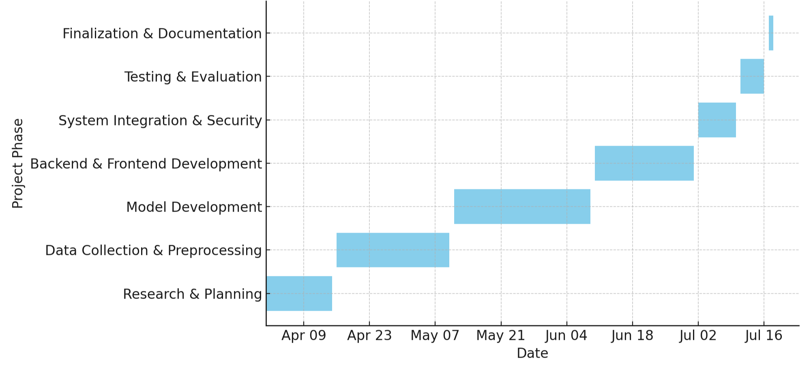
Figure 1: Gantt Chart
Section 3: Project Risk Assessment
The following table outlines the potential risks, their impact on the project, likelihood of occurrence, and proposed mitigating actions:
Risk | Impact | Likelihood | Mitigating action
1. Delayed delivery of hardware components | High | Moderate | Consider multiple suppliers to ensure hardware availability.
2. Insufficient data quality/quantity | High | Likely | Use multiple datasets, augment data, and pre-process rigorously.
3. Model underperformance due to small dataset | High | Likely | Increase dataset size and apply model regularization techniques.
4. Security vulnerabilities | High | Moderate | Implement encryption, secure authentication, and conduct security audits.
5. Difficulty in integrating frontend and backend | Moderate | Likely
  Allocate additional time for integration and ensure clear communication.

References
American Psychological Association (2024) Trends and pathways to access mental health care. Monitor on Psychology, 55(1). Available at: https://www.apa.ordg/monitor/2024/01/trendspathways-access-mental-health-care (Accessed: 7 April 2025).
Anita (2024) ‘Mental Health Support in Schools: Addressing the Growing Needs of Students’, 3, pp.29-33.
Centers for Disease Control and Prevention (2024) Mental Health: Poor Mental Health Impacts Adolescent Well-being. Available at: https://www.cdc.gov/healthyouth/mentalhealth/index.htm (Accessed: 7 April 2025).
Choudhry, F.R., Mani, V., Ming, L.C. and Khan, T.M. (2016) ‘Beliefs and perception about mental health issues: a meta-synthesis’, Neuropsychiatric Disease and Treatment, pp. 2807- 2818.
Djalo Djalo, M.C. (2023) KAI: An AI-powered Chatbot to Support Therapy. Bachelor’s thesis. Universitat Politecnica de Catalunya.
Felman, A. and Tee-Melegrito, R.A. (2024) What is mental health? Available at: https://www.medicalnewstoday.com/articles/154543 (Accessed: 3 April 2025).
Kopelovich, S.L., Monroe-DeVita, M., Buck, B.E., Brenner,C., Moser,L., Jarskog, L.F., Harker, S. and Chwastiak, L.A. (2021) ‘Community mental health care delivery during the COVID-19 pandemic : pratical strategies for improving care for people with serious mental illness’, Community Mental Health Journal, 57, pp. 405-415.
Lakho, S., Farooqi, S.A., Zafar, F. and Siraj, S. (2024) ‘Developing AI-powered chatbots for mental health support’, Spectrum of Engineering Sciences, 2(3), pp. 179-199.
Manoharan , G., Pant, L.M., Tewari, R., Vichare, S., Sarkar, P. and Dhanraj, J.A. (2024) ‘AI-powered chatbots for mental health support’, In 2024 7th International Conference on Contemporary Computing and Informatics (IC31), pp. 436-440. IEEE.
Wainberg, M.L., Scorza, P., Shultz, J. M., Helpman, L., Mootz, J.J., K. A., Neira, Y., Bradford, J.E., Oquendo,M.A., & Arbuckle, M. R. 2017 ‘Challenges and Opportunities in Global Mental Health: a research -to-pratice perspective’, Current Psychaitry Reports, 19(5), p.28.
World Health Organization (2004) Promoting mental health: concepts, emerging evidence, pratice (Summary Report). Geneva: World Health Organization.
Zhang, Z., Zhu, J., Guo, Z., Zhang, Y., Li, Z. and Hu, B. (2024) ‘Natural language processing for Depression predicition on Sina Weibo: Method study and analysis’, JMIR Mental Health, 11, e58259.
https://doi.org/10.2196/58259
https://doi.org/10.1007/s11920-017-0780-z

