Research Work on the spread pattern of

Phytophthora Ramorum in South Wales

Abstract

GIS is the global information system, which can be widely used in environmental conservation. Phytophthora Ramorum seriously infected the larch and resulted in great loss. With the utilization of GIS and databases, this article aims to find some the spread pattern of Phytophthora Ramorum from different aspect including transportation, rivers and terrain. I download different GIS maps and combine them with available data in order to make spread patterns more visual. It can be concluded that different elements may have fairly distinguished effect on the spread of Phytophthora Ramorum.Based on reorganized maps and precedent study results and put forward some suggestion to prevent the spread of Phytophthora Ramorum.

Key words: GIS, Phytophthora Ramorum, Spread pattern

Content

1 Introduction 1
1.1 Overview of GIS 1
1.2 Historical Development 1
1.3 GIS in Environmental Conservation 1
1.4. Research Purpose 2
2 Previous Studies 2
2.1 Threat of Phytophthora Ramorum 2
2.2 Infected Sites in UK 3
2.3 Core Disease Boundaries in Wales 4
3 Methodology 5
3.1 Studies Scope 5
3.2 Databases 5
3.3 Backdrop Maps 6
4 Analysis and Results 6
4.1 Set Study Scope in Map 6
4.2 Creating Points and SQL Select 7
4.3 Building Thematic Maps 11
4.4 Building Road Link Backdrop Maps 14
4.5 Building Water Flow Backdrop Maps 19
4.6 Building Terrain Backdrop Maps 21
4.7 Difference Between FCW and Private Trees 24
5 Conclusions and Suggestions 30
6 Reference 31

1 Introduction

1.1 Overview of GIS
GIS is the global information system. GIS is the information system designed to analyze geographic datas. GIS applications are software tools. It allows users to create and analyze spatial information. It is also convenient for users to present the results of all these projection.

1.2 Historical Development
The first term of GIS appeared in Roger Tomlinson’s paper , who was recognized as the inventor of GIS. In early 20th century conception of layers appeared in GIS. Importantly, layers are the basic principle of GIS. In 1969, the consulting firm applied GIS to establish land use plan and managers of natural resource. Now we can use GIS to solve real-world problem by utilizing large amount of data from database. GIS can be used in many area including education, health insurance, public safety, manufacture nature resource, demography, environmental research and etc.

1.3 GIS in Environmental Conservation

1.3.1 Exploit Nature Resource
Researchers can use GIS to exploit nature resource efficiently. researchers can utilize GIS the optimize the relationship between population and nature resource and make better decisions. For example, GIS can Integrate remote-sensing and real-time data to maximize yield of corps in forestry. With these data, contractors would do little damage to forest and optimum business profit under sustainable conditions. Many types of renewable energy including solar power, tidal power and wind power are relied on geographical conditions.

1.3.2 Environmental Conservation
GIS can be a great aid to ecological restoration and protect them faster and effectively. GIS can also be used to explore mining and help remediation. When faced with ecological crisis, we can use GIS data and sophisticated analysis to understand and better protect biodiversity environment. GIS can also be used in intelligent water management. GIS can also be used to prevent the spread of pathogen in forestry. Before major constructions, contractors can also conduct environmental assessment and make preparations ahead.

1.4. Research Purpose
By utilizing GIS, I decide to research the spread of Phytophthora Ramorum in some areas. My target is to find out some elements that may affect the spread of Phytophthora Ramorum, and put forward my advice to prevent it.

2. Previous Studies

2.1 Threat of Phytophthora Ramorum
Phytophthora ramorum is an algae-like organism called a water mould. It causes extensive damage and death to more than 150 plant species, especially larch tress and European sweet chestnuts in UK. Before the discovery of the disease on larch in 2009, forests of larch occupied about 154,000 hectares, or 5 per cent of Great Britain's total woodland area. Wales government has published Phytophthora Ramorum strategy for wales.

2.2 Infected Sites in UK
Ramorum disease has been found most in Wales, but it is more often reported in western regions of Wales.
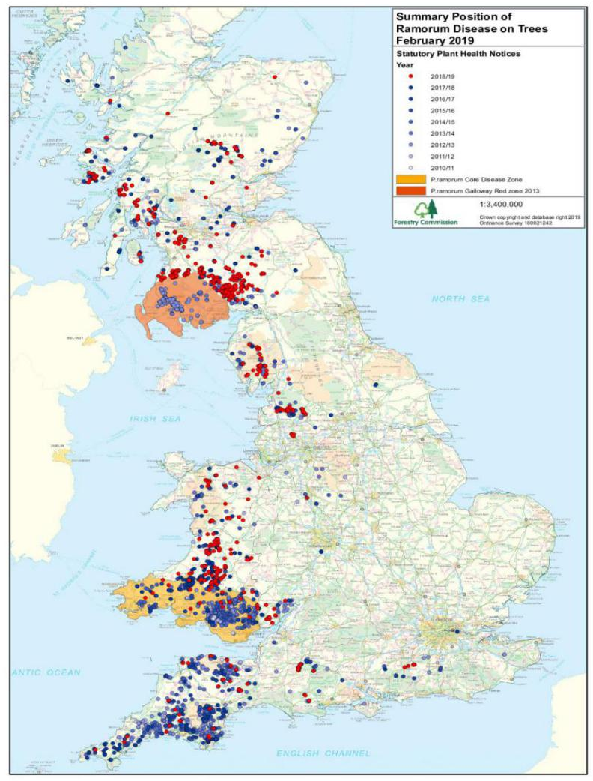
Figure 2.1 Summary Position of Ramorum Disease on February 2019

From Figure 2.1, we can see the west region is seriously affected especially wales. In wales, according to the observed date, Ramorum disease may derive from the southeast region and with time going by, it spread towards north region. In Scotland, resource of disease is south region and gradually affect the north regions. In England disease came from southwest but barely spread towards other region compared with the disease in wales.

2.3 Core Disease Boundaries in Wales
In wales, there is still a large amount of known larch in the North-West and East of the country. According to the Phytophthora Ramorum strategy for wales, The extent of the boundaries of the core disease zones is based on several factors: Level of infection in the area, the local climate model and resource management, Potential impacts of disease management on the environment and communities. Wales will now be split into 3 different disease zones, CDZ1, CDZ2 and DLZ. Different zone is faced with different infected situation and has different aims. Now the CDZ1 and CDZ2 aim to slow the rate of infection into the DLZ.

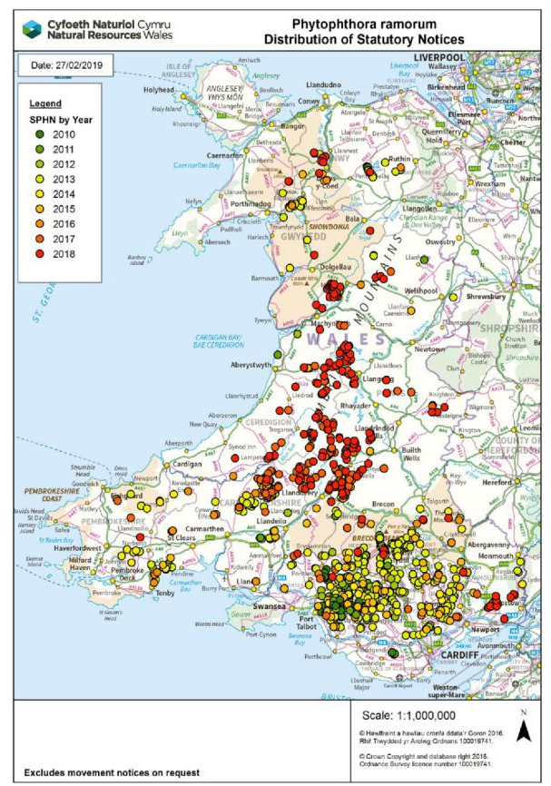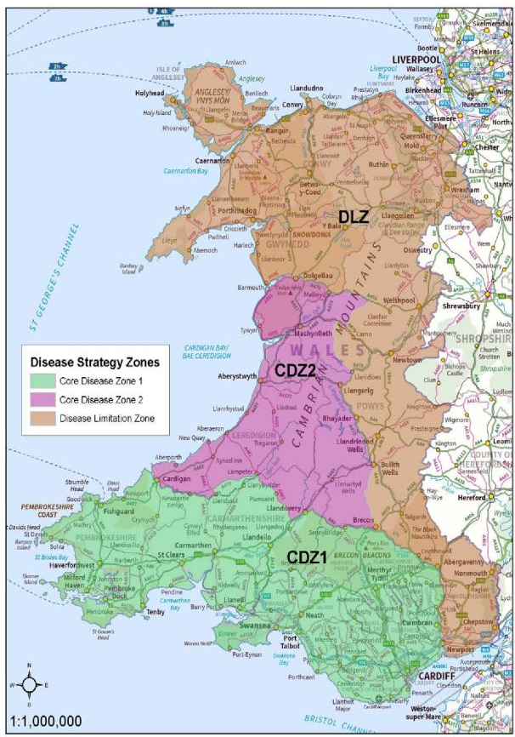
a b
Figure 2.2 The Distribution of Phytophthora Ramorum (a) and Phytophthora Ramorum Management Zone (b)

3Methodology

3.1 Studies scope
CDZ1 contains Swansea. CDZ1 has a high rate of contagious larch tress and an extensive proportion area of woodland situated at high risk area according to the Cambridge climatic risk model. So I decided to choose CDZ1 as my studies scope.

3.2 Database
In the process of my study, I mainly used two databases, Digmap and UK data service. Digimap offers large amount of data collections. It can provide Ordnance Survey, historical, geological, marine, environmental, aerial society lidar and global maps. UK data service has the largest collections of social, economic and population data in UK. In addition, an excel data about infected year of Phytophthora Ramorum was provided by my teacher.

3.3 Backdrop Maps
I choose several backdrop maps including Wales region maps, terrain maps, road link maps and rivers maps.

4 Analysis and Results

4.1 Set Study scope in Map
Firstly, I opened the wales- msoa region map download by UK data service and aerial map as the initial backdrop map.
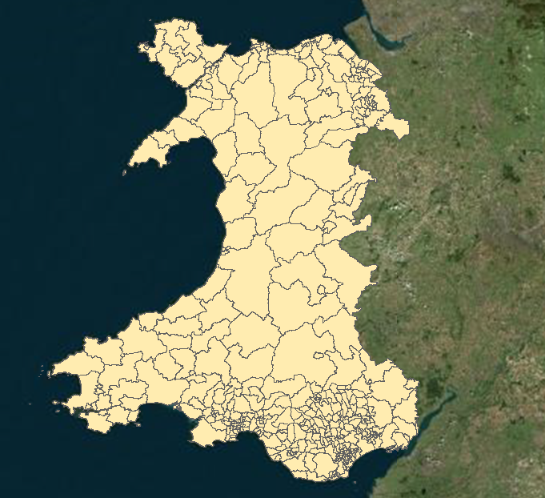
Figure 4.1 Wales Region

Secondly, I selected the zone CDZ1 in the wales map and build a new table ‘zone CDZ1’ as my study scope. In order to make my map more clear I remained the boundary of wales and added a label for it.
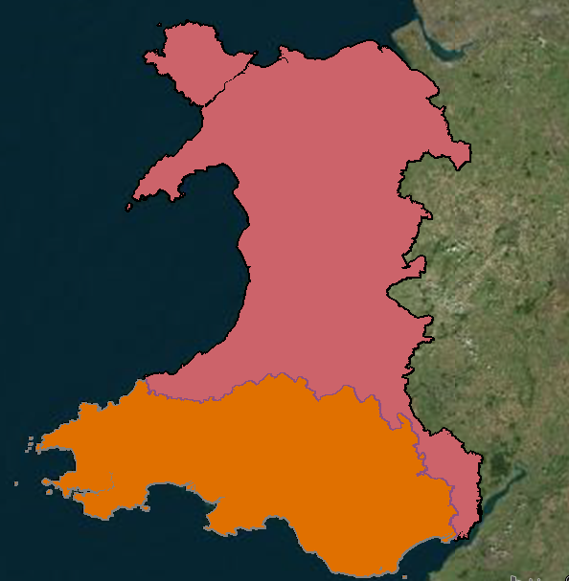
Other Area

CDZ1
(Study Scope)

Figure 4.2 Study Scope Map

4.2 Creating Points and SQL Select
I imported the ‘infected year data 2019’ excel data into GIS by choosing the file of types to Microsoft excel (xls; xlsx).

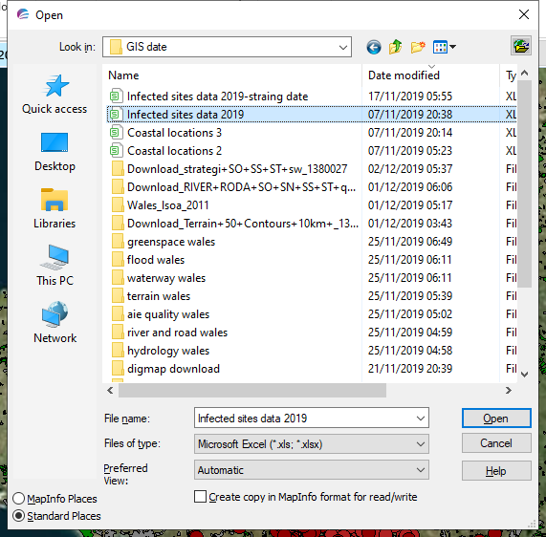
Figure 4.3 Import Infected Year data

Browsing the table of ‘infected year 2019’. then I created all infected points in my map using the projection of British OSGRS80 Grid and changed the style of points. I got the x, y coordination respectively from x, y coordinate column. Then I can get all points in my maps.

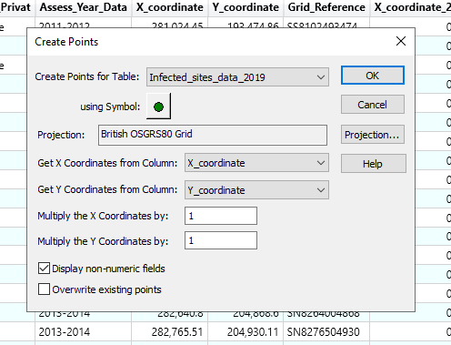
Figure 4.4 Creating Points for Infected Year

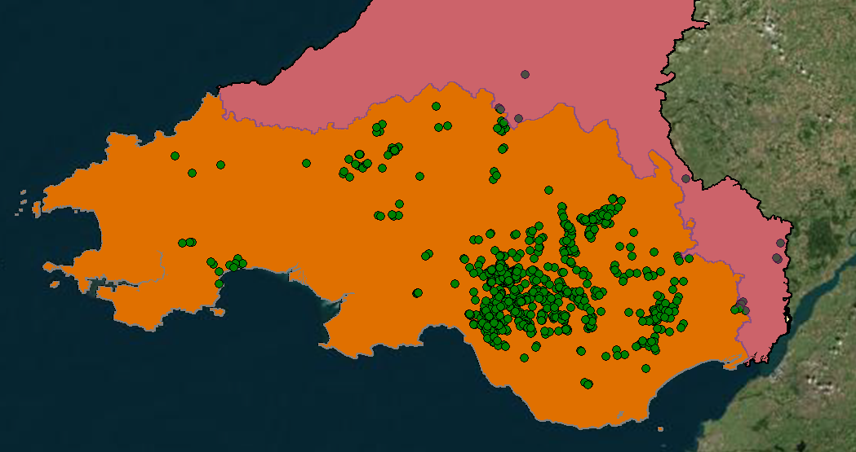
Figure 4.5 All Infected Year Points in CDZ1

In all these points I needed to select the infected sites planted by FCW or Private. I used the SQL selection and choose table as infected year 2019 and FCW-Private as FCW. Then I can get the table only containing FCW.
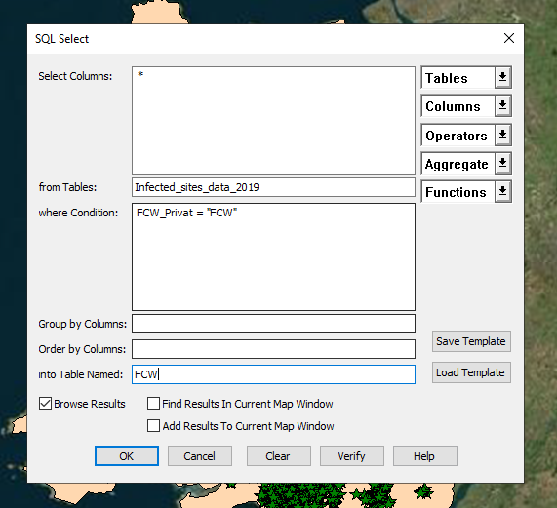
Figure 4.6 Selecting Points for All Infected Year

At the same way, I created points for the FCW table then I can get points of FCW. Then I also selected points for Private and created points for it.

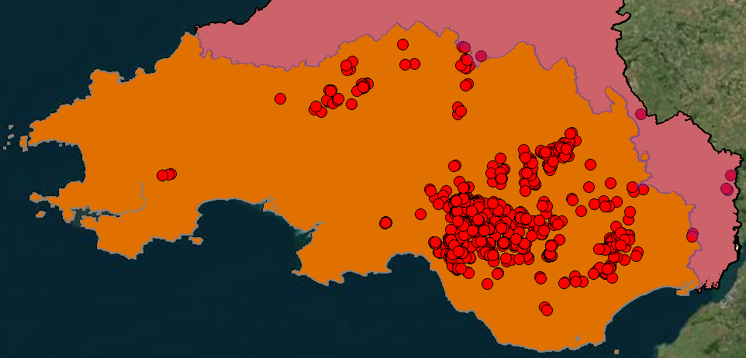
Figure 4.7 FCW Points in CDZ1

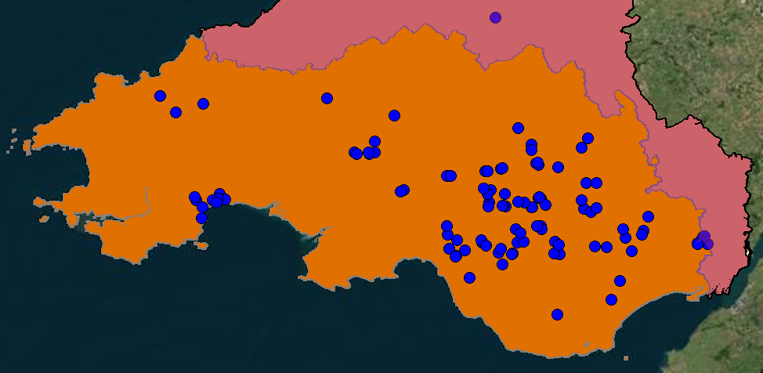
Figure 4.8 Private Points in CDZ1

In CDZ1, according to the Figure 4.4, Figure4.6 and Figure4,7, I concluded that all infected points in my map are coordinate with previous studies I found, The private point is much less then FCW points but these two types has similar distribution patterns. The south region of CDZ1 is the most seriously affected region.

4.3 Building Thematic Maps
Thematic maps can sort of data under specific conditions and make it concisely visual.

Firstly I built Thematic Maps for all infected year by assess year. I choose to add theme and choose ranges. Then I set the ranges and styles for all infected years.

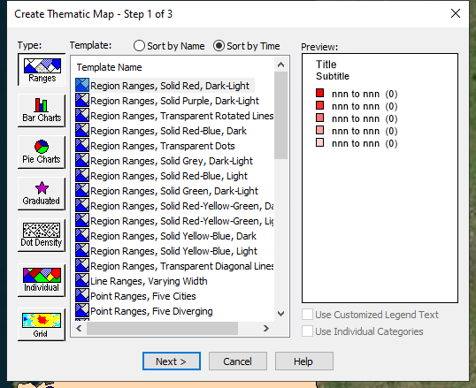
Figure 4.9 Creating Thematic Maps

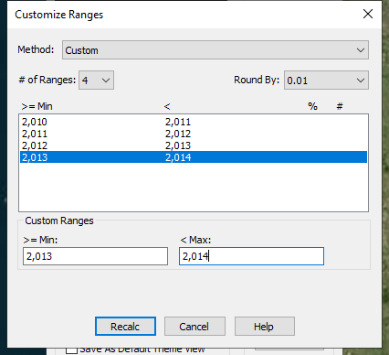
Figure 4.10 Customizing Rang

Then I can get the thematic maps for all infected year and set legend for them.
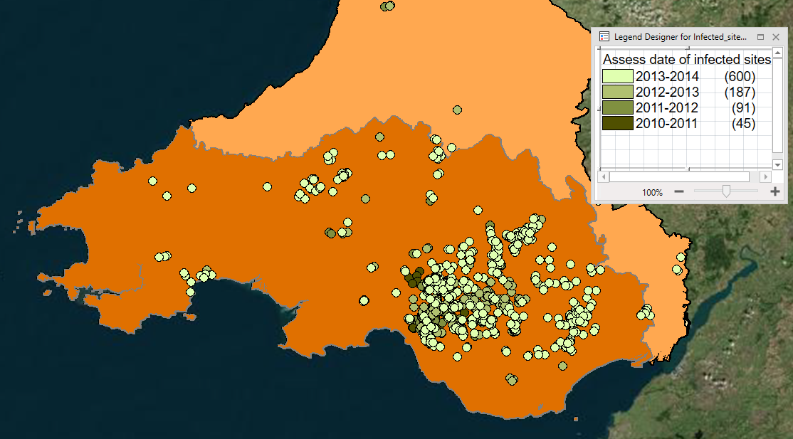
Figure 4.11 Thematic Map of All Infected Sites

I concluded from the Figure 4.11, the resource of pathogen is the middle of CDZ1. From the 2010-2014, the pathogen mainly spread towards but barely spread into west maybe because of some barriers. But in the west of CDZ1 disease also occurs.

At the same way, I also added the thematic maps for table of ‘ FCW ’ and ‘ Private’ by infected years.

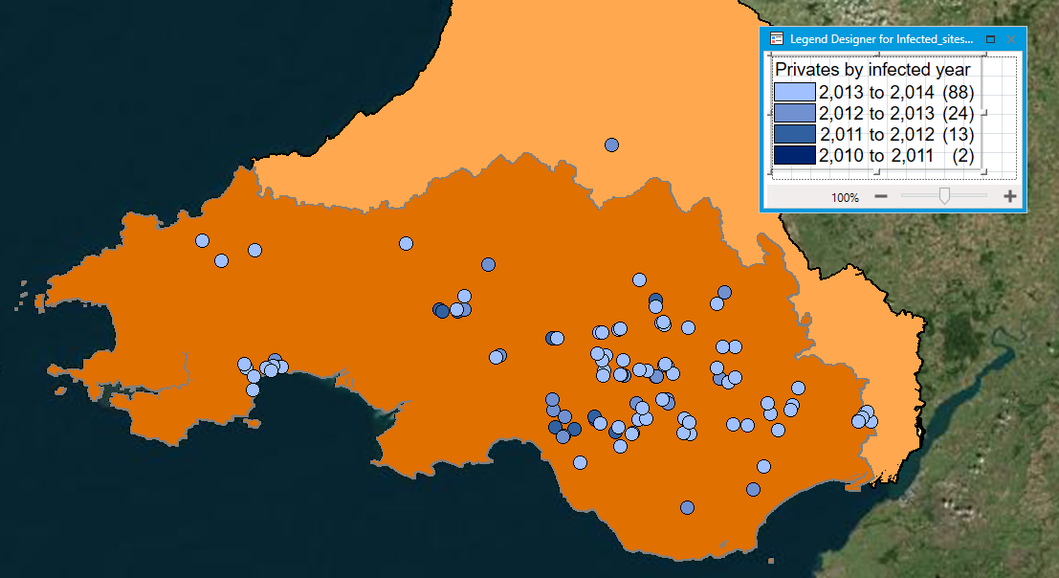
Figure 4.12 Thematic Map of All Private Map

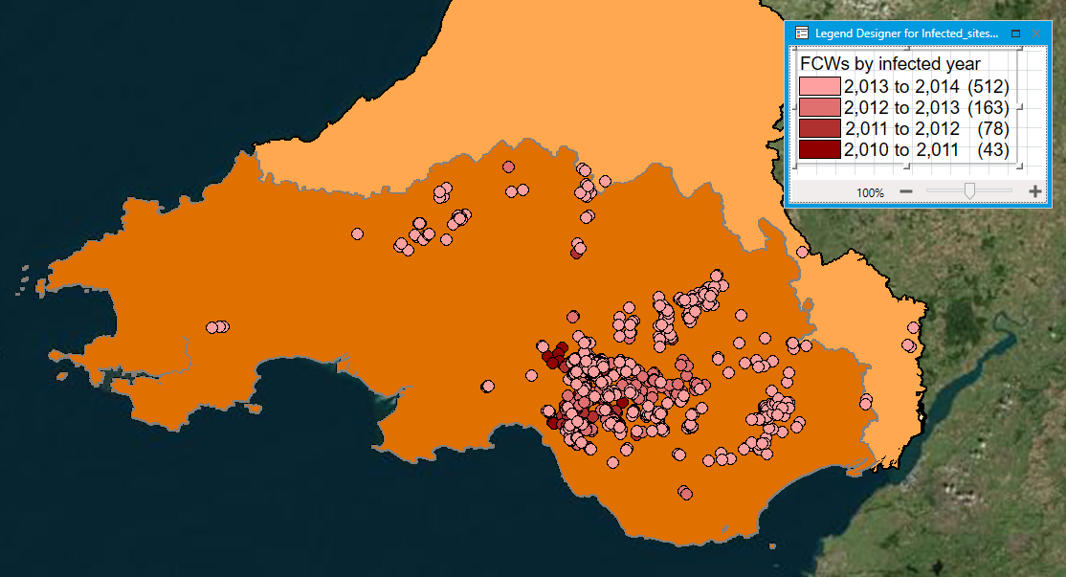
Figure 4.13 Thematic Map of FCW Sites
From the Figure 4.12 and Figure 4.13, transportation patterns of disease in FCW or Private trees are similar. The resource of pathogen is the middle of CDZ1. From the 2010-2014, the pathogen mainly spread towards but barely spread into west maybe because of some barrierss. There is no evident difference between FCW sites and private trees.

4.4 Building Road Link Backdrop Maps
Firstly, I downloaded the road link maps from digimap, which can describe whole roads in my study scope.

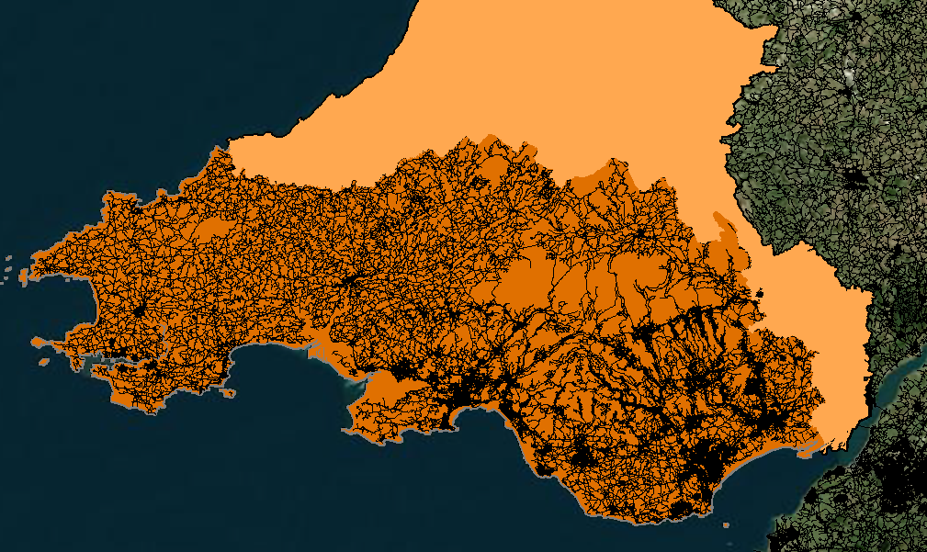
Figure 4.14 All Road in CDZ1

Too much data makes it ambiguous for users. I selected the all A roads and B roads through SQL selection and append all of them. Next I established two new tables ‘all A roads’ and ‘all B roads’ and made them appear in the map. Then I added other elements including urban area wood land and national park into the map to help me analyze.

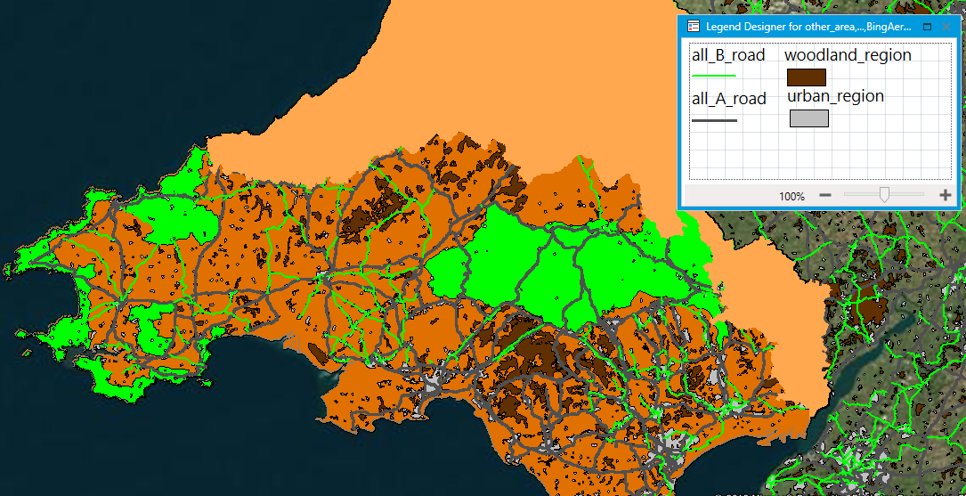
Figure 4.15 All A Road and All B Road in CDZ1

Then I zoomed in the southeast of the CDZ1 and added the thematic map of all infected year into map.

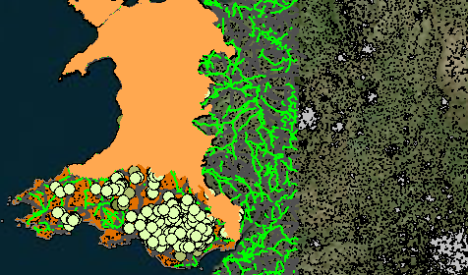
Figure 4.16 East Area of the CDZ1

From the Figure 4.19, the resource came from the woodland area. The earliest sites happened in the woodland in 2010. Phytophthora Ramorum spread alongside the A road. Phytophthora Ramorum also spread along the A road. So transportation may have an important effect on its spread. In the southeast of CDZ, traffic network is more denser than that in west area, which will facilitate the spread of disease. Disease can spread along the A roads and also concentrate at nearby woodlands. At the other side, disease are not tend to concentrate at urban areas. In my perspective, Phytophthora Ramorum can spread on foot, pet' paws, tools, vehicle wheels and etc, including bicycles and mountain-bike wheels. Transportation in the roads carrying the Phytophthora Ramorum or the movement of infected trees can spread disease for a long distance, which will expand the range of infected area and worse the situation.

So one way to cope with the problem can be focus on the transportation. It should be prohibited to delivery the infected tress and the movement of suspected trees should go through a secure examination ahead. The inspection scope includes domestic transportation as well as foreign. In addition, it is also important to check the trees whether it is infected along side A road. Larch species are the most commonly affected trees for Phytophthora Ramorum. In the future study, more other kinds of infected species maybe be found in laboratory. It is supposed to reduce the plantation of these infected species and intense the scrutiny toward these species. There is no cure for Phytophthora Ramorum until now, so infected species should be killed immediately to prevent its wider spread. From the role of public, drivers could wash the wheel of cars or bicycles before leaving sites. Cars and bicycle driven from the mountain areas should be examined and washed.

Figure 4.17 West Area of CDZ

In the west of CDZ1, the situation of Phytophthora Ramorum is much better than that of the southeast of CDZ1. The first reason could be the scarcity of woodlands compared with the southwest of CDZ1. The infected sites generally occur later than the trees in southwest of CDZ1 did. The most seriously infected areas are still the woodland areas. Secondly, According to the road standards in UK, A roads provide large-scale transport links within or between areas. Generally, A roads will be the most significant ways to travel through areas. A roads can also be used as motorways. B roads connect different areas and to feed traffic between A roads. B roads are less important than A roads. In terms of the road links between southwest areas and west areas, A roads have a less proportion in the west area of CDZ1. Traffic condition in the west area of CDZ1 is lighter. What’ more, the traffic conditions between southwest area and west area is less convenient, which may suppress the spread of disease between these two areas.

4.5 Building Water Flow Backdrop Maps
According to reports, ramorum spores can spread over several miles by mists, air currents and rain splash and etc.

Firstly, I download the water map from digimap, which can describe the whole rivers in my study scope. Too much data makes it difficult to understand its pattern. I classified the rivers into major rivers, minor rivers and canals. I also added such elements including national park, woodland, foreshore, woodland and lake to help me analyze.
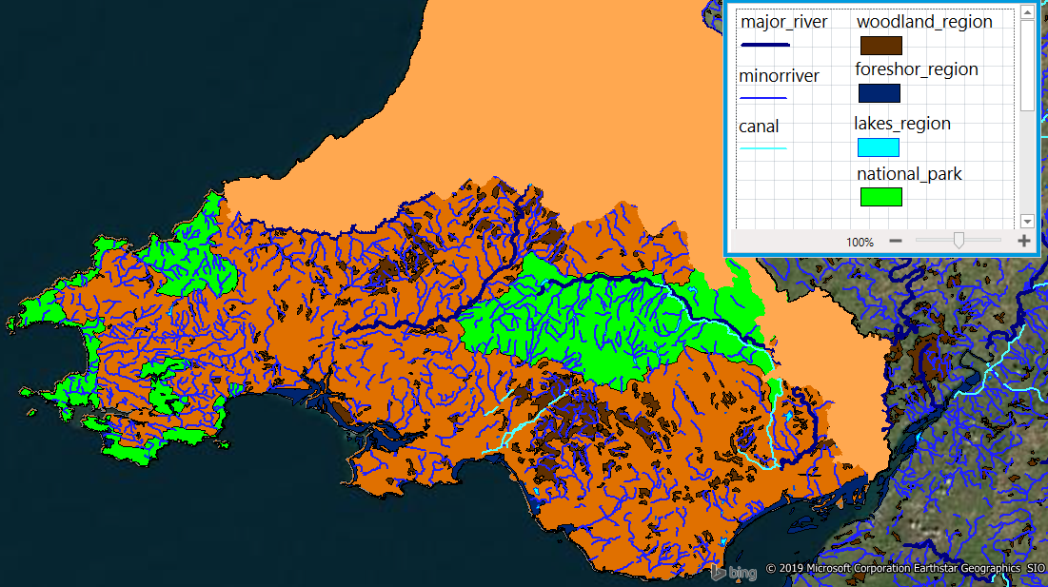
Figure 4.18 rivers in Study Scope

Then I added all infected sites into the maps, and zoomed in the southwest of study scope.

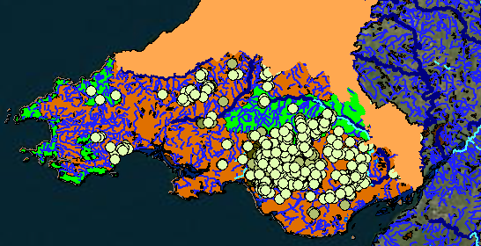
Figure 4.19 East Area in Study Scope

From the Figure 4.19, infected sites concentrated at woodlands. Infected sites do not seem to spread alongside the minor rivers or canals. Minor rivers and canals do not have an evident effect on the spread of Phytophthora Ramorum. Phytophthora Ramorum also do not concentrate in reservoirs and lakes. According to the experiment results, high level of moisture gives aid to the spread of Phytophthora Ramorum but rivers flow do not.

Figure 4.20 West Area of Study Scope
In the west area, infected sites were only concentrating at woodlands. rivers did not improve the expansion of disease. If I focus on FCW and Private maps respectively, same result can be concluded.

4.6 Building Terrain Backdrop Maps
I download the terrain map as my backdrop map. Terrain map is made of contours.
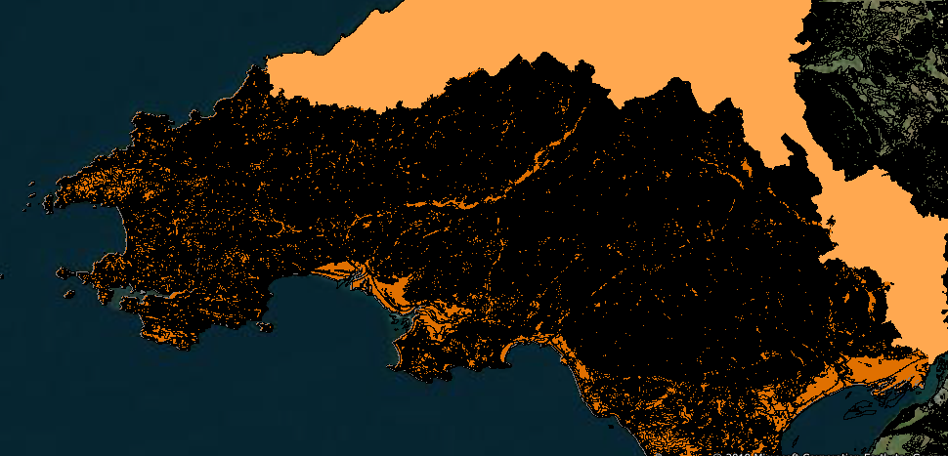
Figure 4.21 Terrain Map in CDZ1
In terrain map, landform is represented by contours. I also zoomed in the west area of CDZ1 and add A roads and B roads into map.

Figure 4.22 West Area of CDZ1
From Figure 4.22, the resource of Phytophthora Ramorum can spread at the same height but barely spread into higher places. Spread routes of Phytophthora Ramorum is alongside ridge. In my perspective, this result firstly affected by the distribution of vulnerable species such as Larch species or European sweet chestnut. It should be investigated that whether these vulnerable species locate at same height or higher mountains. Secondly, high mountains may prevent the spread of disease. High mountains may obstruct wind current. It is studied that disease initially spread from Rhododendron,which is an invasive, non-native species and found in woodlands. The infected Rhododendron can produce large amounts of spores. Wind current can mainly affect the drift of spores. Spores mainly drift with wind and infect other trees. This result may be a support to the spread mechanism of Rhododendron ponticum. So it is important to kill the infected trees to deter its wider spread and examine carefully the other trees at same height. When forecasting the spread of virus, altitude is also an important factor.

Figure 4.23 East Area of CDZ1

4.7 Difference Between FCW and Private Trees
In three kinds of backdrop maps, I analyzed the FCW and Private trees respectively from figure 4.12 and figure 4.13. In same kind of backdrop map, I compared FCW and Private trees in same area.
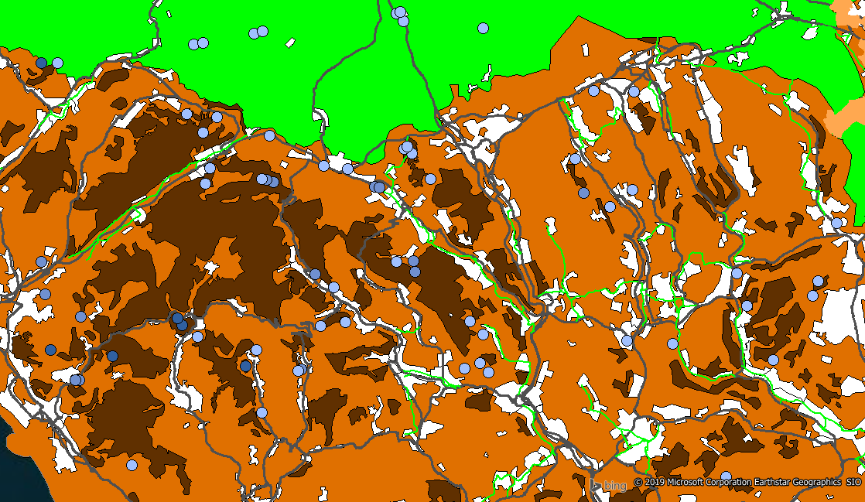

a
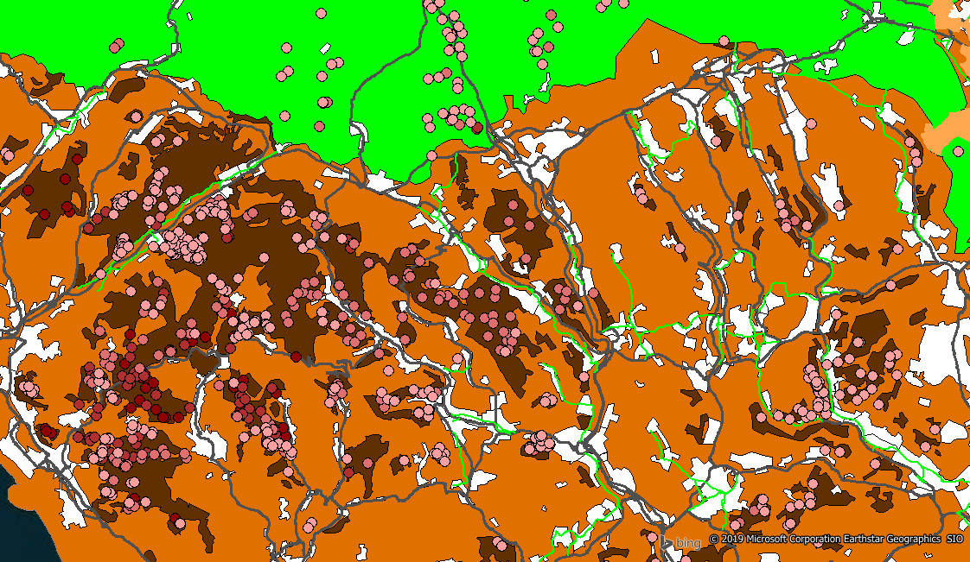

b
Figure 4. 24 East Area of Private Trees (a) and FCW trees (b) in Road Map

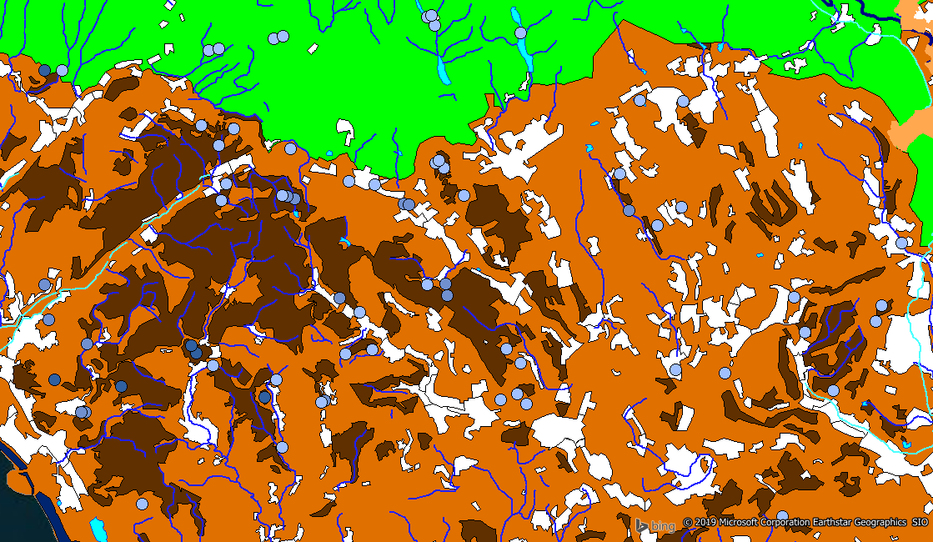

a
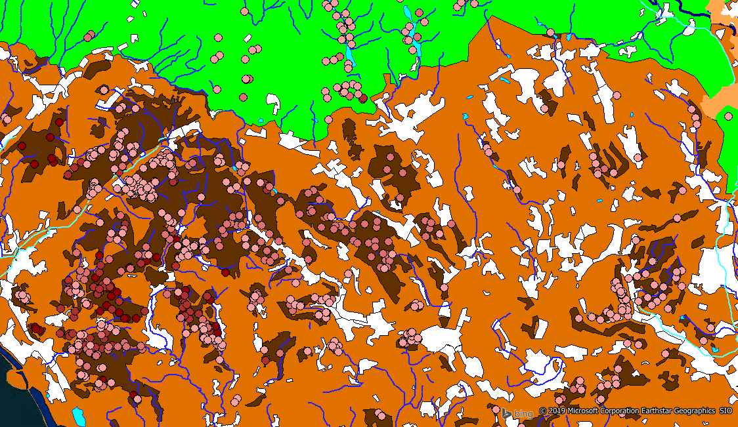

b
Figure 4. 25 East Area of Private Trees (a) and FCW tress (b) in rivers Map

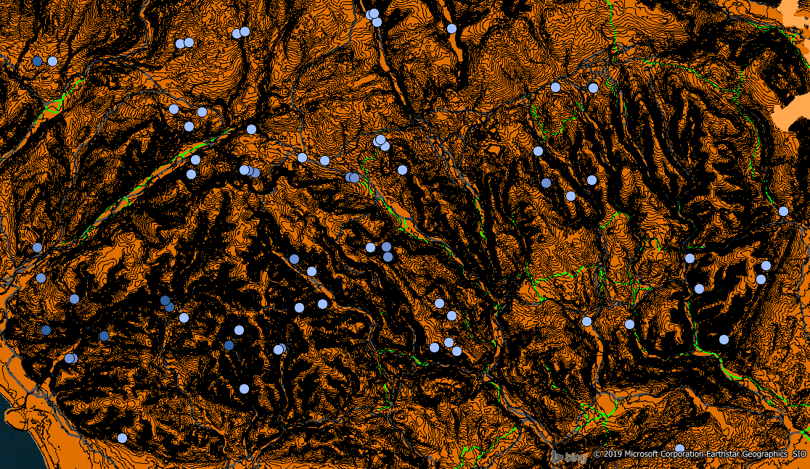

a
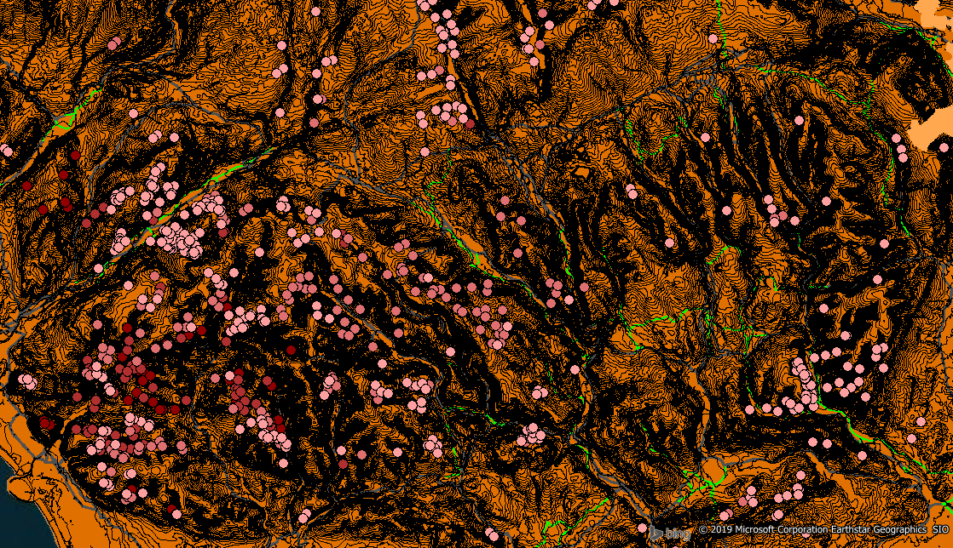

b
Figure 4. 26 East Area of Private Trees (a) and FCW tress (b) in Terrain Map

From Figure 4.24, Figure 4.25 and Figure 4.26, in west area, infected trees from FCW is much more than trees from Private. They have similar resource, which is the middle woodland of CDZ1 area. The spread pattern of Private trees and FCW trees are similar with all infected tress. Infected Private trees are sporadic. FCW is much more than Private and infected FCW trees can spread to Private trees. Because generally speaking, in same place, there are more FCW trees infected earlier. Investigation work should be focused on FCW trees. As for the Private trees, if FCW trees are infected, Private trees will also be finally infected. From the role of public, participating the protection work is meant to protect our trees reversely.
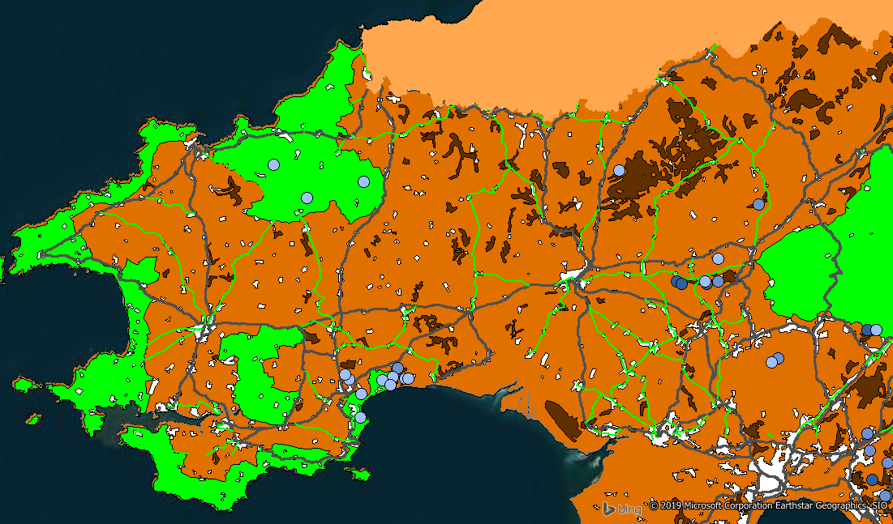a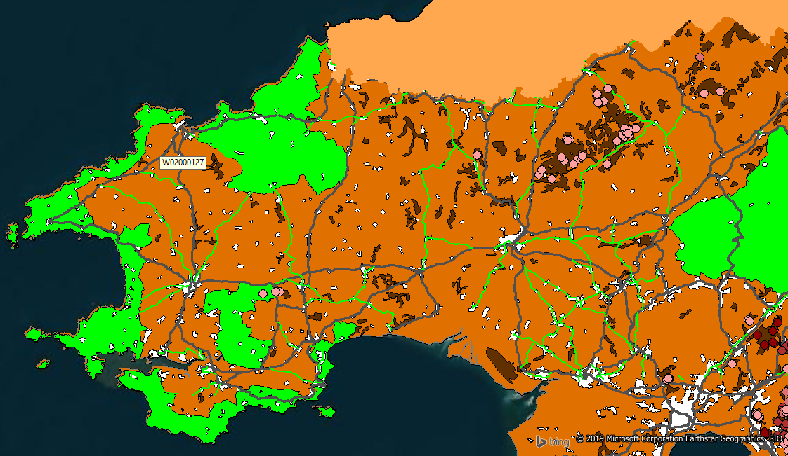

b
Figure 4.27 West Area of Private Trees (a) and FCW tress (b) in Road Map

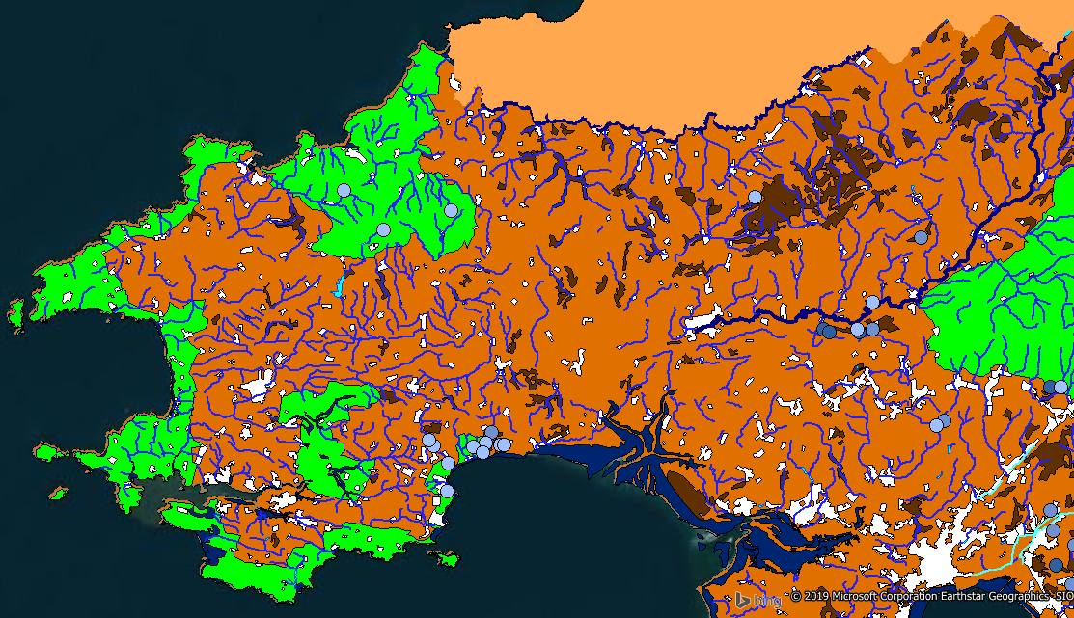

a
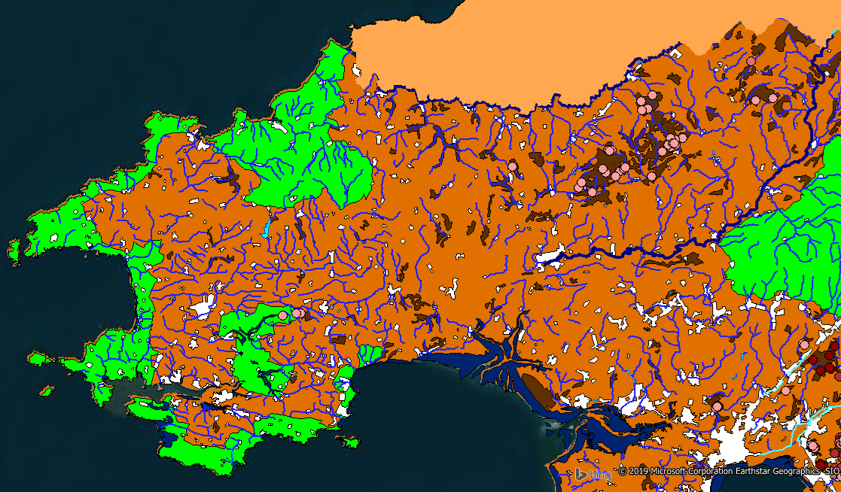

b
Figure 4. 28 West Area of Private Trees (a) and FCW tress (b) in rivers Map
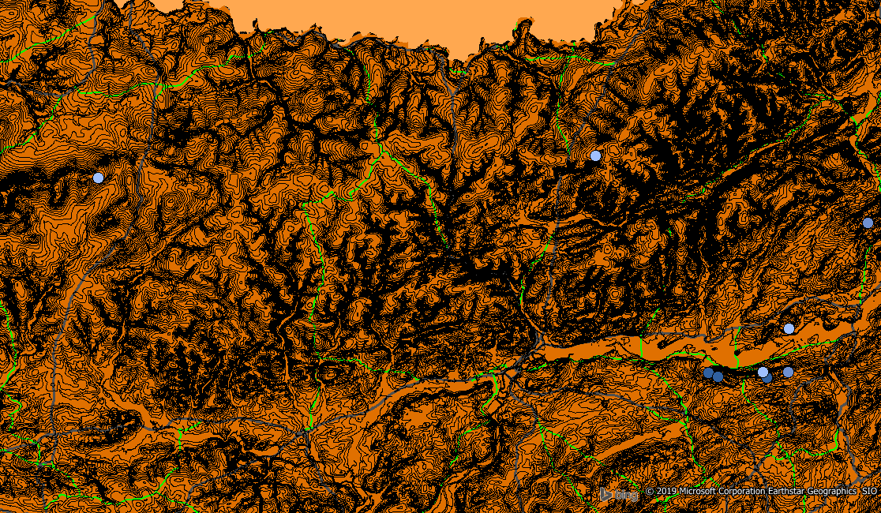

a
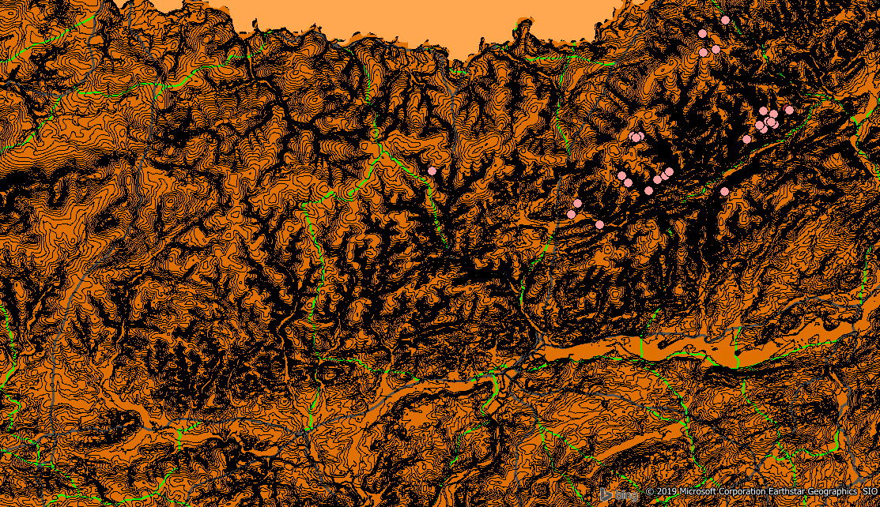

b
Figure 4. 29 West Area of Private Trees (a) and FCW tress (b) in Terrain Map
From figure Figure 4.27, Figure 4.28 and Figure 4.29, infected FCW trees main concentrate at woodland which affected by Phytophthora Ramorum from east area.
Specially, from Figure 4.27 (a) Figure 4.28 (a), in the costal area, and at the end of major rivers ( red circled area), there are some infected Private trees without infected FCW trees nearby. Phytophthora Ramorum is not indigenous to UK, at first it came from other country. It cannot be neglected that that infected tress may be transported from other countries. In this red circled area, virus maybe came from other infected area through shipping without careful examination.

5 Conclusions and Suggestions
Forestry is an important nature resource. Trees are essential to the well being of wales. Trees can lock carbon dioxide and produce oxygen. Trees can slow flood wave and provide place fro biodiversity. In UK, the most commonly-infected by Phytophthora Ramorum is larch, which is a kind of important commercial trees. Spread of Phytophthora Ramorum can be fairly affected by human activities. GIS can be supportive to cope with Phytophthora Ramorum.

In the future, forestry committee should not only focus on formation and identification of Phytophthora Ramorum but also the monitor way of spreading to prevent further expansion. In terms of its complexity and uncertainty, government could encourage public to participate this work. One monitoring point will be on traffic. Transportation carrying virus can spread into a long distance and expand its infected area. At present, west area is less infected compared with east area. Virus spread mainly alongside the A road. Government could intensify examination on A road but also set barrier to suppress the spread of virus towards west area. It is essential to do enough examination especially toward the movement of trees. Helping drivers to recognize Phytophthora Ramorum is also important. Until now, there is not enough evidences that there is relationship rivers on spread of virus. Phytophthora Ramorum mainly spread along the same height possibly because of wind current, which can maybe a support evidences of forecast for Phytophthora Ramorum. In the difference between infected FCW trees and Private trees, it can be concluded that they mainly come from same resource. FCW trees is much more than Private trees.

6 Reference
[1] https://digimap.edina.ac.uk/
[2] https://www.ukdataservice.ac.uk/
[3] Phytophthora Ramorum for wales
[4] Phytophthora ramorum in Sweet Chestnut England Situation Report
[5] Phytophthora Ramorum strategy for wales

