Application Development (Games)
  - Asset Guide
Please note that the assets are for use in your coursework and tutorials and not for redistribution.

All Star Character Collection

Character Weapons
The characters all use the same weapons, you can configure as shown below once we create the scripts in class. Make sure you are selecting the right model element for the game character you are configuring.
Note: you will need to configure the Attack Range for each weapon (not shown).
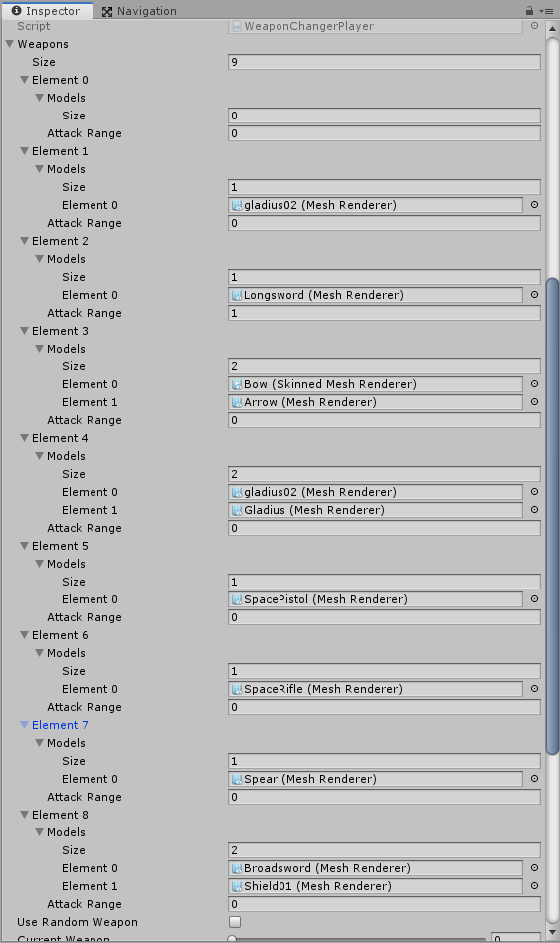

Amazing Amazons Asset

A03
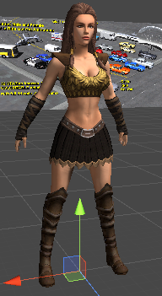

A06
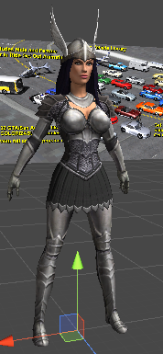

Barbaric Brutes

B01
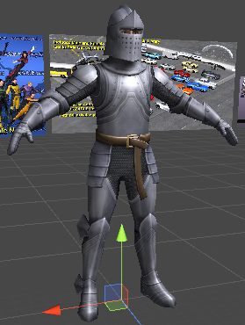

B03
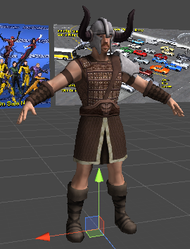

Civilian Chicks

C02
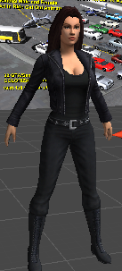

C03
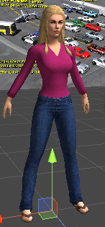

Debonair Dudes

D03
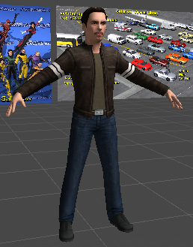

Future Forces

F04
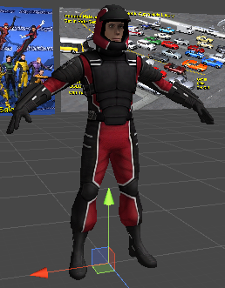

F06
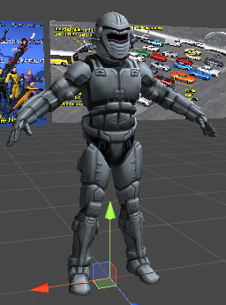

Galactic Girls

G02
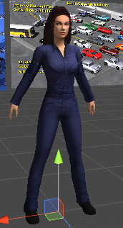

G06
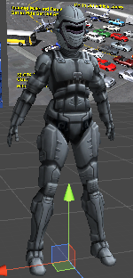

Fantasy Make Civilians

Guard01
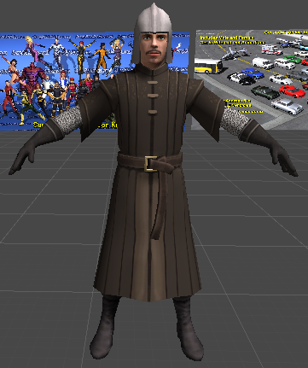

King
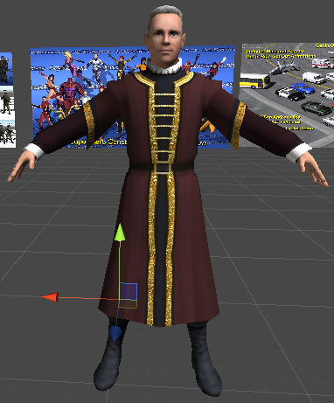

Monk
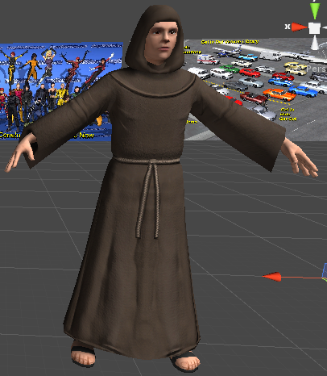

Noble01
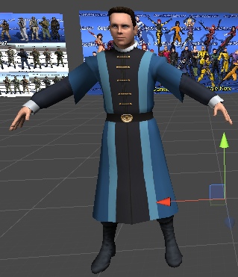

Trader01


