Programme: BSc Applied Computing Module: Business and Web Management Module code: ACCA5019
LECTURER: SUNETH WARNAKULASOORIYA Assignment Title: Component 1 – Website Redesign for Online Business Presence
Submission deadline: 27th March 2026 14:00 (2PM)
University of Wales Trinity Saint David, London Campus
STEFANIA MIOARA IONESCU, STUDENT ID: 2336875

I.INTRODUCTION …………………………………………2
II.Task 1 – UI/UX web Design Phases………………..2
    - Mood Board Creation
    - Wireframe Design
    - Interactive Prototype
III.Task 2 – Report…………………………………………6
    - MealSwift Website Redesign
    - Responsive Design Implementation
    - Implementation Section
    - Canva
IV.CONCLUSION ……………………………….….…..30
V.REFERENCE ……………………………………….….33

I.INTRODUCTION
MealSwift is a rapidly growing food delivery service that connects users with local restaurants. Despite its success, the current website suffers from usability and design issues that negatively impact user experience and reduce order conversions. This project aims to redesign the MealSwift interface using UI/UX principles to improve usability, accessibility, and customer satisfaction.

Analysis of Current System
The existing MealSwift platform has several weaknesses. Navigation is confusing, making it difficult for users to find restaurants quickly. The visual design is outdated, which reduces user trust. Additionally, the website is not responsive, creating issues for mobile users.

The checkout process is inefficient, increasing cart abandonment rates. There is also a lack of personalization, meaning users are not shown relevant restaurant recommendations. Furthermore, accessibility issues prevent some users from interacting effectively with the platform.

Target Audience
The target audience includes students, working professionals, and families. Each group has different needs, such as speed, reliability, and variety. Creating user personas helped guide the design process by ensuring that the platform meets the needs of these different user groups.

Design Requirements
The redesign must:
- Improve navigation
- Be fully responsive
- Include personalization
- Provide real-time tracking
- Enhance accessibility
- Streamline checkout

These requirements ensure that the system meets both user and business goals.

Mood Board and Visual Direction
The visual design focuses on a modern and clean aesthetic. Warm colours such as orange are used to stimulate appetite, while a white background ensures readability. High-quality images improve engagement, and simple typography enhances accessibility.

Wireframes
Wireframes were created to establish the structure of the website. These low-fidelity designs focus on layout and functionality rather than appearance. Key pages include the homepage, restaurant listings, menu pages, checkout, and order tracking.

Final UI Design
The final design includes a visually appealing interface with intuitive navigation. A prominent search bar allows users to quickly find food. Restaurant pages display ratings, reviews, and images. The checkout process is simplified into a single page, reducing friction.

UX Justification
The redesign applies user-centered design principles. Simplified navigation reduces cognitive load, while responsive design ensures accessibility across devices. Personalization improves engagement, and real-time tracking enhances trust.

Accessibility Considerations
Accessibility improvements include high colour contrast, readable fonts, and keyboard navigation. These changes ensure compliance with accessibility standards and make the platform usable for a wider audience.

Prototype
An interactive prototype was developed using Figma. It demonstrates the user journey from browsing restaurants to completing an order. This allows for usability testing and validation of design decisions.

III.Task 2 – Report
I.Implementation of the MealSwift Redesign
The MealSwift website redesign was implemented using a user-centred design approach, focusing on improving usability, accessibility, and responsiveness. The design process was carried out using Figma, which allowed for the creation of wireframes, high-fidelity designs, and an interactive prototype.

II.Responsive Design Implementation
A responsive design approach was adopted to ensure that the MealSwift platform functions effectively across multiple devices, including desktops, tablets, and smartphones.
The layout was designed using a mobile-first approach, where the interface is initially designed for smaller screens and then scaled up for larger devices. This ensures optimal usability for mobile users, who represent the majority of food delivery customers.

Key responsive features include:
- Flexible grid layouts that adjust to screen size
- Scalable images and text for readability
- Collapsible navigation menus for smaller screens
- Touch-friendly buttons and interactive elements

For example, on mobile devices, the navigation bar is simplified into a hamburger menu, while on desktop screens, a full navigation bar is displayed. This ensures both usability and efficiency across devices.

III.Implementation section
Homepage Implementation
The homepage was designed to prioritise ease of use and quick access to key features. A prominent search bar is placed at the top of the interface, allowing users to quickly find food or restaurants.
Below the search bar, categories such as “Pizza,” “Chinese,” and “Indian” are displayed to help users browse efficiently. A personalised “Recommended for You” section was also implemented to enhance user engagement.
High-quality images and clear call-to-action buttons, such as “Order Now,” were used to encourage user interaction.

Restaurant and Menu Page Implementation
The restaurant listing page includes filtering options such as price, rating, and delivery time. This allows users to refine their search and find suitable options quickly.

Each restaurant page provides detailed information, including:
- Ratings and reviews
- Menu items with descriptions
- High-quality images
- Pricing information
This improves transparency and helps users make informed decisions.

Checkout Process Implementation
The checkout process was redesigned to reduce friction and improve efficiency. A single-page checkout system was implemented, allowing users to review their order, enter delivery details, and complete payment in one place.
A progress indicator was also added to provide users with feedback during the checkout process, improving usability and reducing uncertainty.

Real-Time Order Tracking
A real-time order tracking feature was included to improve transparency and user trust. Users can view the status of their order through stages such as “Preparing,” “Out for Delivery,” and “Delivered.”
This feature aligns with modern user expectations and enhances overall satisfaction.

Accessibility Implementation
Accessibility was a key consideration in the redesign. The following features were implemented:
- High colour contrast for readability
- Clear and legible typography
- Large, touch-friendly buttons
- Logical navigation structure
These improvements ensure that the platform is usable by a wide range of users, including those with visual or motor impairments.
IV.Canva
STEP 1: Set Up Frames
Create 3 screen sizes:
- Mobile: 375 x 812
- Tablet: 768 x 1024
- Desktop: 1440 x 1024
STEP 2: Create a GRID SYSTEM
In Canva:
Desktop → 12-column grid
Tablet → 8 columns
Mobile → 4 columns

STEP 3: DESIGN HOMEPAGE
Mobile layout:
- Logo
- Search bar (big + centered)
- Category scroll (horizontal)
- Restaurant cards (stacked)

STEP 4: MAKE IT RESPONSIVE
Duplicate mobile design → adjust for:
Tablet:
- 2 columns of restaurants
Desktop:
- 3–4 columns grid
- Full navigation bar at top

STEP 5: CREATE COMPONENTS
- Make reusable components:
- Buttons
- Cards
- Navigation bar

STEP 6: ADD PROTOTYPE LINKS
In Canva:
- Click “Prototype”
- Link:
- Homepage → Restaurant page
- Restaurant → Checkout

STEP 7: SHOW RESPONSIVENESS (IMPORTANT)
- Elements resize properly
- Text scales
- Layout adapts

Canva Layout
[Logo] [Profile Icon]
[Search Bar: "What do you want to eat?"]
[Categories → horizontal scroll]
(Pizza | Burgers | Chinese | Indian)
[Recommended for You]
[Card]
- Image
- Name
- Rating
- Delivery time
[Top Rated Near You]
[More Cards]

Design Rules:
- Padding: 16px
- Button radius: 12px
- Font:
Heading: 18–22px
Body: 14–16px
DESKTOP HOMEPAGE
[Logo] [Search Bar CENTER] [Login/Profile]
[Categories Row]
[Recommended Section → 3–4 column grid]
[Top Rated → grid layout]

RESTAURANT PAGE
[Restaurant Image Banner]
[Name + Rating + Delivery time]
[Menu Tabs]
(Starters | Mains | Drinks)
[Menu Item Card]
- Image
- Name
- Description
- Price
- [+ Add Button]

CHECKOUT PAGE
[Order Summary]
[Delivery Address]
[Payment Method]
[Place Order Button]

TRACKING PAGE
[Progress Bar]
Preparing → On the way → Delivered
[Map]
[ETA Time]

Frame Setup:
- Width: 375px
- Height: 812px
- Layout grid: 4 columns
- Margin: 16px
- Gutter: 8px

TOP NAVIGATION BAR:
Y: 0 → 80px height
[Logo] (Left)
- X: 16px
- Y: 24px
- Size: 80 × 24
[Profile Icon] (Right)
- X: 327px
- Y: 20px
- Size: 32 × 32

SEARCH BAR:
Y: 96px
Container:
- X: 16px
- Width: 343px
- Height: 48px
- Radius: 12px
Inside:
- Icon (search): 16px left padding
- Text: “What do you want to eat?”
CATEGORY SCROLL (HORIZONTAL):
Y: 160px
Each Category Button:
- Width: 88px
- Height: 36px
- Radius: 18px
- Spacing: 8px

Examples:
[Pizza] [Burgers] [Chinese] [Indian]

SECTION TITLE
Y: 220px

Text: “Recommended for you”
- X: 16px
- Font: 18px bold
RESTAURANT CARD
Y: 260px

Card:
- X: 16px
- Width: 343px
- Height: 220px
- Radius: 16px

Inside:

[Image]
- Height: 140px
- Full width

[Restaurant Name]
- Font: 16px bold
- Margin top: 8px

[Rating + Time]
- Font: 14px
- Example: 4.5 • 25 min

DESKTOP VERSION HOMEPAGE (1440X1024)
Frame Setup:
12-column grid
Margin: 80px
Gutter: 24px
NAV BAR
Height: 80px

[Logo]
- X: 80px

[Search Bar]
- Centered
- Width: 500px
- Height: 48px

[Profile/Login]
- X: 1280px
CATEGORY ROW
Y: 120px

Buttons:
- Height: 40px
- Padding: 16px
- Spacing: 12px
RESTAURANT GRID
Y: 200px

Grid:
- 3 columns
- Gap: 24px

Card:
- Width: ~350px
- Height: 260px
RESTAURANT PAGE
HEADER IMAGE
Height: 200px
Full width

RESTURANT INFO
Padding: 16px

[Name]
- Font: 20px bold

[Rating + Delivery Time]
- Font: 14px

MENU TABS
Tabs:
[Starters] [Mains] [Drinks]

Height: 40px
Spacing: 16px

MENU ITEM CARD
Height: 100px

[Image]
- 80 × 80

[Text Block]
- Name: 16px
- Description: 12px
- Price: 14px bold

[+ Button]
- 32 × 32

CHECKOUT PAGE
ORDER SUMMARY
Card:
- Margin: 16px
- Padding: 16px
- Radius: 12px

Text:
- Item list
- Total price (bold)

DELIVERY ADDRESS
Height: 60px
Editable field style

PAYMENT METHOD
Options:
- Card
- Apple Pay / Google Pay

Spacing: 12px

CTA BUTTON
“Place Order”

- Width: 343px
- Height: 48px
- Radius: 12px
- Fixed at bottom

TRACKING PAGE
Horizontal progress:

● Preparing → ● On the way → ● Delivered

Height: 60px

MAP AREA
Height: 300px
Full width

ETA TEXT
Centered

“Arriving in 15 mins”
Font: 18px bold

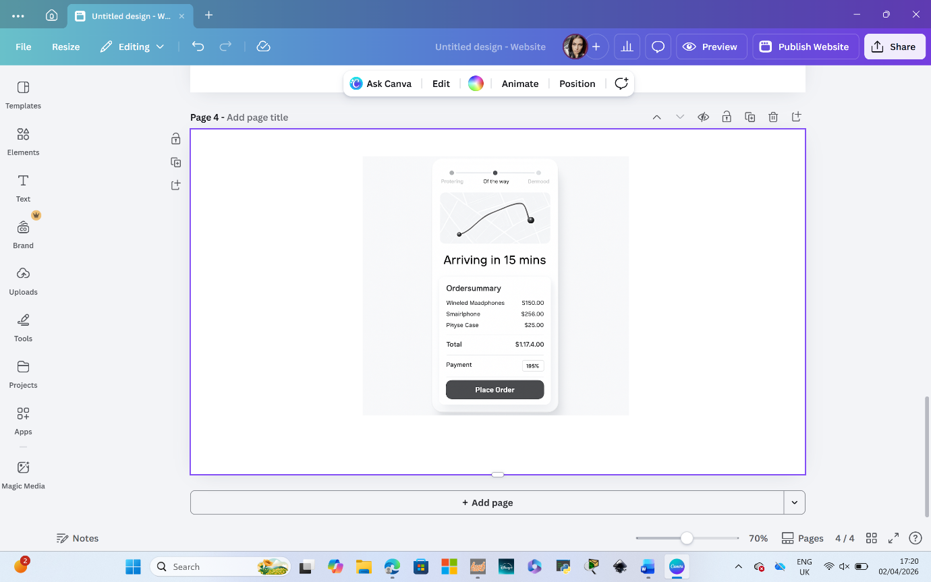
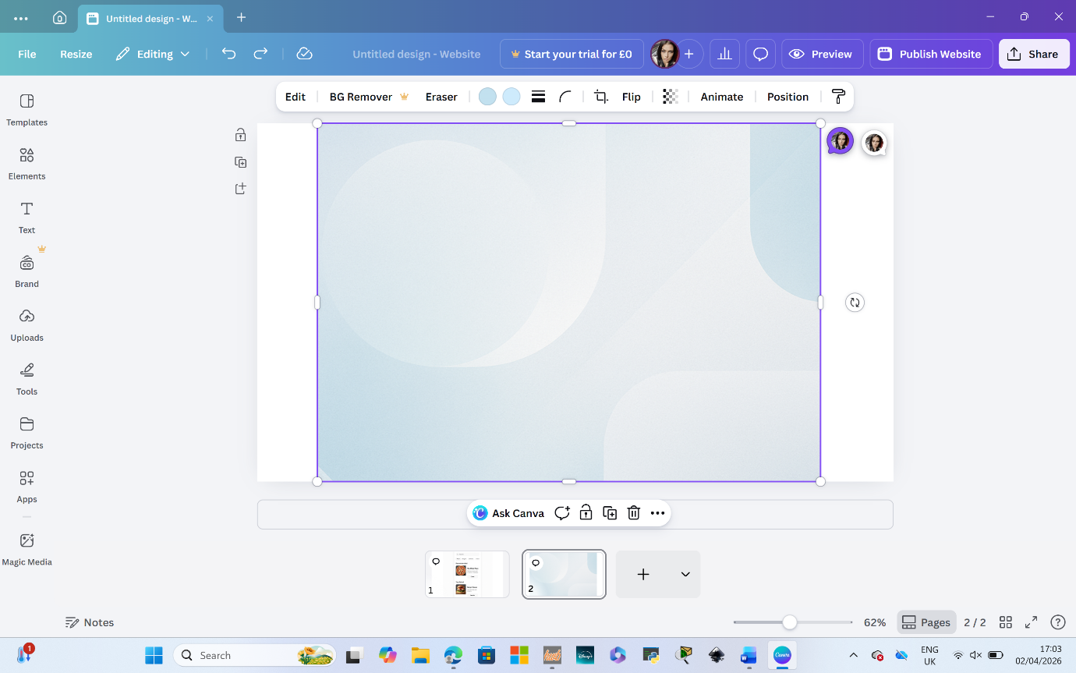
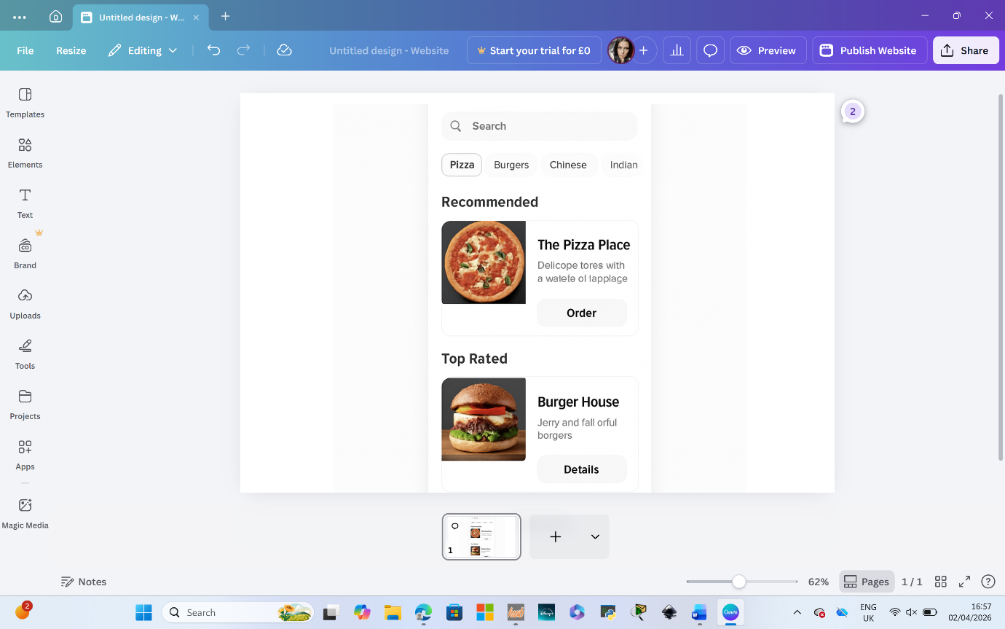
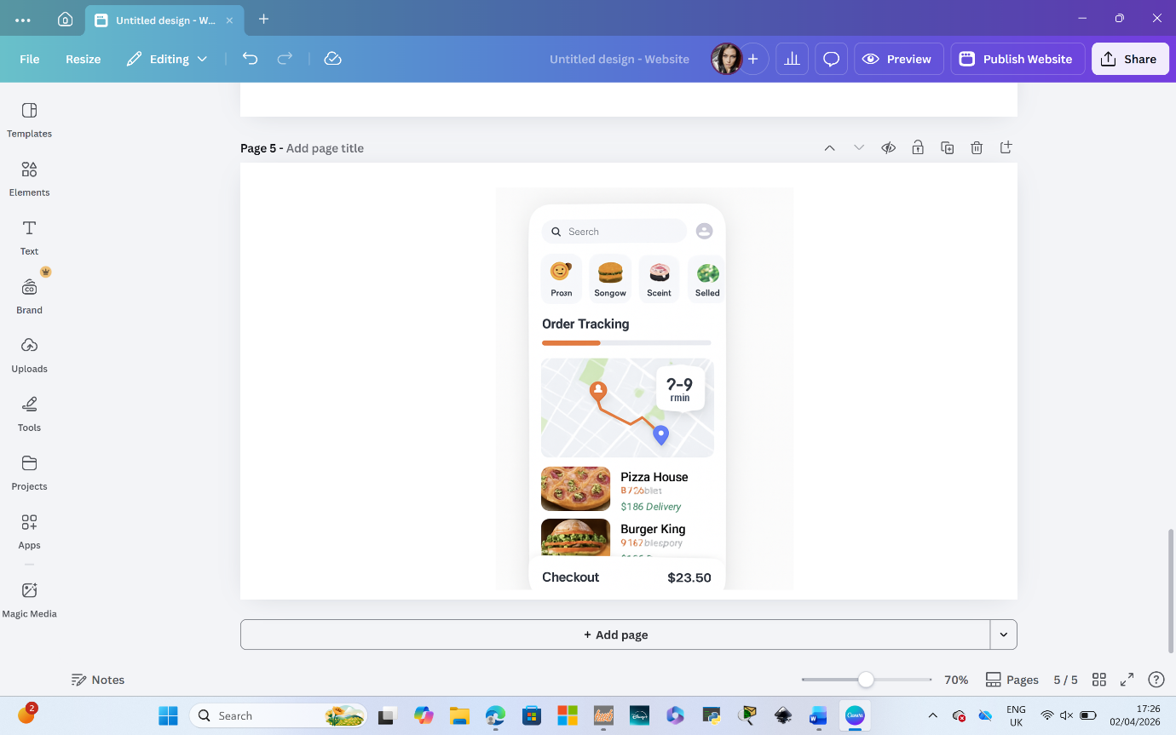
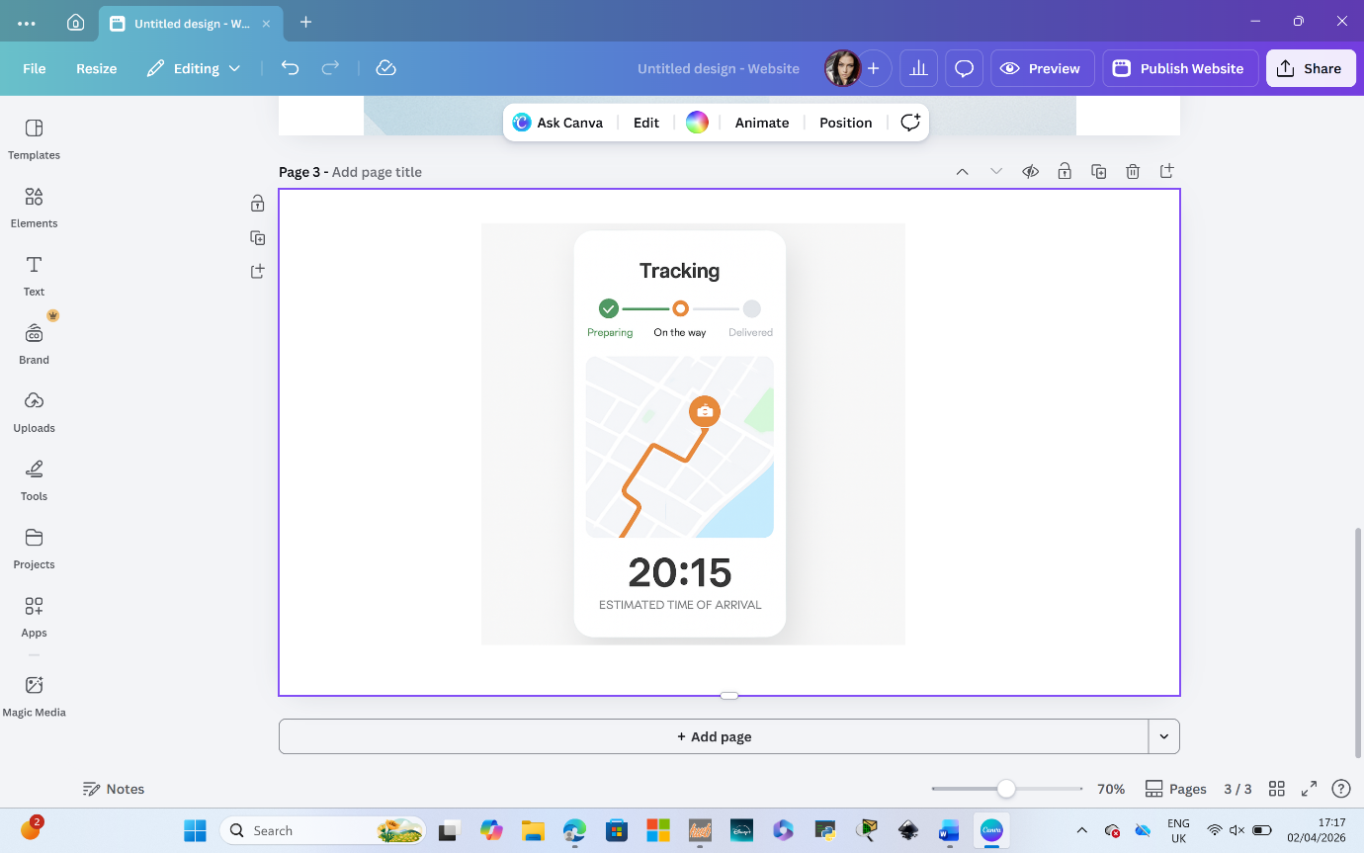

IV.CONCLUSION
The redesigned MealSwift interface successfully addresses the key usability issues identified in the original system. The implementation of a simplified navigation structure has significantly improved the user journey, enabling users to locate restaurants and menu items more efficiently. This aligns with established usability principles such as Nielsen’s heuristic of “visibility of system status” and “user control and freedom.”

The introduction of a mobile-first, responsive design ensures that the platform is accessible across a range of devices. Given that a large proportion of food delivery users access services via smartphones, this improvement is likely to increase user engagement and order frequency.

Additionally, the redesigned checkout process reduces the number of steps required to complete a purchase. This minimises cognitive load and friction, which are key factors contributing to cart abandonment. By streamlining this process, the system is more efficient and user-friendly.

The addition of personalised recommendations enhances user engagement by tailoring content to individual preferences. This feature not only improves user satisfaction but also increases the likelihood of repeat purchases, supporting business objectives.

Real-time order tracking further strengthens user trust by providing transparency throughout the delivery process. This feature addresses a major limitation of the original system and aligns with user expectations established by competitors.

Accessibility improvements, including improved colour contrast and readable typography, ensure that the platform is inclusive and compliant with accessibility guidelines. This broadens the potential user base and enhances overall usability.

However, there are some limitations to the current design. The prototype does not include full backend functionality, meaning features such as real-time tracking are simulated rather than fully implemented. Future development could include user testing to gather feedback and further refine the interface.

Overall, the redesigned MealSwift platform demonstrates a significant improvement in usability, accessibility, and user satisfaction. It is expected that these enhancements will lead to increased order completion rates, improved customer retention, and stronger brand loyalty.

V.REFERENCES
https://www.uwtsd.ac.uk/library
Nielsen, J. (1994) Usability Engineering. Academic Press.
Norman, D. (2013) The Design of Everyday Things. Basic Books.
Krug, S. (2014) Don’t Make Me Think. New Riders.
ISO (2019) ISO 9241-210: Human-centred design for interactive systems.
W3C (2018) Web Content Accessibility Guidelines (WCAG)

