University of Wales Trinity Saint David
School of Engineering


Vehicle Handling Optimisation through Simulation
Advanced Motorsport Dynamics - ACEA7002
Owain Phillips
1809853
03/05/2022

Table of Contents
1 Introduction 3
1.1 Aims 3
2 Literature Review 4
2.1 Multi-body Simulation 4
2.2 Spring-Mass-Damper Systems 4
2.3 Vehicle Setup 4
2.4 Design of Experiments 5
2.5 Vehicle Handling Models 6
2.6 Vi-Grade 6
3 Testing Methodology 8
4 Results and Discussion 11
5 Conclusions 16
6 Bibliography 17

Introduction

Aims
The aim of this report is to demonstrate the ability to optimise a vehicles suspension setup through multibody dynamic simulations. The suspension components changed were spring rates, damping rates and anti-roll bar rates.

Literature Review

Multi-body Simulation
Multibody Dynamics (MBD) simulations are suited to study the dynamic behaviour of interconnected rigid and/or flexible bodies undergoing large translational or rotational displacements. The motion of those bodies is calculated based on applied loads and boundary conditions defined. MBS offer comparably short calculation times. This makes them a very efficient simulation tool and an excellent choice for parameter studies and optimisations of complex assemblies having many degrees of freedom. (code product solutions, n.d.)
MBS models for the main sub-systems are linked together to build a detailed “literal” representation of the full vehicle. Suspension systems, anti-roll bars, steering mechanism, brake system and drive inputs to the wheels are all modelled to a level appropriate for a high-fidelity simulation of the vehicle dynamics. It will be assumed that the chassis and suspension can be treated as rigid bodies, resulting in some errors because the compliance characteristic of chassis and suspension is neglected. (Matteo Balena, 2021)

Spring-Mass-Damper Systems
“The SMD system is of considerable significance in engineering because many simple systems in the real world are very closely approximated by a SMD system. An example is the suspension system for a wheel on an automobile, in which case the shock absorber is the damper. There are two important parameters that completely define the dynamics of the SMD system: these are its undamped natural frequency and its damping ratio. The undamped natural frequency, usually shortened to "natural frequency," is the frequency at which the mass will oscillate about the zero reference if the mass is pushed down (or pulled up) and then let go. Theoretically, the oscillation will go on indefinitely since there is nothing to dissipate the original energy stored in the spring at its initial deflection (the spring is assumed to dissipate no energy). The damping ratio is a convenient mathematical tool that shows the influence of the damping constant, C, on transient response.” (Milliken, 1995)

Vehicle Setup
A major aspect of any vehicle setup is the optimisation of damping rates as this allows for fine tuning of the vehicle response after other variable are set such as spring stiffness and roll bar rate. ‘Although there is a small amount of damping in the tire (approximately 2%) the suspension damper must do the majority of the damping for this whole system. That means damping the sprung mass, unsprung mass, and the tire! While springs and sway bars produce force based on their displacement or deflection, dampers produce force based on how fast you move them, or their velocity. Therefore, the amount of damping produced is proportional to velocity. This means the damper works like a dynamic spring; it produces force only when it is moving. The primary function of the damper on the vehicle is to damp the sprung and unsprung masses at their resonant frequencies. For the sprung mass, this includes the pitch, heave and roll resonant frequencies. A secondary function is to control the rate of weight transfer during transients such as braking, corner entry and acceleration.’ (Kasprzak, 2014)
When a vehicle is sprung, longitudinal accelerations and load transfers will cause vertical movement of the sprung mass and centrifugal acceleration will cause the sprung mass to roll. Road surface irregularities will cause vertical deflection of the unsprung wheels in relation to the chassis. All of these antics cause the wheels' camber to change in relation to the road surface and, in addition, they cause large amounts of energy to be stored in the springs as they compress. If this stored energy is not damped by some form of shock absorber, the car will proceed down the road like four pogo sticks in loose formation to the immense detriment of both tire adhesion and passenger comfort. On most race tracks, bumps and road surface irregularities are relatively minor and are, in any case, transient conditions. We have to allow for the worst bump that the individual track has to offer, but these transients are much less significant in terms of lap time than the vehicle's response and reaction to the load transfers caused by the three major accelerations. Obviously the rougher the race track, the more important will be movement of the unsprung mass in reaction to the road surface. (Smith, 1978)

Design of Experiments
The process of design of experiments allows for a very detailed statistical analysis of set parameters interactions with each other while minimising the time required to analyse such data. ‘The design of experiments refers to the process of planning of experiments in a way that appropriate data can be analysed through statistical methods, resulting in valid and objective conclusions.’ (Montgomery, 2017).
A regular approach of testing each variable in a singular fashion would not allow for this analysis, and it may be found that an ideal setup is created through this singular approach, but as the systems interact, they have a negative effect on each other, thus reducing the maximum performance of the vehicle.
The application of design of experiments within the simulation process in the automotive industry was studied by (José Arnaldo Barra Montevechi, 2007), where it was mentioned that the benefits of design of experiments include the possibility of improving the performance of the simulation process and avoiding the trial-and-error techniques to seek solutions. ‘Research related to design of experiments is often found in specialised magazines, which are rarely read by simulation practitioners’ (Jack P. C. Kleijnen, 2005), showing the lack of awareness of the process within the field, and thus a huge disadvantage to anybody performing multi-variable simulations.
In the journal article from (Jack P. C. Kleijnen, 2005), it is stated that a possible reason that design of experiments is not used at extensively as it should be, could be down to many simulation analysts not being aware of the benefits of the technique. Instead of using even a single experimental design, many end up creating runs of a single system, or modifying various factors at one time reducing the ability to make sound statistical conclusions from their work.

Vehicle Handling Models
“Knowing the side force generated by a given tyre, a vehicle model can be constructed by summing the forces and moments produced by each tyre. The parsimonious bicycle model commonly used in vehicle dynamic literature ignores suspension effects and longitudinal dynamics, and is particularly useful in multi-axle steering work, as it readily allows inclusion of axles with minimal increased complexity. Its results generalise well to steady-state conditions that are easily verified with real-world vehicles. Finally, the bicycle model is particularly useful to compare different commercial vehicle configurations where lateral acceleration is limited to a lower level by the relatively high aspect ratios of these vehicles. With these lower lateral accelerations, the effects of weight transfer and tyre nonlinearities can be more easily neglected for typical driving. These effects might be relevant, however, in transient situations encountered in emergency manoeuvring.” (Williams, 2012)
“One-dimensional” refers to pure vertical motion, i.e. that the vehicle heaves without pitch and without roll. The tyre is stiff and massless. This can be seen as that the whole vehicle mass, m, is modelled as suspended by the sum of all wheels’ vertical forces, = 𝑙 + + 𝑙 + . However, the model can sometimes be referred to as a “quarter-car-model”. That is because one can see the model as a quarter of the vehicle mass, 4, which is suspended by one of the wheel’s vertical force, 𝑖𝑗 . The exact physical interpolation of a quarter car is less obvious, since one can argue whether the fraction ¼ of the vehicle mass is the proper fraction or from which point of view it is proper. Using the fraction ¼ is as least debatable if the vehicle is completely symmetrical, both left/right and front/rear. (Chalmers University of Technology, 2019)
Further to the ‘quarter car’ model, half car and full car models can be created from first principles.

Vi-Grade
VI-CarRealTime is a virtual modelling and simulation environment targeted to a simplified 4 wheels vehicle model. Its functionalities include the ability to assemble the vehicle system by collecting its fundamental subsystems, specifying dynamic manoeuvre schedules, launching standalone or Matlab-Simulink embedded simulations, post-processing the obtained results.
The environment based on underlying solver consists of:
• Symbolically derived parameterized equations of motion;
• Pacejka tire model;
• Sophisticated, virtual driver model.
(VI-grade engineering software & services, 2019)

Historically the Pacejka ‘magic formula’ was developed as a model for road car tyres based on the idea that a combination of sine and arctan curves could represent the lateral force characteristics of a tyre. Essentially curve fitting data to interpolate the tires characteristics at all loads based off a few measured values. The required data to use the curve fitting method are lateral tyre slip angle, longitudinal tyre ratio, camber inclination, and vertical load on the tyre. (Pacejka, n.d.)
MaxPerformance event in VI-CarRealTime is used to define dynamic limit velocity profile on a given track. The event uses a specific static solver (VI-SpeedGen) to compute a velocity profile and then it uses the dynamic solver to verify if the computed speed profile is feasible. If the velocity path is unfeasible (maximum path distance exceeded, zero velocity etc.) the solver turns back to the static and computes a new velocity profile, modifying only the portion nearby the unfeasible point. The process is iterated until a feasible velocity profile is found. Basically, the vehicle model used for static prediction has no suspensions and inherits all properties from the full VI-CarRealTime model. The effect of aero forces is considered, and the effect of suspension jounce is taken into account by the presence of ride height maps. (Vi-Grade, 2020)

Testing Methodology
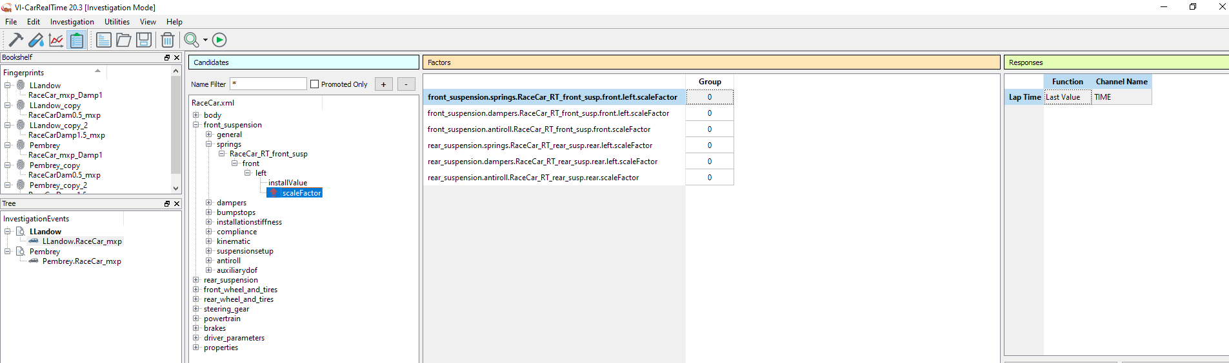
The 3 parameters that were investigated were spring rates, damping rates and anti-roll bar rates. The values of these parameters were changed using the scale factor option in carrealtime.
Figure 1 - Investigation Mode in Vi-CarRealTime
Initially, to save time and get a benchmark of which setup combinations might be fastest, each parameter was selected as an investigation factor and scaling limits of 50% softer and 50% harder were set, then a 2-level Full Factorial investigation was conducted, with a response of lap time at each track. This meant only the softest and hardest setting of each parameter were compared against each other, which still gives an idea of the interaction of each system but does not require hundreds of runs like a full-factorial investigation with multiple levels, which compares every single setup combination possible within the selected number of levels.
All the factor Levels (or Values) are used for the investigation. The number of analysis variants run are equal to the product of the Levels (or Values) of all the factors defined for the current investigation. (Vi-Grade, 2020)
If the full-factorial mode was used for each setup parameter with scaling limits of +- 50% through 10 levels, the number of investigations required would be 1 million. This is why a design of experiments approach in important, to be able to confidently spot trends in the data but through far less required investigations.
The initial results from the 2-level full factorial investigations informed the direction of the full-factorial investigations. For example, for Llandow, the initial results showed that the fastest setups all had the hardest spring setting of 50% stiffer than the baseline setup.
As shown in Figure 2, Llandow had multiple setups that achieved the same time from the initial investigations, whereas Pembrey had 1 setup that was faster than any other combination.
Figure 2 - 2 Level Full-Factorial Investigation Results
From these results, it was decided to run further investigations, using the Llandow setup, with the front scaling values having 5 levels, but the rear setup parameters were fixed in the stiffest configuration. This allowed for more in depth results about the ideal front suspension setup, without having to run in excess of 100,000 investigation runs.
The same was also done using the Pembrey setup, but the rear was fixed at baseline scaling values of 1.
This was later discovered to be the wrong methodology. The results gained from these investigations gave little confidence to the author, as the interaction between front and rear suspension was not fully defined with no variance in rear setup parameters.
As the objective of this paper was to create a setup that could be used at both Llandow and Pembrey, and the initial results showed some overlapping setup parameters, such as front and rear spring rate, the final set of investigations would use 2 levels at 50% and 75% of initial front spring rate, and 150% of baseline rear spring rate. This meant the other parameters (damping rates and anti-roll bar rates), could be run though more levels without hugely increasing the number of required runs.
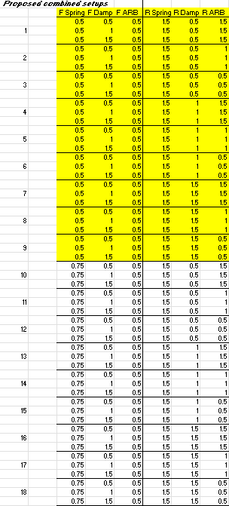
Figure 3 shows, the required parameter combinations to be investigated to give a good idea of the fastest setup for both Llandow and Pembrey.
Figure 3 - Final Investigation Testing values

Results and Discussion
From the final investigations, 3 setups were faster than any other. They had identical spring and anti-roll bar rates, but the damping rates varied.
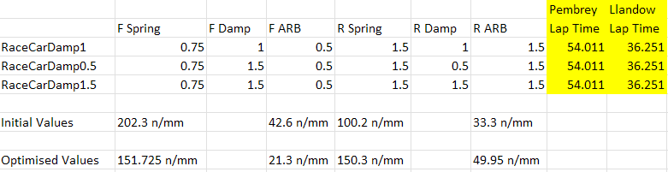
These setups gave lap time improvements of 0.05 seconds at Llandow and 0.12 seconds at Pembrey.
Figure 4 - Final investigation results
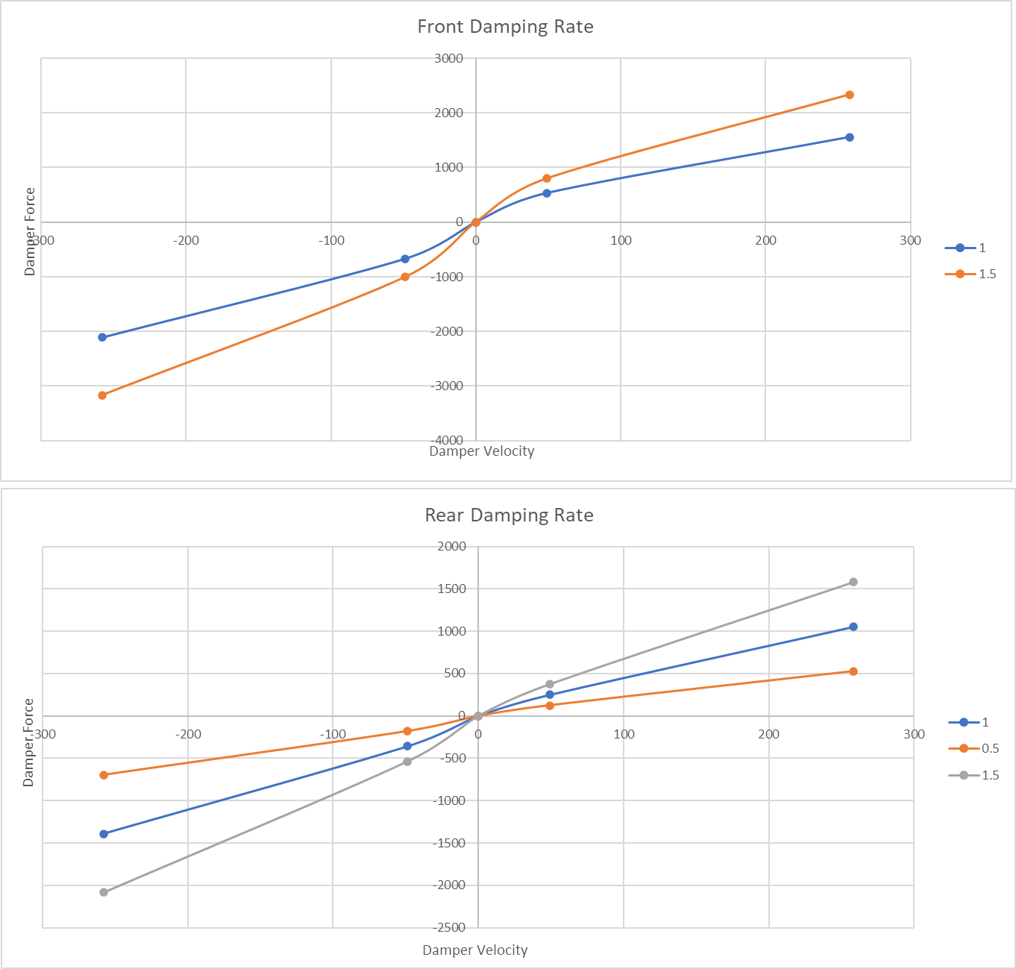
Figure 4 shows the fastest setups all the have a front spring rate 75% of the initial baseline spring rate, 50% of the front anti-roll bar rate, and 150% of the initial baseline rear spring and roll bar rates. The front damping rates varied from the initial baseline value to 50% stiffer, and the rear varied from 50% softer all the way to 50% stiffer.
Figure 5 - Front and Rear damping rates in the fastest setups

The mass balance for the race car model used was 45% front and 55% mass distribution. From this you would assume a stiffer rear spring than front on the baseline setup. But in fact, the front spring was over twice as stiff as the rear spring.
The undamped natural frequency of such a system is given by: $f_{n}= \frac{1}{2π}\sqrt{\frac{k}{m}}$
Using these initial spring rates, the natural frequency of the front suspension system was 3.29 Hz, and the rear natural frequency was 2.1 Hz.
With the optimised spring rates, the front natural frequency was 2.85 Hz, and the rear was 2.57Hz.
The optimised setups give a more balanced platform, as despite a higher natural frequency at the rear, it more closely matches the front frequency. These natural frequencies are typical of this style of car, being within the 2.5 to 3.5 Hz range.
“2.5-3.5Hz = Moderate downforce racecars with up to 50% total weight in max downforce capability” (drtuned racing, 2017).
With the only differences between the 3 setups being damping, it was important to compare the responses of the different rates.
Most race and road cars are under damped, as despite having to deal with some oscillations of the mass, the rate at which the mass reaches a relative displacement of 0 is much quicker than a critically damped system. All 3 fastest setups are under-damped but do have differing damping ratios.

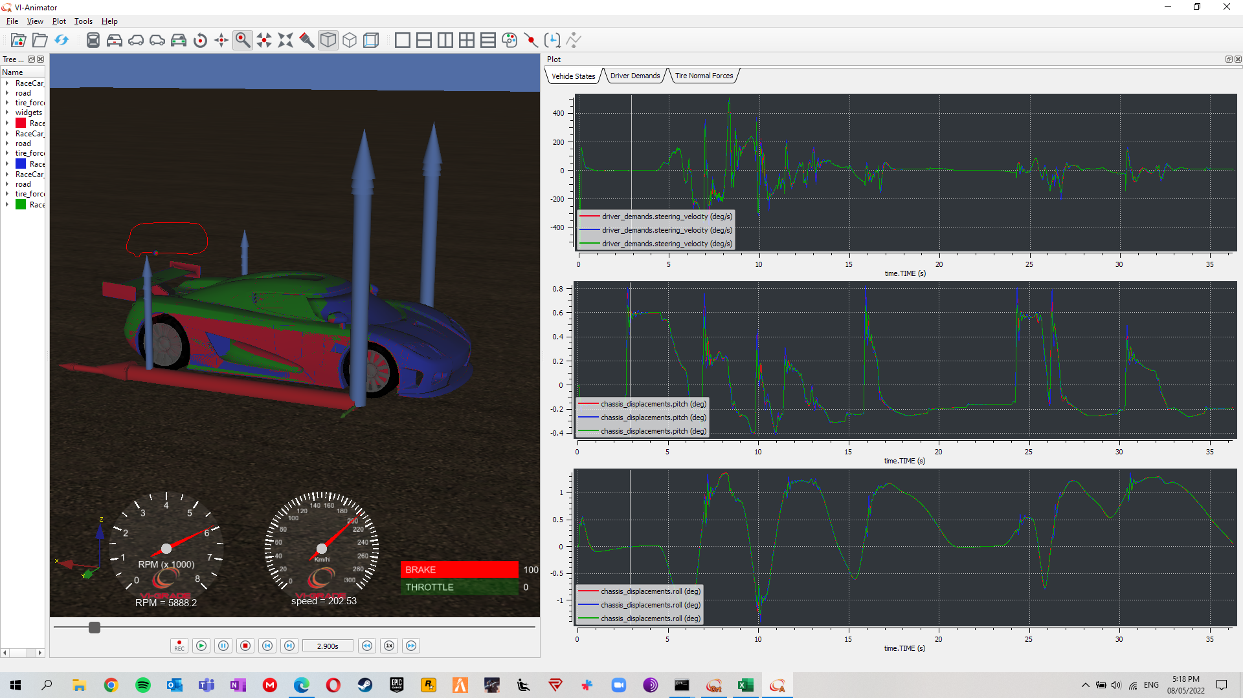
Figure 6 - Steering velocity, chassis pitch, and chassis roll plots from the 3 different setups at Llandow
Figure 6 shows the 3 setups overlayed against lap time. The green line is from Racecardamp1.5 setup, the red line is from RacecarDamp1 setup, and the blue line is from RacecarDamp0.5 setup.
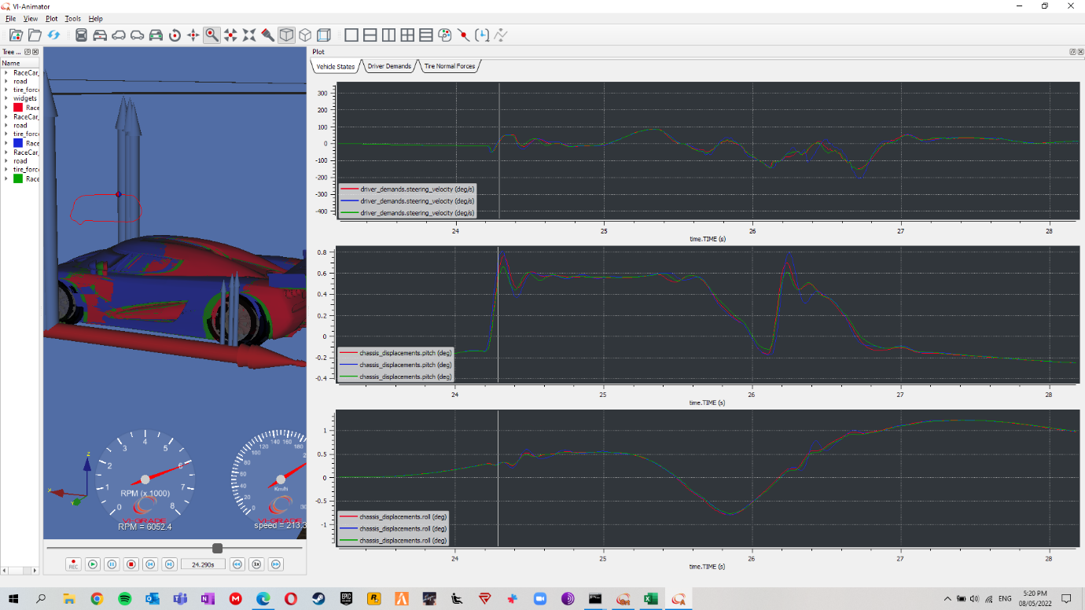
Figure 7 clearly shows the differences between each setup. This section of data comes from the final chicane at Llandow, with two sharp direction changes, it shows the blue line (least damped setup) having more pitch angle and initial roll angle, with the red line (baseline damping) having slightly less pitch and roll angle, then the most damped setup in green shows the least pitch and roll angles.
Figure 7 - Steering velocity, chassis pitch, and chassis roll plots from the 3 different setups at Llandow in the final chicane
An important factor in any vehicle setup is driveability. The top graph in Figure 7 shows steering velocity for each setup. The least damped setup shows the expected results of required a faster steering velocity to stay on the defined driver path. The other 2 setups show similar velocities, possibly meaning that there would be little to no difference in driveability between the two. But it is fairly clear that the most stable setup would be the most damped example. With lower pitch and roll angles, there is less chance of over loading the tyres and exceeding the optimal slip angle of the tyre. Although this statement cannot be fully substantiated without transient tyre load data and accurate tyre slip data.
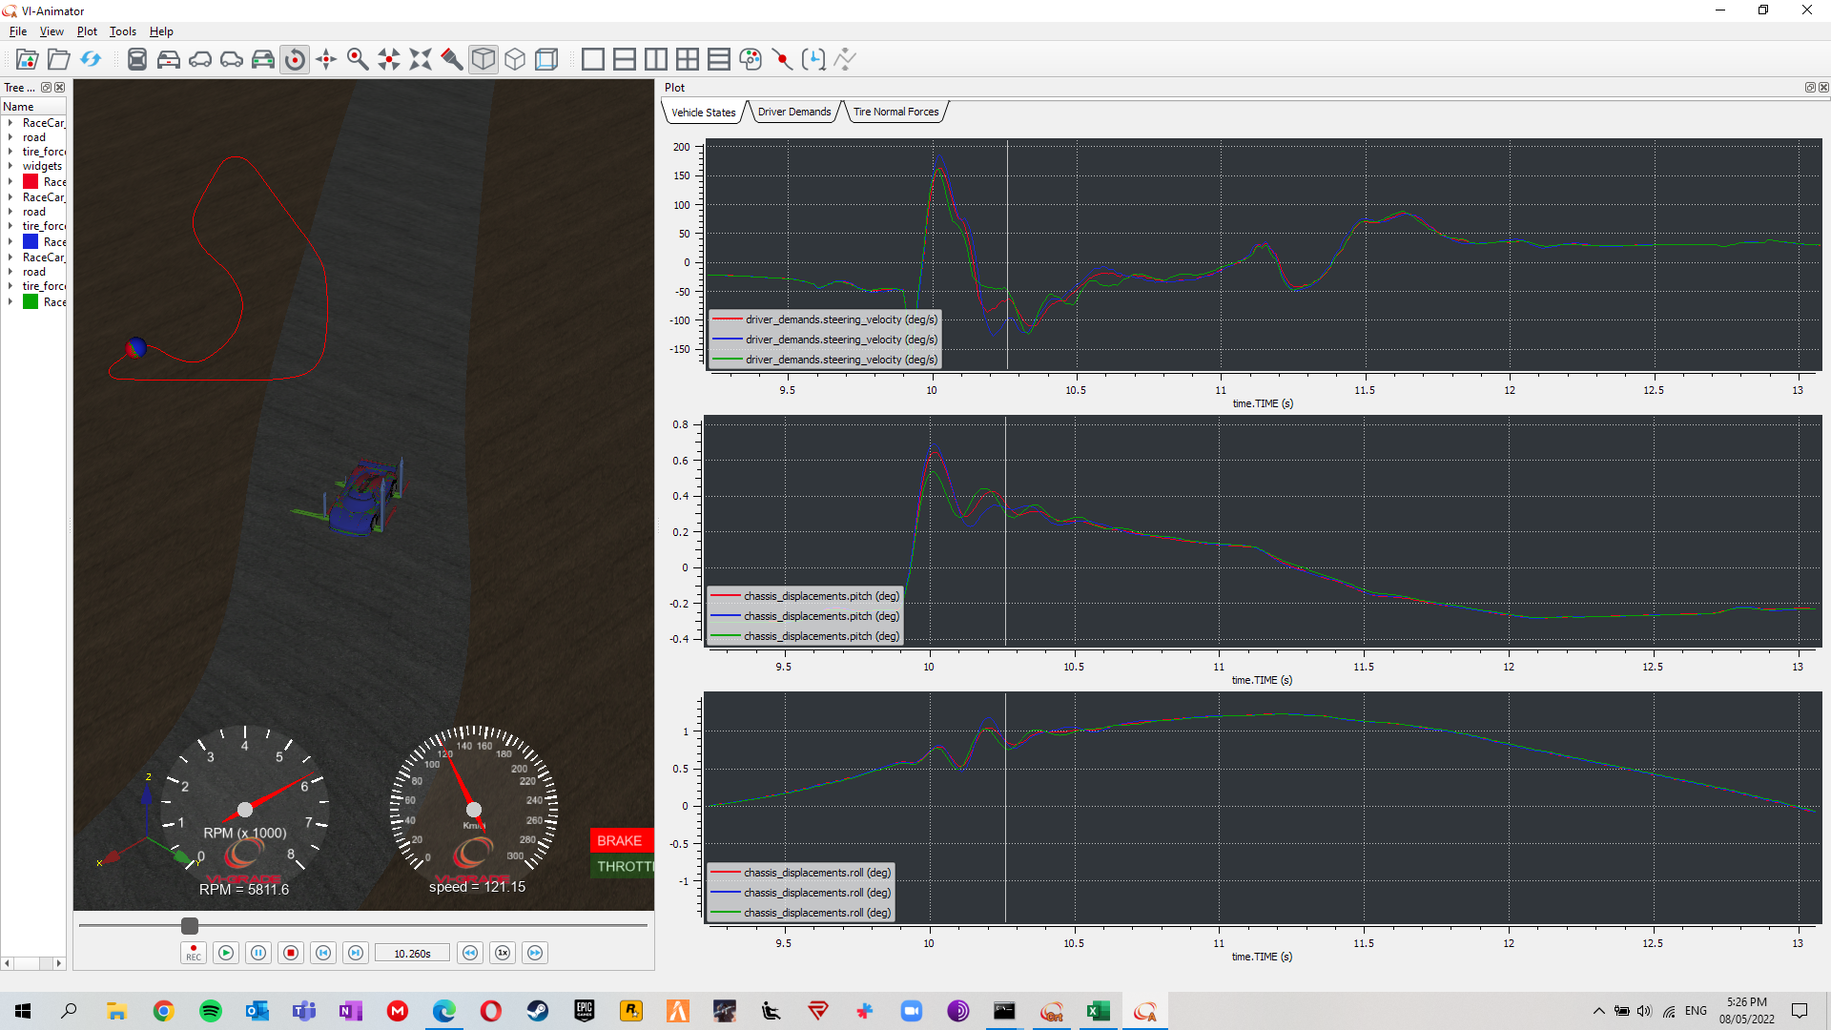
Figure 8 - Steering velocity, chassis pitch, and chassis roll plots from the 3 different setups at Pembrey
Figure 8 shows the same trend as expected, with the least damped setup requireing more driver work to maintain the desired driver path. In this example though, the most damped setup appears to be more responsive than the baseline damped setup, as the same initial steering velocity is required on turn in, but then a slower steering rate once the tyres are loaded.

Conclusions
The results gained from the investigations gave confidence that multi-body dynamic computer simulations can give performance gains. The results, however, are not as in depth as would be preferred, as the smallest steps in parameter changes were 25%, which is a large change in reality.
From the handling response demonstrated in Figures 6, 7, and 8, the author believes the best setup to be the most damped setup, with front and rear damping rates of 150% of the baseline rates. It is not clear, despite these driveability differences, how each setup achieved the exact same lap time at both circuits.
For future work, it would be very beneficial to conduct investigations with smaller increments in parameter change, thus increasing the accuracy of results and potentially improving performance further.

Bibliography
Chalmers University of Technology, 2019. Vehcile Dynamics Compendium. 10th ed. Göteborg: Chalmers University of Technology.
code product solutions, n.d. MULTIBODY DYNAMICS. [Online]
Available at: https://www.code-ps.com/services/multibody-dynamics.html
[Accessed February 2022].
drtuned racing, 2017. SPRING RATES & SUSPENSION FREQUENCIES - PLUS CALCULATOR!. [Online]
Available at: https://www.drtuned.com/tech-ramblings/2017/10/2/spring-rates-suspension-frequencies
[Accessed 04 2022].
Jack P. C. Kleijnen, S. M. S. T. W. L. T. M. C., 2005. A User’s Guide to the Brave New World of Designing Simulation Experiments. INFORMS Journal on Computing, 17(3), pp. 263-289.
José Arnaldo Barra Montevechi, A. F. d. P. F. L. F. A. S. M., 2007. APPLICATION OF DESIGN OF EXPERIMENTS ON THE SIMULATION OF A PROCESS IN AN AUTOMOTIVE INDUSTRY. s.l., Fernando Augusto Silva Marins.
Kasprzak, J., 2014. Understanding your Dampers: A guide from Jim Kasprzak. [Online]
Available at: http://www.kaztechnologies.com/wp-content/uploads/2014/03/A-Guide-To-Your-Dampers-Chapter-from-FSAE-Book-by-Jim-Kasprzak.pdf
[Accessed March 2022].
Matteo Balena, G. M. G. R., 2021. Dynamic Handling Characterization and Set-Up Optimization for a Formula SAE Race Car via Multi-Body Simulation. Machines.
Milliken, W. F. M. a. D. L., 1995. Race Car Vehicle Dynamics. Warrendale, Pa: Society of Automotive Engineers, Inc..
Montgomery, D. C., 2017. Design and Analysis of Experiments. 9th ed. s.l.:John Wiley & Sons Inc.
Pacejka, H. B., n.d. Tyre and Vehicle Dynamics. s.l.:s.n.
Smith, C., 1978. Tune To Win. Fellbrook: Aero Publisher Inc..
VI-grade engineering software & services, 2019. VI-Road v19.0 webhelp, s.l.: s.n.
Vi-Grade, 2020. Vi-CarRealTime PDF Help, s.l.: s.n.
Vi-Grade, 2020. Vi-CarRealTime Web Help. [Online]
Available at: file:///C:/Program%20Files/VI-grade/VI-CarRealTime%2020/help/webhelp/index.html
[Accessed 04 2022].
Williams, D. E., 2012. Generalised multi-axle vehicle handling. International Journal of Vehicle Mechanics and Mobility, 50(1), pp. 149-166.

