Chapter4-Data Analysis

4.1 Introduction
In the questionnaire, it mainly aims at five kinds of questions of Shuanghui Company, a famous food enterprise in China. The first kind of problem is CSR. CSR includes economic responsibility (CSRE), legal responsibility (CSRL), ethical responsibility (CSRM), charitable responsibility (CSRC) and environmental responsibility (CSRG). These six kinds of corporate social responsibility set different problems. The second kind of problem is corporate image (CI). The third kind of problem is customer satisfaction (CS). The fourth category is customer loyalty (CL). The fifth category is the public health event (PHE). At the end of the questionnaire, there are demographic questions, including Gender, Age, education level (Edu), vocational (Prof) and Income. The calculation relationship between variables is shown in the following table:

Table 1 Computational relationship between variables

Variable | Standardized variable names | Computing relation
CSR | ZCSR | CSR= (CSRE+CSRL+CSRM+CSRC+CSRG)/5  CSRE= (CSRE1+ CSRE2+ CSRE3+ CSRE4)/4  CSRL= (CSRL1+ CSRL2+ CSRL3+ CSRL4)/4  CSRM= (CSRM1+ CSRM2+ CSRM3)/3  CSRC= (CSRC1+ CSRC2+ CSRC3)/3  CSRG = (CSRG1+ CSRG2+ CSRG3+ CSRG4)/4
CI | ZCI | CI= (CI1+ CI2+ CI3+CI4)/4
CS | ZCS | CS=(CS1+CS2+CS3)/3
CL | ZCL | CL=(CL1+CL2+CL3)/3
PHE | ZPHE | PHE= (PHE1+ PHE2+ PHE3+ PHE4+ PHE5+ PHE6)/6

4.2 Research Method

4.3 Demographic
This survey uses the questionnaire star to send out the electronic questionnaire.247 valid questionnaires and 18 invalid questionnaires were collected.The number of men surveyed was 143 people,The number of women is 104 people.

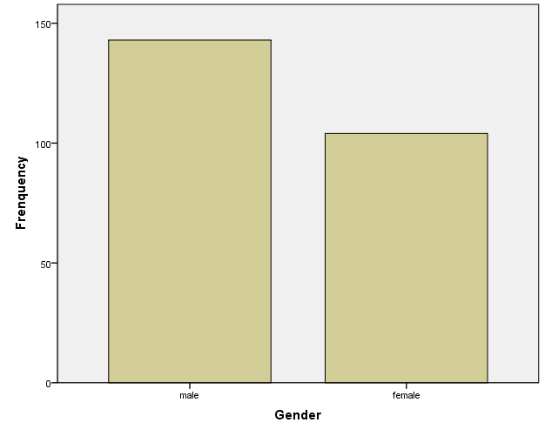

Figure 4.1 Graph of gender identification

Among the respondents, there were the largest number of people aged between 31 and 41, with 93, followed by 61 between 26 and 30, 51 between 18 and 25, 28 between 41 and 50, and 13 over 50. There is only one person under the age of 18.
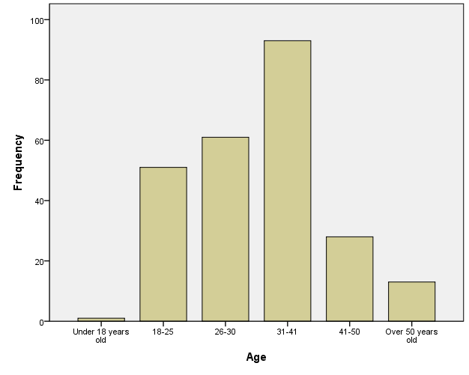

Figure4.2 Age distribution

Among the respondents, the number of people with undergraduate / junior college education level is the largest,there are 206 people.Secondly, there are 26 people with master's degree or above.There are 51 people between the ages of 18 and 25, 12 people in senior high school / technical secondary school, and only 3 people below senior high school.

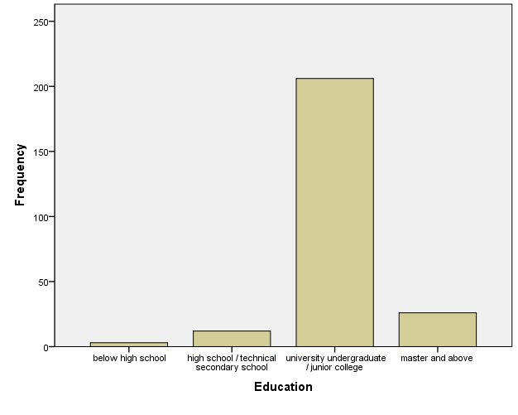

Figure 4.3 Education distribution

From the perspective of the occupational distribution of the respondents, the number of managers is the largest, with 41 people.Followed by full-time students, there are 33.There are 28 technical / R & D staff, 23 sales staff, 21 administrative / logistics staff, 19 civilian / service staff, 19 teachers, 18 production staff, 15 finance / auditors, 13 other professions, 10 marketing / public relations personnel, 5 human resources professionals and 2 professionals.

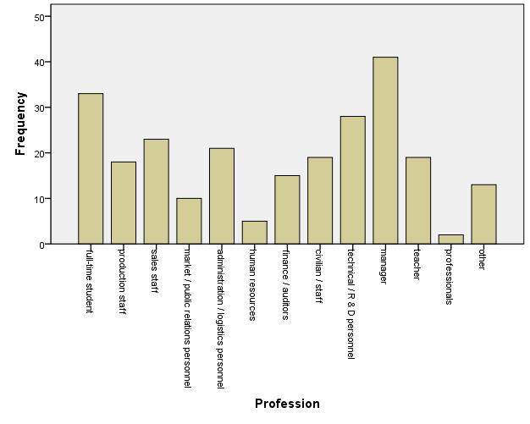

Figure4.4 Profession distribution

According to the income distribution of the respondents, there are 83 people with a monthly income of 8000-15000 yuan, 62 people with a monthly income of 5000-8000 yuan, 37 people with a monthly income of 3000-5000 yuan, 32 people with a monthly income of less than 3000 yuan, 23 people with a monthly income of 15000-20000 yuan, and 10 people with a monthly income of more than 20, 000 yuan.

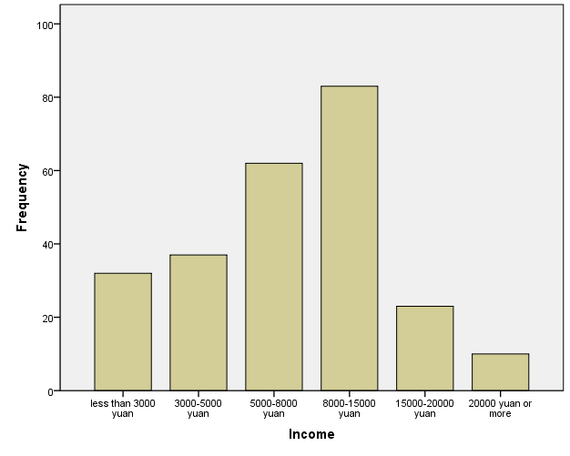

Figure 4.5 Income distribution

4.4 Reliability and validity tests

Table 2 Reliability Statistics
 |  | Cronbach's Alpha | Cronbach's Alpha Based on Standardized Items | N of Items
CSR | Economic Responsibility | 0.574 | 0.588 | 4
CSR | Law Responsibility | 0.711 | 0.712 | 4
CSR | Moral Responsibility | 0.698 | 0.697 | 4
CSR | Charity Responsibility | 0.711 | 0.712 | 3
CSR | Environment Responsibility | 0.711 | 0.712 | 3
Corporate Image |  | 0.774 | 0.777 | 4
Customer Satisfaction |  | 0.745 | 0.744 | 3
Customer Loyalty |  | 0.769 | 0.773 | 3
Public Health Events |  | 0.765 | 0.764 | 6

According to the reliability test results, we should pay attention to the Clonbach coefficient based on the standardized term, which ranges from 0 to 1, and the closer it is to 1, the higher the reliability. Generally, if it is less than 0.5, we should consider re-adjusting the questionnaire. From the above table, we can see that the reliability analysis of all the dimensions of the five measurement indicators of corporate social responsibility, corporate image, customer satisfaction, customer loyalty and public health events shows that the value of the index Cronbach's Alpha is greater than 0.5, indicating that the questionnaire is reliable.

With regard to validity analysis, we only need to pay attention to the value range of KMO and Bartlett's Test of Sphericity,KMO coefficients in Table 2 is between 0 and 1, and the closer to 1 means the better the construct validity of the questionnaire. If the significance of Bartley spherical test is less than 0.05, we can also think that the questionnaire has good construct validity.As can be seen from Table 2, the KMO coefficient is 0.908, which is very close to 1.The significant level of Bartlett's Test of Sphericity was 0.000, less than 0.05. So the questionnaire passed the validity test.

Table 3 KMO and Bartlett's Test
Kaiser-Meyer-Olkin Measure of Sampling Adequacy. |  | 0.908
Bartlett's Test of Sphericity | Approx. Chi-Square | 3650.133
Bartlett's Test of Sphericity | df | 595
Bartlett's Test of Sphericity | Sig. | 0.000

4.5 Analysis of mediating effect with adjustment

4.5.1 Model description

In the analysis of mediating effect, regulatory effect and conditional process in Hayes (2017), 92 models are given. In this paper, the 85th model (Figure1) is adopted according to the problem studied, and the process program in SPSS software is used for analysis. The corresponding relationship between model variables and research variables is shown in Table 3. In addition, age, education and occupation are taken as control variables.
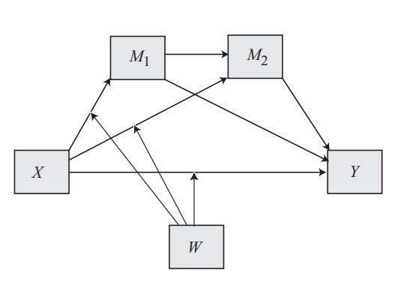

Figure 4.6 Model 85 of Hayes

(Andrew F. Hayes,2017，P609)

Table 4 The corresponding relationship between model variables and research variables
Model variable | X | Y | M1 | M2 | W
Corresponding variable | CSR | CL | CI | CS | PHE

4.5.2 Result analysis
According to the above model, the variables are standardized and analyzed by process in SPSS software. The results are as follows.

4.5.2.1 regression Analysis of CSR to CI
As can be seen from the table below, the effect of CSR on CI is significant, and the corresponding value is 0.000, which is less than the significant level. The regulatory effect of PHE was not significant, because the corresponding P-value=0.9985, which was greater than the significant level of 0.05.

Table 5 Regression Analysis of CSR to CI
Dependent Variable：ZCI
 | coeff | se | t | p | LLCI | ULCI
constant | 0.1989 | 0.3452 | 0.576 | 0.5651 | -0.4812 | 0.8789
ZCSR | 0.6366 | 0.0513 | 12.4094 | 0.000 | 0.5355 | 0.7376
ZPHE | 0.1335 | 0.0542 | 2.4627 | 0.0145 | 0.0267 | 0.2404
Int_1（ZCSR*ZPHE） | -0.0001 | 0.0431 | -0.0019 | 0.9985 | -0.085 | 0.0848
Age | -0.0407 | 0.0445 | -0.9153 | 0.361 | -0.1283 | 0.0469
Edu | -0.0524 | 0.1056 | -0.4959 | 0.6204 | -0.2605 | 0.1557
Prof | 0.0158 | 0.0134 | 1.1738 | 0.2417 | -0.0107 | 0.0423

4.5.2.2 Regression analysis of CSR and CI to CS
As can be seen from the table below, the influence of CSR and CI on CS is significant. The regulatory effect of PHE is significant, because the corresponding P-value=0.0464 , which is less than the significant level.

Table 6 Regression Analysis of CSR and CI to CS
Dependent Variable：ZCS
 | coeff | se | t | p | LLCI | ULCI
constant | 0.0746 | 0.3129 | 0.2384 | 0.8118 | -0.5419 | 0.6911
ZCSR | 0.4406 | 0.0595 | 7.3997 | 0.000 | 0.3233 | 0.5579
ZCI | 0.3802 | 0.0585 | 6.5019 | 0.000 | 0.265 | 0.4954
ZPHE | 0.0635 | 0.0497 | 1.2775 | 0.2027 | -0.0344 | 0.1615
Int_1（ZCSR*ZPHE） | 0.0782 | 0.039 | 2.0022 | 0.0464 | 0.0013 | 0.1551
Age | -0.0181 | 0.0404 | -0.4475 | 0.6549 | -0.0976 | 0.0614
Edu | 0.0095 | 0.0957 | 0.0996 | 0.9207 | -0.1791 | 0.1982
Prof | -0.0115 | 0.0122 | -0.94 | 0.3482 | -0.0355 | 0.0126

4.5.2.3 Regression Analysis of CSR,CI,CS to CL
As can be seen from the table below, the effects of CSR,CI,CS on CL are significant, and the corresponding P-value is 0.0026,0.000 and 0.0002 respectively, which is less than the significant level. The regulatory effect of PHE is not significant, because.
The corresponding P-value=0.923, which is greater than the significant level of 0.05.

Table 7 Regression Analysis of CSR,CI,CS to CL

Dependent Variable：ZCL
 | coeff | se | t | p | LLCI | ULCI
constant | 0.1596 | 0.3405 | 0.4689 | 0.6396 | -0.5111 | 0.8303
ZCSR | 0.2187 | 0.0718 | 3.0459 | 0.0026 | 0.0773 | 0.3602
ZCI | 0.3324 | 0.069 | 4.8167 | 0.000 | 0.1964 | 0.4683
ZCS | 0.2703 | 0.0704 | 3.8409 | 0.0002 | 0.1316 | 0.4089
ZPHE | -0.0291 | 0.0543 | -0.5362 | 0.5923 | -0.1361 | 0.0778
Int_1 | 0.0041 | 0.0428 | 0.0967 | 0.923 | -0.0802 | 0.0885
Age | 0.0431 | 0.0439 | 0.9818 | 0.3272 | -0.0434 | 0.1296
Edu | -0.0891 | 0.1042 | -0.8557 | 0.393 | -0.2943 | 0.1161
Prof | -0.0067 | 0.0133 | -0.5024 | 0.6158 | -0.0329 | 0.0195

4.5.2.4 Mediation effect and Regulatory effect
From the above regression analysis, we can see that the influence of CSR on the two mediating variables CI and CS is significant, the influence of CI on CS is significant, and the influence of CI and CS on CL is significant, so there is a mediating effect in this model. Among the regulatory effects of PHE, among the effects of CSR on CS, the regulatory effect of PHE is significant. Among the effects of CSR on CL and CSR on CI, the regulatory effect of PHE was not significant.

4.6 Matrix analysis of qualitative data from interviews
Questions | Theme | Participant 1 | Participant 2 | Participant 3
Q1. What is the image of Shuanghui Company in your mind in the food industry? | Shuanghui Company Image | Old brand, the first choice in the same type of food. | The scale is large, the quality is guaranteed, and the products are delicious.
Q2. As a customer of Shuanghui Company, what do you think of the product quality of the company? In what way? | the product quality of the company | The overall quality is good; the price is different, but the ratio of performance to price is high. | The quality of the product is very good, which is reflected in its strict control of its own products and the public's reputation for it.
Q3. Do you pay attention to corporate social responsibility activities and why? | corporate social responsibility activities | Will not deliberately pay attention, the relevant news exposure is not high, if the headlines will be hot search, will pay attention to. | Do not pay attention to, and do not have a close relationship with your own study and life.
Q4. Are you a loyal customer of Shuanghui Company? Why? | loyal customer of Shuanghui Company | No, the demand for this kind of products is not high, because minced meat is not healthy enough. | Yes, although we don't buy products very much, we will choose Shuanghui brand when buying the same kind, because it is delicious and the quality of big brands is guaranteed.
Q5. What are you most concerned about Shuanghui Company during COVID-19 's epidemic? | COVID-19 's epidemic | Whether the food safety testing of one's own products is strict or not. | Food safety.
Q6. As an ordinary citizen consumer, what are the reasons for your loyalty to a product or brand? Do you consider factors such as corporate social responsibility and corporate image, and why? | the reasons for your loyalty to a product or brand | Reason: good quality and reasonable price. Corporate image must be considered. Corporate image and social responsibility are the reflection of corporate conscience. | Company reputation, company image, product quality, price factors; will consider and will not choose brands that have no reputation, no sense of social responsibility or even have a negative impact on social order.
Q7. During the COVID-19 epidemic, what kind of social responsibility do you think enterprises should undertake? What about Shuanghui Company? |  | From the point of view of the people, do more public welfare, such as donating our own citizens, helping people of friendly countries, etc. | I think enterprises should first ensure the quality of their products, actively respond to the national call, and contribute to the prevention and control of the epidemic. Shuanghui Company is the same as above.

4.6.1 Analysis of qualitative data collected in the online survey
Theme | Issue | Participant | Participant | Participant | Participant | Participant

4.7 Conclusion

Reference
Hayes, A. F. (2017). Introduction to mediation, moderation, and conditional process analysis: A regression-based approach. Guilford publications.

Appendix1

Questionnaire on Corporate Social responsibility and customer loyalty
I am a college student, because writing papers need to conduct a questionnaire survey on corporate social responsibility. I chose Shuanghui Group, which is located in Luohe City, Henan Province, in the food industry. Thank you for filling out the questionnaire in your busy schedule. I will strictly abide by the ethical requirements of thesis writing, keep the information confidential for each interviewee, and use the survey data after processing, which will not affect individuals and companies.
Variable Name | Question | Strongly disagree | Disagree | Neither agree or disagree | Agree | Strongly agree
CSRE1 | 1.Shuanghui Company has a strong competitive advantage | ☐ | ☐ | ☐ | ☐ | ☐
CSRE2 | 2.Shuanghui Company is an enterprise that can make a profit | ☐ | ☐ | ☐ | ☐ | ☐
CSRE3 | 3. Shuanghui Company has strong economic strength. | ☐ | ☐ | ☐ | ☐ | ☐
CSRE4 | 4. Shuanghui is committed to maximize profits | ☐ | ☐ | ☐ | ☐ | ☐
CSRL1 | 5. Shuanghui Company abides by local and national laws | ☐ | ☐ | ☐ | ☐ | ☐
CSRL2 | 6. The operation of Shuanghui Company conforms to government laws and regulations | ☐ | ☐ | ☐ | ☐ | ☐
CSRL3 | 7. The product safety of Shuanghui Company conforms to the national laws and regulations | ☐ | ☐ | ☐ | ☐ | ☐
CSRL4 | 8. Shuanghui Company fulfills the legal obligations stipulated by the state or community | ☐ | ☐ | ☐ | ☐ | ☐
CSRM1 | 9. Shuanghui Company strives to be a good citizen | ☐ | ☐ | ☐ | ☐ | ☐
CSRM2 | 10. Shuanghui Company is in line with ethical norms in the treatment of employees, consumers, communities and other stakeholders | ☐ | ☐ | ☐ | ☐ | ☐
CSRM3 | 11. The products of Shuanghui Company are in line with ethical norms in terms of safety and green. | ☐ | ☐ | ☐ | ☐ | ☐
CSRM4 | 12. The operation of the company can be in line with social and ethical expectations | ☐ | ☐ | ☐ | ☐ | ☐
CSRC1 | 13. Shuanghui Company actively participates in charitable activities such as relief, poverty alleviation and donation | ☐ | ☐ | ☐ | ☐ | ☐
CSRC2 | 14. Shuanghui Company is committed to supporting the improvement of the quality of life in the community | ☐ | ☐ | ☐ | ☐ | ☐
CSRC3 | 15. Shuanghui Company supports and promotes philanthropy | ☐ | ☐ | ☐ | ☐ | ☐
CSRG1 | 16. Shuanghui Company actively carries out product green certification | ☐ | ☐ | ☐ | ☐ | ☐
CSRG2 | 17. Shuanghui Company actively participates in community environmental protection | ☐ | ☐ | ☐ | ☐ | ☐
CSRG3 | 18. Shuanghui Company actively participates in community public health service | ☐ | ☐ | ☐ | ☐ | ☐
CSRG4 | 19. Pay attention to energy saving and emission reduction in the production process of Shuanghui Company | ☐ | ☐ | ☐ | ☐ | ☐
CI1 | 20. Shuanghui Company has a good social reputation | ☐ | ☐ | ☐ | ☐ | ☐
CI2 | 21. Shuanghui Company is an example of the food industry | ☐ | ☐ | ☐ | ☐ | ☐
CI3 | 22.Shuanghui Company has high transparency | ☐ | ☐ | ☐ | ☐ | ☐
CI4 | 23.Shuanghui Company has a good reputation in the eyes of consumers | ☐ | ☐ | ☐ | ☐ | ☐
CS1 | 24. Shuanghui's social responsibility policy caters to my expectations | ☐ | ☐ | ☐ | ☐ | ☐
CS2 | 25. I am satisfied with the performance of Shuanghui's social responsibility | ☐ | ☐ | ☐ | ☐ | ☐
CS3 | 26.I am satisfied with the company's products and services | ☐ | ☐ | ☐ | ☐ | ☐
CL1 | 27. I am willing to publicize Shuanghui Company to the people around me | ☐ | ☐ | ☐ | ☐ | ☐
CL2 | 28.I would like to patronize Shuanghui products | ☐ | ☐ | ☐ | ☐ | ☐
CL3 | 29.I would like to recommend Shuanghui products to my friends or colleagues | ☐ | ☐ | ☐ | ☐ | ☐
PHE1 | 30.Shuanghui Enterprises under COVID-19 's epidemic situation should bear more social responsibility | ☐ | ☐ | ☐ | ☐ | ☐
PHE2 | 31.During the epidemic of COVID-19, Shuanghui enterprises should take the lead in abiding by the epidemic prevention policy of the community | ☐ | ☐ | ☐ | ☐ | ☐
PHE3 | 32.During the epidemic period of COVID-19, Shuanghui enterprises should bear the corresponding charitable responsibility | ☐ | ☐ | ☐ | ☐ | ☐
PHE4 | 33.During the epidemic of COVID-19, Shuanghui enterprises should bear the ethical responsibility to the stakeholders | ☐ | ☐ | ☐ | ☐ | ☐
PHE5 | 34.During the epidemic period of COVID-19, Shuanghui enterprises should actively participate in community environmental health service activities | ☐ | ☐ | ☐ | ☐ | ☐
PHE6 | 35.If COVID-19 of Shuanghui Company assumes more social responsibility during the epidemic, my loyalty to Shuanghui Company will be enhanced | ☐ | ☐ | ☐ | ☐ | ☐

36. Your gender:
- male
- female

37. Your age:
A under 18 years of age
B 18-25
C 26-30
D 31-41
E 41-50
F over 50 years old

38. Your education level:
A Below high school
B High School / Technical Secondary School
C University undergraduate / junior college
D Master degree or above

39. Your occupation:
- full-time students
- production personnel
- sales staff
- Marketing / public relations staff
- Administrative / logistics staff
- Human resources
- Finance / auditors
- clerical / staff
- Technical / R & D personnel
- management staff
- teacher
- professionals
- other

40. Your average monthly income:
A less than 3000 yuan
B 3000-5000 yuan
C 5000-8000 yuan
D 8000-15000 yuan
E15000-20000 yuan
F over 20000 yuan

