EVALUATING DIGITAL FORENSIC READINESS IN ORGANISATIONS: A SURVEY-BASED STUDY OF CYBER

Abstract
Organisational capabilities are crucial for the digital forensic readiness to effective identification, collection, preservation and analysis of digital evidence after a cyber-incident. This study compares the relationships between organisational readiness, technical capability, employee knowledge and skills, incident-response capability and overall digital forensic readiness in organisations to evaluate the digital forensic readiness in the organisations. The research method applied was quantitative, positivist and deductive with a cross sectional survey design. The primary data was gathered using a structured five-point Likert scale questionnaire and 102 valid responses were received from IT and cybersecurity participants which were analysed using Python. The following statistical methods were used: descriptive statistics, Cronbach's alpha, Pearson and Spearman correlation analysis, multiple linear regression and regression diagnostics. The results show that the level of digital forensic readiness was perceived as moderate with a mean score of 3.262. Technical Capability had the highest mean (3.340), followed by Employee Knowledge and Skills (3.220), Incident-Response Capability (3.208) and Organisational Readiness (3.135). All of the factors measured were positively correlated with Digital Forensic Readiness. The regression model was statistically significant and accounted for 52.5% of the variance (R² = 0.525), with the factors of Technical Capability and Employee Knowledge and Skills being significant predictors. There is low internal consistency and high multi-collinearity which should be interpreted with caution. The study finds that digital forensic readiness must be considered as a multi-dimensional organisational capability, as it is related to technology, human resources, organisational support and incident-response processes.

Table of Contents
Abstract 2
1. CHAPTER ONE: INTRODUCTION 6
1.1 Context and Background 6
1.2 Problem Statement 7
1.3 Research Aim and Objectives 7
1.4 Research Questions 8
1.5 Research Traceability Matrix 8
1.6 Significance of the Study 9
2. Chapter 2: Literature Review 10
2.1 Overview 10
2.2 Digital Forensics and Digital Evidence 10
2.3 Concept of Digital Forensic Readiness 11
2.4 Organisational Digital Forensic Readiness 12
2.5 Technical Capability and Digital Forensic Readiness 12
2.6 Employee Knowledge and Skills 13
2.7 Forensic Policies and Procedures 14
2.8 Incident-Response Capability and Forensic Readiness 15
2.9 Digital Forensic Readiness Frameworks 16
2.10 Legal, Ethical and Governance Considerations 17
2.11 Cloud Computing and Emerging Forensic Challenges 17
2.12 Critical Review of Existing Literature 18
2.13 Research Gap 19
2.14 Conceptual Framework 20
3. Chapter 3: Research Methodology 21
3.1 Introduction 21
3.2 Research Philosophy 22
3.3 Research Approach 22
3.4 Research Design 23
3.5 Population and Sampling 23
3.6 Questionnaire Design 23
3.7 Data Collection 24
3.8 Data Analysis 24
3.9 Ethical Considerations 25
3.10 Methodological Limitations 25
4. Chapter 4: Results and Discussion 25
4.1 Introduction 25
4.2 Respondent Profile 26
4.3 Descriptive Statistics 30
4.4 Reliability Analysis 33
4.5 Correlation Analysis 35
4.6 Multiple Regression Analysis 38
4.7 Regression Diagnostics 39
4.8 Discussion of Findings 42
4.9 Findings related to the research questions 43
4.10 Chapter Summary 43
5. Chapter 5: Conclusion, Recommendations and Future Work 44
5.1 Conclusion 44
5.2 Recommendations 45
5.3 Future Work 46
References 47
Appendix 1: Survey Responses 49

Table of figures
Figure 1: Participant current role 25
Figure 2: Years of experience 26
Figure 3: Years of experience developed in Python 26
Figure 4: Organisation Type analysis via Python 27
Figure 5: Organisation Type via survey 27
Figure 6: Organisational size 28
Figure 7: Organisational size analysis via python 28
Figure 8: Cybersecurity Incident Exposure analysis in Python 29
Figure 9: Cybersecurity Incident Exposure analysis via survey responses 29
Figure 10: Construct-level descriptive statistics 30
Figure 11: Interpret construct means 31
Figure 12: Reliability analysis 33
Figure 13: Reliability interpretation 33
Figure 14: Item-total correlations 34
Figure 15: Pearson and Spearman Correlation 35
Figure 16: P value 35
Figure 17: Correlation matrix 37
Figure 19: STANDARDISED BETA COEFFICIENTS 37
Figure 20: VARIANCE INFLATION FACTOR 39
Figure 21: Regression residuals 39
Figure 22: Q-Q Plot of Regression Residuals 40
Figure 23: Residuals vs fitted values 40

1. CHAPTER ONE: INTRODUCTION

1.1 Context and Background
With the growing reliance on digital technologies, cloud services, networked systems and online business processes in organisations, digital information is becoming an integral part of the organisations' asset base. Concurrently, dependency has raised the chances of cyber incidents, including ransomware, phishing, credential compromise, data breaches and unauthorised access. The Verizon 2025 Data Breach Investigations Report provided an overview of 22,000 security incidents - comprising 12,195 confirmed data breaches - revealing the persistent magnitude and sophistication of cyber threats impacting organisations. The report also revealed that exploitation of vulnerabilities has risen, along with a rise in third-party participation in breaches, which means that organisations should bolster their preventative and investigative measures (Verizon, 2025). After a cyber-incident, there must be an organisation that determines what happened, how it happened, what systems or information were impacted, and if sensitive data was compromised. Digital forensics is a significant aspect in answering these questions as it is the process of identifying, collecting, examining and analysing digital information while ensuring the integrity of the information. Digital forensic activities have been recognised by the National Institute of Standards and Technology (NIST) to be a critical aspect of computer security incident investigation, and sources of evidence such as files, operating systems, and network traffic (Kent et al., 2006). But this is not sufficient to rely upon for effective digital forensic investigations. Organisations need to be ready with their people, processes, policies and technologies to identify and preserve relevant digital evidence. In the context of digital forensics, the concept is referred to as digital forensic readiness. Rowlingson (2004) defines forensic readiness as the Organisational capability which allows the effective use of digital evidence and minimises the cost and complexity of an investigation. The author's suggested method focuses on building the groundwork for an incident, including correct actions, supervision, preservation of evidence and the duties of the organisation. Forensic readiness is deeply linked to wider information security governance and incident response. The new ISO/IEC 27001:2022 is inclusive of people, policy, process and technology, while the latest guidance on incident response from NIST focuses on embedding incident response into a broader (risk management) cybersecurity framework. These principles indicate that forensic readiness should not be considered just a technical task of forensic experts. Rather, it could come into play with organisational policies, employee awareness, security monitoring, logging, evidence management, technical infrastructure, incident-response capabilities and management support.

1.2 Problem Statement
Although digital evidence is key to cyber incident investigations, organisations can have very different levels of preparedness in establishing, collecting and preserving digital evidence. Even a technically advanced organisation can have problems when employees are not forensically aware, logging practices are not adequate, incident response functions are not specified, or organisational policies are missing on evidence preservation. There are also principles and technical recommendations that organisations can follow for guidance at the time of an incident or during a forensic investigation. For instance, NIST SP800-86 offers to establish forensic practices in incident response, and details procedures for gathering, examining, analysing, and reporting on digital evidence (Kent et al., 2006). However, the availability of technical guidance does not guarantee that organisations have successfully put the practices into place to prepare for forensics. The issues in this study are therefore to find out the current preparedness of organisations in conducting digital forensic investigations and to determine the factors that affect the preparedness. Specifically, the analyse the relationships between organisational readiness, technical capability, employee knowledge and skills, and forensic policies and incident-response capability and digital forensic readiness. Using a survey-based approach delivers the opportunity to gather primary evidence from individuals who have relevant organisational, IT, cybersecurity or digital-forensic knowledge, and to statistically analyse such relationships.

1.3 Research Aim and Objectives
Aim
To assess the digital forensic readiness of organisations and analyse the organisational, technical and procedural issues affecting the readiness for cyber incident investigation.
Research Objectives
- To analyse the aspects of digital forensic readiness from the organisational, technical and procedural context in organisations.
- To evaluate existing organisational readiness in digital evidence collection, preservation and analysis in cyber incident investigations.
- To underscore the relationships between organisational readiness, technical capability, employee knowledge, forensic policies, incident-response capability and digital forensic readiness.
- To develop recommendations as per the evidence to boost the organisational digital forensic readiness and cyber incident investigation preparedness.

1.4 Research Questions
- How do organisational, technical and procedural factors affect the digital forensic readiness in organisations?
- How well is the organisation prepared to gather, preserve and analyse digital evidence in cyber incidents?
- How are organisational readiness, technical capability, employee knowledge, forensic policies, incident-response capability and digital forensic readiness linked to each other?
- How can organisations become more digital forensic ready and cyber incident investigation ready?
The research question is developed to match the research goals and will be used as a guideline to develop the questionnaire and the subsequent quantitative analysis.

1.5 Research Traceability Matrix
Research Question | Corresponding Objective | Chapter Addressing the RQ | Evaluation Metric / Method
RQ1: How do organisational, technical and procedural factors affect digital forensic readiness in organisations? | Objective 1: To analyse the organisational, technical and procedural aspects that influence digital forensic readiness. | Chapter 2: Literature Review; Chapter 4: Data Analysis and Results | Descriptive statistics (frequency, percentage, mean and SD); correlation analysis to examine relationships between the identified factors and DFR.
RQ2: How well is the organisation prepared to gather, preserve and analyse digital evidence during cyber incident investigations? | Objective 2: To evaluate existing organisational readiness for digital evidence collection, preservation and analysis during cyber incident investigations. | Chapter 2: Literature Review; Chapter 4: Data Analysis and Results | Descriptive statistics, including mean, standard deviation, frequency and percentage of questionnaire responses relating to DFR and its constituent dimensions.
RQ3: How are organisational readiness, technical capability, employee knowledge and skills, forensic policies, incident-response capability and digital forensic readiness linked? | Objective 3: To examine the relationships between organisational readiness, technical capability, employee knowledge and skills, forensic policies, incident-response capability and DFR. | Chapter 2: Literature Review; Chapter 4: Data Analysis and Results | Cronbach's alpha for construct reliability; Pearson/Spearman correlation analysis; multiple linear regression; correlation coefficients, significance values, regression coefficients, R² and adjusted R².
RQ4: How can organisations improve their digital forensic readiness and preparedness for cyber incident investigation? | Objective 4: To develop evidence-based recommendations for improving organisational digital forensic readiness and cyber incident investigation preparedness. | Chapter 4: Findings and Discussion; Chapter 5: Conclusion and Recommendations | Findings from descriptive statistics, correlation and regression analysis are interpreted to identify key areas requiring improvement and formulate evidence-based recommendations.
Table 1: Research Traceability Matrix

1.6 Significance of the Study
The significance of this study is that it analyses how digital forensic readiness can play a supportive role for organisations. NIST also highlights that forensic capabilities can be used to help organisations reconstruct security incidents and understand what has happened in their systems and networks (Kent et al., 2006). As a result, this knowledge on organisational factors related to forensic readiness can be used as a tool to recognise weaknesses in an organisation prior to an incident happening. This study also has practical implications for cybersecurity managers, IT personnel, incident-response units, and decision-makers within an organisation. The results can help organisations to identify problems with employee awareness, evidence collection, security logging, incident response policies, and forensic policies. Moreover, the findings can help organisations to integrate forensic-readiness activities into the overall context of information-security governance, including the principles set out in ISO/IEC 27001:2022. Academically, the research adds to the body of knowledge by providing empirical evidence by using primary survey data instead of theoretical frameworks or technical forensic procedures. The quantitative analysis will be performed using Python to analyse the descriptive patterns, reliability of the questionnaires, correlation between variables and predictive relationship between the identified organisational factors and digital forensic readiness.

2. Chapter 2: Literature Review

2.1 Overview
The researcher of this dissertation has decided to use journal analysis to discover emerging trends for analysing digital forensic readiness via survey data, as well as discover efficiency of Python and machine learning to discover major attacks that has been disrupt operation in organisations. Also, not only does this critical analysis of the literature accelerate knowledge of technological innovation in digital forensic readiness, but it also evaluates the major gaps that will be filled in this dissertation.

2.2 Digital Forensics and Digital Evidence
The journal analysis has defined that digital forensics has evolved from a specialised field, mainly linked with law enforcement, to an integral part of an organisation's incident response and cyber security. According to Casey (2011), Digital Evidence is the information that may be of value to an investigation and exists in digital form and can be found on computers, networks, mobile devices and other digital environments. DFI is a process that encompasses various steps to identify, retrieve, preserve, analyse, and interpret digital information to help determine what has occurred. This is especially vital after cybersecurity events, as technical security alerts might only show that an event occurred as suspicious activity and do not fully explain the event. The evidential value of digital evidence is important. Timestamps, authentication, network connections, files, system events, application activity and user actions can be included in digital information. These sources can help investigators reconstruct events of an incident and to identify the extent and impact of the incident. The NIST SP 800-86 lists files, operating systems, network traffic, and applications as key areas for forensic data, and offers guidance on how to incorporate forensic techniques into incident response (IR) (Kent et al., 2006). Digital evidence has its own unique challenges, such as being volatile, easily manipulated, spread out and created in vast numbers. Investigators therefore need reliable procedures for collection and preservation. Casey (2011) notes that Digital evidence has to be kept in its context and integrity during its investigation. The effectiveness it can provide in investigating or defending a crime or case can be limited if evidence is not properly collected and preserved. If an organisation relies on the traditional forensic model and evidence collection only starts after an incident, then it may not be suitable for the modern organisation. It is very beneficial that organisations make decisions upfront on what information they should collect, for how long, by whom, and when a formal investigation would commence. Digital forensic readiness is based on these requirements.

2.3 Concept of Digital Forensic Readiness
Forensic readiness is the concept developed out of the realisation that organisations need to be ready for future investigations by preparing their information environments. The concept is widely known for the early work done by Tan (2001) in system monitoring and proactively generating digital evidence. This definition and approach to forensic readiness was later presented by Rowlingson (2004) as an organisational capability that is aimed at maximising the effectiveness of use of digital evidence and minimising the cost and disruption of investigations. This definition is important because it shifts the focus away from just having forensic software or using specialist investigators to forensic readiness. It's related to planning the organisation before the incident. Rowlingson's approach involves identifying those issues which might require evidence, setting up the evidence collection mechanisms, formulating evidence handling policies, and ensuring that staff are aware of their evidence responsibilities and ensuring that relationships are formed with relevant internal and external groups. One of the key differences between forensic readiness and the regular digital forensic investigation is the proactive approach, which is key to forensic readiness. The digital forensic investigation is primarily concerned with analysing evidence from an incident or suspected incident, and forensic readiness is concerned with establishing the conditions to ensure that reliable evidence can be gathered when it is needed. This is also described by Mouhtaropoulos, Grobler and Li (2011), who refer to forensic readiness as a proactive aspect of digital forensics, and note the increasing interest in organisational readiness in the government and academic world. Forensic readiness can be discussed in a number of ways. First, it can save time in locating and/or procuring relevant evidence. Second, it can minimise investigation costs through evidence collection mechanisms and procedures. Third, Forensic readiness can assist regulatory and legal needs by facilitating the ability of organisations to provide evidence of how evidence was collected and retained. Also, it could allow security teams to reconstruct an incident and pinpoint vulnerabilities when learning from the organisation. However, the term forensic readiness does not imply that an organisation has to be able to gather all the information. Gathering too much data could lead to higher storage costs, potential privacy concerns, and complicated analysis. This is especially pertinent to the work of Rowlingson, as a focus on the maximisation of useful evidence and minimisation of investigation cost. Organisations should consider evidence proportional with their risks and business needs.

2.4 Organisational Digital Forensic Readiness
One cogent step forward in the literature is going from being technically prepared for forensic readiness to organisational models. Elyas et al. (2014) suggest that there was not much research investigating the role of organisational factors on digital forensic readiness. They have designed their system to be able to pinpoint factors that lead to organisational readiness and how they interact. In particular, the study is relevant for this research as it adopts a multidimensional concept of forensic readiness as an organisational capability instead of a technical function. Multiple factors were identified by Elyas et al. that affect the forensic readiness of the organisation, which are stakeholders, technology, monitoring, architecture, policy and training, and other organisational factors such as governance, forensic culture and management support. From this perspective, an organisation can have high readiness in terms of the technology but low readiness in terms of employees' knowledge if they are not sufficiently knowledgeable, policies are not adequate, or the senior management is not supportive. The management aspect of forensic preparedness is also highlighted by Reddy and Venter (2013). Their digital forensic readiness management system suggests a coordinated way of managing human and technical resources for organisational forensic readiness. The authors state that large organisations have a number of business units, computing platforms, network infrastructures and departments and that coordination is a key challenge for management. This literature is important because it has implications for the current research. Organisational readiness should be considered to be the amalgamation of planning, responsibility, governance and resource allocation. Digital forensics is not just something an organisation says is important; it needs to be responsible, resourced and embedded within the normal and current cybersecurity processes. Financial, technical and human resources need management support. Elyas et al (2015) identified through expert focus groups that forensic readiness was an important organisational capability and the need for appropriate resources and senior management. The skills and abilities of evidence collection, the preservation of evidence, and the preparation and presentation of evidence were also identified by the experts as being important aspects of readiness. This finding justifies the consideration of organisational readiness as one of the major variables considered in this study. Senior management that is aware of forensic needs, provides adequate resources, and sets clear responsibilities will be needed for coherent forensic readiness.

2.5 Technical Capability and Digital Forensic Readiness
The journal analysis defines that a coherent component of forensic preparedness is technology. Organisations must have the infrastructure to be able to create, store, safeguard and retrieve relevant evidence. These include security logs, intrusion detection systems, endpoint monitoring, network monitoring, authentication logs, system event logs, backups, security information and event management and forensic acquisition capabilities. NIST SP 800-86 puts a strong focus on developing forensic capabilities, and lists a wide variety of data sources that can be involved in the investigation, such as files, operating systems, network traffic and applications. The guidance itself shows a reliance on the availability of relevant technical data in order for forensic investigation. Investigators might have little evidence to reconstruct an incident if the organisation does not record events, if the events are not recorded properly, or if the evidence is incomplete. Reddy and Venter (2013) also show that technology needs to be looked at in conjunction with management. They propose a forensic readiness management system which covers the management and monitoring of a variety of technical and human resources. Technical competence is not enough to make a forensic team ready. Technologies must be properly set up, monitored, maintained and integrated into the organisation's procedures. Logging is a special focus area. Log data can include information related to authentication attempts, network activity, system changes, application events and other potentially relevant activities. But for logs to be useful, they should be selected, have periods of retention, be synchronised in time, be protected in terms of integrity and be accessible. For instance, when log files are overwritten soon after an incident, investigators might not be able to go back and view what had happened earlier. Cloud Computing has made technical capability more complex. Cloud environments spread data and processing over virtualised and geographically-dispersed infrastructures. NIST's Cloud Computing Forensic Science Challenges report outlines a host of challenges to cloud investigations, and NIST SP 800-201 is a Cloud Computing Forensic Reference Architecture designed to help cloud forensic readiness. Alenezi et al. (2019) studied the readiness of cloud forensics and found the technical, legal and organisational factors that are applicable to an organisation that uses cloud infrastructure. Their findings show that with cloud computing, there are extra conditions to make evidence ‘forensic readiness ', as there is no certainty that the underlying infrastructure and evidence are under organisational control. Thus, the technical capability is expected to have a positive correlation with digital forensic readiness. The literature also suggests that technology has to function in the context of suitable organisations and structures.

2.6 Employee Knowledge and Skills
Another key aspect of digital forensic readiness is human ability. While organisations will invest in high-tech security systems, they will also be expected of their employees to use the operating system, detect incidents, report suspicious activity and adhere to procedures to preserve evidence. The lack of awareness can then have a negative impact on forensic readiness. Digital forensic readiness is seen as a component of information security best practice by Grobler and Louwrens (2007), and this further emphasises the need to incorporate digital forensic issues into the organisational information security activity. Their work also reinforces the idea that there is a need for participation beyond specialist forensic investigators to be prepared for forensic investigations. Those who have access to organisational systems could be significant first responders in scenarios of security incidents. There can be multiple ways that employee knowledge can impact forensic readiness. Staff should have developed an awareness of what incidents may be significant. Second, the staff must also be aware of the way in which suspicious activity should be reported in the appropriate reporting system. Third, IT and cybersecurity personnel need to be aware of the evidence-preservation needs. Fourth, specialist personnel need to have adequate technical and forensic capabilities to collect and analyse evidence in a proper manner. Training is important as a mechanism of the organisation. Elyas et al. (2014) list training as one of the factors that affect the readiness of an organisation for forensics. They appreciate that individuals and their skills and capacities need to be supported by technical infrastructure and policies. Further empirical relevance is provided by Hoolachan and Glisson (2010), whose research on the practices of organisational digital evidence is based on a survey of practitioners from commercial organisations and law enforcement. The results of their research guided their recommendations for how organisations should deal with digital evidence and the factors that are relevant to digital forensic practice – these included processes, methodologies, legal considerations and personnel. Also, the human element brings a possibility of inconsistent responses. Inappropriate employee behaviour can alter, delete or compromise potential evidence in a cyber incident. Hence, training must not be limited to forensic experts. The staff member(s) with incident response responsibilities need to preserve evidence and report to the appropriate authority. Thus, the current study underscores employee knowledge and skills as an independent organisational factor. An expectation is that there is a positive relationship between increased awareness, training and technical competency and digital forensic readiness.

2.7 Forensic Policies and Procedures
The research has defined that organisational structure is established via policy and procedure, through which forensic activities are planned and conducted. If there are no policies in place, staff may not be sure of when evidence should be gathered, who has permission to view evidence, how evidence is to be kept and who should escalate incidents. Forensic readiness is an approach which focuses on setting up organisational processes and policies before the incident, as underscored by Rowlingson (2004). Policies establish evidence collection needs, retention schedules, access to evidence, responsibilities for evidence collection, reporting process and how evidence relates to other organisations. These can also set out the conditions that need to be met for a matter to be investigated formally and in-depth as a forensic process. The effectiveness of policy is also demonstrated in NIST SP 800-86, which gives guidance on the establishment of a forensic capability and suggests that organisations consider establishing the policy and procedures in consultation with management and legal counsel. Policy is significant as the digital evidence could have legal and privacy issues. The organisation may have rules, and there may be existing legislation regarding monitoring employees, capturing communications, keeping track of network data and reviewing user activity. Therefore, there is a need for a middle ground between investigative needs and privacy, legal and ethical obligations when creating forensic-readiness policies. According to Elyas et al. (2014), one of the important factors that influence organisational forensic readiness is policy. They outline a framework that suggests policies need to be integrated with technology, monitoring, stakeholders and training, and cannot stand alone. ISO/IEC 27001:2022 gives a broader scope of governance for information security. The standard lays down requirements for the design, development, implementation, maintenance and continual improvement of an information security management system, and is applicable to organisations of varying sizes and activities in sectors. While not a digital forensic readiness standard, ISO/IEC 27001 does offer some principles from the risk-management and information-security governance that are relevant to the context for embedding forensic policies. Thus, the effectiveness of forensic policies in existence, clear and well implemented, is expected to have a positive impact on the forensic readiness of the organisation.

2.8 Incident-Response Capability and Forensic Readiness
The journal analysis also states that digital forensic readiness can be closely linked to incident response. Incident response is about preparing for incidents, detecting incidents, responding to them and learning from them, while digital forensics are about the investigative techniques that can be used to gather and analyse evidence related to an incident. The activities are therefore complementary to each other. In fact, NIST SP 800-86 is dedicated to the use of forensic techniques in incident response (Reddy and Venter, 2013). The guidance describes how organisations need to have forensic skills to investigate security incidents and uncover events taking place in their systems and networks. There is a correlation between Incident Response and Forensic Readiness. An effective incident-response capability sets up procedures for determining and escalating incidents, delegating responsibilities and coordinating activities. Forensic readiness is oriented to confirm that information is appropriate to underscore what happened. For instance, an incident-response team may notice that there is some unusual authentication activity. The investigators can review logs from the organisation and the evidence-preservation process to determine the order of events, if they have effective logs and evidence-preservation policies. On the other hand, if the organisation doesn't have proper logging or procedures to keep evidence, the incident response team will be able to stop the attack but will have a huge time knowing what the attack has accomplished. This shows that the ability to respond to an incident is a beneficial factor related to forensic readiness. Reddy and Venter (2013) highlight the need for coordination of organisational resources, and Rowlingson (2004) underlines the need for preparedness for incidents. These views put together suggest that the concept of forensic readiness must be merged with processes of dealing with incidents.

2.9 Digital Forensic Readiness Frameworks
It has been defined in previous research that there are various frameworks for the explanation and structuring of DF readiness. The first step in improving organisational readiness is provided by Rowlingson (2004), who outlines some feasible actions. It highlights the importance of evidence requirements, monitoring, secure storage, policies, staff training and staff relationships with relevant stakeholders. Elyas et al. (2014) later created a systemic organisational framework after a thorough literature review. They are significant in their framework as they recognise several interacting organisational factors and not just readiness as a technical competency. The framework highlights a number of factors such as stakeholder involvement, technology, monitoring, architecture, policy and training, governance, forensic culture and support for management. Reddy and Venter (2013) focus on the management aspect, with the proposed Digital Forensic Readiness Management System. They define that for large companies, it is necessary to coordinate the work across several departments, people and technical facilities. Another way of advancing the field is by organising forensic readiness into a number of domains, as in the Digital Forensics Readiness Commonalities Framework developed by Whyte and Claims. The framework emphasises the following aspects: strategy, policy, compliance and legal involvement. This reiterates the need for forensic readiness not only in terms of technical evidence collection, but also organisational governance. There have been more recent studies that have tried to rectify this with regard to maturity. Bankole, Taiwo and Claims (2022) develop a forward-looking extended DFR readiness and maturity model and pointed out that the field of DFR had limitations. They also underscore the views of practising forensic experts in both industry and academia in their study to examine the structures needed to establish and control forensic readiness within an enterprise. The development of these frameworks illustrates a transformation from a unidimensional to multidimensional concept of forensic readiness of an organisation. But the literature is still lacking in empirical evidence regarding whether it is predicted by any specific organisational factors across the organisation.

2.10 Legal, Ethical and Governance Considerations
There are also Legal and Ethical aspects of Digital Forensic Readiness. Digital evidence may include personal information, confidential business information, employee communications and information regarding third parties. That means that organisations are not able to gather as much information as they like without taking into account the privacy and legal considerations. NIST SP 800-86 advises that forensic practices be designed, taking into account applicable laws and regulations, management needs and legal counsel. This is a significant difference between "technically" valid evidence collection and "legally and ethically" valid evidence collection. Governance offers a way to deal with these conflicting needs. There should be guidelines for organisations regarding the type of evidence that can be captured, who has access to it and for how long, and why the evidence is being collected. The evidence management procedures should also promote integrity and accountability. Elyas et al. (2015) identified regulatory compliance and legal evidence management as among the objectives deemed important for forensic readiness from experts' view. The discovery suggests that forensic readiness has helped in post-incident investigation and also regulatory, contractual and legal obligations. The governance dimension is also related to information-security management and forensic readiness. Organisations must create and continuously develop an information security management system in accordance with ISO/IEC 27001:2022, which is based on a risk management approach. Forensic evidence collection, logging, incident response and information protection are not an information security forensic-readiness framework, but can be a component of a larger information security governance framework.

2.11 Cloud Computing and Emerging Forensic Challenges
Cloud Computing adds complexity to Digital Forensic Readiness. Traditional forensic investigations are conceptually based on the assumption that investigators have direct access to the physical and/or logical systems. This is a problem that arises in cloud environments, where data can be spread out across virtual machines, storage services, applications and geographically separated infrastructure. NIST's Cloud Computing Forensic Science Challenges report outlines the types of challenges that may occur in a cloud forensic investigation. These include problems such as distributed data, multi-tenancy, access to provider-held data, identification of relevant evidence and its preservation. The NIST Cloud Computing Forensic Reference Architecture was developed by Herman et al. (2024) to aid in cloud-system forensic readiness. The architecture aims to provide organisations with an understanding of the forensics challenges in the cloud and possible mitigations. Alenezi et al. (2019) also found technical, legal and organisational factors affecting the forensic readiness of organisations in the context of using Infrastructure as a Service (IaaS). Their framework was developed with the help of experts and shows the multi-dimensional aspects of forensic readiness in cloud environments. The developments are relevant to the present study since the modern organisational environment is becoming a hybrid environment. Therefore, it is important not only to consider non-classic forensics of desktop and server as part of forensic readiness. Technical capability, policies and procedures, staff abilities and incident response needs should also be considered for a cloud environment.

2.12 Critical Review of Existing Literature
The literature shows that there is an argument that organisations should be prepared for digital forensics prior to an incident happening. Rowlingson (2004) developed the proactive concept of how to train an organisation to be efficient in utilising digital evidence. Further research went beyond this and explored organisational, technical, procedural and governance aspects. But there are variations in focus among the literature. Others are more concerned, for example, with technical aspects like logging, monitoring, evidence collection, or with organisational management, policy and governance. Technical approaches are useful because evidence needs to be generated and maintained by information systems. However, a solely technical approach may fail to account for the human and organisational process elements that need to use technologies coherently. Elyas et al. (2014) show that readiness is a complex phenomenon, and that its components are related to each other. Reddy and Venter (2013) also emphasise the importance of the co-management of human and technical resources. The expert study by Elyas et al. (2015) further emphasises the need for management support and resources. Another point is that there is not much empirical organisational research. Many publications have been dedicated to conceptual frameworks, expert opinions, technical architectures or particular environments like cloud computing. Elyas et al. (2014) specifically pointed out the demand for empirical testing and development of the organisational forensic-readiness frameworks. In the same vein, Bankole et al. (2022) also highlight the lack of research on DFR and call for practitioners' perspectives to be included. This presents a chance for survey research. The perceptions of individuals with organisational, IT, cybersecurity or forensic expertise can be gathered through a questionnaire and relationships between the proposed factors and overall forensic readiness can be examined statistically. This is not conceptual research but offers quantitative evidence of the strength and direction of the relationship between variables. There are also references in the literature that forensic readiness must be taken as a multidimensional phenomenon. Knowledge and readiness of the organisation alone may not generate enough evidence. Employees may not be aware of the technical skills that could lead to inappropriate evidence handling. Policies can be developed in an appropriate manner but deliver little practical use if they are not understood. Likewise, incident response that is not forensically prepared can help contain the attack, but doesn't provide adequate evidence for reconstructing the incident. Hence, the current study takes a cogent approach in integrating organisational, technical, human and procedural aspects.

2.13 Research Gap
The coherent analysis of journals states several significant gaps in the literature. Foremost, while the concept of digital forensic readiness is well developed, there are not many empirical studies that have been conducted to quantify organisational readiness using primary quantitative data. There are many influential studies which have concentrated on conceptual frameworks, literature reviews, expert opinion or technical architectures. Elyas et al. (2014) mentioned that empirical validation is a key research area that needs to be further explored. Also, the frameworks recognise a number of factors with respect to overall organisational forensic readiness, but there is not a high level of consensus about which factors are most strongly associated with overall organisational forensic readiness. Management, technology, policy, training and monitoring are recurring and established factors in the literature, but are not always tested empirically together. A large number of studies are on specific environments. For instance, cloud forensic readiness research deals with challenges of Infrastructure as a Service (IaaS) and distributed cloud infrastructure. This research is useful but does not necessarily have a general view of how ready an organisation is for forensics in a mixed technological environment. Also, there has been less attention to human capability, compared with technical capability. Training and the awareness of employees are identified in the literature as important, but it is unclear whether there is a statistical relationship between the knowledge and skills of employees and the employees' perception of the organisation's forensic readiness. There is a tendency to discuss incident response and forensic readiness together, although the relationship between the two is not empirically studied yet. Organisations can have incident response plans, but not necessarily a forensic evidence capability. An investigation of incident-response capability and other variables can, therefore, give a better picture of an organisation's readiness. The literature reviewed indicated the need for an integrated organisational assessment. The present study focuses on organisational readiness, technical capability, employee knowledge and skills, forensic policies, incident-response capability and digital forensic readiness, rather than on technology, policy, and training separately, in one quantitative research model.

2.14 Conceptual Framework
The critical analysis of literature suggests that a multi-dimensional conceptual framework should be used to explore the organisational digital forensic readiness. The framework has been based on the recurring factors that were evident in the previous research, and the theoretical dimensions were translated into variables that can be analysed using quantitative survey methods. The central dependent construct is Digital Forensic Readiness (DFR). DFR is a measure of the organisation's readiness to find, preserve, collect and analyse digital evidence in the event of a cyber incident. The literature indicates that DFR is not a technical ability but rather is affected by organisational, technological, human and procedural factors. The first suggested independent variable is Organisational Readiness (OR). This is the level of support in terms of organisational structures, management support, resources and preparedness arrangements for forensic activities. The literature shows that management and organisational coordination are relevant because, in order to be prepared in the field, a system of resources, responsibilities and cooperation is required between the different functions of the organisation. Technical Capability (TC) is the second factor. This indicates the accessibility and apparent sufficiency of technologies and technical mechanisms for forensics. These can be logging, monitoring, evidence gathering, secure storage and related information-security features. Technical systems are cited in the literature as being fundamental in that evidence has to be produced and maintained for investigations to be able to analyse it. The third one is Employee Knowledge and Skills (EKS). Staff will be responsible for operating systems, identifying incidents, conducting procedures and may be required to deal with digital evidence. This may lead to a lack of awareness or skills that reduces the effectiveness of how forensic-readiness arrangements are put into practice. The contribution of EKS is filling the research gap in the empirical study of the limited research on the human dimension of DFR. The fourth, Incident-Response Capability (IRC), is the ability to respond to incidents. This is a measure of the organisation's readiness, detection, management and response to cyber incidents. There is a strong correlation between incident response and forensic readiness in the literature, as incident response processes will dictate the way incidents are discovered and escalated, and forensic readiness processes will help ensure evidence is available to investigate incidents afterwards. Also, theoretically, Forensic Policies and Procedures (FP) are identified as a factor. Policies establish who is responsible for the collection of evidence, what evidence can be accessed, how long it is to be retained for, how to escalate issues, and how it is governed. It is therefore expected that good policies will be positively correlated with DFR, as supported by the literature. The empirical inclusion of FP, however, is subject to the availability of items measuring FP in the collected data.
This conceptual link can then be shown as:
- Organisational Readiness (OR)
- Technical Capability (TC)
- Employee Knowledge & Skills (EKS)
- Digital Forensic Readiness (DFR)
- Incident-Response Capability (IRC)
- Forensic Policies & Procedures (FP)
The framework is based on the premise that the greater the organisation's technical, human and incident response capabilities, as well as the greater the perceived digital forensic readiness. These do not imply causal relationships, as it is a cross-sectional survey approach. The framework, however, offers a theoretical framework for analysing the relationships and associations between the identified variables statistically. The framework directly influences the empirical methodology. Descriptive statistics are used to determine the overall pattern of responses; Cronbach's alpha is used to determine the internal reliability of multi-item constructs; correlation analysis is used to determine the direction and magnitude of the relationships between the constructs; and multiple regression is used to determine the statistical prediction of DFR by the identified independent variables, while controlling for the other variables in the model. The conceptual framework is thus connected with the literature review and statistical analysis with the research questions. It converts the multi-dimensional concept of forensic readiness identified in the previous studies into a model which is testable in organisations. The framework also gives the interpretation of the findings, i.e., statistical significance and positive relationships would support the proposition that the organisational factor is linked to greater perceived digital forensic readiness, while weak and non-significant relationships would suggest that it may not have the expected relationship within the sample surveyed.

3. Chapter 3: Research Methodology

3.1 Introduction
This chapter underscores the research methodology that has been used to define digital forensic readiness (DFR) in organisations. The study will explore the factors that affect whether an organisation is ready to identify, preserve and use digital evidence in a cyber incident investigation, including organisational, technical and procedural factors. The research explores the relationships between organisational readiness, technical capability, employee knowledge and skills, forensic policies, incident-response capability, and overall digital forensic readiness. The study is quantitative because its agenda is to measure the factors systematically and look for the relationship between these factors based on data obtained from surveys. The chapter states the research philosophy, research approach, research design, data collection method, sampling strategy, questionnaire design, data analysis techniques, ethical considerations and methodological limitations.

3.2 Research Philosophy
This study is based on the positivist research philosophy. According to positivism, knowledge can be produced by conducting systematic observations and measurements of phenomena objectively and in a structured manner. This philosophy is appropriate for the current study as it is based on the measurable organisational characteristics and relationships and not on subjective interpretations of individual experiences. Various factors can be operationalised and measured in digital forensic readiness that can be addressed as structured survey questions. For instance, the statements that management supports, forensic resources are available, employees' knowledge, security logging is used, and forensic policies and incident-response capability can be define by Likert-scaled (Saunders, Lewis and Thornhill, 2019). These answers can then be statistically analysed to look for trends and relationships among variables. The positivist perspective also argues for the application of standardised questionnaires, numerical data and statistical analysis. This helps to minimise researcher bias and allows results to be analysed in a coherent way. Accordingly, the philosophy is aligned with the goal of this study, which aims to provide empirical evidence of the factors that are associated with an organisation's readiness for digital forensics.

3.3 Research Approach
The researcher of this dissertation has decided to use a deductive research approach. Deduction is the process of starting with theories that are published, concepts and facts that have already been found in previous research and using them with variables and relationships that are to be tested empirically. Organisational, technological, human, policy and incident-response factors have all been identified as important elements of forensic preparedness in previous research on digital forensic readiness (Rowlingson, 2004; Elyas et al., 2014; Elyas et al., 2015). This literature suggests that organisational readiness, technical capability, employee knowledge and skills, forensic policies and incident-response capability might have an impact on digital forensic readiness. Primary survey data are used to explore these relationships. The deductive approach thus creates a logical link between the existing literature, conceptual framework, research questions and statistical analysis.

3.4 Research Design
Here, the researcher uses a quantitative cross-sectional survey design. The type of research is quantitative, as the study needs quantitative data that can be statistically analysed. A cross-sectional design involves obtaining data from respondents at one time, instead of multiple times over a longer period. The main data collection tool is a structured questionnaire. The questionnaire allows for consistent presentation of the same questions to all participants and for statistical comparison (Creswell and Creswell, 2018). The design is suitable for the analysis of the perceived level of organisational preparedness for digital forensic (DF) activities between respondents with various cybersecurity and IT experiences. Organisational readiness, technical capability, employee knowledge and skills and forensic policies and incident-response capability are the independent variables. The dependent variable is digital forensic readiness.

3.5 Population and Sampling
The target groups are people with knowledge or experience in organisational information technology, cybersecurity, incident response, information security or related digital systems. Major participants might range from IT personnel to cybersecurity experts, system administrators, security analysts, incident response personnel and other employees who have adequate knowledge about security practices within the organisation. The researcher has decided to use a non-probability purposive sampling strategy, which is suitable because the participants should have relevant knowledge of the practices of organisational technology and cybersecurity. If the participants do not have any experience with the IT or cybersecurity processes of an organisation, they may not be able to give valuable answers to questions about forensic readiness. The study will try to get a sufficient number of valid responses for descriptive and inferential statistics. No one is forced to participate, and the researcher told the purpose of the study to respondents before they answered the questions on the questionnaire.

3.6 Questionnaire Design
The primary data has been gathered with the help of a structured questionnaire, which contains both demographic questions and statements of the Likert scale. We can use a five-point Likert scale, which ranges from 1 = Strongly Disagree to 5 = Strongly Agree. This format allows the respondent to consistently express his/her degree of agreement and translates perceptions of organisational readiness into numerical data that can be statistically analysed (Saunders, Lewis and Thornhill, 2019). The conceptual framework identified the variables, which are structured in the questionnaire. Organisational readiness refers to factors like management support, resource allocation, organisational responsibility and coordination. Technical capability refers to the security logging, monitoring, evidence gathering, storage and availability of forensic technologies. Knowledge and skills of employees – employee awareness, training, and ability to recognise and preserve potential digital evidence. Forensic policies evaluate procedures in place for evidence collection, preservation, access and retention, and whether they are clear. Incident-response capability looks at the preparedness of the organisation to detect, report, contain and investigate cyber incidents. Also, digital forensic readiness is the organisation's overall readiness for and support of investigations related to digital evidence. The questionnaire should be reviewed or pilot tested before the main survey to note any unclear wording, ambiguity and possible issues with the response options. These can then be modified prior to collecting full data.

3.7 Data Collection
The primary data collection method has been used to collect the data from an online questionnaire, which will be published via Google Forms. The introduction to the survey outlines the purpose of the research, the voluntary nature of participation, and confidentiality protocols. Respondents don't have to give personally identifiable information. All the responses are downloaded as a structured dataset to be analysed. Prior to statistical analysis, data cleaning will be used for missing answers and for multiple or inconsistent responses. Data cleaning is carried out to enhance the trustworthiness and validity of the analytical findings.

3.8 Data Analysis
The quantitative data are analysed with the Python language, with the help of appropriate statistical and data analysis libraries. The characteristics of the respondents and their responses to the questionnaire are first summarised using descriptive statistics. General patterns in a dataset can be defined using measures of frequency, percentage, mean and standard deviation. Cronbach's alpha is used to determine the reliability of multi-item questionnaire constructs. It is used to ensure that items that are supposed to measure are actually measuring the same construct. A commonly accepted threshold for acceptable internal consistency of a questionnaire is about 0.70 or higher, depending on the number of items and their type. Correlation analysis is then performed to analyse the relationships between the organisational readiness, technical capability, employee knowledge and skills, forensic policies, incident-response capability and digital forensic readiness. Depending on the distribution and measurement characteristics of the data, Pearson or Spearman correlation can be considered. A regression analysis is performed to explore the possibility of predicting digital forensic readiness using the independent variables. Multiple regression can be used to underscore the relative impact of the identified organisational, technical and procedural factors, whilst accounting for the impact of the other factors. Appropriate levels of significance, model performance and effect size are used in the interpretation of the statistical findings, not just statistical significance. When appropriate, graphs and tables are created to clearly communicate results. The analysis is thus used to support empirical evidence in answering the research questions and assessing the proposed conceptual relationships.

3.9 Ethical Considerations
Rules of ethics are taken into consideration throughout the research process. The participant has the right to refuse to participate in the study and should be given adequate information on the purpose of the study prior to consent. Participants should be allowed to opt out of the study. Confidentiality and anonymity are maintained by not collecting unnecessary identifying information. Information from surveys is kept confidential and is not used for any other purpose. Here, the researcher does not collect sensitive organisational information, passwords, security configurations or information that might pose a cybersecurity risk from participants in the research. All the collected data will be presented in a non-individualised format, where it is not possible to identify individual participants easily.

3.10 Methodological Limitations
There are some limitations of the methodology. Purposive non-probability sampling could restrict the generalisability of the results as the sample may not be representative of all organisations or cybersecurity professionals. Also, answers provided on the survey will be influenced by participants' perceptions and may therefore be subject to self-reporting bias. Respondents can be over- or underestimating their forensic preparedness in their responses. The cross-sectional design gives empirical evidence of the relationships at a specific time and is not used to prove long-term causal relationships. However, these constraints are not a barrier to using the quantitative survey methodology as a structured and practical way of analysing the readiness of the organisations for digital forensics and the factors that influence it.

4. Chapter 4: Results and Discussion

4.1 Introduction
The results of the quantitative survey regarding the digital forensic readiness of the organisations (DFR) are delivered in this chapter. The Python software was used for statistical analysis of the data, and the analytical procedures defined in the research methodology were followed. Data preparation, data cleaning, analysis of the profile of the respondents, descriptive statistics, reliability test, correlation test and multiple linear regression analysis were performed. Further diagnostics were performed to examine the appropriateness of the regression model, such as variance inflation factor (VIF) assessment of multicollinearity and examination of regression residuals. One hundred and two survey responses were included in the final dataset used by the analytical software developed. Five study constructs are Organisational Readiness (OR), Technical Capability (TC), Employee Knowledge and Skills (EKS), Incident-Response Capability (IRC) and Digital Forensic Readiness (DFR), which were measured using the questionnaire. Five Likert scale items (from strongly disagree to strongly agree) were used for each construct. This analysis was then carried out by calculating the mean score of the questionnaire items and assigning them to the appropriate composite construct scores according to the respondents' perceptions. The notebook verifies that the questionnaire variables were structured into OR1-OR5, TC1-TC5, EKS1-EKS5, IRC1-IRC5 and DFR1-DFR5 for analysis. The results are reported first, followed by interpretation and discussion in the light of the research questions and literature reviewed in Chapter Two.

4.2 Respondent Profile
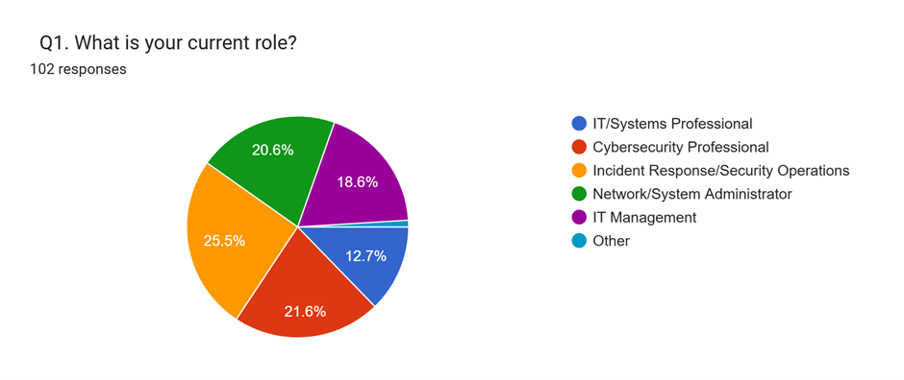

Figure 1: Participant current role
The respondent profile shows that the survey was able to get responses from respondents who have relevant professional backgrounds. The greatest number of respondents were in the Incident Response/Security Operations category (26, 25.49%). The 22 respondents (21.6%) were Cybersecurity Professionals, and the 21 respondents (20.6%) were Network/System Administrators. 19 people (18.6%) identified themselves as IT Management, and 13 (12.75%) identified as IT/Systems Professionals. A single respondent (0.98%) answered Other. The findings suggest that the sample was not purely focused within a single IT/cybersecurity sector, but rather spread across various roles.
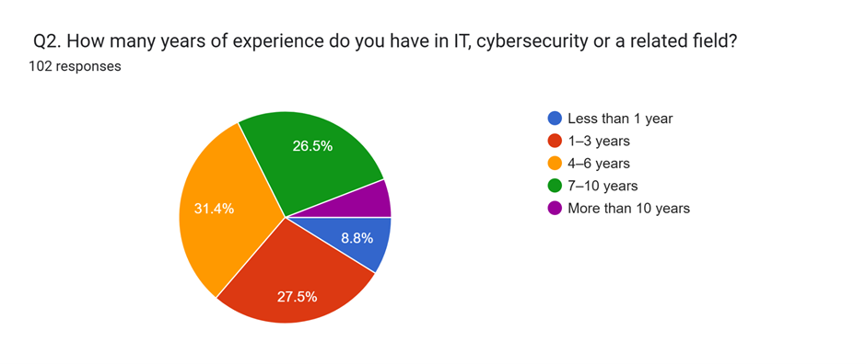

Figure 2: Years of experience
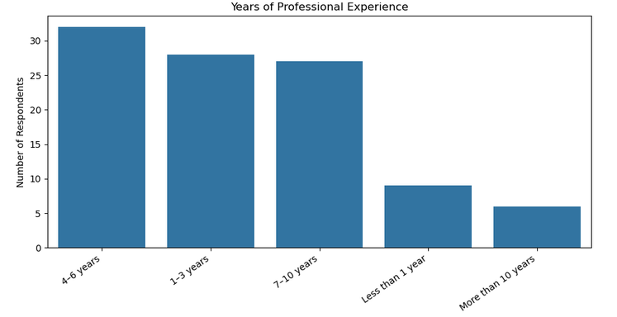

Figure 3: Years of experience developed in Python
As far as professional experience, 32 respondents (31.4%) had 4 to 6 years of experience. Twenty-eight respondents (27.45%) said they had one to three years of experience, and 27 (26.5%) had seven to 10 years of experience. 8.8% had less than one year of experience, and six (5.88%) had over 10 years of experience. Therefore, the respondents consisted of those with varying experience levels, with the majority having 4 to 6 years.
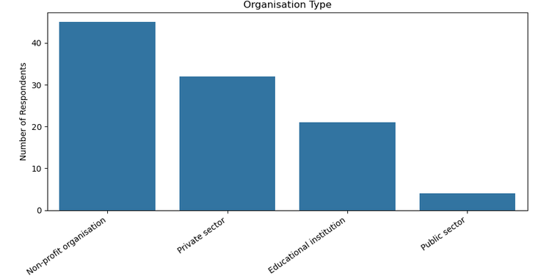

Figure 4: Organisation Type analysis via Python
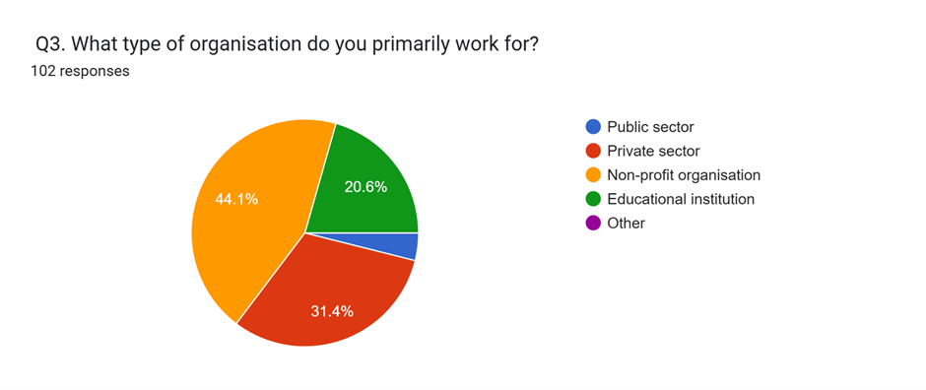

Figure 5: Organisation Type via survey
As regards the type of organisation, 45 respondents (44.1%) worked in non-profit organisations, 32 (31.4%) in the private sector, 21 (20.6%) in educational institutions and four (3.92%) in the public sector.
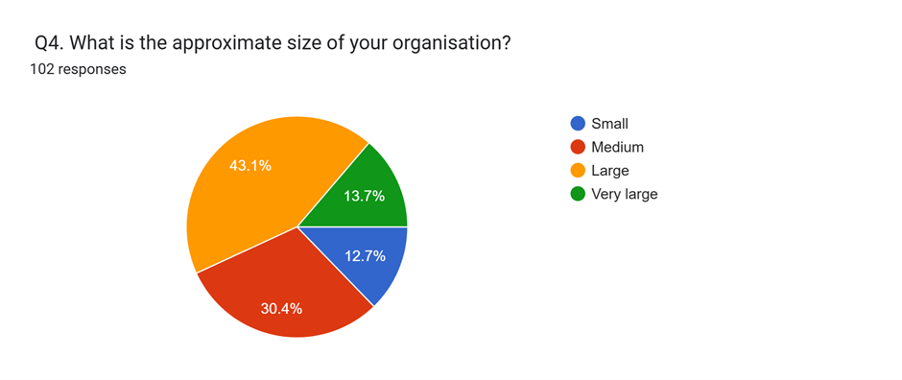

Figure 6: Organisational size
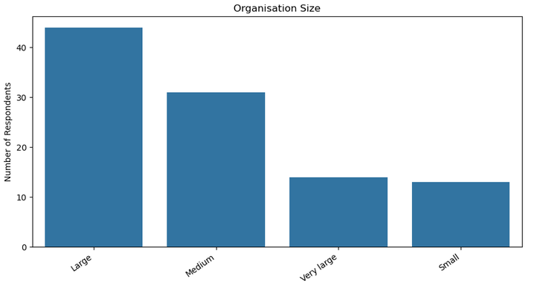

Figure 7: Organisational size analysis via python
In relation to organisational size, 44 respondents (43.1%) identified their organisation as large, 31 (30.4%) as medium, 14 (13.7%) as very large and 13 (12.7%) as small. This meant that there was a high percentage of respondents from medium and large organisations in the sample.
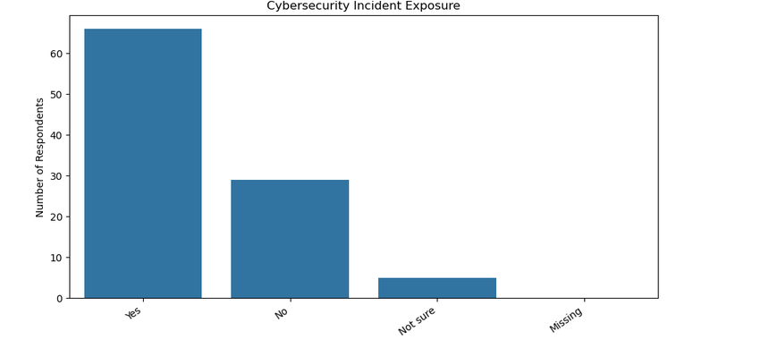

Figure 8: Cybersecurity Incident Exposure analysis in Python
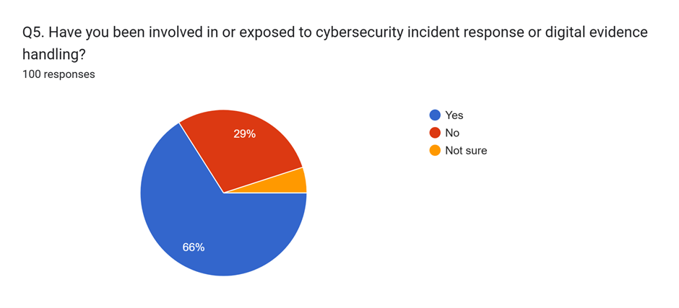

Figure 9: Cybersecurity Incident Exposure analysis via survey responses
Importantly, 66 respondents said they had been exposed to cybersecurity incident response and/or digital evidence handling. Twenty-nine respondents indicated that they did not experience such exposure; five respondents (4.90%) were not sure. This profile serves as a cogent basis to evaluate the perceptions of digital forensic readiness, as most of the respondents had some exposure to incident response or evidence handling.

4.3 Descriptive Statistics
The five composite constructs were calculated using descriptive statistics. The results give information regarding the central tendency, the dispersion and the distribution of respondents' perceptions. The mean scores of each construct were computed from the five items on the questionnaires.
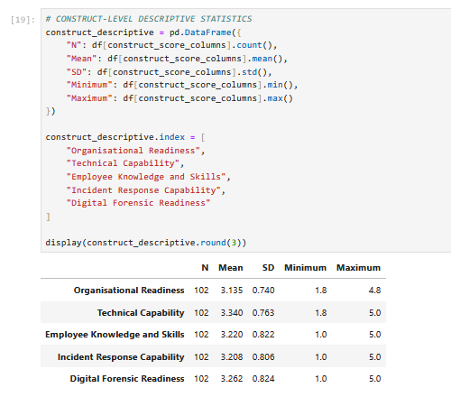

Figure 10: Construct-level descriptive statistics

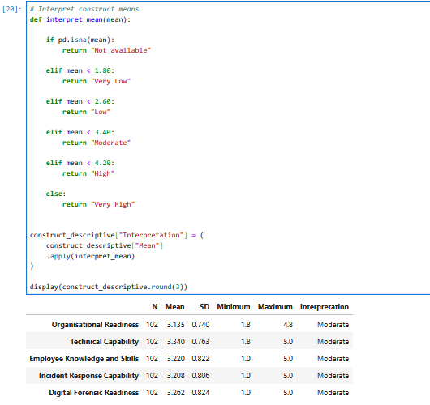

Figure 11: Interpret construct means
All mean scores are above the neutral value of 3.00. The technical capability had the highest mean score of 3.340, and Digital Forensic Readiness came in at 3.262. The means for Employee Knowledge and Skills were 3.220, and for Incident-Response Capability were 3.208. Organisational Readiness scored the lowest with a mean of 3.135. Based on these results, it appears that respondents do not have a very high level of agreement on any of the constructs related to capabilities and readiness of the organisation. The relatively highest score for Technical Capability indicates that some aspects of technical mechanisms (logging, monitoring, evidence collection, secure storage and access to relevant technologies) were viewed somewhat more favourably than the other dimensions. Relevance to digital forensic readiness: Technical evidence sources are an important aspect of the foundation of further investigation. In an incident investigation, identifying, collecting and preserving digital evidence is also important, as noted in NIST SP 800-86 (Kent et al., 2006). The digital forensic readiness (DFR) mean of 3.262 is significant, as it shows that overall readiness was slightly above the neutral point. The result does not reflect a very high degree of readiness. Rather, it proposes a moderate degree of perceived preparedness. This is in line with the conceptualisation of forensic readiness as an organisational capacity that not only involves investigation of an incident, but also preparation for the incident. Rowlingson (2004) believes that having forensic readiness means increasing an organisation's capacity to collect relevant evidence and reducing the cost and disturbance of investigations. The standard deviations are between 0.740 and 0.824. For Employee Knowledge and Skills and Digital Forensic Readiness, there is relatively more variation, suggesting that there is some variation amongst respondents in their perception of employee capability and overall forensic readiness. By contrast, Organisational Readiness has the lowest standard deviation, which indicates more uniform perceptions among respondents. The skewness values range from 0.069 to 0.657, while kurtosis ranges from -0.480 to 0.595. Thus, the distributions are not highly skewed or kurtotic. The software then employed both Pearson and Spearman correlation analyses, which were then contrasted as a comparison of linear and rank-based relationships.

4.4 Reliability Analysis
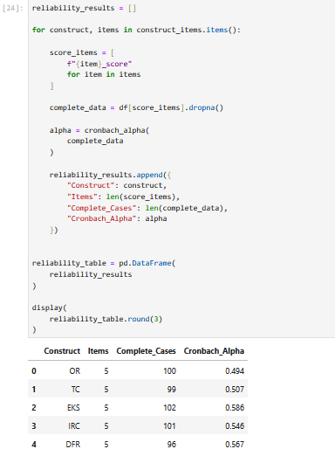

Figure 12: Reliability analysis
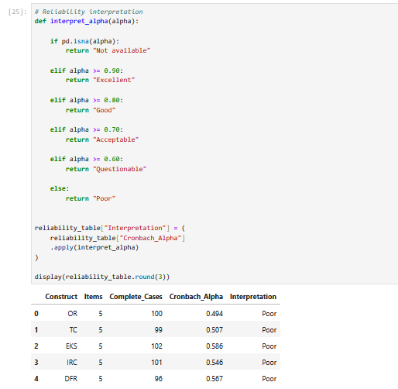

Figure 13: Reliability interpretation
The internal consistency for five multi-item constructs was assessed using Cronbach's alpha. There were five items in each construct. The alpha values are between 0.494 and 0.586 for Organisational Readiness and Employee Knowledge and Skills. The developed software identifies these values as being of poor internal consistency. The item-total analysis still indicates that the items of the questionnaire have positive corrected item-total correlations. For instance, the correlation of Organisational Readiness is from 0.223 to 0.386, and that of Technical Capability is from 0.185 to 0.421. The correlation of Employee Knowledge and Skills ranges from 0.243 to 0.416, while Incident-Response Capability ranges from 0.250 to 0.467, and DFR ranges from 0.283 to 0.421. These findings suggest that the items are directionally related, but there is not a high level of internal consistency. This should be recognised as a limitation of the empirical results. A possible explanation is that each construct represents multiple related but different aspects of organisational readiness. For instance, Technical Capability includes logging and monitoring, evidence collection, storage and forensic technologies. These individual skills may therefore be judged differently by the respondents. The reliability results also indicate that the results should be interpreted with appropriate caution. The relatively low alpha values mean that further refinement and testing of the questionnaire with larger sample sizes could create greater measurement consistency of the constructs.

4.5 Correlation Analysis
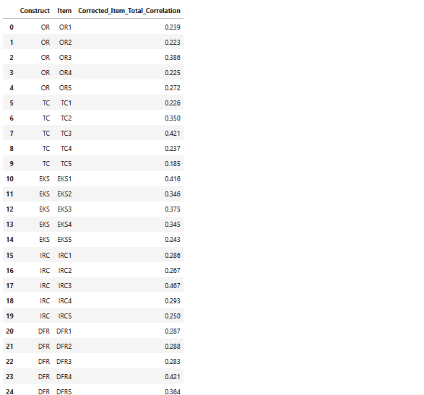

Figure 14: Item-total correlations
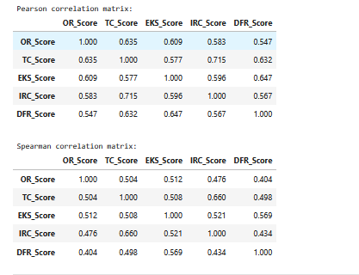

Figure 15: Pearson and Spearman Correlation
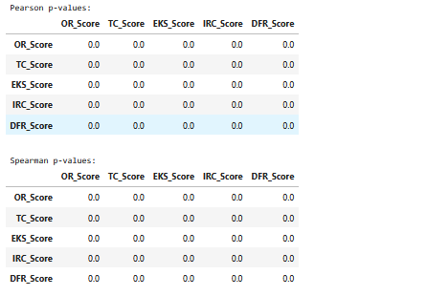

Figure 16: P value
The Pearson and Spearman correlation analyses were conducted to determine the relationships between the study constructs. All the Pearson correlation results indicate positive correlations between each pair of constructs. Organisational Readiness and Technical Capability was determined to be 0.635, and Organisational Readiness and Employee Knowledge and Skills was determined to be 0.609. There was also a positive correlation between Organisational Readiness and Digital Forensic Readiness (r = 0.547) and Incident-Response Capability (r = 0.583). In terms of Pearson correlations, Technical Capability was correlated with 0.577 with Employee Knowledge and Skills, 0.715 with Incident-Response Capability and 0.632 with Digital Forensic Readiness. Employee Knowledge and Skills had correlations of 0.596 with Incident-Response Capability and 0.647 with Digital Forensic Readiness. The correlation between Incident-Response Capability and Digital Forensic Readiness was r = 0.567. The highest Pearson correlation that was highest was between Technical Capability and Incident-Response Capability (r = 0.715). This means that those who said they were better at technical skills also said they were better at responding to incidents. The relationship is conceptually relevant since it is a component of effective incident response, which requires monitoring, logging, evidence sources and technical mechanisms. Employee Knowledge and Skills (r = 0.647), Technical Capability (r = 0.632), Incident-Response Capability (r = 0.567) and Organisational Readiness (r = 0.547) had the highest correlation with DFR. The findings show that the four factors measured are all positively related to perceived digital forensic readiness. The Spearman results are similar, but the coefficients are slightly lower. DFR correlated with EKS at 0.569, TC at 0.498, IRC at 0.434 and OR at 0.404. The pattern of positive relationships is supported by the consistency of Pearson and Spearman results.
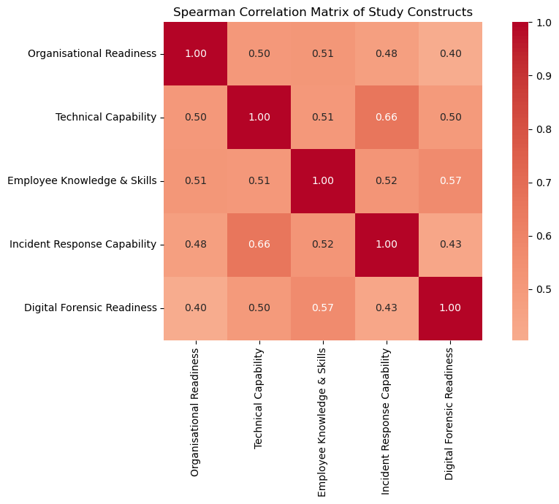

Figure 17: Correlation matrix
The results align with the conceptual discussion made in Chapter Two, which suggests that digital forensic readiness is not dependent on one technical mechanism. Instead, the dimensions of organisation, technical ability, and employee knowledge and incident-response arrangements are interconnected elements of preparedness. This is in line with previous research, where organisational, technical and human factors were identified as important factors in forensic readiness (Elyas et al., 2014; Elyas et al., 2015; Reddy and Venter, 2013).

4.6 Multiple Regression Analysis
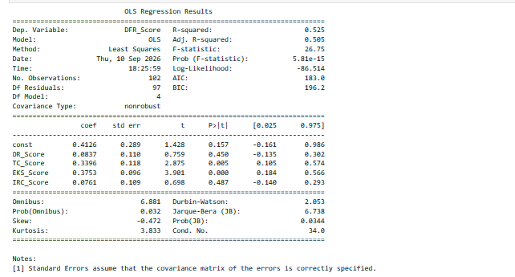
Figure 18: OLS Regression Results
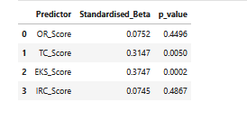

Figure 19: STANDARDISED BETA COEFFICIENTS
Multiple linear regression was used in order to see if Organisational Readiness, Technical Capability, Employee Knowledge and Skills, and Incident-Response Capability together predict Digital Forensic Readiness. The regression model used 102 complete cases and four predictors. The software that has been developed indicates that the sample size was deemed sufficient for the exploratory four-predictor analysis as defined by the benchmark in the notebook. The regression model had an R-squared of 0.525 and an adjusted R-squared of 0.505. Thus, the four predictors explained about 52.5% of the variance in observed Digital Forensic Readiness, and the adjusted value suggests that about 50.5% of the variance remains explained after adjusting for the number of predictors. The overall F-statistic was 26.749, with p < .001. The model is thus statistically significant. Technical Capability is statistically significant (p = 0.005) and has a positive coefficient of 0.3396. An estimated 0.340-unit increase in DFR is associated with a one-unit increase in Technical Capability, when the other variables are held constant. The coefficient of Employee Knowledge and Skills is 0.3753, and it is also statistically significant at p<0.001. Within this model, it has a standardised beta of 0.3747, which is higher than that of Technical Capability (β = 0.3147). Organisational Readiness and Incident-Response Capability were not statistically significant in the multivariable model and had positive coefficients. Organisational Readiness is at p = 0.450, and Incident-Response Capability is at p = 0.487. This does not mean that there are no relationships between these variables and DFR. Instead, the value of each of their contributions is not statistically different from zero when the other predictors are also in the model. One interesting fact is the discrepancy between the results of the correlation and the results of the regression. For instance, the bivariate relationship between Organisational Readiness and DFR is moderately positive (r = 0.547), but the regression coefficient is not significant. This may happen when the predictors are overlapping. The correlation matrix indicates that there are significant positive correlations between the independent variables, especially between Technical Capability and Incident-Response Capability (r = 0.715). So, regression coefficients should be interpreted as unique relationships, and not as simple associations.

4.7 Regression Diagnostics
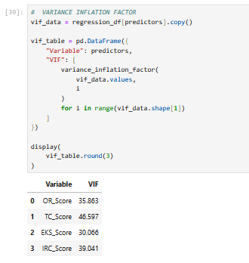

Figure 20: VARIANCE INFLATION FACTOR
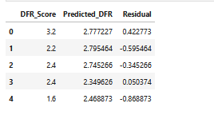

Figure 21: Regression residuals
Multicollinearity was also tested using developed software, where VIF was used. VIF values for Organisational Readiness, Technical Capability, Employee Knowledge and Skills and Incident-Response Capability were 35.863, 46.597, 30.066 and 39.041, respectively. The values are quite high and suggest high levels of multicollinearity among the predictors. This is consistent with the Pearson correlation matrix, where the independent variables have moderate to strong positive relationships. So, individual regression coefficients are to be taken cautiously. The high VIF values are an important reason why some predictors are moderately associated with DFR in bivariate analyses while they are not statistically significant in multivariate analyses.
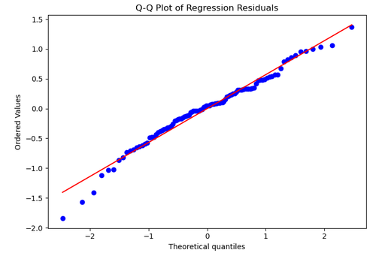

Figure 22: Q-Q Plot of Regression Residuals
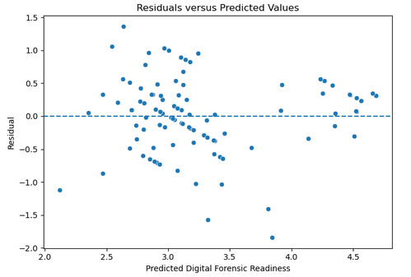

Figure 23: Residuals vs fitted values
The residual diagnostics give more details on the model behaviour. The regression results show a Durbin-Watson statistic of 2.053, meaning that the cross-sectional data is not obviously subject to residual autocorrelation. The residual-versus-fitted plot was also generated by the software as part of the diagnostic process. These diagnostics suggest that the regression model should be used as an exploratory model and not as definitive proof of a fully validated predictive model.

4.8 Discussion of Findings
The results indicate that there are organisational, technical, human and incident-response characteristics associated with digital forensic readiness. The descriptive results indicated that for all five constructs measured, there was a mean score above the neutral score, but the scores were relatively moderate. This implies that the respondents had some level of organisational preparation, but it was not uniformly high. The descriptive mean for Technical Capability was the highest of all the variables, and it was also a significant factor of DFR in the regression model. This is another confirmation of the significance of technical infrastructure in forensic preparedness. If an organisation does not have the ability to securely store and collect evidence and to monitor and log events, it can be hard to reconstruct what has happened after an incident with a cybersecurity. This is consistent with the principles of evidence preservation and collection that Kent et al. (2006) discuss and consistent with the literature on organisational forensic readiness that is discussed by Reddy and Venter (2013). The strongest Pearson correlation with DFR and the strongest standardised regression coefficient were for Employee Knowledge and Skills. This means that the human dimension is one of the factors that plays an important role in forensic readiness. The technical systems will not be effective in the proper handling of evidence unless employees identify potentially relevant evidence, comprehend preservation needs, and understand how to report. This is in line with the literature outlined in Chapter Two, which highlights the need for staff awareness, training and proper handling of digital evidence. Also noteworthy about the role is Incident-Response Capability. The unique regression coefficient for IRC is not statistically significant, but the correlation is moderately positive (r = 0.567) with DFR. This can suggest that there's a large degree of overlap between incident response and forensic readiness and technical and employee skills. Organisations with robust incident-response processes could also be more likely to have a cogent technical infrastructure and better-trained employees. The high VIF values strengthen the interpretation of the high connection between the predictors. Organisational Readiness has a moderate positive bivariate relationship with DFR and a non-significant unique contribution to the regression model. It is not to be taken as a sign that the issue of management support or organisational coordination is irrelevant. Rather, the finding indicates that their impact could be reflected via technical and employee skills. The impact of management support can be less evident when these related variables are included at the same time. The regression model accounts for 52.5% of the variation in DFR. This is a significant percentage for an exploratory survey model, but the magnitude of the multicollinearity and the relatively low reliability coefficients must be taken into account and should not be considered as proof of a causal relationship. Another limitation of the cross-sectional research design is that it can only detect statistical relationships and not temporal causality. The results thus corroborate the main research hypothesis, which holds that digital forensic readiness is an organisational capability with multiple related dimensions. In particular, the results emphasise the significance of technical ability and knowledge and skills of employees at present in the dataset. The results also show that these factors are not independent of each other, as the technical capability of the organisation is closely linked with its readiness, employee skills closely with its incident-response capability, and employee skills are closely linked with its incident-response capability.

4.9 Findings related to the research questions
The first research question was: What are the organisational, technical and procedural issues that impact on digital forensic readiness? The findings indicate positive relationships between all four of the explanatory constructs and DFR. Technical Capability and Employee Knowledge and Skills were statistically significant predictors in the regression model, and Organisational Readiness and Incident-Response Capability were positively associated with DFR, but did not have statistically significant effects. The second research question was about the readiness of organisations to collect, preserve and analyse digital evidence. The DFR mean is 3.262, suggesting a moderate readiness perception. The findings indicate that generally respondents identified some level of organisational readiness, but are not consistent with the sample being highly developed in terms of forensic readiness. The third research question explored the relationships between organisational readiness, technical capability, employee knowledge, incident-response capability and DFR. These constructs have clear evidence of positive relationships, as shown in the correlation analysis. The regression analysis also shows that the variables Technical Capability and Employee Knowledge and Skills are important to the explanation of DFR when they are added together. The fourth research question was about how organisations can enhance their preparedness for forensic and cyber incident investigations. The empirical results indicate that the improvement should focus on enhancing the technical evidence skills and building employee knowledge and skills while retaining and maintaining an appropriate organisation's coordination and incident response processes. These implications are derived from the descriptive, correlation and regression findings and do not require any statement of a one-factor determinant relationship between the readiness.

4.10 Chapter Summary
The quantitative survey analysis presented the results in this chapter. A total of 102 responses were received from a cross-section of IT and cybersecurity practitioners with varied roles and levels of experience. Moderate levels were observed in the descriptive statistics of Organisational Readiness, Technical Capability, Employee Knowledge and Skills, Incident-Response Capability and Digital Forensic Readiness. The reliability analysis gave Cronbach's alpha scores ranging from 0.494 to 0.586, suggesting low internal consistency and therefore, caution should be exercised when interpreting the results. Positive correlations were found between all the measured constructs and DFR using Pearson and Spearman correlation analyses. The model was statistically significant (R² = 0.525 and adjusted R² = 0.505) in multiple regression. The predictors that were significant were Technical Capability and Employee Knowledge and Skills; Organisational Readiness and Incident-Response Capability were not significant. Multicollinearity among the predictors was identified through the diagnostic analysis and was found to be substantial (high VIF values). Thus, the regression results are suggestive of relationships, but not necessarily causal effects. Also, the results show that digital forensic readiness is a multi-dimensional organisational competence, while in the current dataset technical capability and knowledge and skills of employees are of particular importance. The findings serve as the empirical evidence to support the conclusions and recommendations in the next chapter.

5. Chapter 5: Conclusion, Recommendations and Future Work

5.1 Conclusion
The study employed a quantitative survey-based approach to assess the readiness of the digital forensic aspect in organisations. The study analysed the correlation between organisational readiness, technical capability, employee knowledge and skills, incident-response capability and overall digital forensic readiness. A total of 102 respondents were included in the analysis of data by descriptive statistics, reliability analysis, correlation analysis and multiple linear regression. The results showed that the digital forensic readiness was perceived at a moderate level with an average score of 3.262 on a five-point Likert scale. The highest mean was for Technical Capability (3.340), followed by Employee Knowledge and Skills (3.220), Incident-Response Capability (3.208) and Organisational Readiness (3.135), with the remaining constructs showing means between 2.725 and 2.984. These results indicate that there is some current capacity within the sample to assist with digital investigations; yet there is still room for improvement in forensic preparedness within the organisations. Positive associations were found in the correlation analysis with respect to all the measured factors with Digital Forensic Readiness. The regression model was overall statistically significant and accounted for 52.5% of the variance in Digital Forensic Readiness (R² = 0.525). Technical Capability and Employee Knowledge and Skills were important individual predictors, while Organisational Readiness and Incident-Response Capability did not contribute to the prediction significantly beyond the other factors. Thus, the findings suggest that the technical infrastructure is an important dimension of digital forensic readiness as well as the capability of employees in the study sample. The results should be interpreted with reference to the reliability and regression diagnostics. The internal consistency of the constructs varied from Cronbach's α of 0.494 to 0.586. Furthermore, the high values of VIF showed high multicollinearity among the explanatory variables. Causal conclusions are also not possible from the cross-sectional design. Thus, the study does not offer any causal evidence, but rather associations and predictive relationships in the sample. Also, the study highlights that digital forensic readiness is a multi-dimensional capability of an organisation that encompasses technical capabilities, employee awareness, organisational structures, and incident response procedures.

5.2 Recommendations
On the basis of the results, organisations should enhance their technical skills in collecting and preserving digital evidence. This involves maintaining proper security and system logs, installing proper monitoring systems, maintaining proper evidence storage and availing appropriate technologies for evidence collection and investigation. Review logging and monitoring procedures regularly to ensure that relevant evidence is available if incidents arise. Employee knowledge and skills should also be a focus of organisations. Regular training should cover the identification of potential digital evidence, evidence preservation, incident reporting and appropriate escalation procedures. In addition to training for those dedicated to cybersecurity, training should be offered to employees whose actions could impact evidence preservation during an incident. Incident-response procedures and forensic-readiness should be more closely aligned. Incident-response teams need to be aware of the time and circumstances for evidence preservation, and the ways in which containment activities can be conducted without destroying potentially relevant evidence. This integration can be facilitated by having clear roles and communication channels. Management should also ensure that there is adequate organisational support and resources for digital forensic readiness. Policies, responsibilities and procedures should be periodically reviewed to ensure forensic preparedness is aligned to evolving threats, technologies and organisational needs. Also, there needs to be a continuous improvement process within the organisation. Previous cybersecurity incidents should be used as a basis for reviewing the logging, evidence-preservation, employee training, and incident-response procedures. This can assist organisations in understanding their weaknesses ahead of the next incident.

5.3 Future Work
A larger and more diverse sample should be used in future research to enhance the generalisability of the findings. A larger sample would also give more power to test relationships between constructs and would enable more powerful modelling of the relationships in a multivariable model. Future studies might take a longitudinal approach to investigating how digital forensic readiness evolves over time after technology, training, policies and incident-response processes. Qualitative interviews with cyber security managers, forensic investigators and incident-response personnel also might supplement survey results if they offer more in-depth explanations on organisational practices. The questionnaire needs to be further developed and tested for consistency of internal items, as the present reliability data suggest limited internal consistency. Additional items, expert review and pilot testing could be used to improve construct measurement. Future research could also explicitly include forensic policy and procedures as a separate measured construct and test the relationship with the digital forensic readiness in addition to the organisational, technical, human and incident-response factors. Also, further research might be conducted to test the proposed relationships between the organisations by sector and size. Comparative research between public, private, educational and non-profit organisations could help indicate if there is a difference in digital forensic readiness based on context and resources.

References
Alenezi, A., Atlam, H.F. and Wills, G.B., 2019. Experts reviews of a cloud forensic readiness framework for organizations. Journal of Cloud Computing, 8(1), p.11. https://link.springer.com/article/10.1186/s13677-019-0133-z
Bankole, F.O., Taiwo, A.A. and Claims, I. (2022) ‘An extended digital forensic readiness and maturity model’, Forensic Science International: Digital Investigation, 40, 301348. https://www.sciencedirect.com/science/article/abs/pii/S2666281722000178
Casey, E., 2011. Digital evidence and computer crime: Forensic science, computers, and the internet. Academic press. https://books.google.com/books?hl=en&lr=&id=lUnMz_WDJ8AC&oi=fnd&pg=PP1&dq=Casey,+E.+(2011)+Digital+Evidence+and+Computer+Crime:+Forensic+Science,+Computers+and+the+Internet.+3rd+edn.+Waltham,+MA:+Academic+Press.&ots=aMw8IhyNVe&sig=DB_dqDH_-cpjS260STniivxAfQ4
Elyas, M., Maynard, S.B., Ahmad, A. and Lonie, A., 2014. Towards a systemic framework for digital forensic readiness. Journal of Computer Information Systems, 54(3), pp.97-105. https://www.tandfonline.com/doi/abs/10.1080/08874417.2014.11645708
Elyas, M., Ahmad, A., Maynard, S.B. and Lonie, A., 2015. Digital forensic readiness: Expert perspectives on a theoretical framework. Computers & Security, 52, pp.70-89. https://www.sciencedirect.com/science/article/pii/S0167404815000449
Endicott, B., Popovsky, N.K. and Rudolph, C., 2015. Forensic readiness: Emerging discipline for creating reliable and secure digital evidence. Journal of Harbin Institute of Technology (New Series), 22(1), pp.99-106. https://www.researchgate.net/profile/Barbara-Endicott-Popovsky/publication/282202952_Forensic_readiness_Emerging_discipline_for_creating_reliable_and_secure_digital_evidence/links/5669acc008aea0892c49b460/Forensic-readiness-Emerging-discipline-for-creating-reliable-and-secure-digital-evidence.pdf
Grobler, C.P. and Louwrens, C.P., 2007, May. Digital forensic readiness as a component of information security best practice. In IFIP International Information Security Conference (pp. 13-24). Boston, MA: Springer US. https://link.springer.com/chapter/10.1007/978-0-387-72367-9_2
Herman, M., Iorga, M., Salim, A.M., Jackson, R.H., Hurst, M.R., Leo, R.A., Mishra, A.K., Landreville, N.M. and Wang, Y., 2024. Forensic Reference Architecture. https://nvlpubs.nist.gov/nistpubs/SpecialPublications/NIST.SP.800-201.pdf
Hoolachan, S.A. and Glisson, W.B., 2010. Organizational handling of digital evidence. https://commons.erau.edu/adfsl/2010/wednesday/7/
Kent, K., Chevalier, S. and Grance, T., 2006. Guide to integrating forensic techniques into incident. Guide to Integrating Forensic Techniques into Incident Response, pp.800-86. https://nvlpubs.nist.gov/nistpubs/legacy/sp/nistspecialpublication800-86.pdf?
Mouhtaropoulos, A., Grobler, M. and Li, C.T., 2011, September. Digital forensic readiness: an insight into governmental and academic initiatives. In 2011 European Intelligence and Security Informatics Conference (pp. 191-196). IEEE. https://ieeexplore.ieee.org/abstract/document/6061177/
Reddy, K. and Venter, H.S., 2013. The architecture of a digital forensic readiness management system. Computers & security, 32, pp.73-89. https://www.sciencedirect.com/science/article/pii/S0167404812001447
Rowlingson, R., 2004. A ten step process for forensic readiness. International Journal of Digital Evidence, 2(3), pp.1-28. https://www.utica.edu/academic/institutes/ecii/publications/articles/A0B13342-B4E0-1F6A-156F501C49CF5F51.pdf
Tan, J., 2001. Forensic readiness. Cambridge, MA:@ Stake, 1, p.148. https://home.engineering.iastate.edu/~guan/course/CprE-536/paperreadinglist920/forensic_readiness.pdf
Whyte, D. and Claims, I. (2012) ‘Digital forensics readiness commonalities framework’. https://www.researchgate.net/publication/353659909_Review_on_Digital_Forensic_Framework_and_Its_Applicability_in_Organization#pf7
Saunders, M., Lewis, P. and Thornhill, A. (2019) Research Methods for Business Students. 8th edn. Harlow: Pearson. https://www.researchgate.net/publication/240218229_Research_Methods_for_Business_Students/link/66caf9f575613475fe7891e4/download?_tp=eyJjb250ZXh0Ijp7ImZpcnN0UGFnZSI6InB1YmxpY2F0aW9uIiwicGFnZSI6InB1YmxpY2F0aW9uIn19
Creswell, J.W. and Creswell, J.D. (2018) Research Design: Qualitative, Quantitative, and Mixed Methods Approaches. 5th edn. Thousand Oaks, CA: SAGE Publications. https://www.ucg.ac.me/skladiste/blog_609332/objava_105202/fajlovi/Creswell.pdf

Appendix 1: Survey Responses


