ESSENTIAL SKILLS FOR STUDY AND EMPLOYMENT
In the busy and fast-paced world that we are living today, whether studying or working, an individual should be able to develop a set of skills that will help him/her to be more efficient in their activities. Nowadays, this essential set of skills is mostly associated with technology and digitalization. Therefore, to be a successful student or professional, one should be equipped with the right personality and digital skills.
The personality skills which are essential for studying have been summarized by Stella Cotrell in her book The study skills handbook (2019) describes the C-R-E-A-M strategy for learning:
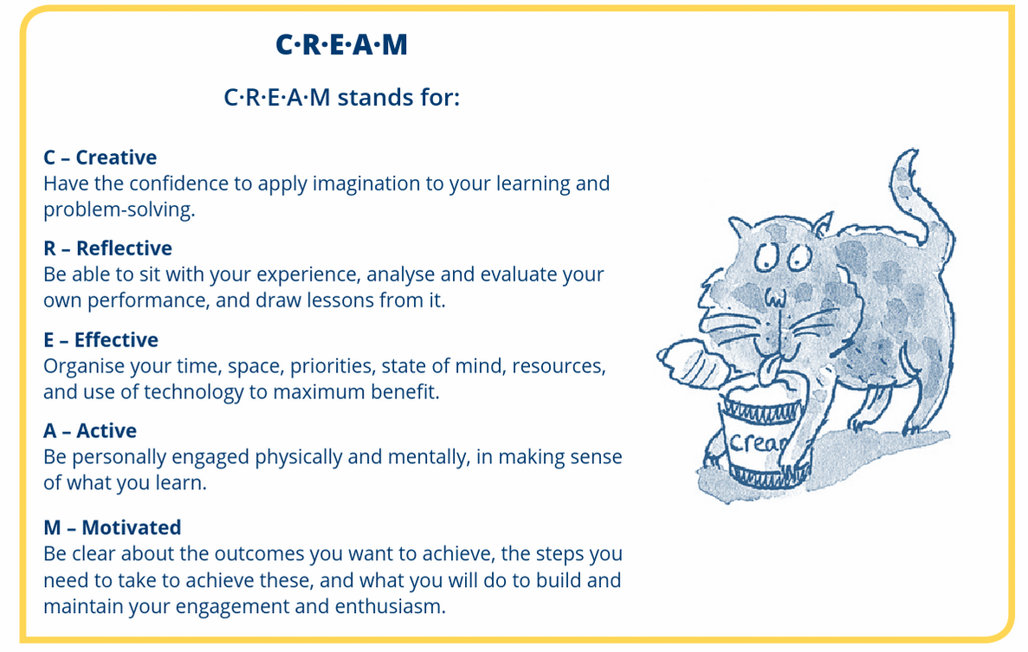
Figure 1: The C-R-E-A-M Strategy (The Study skills handbook, Macmillian Education UK, 2019)
The above picture covers the main aspects of a successful learning and at the same time the above skills are essential to a working environment as well. For example, creativity is directly related to problem solving while studying or working, because it allows one to see a problem from a different perspective and subsequently find a solution for it. To be reflective means being able to analyze one’s experience and draw conclusions from it – this can be applied to both studies and work. Being effective is about time management and using all resources (both online and offline) to a maximum benefit. Effectiveness is very similar to being organized. In the article published on Indeed.com, 9 Ways to Improve Your Personal Development Skills, organization skills are described as “your ability to plan, schedule and prioritize” and “Good organization skills can help save time, prevent miscommunications and improve efficiency.”
Digital skills are another part of the essential skill set for successful work and studying. According to Elizabeth Marsh, a Digital Workplace Skills Framework can be developed and it consists of four elements:
- Reflecting on and adapting one’s digital practices
- Finding, processing and applying information
- Creating content and connecting with people
- Using the digital workplace competently and safely
The importance and development of digital skills occupations can be seen in the following graphs:
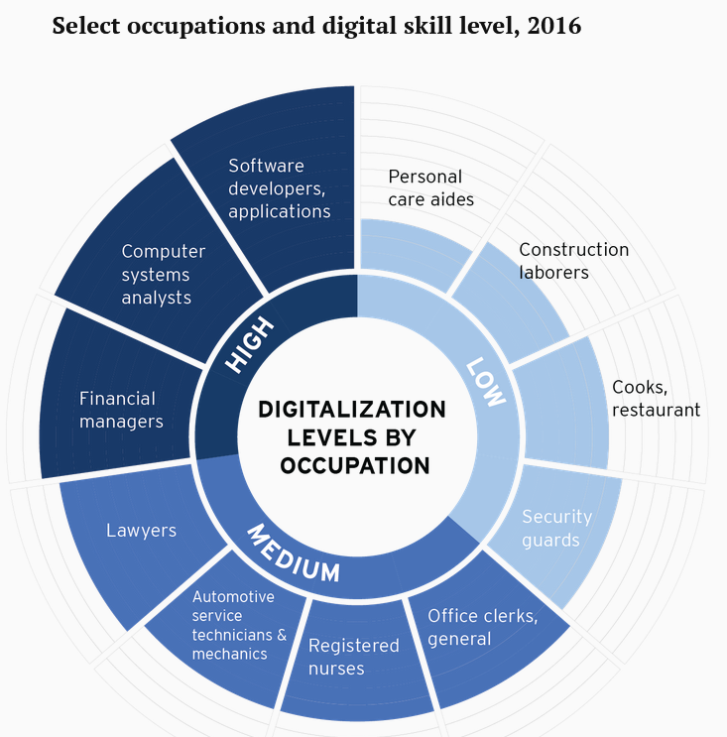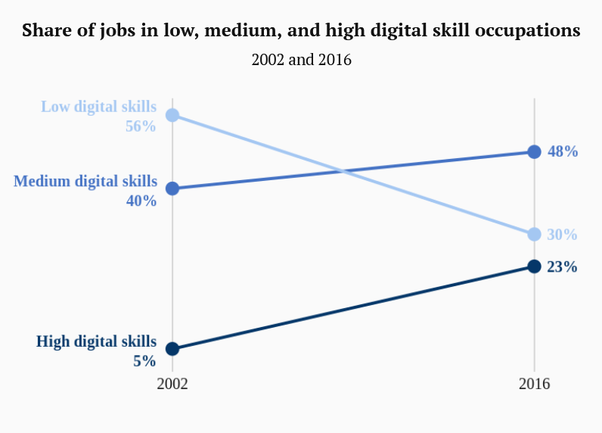

The importance of digital skills can further be emphasized by the UK figures for demand by skill level in 2017:
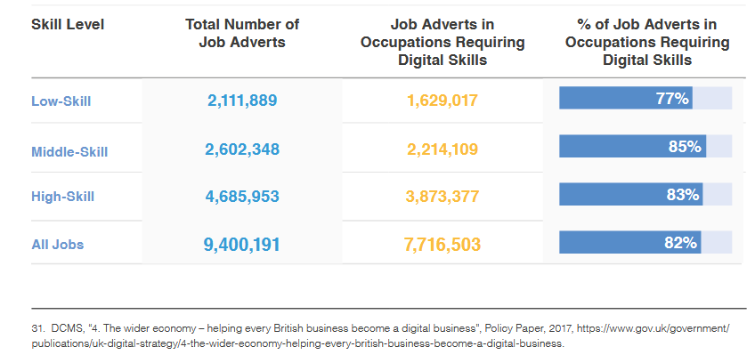
Figure 2: Demand by skill level in UK in 2017
The specific digital skills needed for everyday life are:
- Finding, managing, and storing information
- Communicating and collaborating with others
- Solving problems and finding solutions using digital tools
- Creating basic digital content
As a conclusion, the essential skills for study and employment are a combination of personal development and digital skills. The development of both types of skills determines the success of the individual in studying or employment.

S. Cotrell, The Study skills handbook, Macmillian Education UK, 2019, p.89
Ineed.com, “9 Ways to improve your personal development skills”, https://www.indeed.com/career-advice/career-development/improve-your-personal-development-skills (accessed Jun 16, 2021)
E. Marsh, Digital Workplace Skills Framework: Ensuring the workforce is ready to work digitally, Digital Work Research 2018, p.3
M. Muro et al., “Digitalization and the American Workforce”, https://www.brookings.edu/research/digitalization-and-the-american-workforce/ (accessed Jun 17, 2021)
J. Hania et al., “No longer optional: Employer demand for digital skills”, June 2019 , [Online], Available: https://assets.publishing.service.gov.uk/government/uploads/system/uploads/attachment_data/file/807830/No_Longer_Optional_Employer_Demand_for_Digital_Skills.pdf
Digital skills for everyday life, The Open University, https://www.open.edu/openlearn/ocw/mod/oucontent/view.php?id=105152&section=3

