Appendices

APPLICATION FOR ETHICAL APPROVAL

RESEARCH STUDENTS
This form is to be completed by the student within SIX months for full-time students and TWELVE months for part time students, after the commencement of the research degree or following progression to Part Two of your course.

Once complete, submit this form via the MyTSD Doctoral College Portal at (https://mytsd.uwtsd.ac.uk).

This document is also available in Welsh.

RESEARCH STAFF ONLY
All communications relating to this application during its processing must be in writing and emailed to pgresearch@uwtsd.ac.uk , with the title ‘Ethical Approval’ followed by your name.

STUDENTS ON UNDERGRADUATE OR TAUGHT MASTERS PROGRAMMES should submit this form (and receive the outcome) via systems explained to you by the supervisor/module leader.

In order for research to result in benefit and minimise risk of harm, it must be conducted ethically. A researcher may not be covered by the University’s insurance if ethical approval has not been obtained prior to commencement.

The University follows the OECD Frascati manual definition of research activity: “creative work undertaken on a systematic basis in order to increase the stock of knowledge, including knowledge of man, culture and society, and the use of this stock of knowledge to devise new applications”. As such this covers activities undertaken by members of staff, postgraduate research students, and both taught postgraduate and undergraduate students working on dissertations/projects.

The individual undertaking the research activity is known as the “principal researcher”.

Ethical approval is not required for routine audits, performance reviews, quality assurance studies, testing within normal educational requirements, and literary or artistic criticism.

Please read the notes for guidance before completing ALL sections of the form.

This form must be completed and approved prior to undertaking any research activity. Please see Checklist for details of process for different categories of application.

SECTION A: About You (Principal Researcher)
1 | Full Name: |  | Hollie Mathias
2 | Tick all boxes that apply: |  | Member of staff: | ☐ | Honorary research fellow: | ☐
 | Undergraduate Student | ☒ | Taught Postgraduate Student | ☐ | Postgraduate Research Student | ☐

3 | Institute/Academic Discipline/Centre: | University of Wales Trinty Saint David
4 | Campus: | Carmarthen
5 | E-mail address: | 2000663@student.uwtsd.ac.uk
6 | Contact Telephone Number: | 07902909619
 | For students:
7 | Student Number: | 2000663
8 | Programme of Study: | Primary Education with QTS
9 | Director of Studies/Supervisor: | Nicola Evans

SECTION B: Approval for Research Activity
1 | Has the research activity received approval in principle?  (please check the Guidance Notes as to the appropriate approval process for different levels of research by different categories of individual) |  | YES | ☒ | NO | ☐
 |  |  |  |  | Date
2 | If Yes, please indicate source of approval (and date where known): Approval in principle must be obtained from the relevant source prior to seeking ethical approval | Research Degrees Committee |  | ☐
2 |  | Institute Research Committee |  | ☐
2 |  | Other (write in)  Julia Holloway, Module Lead |  | ☒ | 5/12/22

SECTION C: Internal and External Ethical Guidance Materials
 | Please list the core ethical guidance documents that have been referred to during the completion of this form (including any discipline-specific codes of research ethics, location-specific codes of research ethics, and also any specific ethical guidance relating to the proposed methodology). Please tick to confirm that your research proposal adheres to these codes and guidelines. You may add rows to this table if needed.
1 | UWTSD Research Ethics & Integrity Code of Practice | ☒
2 | UWTSD Research Data Management Policy | ☒
3 | [List any other relevant documents here]  UWTSD Code of Ethics here BERA (2018) | ☒

SECTION D: External Collaborative Research Activity
If there are external collaborators then you should gain consent from the contact persons to share their personal data with the university. If there are no external collaborators then leave this section blank and continue to section E.
1 | Institution
2 | Contact person name
3 | Contact person e-mail address
4 | Is your research externally funded? |  | YES | ☐ | NO |  | ☒
5 | Are you in receipt of a KESS scholarship? |  | YES | ☐ | NO |  | ☒
6 | Are you specifically employed to undertake this research in either a paid or voluntary capacity? | Voluntary | YES | ☐ | NO | ☒
7 |  | Employed | YES | ☐ | NO | ☒
8 | Is the research being undertaken within an existing UWTSD Athrofa Professional Learning Partnership (APLP)? | If YES then the permission question below does not need to be answered. | YES | ☐ | NO |  | ☒
9 | Has permission to undertake the research has been provided by the partner organisation? | (If YES attach copy)  If NO the application cannot continue | YES | ☐ | NO |  | ☒

Where research activity is carried out in collaboration with an external organisation
10 | Does this organisation have its own ethics approval system? | YES | ☐ | NO | ☒
 | If Yes, please attach a copy of any final approval (or interim approval) from the organisation (this may be a copy of an email if appropriate).

SECTION E: Details of Research Activity
1 | Indicative title: | An exploratory case study arising from practice (noticing) and investigated further through identified research tools. The assignment concludes with the identification of an intervention which can be piloted throughout Professional Teaching Experience and evidenced through reflection in the Professional Learning Standards (professional learning standards).
2 | Proposed start date: | 17th January 2023 | Proposed end date: | 28th January 2023
Introduction to the Research (maximum 300 words per section)
Ensure that you write for a Non-Specialist Audience when outlining your response to the points below:
- Purpose of Research Activity
- Proposed Research Question
- Aims of Research Activity
- Objectives of Research Activity
Demonstrate, briefly, how Existing Research has informed the proposed activity and explain
- What the research activity will add to the body of knowledge
- How it addresses an area of importance.
3 | Purpose of Research Activity  - To gain an understanding on whether the schools behaviour management technique ‘it’s good to be green’ is effective.  (this box should expand as you type)
4 | Research Question  What are year one pupils experiences of the behaviour management technique ‘it’s good to be green’…?  (this box should expand as you type)
5 | Aims of Research Activity  - Gain an understanding on children’s and staff perceptions on the behaviour management technique used,  - Gain feedback from teachers on whether they feel it works well.  - Gain an understanding on if a pupils learning, and well-being is affected  (this box should expand as you type)
6 | Objectives of Research Activity  - Interview children on how they feel about the behaviour management techniques and whether they feel they like it.  - Questionnaires will be sent to staff around the school asking on their perceptions on the behaviour management techniques  (this box should expand as you type)
Proposed methods (maximum 600 words)
Provide a brief summary of all the methods that may be used in the research activity, making it clear what specific techniques may be used. If methods other than those listed in this section are deemed appropriate later, additional ethical approval for those methods will be needed. You do not need to justify the methods here but should instead describe how you intend to collect the data necessary for you to complete your project.
7 | - Interviewing the children to evaluate their understanding on the behaviour strategies/techniques and whether they like the strategy used.  - Questionnaires will be used to gain teachers understanding on the behaviour management techniques, looking closely on their strategy ‘it’s good to be green’  I have chosen to use these methods because I feel they are the most suitable to my research topic. When interviewing children, I can tailor my questions for them to be suitable for the children. They are a quick and easy method which can allow me to gather in depth answers and their own opinion on the topic. They are really cost-effective and can be carried out over a short space of time. Questionnaires are a really good tool to use as they allow people to remain confidential and not share which answers are theirs. They are the most appropriate for this research topic as I feel they are the quickest tool to use and can provide me with broaden and in-depth answers.  (this box should expand as you type)
Location of research activity
Identify all locations where research activity will take place.
8 | - The research activity will be conducted in a fairly large primary school in an affluent area of South Wales  (this box should expand as you type)
Research activity outside of the UK
If research activity will take place overseas, you are responsible for ensuring that local ethical considerations are complied with and that the relevant permissions are sought. Specify any local guidelines (e.g. from local professional associations/learned societies/universities) that exist and whether these involve any ethical stipulations beyond those usual in the UK (provide details of any licenses or permissions required). Also specify whether there are any specific ethical issues raised by the local context in which the research activity is taking place, for example, particular cultural and/or legal sensitivities or vulnerabilities of participants. If you live in the country where you will do the research then please state this.
9 | Not Applicable  (this box should expand as you type)

10 | Use of documentation not in the public domain: Are any documents NOT publicly available? | NO | ☒
10 |  | YES | ☐
11 | If Yes, please provide details here of how you will gain access to specific documentation that is not in the public domain and that this is in accordance with the current data protection law of the country in question and that of England and Wales.  (this box should expand as you type)

 | Does your research relate to one or more of the seven aims of the Well-being of Future Generations (Wales) Act 2015? | YES | NO
12 | A prosperous Wales | ☐ | ☒
13 | A resilient Wales | ☐ | ☒
14 | A healthier Wales | ☐ | ☒
15 | A more equal Wales | ☐ | ☒
16 | A Wales of cohesive communities | ☐ | ☒
17 | A Wales of vibrant culture and thriving Welsh language | ☐ | ☒
18 | A globally responsible Wales | ☐ | ☐
19 | If YES to any of the above, please give details:
 | (this box should expand as you type)

SECTION F: Scope of Research Activity
 | Will the research activity include: | YES | NO
1 | Use of a questionnaire or similar research instrument? | ☒ | ☐
2 | Use of interviews? | ☒ | ☐
3 | Use of focus groups? | ☒ | ☐
4 | Use of participant diaries? | ☐ | ☒
5 | Use of video or audio recording? | ☒ | ☐
6 | Use of computer-generated log files? | ☐ | ☒
7 | Participant observation with their knowledge? | ☐ | ☒
8 | Participant observation without their knowledge? | ☐ | ☒
9 | Access to personal or confidential information without the participants’ specific consent? | ☐ | ☒
10 | Administration of any questions, test stimuli, presentation that may be experienced as physically, mentally or emotionally harmful / offensive? | ☐ | ☒
11 | Performance of any acts which may cause embarrassment or affect self-esteem? | ☐ | ☒
12 | Investigation of participants involved in illegal activities? | ☐ | ☒
13 | Use of procedures that involve deception? | ☐ | ☒
14 | Administration of any substance, agent or placebo? | ☐ | ☒
15 | Working with live vertebrate animals? | ☐ | ☒
16 | Procedures that may have a negative impact on the environment? | ☐ | ☒
17 | Other primary data collection methods. Please indicate the type of data collection method(s) below. | ☐ | ☒
 | Details of any other primary data collection method:  (this box should expand as you type) | ☐ | ☒
If NO to every question, then the research activity is (ethically) low risk and may be exempt from some of the following sections (please refer to Guidance Notes).

If YES to any question, then no research activity should be undertaken until full ethical approval has been obtained.

SECTION G: Intended Participants
If there are no participants then do not complete this section, but go directly to section H.

 | Who are the intended participants: | YES | NO
1 | Students or staff at the University? | ☐ | ☒
2 | Adults (over the age of 18 and competent to give consent)? | ☒ | ☐
3 | Vulnerable adults? | ☐ | ☒
4 | Children and Young People under the age of 18? (Consent from Parent, Carer or Guardian will be required) | ☒ | ☐
5 | Prisoners? | ☐ | ☒
6 | Young offenders? | ☐ | ☒
7 | Those who could be considered to have a particularly dependent relationship with the investigator or a gatekeeper? | ☐ | ☒
8 | People engaged in illegal activities? | ☐ | ☒
9 | Others. Please indicate the participants below, and specifically any group who may be unable to give consent. | ☐ | ☒
 | Details of any other participant groups:  (this box should expand as you type) | ☐ | ☒

Participant numbers and source
Provide an estimate of the expected number of participants. How will you identify participants and how will they be recruited?
10 | How many participants are expected? | 6 year one pupils for interviews (2 pupils from each focus group)  Approximately 8 teachers to have a questionnaire  (this box should expand as you type)
11 | Who will the participants be? | Pupils from a year One class  Staff from around the school for questionniares  (this box should expand as you type)
12 | How will you identify the participants? | The children will be selected by the class teacher, having two children from each ability group. Their ability groups are the same for each subject/AoLE. There are three groups which determine their level of learning. These are the under/low achieving/low group. The middle group is where the children should be at for their age group and then finally the top group, which are also known as the more able and talented.  (this box should expand as you type)

 | Information for participants: | YES | NO | N/A
13 | Will you describe the main research procedures to participants in advance, so that they are informed about what to expect? | ☒ | ☐ | ☐
14 | Will you tell participants that their participation is voluntary? | ☒ | ☐ | ☐
15 | Will you obtain written consent for participation? | ☒ | ☐ | ☐
16 | Will you explain to participants that refusal to participate in the research will not affect their treatment or education (if relevant)? | ☒ | ☐ | ☐
17 | If the research is observational, will you ask participants for their consent to being observed? | ☒ | ☐ | ☐
18 | Will you tell participants that they may withdraw from the research at any time and for any reason? | ☒ | ☐ | ☐
19 | With questionnaires, will you give participants the option of omitting questions they do not want to answer? | ☒ | ☐ | ☐
20 | Will you tell participants that their data will be treated with full confidentiality and that, if published, it will not be identifiable as theirs? | ☒ | ☐ | ☐
21 | Will you debrief participants at the end of their participation, in a way appropriate to the type of research undertaken? | ☒ | ☐ | ☐
22 | If NO to any of above questions, please give an explanation
 | (this box should expand as you type)

 | Information for participants: | YES | NO | N/A
24 | Will participants be paid? | ☐ | ☒ | ☐
25 | Is specialist electrical or other equipment to be used with participants? | ☐ | ☒ | ☐
26 | Are there any financial or other interests to the investigator or University arising from this study? | ☐ | ☒ | ☐
27 | Will the research activity involve deliberately misleading participants in any way, or the partial or full concealment of the specific study aims? | ☐ | ☒ | ☐
28 | If YES to any question, please provide full details
 | (this box should expand as you type)

SECTION H: Anticipated Risks

Outline any anticipated risks that may adversely affect any of the participants, the researchers and/or the University, and the steps that will be taken to address them.

If you have completed a full risk assessment (for example as required by a laboratory, or external research collaborator) you may append that to this form.
1 | Full risk assessment completed and appended? |  | Yes | ☒
1 |  |  | No | ☐
2 | Risks to participants  For example: sector-specific health & safety, emotional distress, financial disclosure, physical harm, transfer of personal data, sensitive organisational information
 | Risk to participants:  Confidentiality  Anonymity  (this box should expand as you type) | How you will mitigate the risk to participants:  Pupils will be referred to as child A, B and so on  Data will only be shared with the relevant bodies  Any recordings will be deleted once transcripts have been written  (this box should expand as you type)
3 | If research activity may include sensitive, embarrassing or upsetting topics (e.g. sexual activity, drug use) or issues likely to disclose information requiring further action (e.g. criminal activity), give details of the procedures to deal with these issues, including any support/advice (e.g. helpline numbers) to be offered to participants. Note that where applicable, consent procedures should make it clear that if something potentially or actually illegal is discovered in the course of a project, it may need to be disclosed to the proper authorities
 | (this box should expand as you type)
4 | Risks to the investigator  For example: personal health & safety, physical harm, emotional distress, risk of accusation of harm/impropriety, conflict of interest
 | Risk to the investigator:  Children may make accusations of harm  Relationship with class teacher  (this box should expand as you type) | How you will mitigate the risk to the investigator:  Keep door open, ensure others know the purpose of what you’re carrying out  Make sure the teacher knows this is for my own learning and not to observe them  (this box should expand as you type)
5 | University/institutional risks  For example: adverse publicity, financial loss, data protection
 | Risk to the University:  University’s reputation  (this box should expand as you type) | How you will mitigate the risk to the University:  Remain professional at all times adhering to all the relevant guidelines,  (this box should expand as you type)
6 | Environmental risks  For example: accidental spillage of pollutants, damage to local ecosystems
 | Risk to the environment:  Not Applicable  (this box should expand as you type) | How you will mitigate the risk to environment:  Not Applicable  (this box should expand as you type)

 | Disclosure and Barring Service
 | If the research activity involves children or vulnerable adults, a Disclosure and Barring Service (DBS) certificate must be obtained before any contact with such participants. | YES | NO | N/A
7 | Does your research require you to hold a current DBS Certificate? | ☒ | ☐ | ☐
8 | If YES, please give the certificate number. If the certificate number is not available please write “Pending”; in this case any ethical approval will be subject to providing the appropriate certificate number. | Pending

SECTION I: Feedback, Consent and Confidentiality

1 | Feedback  What de-briefing and feedback will be provided to participants, how will this be done and when?
Participants, both pupils and teachers will be told how they’re data will be used
This will be mentioned prior to the interviews and questionnaires.

(this box should expand as you type)
2 | Informed consent  Describe the arrangements to inform potential participants, before providing consent, of what is involved in participating. Describe the arrangements for participants to provide full consent before data collection begins. If gaining consent in this way is inappropriate, explain how consent will be obtained and recorded in accordance with prevailing data protection legislation.
Following BERA guidelines
Ensuring consent from participants and assent for participants who are under 18. – When conducting the interviews with both the children and the staff I will verbally ask for their permission and ask that they are still happy to take part. I will make it clear that they have the right to withdraw at any time and if they wish to stop the interview or pass on any question they can. They also have the right to withdraw after the interviews have taken place and then any data they gave would need to be destroyed. When handing questionnaires out there will be a brief introduction alongside it explaining that they have the right to remain anonymous and kept heir answers confidential. They also have the right to withdraw from the research study and all their input will be discard.

(this box should expand as you type)
3 | Confidentiality / Anonymity  Set out how anonymity of participants and confidentiality will be ensured in any outputs. If anonymity is not being offered, explain why this is the case.
Following BERA Guidelines - BERA 2018

(this box should expand as you type)

SECTION J: Data Protection and Storage

 | Does the research activity involve personal data (as defined by the General Data Protection Regulation 2016 “GDPR” and the Data Protection Act 2018 “DPA”)? | YES | NO
1 | “Personal data” means any information relating to an identified or identifiable natural person (‘data subject’). An identifiable natural person is one who can be identified, directly or indirectly, in particular by reference to an identifier such as a name, an identification number, location data, an online identifier or to one or more factors specific to the physical, physiological, genetic, mental, economic, cultural or social identity of that natural person. Any video or audio recordings of participants is considered to be personal data. | ☐ | ☐x
 | If YES, provide a description of the data and explain why this data needs to be collected:
2 | Data including the recordings of interviews until transcripts have been written. This data is important because due to schooling policy I am unable to keep hold of the recordings. Whilst on site I will need to write transcripts so that the recordings can be deleted. This data will give me in-depth answers and allow people to provide their own opinions and elaborate and give as much as a detailed answer as they like.  (this box should expand as you type)
 | Does it involve special category data (as defined by the GDPR)? | YES | NO
3 | “Special category data” means sensitive personal data consisting of information as to the data subjects’ –  (a) racial or ethnic origin,  (b) political opinions,  (c ) religious beliefs or other beliefs of a similar nature,  (d) membership of a trade union (within the meaning of the Trade Union and Labour Relations (Consolidation) Act 1992),  (e) physical or mental health or condition,  (f) sexual life,  (g) genetics,  (h) biometric data (as used for ID purposes), | ☐ | ☐ X
 | If YES, provide a description of the special category data and explain why this data needs to be collected:
4 | (this box should expand as you type)

 | Will data from the research activity (collected data, drafts of the thesis, or materials for publication) be stored in any of the following ways? | YES | NO
5 | Manual files (i.e. in paper form)? | ☒ | ☐
6 | University computers? | ☐ | ☒
7 | Private company computers? | ☐ | ☒
8 | Home or other personal computers? | ☐ | ☒
9 | Laptop computers/ CDs/ Portable disk-drives/ memory sticks? | ☐ | ☒
10 | “Cloud” storage or websites? | ☐ | ☒
11 | Other – specify:  Recording from my phone, interviews will be deleted once transcripts have been written, these will be written whilst in school and my class teacher will watch me delete the recordings. | ☒ | ☐
12 | For all stored data, explain the measures in place to ensure the security of the data collected, data confidentiality, including details of backup procedures, password protection, encryption, anonymisation and pseudonymisation:
Questionnaires will be made confidential and secured on Microsoft forms via my one drive that will be password protected and will require an authenticator to open. Interviews will be written into transcripts. These will be saved on my one drive and will be password protected via a face ID authenticator and a password protected computer.

(this box should expand as you type)

 | Data Protection
 | Will the research activity involve any of the following activities: | YES | NO
13 | Electronic transfer of data in any form? | ☐ | ☒
14 | Sharing of data with others at the University outside of the immediate research team? | ☐ | ☒
15 | Sharing of data with other organisations? | ☐ | ☒
16 | Export of data outside the UK or importing of data from outside the UK? | ☐ | ☒
17 | Use of personal addresses, postcodes, faxes, emails or telephone numbers? | ☐ | ☒
18 | Publication of data that might allow identification of individuals? | ☐ | ☒
19 | Use of data management system? | ☐ | ☒
20 | Data archiving? | ☐ | ☒
21 | If YES to any question, please provide full details, explaining how this will be conducted in accordance with the GDPR and Data Protection Act (2018) (and any international equivalents, where appropriate):
 | (this box should expand as you type)
22 | List all who will have access to the data generated by the research activity:
Myself – the researcher
Julia Holloway – module lead

(this box should expand as you type)
23 | List who will have control of, and act as custodian(s) for, data generated by the research activity:
The Research

(this box should expand as you type)
24 | Give details of data storage arrangements, including security measures in place to protect the data, where data will be stored, how long for, and in what form. Will data be archived – if so how and if not why not.
Questionnaires will be made confidential and secured on Microsoft forms via my one drive that will be password protected and will require an authenticator to open. Interviews will be written into transcripts. These will be saved on my one drive and will be password protected via a face ID authenticator and a password protected computer.

(this box should expand as you type)
25 | Please indicate if your data will be stored in the UWTSD Research Data Repository (see https://researchdata.uwtsd.ac.uk/ ). If so please explain. (Most relevant to academic staff)
Not Applicable

(this box should expand as you type)
26 | Confirm that you have read the UWTSD guidance on data management (see https://www.uwtsd.ac.uk/library/research-data-management/) | YES | ☒
27 | Confirm that you are aware that you need to keep all data until after your research has completed or the end of your funding | YES | ☒

SECTION K: Declaration
The information which I have provided is correct and complete to the best of my knowledge. I have attempted to identify any risks and issues related to the research activity and acknowledge my obligations and the rights of the participants.

In submitting this application I hereby confirm that I undertake to ensure that the above named research activity will meet the University’s Research Ethics and Integrity Code of Practice which is published on the website: https://www.uwtsd.ac.uk/research/research-ethics/
1 | Signature of applicant: | H Mathias | Date: 5/12/22

For STUDENT Submissions:
2 | Director of Studies/Supervisor: |  | Date:
3 | Signature: |  | Date:

For STAFF Submissions:
4 | Academic Director/ Assistant Dean: |  | Date:
5 | Signature: |  | Date:

Checklist: Please complete the checklist below to ensure that you have completed the form according to the guidelines and attached any required documentation:
☒ | I have read the guidance notes supplied before completing the form.
☒ | I have completed ALL RELEVANT sections of the form in full.
☒ | I confirm that the research activity has received approval in principle
☐ | I have attached a copy of final/interim approval from external organisation (where appropriate)
☒ | I have attached a full risk assessment (where appropriate) ONLY TICK IF YOU HAVE ATTACHED A FULL RISK ASSESSMENT
☒ | I understand that it is my responsibility to ensure that the above named research activity will meet the University’s Research Ethics and Integrity Code of Practice.
☒ | I understand that before commencing data collection all documents aimed at respondents (including information sheets, consent forms, questionnaires, interview schedules etc.) must be confirmed by the DoS/Supervisor, module tutor or Academic Director.

RESEARCH STUDENTS ONLY
Once complete, submit this form via the MyTSD Doctoral College Portal at (https://mytsd.uwtsd.ac.uk).

RESEARCH STAFF ONLY
All communications relating to this application during its processing must be in writing and emailed to pgresearch@uwtsd.ac.uk , with the title ‘Ethical Approval’ followed by your name.

STUDENTS ON UNDERGRADUATE OR TAUGHT MASTERS PROGRAMMES should submit this form (and receive the outcome) via systems explained to you by the supervisor/module leader.

Consent Form

Dear Parent / Guardian,

My name is Miss Mathias and I am studying for a BAEd qualification at Yr Athrofa, University of Wales Trinity Saint David. I am currently a student teacher within Maes Yr Haul Primary and am teaching in your child’s class.
I would like to invite your child to participate in my research project. The title of the project is What are year one’s perspective on the behaviour management technique “it’s good to be green” and I aim to gather opinions on whether the children enjoy using the technique. Through your child’s participation, I hope to ascertain the benefits and drawbacks of the behaviour management technique.
I will be asking the children to complete a questionnaire on the research topic and will be interviewing some children to get their thought and opinions too. The interviews will be recorded on a school iPad and will be destroyed once I have gathered all the information I need.
All names will be kept strictly confidential and will only be known by myself and my research partner. Your child’s participation in this study is completely voluntary so you or your child can withdraw from the study at any stage. Your child will also be asked to give their assent before the beginning of the study.
After careful and precise analysis of the data obtained from the lesson observation and group interview, I would be happy to provide you with a copy of the findings at your request. The results of the research will be discussed in a university assignment that will contribute to my PGCE course. The results of this study will be stored on a school iPad and all raw data will be destroyed once the assessment has been marked.
I thank you in advance for your time. If any questions do arise, feel free to contact me at your convenience.

Yours sincerely,

Name of Researcher: Miss Mathias

Please initial box

1. I understand that my child’s participation is voluntary and that I am free to withdraw my child from the study at any time, without giving any reason.

2. I understand that my child can choose to withdraw at any time, without giving a reason.

3. I understand that the information given by my child will be used in a university assignment.

4. I understand that my child’s name will not appear at any time.

5. I agree for my child to take part in the above study.

_____________________ _____________________________ __________
Child’s name Parent signature Date

Questionnaires
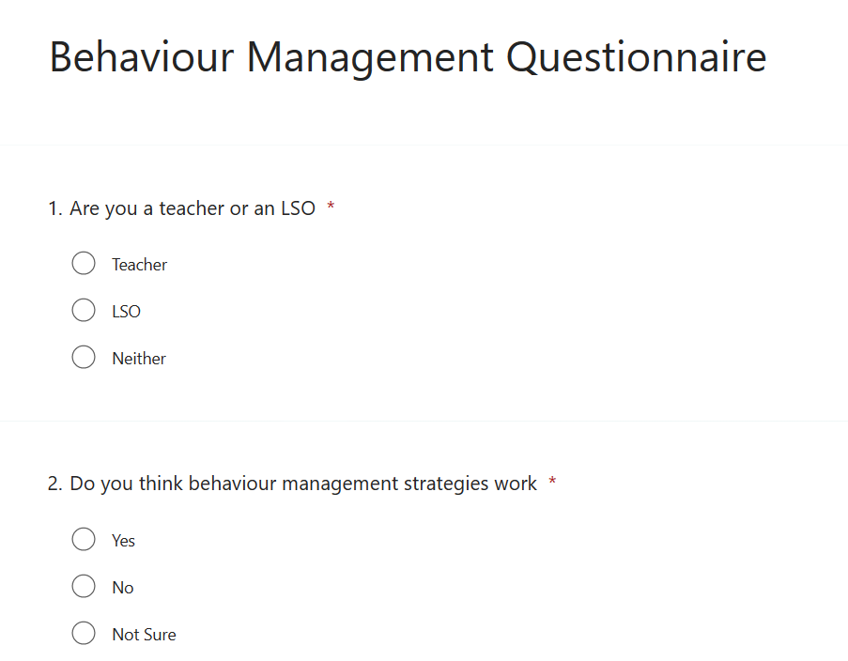

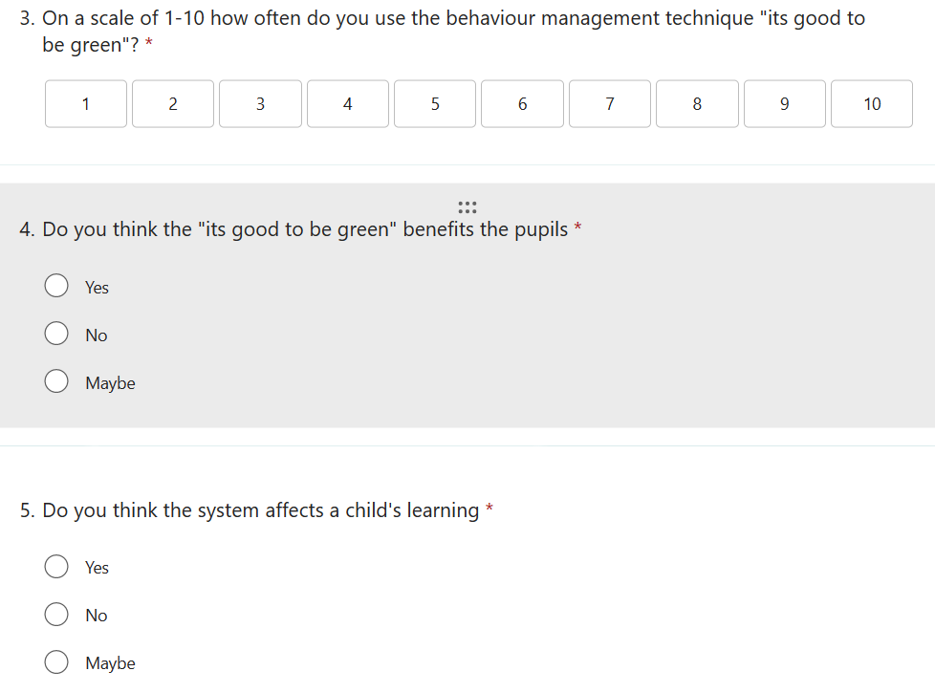

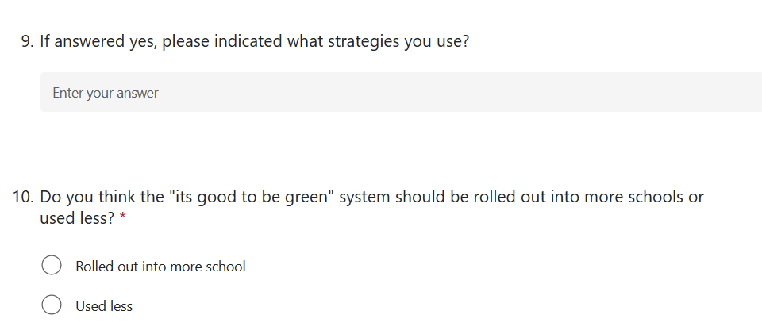
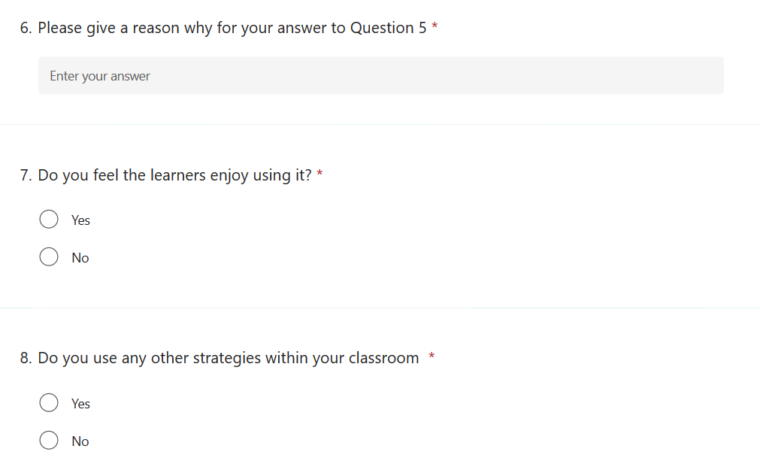

Interview Questions

- Are you a boy of girl?

- How does it make you feel when the good to be green system is used?

- What happens if you move to an amber or red card?

- How often is it used?

- Do you find it helps with your learning?

- Do you enjoy using the system?

