Name: Emma Landek

Student number: 1803146

BA course title: Surface pattern and design

Word count: 4769

Supervisor: Catherine Hammerton

What is fast fashion? And how can our society strive towards a more circular fashion industry?

This enquiry is aimed to inform the reader on the misconceptions surrounding fast fashion. I will be discussing how the term ‘fast fashion’ was developed and why its popularity has soared since its arrival in the early 2000’s (Edology, 2021). I will be unpicking the reasons fast fashion brands are appealing to society, in particular generation Z and how the role of social media and social influencers have created a new realm of marketing and advertisements for these brands (Watkins, 2021). Furthermore, I will be addressing how the fast fashion industry follows a linear economic model of “Take, Make, Dispose” (Ellenmccarthurfoundation, 2014), subsequently leading to detrimental impacts within our climate system, giving the fashion industry’s title of being the second largest polluting industry after oil and gas (Hawthornintl.com, 2021). In contrast to a linear economy, I will be introducing the principles of a closed loop system within fashion and the importance of striving towards a circular fashion industry (Chathamhouse.org, 2021). Additionally, I will be exploring the role of the UNFCCC to understand why we must act urgently to prevent any more damage to our eco systems. To help project the idea of circularity within fashion, I will be including research on Christopher Raeburn who is pioneering a new vision for the fashion industry through sustainability (Delle, 2019). Taking into account consumers responsibility in regard to our climate impact, I will be introducing alternative closed loop systems we can apply to minimize our own footprint, which will contribute to the larger system of circularity.

The etymology of the word ‘fashion’ sources back to the Latin word lactio, which translates to making or doing. The original fundamental of the word describes the activity of creating. (Barnard, 2002, p.20) The meaning of fashion
today can be described as,
‘a style that is popular at a particular time, especially in clothes, hair, make-up, etc.:’ (Cambridge English dictionary, 2021)
This definition can be contradictory to the etymology of the word fashion as over time, we as a society have become materialistic towards fashion, and often overlook the known negative impacts surrounding fashion in an attempt to fit in. Historically, clothing brands would introduce new collections on a seasonal basis to coincide with the 4 seasons of Spring/Summer, Autumn/Winter (Jordan, 2021). However, since the late 1990s the fashion industry has evolved into introducing new styles much more frequently, largely due to the rapid technological advances, allowing the process of designing, manufacturing, transporting and selling to become much quicker (Rauturier, 2021).
Further technological advances such as the internet, have allowed fashion brands to extend their reach, navigating a new way of operating online, through advertising, promotion and selling (Tuman, 2020). These advances have impacted the way garments are designed utilising new software innovations and digital programmes to facilitate designing garments and patterns to be much quicker and more efficient (Tuman, 2020).
Frequently, we have been seduced by large marketing campaigns and high street brands into consuming large quantities of clothing based on the principle that quantity overrides quality (The well co, 2020). As society strives towards a more digitized future, brands are shifting from traditional means of communication through physical publications such as Elle and Cosmopolitan, to digital marketing and social campaigns via social media platforms like Instagram and Facebook (Skeldon, 2019). Principal and CEO of one of the UK’s leading fashion schools, Lee Lucas states “Fashion inspiration was once the domain of glossy magazines and photoshoots, but now more and more people are making money by styling themselves and sharing pictures on social media.” (Skeldon, 2019).
Fast fashion is a term used to describe the rapid production of on-trend clothing for mass market retail at an affordable cost for the consumer (Brookes, 2019. p.3). These garments are inspired by high end designers who share their work through shows and runways, allowing the consumer to keep pace with current trends at a much lesser cost (The F team, 2020, P.4). These high-end designers and fashion influencers pave the way in which direction trends will follow, feeding inspiration to fast fashion brands in order to deliver new styles to the consumers. The temptation we feel to buy into fast fashion chains such as PrettyLittleThing, due to low-cost product and fast delivery, implicates us in the unsustainable practices within production and consumption that these businesses execute (Szaky,2019, p.6). Contributing towards a linear model of design and consumption.
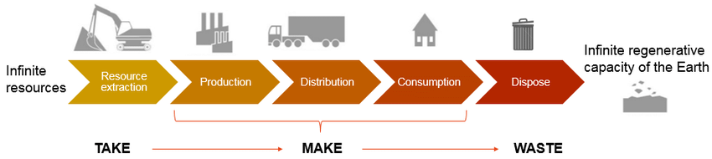
Figure 1 (Researchgate, 2021)

A linear economy describes the process of “Take-Make-Dispose” as shown in Figure 1. This process abbreviates the chain of consumption, beginning with the extraction of raw materials, then the production of goods, and then thirdly the distribution to the consumer (EllenMcCarthurFoundation, 2013, p.14). Once these garments have served their purpose to the consumer, they are often disposed of (Taylor, 2020). Sending nearly £140 million pounds worth of wearable garments to landfill in the UK, each year (Clothesaid.co.uk, 2020). Many of these disposed garments include synthetic materials, and non-biodegradable fibres such as polyester, taking a staggering 200 years to decompose (Hawthorn.com, 2021).
Through supplier marketing and consumerism, brands are delivering styles on a regular basis feeding into a system of over-consumption (Formaggia, 2021). Taking inspiration from current trends set out by high end designers has encouraged fast fashion brands to compete in delivering the latest trends in the shortest turnaround time (Formaggia, 2021). Brands are delivering new trends at a fast pace in order to fit the criteria of what is fashionable and what is ‘in’ (Formaggia, 2021). This fast-paced change in trends is how retailers can persuade consumers to buy more frequently as new collections and merchandise may only be available to purchase for a matter of days, creating a sense of urgency to the consumer (Bhardwaj, 2010).
Fast fashion brands often appeal to the younger generation in particular Generation Z; Which refers to the generation that follows millennials, born between 1997-2012 (Meola, 2021). People who fall into the bracket of generation Z are often viewed as digital natives (Abu, 2019). ‘Digital native’ was a phrase coined by Marc Prensky in 2001 to describe those that have grown up in an era of ever-present technology, subjected to computers and the internet from an early age and consider its use to be a necessity. (Boyle, 2021) Born amongst the presence of smartphones, their ability to engage and absorb digital information has become second nature, and understandably has led social media to become an indispensable part of everyday life (JasonDorsey.com, 2021). Coupled with our flexibility to shop online, readily accessible at our fingertips, brands target this youth audience through tempting discounts and influencer advocates (Abu, 2019).
Fashion is a form of expression, it is a visual communication of a person (Publishers guild, 2021 edition). Our visual perception of ourselves is frequently documented through image based social media platforms like Instagram, Snapchat, Facebook becoming the “The most photographed generation in the world’s history” as claimed by Generation Z expert Jason Dorsey (Hanbury, 2019). social media has provided a platform for connectivity and has allowed people to visually and publicly document their lives (Nguyen, 2020). This public documentation has created a society that avoids wearing outfits repeatedly in fear of being scrutinized online, often leading to these garments being discarded after very few wears in favour of new ones (TheFashionLaw.com, 2018).
“A recent social media phenomenon which reflects on endorsement practices by individuals with a significant social media audience, with purpose of increasing online engagement for the endorsed product or service” (The regulation of social influencers, 2020, p.8). Utilizing their platforms, social media influencers recognise the value of their relationship with their followers and create relatable content. By constructing content in this way, social media influencers can be seen as ‘normal people’ enabling them to cultivate a more intimate relationship with their followers, while achieving a sense of community (Watkins, 2021).
Breaking Fashion is a BBC documentary that follows Adam Frisby, 32-year-old CEO of fast fashion brand In The Style (BBC, 2019). The documentary is a clear demonstration of how fast fashion brand In the style uses platforms like Instagram to source inspiration from celebrities and influencers for their
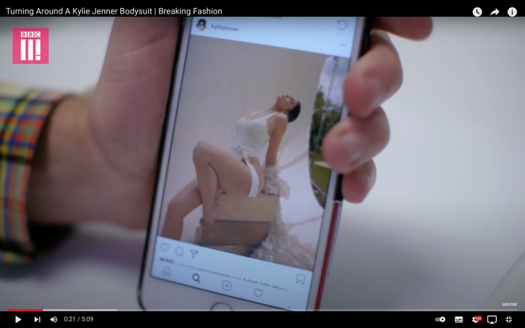
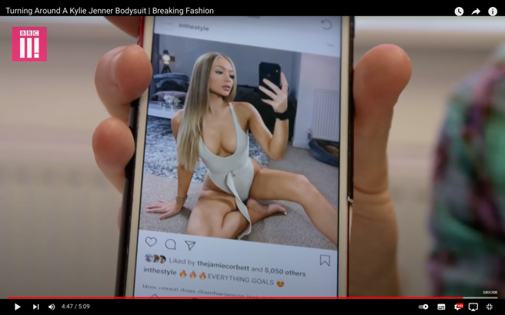
Latest collections, “Something that was previously unprecedented.” (Mcclymont,2021) The six-part documentary on the BBC, shows the relationship between high value celebrities, fast fashion brands and fashion influencers. Within 10 days of Kylie Jenner posting an image of herself in a high-end swimsuit, In The Style were able to design, manufacture and have a close reproduction available to purchase online. This is an example of how fast fashion brands are creating a demand in comparison to responding to the demand (Crumbie, 2021).

This documentary demonstrates how influencers and celebrities have the
power to alter trends and how quickly brands can instantaneously deliver a replica at an affordable price to the general public.
Attempting to achieve an image of idealization that fast fashion brands portray on social media through extensive shopping, is creating a throwaway culture that on average disposes nearly 300,000 tonnes of clothing per year in the UK alone, which ends up in landfill (Bravo, 2020, p.10).
The fashion industry is named as the second largest polluting industry in the world after oil and gas (Hawthornintl.com, 2021). In order to keep up with “the global appetite for newness” (Hawthornintl.com, 2021), Fashion brands are economizing their expenses along the production chain to harvest a larger profit on their garments (hawthornintl,2021). Capitalizing on the production of their garments to deliver a quick turnaround time increases the likelihood of environmental corners being cut (Hawthornintl.com,2021).
During the global pandemic, many people were forced into the constraints of their home, and as stated by Forbes “Every crisis generates innovation” (Durocher, 2021). Spending time in the comfort of our homes during the ever-changing circumstances of COVID-19, has led to the development of a new apparel category; loungewear (Durocher, 2021). This new category of loungewear within fashion aimed to produce multi-purpose pieces that would be versatile, comfy and practical, largely consisting of athleisure wear to coincide with the increased amount of time spent (Durocher,2021). The materials used for this apparel, mainly consist of synthetic plastic fibres such as polyester, nylon and acrylic to achieve the breathability and stretch that allows them to feel so comfortable (Cho,2021). Being affordable and readily available, Polyester is now used in up to 60% of our clothes (Brodde, 2017). These fibres are created through energy intensive processes that require the burning of fossil fuels (Hawthornintl.com, 2021), These garments release around 1,900 microfibres per wash (Hawthornintl.com, 2021), microfibres are microscopic pieces of plastic that are flushed down our drains and in due course enter our water systems and oceans (Cho, 2021). Fashion holds the responsibility for 35% of all microplastics found in the ocean (Traid.org.uk, 2018). Some polymers contain contaminants and chemical additives, that may be harmful to marine biota, causing a risk towards marine ecosystems, food availability and biodiversity when indigested (Gallo, 2017).
The production of polyester produces around 706 billion kg of greenhouse gasses per year (Hawthornintl.com, 2021) These emissions contribute towards the concentration of greenhouse gasses in the atmosphere, which amplify the earth’s natural greenhouse effect of trapping heat (Denchak, 2019). The greenhouse effect raises the temperature of the earth leading to detrimental impacts including the rise of sea levels due to ice glaciers melting, extreme and unexpected weather events (Denchak, 2019), and the change in eco systems and animal behaviours (Bradford, 2017). With such irreversible effects on the environment from the fashion industry, why aren’t we doing better to save our planet?
In contrast to a linear economy, a circular economy is a system that innovates design principles to reduce waste and pollution (Chathamhouse.org, 2021). The model entails redesigning products and garments with their whole life cycle in mind in order to avoid the “take, Make, Dispose” economy we are currently following (Zero Waste Scotland, 2021) 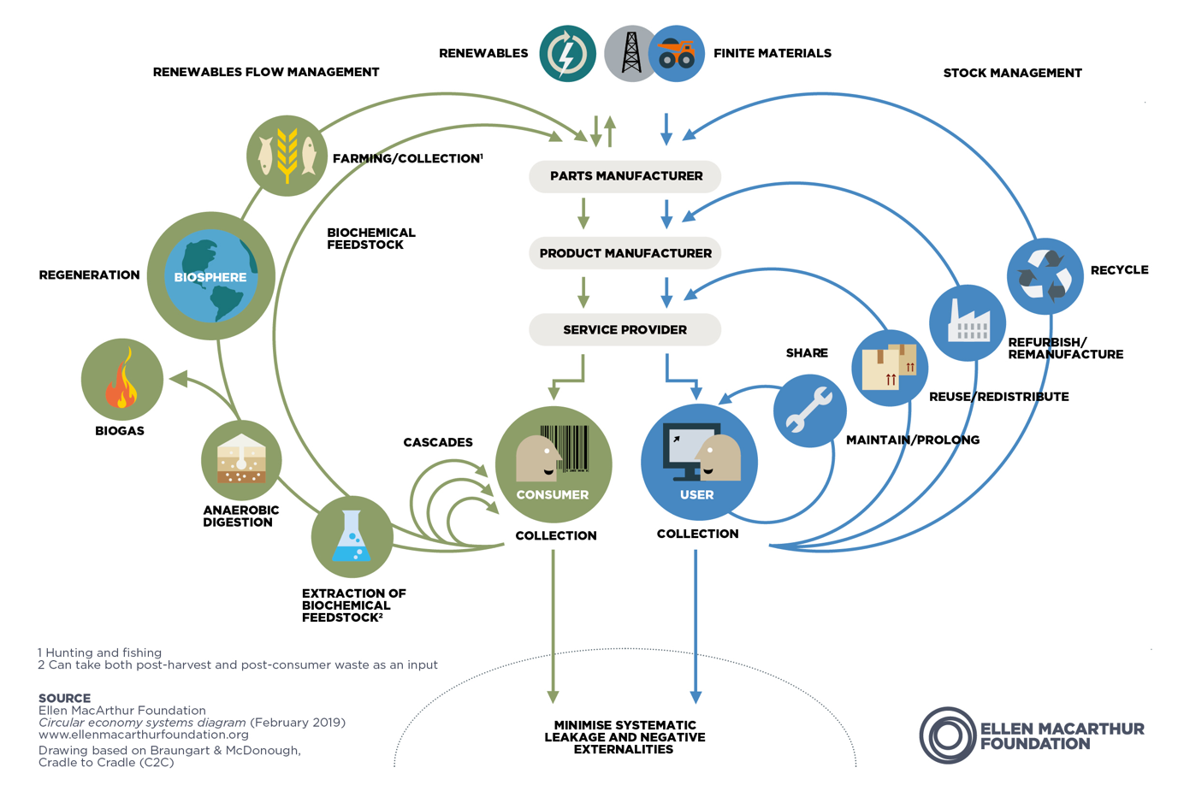
Figure 2- (Ellen Mccarthur Foundation, 2021)

As shown in Figure 2, The principle of a circular economy depends on the circularity of materials. Through adopting strategies that extend the life of products and garments leads to positive outcomes such as eliminating waste, creating sustainable resources, decreasing our carbon footprint and creating a more efficient and renewable economy (Wrap, 2021). It is vital to consider the life cycle beyond their intended use, by considering ways to maximize the value of these garments once their first life is deemed over (Zero Waste Scotland, 2021).
Adopting a more circular economy is vital in tackling our current issues in climate change. Over the last 3 decades the significance of striving towards a more sustainable future has progressed from being a fringe issue to becoming a global priority. (UN climate change conference UK 2021, 2021) To tackle the climate change crisis, an annual event is held each year consisting of 197 countries known as The Conference of the Parties (COP). (Begum & Pavid, 2021)
COP is the platform for The UNFCCC which stands for The United Nations Framework Convention on Climate Change (Romdhane & Diringer, 2021). The UNFCCC is an international treaty that entered force in 1994, made up by 154 countries which has since compromised to 197 parties to date (Romdhane & Diringer, 2021). The objective of the international treaty UNFCCC is to stabilize greenhouse gas emissions preventing human interference with the climate system (United Nations Climate Change, 2021).
Each year, the nations of the convention come together to discuss and reach agreements on how to tackle climate change going forward (United Nations Climate Change, 2021). A successful meeting was held in Paris in 2015, the 21st COP meeting led to the legally binding treaty named the Paris Agreement (European Commission, 2021). The Paris agreement set out a global framework that prompted the decision-making of nations in response to global warming (European Commission, 2021). All nations agreed to limit the temperature of global warming to below 2 degrees and strive towards reducing even further to 1.5 degrees by controlling greenhouse gas emissions (UK Government, 2021). Each fraction of a decimal is immensely important in reducing environmental damages caused by global warming (UK Government, 2021). The terms of the Paris agreement are assessed every 5 years to set new ambitions for nations to continue efforts to reduce greenhouse gas emissions, also known as nationally determined contributions (NDC’s) (UK Government, 2021).
Due to the extent of the global pandemic, the 2020 COP meeting was withheld and was rescheduled for November 2021. COP26 was the first meeting to revise and revisit the goals set out by the Paris Agreement since 2015 (Begum & Pavid, 2021). After the 2-week conference, COP26 president Alok Sharma stated that the aim to limit temperatures to 1.5 degrees is still achievable. However, nations must work together and translate promises into rapid action immediately (UK Government, 2021). With current global temperatures trajected to rise by 3-5 degrees by 2100 (National Grid, 2021), the effects of current climate change will continue to worsen, causing further erratic weather patterns such as flooding, heatwaves, severe storms and rising sea levels (National Grid, 2021).
In line with limiting the temperature of the earth to 1.5 degrees, the Fashion Industry Charter was convened by the UNFCCC and launched in 2018 during COP24 (United Nations Climate Change, 2021). The fashion industry charter for climate action is guided by its mission to ensure the fashion industry drives towards a more sustainable system that will reach net-zero greenhouse gas emissions by 2050 (United Nations Climate Change, 2021). Net-Zero greenhouse gas emissions refers to the balance of the amount of greenhouse gas emissions that we produce and the amount that is removed from the atmosphere (Shepheard, 2020).
Since launching in 2018, 125 companies and 41 supporting organizations have signed the fashion charter convention including brands such as Burberry, Chanel, Adidas, and Levis (Hirsh, 2020). The fashion industry charter for climate action aims to collaborate with its working groups to amplify the use of better practices, increase current efforts, facilitate and strengthen communication within the convention, enabling the sector to achieve a collaborative industry that strives towards a sustainable economy (United Nations Climate Change, 2021).
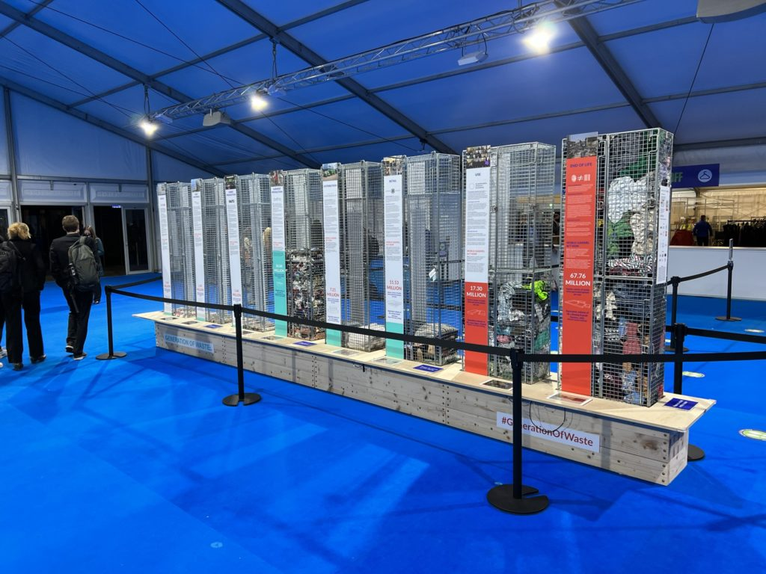
To accelerate systematic change worldwide in the textile industry, an installation entitled ‘Generation of waste’ was exhibited at COP26 in the blue zone of the Scottish event campus, accessed only by VIP delegates (Scotland RE:design, 2021). This exhibition was presented to 25,000 attendees at COP26, addressing the viewers on the seriousness of the global fashion supply chain and the waste it generates (Scotland RE:design, 2021).
Figure 3- (Eminton, 2021)
The exhibition was a collaborative project between 3 organisations who each work independently to address current issues of the fashion industry (Generationofwaste, 2021). The organisations contributing to this exhibit include Sustainable Fashion Scotland, Beira and Zero waste design online (Generationofwaste, 2021). Working collaboratively on their common values of revolutionising the fashion industry to accelerate systemic change, led to an educational display of our textile waste through a linear bar chart to emulate the linear economy we are currently following (Generationofwaste, 2021). The structure includes 8 sectors, showcasing the different stages where waste is generated during the value chain, beginning at the design stage and ending at the end of life of the garments (Generationofwaste, 2021).
To understand the extent of the waste produced from the fashion industry, the exhibition provides staggering figures on the number of textiles wasted at each stage (Eminton, 2021). According to the statistics provided by the #Generationofwaste exhibition, during the retail stage of the value chain 11.53 million tonnes of clothing are wasted from garments being returned, damaged and unsold (Generationofwaste, 2021).
Due to the expansion of fast fashion, the cycles of fashion trends have become much shorter (Lieber, 2018). Creating an industry that drives over-consumption by the constant need to deliver newness (UK Parliament , 2019). Often leaving brands with excess stock, Burberry being an example. Luxury brand Burberry, admitted to incinerating $36.8million of unsold merchandise in 2018 (Lieber, 2018). The practice of incinerating their unsold garments and perfumes was an attempt to protect their brand identity of luxe and exclusivity, avoiding the merchandise from being sold cheaply and falling into the hands of those who do not fit their customer profile (UK Parliament , 2019).
As I mentioned previously, Burberry is a signatory member for the fashion charter convention for climate change, which speaks on values of climate change and the importance of adopting more sustainable practices throughout the production chain (Hirsh, 2020). The actions of Burberry burning unsold inventory is brutally contrasting to the goals of the fashion charter in reducing greenhouse gas emissions and its environmental impacts, which outlines how brands “have a long way to go to meet the demand for sustainability” (Cheng, 2019). Lucy Siegle, a journalist and author responded to the news of this story at the time (Parliament, 2019). She explained how the input of intense processes such as extracting plants for raw materials to using thousands of litres of water to process textile yarns, in addition to hundreds of hours of human labour is squandered by burning (Parliament, 2019). The whole process is wasted, representing waste from the whole production line, multiplying the climate impact these garments already had to begin with (Parliament, 2019).
With finite resources depleting, it is quickly becoming apparent that the fashion industry can no longer sustain current practices (Get Smarter, 2021).Pioneering a new vision for the fashion industry through circularity and re-generative design, Christopher Raeburn debuted his brand Raeburn during London’s fashion week in 2009 (Delle, 2019). The brand focuses on the ethos “RAEMADE, RAEDUCED, RAECYCLED & RAEBURN” (Raeburndesign.co.uk, 2021).
In comparison to Burberry, Raeburn aims to deliver fashion forward pieces by reworking surplus fabrics (Raeburndesign.co.uk, 2021).The brand creates apparel that is eco-friendly, carbon-neutral and utilises waste as a form of resource (Delle, 2019). Through our current economy of “take, make, dispose’ approximately 2.625kg of clothing is incinerated or sent to landfill each second, Christopher Raeburn puts his efforts into closing the loop of the linear economy and diverting materials away from landfill, paving the way towards a responsible fashion industry (Conlan, 2019).
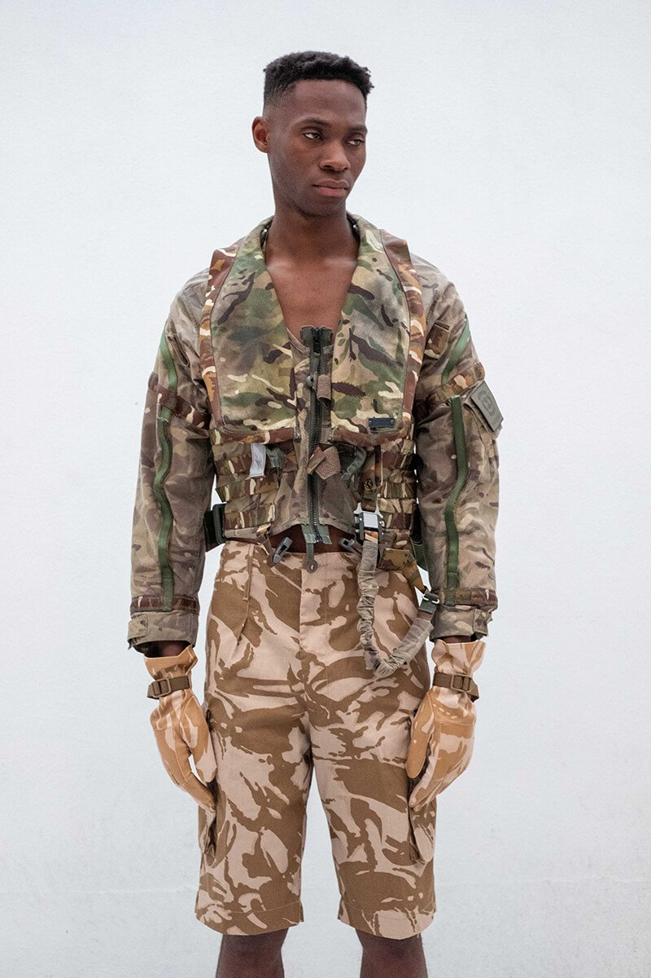
Raeburn launched the RAEFOUND collection, which is an evolving collection of de-commissioned military pieces that have become obsolete, re-purposing them to drive design purity and avoid scandalous actions of wastefulness like brand Burberry, especially in our current climate crisis (Raeburndesign.co.uk, 2021).
Figure 4- (Raeburndesign.co.uk, 2021)

As stated on the Raeburn website, “We overproduce, we over consume, and we waste too much. We need to stop making more stuff” (Raeburndesign.co.uk, 2021) this collection offers a solution to mounting wasted inventory, “Nothing new. Nothing wasted.” (Raeburndesign.co.uk, 2021).
The collection is made up of Airman battle uniforms, and army combat uniforms originally created for the US military Gen III, Acknowledging the value of the pieces in their original form, they are re-branded and sold (Raeburndesign.co.uk, 2021). Reclaiming their purpose, the collection offers a utilitarian meet streetwear aesthetic (Conlan, 2019). Appreciating the efforts of Christopher Raeburn, it begs the question what would have happened to these pieces if they weren’t sourced and re-purposed, would they have had the same fate as the unsold stock at Burberry?.
There are several methods that embrace circularity in order to maximize the life span of materials and products. Being mindful of the life cycle of garments after their intended use, embraces the use of more regenerative materials (Zero Waste Scotland, 2021). Separating materials into component parts that can be repurposed into new products, designs out waste and reduces our demand for raw material, subsequently minimizing the environmental impact of resource extraction (Chathamhouse.org, 2021).
Since 2018, Christopher Raeburn has implemented his ethos into his role as Creative Director of Timberland (Wickes, 2021). Their latest collaboration fuses progressive style and innovation, creating an A/W 21 capsule of apparel named ‘Timberland Eartherkeepers by Raeburn’ (Raeburn, 2021). Re-imagining classic Timberland pieces with circularity in mind, without compromising on style the collection includes ‘Greenstride edge waterproof boots’ which features soles made from 75% renewable sugarcane, natural rubber from trees, linings made from 50% recycled plastics and leather that is sourced from a sustainable tannery (Timberland , 2021). The capsule pushes the boundaries of circularity whilst working towards a greener future (Raeburndesign.co.uk, 2021).
Christopher Raeburn is at a high-end fashion level and is using his platform to empower and inform both consumer and businesses to think about their environmental impact through fashion (Schills, 2021). With the current population set to increase to 9 billion by 2030, natural resources will continue to be put under immense pressure to meet human demand (Motif, 2021) “Never before has it been so clear that we need long-term, inclusive. Clean transitions to tackle the climate change and achieve sustainable development.” (BBC, 2020). Our desire to purchase clothing that is cheap and on trend is literally costing the earth (Whiting, 2019), the effort of consumers adopting circular approaches in fashion is just as significant as large brands, the linear approach we are currently following cannot continue pre and post-consumer (Hill, 2020).
With the average consumer throwing away 70 pounds of clothing per year, and 73% of these clothing either ending up in landfill or being incinerated (Ethical Brand Directory , 2021), it is vital for us as the consumers to be more conscious and responsible for our own impact on the planet we need to stop the “take, make, dispose” ideology immediately (Ethical Brand Directory , 2021). To become 100% sustainable in our wardrobes would be extremely difficult due to our individual budgets and inclusivity and accessibility to sustainable brands (Ethical Brand Directory , 2021), However, there are small ways we can participate in helping transcend the fashion industry from a linear economy to a circular one (Lilly, 2020).
Christopher Raeburn’s ethos of pursuing a circular economy in fashion through reusing, reducing and recycling is a core principle in sustainable living (Astoul, 2020). Efforts of reusing garments has accelerated through the advent of online marketplaces for second-hand clothing such as Depop and Vinted. (Thrifted, 2021) Apps like Depop are providing an alternative to fast fashion and promote a fashion-conscious fan base for users to buy and sell pre-loved items (Thrifted, 2021). Creating a new realm of shopping that avoids wastage and over-production that is often seen in fast fashion, keeping clothes in circularity for much longer (Thrifted, 2021).
The COVID19 pandemic has enormously influenced the role of second hand shopping (Hickey, 2020) Being constrained to the confinements of our home, many people have gained a greater prospective on the role we play in contributing towards climate change (Hickey, 2020) 33 million consumers bought second hand apparel for the first time in 2020, and the numbers are projected to rise as 50% of consumers are more conscious of avoiding waste than they did pre-pandemic (Mau, 2021).
Buying less is another way to participate in mitigating the climate impact the fashion industry has on the environment (Hill, 2020). British designer Vivienne Westwood employs the mantra ‘Buy less, Choose well, Make it last’, opting for more traditional pieces of clothing that aren’t trend based, extends the life span of the garments (Hill, How to buy less, Choose well and make it last, 2018).Preventing them from being discarded once a new trend is introduced. (Hill, How to buy less, Choose well and make it last, 2018).
A brand that adopts the principle of Vivienne Westwood is Levi Strauss & co, the brand aims to raise awareness on the shared responsibility in the fashion industry to tackle its environmental impacts (William Cowen, 2021). Levi’s brand president, Jennifer Sey states “Levi’s denim is meant to be worn for generations, not seasons” (William Cowen, 2021). In April of this year, the brand launched the campaign ‘Buy better, wear longer’, which employs sustainable practices within the manufacturing of their products to achieve apparel that is durable and lasting whilst being environmentally responsible (Joe, 2021). The campaign embraces closed loop systems within fashion, by encouraging customers to make intentional decisions about their purchases (Joe, 2021).
As consumers the main way we can benefit the environment is by being conscious of our actions, we should wear our clothes for longer, re-sell our clothes if we don’t want them anymore, and mainly stop contributing to the ‘throwaway culture’ which has devalued our clothes (Yong, 2021). All our small
scale actions will contribute on a larger scale to lead the fashion industry towards a circular system that can be sustained.
Throughout this enquiry I have explored key elements that explore and develop the understanding of fast fashion in current society. Understanding that the advent of fast fashion has coincided with the advances of technology, has allowed the processes of designing, manufacturing and selling to become much easier. The ability of operating online has further extended fast fashions reach in targeting consumers to purchase their products through brand advertisement and promotion using social media influencers. As a result of low costs and quick delivery, fast fashion brands are largely appealing to the younger generation. In addition, influencers and celebrities are creating an image of idealization through social media platforms, convincing their audiences that quantity overrides quality. This methodology contributes to the “take, make, dispose” attitude of our society which been generated through extensive shopping and consumption. It is clear from my research that the impact the industry has on the environment occurs pre and post-consumer, from water pollution and greenhouse gas emissions during production to clothing being discarded after minimal wears. The immediate action required to minimize environmental impact from the fashion industry must be a joint effort of both consumers and manufacturers. Based on the exploration of a circular economy, it is vital to start approaching fashion with a conscious mindset to prevent irreversible impacts on our climate change. Sourcing inspiration from sustainable pioneers like Christopher Raeburn, we must begin adopting his ethos of “remade, reduce, recycle” into our own clothing in order to keep garments within circulation for longer, allowing us as individuals to engage with the principles set out by the fashion industry charter. Throughout this enquiry, I have reiterated the cost of fast fashion and that the subsequent price tag is the earth. It is certainly the case that as consumers we must implement circularity into our lives, through considering new avenues of shopping like Depop and Vinted that avoids wastage and over consumption. Other steps include Levi’s campaign of ‘Buy better, wear longer’ through making more intentional purchases where we take into consideration the value a garment would be to us for an extended amount of time in comparison to how current it is. Buying and selling with circularity in mind will not only bring benefits to the environment but will allow us to truly feel good about what we are wearing, we must act now.

Bibliography
AMZA. (2021, January 19). Sustainability: Why the mindful shopping mindset is more than a trend. Retrieved from amzabags.com: https://www.amzabags.com/blogs/stories/sustainability-why-the-mindful-shopping-mindset-is-more-than-a-trend
Astoul, E. (2020, August 22). How second-hand shopping can save the planet. Retrieved from Greenwithless.com: https://greenwithless.com/second-hand-shopping-planet/
BBC (Director). (2019). Breaking Fashion [Motion Picture].
BBC. (2020, September 9). Climate chnage:'Urgent' action needed to meet climate targets says UN. Retrieved from BBC.co.uk: https://www.bbc.co.uk/newsround/54085923
Begum, T., & Pavid, K. (2021, October 21). Natural history museum . Retrieved from Cop26 explained: what is it and why it's imprtant for tackling climate change: https://www.nhm.ac.uk/discover/news/2021/october/cop26-explained.html
Ceransky, r. (2021, November 18). The fashion takeaways from COP26. Retrieved from VOGUEBUSINESS: https://www.voguebusiness.com/sustainability/the-fashion-takeaways-from-cop26
Chathamhouse.org. (2021, june 17). What is the circular economy? Retrieved from Chathamhouse.org: https://www.chathamhouse.org/2021/06/what-circular-economy
Cheng, A. (2019, October 17). More consumers want sustainable fashion, but are brands delivering it? Retrieved Decmeber 2021, from forbes: https://www.forbes.com/sites/andriacheng/2019/10/17/more-consumers-want-sustainable-fashion-but-are-brands-delivering-it/
Common Objective . (2019, March 12). What next for fashion? The leadersip trends driving change . Retrieved from Commonobjective.co: https://www.commonobjective.co/article/what-next-for-fashion-the-leadership-trends-driving-change
Conlan, S. (2019, January 5). Success is sustainable for designer turning waste into fashion statement. Retrieved December 2021, from Theguardian.com: https://www.theguardian.com/fashion/2019/jan/05/christopher-raeburn-sustainable-design-london-fashion-week-mens
Davey, J. (2021, October 21). Christopher Raeburn x Timberland's new collection looks to the future. Retrieved December 2021, from Complex uk: https://www.complex.com/style/raeburn-timberland-2021
Delle, C. (2019, December 27). Landfill is being turned into luxury to fight back agasint fast fashion. Retrieved from wired.co.uk: https://www.wired.co.uk/article/raeburn-fast-fashion
Edology. (2021). Find out how this unique business practice has benefited consumers and taken the fashion industry by storm . Retrieved from edgoloy.com: https://www.edology.com/blog/fashion-media/rise-of-fast-fashion/
Ellen Mccarthur Foundation. (2021). Circular economy diagram. Retrieved from EllenMccarthurfoundation.org: https://ellenmacarthurfoundation.org/circular-economy-diagram
Eminton, S. (2021, November 10). News in brief from cop26, Glasgow. Retrieved from letsrecycle.com: https://www.letsrecycle.com/news/news-brief-cop26-glasgow/
Ethical Brand Directory . (2021). Conscious Shopping: How small changes can make a big difference . Retrieved from Ethicalbranddirectory.com: https://ethicalbranddirectory.com/conscious-shopping-how-small-changes-can-make-a-big-difference/
European Commission. (2021). Paris Agreement . Retrieved from European Commission: https://ec.europa.eu/clima/eu-action/international-action-climate-change/climate-negotiations/paris-agreement_en
Geissedoerfer, M. (2020). Circular business models: A review. Journal of cleaner production, 4.
Generationofwaste. (2021). Retrieved from generationofwaste.com: https://www.generationofwaste.com/about
Get Smarter. (2021, November 5). why every business should commit to a circular economy. Retrieved from getsmarter.com: https://www.getsmarter.com/blog/career-advice/why-every-business-should-commit-to-a-circular-economy/
Hickey, S. (2020, November 22). Secondhand no longer second-best for UK's 'Circular economy' consumers. Retrieved from The Guardian : https://www.theguardian.com/money/2020/nov/22/from-baby-clothes-to-ikea-furniture-were-shopping-secondhand-to-save-the-planet
Hill, M. (2018, June 8). How to buy less, Choose well and make it last. Retrieved from Goodonyou.eco: https://goodonyou.eco/how-to-buy-less-choose-well-and-make-it-last/
Hill, M. (2020, July 06). What is circular fashion? Retrieved from good on you: https://goodonyou.eco/what-is-circular-fashion/
Hirsh, S. (2020, November 2020). 100+ fashion brands have signed the UN fashion industry charter for climate change. Retrieved from GreenMatters: https://www.greenmatters.com/p/un-fashion-industry-charter-climate-action
Joe, T. (2021, April 28). Levi's unveils latest campaign 'Buy better, wear longer' to encourage sustainable fashion production practices . Retrieved from Greenqueen.com: https://www.greenqueen.com.hk/levis-unveils-latest-campaign-buy-better-wear-longer-encourage-sustainable-fashion-production-practices/
Jordan, D. (2021, September 14). Fashion seasons explained . Retrieved from wear-next.com: https://wear-next.com/news/fashion-seasons-explained/
Levi's. (2021). We're on a mission to chnage the clthing industry. For good. Retrieved from Levi.com: https://www.levi.com/GB/en_GB/features/sustainability?camp=PaidSearch_DR_Levis_UK_EN_GOO_Brand-Pure_Non-Gender_BMM&gclid=CjwKCAiA78aNBhAlEiwA7B76p-hGiXKPFWMFZWyUHnyuxMCvoE7l4juk3zU6nLRNkhnXfdjx9KbQORoC94gQAvD_BwE&gclsrc=aw.ds
Lieber, C. (2018, September 17). Why fashion brands destroy billions' worth of their own merchandise every year. Retrieved from VOX: https://www.vox.com/the-goods/2018/9/17/17852294/fashion-brands-burning-merchandise-burberry-nike-h-and-m
Lilly. (2020, December 20). The problem(s) with sustainable fashion. Retrieved from Imperfectidealist.com: https://imperfectidealist.com/problem-with-sustainable-fashion/
Mau, D. (2021, June 22). The 'Post pandemic consumer' is embracing secondhand clothes. Retrieved from Fashionista.com: https://fashionista.com/2021/06/thredup-2021-resale-report
Motif. (2021). Moving towads a circular fashion economy. Retrieved from Motif.org: https://motif.org/news/circular-fashion-economy/
Mukherji, R. (2020, February 21). It takes 7,600 litres of water to make your jeans. Retrieved from Thehindubusinessline.com: https://www.thehindubusinessline.com/blink/know/it-takes-7600-litres-of-water-to-make-your-jeans/article30871977.ece
National Grid. (2021). What is Net Zero? Retrieved from National Grid: https://www.nationalgrid.com/stories/energy-explained/what-is-net-zero
Parliament. (2019, February 19). fixing fashion: clothing consumption and sustainability . Retrieved from www.parliament.uk: https://publications.parliament.uk/pa/cm201719/cmselect/cmenvaud/1952/report-files/195202.htm
Raeburn. (2021). Timberland Earthkeepers by Raeburn. Retrieved December 2021, from Raeburndesign.co.uk: https://www.raeburndesign.co.uk/pages/timberland-earthkeepers-raeburn
Raeburndesign.co.uk. (2021). Raeburn:chnaging the world through responsible design . Retrieved from Raeburndesign.co.uk: https://www.raeburndesign.co.uk/pages/about
Researchgate. (2021). Retrieved from https://www.researchgate.net/figure/The-linear-economy-The-take-make-and-waste-approach-of-production_fig2_323809440
Romdhane, M., & Diringer, V. (2021, january 31). What is the conference of the parties . Retrieved from ClimaTalk: https://climatalk.org/2021/01/31/what-is-cop/
Schills, L. (2021, August 3). Why consumers flock to brands with a circular business model. Retrieved from Growth from knowledge : https://www.gfk.com/blog/why-consumers-flock-to-brands-with-a-circular-business-model
Scotland RE:design. (2021). Generation of waste, on fashion & futures post COP26. Retrieved from Universe: https://www.universe.com/events/generation-of-waste-on-fashion-futures-post-cop26-tickets-L5047N
Shepheard, M. (2020, April 20). UK net zero target. Retrieved from institute for government : https://www.instituteforgovernment.org.uk/explainers/net-zero-target
Thrifted. (2021, June 07). What is the differnce between Vinted & Depop?- which is better? Retrieved from Thrifted.com: https://www.thrifted.com/blogs/the-edit/what-is-the-difference-between-vinted-depop-which-is-better
Timberland . (2021). Retrieved from Timberland.co.uk: https://www.timberland.co.uk/shop/en/tbl-uk/greenstride-tbl-originals-ultra-waterproof-boot-for-men-in-a285af13
UK Government . (2021). COP26: THe negotiations explained ., (p. 3).
UK Parliament . (2019, February 19). Fixing fashion: clothing consumption and sustainability. Retrieved from UK Parliament: https://publications.parliament.uk/pa/cm201719/cmselect/cmenvaud/1952/full-report.html#content
UN climate change conference UK 2021. (2021). What is a cop? Retrieved from https://ukcop26.org/uk-presidency/what-is-a-cop/
UN Climate Change CONFERENCE UK 2021. (2021). What is a COP? Retrieved from https://ukcop26.org/uk-presidency/what-is-a-cop/
United Nations Climate Change. (2021). About the fashion industry charter for climate action. Retrieved December 2021, from United Nations Climate Change: https://unfccc.int/climate-action/sectoral-engagement/global-climate-action-in-fashion/about-the-fashion-industry-charter-for-climate-action
United Nations Climate Change. (2021). About the fashion insutry charter for climate action. Retrieved from united nations climate change: https://unfccc.int/climate-action/sectoral-engagement/global-climate-action-in-fashion/about-the-fashion-industry-charter-for-climate-action
United Nations Climate Change. (2021). About the Secretariat. Retrieved from United Nations Climate Change: https://unfccc.int/about-us/about-the-secretariat
United Nations Climate Change. (2021). Fashion industry charter for climate action.
United Nations Climate Change. (2021, November 5). Fashion industry charter fro climate change. Retrieved from https://unfccc.int/sites/default/files/resource/Fashion%20Industry%20Carter%20for%20Climate%20Action_2021.pdf
United Nations climate change. (2021). The Paris Agreement . Retrieved from United Nations Climate Change: https://unfccc.int/process-and-meetings/the-paris-agreement/the-paris-agreement
Whiting, K. (2019, February 22). 7 ways to break the fast fashion habit- and save the planet. Retrieved from world economic forum: https://www.weforum.org/agenda/2019/02/7-ways-to-break-the-fast-fashion-habit-and-save-the-planet/
Wickes, J. (2021, October 19). Christopher RAeburn's latest Timberland collection is his most innovative yet. Retrieved from The Face: https://theface.com/style/christopher-raeburn-timberland-earthkeepers-collection-sustainability-fashion-earthkeepers-aw21
William Cowen, T. (2021, April 19). Levi's launches 'Buy better, wear longer' Sustainability campaign. Retrieved from Complex.com: https://www.complex.com/style/levis-launches-buy-better-wear-longer-campaign/
Wrap. (2021). Wrap. Retrieved from Wrap.org.uk: https://wrap.org.uk/taking-action/climate-change/circular-economy
Yong, A. (2021). Throwaway or fast fashion is throwing away our children's right to a cleaner envronment . Retrieved from unsustainablemagazine.com: https://www.unsustainablemagazine.com/throwaway-or-fast-fashion-is-throwing-away-our-childrens-right-to-a-cleaner-environment/
Zero Waste Scotland. (2021). What is the circular economy? Retrieved from Zerowastescotland.org.uk: https://www.zerowastescotland.org.uk/circular-economy/about

Abu, Fedora (2019) Generation Z and the fast fashion paradox https://www.refinery29.com/en-gb/fast-fashion-gen-z (accessed 16.11.21)

Assoune, Alex (2021) Top ten reasons why fast fashion is so popular Panaprium.com https://www.panaprium.com/blogs/i/fast-fashion-popular (accessed, 16.11.21)

Barnard, Malcolm (2002) Fashion as communication

BBC THREE (2019) Turning Around A Kylie Jenner Bodysuit | Breaking Fashion

Bhardwaj, Vertica and Ann Fairhurst (2010) Fast fashion: Response to change in the fashion industry https://www.researchgate.net/publication/232964904_Fast_fashion_Response_to_changes_in_the_fashion_industry (accessed 6.11.21)

Boyle, Michael J (2021) Investopedia: Digital Native https://www.investopedia.com/terms/d/digital-native.asp (accessed 16.11.21)

Bradford, Alina (2017) The effects of global warming https://www.livescience.com/37057-global-warming-effects.html (accessed 26.11.21)
Bravo, Lauren (2020, p.10) How to break up with fast fashion: a guilt free guide to changing the way you shop for good.

Brode, Kirtsen (2017) What are micro-fibres and why are our clothes polluting the oceans? https://www.greenpeace.org/international/story/6956/what-are-microfibers-and-why-are-our-clothes-polluting-the-oceans/ (accessed 26.11.21)

Brookes, Andrew (2019) Clothing poverty: The hidden world of fast fashion and second hand clothes.
Cambridge English dictionary (2021)

Cho, Renee (2021) Why fashion needs to be more sustainable https://news.climate.columbia.edu/2021/06/10/why-fashion-needs-to-be-more-sustainable/ (accessed 26.11.21)

Clarke, Rebekah (2021) Fast fashions carbon footprint https://carbonliteracy.com/fast-fashions-carbon-footprint/ (accessed 26.11.21)

Clothesaid.co.uk (2020) Facts on clothes recycling https://clothesaid.co.uk/about-us/facts-on-clothes-recycling/ (accessed 23.11.21)

Crumbie, Alex (2021) Ethical consumer. What is fast fashion and why is it a problem? https://www.ethicalconsumer.org/fashion-clothing/what-fast-fashion-why-it-problem (accessed 6.11.21)

Denchank, Melissa (2019) Greenhouse effect 101

Durocher, Yani (2021) Riding the loungewear wave after covid-19 https://www.forbes.com/sites/forbesagencycouncil/2021/02/25/riding-the-loungewear-wave-after-covid-19/ (accessed 26.11.21)

Eadicicco, Lisa (2017) This is why the iPhone upended the tech industry

Ellen McCarthur Foundation (2013, P.14) Towards the circular economy

Formaggia, Elias (2021) Fast fashion lets make this trend a quick one

Gallo, F, Fossi, C., Weber, (2018). Marine litter plastics and microplastics and their toxic chemicals components: the need for urgent preventive measures. https://doi.org/10.1186/s12302-018-0139

Hanbury, Mary (2019) Insider: Gen Z is likely photographed more often than anyone else – and its fuelling big changed in how they shop https://www.businessinsider.com/gen-z-most-photographed-generation-changes-shopping-habits-2019-6?r=US&IR=T (accessed 16.11.21)

Hawthorn.com (2021) The Environmental Impact of Fast Fashion https://www.hawthornintl.com/impact-of-fast-fashion (accessed 23.11.21)
https://www.oxfordstudent.com/2021/10/08/fast-fashion-lets-make-this-trend-a-quick-one/ (accessed 17.11.21)

JasonDorsey.com (2021) https://jasondorsey.com/blog/gen-z-and-tech-dependency-how-the-youngest-generation-interacts-differently-with-the-digital-world/ (accessed 17.11.21)

McClymont, Monique (2021) How social media fuels fast fashion https://aequem.com/blogs/news/how-social-media-fuels-fast-fashion (accessed 17.11.21)
McClymont, Monique (2021) How social media fuels fast fashion https://aequem.com/blogs/news/how-social-media-fuels-fast-fashion (accessed 16.11.21)
Meola, Andrew (2021) Generation Z news: Latest characterises, research and facts. https://www.insiderintelligence.com/insights/generation-z-facts/ (accessed 15.11.21)

Nguyen, Terry (2020) Fast Fashion, explained. https://www.vox.com/the-goods/2020/2/3/21080364/fast-fashion-h-and-m-zara (accessed 16.11.21)

Palandrani, Pedro & Andrew Little (2020) A decade of change: how tech evolved in the 2010’s and what’s instore for the 2020’s https://www.globalxetfs.com/a-decade-of-change-how-tech-evolved-in-the-2010s-and-whats-in-store-for-the-2020s/ (accessed 9.11.21)

Publishers guild (2021) Concept of fashion

Rauturier, Solene (2021) What is fast fashion? https://goodonyou.eco/what-is-fast-fashion/ (accessed 6.11.21)

Schmidt, Eric & Jared Cohen (2013) The new digital age: Re-shaping the future of people, nations and business

Skeldon, Paul (2019) Social influencers have led to the rise in fast fashion, with 30% of shoppers using instagram for inspiration https://internetretailing.net/mobile-theme/mobile-theme/social-influencers-have-led-to-the-rise-in-fast-fashion-with-30-of-shoppers-using-instagram-for-inspiration-20388 (accessed 23.11.21)

Statistica.com (2021) Number of global social network users 2017-2021 https://www.statista.com/statistics/278414/number-of-worldwide-social-network-users/ (accessed 10.11.21)

Szaky, Tom (2019, p.6) The future of packaging: from liner to circular

Taylor, Liam (2020) What is the linear economy and why do we need to go circular? https://planetark.org/newsroom/news/what-is-the-linear-economy-and-why-do-we-need-to-go-circular (accessed 23.11.21)

The regulation of social influencers (2020) Edward Elgar Publishing.
The well co (2020) What is fast fashion? How your clothes are hurting the planet https://www.thewellessentials.com/blog/what-is-fast-fashion-how-your-clothes-are-hurting-the-planet (accessed 6.11.21)

Traid.org.uk (2018) The impacts of clothing fact sheet.

Tuman, Albert (2020) How technology is changing the fashion industry. https://www.tmcnet.com/topics/articles/2020/03/10/444734-how-technology-changing-fashion-industry.htm (accessed 16.11.21)

Twenge, Jean.M (p.50, 2017) IGen: Why Today's Super-Connected Kids Are Growing Up Less Rebellious, More Tolerant, Less Happy--and Completely Unprepared for Adulthood--and What That Means for the Rest of Us.

Watkins, Brandi (2021) Research prospective on social media influencers and their followers
Wrap.org.uk (2017) Valuing our clothes: The cost of UK fashion https://wrap.org.uk/sites/default/files/2020-10/WRAP-valuing-our-clothes-the-cost-of-uk-fashion_WRAP.pdf (accessed 26.11.21)

