Combined Advanced Vehicle Dynamics
AWD Torque Vectoring
Ferrari FF

BEng/Automotive and Motorsport Engineering
ACHA6003/6011
Callum Evans
1702660
21st March 2022

Contents
1. Research 3
1.1. Base Vehicle Data 3
1.2 Torque vectoring 3
1.3 Lump Mass model Ferrari FF 4
1.4 Mechanical Torque Path to Front wheels 5
2. Calculations 6
2.1. Longitudinal Centre of gravity position 6
2.2. Clutch Pack Torque Capacity Calculations 7
2.3 Calculation of Longitudinal Acceleration on Different surfaces 8
3. Analysis of calculations 10
3.1 Dynamic Index 10
3.2 Clutch Pack torque and Longitudinal Acceleration on Different surfaces 10
4 Discussion 10
4.1 Possible System Improvements 11
4.2 On limit lane changes 11
4.3 AWD and dynamic control systems 11
6. References 13
Bibliography 13

Abstract
This technical report involves analysing the all-wheel-drive system used by the 2011 Ferrari FF. An Investigation into the effects this AWD system has on the vehicle dynamics and control strategies from the torque vectoring front-wheel-drive system. This technical report includes calculations of the longitudinal Centre of Gravity position of the FF, and the moment of inertia. The dynamic index and inertial conjugate have also been calculated. Detailed research into the driveline of the Ferrari FF is also present.

Figure 1 Lump mass model of ferrafi FF 4
Figure 2 Torque map of front PTU 5
Figure 3 3D plot graph of road forces of different surfaces 9

Research

1.1. Base Vehicle Data

The Ferrari FF with its naturally aspirated V12 is a GT car from 2011 with a patented 4RM drive train. The system provides power intelligently to each of the four wheels as needed. It functions only when the steering wheel toggle switch is in comfort or snow setting. This leaves the car mostly in the RWD layout.
The engine is located behind the front wheels in a front-mid arrangement. The FF has a front-wheel-drive transmission that sits at the front of the engine and is driven off the crankshaft by a conical gear. This transmission has two forward gears and one reverse and can handle up to 20% of the engine’s total torque output. The gear ratios are 6% taller than the corresponding ratios in the rear gearbox. This means the system is only active through first to fourth gears. Power is routed through two electronically controlled, hydraulic wet multi-plate clutches, one for each wheel with no differential. The front mount transmission can also use torque vectoring to distribute power side to side. (Austin, 2011)
The FF has a 7-speed DCT (dual-clutch transmission) at the rear of the car. This system weighs less than 90 pounds and is about half the weight of a conventional four-wheel-drive system. The power to the wheels goes through an electronically controlled differential (E-diff). The on-board computer continuously monitors torque sent to the wheels, wheel slip, and adjusts accordingly. Therefore, by distributing torque between the wheels using two sets of friction discs controlled by a hydraulic actuator; the amount of torque transmitted is dependent on variables including steering angle, throttle pedal input, and yaw (the rotation of a vehicle about the vertical axis). (Ferrari, 2013)

1.2 Torque vectoring

Torque vectoring is a computer-controlled system that controls how much power/torque is sent to each wheel. A car with torque vectoring will have more grip I slippery inconsistent surfaces and can accelerate much quicker.
Torque vectoring using a differential
The most common differential that is used in a road car is an ‘open differential’. This system can’t control which wheel receives the most torque. When a wheel starts to spin, the engine power takes the path of least resistance. This means the wheel that has the most traction won’t be turning.
A torque vectoring system manages how the power is distributed electronically. It does this with the use of small clutch plates within the differential that precisely control how much torque is sent to each wheel. Therefore, the amount of wheel slip is managed to improve traction. A limited-slip differential is a similar system but is fully mechanical. An LSD can limit power to a wheel that doesn’t need it, but an electronic system can actively redistribute this power and torque to the wheel with the most grip. (Hirons, 2022)
Torque vectoring using brakes
Torque vectoring systems don’t always use a differential. In small hot hatches like the VW polo GTI for example, it’d be too expensive for its price point and complex to put into such a small space.
In this type of application, torque vectoring through braking can be used. This system works by using the brakes to stop a wheel from slipping. (Hirons, 2022) With the use of ABS sensors to measure wheel speeds and an electronically controlled ABS pump can apply brake pressure to the slipping wheel.
This allows more power to be sent to the wheels that still have grip, improving a car’s ability to accelerate on slippery roads or accelerate out of tight corners.
Pros of torque vectoring
- Most beneficial in slippery conditions
- Improves cornering stability at high speeds on track
- improved traction during corner and exit
Cons of torque vectoring
- Not beneficial in normal driving conditions.
- Complicated and expensive
- Most users won’t see any benefit and therefore not worth the purchase (Hirons, 2022)

1.3 Lump Mass model Ferrari FF
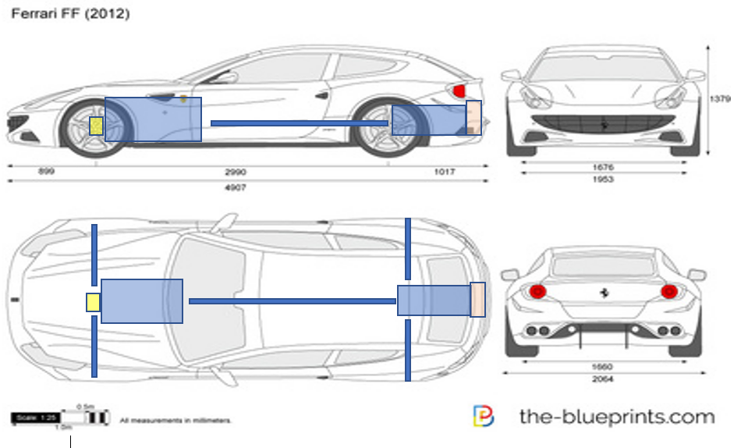
4
3
2
1
5
Figure 1

- 2-speed gearbox (PTU) driven off the crankshaft
- V12 engine mounted behind front wheels
- 7-speed DCT gearbox with E diff
- Crash structure
- Drive shaft

1.4 Mechanical Torque Path to Front wheels

1
2

4

6
3

Figure 2
5

- Pinion and gear, transferring drive through 90 degrees
- Two speed PTU gearbox driven directly off the crankshaft
- Twin multi-plate clutch pack. One clutch pack per driveshaft
- Ferrari V12 engine Crankshaft
- Front Wheel
- Electronically controlled Actuator/Solenoid bank (allows torque vectoring)

Calculations

2.1. Longitudinal Centre of gravity position
Wheelbase | 2.99 | m
Front Track | 1.676 | m
Rear track | 1.66 | m
Total Mass | 1880 | kg
%Mass Front | 47%
%Mass Rear | 53%
Total length | 4.907 | m
Mass On Front | 883.6 | kg
Mass On Rear | 996.4 | kg
Centre of gravity
Engine KG | 300
Gearbox KG | 160
Driver KG | 90
Passenger KG | 90

Estimated Weight position M
1.45
4.4
2.15
2.15

$$Long CofG Position Rear=Wheel base X \% Mass Rear$$
$$Long CofG Position Front=Wheel base X \% Mass front$$
Longitudinal Centre of Gravity Position
Front M | 1.4053
Rear M | 1.5847

$$Longitudinal Centre of Gravity M=\frac{883.6 x 1.4053+996.4 x 1.5847+90 x 2.15+90+2.15}{883.6+996.4+90+90}$$
Longitudinal Centre of Gravity M
1.5571

$$Moment of Inertia=(883.6+996.4+180)X({\left(\left(1.5571-1.4053\right)+\left(1.5847-1.5571\right)+\left(2.15-1.5571\right)+\left(2.15-1.5571\right)\right)}^{2}$$
Moment of Inertia Kg/M^2
3838.865092

$$Dynamic index=\frac{Moment of inertia }{Front CofG position X Rear CofG position X Total Mass}$$
Dynamic index
0.916914618

$$K= \sqrt{\frac{Moment of inertia }{Total Mass}}$$
$$Inertial Conjugate=\frac{K^2}{Long CofG position front}$$
Inertial conjugate
1.453034595

k
1.428968

2.2. Clutch Pack Torque Capacity Calculations
Surface | 0.01944 | m^2
Pressure | 282919.3 | pa
Area | 0.050215 | m^2
Normal Forces | 14206.85 | Nm
Friction | 1420.685 | Nm
Torque capacity | 273.2 | Nm^2
Axial forces | 1236.531 | Nm

Outer radius | 0.108
Inner radius | 0.074
Number of plates | 6
Number of faces | 12
Force on the pressure plate | 5500
Pi | 3.142
Coeff friction | 0.1
Torque to PTU | 136.6
Power to PTU | 97200

(data, 2021)

$$surface=\left(pi X outer radius^{2}\right)-(pi X inner radius^{2})$$
$$pressure=\frac{Force on clutch plate}{surface}$$
$$Area=2 X pi X inner radius X outer radius$$

$Normal Forces=pressure X Area$

$$Friction= Normal forces X Coeff friction for carbon clutch plate$$

$$Axial Forces=\frac{(3 X Torque to PTU\left(outer radius^{2}-inner radius {}_{}^{2}\right))}{(2 X coeff friction X \left(inner radius^{3}-outer radius^{3}\right)X 2 X Number of plates}$$

$$Torque capacity=\frac{\left(\frac{2}{3}\right)X Coeff friction X Axial forces (\left(inner radius^{3}\right)-\left(outer radius^{3}\right))}{(\left(outer radius^{2}\right)-\left(inner radius^{2}\right) X(2 X Number of faces )}$$

2.3 Calculation of Longitudinal Acceleration on Different surfaces

Vehicle mass KG | 1880
Gravity | 9.81
Vehicle velocity m/s | 10
Fw Radius M | 0.33987
Rw radius M | 0.35687
Driver and passenger mass | 160
Mass Factor | 1.34
Road angle | 0
Air density | 1.225
Ferrari FF drag coeff | 0.329
Ferrari FF Frontal area estimate | 2.09
Gear ratio Rear | 2.19
Front Traction Forces
Engine torque | 136.6
gear ratio | 2.3214
Driveline efficiency | 0.85
dynamic wheel radius | 0.333073
front traction forces | 809.2463

Rear Traction forces
Engine torque | 683
gear ratio | 3.4
Final drive ratio | 4.38
Driveline efficiency | 0.85
dynamic wheel radius | 0.349733
Rear traction forces | 24720.46
 | mu | Road load coeff
Dry tar | 0.1 | 0.014
Wet tar | 0.7 | 0.017
Gravel | 0.6 | 0.2
Snow | 0.15 | 0.16
ice | 0.08 | 0.014
(data, 2021) (portal, 2010)
$Front traction forces = \frac{engine torque X gear ratio X driveline efficency}{dynamic wheel radius}$
$$Forces on Front wheels=\frac{Mass Front X gravity X MU of surface }{2}$$
$$Combined Forces on wheels =Forces on front wheels+Forces on rear$$
Forces on rear wheels | 3421.139

Forces on front wheels | 3033.841

Combined Forces on wheels | 6454.98

$$Total vehicle mass MV=mass factor X Vehicle mass+driver and passenger mass$$

$$Inertia resistace=Vehicle Velocity X total vehicle mass MV$$
$$Aerodynamic Drag=\frac{1}{2} X Air density X Ferrari FF Drag coeff X Front area X vehicle velocity{}_{}^{2}{}$$

$$Road Load Forces=Total vehicle mass MV X Gravity X Road load coeff X cos⁡(Road angle)$$
$$Longitudinal Forces=Road load forces+Aero drag+inertia resistance$$
Figure 1 above shows that gravel and snow give the largest road forces. This is because material tends to gather in front of the tyre increasing the resistance. Tarmac and ice are smooth so don’t have the same effect
Figure 3

Analysis of calculations

Dynamic Index

The calculations found in part 3.1 show that the dynamic index of the Ferrari ff is quite low compared to similar GT cars. The dynamic index with a driver and passenger weighing 90 kg was 0.9. The UWTSD formula student car has a DI of 0.5 as the Centre of gravity is very low and the wheelbase is short. This means for quite a long vehicle the DI of the Ferrari is low because of the nature of the 4RM driveline layout. Vehicles with a regular 4WD have a DI above 1 like a BMW M5. This is due to the weight of these systems being higher up compared to the 4RM system in the FF.
The lower the DI the twitchier a car becomes. The higher the DI the more stable a vehicle is. With an 80 kg driver the Ferrari ff DI is as low as 0.83

Clutch Pack torque and Longitudinal Acceleration on Different surfaces

Most of the data in these sections has been estimated and taken from similar vehicles and passed research from old assignments. Therefore, the calculations may not be accurate. The axial force will be different depending on the estimations of the clutch plate size and friction values. The front PTU is made to take 20% of the torque. Because the gear ratios are different in the 7-speed gearbox compared to the front PTU (6% taller in PTU) the clutch packs constantly slip to match the wheel speeds as both gearboxes are driven off the crank. This is only when the front PTU is necessary for traction or stability purposes. When not needed the PTU stays in neutral.

Discussion

The Ferrari FF’s on-board computers will use a variety of sensors to ensure that the control algorithms can function correctly. The torque vectoring systems will be using steering angle, wheel speed, vehicle speed, throttle position and much more. This means that in slow or fast corners the car will assist the driver in the best way possible. During a slow tight hairpin corner, the computer knows the steering inputs and wheel speeds and will therefore open the differential to help the car rotate. This helps the car hit the apex of the corner. The E-diff will adjust the pressure on the multi plate clutch packs by using electronically switched hydraulic actuators/solenoids. During on throttle situations/heavy acceleration out of corners, the vehicle will detect slip on the inside wheel and send torque to the outside wheel by adjusting the pressures in the clutch packs. This is called torque vectoring.

4.1 Possible System Improvements

The Ferrari FF could also use the ABS systems during certain situations to apply brake pressure to the slipping wheel. This would transfer torque to the other side if the diff were fully open. This could be used if the clutch plates in the differential overheat.

4.2 On limit lane changes

During a high-speed manoeuvre/change of direction with no throttle. The safest option would be for the diff to be open, this would allow each wheel to find its own grip. Having a locked diff in this situation would cause the car to brake traction and become uncontrollable. The benefit of the 4RM system is that it is possible to change the diff settings quickly by adjusting clutch pressures. However, during a moose test at a constant speed with throttle inputs and wheel slip detected torque vectoring would be necessary to archive high stability.

4.3 AWD and dynamic control systems
The Ferrari FF is fitted with EBD (electronic brake distribution) ABS (antilock braking system) ESP (electronic stability programme) ESC (electronic stability control). The vehicle also uses active dampers. The damping ratio can be changed when adjusting driving modes. (peirce, 2011)
Mainly the active dampers work closely with the AWD system. The dampers can estimate the vertical loads on the wheels. Therefore, the car knows how much to vector before wheel slip occurs. The car also uses lateral G force and the steering angle sensors to help with vectoring before wheel slip.

References

Bibliography
Austin, M., 2011. Ferrari 2 gearbox 4wd system. [Online]
Available at: https://www.caranddriver.com/news/a18736603/funky-four-explaining-the-ferrari-ffs-two-gearbox-four-wheel-drive-system/
[Accessed 10 03 2022].
data, a., 2021. auto data ferrari ff. [Online]
Available at: https://www.auto-data.net/en/ferrari-ff-6.3-v12-660hp-4wd-18347
[Accessed 12 3 2022].
Ferrari, 2013. The E diff. [Online]
Available at: https://www.ferrari.com/en-GM/magazine/articles/great-ferrari-innovations-the-e-diff-and-slide-slip-control?amp=true
[Accessed 11 03 2022].
Hirons, R., 2022. Torque vectoring explained. [Online]
Available at: https://www.carwow.co.uk/guides/glossary/what-is-torque-vectoring#gref
[Accessed 15 3 2022].
peirce, d., 2011. Ferrari FF data. [Online]
Available at: https://www.premierfinancialservices.com/2012/02/26/model-perspective-the-next-one-the-ferrari-ff/
[Accessed 18 03 2022].
portal, a., 2010. auto portal ferrari ff specs. [Online]
Available at: https://autoportal.com/newcars/ferrari/ff/qna/352280.html
[Accessed 5 3 2022].



