

Engineering Design Project: Drill Press Main Sliding Unit
Module Code: ACMA4008
Lecturer: Richard Morgan

BEng Mechanical Engineering

Aryan Adibmehr 1802462

Introduction
A drill press is a type of machine tool primarily used for drilling, and its main purpose is to provide accurate and repeatable alignment of a rotating cutting tool such as a drill bit relative to a work piece while allowing for the movement of the rotating cutting tool in a straight path that is parallel with the axis of rotation of the tool. Drill presses can range in size from a table-top unit that can be carried easily by one person to machines weighing several tones and meres tall installed in factories.
This report is about a small drill press stand that can be used to adapt a standard hand-held drill for use as a drill press.
A machine tool manufacturer is developing this new drill press which they intend to take to market. The company intends to produce 1000 units per week. This report will look into developing the design for the drill press main sliding unit (DPMSU) (fig. 1) which is the subject of this report.

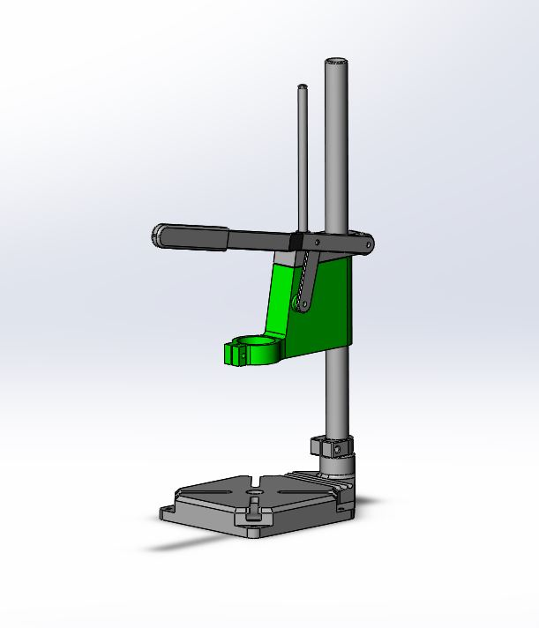

Figure 1: 3D model of the complete drill press stand with all components assembled.
The concept DPMSU is highlighted in green.
Existing concept model of DPMSU
The drill press stand that is the subject of this report will likely be marketed at DIY enthusiasts for light-duty applications such as drilling holes in wood, plastic and soft metals such as aluminium.
Since the drill press will be used in conjunction with standard hand-held drills, it will have to have provision for mounting such a drill securely. There is a common European mounting clamp diameter, also known as ‘’collar diameter’’ of 43 mm often used on power tools such as drills and die grinders. This clamping area is usually used for the attachment of handles to hand-held drills and also used for holding die grinders in fixtures for various purposes. In the case of this drill press it needs to accommodate the 43 mm clamping diameter which is standard on most drills that customers will expect to be able to mount on this drill press using that mounting area. Additional reducing sleeves can also be provided to accommodate smaller clamping diameters such as 38mm (corresponding to 1.5 inch) which is also a common clamping diameter on smaller drills.
The DPMSU concept model provided includes a 43mm diameter clamp which is an important feature.
The DPMSU must form a close fit over the main shaft or column of the drill press to ensure minimal clearance and therefore minimal play between the DPMSU and the column. This is an important functional requirement of the drill press as the amount of play between the DPMSU and the column will largely determine how accurately the drill spindle is aligned with the travel of the DPMSU. Another problem that can arise is vibration if there is excessive clearance between the DPMSU and the column.

The clamping collar on the main siding unit has a bolt for gripping the 43 mm clamping portion of a drill. There is a counter-bore provided on the concept unit for a M5 socket head cap screw. The hole that goes through to the other side of the clamp has a 5.5 mm diameter which will clear the major diameter of a M5 thread. This suggests that this is a clearance hole designed for an M5 bolt to pass through and a nut to be fitted on the other side. There is no mechanism for constraining the nut against turning as the bolt is tightened. This means an additional tool might be required to hold the nut when tightening the bolt. The advantage of this is that the part has less features which have to be created in manufacture such as a hexagonal seat for a nut which simplifies the part.

The concept DPMSU has appropriate proportions relative to the rest of the drill press which is aesthetically pleasing. Various fillets used in different parts also contribute to the look.

Design specification
Considering the existing concept model that is provided, the anticipated customer needs and looking at similar products that already exist on the market, the following design requirements can be determined:
- The DPMSU must be able to accept the mounting of standard hand drills in a simple way utilising the standard clamping area provided on hand drills commonly possessed by customers.

- The DPMSU must provide adequate alignment of the spindle axis of a given hand drill with the travel of the DPMSU such that the spindle axis is parallel to the travel.

- The DPMSU prototype design must be able to integrate with the other components of the drill press that are already provided such as the guide shaft, main shaft and link arm.

- The DPMSU must be able to be manufactured as economically as possible to the required quantity of 1000 units per week.

Manufacturing method and material
The manufacturer intends to make 1000 units per week. This is a relatively high output and the economics of manufacturing and cost drivers must be considered to keep the manufacturing cost of the pillar drill as low as possible.
The material used for the DPMSU and the manufacturing method used to produce it go hand in hand, as certain materials don’t lend themselves well to certain manufacturing methods and vice versa.
The most common materials used in the manufacture of machines and tools in general are steel and cast iron. This is apparent when looking at just about any hand tool or piece of machinery. Traditionally the frame or main structural components of machine tools are made of cast iron for its dimensional stability, vibration damping characteristics and its good performance at providing a direct bearing surface for linear sideways and even plain shaft bearings on machine tools (Moore, 1970).
Since the scale of the DPMSU is quite small relative to usual machine tool members, and the drill press that is the subject of this report is a basic low-cost unit that is aimed at DIY use, the usual advantages of cast iron that make it desirable are not as important. Therefore adequate strength and mass-manufacturability are the most important factors. Usually the material of choice for high-quantity manufacturing of machine parts outside of steel and cast iron is aluminium.
The reason that aluminium is used is because it lends itself well to die-casting (while steel and cast iron do not), which is a method of casting that uses a steel mould instead of a sand mould which is traditionally used in casting (Mason, 2013). The use of a steel mould means the mould can be reused thousands of times and the die casting process itself can be as quick as a few seconds per part (Premier Engineered Products, 2015).
This means that if the high strength and other desirable properties of steel and cast iron are not necessary, die cast aluminium can offer huge cost and time savings for countless parts used in machinery. For example the gearbox casing on many hand drills (of the type that will be used on this drill press) is die-cast aluminium.
The most popular alloy for die-casting is A380 aluminium alloy, which has a good mix of mechanical and physical properties such as strength, corrosion resistance and dimensional stability (Premier Engineered Products, 2018)

Design and development of the prototype
The basic design of the concept DPMSU is appropriate, however a few changes were made after assessing it to simplify the design and improve the manufacturability and function.
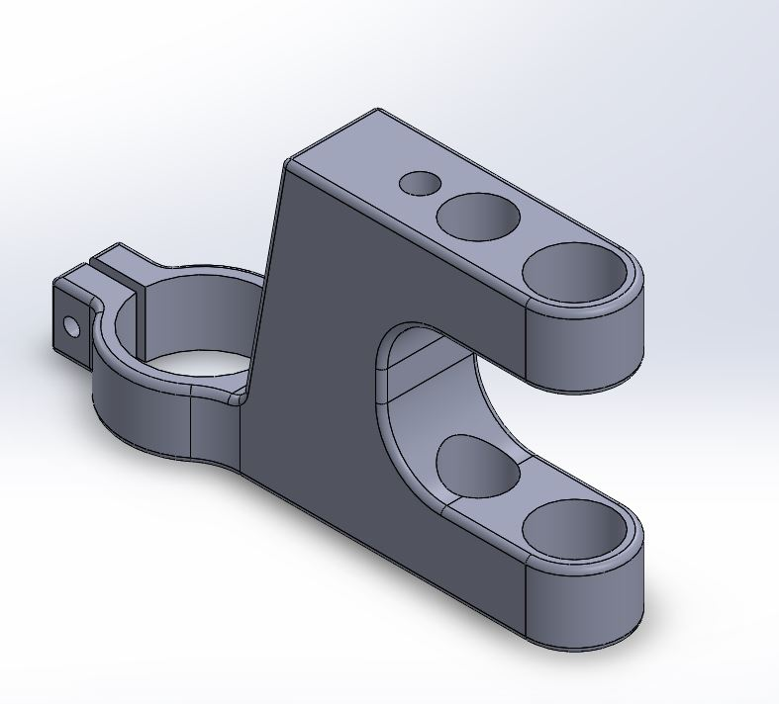

Figure 2: Solid Works Isometric view of completed DPMSU new prototype model
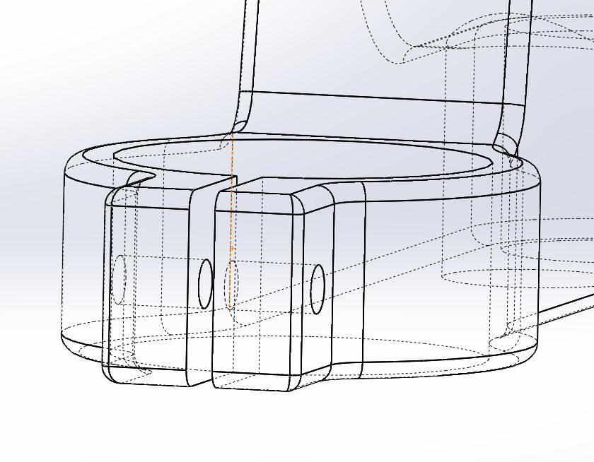The most drastic difference between the concept DPMSU and the new prototype is the large cut out in the side of the DPMSU visible in figure 2. This splits the bore for the main shaft in 2,creating a top portion and a bottom portion. This hole needs to be a close fit on the main shaft to minimise play between the parts. Creating an accurately sized deep bore is always problematic in production, the two short bores will be easier to machine. The loss of material in the centre isn’t a problem, as when the DPMSU is under drilling load it tilts slightly and the bore clearance is taken up, meaning only the top and bottom portions of the bore are effectively working (bearing against the column). This cut out also saves material. All the external edges are filleted which facilities part ejection out of the die and reduces stress in service risers.

Figure 3: View of Solid Works new prototype model showing holes for the clamping bolt.
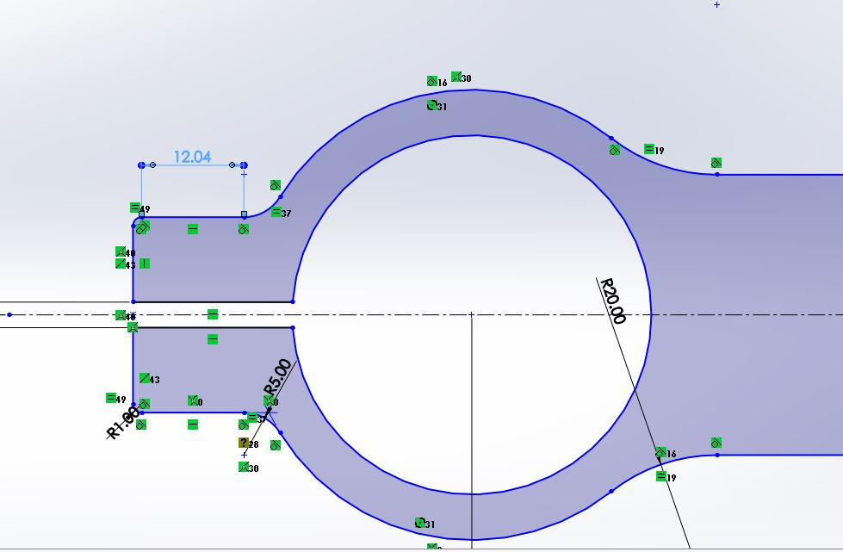Figure 3 shows an M5 clearance hole drilled from one side clear through to the other side of the drill clamping collar. No counter bore was chosen to simplify the casting die and to also remove a stress riser from a crucial part of the DPMSU which reduces the chances of a potential crack developing.

Figure 4: Top view of clamping collar of the DPMSU.
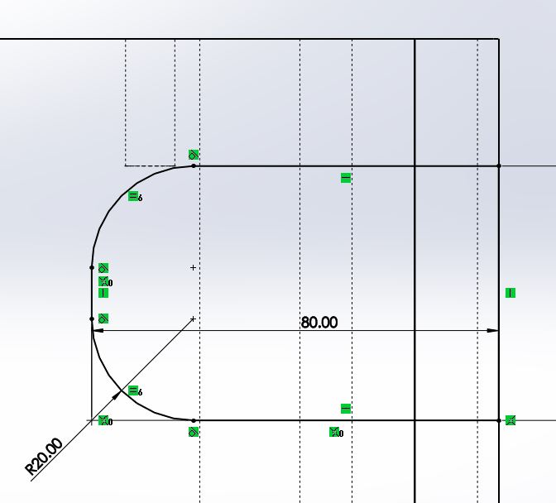The 12.04 mm dimension shown in figure 4 is the width of the flat face where the bolt hole is drilled. The bolt hole is drilled centrally within this flat area. Standard M5 washers have an outside diameter of 10 mm meaning they will fit on this face without interfering with the radius.

Figure 5: View of the large cut out feature sketch. Initial cut out would interfere with the bottom of the hole for the guide shaft.
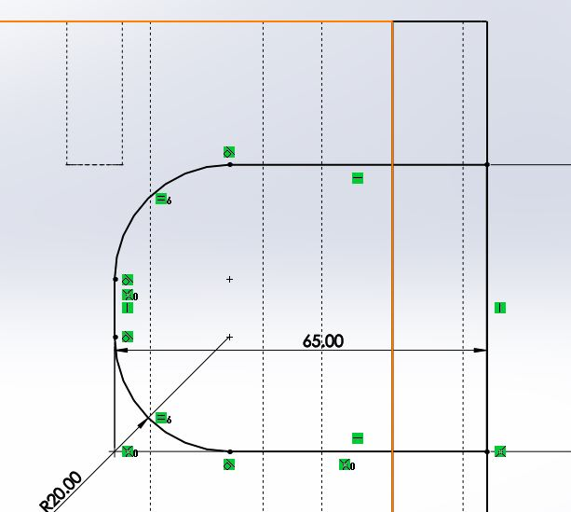

Figure 6: Cut out width reduced to clear the bottom of the guide shaft hole.
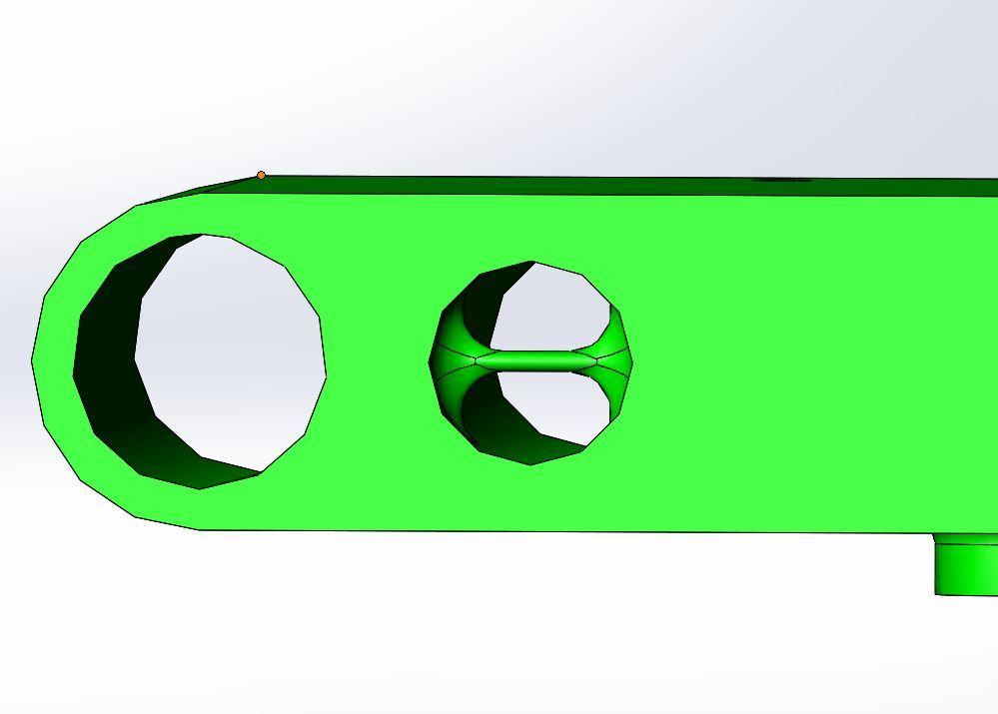

Figure 7: Integral cross pin in the concept DPMSU for a return spring to attach to. This is not a feasible feature to die-cast. A separate pin can span the hole at the bottom of the prototype casting for the return spring to anchor to. The spring will naturally retain this pin in place making drilling a cross-hole unnecessary.

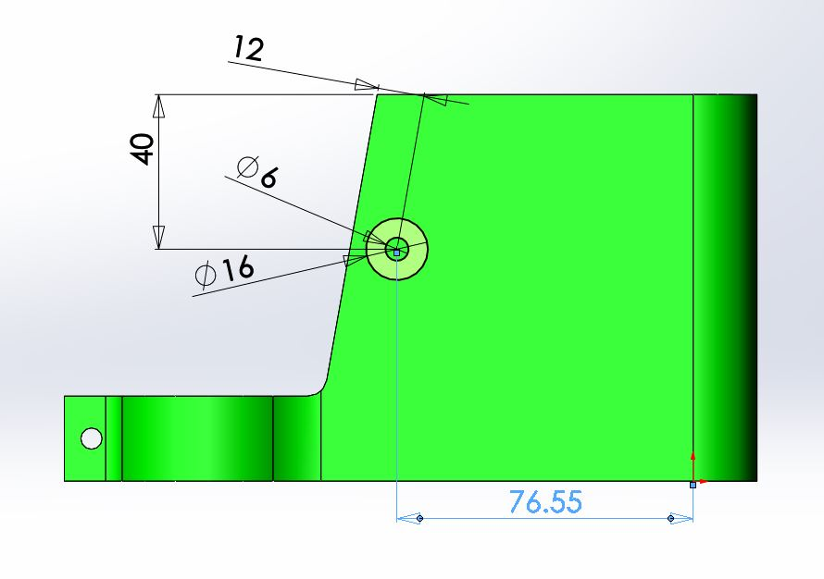

Figure 8: Concept DPMSU with link arm pivot location dimensions.

The 76.55 mm dimension in figure 8 (taken from the original concept model) allows locating the link arm pivot on the prototype relative to other features without relying on the location of the 100 degree slanted face which is in a slightly different position on the new prototype. This conserves the mechanical relationship of this pivot point with respect to the other pivots on the drill press.
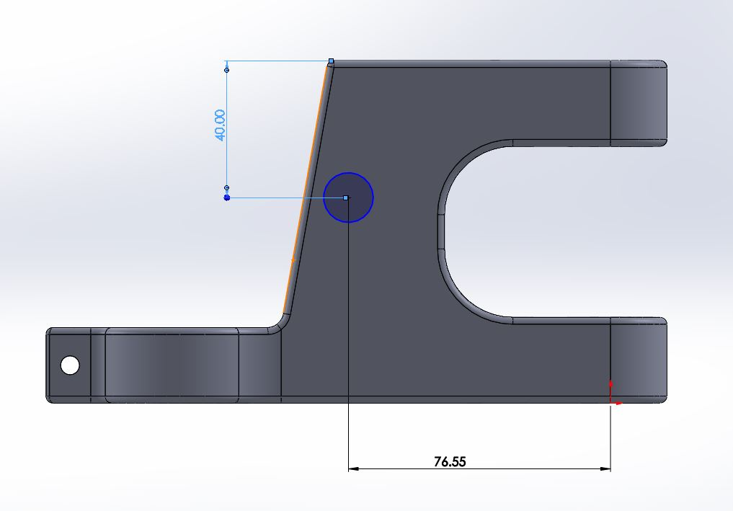

Figure 9: Mechanically equivalent location of link arm pivot on the new prototype.

References
Wayne R. Moore (1970) Foundations of Mechanical Accuracy.

Gavin Mason (2013) Difference between sand casting and die casting. CPM Industries Available at: http://info.cpm-industries.com/blog/bid/328544/difference-between-sand-casting-and-die-casting#:~:text=The%20process%20of%20die%20casting,pressures%20and%20extreme%20heat%20repeatedly Accessed 17/05/2021

Premier Engineered Products (2018) The best Aluminium alloys for die casting. Available at: https://diecasting.com/blog/best-aluminum-alloys/ Accessed 17/05/2021

Premier Engineered Products (2015) Die casting products and services for a broad range of industries. Available at https://diecasting.com/blog/die-casting-services-guide/#:~:text=extend%20die%20life.-,The%20Die%20Casting%20Process,%2C%20cooling%2C%20ejection%20and%20trimming. Accessed 17/05/2021

