I confirm that I have not used any AI tools in the research and creation of this assignment. I confirm that I have not presented any AI generated materials as my own work. I confirm that I have copies of my drafts, notes, and other resources I used, which I may be asked to provide as evidence.

Lisa miggins

Placement

Portfolio

Trem Y Mor

Respite service

Contents
Reflective commentary.... Pages 4-7
Additional evidence.......... Pages 8- 13
References........................ Page 14
Appendices......................... Pages 15- 27

Reflective commentary
Over the course of several months, I volunteered at Trem Y Mor, a facility supporting individuals with diverse learning and/or mental health and communication needs. My journey began on November 1, 2025, marked by a sense of mutual awkwardness between myself and the service users. This foundational stage was crucial for establishing rapport and building the trust necessary for a person-centred approach. By prioritising the individuals comfort levels and following their lead in social interactions, I began to understand their unique preferences, which allowed me to transition from a generic volunteer role to providing more tailored, individualised support. Initial activities were centred on low-pressure interactions, such as playing Scrabble or board games. As the placement progressed, my role evolved from a passive observer to an active participant in a low level of crisis management and emotional support. Key incidents included supporting an individual with limited verbal communication via a tablet, sitting with a distressed resident who felt responsible for others leaving the facility (March 5, 2026), and managing a high-risk situation where an individual with self-injuring behaviours was ingesting non-food items (February 24, 2026). I also navigated communication barriers with a hearing-impaired resident during a period of staff-induced distress.

My feelings towards the situation were initially that I felt a significant amount of beginner’s anxiety. My record on November 1st notes a fear of provoking triggers due to the nature of the service. I felt out of my depth when faced with non-verbal communication and was initially tempted to offer unsolicited advice when a resident confided their mental health struggles to me. I feel this urge to fix things was a natural response to my discomfort, but I soon realised that person-centred support requires emotional containment rather than intervention. Learning to sit with my own uncertainty allowed me to become a more stable presence for those who were experiencing their own distress. However, as I spent more time at the facility, my feelings shifted from apprehension to empathy and professional alertness. I felt touched by the trust residents placed in me but also experienced genuine worry during the choking hazard incident. By the end of the placement, I felt a sense of quiet confidence, particularly when I successfully facilitated a conversation between a talkative resident and a withdrawn one on February 18th. It could be said this transition from fear to professional alertness was a key milestone, as it moved my focus away from my own insecurities and toward the immediate emotional and safety needs of the individuals in my care.
By evaluating of my time spent at Trem Y Mor it demonstrates that I began to experience Trust Building: Through consistent presence and active waiting; sitting quietly during TV shows, I built a rapport that allowed residents to feel safe. This was evidenced by the resident who refused to give items to staff but gave them to me safely. In addition to this I feel that I gained the skill of Adaptability: I successfully utilised various communication tools, including sign language (if only a small amount), tablets, and craft activities, to bridge gaps. I also feel that I maintained while in this role: I recognised early on (Nov 4) that my role was to listen, not to provide clinical advice, which is a vital boundary in social care. I found these to be my positive outcomes of my time there. I also feel there were some negative aspects of this time that can be resolved in the future such as: I felt there were times when there were communication gaps: My lack of British Sign Language (BSL) knowledge caused me concern, as I feared my inability to understand might escalate a resident's distress. In addition, I my initial fear, my early nervousness may have been sensed by the residents, potentially contributing to the initial awkwardness recorded in the first session.
The transition from playing games to managing unwanted consequences reflects a growing understanding of Person-Centred Care (Raskin & Rogers, 2005). In the beginning, I focused on the activity (Scrabble), and by the end, I focused on the person, their triggers, their communication style, and their emotional state, which felt easier to do as the main focus was the game but gave the individual the opportunity to talk when they felt safe.
The incident on February 9, where a change in the staff rota caused distress, highlights the importance of predictability and routine for individuals with complex needs. My concern that my communication gap could cause a resident to come away from baseline shows an analytical understanding of behavioural escalation. Furthermore, the March 5 incident regarding guilt over others leaving suggests that many residents struggle with attachment and loss, requiring specific reassurance that their environment is stable.

Looking back, I have moved from a state of cautious observation to one of proactive support. I realised that doing nothing, like sitting quietly by the TV, is often a powerful therapeutic tool for building trust. This realisation challenged my initial assumption that I always needed to be doing an activity to be helpful; instead, I learned that providing a consistent, calm presence is a cornerstone of person-centred care.I also learned that safety in a high-stakes environment like Trem Y Mor relies heavily on the quality of the relationship between the volunteer and the resident. While I successfully managed risks, I identified a clear need for better technical communication skills to fully support every individual.

If I were to encounter these situations again, I would, try to up-skill in communication: I intend to learn basic BSL signs to ensure I can communicate during staff transitions without relying solely on a bridge person to help with communication. In regards to pre-emptive briefings: I will continue my practice of speaking to staff before shifts to identify potential triggers, making this a standard part of my professional routine in addition to this I intend to expand on the facilitation skills: I will more actively look for opportunities to facilitate peer-to-peer interaction among residents, as seen in the successful movie night on February 18, to help reduce social isolation within the facility (Trimasse, 2025).

Additional evidence

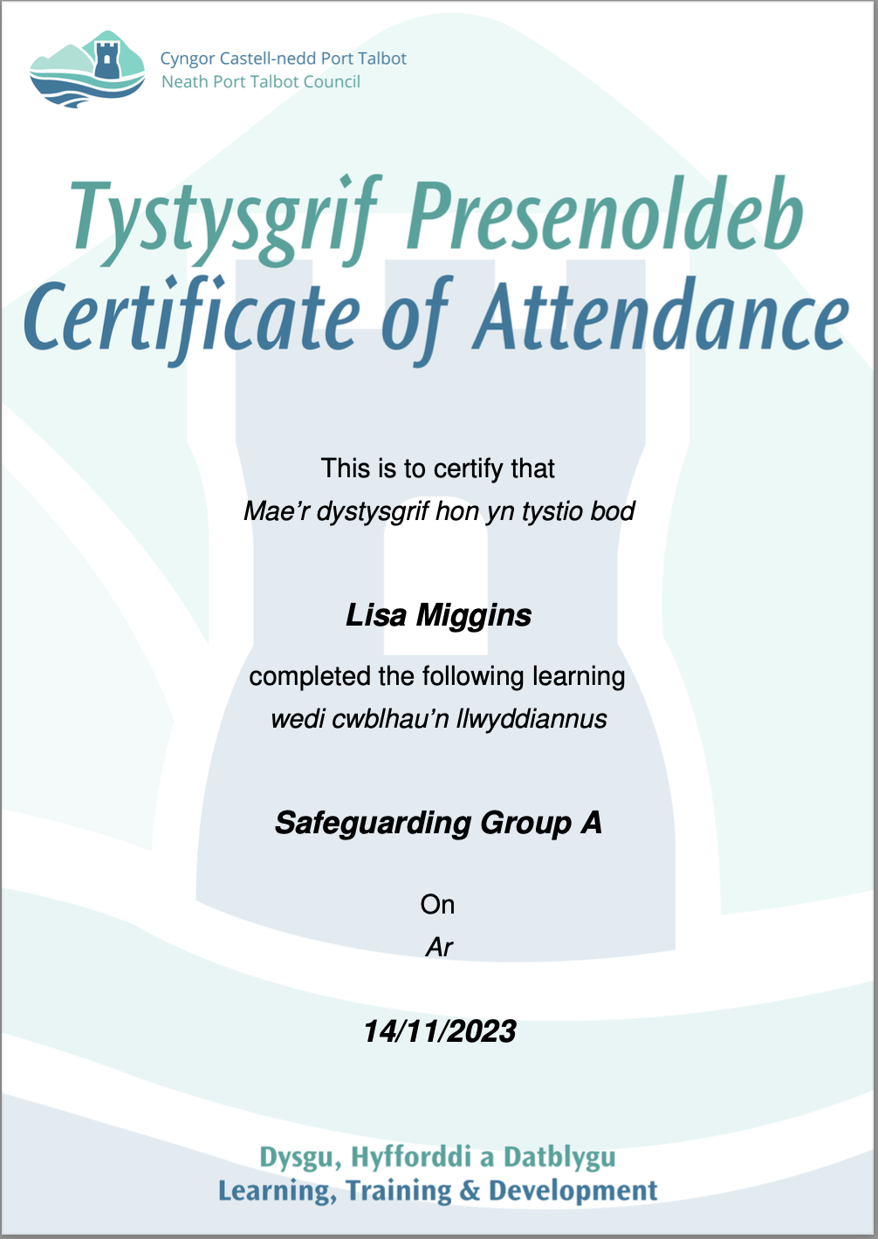

Staff Supervision

Employee Name: Lisa Miggins
Supervisor Name: Becky Stewart
Date of Supervision: 27th Jan 2026
Next Supervision Due: March 2026

1. Wellbeing & General Check-In

How are you feeling? Lisa said she is good.

Any personal or professional challenges you'd like to discuss? No, Lisa has no challenges to discuss that hasn’t been discussed previously.

Are you receiving enough support? Lisa said she is getting enough support now, and she knows how to get support when needed in her personal and professional setting if her needs change.

Notes:

2. Performance & Responsibilities

Any concerns or challenges in fulfilling your duties? no issues.

Examples of good practice or achievements? Lisa works well with the individuals she supports and supports other staff members with her teamwork skills.

Notes:

3. Training & Development

Training completed since last supervision. Training week Nov 25 – Diabetes, PBM. Lisa’s online training is up to date

Training needs or interests. Lisa has no training requests

Opportunities for shadowing or mentoring? Not required. Lisa acts up occasionally and is familiar with the mentoring role.
Notes:

4. Individual we support

Reflections on recent interactions with service users. Lisa works well with all individuals and is getting to know the newer individual who we don’t support often (R B, A T, etc). AL – Lisa meets AL’s needs and not let AL comments and actions impact her professionalism. Lisa works very well with AT who has been in for a prolonged time. Lisa commented on RS and how difficult it is to work with him when he doesn’t have a nighttime routine that helps him settle.

Any safeguarding concerns? Lisa has discussed concern over JB & EC sleeping in the corridors and the risk should the fire alarm sound and the main doors opening.

Suggestions for improving care or support? No suggestions at this time, Lisa will inform management if she has any suggestions in the future.

Notes
AD – Transition has started. No plans as far as I’m aware for LI, SL & AL.

5. Teamwork & Communication

How is communication within the team? Lisa said the communication is mostly good within the team.

Any conflicts or issues? Lisa has no conflicts or issues.

Suggestions for improving teamwork? No suggestions currently.

Notes:

6. Goals & Actions

Goals for the next supervision period. Complete further online training.

Actions agreed upon during this session. Keep up to date with any training provided

Support needed to achieve goals? None

Notes:

7. Feedback

Feedback from supervisor. Lisa works well with individuals, within the team and completes all her duties to a good standard

Feedback from support worker. Lisa said she is happy with her workload, has no issues or concerns.

Support Worker: L Miggins
Supervisor: B Stewart
Date: 27/01/2026

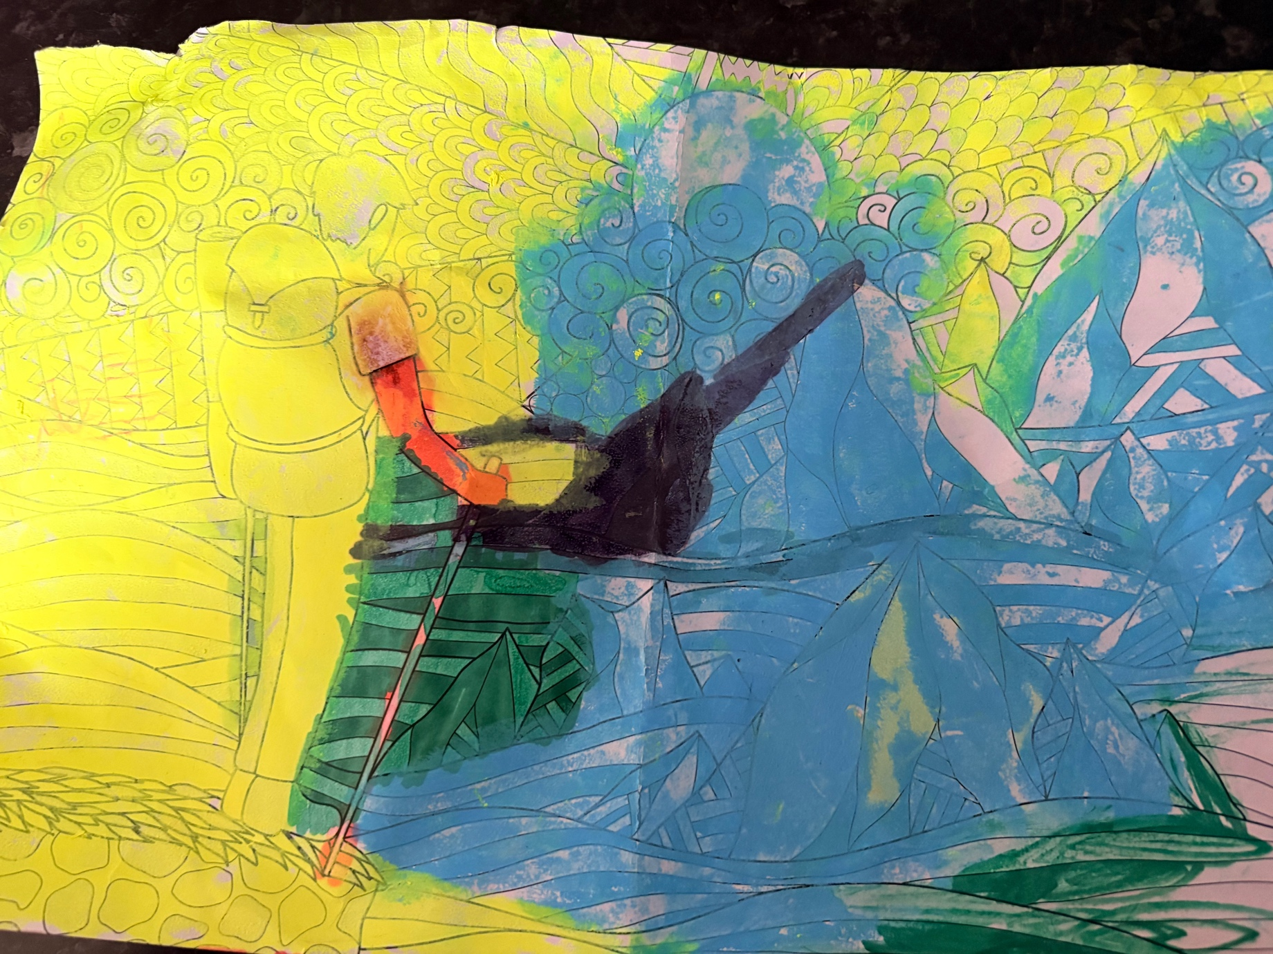

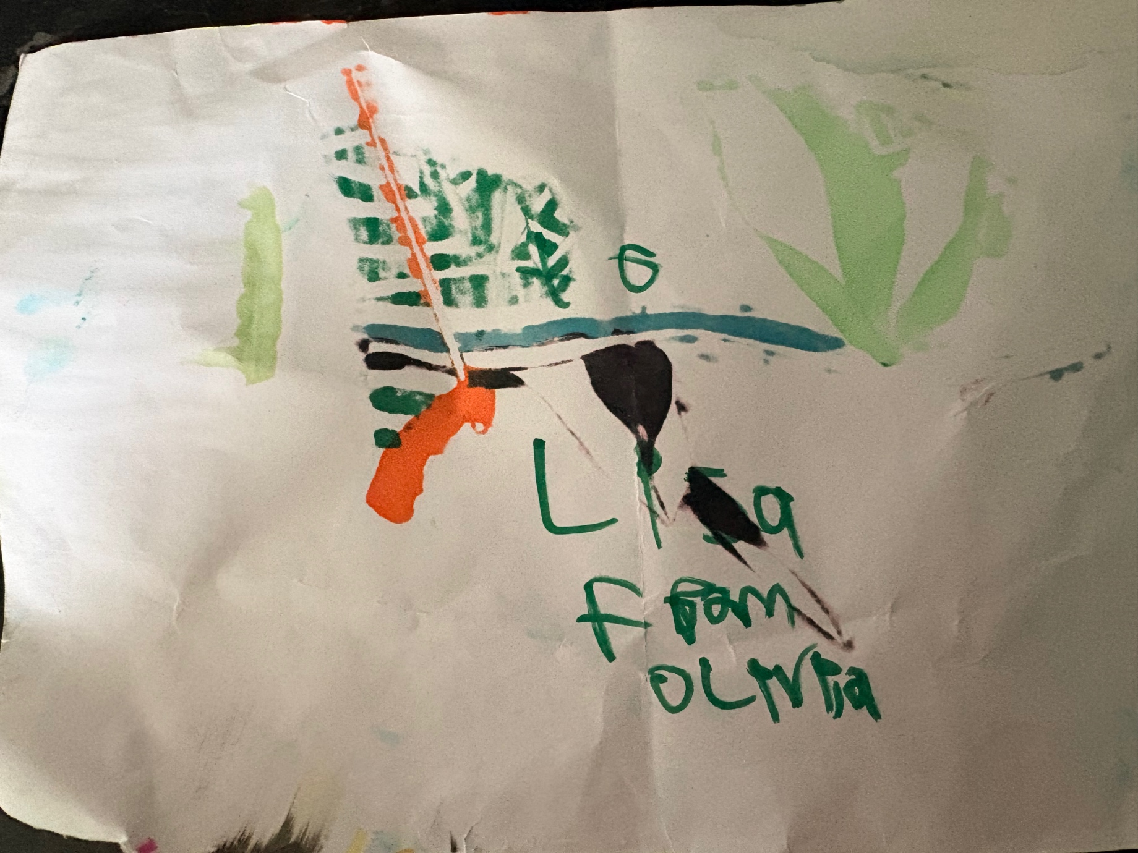

References

Raskin, N. J., & Rogers, C. R. (2005). Person-centered therapy.
Trimasse, N. (2025). The use of reflective reports in higher education. Reflective Practice, 26(1), 154–171. https://doi.org/10.1080/14623943.2024.2424520
University of Edinburgh. (2024, October 15). Gibbs' reflective cycle. https://reflection.ed.ac.uk/reflectors-toolkit/reflecting-on-experience/gibbs-reflective-cycle

Appendices
A
Volunteers name: Lisa miggins
Date of visit: 1/11/25
Time spent in total: 4 hours

BRIEF DESCRIPTION OF VISIT/ACTIVITY
First visit in placement, a staff member introduced me to one of the individuals, I felt a little award at the beginning, as did the individual. He was sat at a table with some board games, I asked if he would like to play one for a while.

RECORD OF ANYTHING IMPORTANT THAT HAPPENED
Individuals appeared to engage well today, after the initial awkwardness. Appeared to enjoy chatting and telling me about their interactions throughout their day, while playing scrabble.

RECORD OF ANY CONCERNS OR WORRIES

I am still a little nervous of some of the individuals that attend Trem Y Mor, due to the nature of the service.

RECORD OF ANYTHING THAT NEEDS TO BE DONE

I will talk to the staff beforehand to see how the individuals have been throughout the day. Noting anything that I need to be aware of, to help avoid any triggers that I could possibly provoke.
Volunteers name: Lisa Miggins
Date of visit: 4/11/25
Time spent in total: 4 hours

BRIEF DESCRIPTION OF VISIT/ACTIVITY
On arrival there were 3 individuals in the communal area. As I sat at the table the individual that played scrabble the week before came over and asked if I would play again. As we were playing, he started telling me why he was there and how much of a difference having the opportunity to use this facility has made to his life.

RECORD OF ANYTHING IMPORTANT THAT HAPPENED
While we were talking this individual spoke about some personal issues about his mental health, I was touched that he felt able to confide in me. At first I felt the need to offer some advice but realised quickly that I was not there for that, my place was to listen.

RECORD OF ANY CONCERNS OR WORRIES

N/A

Volunteers name: Lisa Miggins
Date of visit: 10/11/25
Time spent in total: 4 hours

BRIEF DESCRIPTION OF VISIT/ACTIVITY
There was a few individuals in the communal area, when I sat down at the table one of them came over to show me what he was watching on his tablet. This individual had limited verbal communication, but managed to communicate by showing me the things he liked on the tablet and some sign language. He seemed to enjoy showing me the videos and pictures. Staying with me for the duration of the visit.

RECORD OF ANYTHING IMPORTANT THAT HAPPENED

N/A

RECORD OF ANY CONCERNS OR WORRIES

I found it hard to understand at first what the individual was trying to say, however, with some patience from us both we managed to over come this.

Volunteers name: Lisa Miggins
Date of visit: 17/11/25
Time spent in total: 4 hours

BRIEF DESCRIPTION OF VISIT/ACTIVITY

This evening there was only one individual in the communal area, at first they were reluctant to talk. As they were watching TV I choose to just sit quietly by them. After a little while they spoke asking if I had seen the series before. This opened up to a conversation for a bit then they went back to watching the TV as before. When it was time to leave, they said goodnight, see you again.

RECORD OF ANYTHING IMPORTANT THAT HAPPENED

NA

RECORD OF ANY CONCERNS OR WORRIES

NA

Volunteers name: Lisa Miggins
Date of visit: 1/12/25
Time spent in total: 4 hours

BRIEF DESCRIPTION OF VISIT/ACTIVITY

On arrival, there was an individual near the entrance. She asked if I would sit with her for a bit. When I did she started chatting about her day and what she had done/seen. She asked about my day, when I told her what I had done. We chatted for awhile before she said she was going to have a lay down in her room.

RECORD OF ANYTHING IMPORTANT THAT HAPPENED

N/A

RECORD OF ANY CONCERNS OR WORRIES

N/A

Volunteers name: Lisa Miggins
Date/Time of visit: 17/12/25
Time spent in total: 4 hours

BRIEF DESCRIPTION OF VISIT/ACTIVITY
Spent time with one of the individuals doing Christmas crafts. As we chatted she was telling me how much she was looking forward to going home and showing her family what she had made during her stay. She also talked about what Christmas was going to be like at home

RECORD OF ANYTHING IMPORTANT THAT HAPPENED
Was nice to engage with the individual and find out about her family life.

RECORD OF ANY CONCERNS OR WORRIES

N/AVolunteers name: Lisa Miggins
Date/Time of visit: 8/1/26
Time spent in total: 4 hours

BRIEF DESCRIPTION OF VISIT/ACTIVITY
This visit was spent playing board games in the communal area.

RECORD OF ANYTHING IMPORTANT THAT HAPPENED
Nobody seemed to be very chatty today so we just played the games

RECORD OF ANY CONCERNS OR WORRIES

N/AVolunteers name: Lisa Miggins
Date of visit: 13/1/26
Time spent in total: 4 hours

BRIEF DESCRIPTION OF VISIT/ACTIVITY

Today was one of the individuals birthdays and there was a party.

RECORD OF ANYTHING IMPORTANT THAT HAPPENED

After the party was finished one of the individuals that I have met on a few occasions came over and chatted about the party and was telling me what he would like to do on his birthday. Spent the rest of the evening chatting with him and a few others.

RECORD OF ANY CONCERNS OR WORRIES
N/AVolunteers name: Lisa miggins
Date of visit: 13/2/26
Time spent in total: 4 hours

BRIEF DESCRIPTION OF VISIT/ACTIVITY
Spent time in communal area with three individuals. In this time we chatted about their day and what activities they had done, assisted to make coffee and toast.

RECORD OF ANYTHING IMPORTANT THAT HAPPENED
Individuals appeared to engage well today, enjoyed chatting and telling me about their interactions throughout their day.

RECORD OF ANY CONCERNS OR WORRIES

N/A

Volunteers name: Lisa Miggins
Date of visit: 14/2/26
Time spent in total: 4 hours

BRIEF DESCRIPTION OF VISIT/ACTIVITY
Today was spent doing crafts with some of the individuals.

RECORD OF ANYTHING IMPORTANT THAT HAPPENED
Spent this time chatting and getting to know some of the individuals that live in Trem Y Mor. This was interesting as they spoke about the things they enjoyed while being here. One lady said she would be very sad when the time came for her to move to her forever home.

RECORD OF ANY CONCERNS OR WORRIES
N/AVolunteers name: Lisa miggins
Date of visit: 17-2-26
Time spent in total: 4 hours

BRIEF DESCRIPTION OF VISIT/ACTIVITY
Assisted while an individual made themselves a small breakfast, then sat with them chatting about their day ahead, and what they were looking forward to doing.

RECORD OF ANYTHING IMPORTANT THAT HAPPENED
I felt I made a good connection with this individual, she opened up and had a comfortable conversation about the things she was planning and the people she would be seeing that day.

RECORD OF ANY CONCERNS OR WORRIES

N/A

Volunteers name: Lisa miggins
Date of visit: 9-2-26
Time spent in total: 4 hours

BRIEF DESCRIPTION OF VISIT/ACTIVITY
Spent time with an individual and a member of staff chatting, and watching a film. This individual has a hearing impairment and uses sign language, lip reading and written communication to communicate with others. This particular individual became concerned as there was a change in the staff rota, causing the individual to become a little distressed.

RECORD OF ANYTHING IMPORTANT THAT HAPPENED
The member of staff helped to bridge the gap between our communication as I know very little sign language. However, we did manage to resolve the individuals concerns.

RECORD OF ANY CONCERNS OR WORRIES
I was a little concerned that my lack of communication skills regarding this individual could have potentially caused her to come away from baseline then progress to unwanted consequences, which could then upset them further.
I could learn a little bit of sign language to help avoid this from happening in the future.
Volunteers name: Lisa Miggins
Date of visit: 18-2-26
Time spent in total: 4 hours

BRIEF DESCRIPTION OF VISIT/ACTIVITY
When I arrived there was an individual that I had met on a previous shift, she came over and asked if I would sit with her. She wanted to watch a film. The individual was chatting throughout, talking about her family and what they had been doing recently. There was another individual present, but she was very quiet. I would try to encourage her to join in with the conversation, by asking questions that were relevant to what the other individual was talking about.

RECORD OF ANYTHING IMPORTANT THAT HAPPENED
By the end of the evening, both individuals were talking and seemed to be enjoying each others company. Even talking about doing activities together in the morning.

RECORD OF ANY CONCERNS OR WORRIES

N/A

Volunteers name: Lisa Miggins
Date of visit: 24/2/26
Time spent in total: 4 hours

BRIEF DESCRIPTION OF VISIT/ACTIVITY
Was asked to interact specifically with one individual tonight, who I have meet on several occasions. she is known to have self injury related be behaviours. That are not normally life threatening but could cause harm. I sat with her chatting in different areas of the building , she seemed to enjoy the sensory area mostly.

RECORD OF ANYTHING IMPORTANT THAT HAPPENED
This individual kept putting things in her mouth that she could choke on. She refused to remove them when asked by staff members at, however, with some encouragement she did give them to me safely.

RECORD OF ANY CONCERNS OR WORRIES

I was worried that this individual would choke due to the items she had found and placed in her mouth. But due to staff present the risk was low and managed.

Volunteers name: Lisa Miggins
Date of visit: 5/3/26
Time spent in total: 4 hours

BRIEF DESCRIPTION OF VISIT/ACTIVITY
Spent time in the communal area. Catting to one of the individuals who are currently residing at Tree Y Mor.

RECORD OF ANYTHING IMPORTANT THAT HAPPENED
While we were chatting she became upset. She felt she was to blame for the people who had left that day (their stay had come to an end). I spent time listening to her concerns and reassuring her that it was normal for them to go and had nothing to do with anything she had done. After some time she seemed to be happy knowing it was not her doing and she started chatting about other things.

RECORD OF ANY CONCERNS OR WORRIES

N/A

B
Dear Sharon,
I am writing to you to enquire about spending time within your organisation (Term Y Mor), with the intension of providing the support and care that is required in a voluntary role, to support the individuals that attend your service. I am happy to undergo any training that is required to enable me to provide the support safely and within your care standards according to any policies and procedures that are needed to be adhered to. If you have any availability for my service at this time, please contact me on 07984263198.
Yours sincerely,

Lisa Miggins

C

Dear Lisa,
Following our meeting yesterday, I am pleased to inform you that your interview was successful. We would be delighted to invite you to join our team on a voluntary basis.
We have scheduled an induction session for Wednesday, 5th October 2025, at 1:00 pm. Would you be available to attend? During this session, we can further discuss your availability and the specific hours you will be volunteering with the service.
If this time is inconvenient, please let me know, and we can arrange an alternative date. You can confirm your attendance or reschedule by contacting me at 01639 763014.
We look forward to welcoming you to the team.
Best regards,
Sharon Andrews

D
Placement Information Form
Name of student: | Lisa Miggins
Proposed placement setting and address: | Trem Y Mor  Scarlet Avenue  Sandfields  Portalbot  SA12
Proposed dates of placement: | Present day
Name and position of contact: | Sharon Andrews  Manager
Contact email address: | s.andrews@npt.gov.uk
Contact telephone number: | 07981031883
Is a DBS required for you to attend this placement? | X Yes  - No  If Yes, have you applied for this?  X Yes applied on February 2025  - No
Explain how your role in this organisation/on this placement meets the criteria for the assessment for the module  (e.g., what duties/tasks will you be undertaking that are relevant for the module assessment) | Listening and talking to individuals that are attending respite. Doing tasks and activities that individuals are interested in. Promoting independence by assisting or advising while they carry out tasks. When asked for advice or anything is disclosed signposting them to the relevant person or team. In some cases, reporting information if it is felt someone is a danger to themselves or others or could be in danger from another source.


ALL information must be provided. Incomplete forms will be returned to the student.
Please return this form to Stacey Coleman (stacey.coleman@uwtsd.ac.uk) by no later than 12pm on Monday 1st July.

E
Lisa Miggins (2405698) shared "placement information form" with you
Summarise
Lisa Miggins (2405698)
Stacey Coleman


Stacey Coleman
Lisa Miggins (2405698)
Hi Lisa,

This email is just to confirm that your placement provider has confirmed your placement.

Good luck, enjoy, and I look forward to hearing all about it over the course of this year.



Cofion cynnes, | Kind regards,

Stacey.




