
Development and Application of Manufacturing Automation

Control and Automation

21/04/2024

Taylor Davies

Contents
Introduction 3
Types of Manufacturing Automation 4
Fixed Automation 4
Programmable Automation 5
Flexible Automation 6
Application of Flexible Automation in Flat-packed Furniture 7
Overview of the Flat Pack Furniture Industry 7
Flexible Automation Within the Flat pack Furniture Industry 7
Conclusion 8
References 9

Introduction

Automation in manufacturing is the use of technology to automate industrial processes, this allows manufacturing companies to reduce the need for human labour while increasing productivity, quality, and Flexibility (Access Industrial Automation, 2023).

Although the idea of manufacturing automation is not new, its importance in the current industrial environment has never been greater. With technology developing at an unstoppable pace, companies looking to remain competitive in a constantly changing global market must embrace automation in their manufacturing processes (Access Industrial Automation, 2023).

There are three main types of automation used in manufacturing; these are Fixed Automation, Programmable Automation and Flexible Automation. Fixed automation is where the equipment and configuration determine the order in which processing or assembly operations take place. On the other hand, programmable automation refers to the process of manufacturing items in the batches where the production machinery must be reprogrammed to accept the new product style of the subsequent batch. Finally, flexible automation is the resolution to changeover time and wasted production time. When compared to the programmable automation, the low number of product types makes this achievable (AURORA, 2021).

The sector for flat pack furniture has had impressive expansion and demand due to its reasonable prices, simple installation, and customisable choices. Flat pack furniture offers a wide selection of items catering to varied interests and preferences, a response to market leaders such as IKEA that are setting consumer expectations. The requirement for effective production procedures grows as the sector develops further. A workable answer is revealed in the form of flexible automation, which enables producers to satisfy modular furniture design specifications while boosting output and quality assurance. This introduction lays the groundwork for examining how flexible automation transforms the flat pack furniture industry's production, spurring creativity and competitiveness.

Types of Manufacturing Automation

Fixed Automation

In a fixed automation manufacturing system, every production and assembly task are managed by equipment that has been precisely programmed for that function. Manufacturers configure equipment for fixed automation to repeatedly carry out a single duty, in contrast to programmable automation. Creating a series of automated processes that, when fully integrated, will generate a certain product or fulfil a specific activity from beginning to end is the aim of fixed automation (Automation, 2022).

Fixed automation has historically developed in a variety of industries because to the demand for higher production process productivity, efficiency, and uniformity. The development of fixed automation is being shaped by ongoing technological advances and advancements, which allow industries to operate with more automation and precision.

Fixed automation is used in several industries to complete tasks with the use of specialised equipment to increase efficiency. Fixed automation is used greatly in the aerospace industry and the automotive industry. Within the aerospace sector, stationary automation systems aid in the testing, quality control, and assembly of aircraft parts. Automating these procedures helps preserve accuracy and eliminate errors because manufacturing automation is necessary in this industry due to the high standards of safety and precision. In addition, fixed automation systems are widely used in the automobile sector, which uses them for body assembly, painting, and inspection, among other stages of vehicle production. Automation guarantees the consistency and quality of manufactured automobiles while also accelerating the production process (Parmar, 2023).

Systems that make use of fixed automation have benefits and drawbacks. A robot that is programmed to do a series of preprogrammed tasks or a single task repeatedly is an example of a system based on fixed automation. Furthermore, the automated equipment in these systems is hard-wired, meaning that production is managed by wiring and mechanical tools. Fixed automation is perfect for manufacturers who wish to produce a single product on a large scale because it has a cheap cost per unit once implemented. However, the disadvantage of fixed automation is that it is difficult to reconfigure to make different items (Inc, 2023).

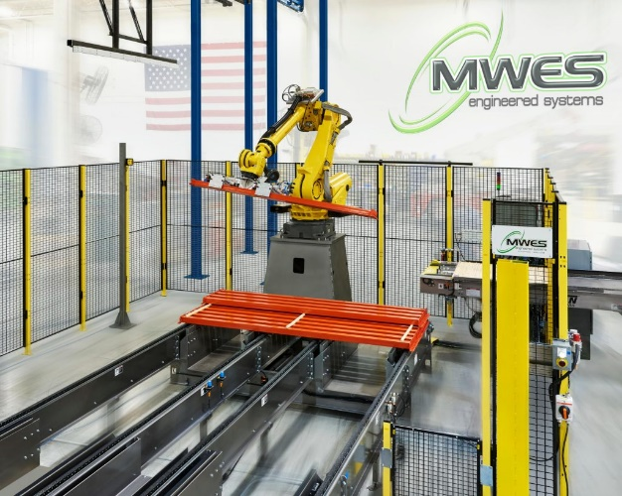

(MWES, n.d.)

Programmable Automation

Real-time programmable logic controllers (PLCs), industrial robotic applications, and a variety of CNC (Computer Numerical Controlled) machine tools are all used in programmable automation. Applying logical programming commands with automation technologies that power machines and equipment results in operational efficiency. Setting up a programmable automation system comes with a considerable initial cost. But over time, the initial high-cost balances because the procedures are ongoing and constant (Inc, 2020)/

A team of engineers at General Motors (GM) created the first programmable logic controller (PLC) in the late 1960s to replace the intricate and expensive relay-based control systems that were widely in use at the time. The first PLC, the GM50, was developed by General Motors and was utilised by the company's Packard Electric Division. This announcement was made in 1968. As the first PLC with a microprocessor, the GM50 was more compact, dependable, and adaptable than the relay-based systems it replaced. Programmable logic controllers (PLCs) have evolved to become smaller, more powerful, and more affordable while also gaining additional functionality and capabilities 6 (Automation Community, 2023).

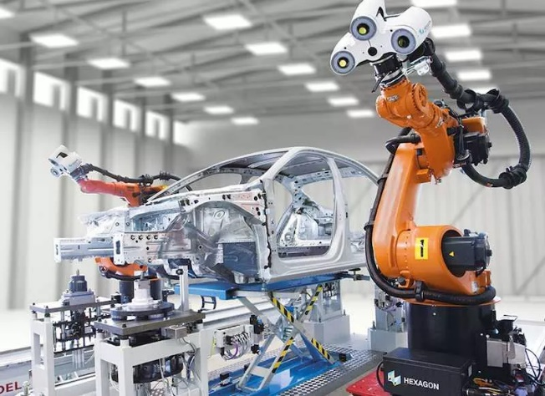
As mentioned, programmable automation is used in various industries to complete tasks that may be dangerous or even tedious which results in human error. One well-known example is the computer numerical control (CNC) machine. They are designed to carry out exact machining operations like milling, turning, and drilling. The manufacturing sector uses these machines extensively. In addition to this production lines, HVAC (heating, ventilation, and air conditioning) systems, and municipal water treatment facilities are just a few of the industrial activities that PLCs manage. When necessary, they can be reprogrammed to control different processes. PLCs are the most known form of automation across several different industries due to their versatility. Finally, industrial robots can be designed to handle a variety of items, package sizes, and packaging patterns. Examples of these robots are those used in palletising and packing activities. Industrial robots are also used heavily in the car manufacturing industry due to being able to move cars across the production facility with ease and able to complete more dangerous tasks which could cause issues for a company if humans completed the tasks (Shoplogix, 2024). (Phoenix Control Systems, n.d.)

There are several advantages to using programmable automation within manufacturing lines such as increased productivity, shorter cycle times and higher production output result from this. When automated systems work nonstop and without interruption, productivity soars, resulting in increased output and quicker project completion. In addition to this programmable automation improves quality. Automation adheres to exacting instructions, reducing human error, and guaranteeing output quality that is constant. Automation significantly lowers the likelihood of errors due to human error in sectors where accuracy is essential, such as pharmaceutical manufacturing, producing goods of higher quality. Finally, machines can be trained to perform hazardous activities, reducing industrial accidents, and enhancing worker safety. Chemical processing facilities and other industries with hazardous surroundings gain greatly from automation since it keeps human operators out of dangerous circumstances and ensures staff safety and continuous operations. On the other hand, there are some disadvantages that come with programmable automation. For example, it costs a lot of money up front to implement automated systems because of setup, training, and equipment costs. However, long-term cost reductions and efficiency advantages are frequently the result of this initial investment. Also, automation can increase productivity but can result in job losses in labour-intensive industries. As such, technology and worker welfare must be carefully balanced. Governments and business associations ought to investigate ways to lessen possible adverse effects on employment (admin, 2023).

Flexible Automation

A kind of factory automation known as "flexible automation" demonstrates some degree of "flexibility." The ability to quickly produce a variety of items is the most common example of this flexibility. The fabrication of various part types with overlapping life cycles is made possible by this "process flexibility."

Multiple part types can be produced in small or unit batch sizes thanks to flexible automation. Flexible automation (FA) can involve many different technology combinations, although it usually takes the form of machining systems, or production systems that remove material from a workpiece. The programmability of the computers operating the devices provides the versatility. Assembling systems also exhibit flexible automation (Stecke and Parker, 2020).
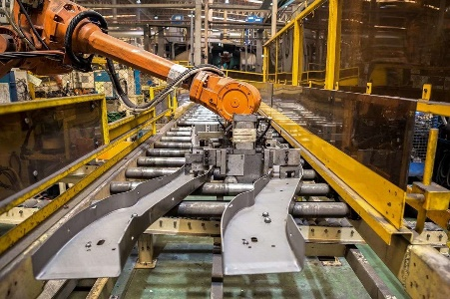
There are several advantages and disadvantages to using flexible automation within manufacturing. Manufacturers can expand their product lines and adapt their output to meet market demands by utilising flexible automation. There once was a time when manufacturers also failed when an industry did. However, with adaptable automation, such establishments may have switched to brand-new, developing markets. Markets change, and their goods can too (CSD, 2021). (Hendey, 2018)

Furthermore, flexible manufacturing methods offer remarkable accuracy and dependability, which enhance quality control. Data monitoring may swiftly detect and resolve quality issues. Because there is very little downtime required to set up for new products or product variations, production is more efficient.

Before implementing flexible manufacturing systems, companies should be aware of the substantial up-front costs associated with equipment installation, purchasing, and setup. Additionally, there can be a skills gap in the current staff, necessitating hiring additional engineers and technicians to make up for lost productivity or training to become up to date on the new technologies. FMS can also be costly to manage and maintain after it is up and running. With such limitations in mind, manufacturers who embrace flexible manufacturing can become more effective, versatile, and less dependent on unstable supply chains and demand swings. Having an FMS in place makes it easier to adjust production settings to accommodate different products or assemblies or to self-produce necessary parts in response to changes in product demand and supply chains (Autodesk, 2024).

An example of where flexible automation is used in industry is automated packing. Packaging can involve anything from shrink-wrapping entire pallets of goods to prepare them for delivery to a distributor, to simply wrapping individual candies that are subsequently bagged for consumers. Packaging machine designs need to satisfy distributors or manufacturers based on the product, and these systems are frequently highly customised. The design of packaging systems should offer a broad range of capabilities, as automation for packaging relies on the kind, size, fragility, and other aspects of the products being wrapped. By maximising efficiency, automated packaging technology helps smaller producers maintain their competitiveness in the market versus mass-produced packaged goods. More product categories with different packaging needs can also be accommodated by current automated engineering. It assists producers in cutting down on product packaging time, which lowers operational expenses (Inc, 2022).

Application of Flexible Automation in Flat-packed Furniture

Overview of the Flat Pack Furniture Industry

Flat pack furniture is a very popular and preferred type of furniture due to being so inexpensive and easy to assemble. The Thonet chair is credited as being the first piece of flatpack furniture ever created. Michael Thonet designed it in the middle of the 19th century in what was then the eastern Czech Republic, then Austria-Hungary. Nevertheless, this chair was packaged and distributed in bulk rather than being supplied straight to individual consumers. The method was developed gradually but steadily in the early 20th century, mostly in Central Europe (IKEA Museum, n.d.).

Market leaders in the flat-pack furniture space, like IKEA, have shaped customer expectations and market trends and have played a major role in the industry's growth and development. The market landscape of the sector is defined by a wide variety of products that meet different budgetary limitations, tastes, and preferences. Flat-pack furniture is becoming more and more popular, according to consumer trends, because of its customisable options, compact designs, and eco-friendly packing (Anil, 2023).

Flexible Automation Within the Flat pack Furniture Industry

From the research conducted I have concluded that flexible automation is well suited to the flat packaged furniture industry.

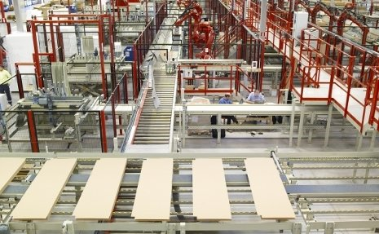
Flat packaged furniture is distinguished by its modular design, which consists of separate parts that the final user may readily assemble on-site. This puts pressure on manufacturers to efficiently produce a large range of components while allowing for frequent design modifications and customisation choices. Manufacturers can accomplish this using robotic systems, CNC machines, and other automated equipment that can quickly transition between tasks and adjust to changing production demands. This is made possible by flexible automation.

Furthermore, flexible automation's scalability makes it ideal for the dynamic flat packed furniture business. By adding or rearranging automation systems, manufacturers can readily adapt production capacity in response to changes in demand or the launch of new product lines. Because of its scalability, businesses can minimise capital expenditure and operating costs while maintaining competitiveness in a market that is changing quickly.

Flexible automation offers many advantages to the flat packed furniture business overall, such as enhanced quality control, better productivity, and enhanced customisation options, all of which boost profitability and competitiveness.

Conclusion

In conclusion, automation has emerged as a critical element of contemporary production, boosting output, quality, and efficiency across all sectors. Businesses need to adopt automation to be competitive in the global market as technology continues to improve quickly. Different production needs are met by the three primary forms of automation, which are fixed, programmable, and flexible. They offer differing degrees of efficiency and adaptability.

The different types of automation are suited to various types of tasks which vary from simple packing items to tasks which could endanger human life. Automation also has the benefit of removing the risk of human error therefore the pay back on investment is worth it in the long run.

The industry for flat pack furniture has grown significantly in popularity and demand because to its low cost, simplicity of assembly, and customisability. Leaders in the market, such as IKEA, have been crucial in influencing consumer expectations and promoting innovation in the industry. Production methods that are efficient are becoming more and more important as the industry develops.

Fundamentally, the confluence of programmable, flexible, and fixed automation technologies provides producers with a broad range of tools to satisfy changing market demands and spur innovation. Businesses can position themselves for long-term growth and competitiveness in an increasingly complex and dynamic business environment by embracing automation.

References

Access Industrial Automation (2023). What Does Manufacturing Automation Mean? - Access Industrial Automation. [online] aiautomation.org. Available at: https://aiautomation.org/blog/what-does-manufacturing-automation-mean-today/#:~:text=Manufacturing%20automation%20refers%20to%20the%20utilization%20of%20technology [Accessed 23 Mar. 2024].
admin (2023). 4 Types of Automation - Benefits, Pros and Cons & More. [online] QodeNext. Available at: https://www.qodenext.com/blog/types-of-automation/ [Accessed 11 Apr. 2024].
Anil, U. (2023). Behind the Success: Decoding IKEA’s Blueprint to Global Domination. [online] Unfold Anil. Available at: https://unfoldanil.ai/behind-the-success-decoding-ikeas-blueprint-to-global-domination/ [Accessed 15 Apr. 2024].
AURORA (2021). The Three Different Types of Automation in Manufacturing | Aurora Process. [online] My CMS. Available at: https://aurora-process.com/the-three-different-types-of-automation-in-manufacturing/ [Accessed 23 Mar. 2024].
Autodesk (2024). Flexible Manufacturing Systems (FMS) | What is Flexible Manufacturing? | Autodesk. [online] Autodesk.com. Available at: https://www.autodesk.com/solutions/flexible-manufacturing-system [Accessed 12 Apr. 2024].
Automation Community (2023). History and Applications of PLC - Automation Community. [online] Automation Community. Available at: https://automationcommunity.com/history-and-applications-of-plc/ [Accessed 10 Apr. 2024].
Automation, C. (2022). Fixed Automation System: What It Is and Its Application in Manufacturing. [online] Captech Automation, LLC. Available at: https://www.captechautomation.com/blog/fixed-automation-system-application-manufacturing/ [Accessed 10 Apr. 2023].
CSD (2021). The Difference Between Fixed & Flexible Automation. [online] CSD & Integration, Inc. Available at: https://controlsystemsdesign.com/blog/the-difference-between-fixed-flexible-automation/ [Accessed 12 Apr. 2024].
Hendey, M. (2018). Bringing Flexible Automation to Your Business - Robotic Automation. [online] Product Development, Manufacturing, Problem Solving | The Hendey Group. Available at: https://hendeygroup.com/blog/bringing-flexible-automation-to-your-business/ [Accessed 20 Apr. 2024].
IKEA Museum (n.d.). How IKEA Took Flatpacks to a Whole New Level - IKEA Museum. [online] WordPress på Azure. Available at: https://ikeamuseum.com/en/explore/the-story-of-ikea/flatpacks/ [Accessed 15 Apr. 2024].
Inc, E.A.M. (2020). What is Programmable Automation & How Does it Work? - EAM Inc. [online] Engineered Automation of Maine. Available at: https://www.eaminc.com/blog/what-is-programmable-automation/ [Accessed 10 Apr. 2023].
Inc, E.A.M. (2022). 3 Flexible Automation Examples Explained | EAM, Inc. [online] Engineered Automation of Maine. Available at: https://www.eaminc.com/blog/flexible-automation-examples/ [Accessed 12 Apr. 2024].
Inc, E.A.M. (2023). Flexible Automation vs. Fixed Automation | EAM, Inc. [online] Engineered Automation of Maine. Available at: https://www.eaminc.com/blog/flexible-automation-vs-fixed-automation/ [Accessed 10 Apr. 2024].
Parmar, P. (2023). 6 Examples of Fixed Automation - Go Roboted. [online] Go Roboted. Available at: https://goroboted.com/6-examples-of-fixed-automation/ [Accessed 10 Apr. 2024].
Phoenix Control Systems (n.d.). Assembly Line Robots. [online] Phoenix Control Systems Ltd. Available at: https://www.phoenixrobotic.co.uk/assembly-line-robots/ [Accessed 11 Apr. 2024].
Shoplogix (2024). What is Programmable Automation? - shoplogix. [online] shoplogix.com. Available at: https://shoplogix.com/what-is-programmable-automation [Accessed 11 Apr. 2024].
Stecke, K.E. and Parker, R.P. (2020). FLEXIBLE AUTOMATION. Encyclopedia of Production and Manufacturing Management, [online] pp.213–217. doi:https://doi.org/10.1007/1-4020-0612-8_343.

