Your Exit Strategy: Personal Promotional Material
Rory Evans
2218702

Contents
- Database Excel Spreadsheet..........................................................................3
- Personal Showreel Link..................................................................................4
- Business Card...............................................................................................5
- References....................................................................................................7
- Bibliography...................................................................................................9
- Appendecies................................................................................................11

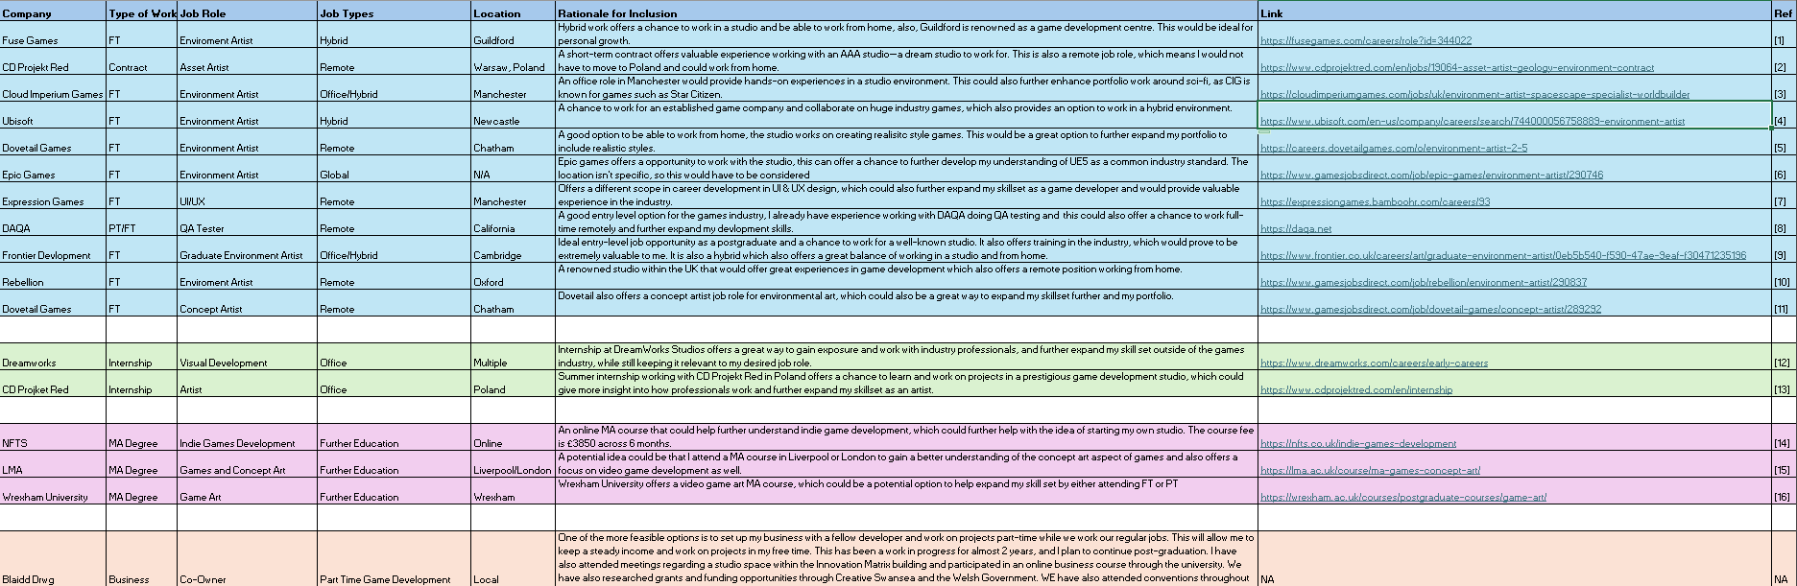
1. Database Excel Spreadsheet
Book1.xlsx

2. Personal Showreel Link
https://www.youtube.com/watch?v=BGtLUKIEyHo
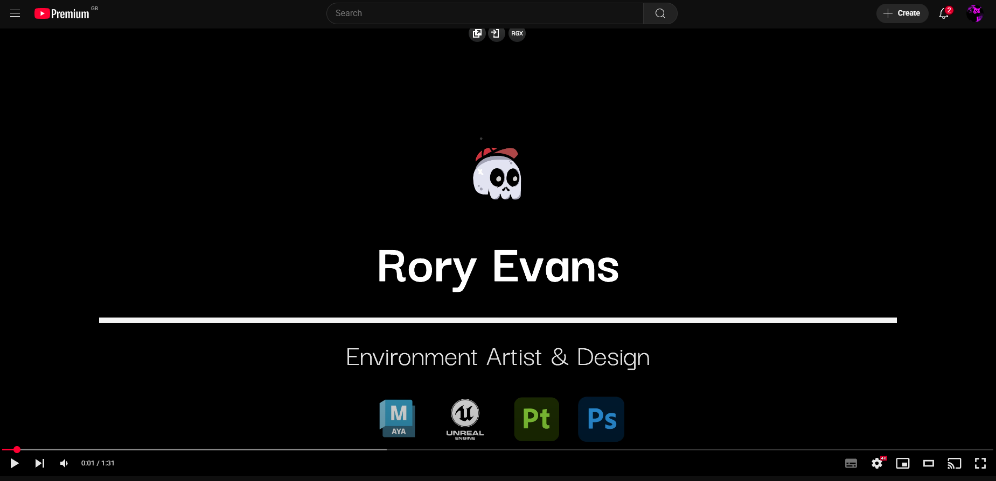

3. Business Card
First Draft
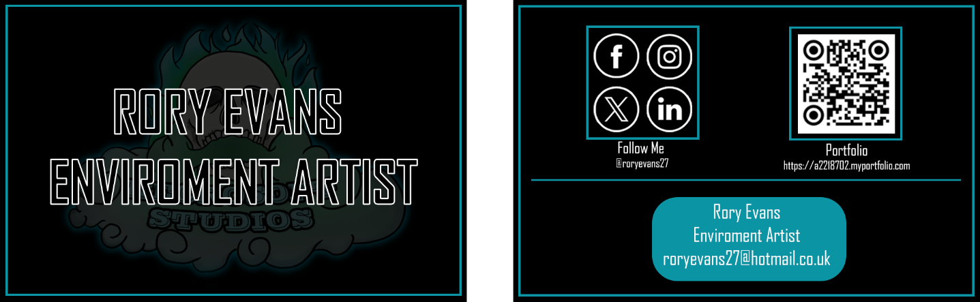
Front | Back
Notes: I worked on an early draft of my business card, working on basic graphics and branding styles to help establish a base. I also wanted to include fundamental aspects of a business card, including contact details, socials, and a QR code, in my portfolio. However, I wasn’t happy with how basic the card looked and didn’t stand out. I also think it didn’t do a good job of projecting me as an environment game artist.
Second Draft
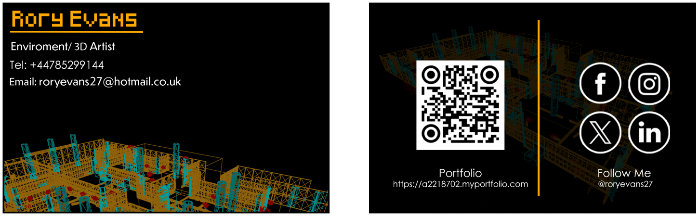
Front | Back

Notes: In the second draft, I focused on creating a design with better readability and established a better legibility of what I was selling as an environment artist by using video game-styled text and an environment wireframe. This I would also consider more my personal card than a company.
Final Draft
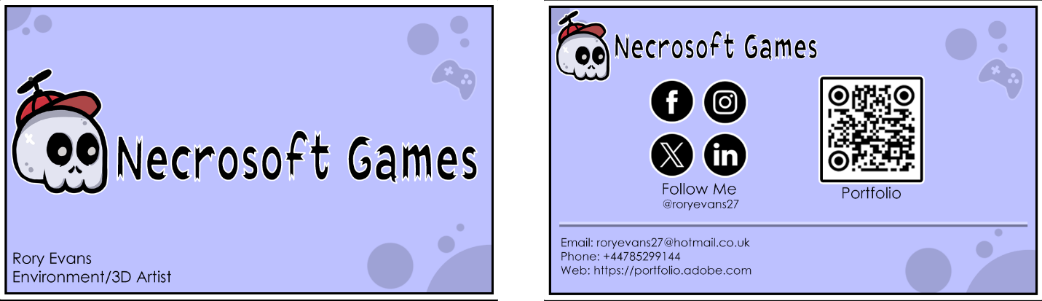
Front | Back
Notes: For my final draft, I focused on working on a brand that represents myself and reflects the business I want to set up. I also tried to create a business card that would be more appealing for a person to pick up by using a bright, colourful palette. I also added some minor details that would be interpreted as video game-related. This card focused more on creating a company business card than a personal one.
4. References
[1] Fuse Games, “Environment Artist – Fuse Games,” Fuse Games, [Online]. Available: https://fusegames.com/careers/role?id=344022
[2] CD Projekt Red, “Asset Artist – Geology & Environment (Contract),” CD Projekt Red, [Online]. Available: https://www.cdprojektred.com/en/jobs/19064-asset-artist-geology-environment-contract
[3] Cloud Imperium Games, “Environment Artist - Spacescape Specialist/Worldbuilder,” Cloud Imperium, [Online]. Available: https://cloudimperiumgames.com/jobs/uk/environment-artist-spacescape-specialist-worldbuilder
[4] Ubisoft, “Environment Artist,” Ubisoft Careers, [Online]. Available: https://www.ubisoft.com/en-us/company/careers/search/744000056758889-environment-artist
[5] Dovetail Games, “Environment Artist,” Dovetail Games Careers, [Online]. Available: https://careers.dovetailgames.com/o/environment-artist-2-5
[6] Epic Games, “Environment Artist – Epic Games,” Games Jobs Direct, [Online]. Available: https://www.gamesjobsdirect.com/job/epic-games/environment-artist/290746
[7] Expression Games, “Careers,” Expression Games, [Online]. Available: https://expressiongames.bamboohr.com/careers/93
[8] DAQA, “Home,” DAQA, [Online]. Available: https://daqa.net
[9] Frontier Developments, “Graduate Environment Artist,” Frontier Careers, [Online]. Available: https://www.frontier.co.uk/careers/art/graduate-environment-artist/0eb5b540-f590-47ae-9eaf-f30471235196
[10] Rebellion, “Environment Artist – Rebellion,” Games Jobs Direct, [Online]. Available: https://www.gamesjobsdirect.com/job/rebellion/environment-artist/290837
[11] Dovetail Games, “Concept Artist – Dovetail Games,” Games Jobs Direct, [Online]. Available: https://www.gamesjobsdirect.com/job/dovetail-games/concept-artist/289292
[12] DreamWorks, “Early Careers,” DreamWorks Careers, [Online]. Available: https://www.dreamworks.com/careers/early-careers
[13] CD Projekt Red, “Internship Program,” CD Projekt Red, [Online]. Available: https://www.cdprojektred.com/en/internship

[14] NFTS, “Indie Games Development – MA,” NFTS, [Online]. Available: https://nfts.co.uk/indie-games-development
[15] LMA, “MA Games and Concept Art,” LMA, [Online]. Available: https://lma.ac.uk/course/ma-games-concept-art/
[16] Wrexham University, “MA Game Art,” Wrexham University, [Online]. Available: https://wrexham.ac.uk/courses/postgraduate-courses/game-art/
5. Bibliography
https://www.youtube.com/watch?v=vs3K9ZckMZ4 https://www.youtube.com/watch?v=sqVSUjKhA2c https://www.youtube.com/watch?v=SfRIT6LgRzs https://www.youtube.com/watch?v=AMy0hxJ_jns https://www.youtube.com/watch?v=0gCOP9B178Y https://www.youtube.com/watch?v=eAroYO8u7vM https://www.cdprojektred.com/en/jobs/19064-asset-artist-geology-environment-contract https://www.cdprojektred.com/en/internship https://www.ubisoft.com/en-us/company/careers/search/744000056758889-environment-artist https://uk.indeed.com/cmp/Hyper-Luminal-Games/jobs?jk=0e4422cea1d5da7c&start=0&clearPrefilter=1#cmp-skip-header-desktop https://cloudimperiumgames.com/jobs/uk/environment-artist-spacescape-specialist-worldbuilder https://fusegames.com/careers/role?id=344022 https://www.dreamworks.com/careers/early-careers https://careers.dovetailgames.com/o/environment-artist-2-5 https://www.gamesjobsdirect.com https://expressiongames.bamboohr.com/careers/93 https://gamesjobs.live/regions/wales/ https://www.frontier.co.uk/careers/art/graduate-environment-artist/0eb5b540-f590-47ae-9eaf-f30471235196 https://forums.unrealengine.com/t/upgrading-the-project-from-version-5-2-to-5-4-compilation-fails/1820278 https://forums.unrealengine.com/t/start-level-without-all-region-loaded/769322 https://fusegames.com/careers/role?id=344022 https://www.cdprojektred.com/en/jobs/19064-asset-artist-geology-environment-contract https://cloudimperiumgames.com/jobs/uk/environment-artist-spacescape-specialist-worldbuilder https://www.ubisoft.com/en-us/company/careers/search/744000056758889-environment-artist https://careers.dovetailgames.com/o/environment-artist-2-5 https://www.gamesjobsdirect.com/job/epic-games/environment-artist/290746 https://expressiongames.bamboohr.com/careers/93 https://daqa.net https://www.frontier.co.uk/careers/art/graduate-environment-artist/0eb5b540-f590-47ae-9eaf-f30471235196 https://www.gamesjobsdirect.com/job/rebellion/environment-artist/290837 https://www.gamesjobsdirect.com/job/dovetail-games/concept-artist/289292 https://www.dreamworks.com/careers/early-careers https://www.cdprojektred.com/en/internship https://nfts.co.uk/indie-games-development https://lma.ac.uk/course/ma-games-concept-art/ https://wrexham.ac.uk/courses/postgraduate-courses/game-art/ https://www.youtube.com/watch?v=_t00EmpboBk https://www.youtube.com/watch?v=qd9wZjIyYhM https://www.youtube.com/watch?v=ZqvVHg9AHdE https://www.youtube.com/watch?v=_qeouC-qm-4 https://www.youtube.com/watch?v=4OLfXYzoTz0
6. Appendices


