- Inter VLAN Routing
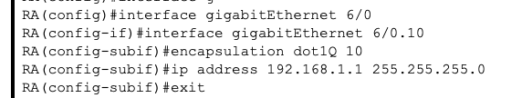

- Ether Channel
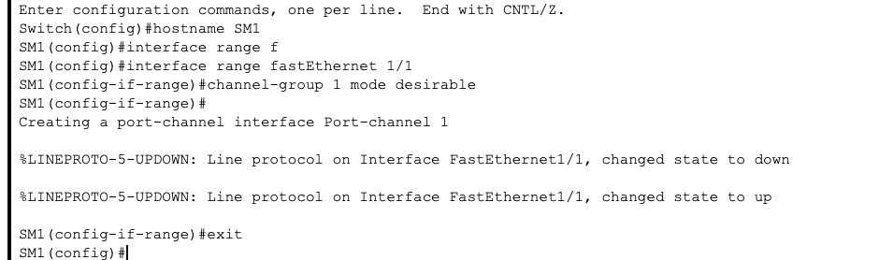

3.WLAN

- EIGRP
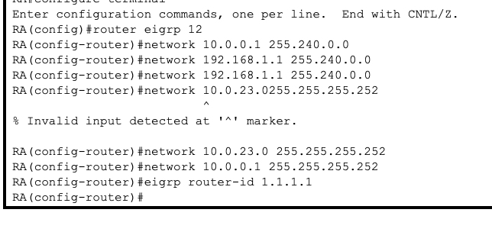

Appendix
Tue Nov 14 11:19:14 2023 Router2 Router>enable
Tue Nov 14 11:19:17 2023 Router2 Router#configure terminal
Tue Nov 14 11:19:22 2023 Router2 Router(config)#hostname RA
Tue Nov 14 11:19:24 2023 Router2 RA(config)#exit
Tue Nov 14 11:19:39 2023 Switch0 Switch>enable
Tue Nov 14 11:19:42 2023 Switch0 Switch#configure terminal
Tue Nov 14 11:19:46 2023 Switch0 Switch(config)#hostname SA
Tue Nov 14 11:19:48 2023 Switch0 SA(config)#eit
Tue Nov 14 11:19:53 2023 Switch0 SA(config)#exit
Tue Nov 14 11:20:05 2023 Switch1 Switch>enable
Tue Nov 14 11:20:09 2023 Switch1 Switch#configure terminal
Tue Nov 14 11:20:15 2023 Switch1 Switch(config)#hostname RA
Tue Nov 14 11:20:17 2023 Switch1 RA(config)#exit
Tue Nov 14 11:24:28 2023 Switch1 RA>enable
Tue Nov 14 11:24:31 2023 Switch1 RA#configure terminal
Tue Nov 14 11:24:36 2023 Switch1 RA(config)#hostaname SB
Tue Nov 14 11:24:42 2023 Switch1 RA(config)#hostname SB
Tue Nov 14 11:24:44 2023 Switch1 SB(config)#exit
Tue Nov 14 11:25:15 2023 Router3 Router>exit
Tue Nov 14 11:25:19 2023 Router3 Router>enable
Tue Nov 14 11:25:22 2023 Router3 Router#configure terminal
Tue Nov 14 11:25:28 2023 Router3 Router(config)#hostname RB
Tue Nov 14 11:25:30 2023 Router3 RB(config)#exit
Tue Nov 14 11:26:11 2023 Router2 RA>enable
Tue Nov 14 11:26:16 2023 Router2 RA#configure terminal
Tue Nov 14 11:26:41 2023 Router2 RA(config)#no ip domain-lookup
Tue Nov 14 11:31:57 2023 Router4 Router>enable
Tue Nov 14 11:32:01 2023 Router4 Router#configure terminal
Tue Nov 14 11:32:07 2023 Router4 Router(config)#hostname RC
Tue Nov 14 11:32:09 2023 Router4 RC(config)#exit
Tue Nov 14 11:32:36 2023 Router4 RC#interface Se 2/0
Tue Nov 14 11:32:40 2023 Router4 RC#enable
Tue Nov 14 11:32:43 2023 Router4 RC#configure terminal
Tue Nov 14 11:32:54 2023 Router4 RC(config)#interface serial 2/0
Tue Nov 14 11:33:25 2023 Router4 RC(config-if)#ip address 10.0.23.2 255.255.255.0
Tue Nov 14 11:33:30 2023 Router4 RC(config-if)#no shutdown
Tue Nov 14 11:33:48 2023 Router4 RC(config-if)#exit
Tue Nov 14 11:34:10 2023 Router4 RC(config)#interface gigabitEthernet 6/0
Tue Nov 14 11:34:29 2023 Router4 RC(config-if)#ip address 172.16.0.2 255.255.255.0
Tue Nov 14 11:34:35 2023 Router4 RC(config-if)#no shutdown
Tue Nov 14 11:37:43 2023 Router2 RA>enable
Tue Nov 14 11:37:46 2023 Router2 RA#configure terminal
Tue Nov 14 11:38:06 2023 Router2 RA(config)#router eigrp 12
Tue Nov 14 11:40:13 2023 Router2 RA(config-router)#network 10.0.0.1 255.240.0.0
Tue Nov 14 11:41:13 2023 Router2 RA(config-router)#network 192.168.1.1 255.240.0.0
Tue Nov 14 11:41:31 2023 Router2 RA(config-router)#network 192.168.1.1 255.240.0.0
Tue Nov 14 11:42:28 2023 Router2 RA(config-router)#network 10.0.23.0255.255.255.252
Tue Nov 14 11:42:34 2023 Router2 RA(config-router)#network 10.0.23.0 255.255.255.252
Tue Nov 14 11:42:47 2023 Router2 RA(config-router)#network 10.0.0.1 255.255.255.252
Tue Nov 14 11:44:31 2023 Router2 RA(config-router)#eigrp router-id 1.1.1.1
Tue Nov 14 11:46:18 2023 Router2 RA(config-router)#passive-interface gigabitEthernet 2/0
Tue Nov 14 11:48:29 2023 Switch0 SA>enable
Tue Nov 14 11:48:33 2023 Switch0 SA#configure terminal
Tue Nov 14 11:48:41 2023 Switch0 SA(config)#vlan 10
Tue Nov 14 11:48:49 2023 Switch0 SA(config-vlan)#name VLAN 10
Tue Nov 14 11:48:53 2023 Switch0 SA(config-vlan)#name VLAN10
Tue Nov 14 11:49:00 2023 Switch0 SA(config-vlan)#exit
Tue Nov 14 11:49:08 2023 Switch0 SA(config)#vlan 20
Tue Nov 14 11:49:12 2023 Switch0 SA(config-vlan)#name VLAN20
Tue Nov 14 11:49:14 2023 Switch0 SA(config-vlan)#exit
Tue Nov 14 11:50:36 2023 Switch0 SA(config)#interface fastEthernet 3/1 - 0
Tue Nov 14 11:50:40 2023 Switch0 SA(config)#interface fastEthernet 3/1 -0
Tue Nov 14 11:50:42 2023 Switch0 SA(config)#interface fastEthernet 3/1-0
Tue Nov 14 11:50:43 2023 Switch0 SA(config)#interface fastEthernet 3/1
Tue Nov 14 11:50:50 2023 Switch0 SA(config-if)#switchport mode access
Tue Nov 14 11:51:10 2023 Switch0 SA(config-if)#switchport access vlan 10
Tue Nov 14 11:51:20 2023 Switch0 SA(config-if)#write memory
Tue Nov 14 11:52:01 2023 Switch0 SA(config-if)#exit
Tue Nov 14 11:52:05 2023 Switch0 SA(config)#write memory
Tue Nov 14 11:53:42 2023 Router2 RA(config-router)#exit
Tue Nov 14 11:53:47 2023 Router2 RA(config)#router eigrp 12
Tue Nov 14 11:54:05 2023 Router2 RA(config-router)#no auto-summary
Tue Nov 14 11:54:18 2023 Router2 RA(config-router)#network 10.0.0.1 255.240.0.0
Tue Nov 14 11:56:17 2023 Router2 RA(config-router)#exit
Tue Nov 14 11:56:22 2023 Router2 RA(config)#exit
Tue Nov 14 11:56:24 2023 Router2 RA#clear
Tue Nov 14 11:56:27 2023 Router2 RA#enable
Tue Nov 14 11:56:32 2023 Router2 RA#configure terminal
Tue Nov 14 11:56:46 2023 Router2 RA(config)#interface gigabitEthernet 6/0
Tue Nov 14 11:57:03 2023 Router2 RA(config-if)#switchport mode trunk
Tue Nov 14 11:57:47 2023 Router2 RA(config-if)#switchport mode trunk
Tue Nov 14 11:58:38 2023 Switch0 SA(config)#interface fastEthernet 0/1
Tue Nov 14 11:58:48 2023 Switch0 SA(config-if)#switchport mode trunk
Tue Nov 14 11:59:14 2023 Switch0 SA(config-if)#switchport trunk allowed vlan all
Tue Nov 14 12:00:15 2023 Switch0 SA(config-if)#exity
Tue Nov 14 12:00:17 2023 Switch0 SA(config-if)#exit
Tue Nov 14 12:00:49 2023 Switch0 SA(config)#spanning-tree mode rapid-pvst
Tue Nov 14 12:01:16 2023 Switch0 SA(config)#spanning-tree vlan 10,20 priority 4096
Tue Nov 14 12:01:29 2023 Switch0 SA(config)#write memory
Tue Nov 14 12:02:43 2023 Switch1 SB>enable
Tue Nov 14 12:02:46 2023 Switch1 SB#configure terminal
Tue Nov 14 12:03:07 2023 Switch1 SB(config)#interface range fastEthernet 2/1
Tue Nov 14 12:03:19 2023 Switch1 SB(config-if-range)#spanning treep
Tue Nov 14 12:03:31 2023 Switch1 SB(config-if-range)#spanning tree portfast
Tue Nov 14 12:03:38 2023 Switch1 SB(config-if-range)#spanning-tree portfast
Tue Nov 14 12:04:07 2023 Switch1 SB(config-if-range)#spanning-tree bpduguard enable
Tue Nov 14 12:04:16 2023 Switch1 SB(config-if-range)#shutdown
Tue Nov 14 12:04:22 2023 Switch1 SB(config-if-range)#write memory
Tue Nov 14 12:04:25 2023 Switch1 SB(config-if-range)#exit
Tue Nov 14 12:04:28 2023 Switch1 SB(config)#write memory
Tue Nov 14 12:05:55 2023 Switch2 Switch>enable
Tue Nov 14 12:06:27 2023 Switch2 Switch#configure terminal
Tue Nov 14 12:06:38 2023 Switch2 Switch(config)#hostname SM1
Tue Nov 14 12:07:18 2023 Switch2 SM1(config)#interface range fastEthernet 1/1
Tue Nov 14 12:07:39 2023 Switch2 SM1(config-if-range)#channel-group 1 mode desirable
Tue Nov 14 12:07:49 2023 Switch2 SM1(config-if-range)#exit
Tue Nov 14 12:08:41 2023 Switch3 Switch>enable
Tue Nov 14 12:08:44 2023 Switch3 Switch#configure terminal
Tue Nov 14 12:08:51 2023 Switch3 Switch(config)#hostname S2
Tue Nov 14 12:09:18 2023 Switch3 S2(config)#interface fastEthernet 0/1
Tue Nov 14 12:09:50 2023 Switch3 S2(config-if)#channel-group mode desirable
Tue Nov 14 12:09:58 2023 Switch3 S2(config-if)#channel-group 1 mode desirable
Tue Nov 14 12:10:02 2023 Switch3 S2(config-if)#exit
Tue Nov 14 12:11:17 2023 Router3 RB>enable
Tue Nov 14 12:11:21 2023 Router3 RB#configure terminal
Tue Nov 14 12:12:33 2023 Router3 RB(config)#interface serial 2/0
Tue Nov 14 12:13:24 2023 Router3 RB(config-if)#standby 1 ip 10.0.12.0
Tue Nov 14 12:13:43 2023 Router3 RB(config-if)#standby 1 ip 10.0.12.0
Tue Nov 14 12:14:18 2023 Router3 RB(config-if)#standby 1 ip 169.254.179.57
Tue Nov 14 12:14:37 2023 Router3 RB(config-if)#exit
Tue Nov 14 12:14:44 2023 Router3 RB(config)#interface gigabitEthernet 6/0
Tue Nov 14 12:15:20 2023 Router3 RB(config-if)#tandby 1 ip 172.16.0.1
Tue Nov 14 12:15:26 2023 Router3 RB(config-if)#standby 1 ip 172.16.0.1
Tue Nov 14 12:15:51 2023 Router3 RB(config-if)#standby 1 ip 172.16.0.253
Tue Nov 14 12:16:05 2023 Router3 RB(config-if)#standby 1 priority 110
Tue Nov 14 12:16:19 2023 Router3 RB(config-if)#standby 1 preempt
Tue Nov 14 12:18:00 2023 Router2 RA>enable
Tue Nov 14 12:18:03 2023 Router2 RA#configure terminal
Tue Nov 14 12:18:55 2023 Router2 RA(config)#ip dhcp excluded-address 192.168.1.1 192.168.1.10
Tue Nov 14 12:19:29 2023 Router2 RA(config)#ip dhcp pool RVlan10
Tue Nov 14 12:19:49 2023 Router2 RA(dhcp-config)#network 192.168.1.0 255.255.255.0
Tue Nov 14 12:20:04 2023 Router2 RA(dhcp-config)#default-router 192.168.1.1
Tue Nov 14 12:20:23 2023 Router2 RA(dhcp-config)#dns-server 172.16.0.264
Tue Nov 14 12:20:28 2023 Router2 RA(dhcp-config)#dns-server 172.16.0.254
Tue Nov 14 12:20:42 2023 Router2 RA(dhcp-config)#exit
Tue Nov 14 12:21:21 2023 Router2 RA(config)#ip dhcp excluded-address 192.168.2.1 192.168.2.10
Tue Nov 14 12:21:36 2023 Router2 RA(config)#ip dhcp pool RVlan20
Tue Nov 14 12:22:01 2023 Router2 RA(dhcp-config)#network 192.168.2.0 255.255.255.0
Tue Nov 14 12:22:25 2023 Router2 RA(dhcp-config)#default-router 192.168.2.1
Tue Nov 14 12:22:45 2023 Router2 RA(dhcp-config)#dns-server 172.16.0.254
Tue Nov 14 12:32:42 2023 Router2 RA(dhcp-config)#exit
Tue Nov 14 12:33:15 2023 Router2 RA(config)#interface gigabitEthernet 6/0
Tue Nov 14 12:33:31 2023 Router2 RA(config-if)#interface gigabitEthernet 6/0.10
Tue Nov 14 12:33:52 2023 Router2 RA(config-subif)#encapsulation dot1Q 10
Tue Nov 14 12:34:39 2023 Router2 RA(config-subif)#ip address 192.168.1.1 255.255.255.0
Tue Nov 14 12:34:59 2023 Router2 RA(config-subif)#exit

