Name: Louise Labbett
Student: 2215831@student.uwtsd.ac.uk
Assessment: E-portfolio. Learning in the digital era. ECGE4005R

Contents:
- Journal article summary
- Video presentation
- Academic poster
- Personal reflection on academic poster
- Evidence for academic poster
- References

Task #1: Summary of Mindfulness in psychology: A breath of fresh air?

https://uowtsd-my.sharepoint.com/:w:/g/personal/2215831_student_uwtsd_ac_uk/ESv1kBHBy8pLlXvbszG62-IBEsOJUijrDar9oWD1sfsy3Q?e=qqOXG6

This is a summary of the article “Mindfulness in psychology – A breath of fresh air? “, Shonin et al., (2015).
Shonin et al., looked at mindfulness in western psychology and healthcare and compared it to its foundations in Buddhism and its teachings. They question if the practice of using mindfulness in various treatments lives up to its huge growth in popularity and ask if it really is a tool in the advancement of understanding how our minds work or is just the current fad.
They define mindfulness, the Buddhist meditation practice of over 2000 years as living in the present moment. Throughout the article they discuss definitions and debate whether the practice, as adopted by western psychology circles has any concrete connections to its original form, with the context of mindfulness in spirituality and raise doubt on the ethical question of the continued association. They go on to explain the many different areas of psychological practice and the intervention methods where mindfulness is used to treat a wide variety of conditions, disorders, and diseases, as well as being regarded and utilised as a useful tool for regulating mental health.
During the article Shonin et al., highlight the strengths of the argument by describing the varied ways it can be taught to psychological professionals and how the approach can be adapted to suit diverse kinds of people ranging from professional adults to children to individuals requiring psychological treatment. It is regarded inexpensive as a treatment and is more accepted among different cultures and religions as it is thought of as being secular in its nature. They point out the limitations of mindfulness including the imbalance in the standard of practitioners.
They conclude that, as in all emerging, potential psychological interventions, more research needs to be done as though it does appear to be safe and beneficial in some areas, there is a lack of long-term research as evidence.

Task #2: Video presentation

https://uowtsd-my.sharepoint.com/:p:/g/personal/2215831_student_uwtsd_ac_uk/EfjSb9x9zK5KoTf_QzFRnloBK6e8qe9RwWX220CBu9YQDg?e=ywcOBi

Task #3: Academic poster

https://uowtsd-my.sharepoint.com/:p:/g/personal/2219662_student_uwtsd_ac_uk/Ea5ky01rGr9HuZQV4NAH6bgBz_F9xMvxVh-dY5La2jUhNg?e=okaAZa

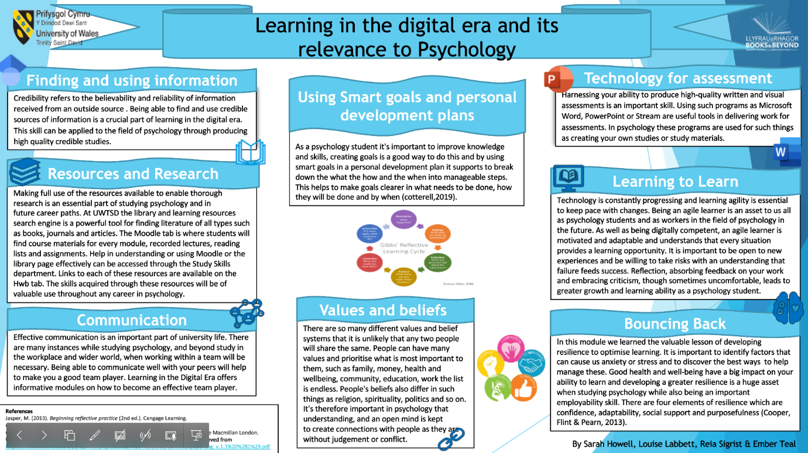

Task #4: Reflection on academic poster

https://uowtsd-my.sharepoint.com/:w:/g/personal/2215831_student_uwtsd_ac_uk/EeUs44NqRXlIqUxHvGzrH3QBi8JNDhyQJxLcLUOoF2edDQ?e=XknSYK

My contribution to the poster covered topics from Unit 4, Becoming a lifelong learner. Due to illness, I was absent from class during the team forming session and after I inquired in a WhatsApp message, my team kindly offered me to join them. After a joint discussion, I decided on, researched, and wrote my pieces for the poster. Then, I added some basic, stock graphics to enhance the appearance of it. We used a communication page to share information and update each other on progress and changes. I feel we all contributed positively, and the project went well. After initially feeling hindered by not being involved, through communicating and feedback, this was soon rectified. Through working on this task, I have a better understanding of the dynamics involved in teamwork and this experience has given me more confidence in my own strengths and ability to contribute as a team member.

Task #5: Evidence of collaboration on academic poster – Evidence on 2nd page

https://uowtsd-my.sharepoint.com/:p:/g/personal/2219662_student_uwtsd_ac_uk/Ea5ky01rGr9HuZQV4NAH6bgBz_F9xMvxVh-dY5La2jUhNg?e=v9wXCE

Task #6: References

https://uowtsd-my.sharepoint.com/:w:/g/personal/2215831_student_uwtsd_ac_uk/EfE9kQ19RCFEq7OjoGryy8wB2mkHGPSQYM0tXU6i6EprcA?e=lexEyW

References
Cooper, L., Flint-Taylor, J. & Pearn, M. (2013). Building Resilience for success. Palgrave Macmillan London.
Mann, K., Gurdon, J., & Mcleod, A. (2007). Reflection & reflective practice in health professions education: A systematic review. Advances in health sciences education, 14(4):595-621. https://doi:.org/10.1007/s10459-007-9090-2.
McLeod, J. (2009) An introduction to counselling (4th ed.). McGraw Hill/ Open University Press.
Page, L., Hargreaves, J. (2013). Reflective practice (1st ed.). Polity Press.
Shonin, E., Von Godon, W., & Griffiths, M. D. (2015). Mindfulness in psychology – A breath of fresh air? The Psychologist, Vol 28, No.1. Bps.org.uk/ the psychologist. https://www.bps.org.uk/volume-28/january-2015/mindfulness-psychology-breath-fresh-air
University of Wales Trinity Saint David. (n.d.) Referencing handbook: APA. (7th ed.).

