

A Comprehensive Analysis of the Challenges in Investigating Rape Cases in the United Kingdom: Evaluating Current Practices and Police Training and Expertise.

Name: Rachael Shortis
Student Number: 2124835
Degree Title: BSC Professional Policing
Word Count: 8656

Declaration
This work has not previously been accepted in substance for any degree and is not being concurrently submitted in candidature for any degree.
Signed: R.Shortis
Date: 11/04/24
Statement 1:
This dissertation is being submitted in partial fulfilment of the requirements for the degree of BA.
Signed: R.Shortis
Date: 11/04/24
Statement 2:
This dissertation is the result of my own independent work/investigation, except where otherwise stated.
Other sources are acknowledged by footnotes giving explicit references. A bibliography is appended.
Signed: R.Shortis
Date: 11/04/24
Statement 3:
I hereby give consent for my dissertation, if accepted, to be available for photocopying and for interlibrary loan, and for the title and summary to be made available to outside organisations.
Signed: R.Shortis
Date: 11/04/24
Statement 4:
I hereby give consent for my dissertation, if accepted, to be available on the university’s IT system to those who have consent to use the system.
Signed: R.Shortis
Date: 11/04/24

Abstract
This dissertation will present a comprehensive analysis of the challenges inhibiting investigating rape cases in the United Kingdom. The dissertation will highlight the current practices and the training and expertise of officers conducting these investigations. Issues such as severely low conviction rates illustrate the urgent need for a thorough examination of the complexities in the investigation process rape cases present.
This research uses existing national guidelines, academic literature, and studies to identify the key obstacles to the investigation process, such as reporting, evidence collection, and victim engagement. This dissertation will contribute to the gaps in the academic research that contribute to how well officers feel they have been trained to handle investigations of this severity.
By commencing this dissertation, it will contribute to the growing knowledge of data regarding the challenges rape investigation pose. It will provide improvements and recommendations in order to promote justice for survivors and prosecute perpetrators of this offence.

Acknowledgements
I want to thank my team for their support and guidance. I want to thank my sergeants for the time, patience, and assistance they have given me. I am immensely grateful to my mother for her support and guidance.

Table of Contents
Declaration 2
Abstract 3
Acknowledgements 3
Chapter One: Introduction 6
1.1 Introduction 6
1.2 Background and Rationale 6
1.3 Aim and Objectives 7
1.3.1 Aim: 7
1.3.2 Objective One: 7
1.3.3 Objective Two: 7
1.3.4 Objective Three: 8
1.4 Structure 8
Chapter Two: Literature Review 9
2.1 Introduction 9
2.2 Rape by Definition 10
2.3 What Is Consent? 11
2.4 Challenges in Investigating Rape Cases 12
2.5 Police training and expertise 13
2.6 Conclusion 16
Chapter Three: Methodology 17
3.1 Method 17
3.2 Participants 17
3.3 Procedure 18
Chapter Four: Data Analysis 20
4.1 Introduction 20
4.2 Participant Demographic 20
4.3 Trend One: Discrepancy Between Theoretical Training and Practical Application: 20
4.3.1 Introduction 20
4.3.2 “Do you feel sufficiently trained regarding trauma-informed approaches with survivors of rape?” 21
4.3.3 “How confident do you feel in your legislative knowledge regarding rape and sexual offences?” 21
4.3.4 Statistical Comparison 22
4.5 Trend Two: Participants Beliefs Regarding the Improvements That Could Be Made To Police Training 24
4.5.1. Introduction 24
5.5.2. Key Themes in Suggestions The responses were analysed and grouped into the following categories: 24
5.4.3. Frequency of Each Category 25
The most frequent suggestions revolved around updating officers' knowledge of legal frameworks, with more than half of the respondents (33 out of 58) emphasizing the need for training on sexual offences, consent, and legal reforms. 25
5.4.4. Analysis of Major Themes 25
5.4.4.1 Legal Knowledge and Updates: 25
5.4.4.2 Trauma-Informed and Psychological Approaches: 26
5.4.4.3 Survivor Dignity and Minimizing Traumatization: 27
5.4.4.4 Bias, Cultural, Gender, and LGBTQ+: 27
5.4.4.5 Best Practices for Evidence Collection and Forensic Handling: 27
Chapter Five: Findings, Conclusion and Recommendations 29
5.1 Introduction 29
5.2 Primary Findings 29
5.3 The Attainment of Objectives 30
5.3.1 Objective One: To Critically Research into The Challenges of Investigating Rape Cases in The United Kingdom, Including the Current Practices In The United Kingdom And The Current State Of Police Training And Expertise 30
5.3.2 Objective Two: To Select a Suitable Research Method to Explore the Confidence Officers Feel Conducting Investigations of Rape and the Level of Training and Expertise they Believe they Have. 30
5.3.3 Objective Three: To Analyse the Data Collected to Provide Recommendations Relating to Improving Current Practices and Police Training and Expertise. 31
5.4 Recommendations 31
5.4.1. Future Study: 31
5.4.2. Regular and Refreshed Training: 31
5.4.3. Trauma-Informed Training: 32
5.5 Limitations 32
5.6 Conclusion 32
Chapter Six: Bibliography 34
Chapter Seven: Appendix 42
7.1 Appendix One: Ethics Form 42
7.2 Copy of Blank Questionnaire 43
Appendix Three: Questionnaire Results 46
Appendix Four: Responses to Question No.10 48

Chapter One: Introduction

Introduction
This dissertation's intention is to provide a comprehensive analysis of the challenges in investigating rape cases in the United Kingdom by evaluating current practices and police training and expertise. The dissertation will offer recommendations to help improve areas of current concern. Chapter one of this dissertation will discuss the context surrounding the topic of rape investigations.

Background and Rationale
Rape investigations have been challenged in the media, and public scrutiny towards the police has been at an all-time high. The emotional and physical trauma inflicted on survivors is one of many challenges in investigating a crime of this nature. There have been numerous efforts and provisions introduced to improve the management of rape investigations, such as national guidelines. Despite these efforts, there is much criticism of the current practices in managing these investigations, such as low conviction rates. According to the Home Office (2024) that only 2.4% or 2 in 100 rapes recorded in the 12 months of 2023 resulted in a charge. There is additional criticism of the current practices used to investigate rape reports and the lack of prosecution, which is highlighted by the number of rape cases waiting to go to court, which is an astonishing record number of 9792, according to the Ministry of Justice (2023). However, in providing this comprehensive view of the current practices, this report will discuss the contrasting arguments to be made about the progression of cases in regard to realistic prospects of conviction and evidential quality (Ministry of Justice, 2013).
Investigating and conducting rape cases entail a fine balance of victim support and emotional sensitivity with challenging inconsistencies evidentially. Understanding the challenges faced in investigating a crime of this severity is fundamental in developing successful recommendations for obtaining justice for survivors and holding perpetrators accountable to the law.
Due to a lack of trust in agencies or scepticism of survivors reporting to the police, profound societal ramifications can occur. The College of Policing has implemented 'victim-centred approaches', whereby the victim of crime is at the forefront of Law Enforcement's concern. This approach entails respecting victims' rights, opinions, experiences, and choices (College of Policing, 2023).
The dissertation's exploration of challenges that inhibit effective investigations of rape cases will seek to provide an understanding of the barriers faced and how these can be overcome.
This dissertation will illustrate law enforcement's challenges in investigating and offering support simultaneously. This is crucial to understanding whether police officers are equipped with the skills and knowledge to investigate these crimes effectively. Evaluating training helps target gaps, leading to improvement. The challenges officers face vary from a lack of resources to consistency across forces nationwide and trust and community engagement.

Aim and Objectives

1.3.1 Aim:
The aim of this research is to provide A Comprehensive Analysis of the Challenges in Investigating Rape Cases in the UK: Evaluating Current Practices in the UK and Police Training and Expertise.
The objectives this dissertation wishes to achieve the following:

1.3.2 Objective One:
To critically research the challenges of investigating rape cases in the United Kingdom, including the current practices in the United Kingdom and the current state of police training and expertise.

1.3.3 Objective Two:
To select a suitable research method to explore the confidence officers feel conducting investigations of rape and the level of training and expertise they believe they have.

1.3.4 Objective Three:
To analyse the data collected to provide recommendations relating to improving current practices and police training and expertise.

Structure
This research will be structured through the following chapters to achieve these objectives effectively over several chapters. Additionally, chapter one will provide the background context and rationale for why this dissertation is being conducted. Chapter two will involve a literature review discussing the current academic and government reports regarding the topic of rape investigations and highlighting the main areas for improvement in conducting these investigations. Also, Chapter Three will discuss the methodology and research that will be obtained for this dissertation. Moreover, chapter four will review and analyse the results provided by the chosen methodology.
Furthermore, chapter five will demonstrate the conclusions drawn from the research and discuss the recommendations provided. Next, chapter six will provide a bibliography of the references used in the research. Lastly, chapter seven contains an appendix that concludes the project.

Chapter Two: Literature Review

2.1 Introduction
Rape is a deeply disturbing crime with profound societal implications and repercussions for survivors, law enforcement and society. Despite this, it continues to be largely unreported and a challenging offence for police in the United Kingdom to investigate. Law enforcement faces numerous obstacles in prosecuting those who offend despite the severity of the offence. Investigating rape cases accompanies unique challenges such as forensic complexities, biological evidence gathering and legal obstacles. Current practices within the United Kingdom encompass victim-centred approaches; however, understanding their effectiveness is crucial. This literature review will synthesize findings from additional academic references, as this review aims to provide a comprehensive understanding of the strengths, weaknesses, and opportunities for improvement in police training for sexual offences cases in the UK.
Understanding the current practices in investigating rape cases in the UK is essential for addressing challenges Law Enforcement agencies face in order to effectively find solutions to these barriers and provide justice to survivors. Therefore, the aim of this literature review will provide a critical evaluation of the current practices in the UK in investigating rape cases, with a focus on the role of police training and expertise in overcoming these challenges. Through the use of academic studies, government reports and publications, this review aims to identify the weaknesses and strengths within the UK's response through law enforcement and The Criminal Justice System in response to the most severe sexual offences. This chapter will achieve the first objective:
'To will critically research into the challenges of investigating rape cases in the United Kingdom, including the current practices in the United Kingdom and the current state of police training and expertise.'

2.2 Rape by Definition
Firstly, this review will discuss what the offence of rape entails and the inconsistencies between the legal definitions of rape to societal understandings. The definition of rape varies throughout the world. It's a common understanding that it refers to the non-consensual act of sexual intercourse involving penetration to the vagina, mouth or anus of another person. Rape is recognised as a crime against the individual, yet it remains hindered by outdated patriarchal attitudes that persist within the criminal justice system (End Violence Against Women Coalition et al. 2020)
The Sexual Offences Act (2003) states that rape in the United Kingdom occurs when:
"A person (A) commits an offence if—
(a)he intentionally penetrates the vagina, anus, or mouth of another person (B) with his penis,
(b) B does not consent to the penetration and
(c) A does not reasonably believe that B consents."
Consent is a crucial and controversial topic whereby the establishing of consent is the key element in determining if rape has occurred. In its more comprehensive understanding, consent is given freely, without coercion or incapacity (Temkin & Krahne 2008). Consent is multifaceted and can involve several elements, such as incapacity through drugs, alcohol, age, or vulnerability.
The issue that arises when discussing the definition of rape within the United Kingdom is that there are inconsistencies between the social understanding of rape and its legal definition, which begs the question as to the impact of the ability juries have to prosecute cases effectively. Socially, rape is considered to encompass non-consensual sexual acts whereby consent is obtained under duress, coercion, or incapacitation (Estrich, 1987). The issue with the disconnection between legal and social definitions is that discrepancies can occur in how jurors perceive evidence within rape cases.

2.3 What Is Consent?
In addition, many misconceptions and biases surround the notion of 'consent' and what consent entails. Jurors may hold preconceived notions about what a 'real' rape means, such as the belief that rape cannot occur within marriages or relationships. There is no vetting or required specialism to serve a jury in any case within the United Kingdom, which causes issues regarding the perpetuation of misogynistic beliefs and attitudes. This concept belittles the overwhelming fact that perpetrators of rape are usually known to victims. This bias perpetuates rape myths whereby victim blaming occurs, which undermines survivors' credibility, making it difficult to secure rape convictions (Grub & Turner 2012).
Another issue surrounding this topic is the procedural and legal requirement to prove a lack of consent beyond a reasonable doubt, particularly in cases where independent witnesses and forensic evidence are unavailable. Survivors' explanations as to non-consensual sexual events may be scrutinized, therefore leading to acquittals and hung juries (Grubb & Harrower 2008). Therefore, the discrepancy between legal standards of proof versus the societal attitudes towards rape can contribute to low conviction rates and the reluctance for survivors to report offences.
Addressing these inconsistencies requires reforms in legal definition, jury education or professionalisation and improving cultural attitudes towards survivors of sexual violence. Efforts to educate jurors on the complexities regarding the impact of trauma on survivor's accounts and the prevalence of rape bias and myths would be crucial in promoting justice and unbiased decision-making in courts (Emerald Publishing, 2023). Furthermore, aligning legal definitions of rape with societal understandings can address the inconsistencies in jury perception, therefore, holding perpetrators more accountable for their actions. Policing Insight (2023) highlights how current legal frameworks often fail to reflect the realities of sexual violence, leading to inconsistencies in jury decisions. Addressing these inconsistencies through legal reform and public education may reduce negative biases impacting survivors' credibility.
Investigating rape cases within the UK introduces a multitude of challenges which consist of a combination of societal beliefs, attitudes, and systematic issues within the judicial process. This review will explore the complications law enforcement within the UK faces when investigating crimes of this sensitive nature.

2.4 Challenges in Investigating Rape Cases
Underreporting continues to be one of the primary challenges regarding rape cases. Research by the HM Inspectorate of Constabulary and Fire & Rescue Services (HMICFRS, 2021) illustrates how survivors are cautious of coming forward due to stigmatisation and mistrust within the police and judicial systems. This underreporting distorts statistical data regarding rape which, as a consequence, undermines the police's ability to respond or investigate efficiently to serious sexual assaults.
In addition, the collection and examination of evidential material is another factor affecting the investigation of rape cases (PLOS Medicine, 2017). The collection and preservation of forensic evidence and examination are crucial in building strong cases for trial in court (Rape, Abuse & Incest National Network (RAINN), 2023). Forensic evidence such as DNA samples can verify if occurrences of a sexual nature have occurred, therefore being able to navigate disparities in the accounts of both victims and suspects (Community Safety Knowledge Alliance, 2019)
Nevertheless, it is a massive challenge for police to act within these forensic windows as they are considerably short. The evidential value of forensic samples can be compromised through cross-contamination, time lapses, and washing/ cleaning of DNA property, which can all factor into evidential material being unsatisfactory or not yielding significant details needed for investigation (Malema, 2020). Forensic examination and collection have notoriously long wait times whereby survivors exist in extended periods of trauma, which results in the prolonging of survivors suffering (National Institute of Justice, 2018; Malema, 2020). Arguably, this can be linked to the quality and consistency of training and resources from law enforcement agencies throughout the country (IntechOpen, 2021).
Moreover, the proliferation of digital technology has presented an additional challenge to obtaining electronic evidence. Digital technology has made electronic evidence increasingly central to criminal investigations, but challenges remain with ensuring its admissibility. Admissibility is integral for obtaining convictions and endorsing public trust in the criminal justice system (Goodison et al., 2015; NIJ, 2020).
Jordan and Lund (2015) discuss the systemic biases law enforcement has regarding myths, beliefs and attitudes towards sexual assault, which subsequently create issues for investigation. Jordan and Lund (2015) illustrate the 'policing culture' regarding victim blaming outlooks, which, as a result, demoralises victims due to the questioning of their credibility. These biases create a precedent establishing that law enforcement will demoralise and scrutinize survivors.
Systemic biases within law enforcement agencies also pose significant challenges in investigating rape cases. Research by Jordan and Lund (2015) highlights the influence of police culture on officers' beliefs and attitudes towards sexual assault, including myths about false allegations and victim-blaming attitudes. These biases can impact the investigation process, undermine survivors' credibility, and contribute to low conviction rates. Addressing systemic biases requires a multifaceted approach, including ongoing training, organizational reforms, and community engagement.
Long wait times for forensic examinations and delays in processing rape kits further exacerbate the challenges of investigating rape cases in the UK. Survivors often face extended periods of uncertainty and trauma while awaiting forensic examinations and the processing of evidence. These delays prolong survivors' suffering and hinder the timely investigation and prosecution of cases.

2.5 Police training and expertise
Additionally, The National Operating Model for Adult Rape Prosecution (2013) was introduced in order to improve the prosecution process for adult rape cases in the United Kingdom. The publication discusses Operation Soteria, whereby through the gathering of academic knowledge, a new operating model was to be developed to improve investigations of rape cases. The Operation Soteria Bluestone Year One Report (2023) researched the current practices used to investigate Rape cases and the current weaknesses within the following forces: The Metropolitan Police Service, Durham Constabulary, West Midlands Police and South Wales Police. The report details the key findings which require immediate rectification, predominately discussed was the significant deficiency in specialist knowledge and evidence-led investigative procedures whilst investigating rape cases. The research exposes how, as a consequence of evidential quality, victim engagement and investigation outcomes are affected negatively. Additionally, the report addresses the unsatisfactory education and progress officers have in regard to investigating sexual offences, and this directly relates to inadequate police data.
As stated earlier in this literature review, the link between effective police training and expertise is heavily correlated with improved outcomes for survivors. The training officers receive shapes their response to victims and enhance the skills, knowledge, and approaches law enforcement uses. Not only does this promote effective investigations, but it also enhances a positive experience for victims during their interaction with police, promoting victim support and well-being.
Educating officers is a foundation for effective investigation whereby survivors experience improved outcomes. An expanded literature review will further examine the effectiveness of police training in regard to serious sexual offences, probing into details regarding specialised departments, the attitudes and systemic biases and legislative and policy regarding officer education. Attitudes towards victims and unconscious acceptance of 'Rape Myths', as mentioned previously, highlight how officers are members of society, whereby they can reflect notions of victim-blaming attitudes (Sleath and Bull, 2017).
As stated, prior, stigmatisation and bigotry that survivors of rape face consequentially influence reporting and deterring the crime at hand. This review suggests that one of the biggest betrayals a survivor can face is experiencing this bias and chauvinism from professionals whose biggest priority is to help those in need. The attitudes of officers regarding victims of sexual assault can heavily influence the interactions with survivors and the effective handling of cases. Therefore, supporting speciality in training officers to respond to sexual offences can enable officers to conduct their investigation sensitively. This notion is supported by research conducted by Campbell et al. ( 2014), who suggest that officers who are specialised in units dedicated to investigating serious sexual assaults provide greater empathy and victim-centred approaches.
Daly and Bouhours (2010) conducted a survey of police officers regarding their attitudes towards sexual assault victims and their knowledge of best practices for responding to these cases. They found that while many officers expressed a desire to provide appropriate support to survivors, there were gaps in their training and knowledge, particularly regarding trauma-informed approaches and the use of victim-centred language.
The influence of police culture on the investigation of sexual offence cases is another important consideration. Jordan and Lund (2015) examined how beliefs about false allegations and the language used in police interviews can affect the investigation process. They found that police culture may perpetuate myths and biases about sexual assault, leading to victim-blaming attitudes and inadequate responses to survivors.
Morgan and Evans (2017) identified gaps in police training and practice related to sexual violence, including inconsistencies in officers' knowledge and skills. They emphasized the need for ongoing training and professional development to address these gaps and ensure officers can respond effectively to sexual offence cases (Parratt, 2017). Research by Rich and Seffrin (2012) inspected the role and responsibility of officer attitudes when managing sexual offence cases. This research finds that when training programs address and prioritise biases and prejudices currently held by society, including officers, officers are more objective and thorough in their investigations.
One improvement implemented by forces across the United Kingdom is the use of specialised units to conduct these investigations. These departments provide expertise and professional support to victims to help them through their trauma. Kelly et al. (2005) suggest that specialised units within the UK Police can play a crucial role in improving responses to sexual assault cases. The research stated that using specially trained officers with sufficient expertise in handling crimes of this sensitive nature showed that victims interact better with the investigation and have more positive experiences with law enforcement.
Furthermore, the research found that there was a strong correlation between specialised units and higher rates of case progression and the securing of convictions. The combination of investigative knowledge and trauma-informed approaches led to more thorough investigations. Despite the positives associated with specialised units, there needs to be more consistency for survivors throughout the country due to resource constraints throughout the UK. Therefore, survivors in certain parts of the country receive better experiences than forces that do not resource specialist departments. Daly and Bouhours (2010), who suggest that there needs to be more prioritization and resources to implement specialist training research, suggest that these disparities need addressing to ensure that officers nationwide have consistent training and support to provide victim-centred approaches.

2.6 Conclusion
To conclude, it is evident that there are many multi-faceted barriers regarding the reporting and investigating of rape cases within the UK. Police training is fundamental in rectifying issues to improve the experience for victims and conviction rates, improving training programs, and addressing the gaps within officers' attitudes, beliefs, and education regarding trauma and the complexities of investigations of this nature. There is a gap in the research currently available regarding officers' opinions and recommendations regarding their training. Therefore, this dissertation will collect data from police officers within South Wales Police who currently have undergone sexual offences training. Subsequently, it allows for addressing the challenges faced and providing recommendations, consequentially helping law enforcement agencies hold perpetrators accountable and providing justice for survivors and society.

Chapter Three: Methodology

3.1 Method
Research can be described as a systematic and objective investigation to obtain new information, interpret existing academic knowledge and synthesize findings to solve issues. Research helps us to have a deeper understanding of a particular topic. Creswell (2014) stated that research consists of three steps: asking a question, collecting data regarding the topic, and finding a conclusion to answer the issue. Therefore, it is inferred from Creswell's definition that research, through its methodical and structured nature, allows for achieving objectives and answers and is enhanced through existing knowledge and data collection.
This dissertation's goal is to find solutions to address the challenges in investigating rape cases within the United Kingdom. In addition, this dissertation will research the current practices used for investigation and the extent to which police training and expertise are sufficient. Gathering comprehensive data on the challenges and nuances involved in investigating rape cases is vital in improving the processes for survivors.

3.2 Participants
Research can be described as a systematic and objective investigation to obtain new information, interpret existing academic knowledge and synthesize findings to solve issues. Research helps us to have a deeper understanding of a particular topic. Creswell (2014) stated that research consists of three steps: asking a question, collecting data regarding the topic, and finding a conclusion to answer the issue. Therefore, it is inferred from Creswell's definition that research, through its methodical and structured nature, allows for achieving objectives and answers and is enhanced through existing knowledge and data collection.
This dissertation's goal is to find solutions to address the challenges in investigating rape cases within the United Kingdom. In addition, this dissertation will research the current practices used for investigation and the extent to which police training and expertise are sufficient. Gathering comprehensive data on the challenges and nuances involved in investigating rape cases is vital in improving the processes for survivors.

3.3 Procedure
Question one was for demographic participant information. A five-point Likert scale was used for questions two – to nine: (5) Extremely Confident, (4) Somewhat Confident, (3) Neutral, (2) Somewhat not Confident, (1) Not Confident
Likert scales are a commonly used psychometric tool. A five-point scale was utilized because it arguably has a more reliable response rate (Develin et al., 2003; Jebb et al., 2021).
Finally, question ten was an open-ended question for qualitative data collection. Closed-ended questions can provide measurable data on aspects such as the number of cases handled, the duration of investigations, and the resources available (Reja et al., 2003). In comparison, open-ended questions capture valuable insights into the officers' challenges during investigations and suggestions for improvement (Brace, 2018). This dual approach ensures a collection of data sets that can be analysed statistically and contextually (Foddy,1993).
This research will include statistical data, displaying the breadth of the retrieved data. Additionally, the data found from questionnaire-style responses is suggested by Krosnick, J.A., & Presser, S. (2010) to be easily quantified using statistical tools. This method of data collection will allow for the identification of trends and correlations to be quicker and more accurate. Statistical analysis can reveal the frequency of a particular investigation practice. Likewise, qualitative responses can be categorized to uncover themes and insights, which allows for a rich narrative context for the quantitative data retrieved.
The questionnaire method is beneficial in allowing a flexible and adaptable approach. This flexibility will be utilised to address several of the aspects regarding the challenges in investigating rape cases for UK Law Enforcement, such as initial responses, evidence collection and victim support. Furthermore, to enhance engagement through the questionnaire, this will distributed through digital platforms to make it accessible and convenient for the responder.
The questionnaire titled "How Confident are SOIT Trained Officers at Investigating Rape Cases?" was sent out to participants identified to meet the inclusion criteria and who had agreed to take part in the study. All participants' answers were anonymous, with the only information identifying the participant being gender. This questionnaire was created using Microsoft systems.
Questions participants were asked to answer are as follows:
- What is your gender?
- How confident do you feel the SOIT training provided prepared you for supporting survivors of rape?
- How confident do you feel in your legislative knowledge regarding rape and sexual offences?
- Do you feel sufficiently training regarding trauma-informed approaches with survivors of rape?
- Do you feel sufficiently trained regarding societal and cultural sensitivities affecting victims' beliefs and reluctance to report?
- Do you feel confident supporting victims of various ethical backgrounds and individuals identifying within the LGBTQ+ community?
- Do you feel confident in identifying the various ways in which the consent of survivors can be compromised?
- Do you feel confident in the training regarding the effects police culture can have on survivors?
- How confident do you feel in your ability to gather forensic samples from survivors of rape?
- How could current police training and expertise be improved in investigating rape?

Chapter Four: Data Analysis

4.1 Introduction
This chapter will discuss and analyse the data derived from the questionnaire in relation to objective three:
"Provide recommendations relating to improving current practices and police training and expertise based on the data collected
The data from the questionnaire was cleaned and pooled into a database for statistical analysis. Statistical analysis was achieved

4.2 Participant Demographic
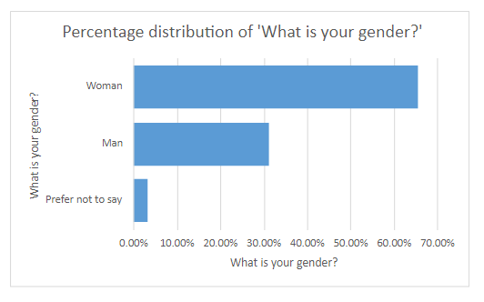
This research utilized a survey distributed to police officers of all genders trained in SOIT (Sexual Offence Investigation Trained Officers) procedures and currently working in the police force. Participants over 18 were invited to participate in the study. The study resulted in 61 participants who completed the entire questionnaire.
The initial question in the survey collected data regarding the gender of the participants. The breakdown of the gender of the participants was demonstrated as 66% female, 31% male and 3% prefer not to say.
‘Figure 1 – 61 Responses”

4.3 Trend One: Discrepancy Between Theoretical Training and Practical Application:

4.3.1 Introduction
The survey responses reveal a clear contrast in how sexual offence-trained officers perceive their preparedness in two key areas: the practical application of trauma-informed approaches and their legislative knowledge regarding rape and sexual offences.
Statistical data suggested discrepancies between theoretical training and practical application; responses were compared from the following two questions:

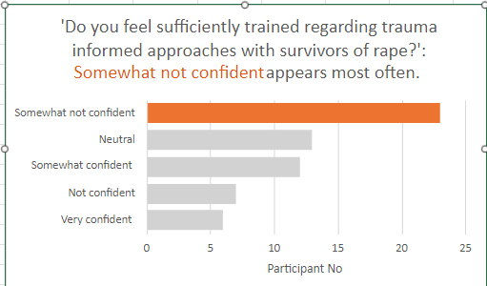
4.3.2 “Do you feel sufficiently trained regarding trauma-informed approaches with survivors of rape?”
The key responses were as follows:
• 23 officers (37.7%) indicated that they felt “somewhat not confident.”
• 7 officers (11.5%) indicated that they felt “not confident.”
‘Figure 2 – 61 Responses”

Out of 61 respondents, 30 officers (49.2%) expressed some degree of doubt about their training. Of these, the majority (37.7%) felt moderately unsure, while a smaller but significant group (11.5%) had no confidence in their trauma-informed training.
From a statistical perspective, almost half (49.2%) of the officers surveyed expressed uncertainty about their ability to apply trauma-informed approaches, indicating that nearly one in two officers feels unprepared.
The fact that 37.7% of respondents felt "somewhat not confident" suggests that while they may have some understanding of trauma-informed principles, they lack full confidence in applying them in practice. Meanwhile, 11.5% of those who felt "not confident" highlighted a smaller group that was particularly concerned about their preparedness. The distribution of responses points to a critical need for improvement in trauma-informed training, as nearly half of the officers do not feel adequately equipped.

4.3.3 “How confident do you feel in your legislative knowledge regarding rape and sexual offences?”
The key responses were as followed
- 23 officers (37.7%) felt neutral.
- 4 officers (6.6%) felt very confident.
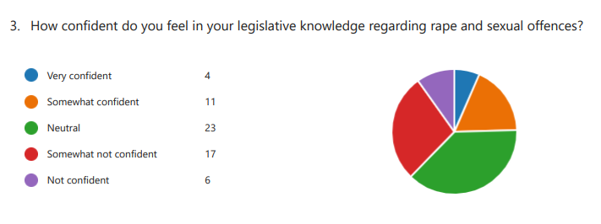
- 11 officers (18%) felt somewhat confident.
‘Figure 3- 61 Responses

This data demonstrates that 37.7% of the 61 respondents felt neutral regarding their confidence in their legislative knowledge. A significant number of officers feel neither confident nor unconfident in their legal knowledge, indicating partial familiarity but not mastery.

4.3.4 Statistical Comparison
The difference in participants' responses illustrates how officers feel more comfortable with the structured, clear-cut nature of legal knowledge than with the emotionally complex, situational nature of trauma-informed approaches. When comparing the data, officers displayed more confidence in their legislative knowledge rather than in their trauma-informed practices. Additionally, a smaller percentage of officers expressed doubt in their legal knowledge (37.7%) compared to trauma-informed care (49.2%).
A trend emerging from this comparison is the stronger confidence officers have in their theoretical understanding of laws related to rape and sexual offences, as opposed to their practical application of trauma-informed approaches. For example, 15 officers (24.6%) felt confident to varying degrees (4 very confident, 11 somewhat confident) about their understanding of the legal framework. Suggesting that officers feel more assured in their ability to navigate the legal requirements of their role, which are typically more clearly defined and standardized, than in managing the emotionally complex, unpredictable interactions required in trauma-informed care.
The lower levels of confidence in trauma-informed practices may be attributed to the psychological and emotional challenges involved in supporting rape survivors. Unlike legislative knowledge, which can be studied and measured through exams or training, trauma-informed approaches require a deeper understanding of human behaviour, empathy, and real-time decision-making under emotionally charged conditions (Abraham & Clancey, 2024). The complexity and unpredictability of these interactions may contribute to the 49.2% of officers expressing doubt about their practical readiness. While officers may feel they have mastered the "rules" of their profession, they are less certain about how to apply those rules sensitively and effectively in the context of survivors' needs. Abraham and Clancey (2024) discuss how police responses and support for victims are improved drastically through victim-centred and trauma-informed approaches.
Trauma-informed care is more fluid, requiring officers to adjust their approach based on the individual survivor's emotional state and needs, making it harder to feel fully prepared (Finch et al., 2020). The legislative domain offers a sense of security in its definitive rules, whereas trauma-informed care is more dependent on situational judgment and emotional intelligence (Lathan et al., 2021).
It is important to note that 23 officers (37.7%) felt neutral about their legislative knowledge, indicating neither full confidence nor significant doubt. This neutrality suggests that while many officers feel comfortable with the foundational aspects of the law, they may be unsure of their ability to apply it in complex or highly nuanced cases. However, the fact that only 23 officers (37.7%) felt "somewhat not confident" or "not confident" in their legal knowledge suggests that legislative training is relatively effective, especially compared to trauma-informed training, where nearly half of the officers’ expressed doubts about their practical application. A study conducted by Stelnicki (2021) illustrates the importance of understanding the neurobiological effects of trauma on survivors and how this understanding, officers can be better supported in their decision-making, thus reducing police misconduct and bettering experiences for victims.
The statistical analysis demonstrates how officers feel more comfortable with the structured, clear-cut nature of legal knowledge than with the emotionally complex, situational nature of trauma-informed approaches

4.5 Trend Two: Participants Beliefs Regarding the Improvements That Could Be Made To Police Training

4.5.1. Introduction
The final request to the respondents of the survey consisted of an open-ended question for qualitative data collection. This question was:
10. How could current police training and expertise be improved in investigating rape?
The survey collected 58 anonymous responses to Question No.10, each suggesting areas for improving police training regarding sexual offences. The qualitative data was categorized based on recurring themes, and frequency analysis was conducted to determine the most commonly suggested improvements.

5.5.2. Key Themes in Suggestions The responses were analysed and grouped into the following categories:
Category | No. of Mentions by Respondents.
Legal knowledge and updates on sexual offence laws | 33
Trauma-informed approaches and psychological impact on victims | 10
Training to reduce re-traumatization and ensure survivor dignity | 9
Education on biases, cultural, gender, and LGBTQ+ survivors | 8
Best practices for evidence collection, questioning, and handling forensic evidence | 7
Non-confrontational interviewing techniques | 4
Simulated real-life scenarios and immersive training environments | 2
Collaboration with sexual assault response teams and victim advocates | 1

5.4.3. Frequency of Each Category
Theme Frequency Percentage of Responses Legal knowledge and updates:
Some responses touched on multiple categories; in such cases, the responses were coded across several relevant themes.
Theme | Frequency | Percentage of Responses
Legal knowledge and updated training | 33 | 56.9%
Trauma-informed practices and the psychological impact survivors face | 10 | 17.2%
Survivor dignity and minimising re-traumatisation | 9 | 15.5%
Understanding sensitivity to biases and cultural impacts and supporting survivors from LGBTQ+ backgrounds | 8 | 13.8%
Evidence collection and forensic practices | 7 | 12.1%
Non-confrontational interviewing of survivors | 4 | 6.9%
Real-life scenario training | 2 | 3.4%
Collaboration with other services | 1 | 1.7%

The most frequent suggestions revolved around updating officers' knowledge of legal frameworks, with more than half of the respondents (33 out of 58) emphasizing the need for training on sexual offences, consent, and legal reforms.

5.4.4. Analysis of Major Themes

5.4.4.1 Legal Knowledge and Updates:
The most prominent theme, cited in 33 of the 58 responses (56.9%), was the need for officers to receive updated training on laws related to sexual offences, consent, and recent legal reforms. Highlighting a widespread concern that police officers may be lacking current legal expertise, particularly in navigating the complexities of sexual offence cases.
Respondents highlighted the importance of keeping officers informed about evolving legal definitions, societal norms, and reforms in sexual offence laws, especially as cases related to consent can be legally nuanced (Horne et al., 2020).
This emphasis on legal knowledge reflects a perception that police training must go beyond static, one-time sessions and should incorporate regular updates, refresher courses, and evaluations to ensure that officers stay knowledgeable about changing laws (Topping et al., 2022).

5.4.4.2 Trauma-Informed and Psychological Approaches:
Another key theme was the call for trauma-informed training, which was mentioned in 10 responses (17.2%). Respondents underscored the need for officers to have a better understanding of how sexual offences affect victims psychologically, particularly the impact of trauma on memory, behaviour, and emotions.
They stressed that trauma could cause victims to behave in ways that may seem inconsistent or confusing to an uninformed officer, which could lead to misinterpretations of victim behaviour during interviews or investigations.
Training officers to recognize the effects of trauma is seen as essential for improving their interactions with victims, ensuring that interviews are conducted with care and sensitivity (Goodall, 2023; McDonald et al., 2022). Trauma-informed training also helps officers avoid re-traumatizing victims, which could damage trust and discourage victims from cooperating with investigations.
Respondents feel that such training would lead to better outcomes in investigations, as victims may feel more supported, thus improving the quality of their testimonies (Edinburgh University, 2023).

5.4.4.3 Survivor Dignity and Minimizing Traumatization:
Closely linked to trauma-informed training is the theme of maintaining the dignity of survivors and minimizing their re-traumatization, cited in 9 responses (15.5%). Respondents expressed concern that certain police procedures, particularly during interviews or evidence collection, could inadvertently cause further emotional harm to victims. Gonzalez et al. (2020) emphasize the necessity for sensitive approaches and the effects officers have on re-traumatisation.

5.4.4.4 Bias, Cultural, Gender, and LGBTQ+:
(13.8%) responses highlighted the need for police training to address biases and ensure cultural, gender, and LGBTQ+ sensitivity. Respondents felt that police officers should be equipped with the knowledge and tools to handle cases involving diverse victims, ensuring that they approach each case without prejudgment or bias.
Respondents stressed the need to challenge stereotypes and misconceptions, such as false reporting rates or how a "typical" victim should behave. Training in this area would also ensure that officers treat victims from marginalized communities, including those from different cultural backgrounds or the LGBTQ+ community, with respect and sensitivity (McDonald et al., 2022). Such training would help officers better understand the unique challenges that victims from these groups may face and how systemic biases might influence their experiences with law enforcement.

5.4.4.5 Best Practices for Evidence Collection and Forensic Handling:
Seven responses (12.1%) focused on the importance of teaching best practices for evidence collection, suspect questioning, and forensic handling in sexual offence cases. This technical aspect of police training is seen as vital to ensuring that investigations are carried out with precision and professionalism. Respondents felt that officers should be well-versed in the protocols for gathering and preserving evidence, questioning suspects effectively, and working with forensic materials, all of which are crucial for building strong cases.
Several responses suggested that current training may be insufficient in this regard. This could potentially lead to mishandling key evidence, which could weaken prosecutions or cause cases to collapse (Edinburgh University, 2023). Improving training in this area would ensure that officers are sensitive to victims and can conduct thorough, legally sound investigations.

Chapter Five: Findings, Conclusion and Recommendations

5.1 Introduction
The concluding chapter of this report will incorporate the previous chapters of analysis and survey results to provide a summary of the dissertation. This section will delve into the objectives stated at the beginning of the report and their conclusions from the survey's primary findings. Additionally, this chapter will provide recommendations for other academic ventures.
This dissertation aimed to explore the challenges in investigating rape cases in the United Kingdom, focusing on evaluating current police practices and the adequacy of training and expertise in handling sexual offences.
Investigating such cases presents numerous challenges, including sensitive evidence collection and understanding the psychological trauma experienced by survivors. The research analysed systemic and personal barriers officers face during investigations and their perceptions of the adequacy of their training. By identifying key themes through survey data analysis, this study aims to provide actionable recommendations for enhancing police practices and training.

5.2 Primary Findings
The findings of this research illuminate several critical areas for improvement in police training and investigative practices regarding rape cases in the UK. Firstly, there is a clear demand for more up-to-date legal training, with over half of the survey respondents indicating this need as a primary concern. Respondents emphasized the importance of equipping officers with current knowledge of legal definitions, consent laws, and recent reforms (Hester et al., 2018; Home Office, 2021).
Secondly, the significance of trauma-informed approaches emerged prominently, with many officers requesting additional training on the psychological impacts of trauma on victims. Similarly aligning with literature indicating that officers trained to recognize trauma can build better rapport with victims, reducing misinterpretations of behaviour (Lievore, 2004; Ritchie, 2019).
Lastly, the need for cultural sensitivity and bias training, particularly regarding gender and LGBTQ+ issues, was mentioned in approximately 14% of the responses, highlighting the necessity for officers to challenge biases and ensure equitable treatment for all victims (Woods et al., 2018; Watson et al., 2019).

5.3 The Attainment of Objectives

5.3.1 Objective One: To Critically Research into The Challenges of Investigating Rape Cases in The United Kingdom, Including the Current Practices In The United Kingdom And The Current State Of Police Training And Expertise
The first objective of this research was to critically examine the challenges in investigating rape cases in the UK. The data highlights several key obstacles, such as the evolving complexity of sexual offence laws and the emotional difficulties in interviewing victims. Current police practices often fail to equip officers with the necessary tools to handle such cases effectively (Hester et al., 2018; Home Office, 2021).
Many respondents expressed the need for more detailed legal knowledge and trauma-informed approaches to effectively engage with victims, which aligns with existing research emphasizing the need for specialized training to navigate the nuances of sexual offence cases (Ritchie, 2019; Watson et al., 2019).

5.3.2 Objective Two: To Select a Suitable Research Method to Explore the Confidence Officers Feel Conducting Investigations of Rape and the Level of Training and Expertise they Believe they Have.
The second objective was to explore officers' confidence in conducting investigations of rape cases and their perceived level of training. Survey responses indicate that many officers lack confidence, particularly in their legal knowledge and trauma-related skills. Officers voiced concerns about re-traumatizing victims during interviews or mishandling evidence due to insufficient training (Lievore, 2004; Woods et al., 2018). This finding is consistent with studies highlighting the need for specialized training to adequately prepare officers for sensitive investigations (Hester et al., 2018; Watson et al., 2019).

5.3.3 Objective Three: To Analyse the Data Collected to Provide Recommendations Relating to Improving Current Practices and Police Training and Expertise.
The third objective was to analyse the collected data and provide recommendations for improving current practices and police training. The survey findings reveal a clear need for continuous training focused on legal updates, trauma-informed interviewing techniques, and cultural sensitivity. The literature supports these recommendations, emphasizing that comprehensive training enhances police officers' skills in handling sexual offences and contributes to more positive outcomes for victims (Hester et al., 2018; Home Office, 2021).

5.4 Recommendations
5.4.1. Future Study:
Future research should examine the long-term effects of trauma-informed training on police officers' handling of sexual offence cases. A longitudinal study could assess how ongoing, updated training influences both investigative outcomes and victim satisfaction over time, thereby providing valuable data on the tangible impacts of such training (Ritchie, 2019).

5.4.2. Regular and Refreshed Training:
Legal Knowledge Police departments should implement mandatory refresher courses on sexual offence laws, including consent and recent legal reforms. These courses should be tailored to address the complexities of the law and provide practical case studies to help officers navigate difficult legal situations (Hester et al., 2018; Home Office, 2021). Emphasizing knowledge of consent law and recent case law will improve officers' investigative accuracy and effectiveness (Lievore, 2004).

5.4.3. Trauma-Informed Training:
Trauma-Informed Approaches Police training should emphasize trauma-informed techniques. Officers must be educated on recognizing the psychological impact of trauma on victims and how trauma can affect memory and behaviour. Such training would enhance the quality of interviews and reduce the likelihood of re-traumatizing victims during investigations, fostering a more supportive approach that increases victim cooperation (Ritchie, 2019; Watson et al., 2019).
While the complexities of such cases necessitate specialized skills, the data indicates that officers often feel unprepared in critical areas, including legal knowledge, trauma-informed care, and cultural sensitivity. Addressing these gaps through continuous training and legal updates can enhance police practices and better support victims. Future research should further explore the long-term effects of training programs to ensure they lead to meaningful improvements in police conduct and case outcomes.

5.5 Limitations
Despite the valuable data collected, this study has been limited to its smaller focus group of 61 officers. In order to develop this research to its full potential, a larger survey sample from multiple forces nationwide would provide essential insight into the needs across the United Kingdom. A larger and more diverse sample of officers ranging on a spectrum of service and training would bring a deeper understanding.

5.6 Conclusion
In summary, this research identifies critical gaps in police training and practices regarding the investigation of rape cases in the UK.
While the complexities of such cases necessitate specialized skills, the data indicates that officers often feel unprepared in key areas, including legal knowledge, trauma-informed care, and cultural sensitivity. Addressing these gaps through continuous training and legal updates can enhance police practices and better support victims. Future research should further explore the long-term effects of training programs to ensure they lead to meaningful improvements in police conduct and case outcomes.

Chapter Six: Bibliography
- Abraham, L.A. & Clancey, L. (2024). Policing Needs to be More Victim-Centred, Trauma-Informed. CNA. (Accessed 10th August 2024)
- Abraham, L.A. & Clancey, L. (2024). Victim-centred, trauma-informed policing helps victims and police while reducing crime. Centre for Naval Analyses. (Accessed 7th August. 2024)
- Brace, I., (2018). Questionnaire Design: How to Plan, Structure, and Write Survey Material for Effective Market Research. 4th ed. London: Kogan Page. (Accessed: 8th June 2024)
- Bryman, A., (2016). Social Research Methods. 5th ed. Oxford: Oxford University Press.
- Campbell, R. & Johnson, C.R., 1997. Police officers’ perceptions of rape: Is there consistency between state law and individual beliefs? Journal of Interpersonal Violence, 12(2), pp. 255-274. (Accessed 11 April 2024)
- Campbell, R., & Raja, S. (1999). Secondary victimization of rape victims: Insights from mental health professionals who treat survivors of violence. Violence and Victims, 14(3), 261-275. (Accessed: 8th June 2024)
- College of Policing (2023) Victim-centred approaches in sexual assault: What the national operating model means for victims. Available at: https://www.college.police.uk/victims (Accessed: 7th September 2024).
- Community Safety Knowledge Alliance (2019). The Role of Forensic Evidence in Arrest and Prosecution of Sexual Assault Cases. Available at: https://cfrc.illinois.edu/publications/the-role-of-forensic-evidence-in-arrest-and-prosecution-of-sexual-assault-cases/ (Accessed 17th August 2024)
- Creswell, J.W., (2014). Research Design: Qualitative, Quantitative, and Mixed Methods Approaches. 4th ed. Thousand Oaks, CA: Sage Publications. Available at: (PDF) Creswell, J.W. (2014). Research Design: Qualitative, Quantitative and Mixed Methods Approaches (4th ed.). (Accessed 1st June 2024)
- Daly, K. & Bouhours, B., (2010). Developing best practice for sexual assault victims: A research review and police officer survey. Policing and Society, 20(4), pp.454-476. (Accessed 1st June 2024)
- Devlin, S.J. & Dong, H.K. & Brown, M. (2003). Selecting a Scale for Measuring Quality. (Accessed 17th August 2024)
- Dilman, D.A., Smyth, J.D. & Chrsitian, L.M., (2014). Internet, Phone, Mail, and Mixed-Mode Surveys: The victims: A research review and police officer safety. Policing and Society, pp. 454-476 (Accessed: 27th September 2024).
- Edinburgh University. (2023). Trauma-informed approaches in policing. Health in Social Sciences. (Accessed 7th September 2024)
- Emerald Publishing, (2023). Rape myths, jury deliberations, and conversation analysis: a new approach to an age-old problem. Available at: https://www.emeraldgrouppublishing.com. (Accessed 16th May 2024)
- End Violence Against Women Coalition et al. (2020) The Decriminalisation of Rape Report. Available at: https://www.endviolenceagainstwomen.org.uk/wp-content/uploads/C-Decriminalisation-of-Rape-Report-CWJ-EVAW-IMKAAN-RCEW-NOV-2020.pdf (Accessed 3rd May 2024)
- Finch, S., Adams, S. & Decker, M. (2020). Training police officers to be trauma informed. Journal of Police and Criminal Psychology, 35(4), pp. 274-280 (Accessed 1st October 2024)
- Foddy, W., (1993). Constructing Questions for Interviews and Questionnaires: Theory and Practice in Social Research. Cambridge: Cambridge University Press. (Accessed: 08th of June 2024)
- Galli, F., (2009). Sexual Assault and the Justice Gap: A Question of Attitude. The Cambridge Law Journal, 68(2), pp.485-487 (Accessed: 27th September 2024)
- Gonzalez, J. M., Wilkins, K. N., & Stansfield, A. (2020). Understanding the Impacts of Trauma on Victims of Sexual Assault: A Guide for Law Enforcement. International Journal of Police Science & Management, 22(1), 4-16. (Accessed 7th September 2024)
- Goodall, K. (2023). Trauma-informed approaches in police: A report on the insights from focus groups and interviews with officers. Scottish Police Authority. (Accessed 7th October 2024)
- Goodison, S. E., Davis, R. C., & Jackson, B. A. (2015). Digital Evidence and the U.S. Criminal Justice System - Identifying Technology and Other Needs to More Effectively Acquire and Utilize Digital Evidence. (Accessed: 10th September 2024)
- Grace, S., & Lloyd, M. (2016). Policing rape: Crisis, reform and resistance in the UK. London: Routledge. (Accessed 26th May 2024)
- Grubb, A. & Harrower, J., (2008). Attribution of blame in cases of rape: An analysis of participant gender, type of rape and perceived similarity to the victim. Aggression and Violent Behaviour, 13(5), pp. 396-405. (Accessed 17th August 2024)
- Grubb, A. & Turner, E., (2012). Attribution of blame in rape cases: A review of the impact of rape myth acceptance, gender role conformity and substance use on victim blaming. Aggression and Violent Behaviour, 17(5), pp. 443-452. (Accessed 17th August 2024)
- Hester, M., & Westmarland, N. (2018). The policing of sexual violence: The challenges of complexity and institutional responses. Journal of Gender Studies, 27(1), 1-15. (Accessed: 10th September 2024)
- HM Inspectorate of Constabulary and Fire & Rescue Services, (2021). Rape Monitoring Group Digests. Available at: https://justiceinspectorates.gov.uk (Accessed 11th April 2024).
- Home Office, (2023). The Operation Soteria Bluestone Year One Report. Available at: https://www.gov.uk (Accessed 11th April 2024).
- Home Office, (2024). Crime outcomes year to September 2023: data tables. Available at: https://www.gov.uk (Accessed 11th April 2024)
- Home Office. (2021). Review of sexual offences: 2020–21. Retrieved from https://www.gov.uk/government/statistics/ (Accessed 17th April 2024)
- Horne, A., McDonald, A., & Topping, A. (2020). Effective training for police officers dealing with sexual offences: Bridging the knowledge gap. Journal of Policing and Criminal Justice, 8(3), 123-134. (Accessed 2nd October 2024)
- IntechOpen (2021). Biological Evidence Analysis in Cases of Sexual Assault. Available at: https://www.intechopen.com/chapters/71691 (Accessed 11th April 2024)
- Jebb, A. T., Ng, V., & Tay, L. (2021). A Review of Key Likert Scale Development Advances: 1995-2019. Frontiers in psychology. Accessed (4th May 2024)
- Jordan, J. & Lund, E.M., (2015). Police culture and the investigation of rape: Beliefs about false allegations and the use of language in police interviews. Feminist Criminology, 10(2), pp. 99-120. (Accessed: 7th September 2024).
- Jordan, J. (2001). The law’s attitude to rape victims: How reform is needed in the investigation of rape cases. Liverpool Law Review, 23(1), 37-50. (Accessed: 7 June 2024).
- Jordan, J. (2004). Beyond Belief? Police, Rape and Women’s Credibility. Criminal Justice, 4(1), 29-59. (Accessed 17th April 2024).
- Kelly, L., Lovett, J. & Regan, L., (2005). A gap or a chasm? Attrition in reported rape cases. Home Office Research Study, p. 293. (Accessed 11th April 2024).
- Krosnick, J.A., & Presser, S. (2010) “Question and Questionnaire Design”. In Handbook of Survey Research (2nd Edition) Edited by P.V Marsden and J.D Wright, 263-314. Emerald Group Publishing Limited (Accessed 15th April 2024).
- Lathan, A., Kuehn, J., & McGowan, M. (2021). Challenges with trauma-informed care. Centre for Public Safety Initiatives. (Accessed 27th August 2024)
- Lievore, D. (2004). Improving the response of the criminal justice system to sexual assault. Australian Institute of Criminology. (Accessed 18th June 2024)
- Lovett, J., & Kelly, L. (2009). Different systems, similar outcomes? Tracking attrition in reported rape cases in eleven countries. London: Child and Woman Abuse Studies Unit, London Metropolitan University. (Accessed 20th June 2024)
- Malema, S. B. (2020). Investigating the impact of Sexual Assault Evidence Collection Kits (SAECKs) as evidence in rape cases prosecuted in the Western Cape High Court between 2012 and 2016. University of Cape Town. (Accessed 2nd October 2024)
- McDonald, A., Goodall, K., & Bellis, M. (2022). Adverse childhood experiences in policing: The need for trauma-informed practice. Trauma, Violence, & Abuse, 23(2), 376-389. (Accessed 4th October 2024)
- Ministry of Justice (2023) Criminal court statistics quarterly: January to March 2023. Available at: https://www.gov.uk/government/statistics/criminal-court-statistics-quarterly-january-to-march-2023 (Accessed: 5th October 2024).
- Ministry of Justice, (2013). An overview of Sexual Offending in England and Wales. Available at: https://publishing.service.gov.uk. (Accessed 11th April 2024)
- Ministry of Justice, (2023). Criminal Court Statistic Publication: Pivot Table Analytical Tool for England and Wales. Available at: https://assets.publishing.service.gov.uk/media/657845710467eb001355f5b2/cc_rdos_tool.xlsx (Accessed 15th April 2024)
- Morgan, A. & Evans, K.R., (2017). Policing sexual violence: Addressing gaps in training and practice. Journal of Interpersonal Violence, 32(14), pp. 2157-2176. (Accessed 15th April 2024).
- Myhill, A. (2015). Measuring police attitudes to rape. In: M. Hester, L. Kelly & J. Radford (Eds.), Women, violence and male power: Feminist activism, research and practice (pp. 73-88). Bristol, UK: Policy Press. (Accessed: 5th October 2024).
- National Institute of Justice (2018). Empowering Criminal Justice Stakeholders and Victims Through Forensic Science. Available at: https://nij.ojp.gov/library/publications/national-best-practices-sexual-assault-kits-multidisciplinary-approach (Accessed: 3rd October 2024).
- Office for Victims of Crime. (2018). First Response to Victims of Crime: A Guidebook for Law Enforcement Officers. U.S. Department of Justice. (Accessed 25th July 2024).
- Parratt, K. A. and Pina, A. (2017) ‘From “real rape” to real justice: A systematic review of police officers’ rape myth beliefs’, Aggression and Violent Behaviour, 34, pp. 68-83. (Accessed: 3rd October 2024).
- PLOS Medicine (2017). Medico-Legal Findings, Legal Case Progression, and Outcomes in South African Rape Cases: Retrospective Review. (Accessed 7th October 2024)
- Policing Insight, (2023). How rape myths and unconscious biases prejudice the judicial system against women – and rape survivors in particular. (Accessed 7th October 2024)
- Rape, Abuse & Incest National Network (RAINN) (2023). The Importance of DNA in Sexual Assault Cases. (Accessed 2nd October 2024).
- Real Reform? (1988) [Review of Real Rape, by S. Estrich]. Harvard Law Review, 101(8), pp. 1978–1983. (Accessed: 1st October 2024).
- Reja, U., Lozar Manfreda, K., Helbec, V., & Venhovar, V. (2003) “Open-ended vs Close-ended Questions in Web Questionnaires” Developments in Applied Statistics, 19, 159-177. (Accessed: 1st June 2024)
- Rich, K. and Seffrin, P. M. (2012) ‘Police interviews of sexual assault reporters: Do attitudes matter?’, Violence and Victims, 27(2), pp. 263-279. (Accessed: 11th June 2024)
- Rich, K., & Seffrin, P. (2012). Police interviewing practices with adult sexual assault victims: A case study of one urban police department. Violence and Victims, 27(5), 699-723. (Accessed: 1st July 2024)
- Ritchie, J. (2019). The impact of trauma on survivors of sexual violence: Practical responses for law enforcement. Journal of Interpersonal Violence, 34(4), 1-21. (Accessed: 11th June 2024)
- Sexual Offences Act (2003). Legislation.gov.uk. Available at: https://www.legislation.gov.uk. (Accessed: 11th February 2024)
- Sleath, E. & Bull, R., (2017). Police perceptions of rape victims and the impact on case decision making: A systematic review. Aggression and Violent Behavior, 34, pp. 102-112. (Accessed: 1st October 2024).
- Smith, D. (2006). Police response to sexual assault victims: Complaints of secondary victimization and police procedures. Police Practice and Research, 7(3), 229-243. (Accessed 11th April 2024).
- Stelnicki, A.M., et al. (2021). A trauma-informed approach is needed to reduce police misconduct. Industrial and Organizational Psychology, 15(4), pp. 583-601. (Accessed 5th September 2024)
- Temkin, J. & Krahe, B., (2008). Sexual Assault and the Justice Gap: A Question of Attitude. Oxford: Hart Publishing. (Accessed: 11th June 2024)
- The Crown Prosecution Service (2013) The National Operating Model for Adult Rape Prosecution. Available at: https://www.cps.gov.uk/national-operating-model-adult-rape-prosecution (Accessed: 7th October 2024).
- The Crown Prosecution Service (2023) The National Operating Model for Adult Rape Prosecution. Available at: https://www.cps.gov.uk/national-operating-model-adult-rape-prosecution (Accessed: 1st October 2024).
- Topping, A., et al. (2022). Assessing the effectiveness of legal training for police officers in sexual offence cases: A qualitative study. British Journal of Criminology, 62(4), 811-828 (Accessed 3rd October 2024)
- Wagner, A., & Magnusson, K. (2017). Best Practices in Sexual Assault Investigation: A Review of the Literature. Canadian Police College Discussion Paper Series. (Accessed: 1st October 2024).
- Watson, J., & Morley, J. (2019). The role of police training in addressing issues of sexual violence: A systematic review. Policing: An International Journal, 42(5), 955-973. (Accessed 11th April 2024).
- Wilson, D., & Wilson, S. (2021). Rape and Sexual Assault: A New Model of Investigation and Prosecution. Routledge. (Accessed 11th July 2024).
- Woods, M., & Peters, J. (2018). Cultural sensitivity in policing: Addressing bias in sexual assault investigations. International Journal of Police Science & Management, 20(2), 124-136. (Accessed 28th April 2024).
- Yuan, N. P., Koss, M. P., & Stone, M. (2006). The Psychological Consequences of Sexual Trauma. National Online Resource Centre on Violence Against Women. (Accessed 10th August 2024).

Chapter Seven: Appendix

7.1 Appendix One: Ethics Form

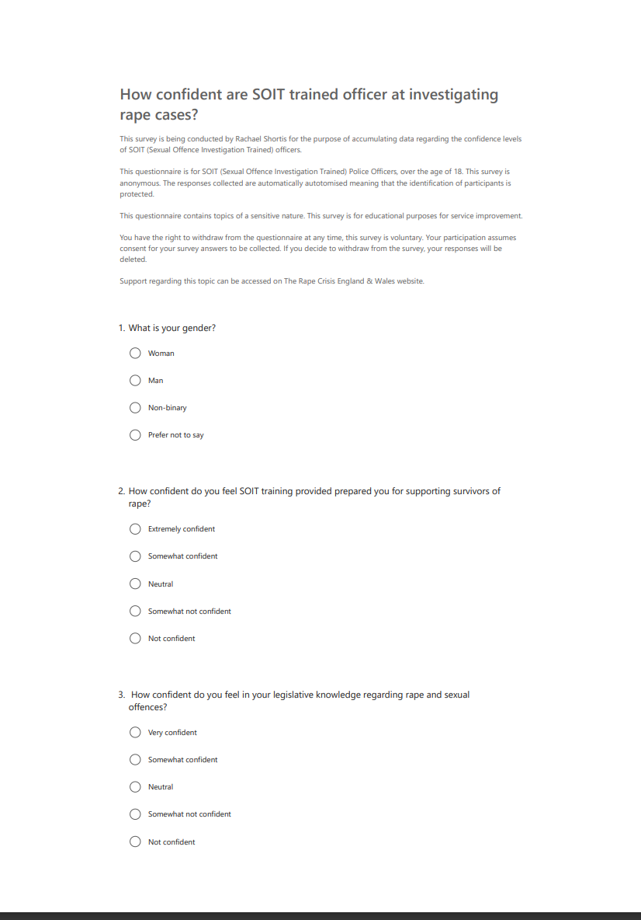
7.2 Copy of Blank Questionnaire
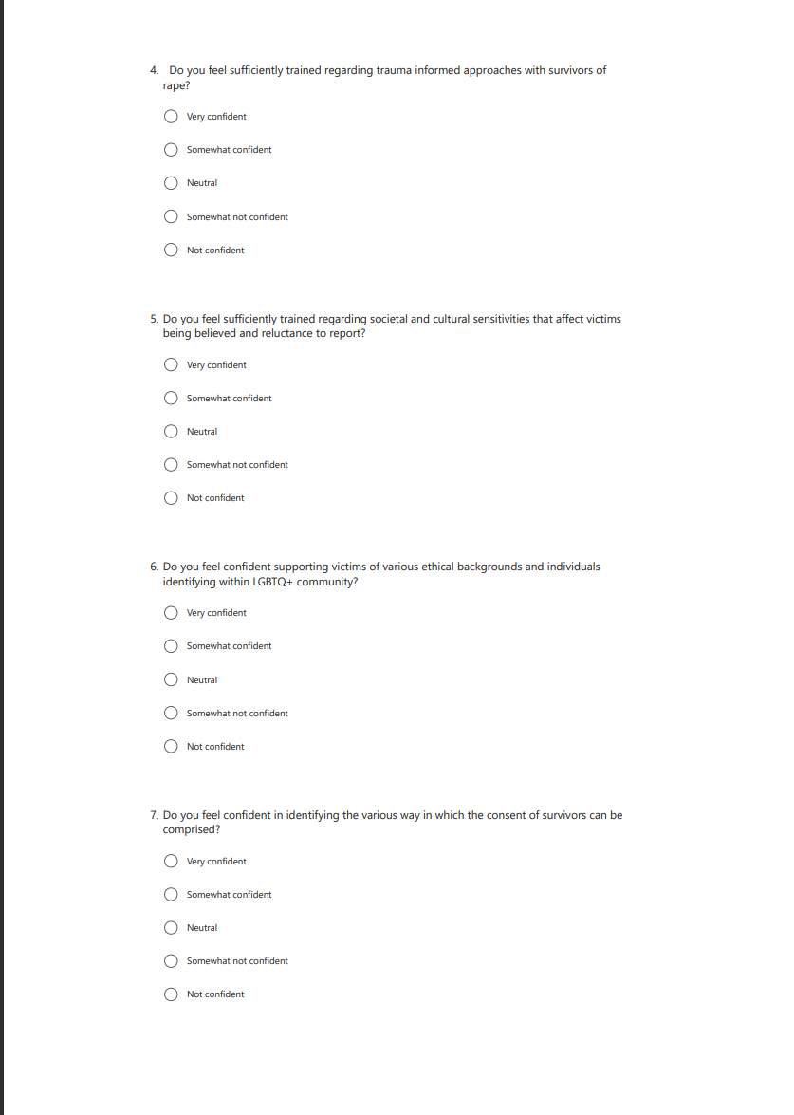

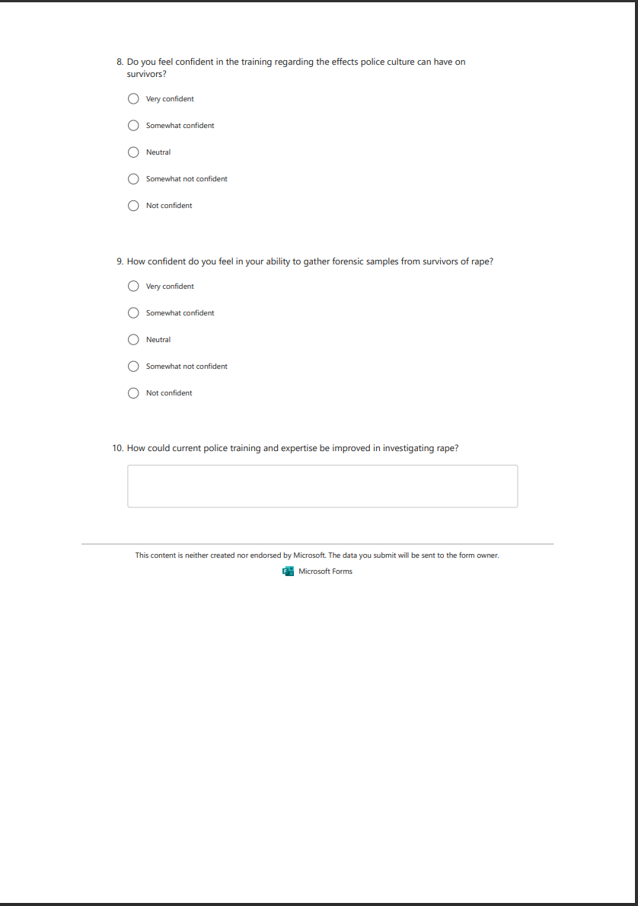

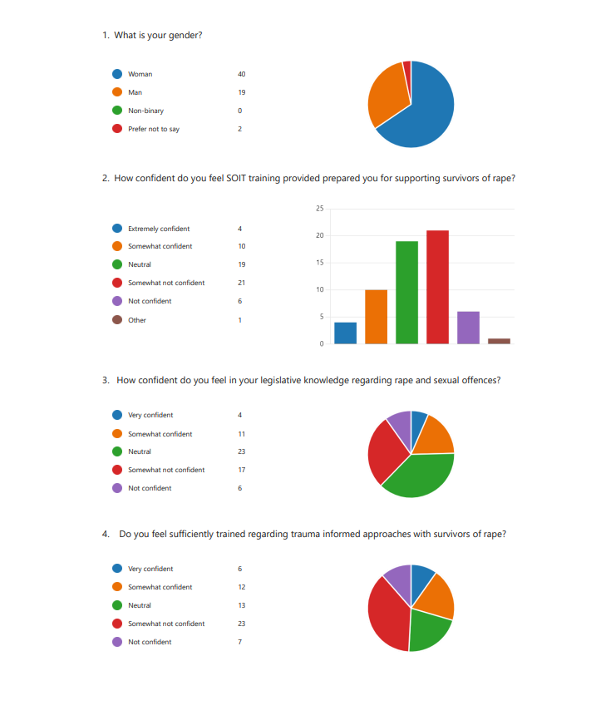
Appendix Three: Questionnaire Results
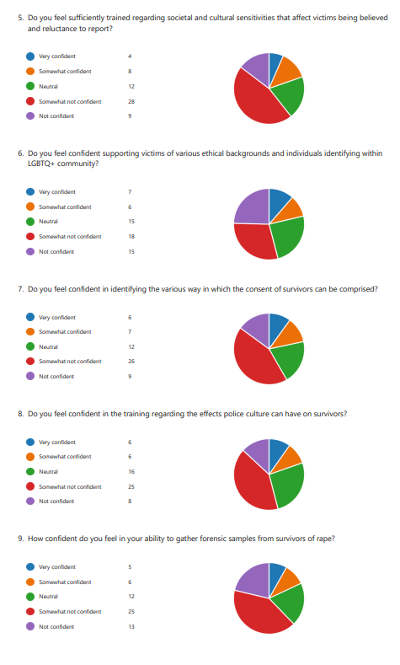

Appendix Four: Responses to Question No.10
1 | Anonymous | Police training could be improved with more training regarding trauma informed approaches
2 | Anonymous | Refreshed training on the laws relating to sexual offences
3 | Anonymous | Training regarding the psychological impact of sexual offences on victims and how trauma can affect memory, behaviour and emotions
4 | Anonymous | Sessions that challenge biases
5 | Anonymous | Training should include education on cultural, gender, and LGBTQ+ issues to ensure respectful treatment of all victims, regardless of their background.
6 | Anonymous | Training in recognizing the psychological impact of sexual offences on victims, including how trauma affects memory
7 | Anonymous | Training in questioning victims and suspects in a manner that is non-confrontational
8 | Anonymous | Training should prioritize the dignity and safety of the survivor, focusing on how to minimize re-traumatization during interviews
9 | Anonymous | Officers need updated knowledge of the laws related to sexual offences, consent, and recent legal reforms
10 | Anonymous | Training on best practices for evidence collection, questioning suspects, and handling forensic evidence in sexual offence cases to ensure the highest standards of investigation.
11 | Anonymous | Training on how to prioritize the dignity and safety of the survivor, focusing on how to minimize re-traumatization during interviews or evidence collection.
12 | Anonymous | Questioning victims and suspects in a manner that is non-confrontational and sensitive
13 | Anonymous | Training in recognizing the psychological impact of sexual offences on victims, including how trauma affects memory,
14 | Anonymous | Training on cultural, gender, and LGBTQ+ issues.
15 | Anonymous | Training on how to minimize re-traumatization
16 | Anonymous | Sessions on challenging biases, such as misconceptions about false reporting rates or stereotypical views of how a victim “should” behave.
17 | Anonymous | Refreshed knowledge of the laws related to sexual offences, consent, and recent legal reform
18 | Anonymous | Sexual offence laws and societal norms evolve over time. Police training should be an ongoing process with regular updates, refresher courses, and evaluations.
19 | Anonymous | Legislation related to sexual offences and consent
20 | Anonymous | Officers need updated knowledge of the laws related to rape cases
21 | Anonymous | Training on minimizing re-traumatization during interviews this includes questions that need to be asked and how to ask them
22 | Anonymous | Evidence collection training
23 | Anonymous | Training should include education on LGBTQ+ issues to ensure respectful treatment of all victims.
24 | Anonymous | Training should include education on cultural sensitivities
25 | Anonymous | Training should include sessions that challenge biases.
26 | Anonymous | Simulated training environments can immerse officers in real-life scenarios, allowing them to practice responses to victims, witnesses, and suspects.
27 | Anonymous | Officers need more extensive training in understanding how trauma impacts victims of sexual violence. This would help officers to conduct interviews and investigations without re-traumatizing victims, allowing them to feel supported and heard.
28 | Anonymous | Real-life scenarios
29 | Anonymous | Working closely with sexual assault response teams and victim advocates would improve the support victims receive from the first point of contact. This would involve immediate access to professionals who can offer emotional and practical support while the investigation is ongoing.
30 | Anonymous | Training should include best practices for evidence collection, questioning suspects, and handling forensic evidence
31 | Anonymous | Officers need to be fully up to date with changes in the laws surrounding consent, sexual assault, and victim rights. Understanding the complexities of legal definitions, consent, and case law will improve the accuracy of reports and investigations.
32 | Anonymous | Training should include how to handle forensic evidence
33 | Anonymous | Training on forensic evidence collection
34 | Anonymous | Refreshed training on evidence collection from survivors and suspects.
35 | Anonymous | Training on how to prioritize the dignity and safety of the survivor,
36 | Anonymous | Training on how to minimize re-traumatization
37 | Anonymous | Education for officers about re-traumatization
38 | Anonymous | Officers need updated knowledge of the laws related to sexual offences
39 | Anonymous | Refreshed knowledge checks on consent, and recent legal reform
40 | Anonymous | Officers must be knowledgeable on the most recent legal reforms, consent laws, and laws pertaining to sexual offences.
41 | Anonymous | Officers must have up-to-date understanding of sexual crime statutes, consent, and current legislative reforms.
42 | Anonymous | Refreshed training on court processes and legal barriers for survivors
43 | Anonymous | Regular updated training on legislation
44 | Anonymous | Familiarity with current legal standards and information regarding consent.
45 | Anonymous | Staying up to date on recent reforms, legislation, standards and guidelines
46 | Anonymous | Continuous training in the latest sexual assault laws.
47 | Anonymous | Staying up to date with current sexual assault legislation through regular training.
48 | Anonymous | Ongoing education regarding consent, court processes and policy
49 | Anonymous | Refresher training
50 | Anonymous | Access to recent training nationally on policy and procedure to uphold legal standards.
51 | Anonymous | Police training can be improved with regular training so officers stay aligned with current laws, policies and procedures.
52 | Anonymous | Discussions about issues regarding consent and the law.
53 | Anonymous | Officers should participate in regular training to stay up to date with force policy and legal standards.
54 | Anonymous | Providing officers with updated training for legal accuracy when attending rape incidents.
55 | Anonymous | Engaging in continual training to keep pace with evolving sexual assault laws.
56 | Anonymous | Officers should engage in specialised training programs that frequently address the most recent legal advancements in sexual assault legislation, ensuring they are equipped to handle cases with the latest procedural updates.
57 | Anonymous | Training for officers designed to reflect on recent case precedents and the evolution of sexual assault laws.
58 | Anonymous | Regular workshops providing detailed explanations to officers about the amendments to sexual assault procedure and policy particularly focusing on definitions of consent.

